AURA - GAS
Multiplayer 3
Peer to peer 3
Client-Server model 3
GAME MODE vs GAME MODE BASE 5
FORCEINLINE 6
PlayerController 6
GAS – Gameplay Ability System 7
Ability System Component 7
Attribute Set 7
Gameplay Ability 7
Gameplay Effects 7
Gameplay Cues 7
Gameplay Tags 8
How To Start 9
Comparison: Pawn vs Player State 9
GAS in multiplayer 11
Replication Mode 13
Init Ability Actor Info 14
Attributes 16
Game UI Architecture 18
Overlay UI 18
Attribute Menu UI 19
Plan for displaying Attribute Data. 20
Asset Manager 23
Gameplay Effects 24
Duration Policy: 25
Stacking 27
Modifiers 28
Order of operations: modifiers are applied one by one in order 29
Coefficients 31
Derived attributes 33
Custom calculations MMC 34
Execution Calculation 35
PreAttributeChange 37
PostGameplayEffectExecute 38
Gameplay Tags 39
Types of Tags in GameplayEffect: 40
Gameplay Abilities 41
GameplayAbilities 41
AbilityTasks 42
Granting Abilities 44
Settings in GameplayAbilities (lesson 99) 46
Tags: 46
Input: 46
Advanced: 47
Costs: 48
Triggers: 48
Cooldowns: 48
Things Not to use: 49
Target Data 50
Prediction Key 52
GameplayEffectContext 53
NetSerialize in GameplayEffectContext 54
Prediction 55
Prediction in GAS 57
Prediction Window 58
Ability overview regarding prediction 59
GameplayEffectPrediction 60
Meta Attributes 61
Difference between MetaAttribute and NormalAttribute. 61
Gameplay CUEs 63
Input 65
Click to Move 66
CursorTrace 70
MotionWarping 71
Character Classes 72
SomeFunctions 73
Enemy AI 74
EQS-Environment Query System 76
Experience 78
Main Experience Plan 78
Awarding XP Game Plan 80
Spell Menu Plan 81
Ability Status 82

Multiplayer

Peer to peer

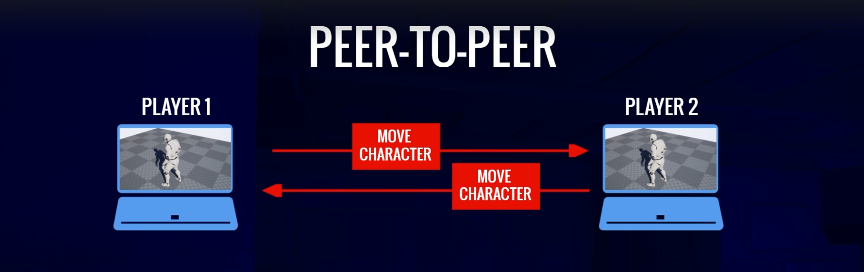

Client-Server model
Replication – distribution of data from server down to the clients
Listen-Server – (playing the game, rendering graphics)
Dedicated Server – (not playing the game, not rendering graphics)

Online subsystem – provides a way to access the functionality of the online platform services. (Platform services like steam or xbox live etc). Each of those platforms has its own set of services support for things like friends, achievements, sessions etc.

Online subsystem handles those platform services using interfaces, not matter which service.

Session interface – handles creating, managing and destroying game sessions. Also handles searching for sessions and matchmaking.

Session can be thought of as an instance of the game. Can be advertised (players can join), or private (invite only).
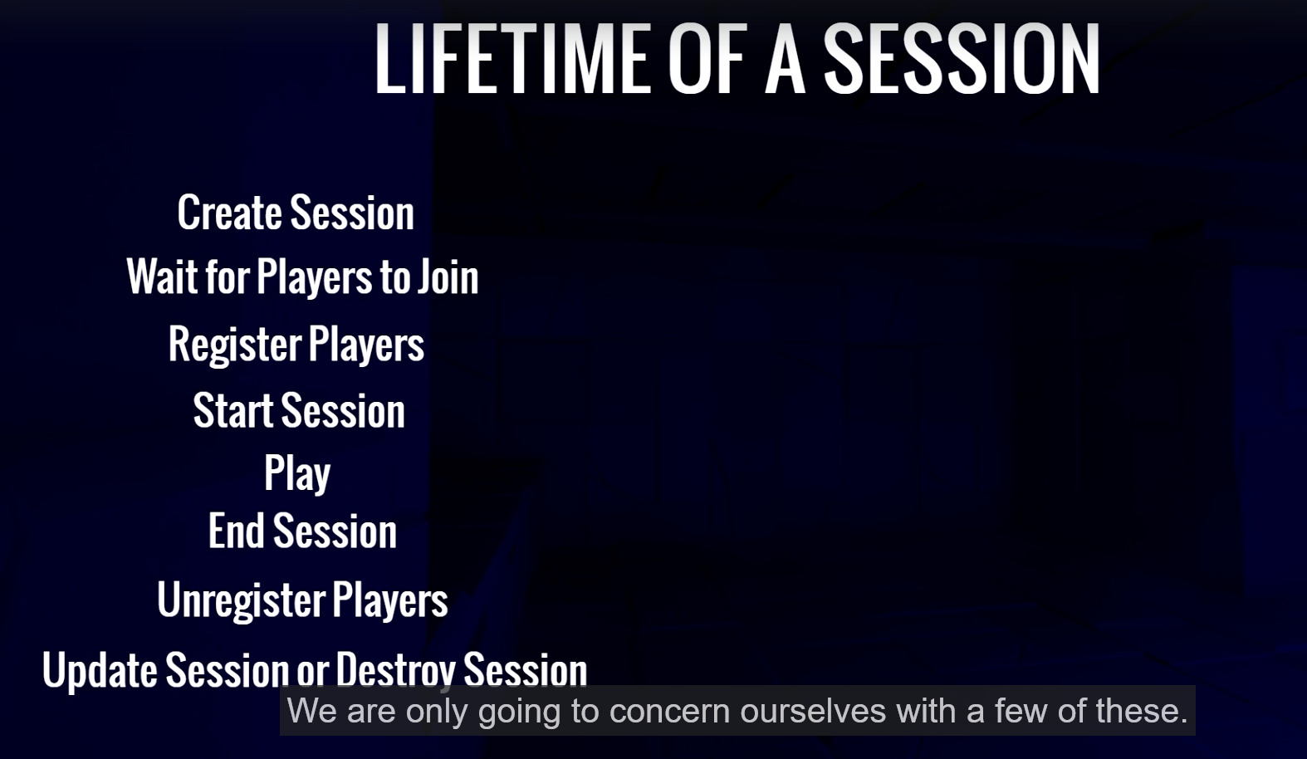
RIG – is just an asset that allows you to map skeleton's bones to a list

Round-Trip time – total time that it takes for a message to reach a server and come back straight to client. There is also asymmetrical round-trip time (different trip time for client->server and diferent time for server->client)

GAME MODE vs GAME MODE BASE
GameMode is a child class of GameModeBase.
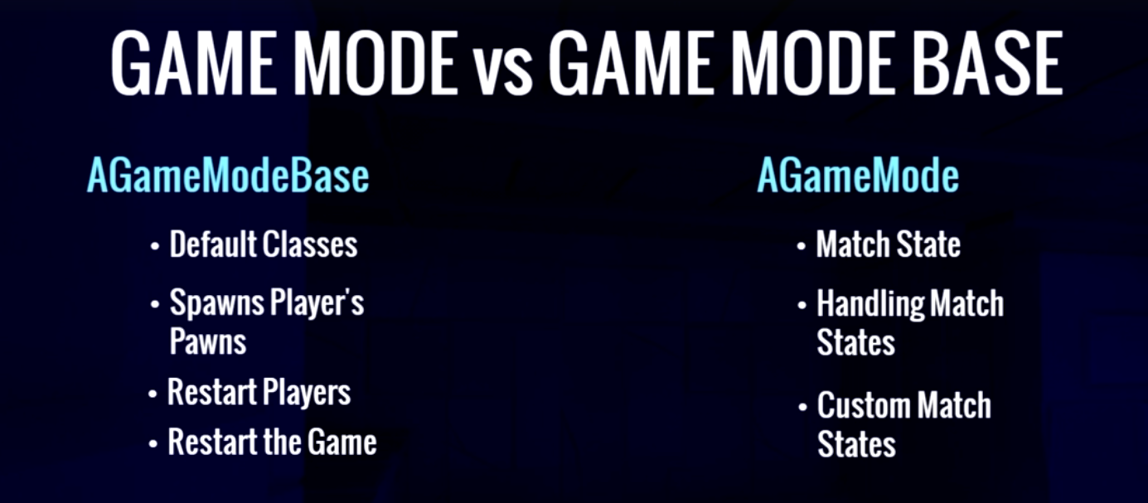
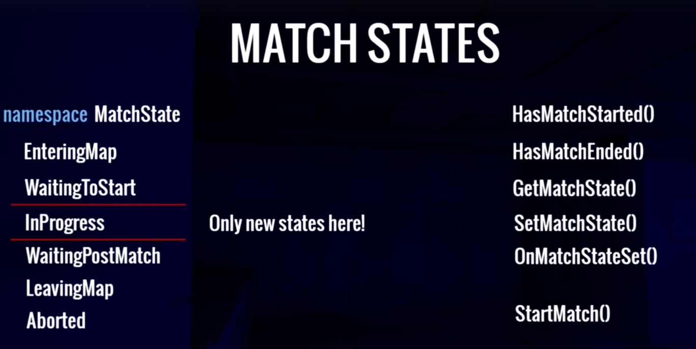
If your game does have match states then game mode base is more appropriate for your game.

FORCEINLINE
It's possible that using FORCEINLINE on a large function could cause the project to compile successfully but not package properly. Inlining large functions can cause the size of the compiled code to become very large, which could exceed the limits of the linking or packaging process. This could cause the linker to fail or the resulting package file to be too large to be used or distributed. Additionally, inlining large functions could also cause the stack or heap usage to increase, which could lead to issues with runtime memory allocation and management. It's important to note that, even if the project compiles without error, it may not function correctly or be usable in a production environment. It's good practice to keep an eye on the size of the final binary and make sure that it doesn't exceed the limits.

PlayerController

On PlayerController, we can call GetPawn() to get currently possessed pawn which we can cast to character.

GAS – Gameplay Ability System

GAS – is a highly flexible framework for building the types of abilities and attributes that you might find in an RPG or MOBA title. You can build actions or passive abilities for the characters in your games to use, and status effects that can build up or wear down various attributes as a result of these actions, additionally you can implement cooldown timers or resource costs to regulate usage of these actions, change the level of ability and its effects at each level, activate particle, sound effects and more. The Gameplay Ability System can help you to design, implement and efficiently network in-game abilities from as simple as jumping to as complex as your favorite characters ability set in any modern RPG or MOBA title.

GAS was implemented in Paragon, but after the game was cancelled they used it to create a separate component from it.

Ability System Component
Type of component that can be added to an actor and it handles lots of important things such as granting abilities, activating those abilities, handling notifications for when certain abilities are activated or effects are applied and lots of other things.

Attribute Set
Used to store attributes. Has number of capabilities that allow us to associate those attributes with other various parts of the gas system.

Gameplay Ability
Are classes that we use to encapsulate the functionality of some sort of thing that a character or object can do in the game. Things like attacks and casting spells are generally abilities.
Gameplay abilities run asynchronous tasks that we call Ability Tasks. These allow us to execute code that is asynchronous, meaning that once we start the task it may perform its job and finish immediately or its job may span across a period of time and may do different things depending on what is going on in the game for that specific ability. So Ability Tasks are like the workers that perform the work for the Gameplay Ability itself.

Gameplay Effects
These are what we use to change the values of attributes and they are capable of a number of different things related to attributes. We can use Gameplay Effects to change attributes directly, change them over time, periodically increase or decrease them and associate those attribute changes with various calculations that take other parameters and attributes into account.

Gameplay Cues
These are responsible for handling cosmetic effects such as particle systems and sounds and can handle the replication of those as well.

Gameplay Tags
There are not unique to the GAS system. They exists outside of gas and can be used in non gameplay ability system projects, but their use is pervasive all throught gas and gameplay tags are extremely useful for identifying just about anything you can think of and their hierarchical nature makes them more versatile than simple variables such as enums, booleans or string.
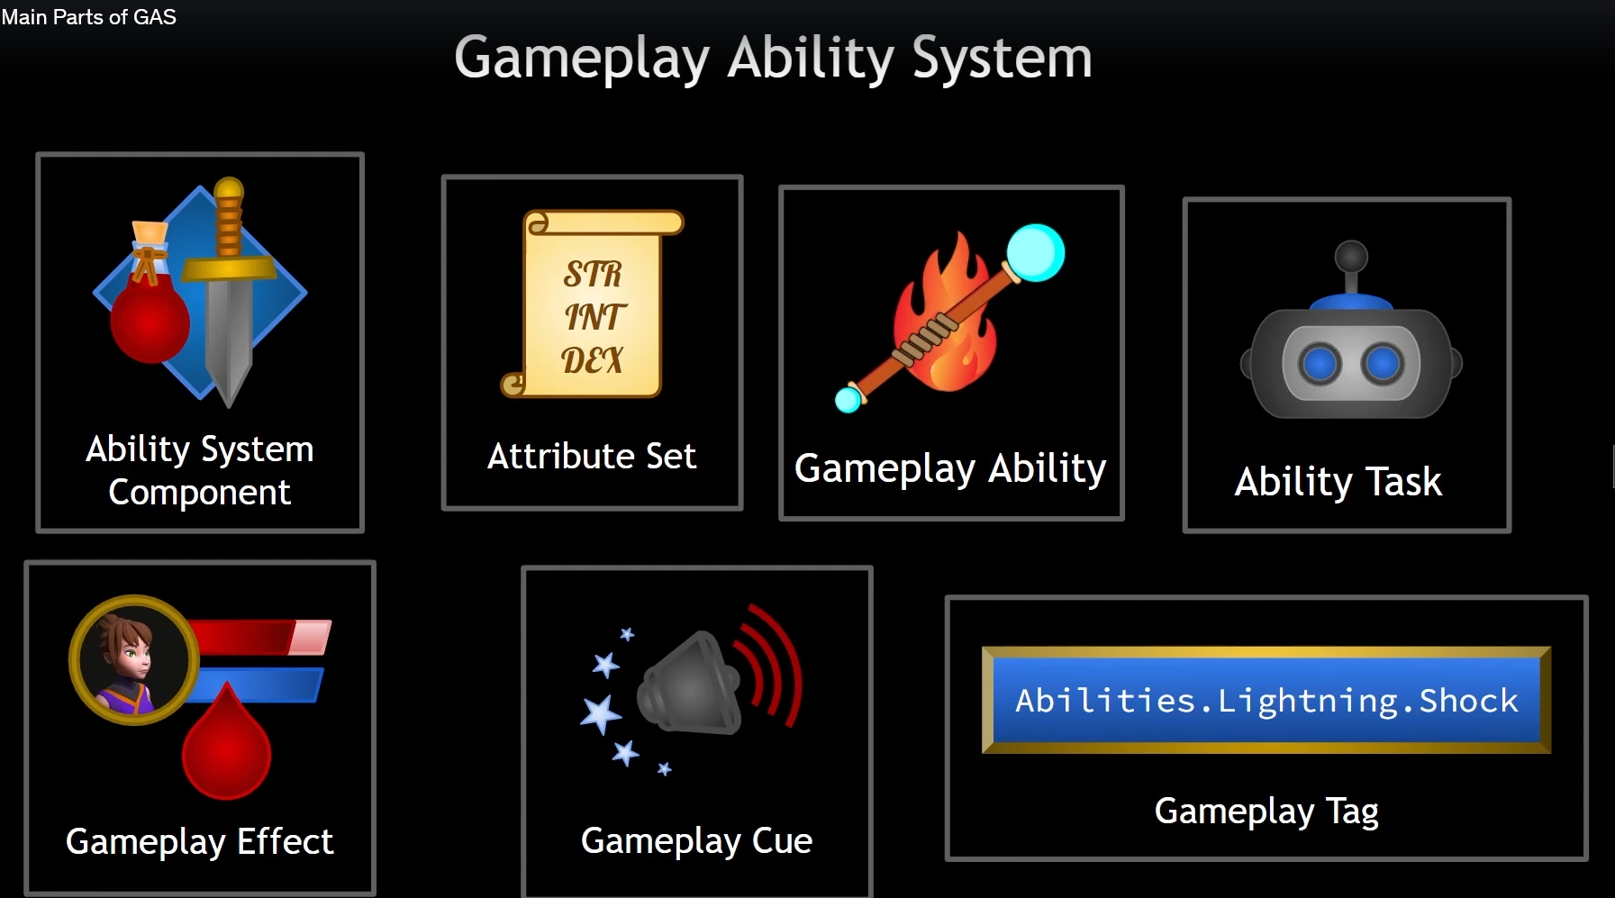

How To Start
Ability System Component and/or Attribute set could be directly used in the Pawn/Character.
Other option is to take some other class associated with pawn, such as the player state and and them to that class.
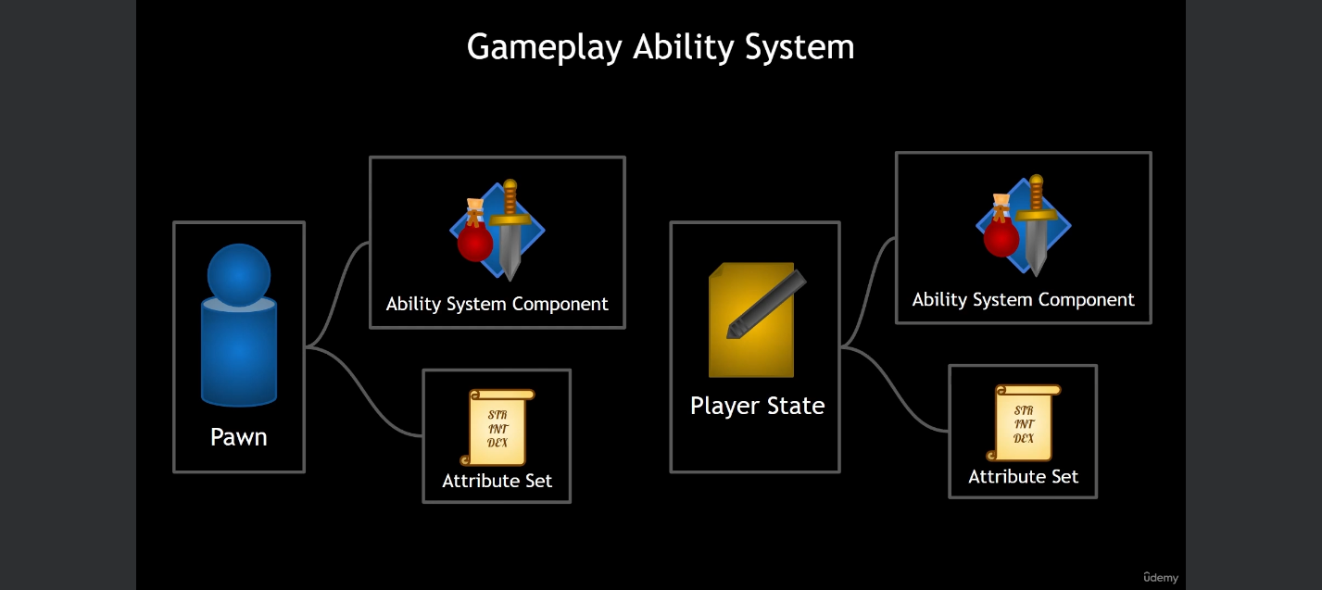

Comparison: Pawn vs Player State
Pawn:
-when the pawn is destroyed, so is the Ability System Component and Attribute Set. And if you havent taken measures to save any pertinent data on those classes, say in a save game object or on a database somewhere, that data is gone. And when you respawn a new pawn, the Ability System Component and Attribute Set are created fresh with default values and default abilities.
-if it is simple,might be use here for example for enemies (just some simple attributes and abilities controlled by AI)
Player State:
-when the pawn is destroyed, the Ability System Component and Attribute Set are not destroyed because the do not exist on that class. They exist on the Player State which persists when the pawn is destroyed. We still have the same values and attributes and abilities because they have not been destroyed.
-no need to clutter up the character with code for abilities, attributes etc
-you may wish to swap out the character for another character and still have the same attributes and abilities

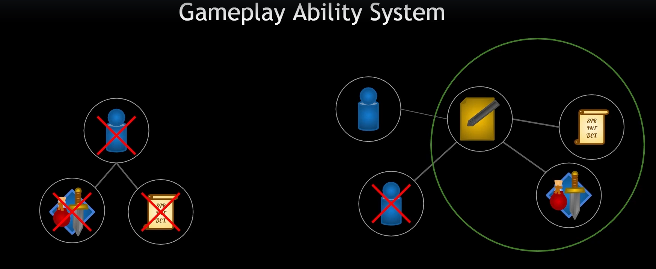
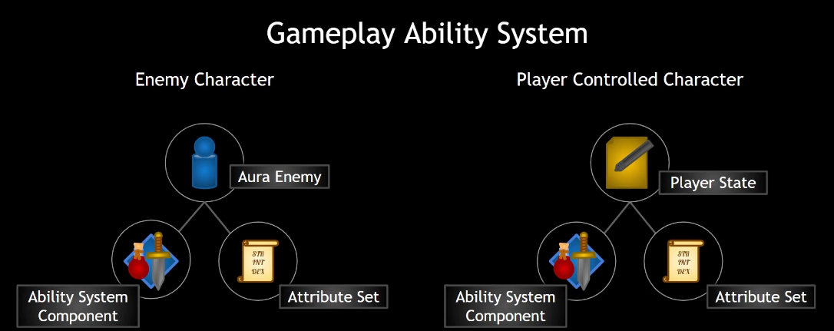
Approach:

GAS in multiplayer

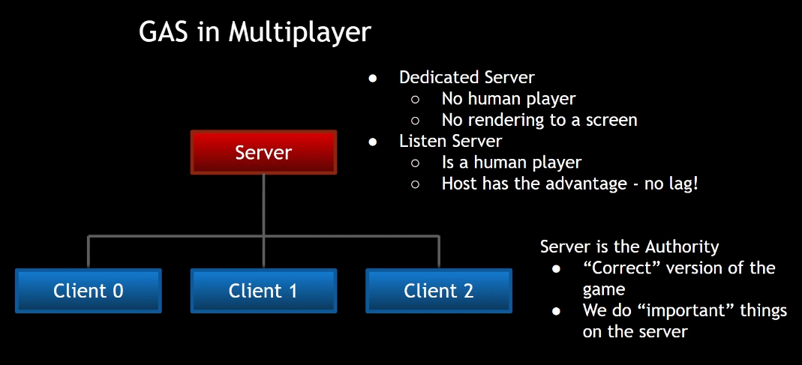
GameMode exists only on the server. If you attempt to access the game mode on one of the clients, you will get a null pointer. Because GameMode is responsible for things like rules of the game, spawning players and restarting the game.

PlayerControllers exists on the server, but it also exists on each of the client. Only server has all the PlayerControllers. Clients only has their own.

PlayerStates exists on the server, but also clients has all of the PlayerStates.

Pawns – Server has all Pawns and client also has all the Pawns.

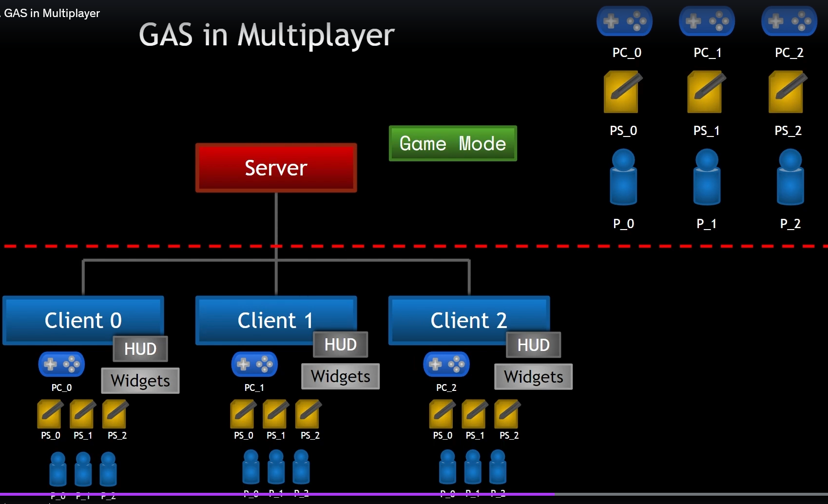
HUD – each client has its own HUD class and it only exists on that client.

Replication only works one way from server to client. So if a variable is marked as replicated, it should no be changed on clients because the server will not know about that change and neither will other clients.
To went from client to server we use RPC functions.

Replication Mode
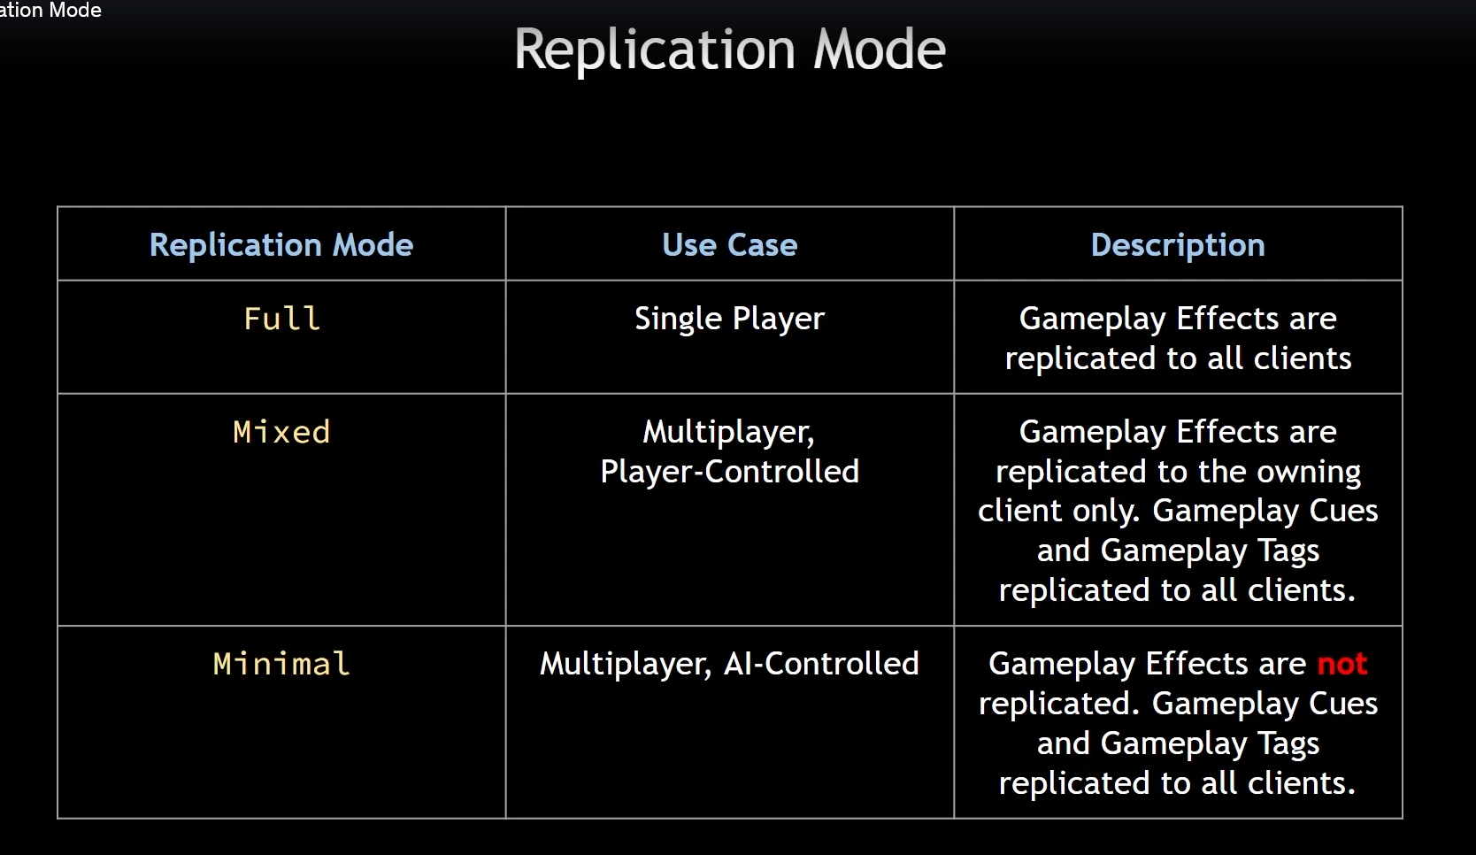
For Mixed Replication Mode:
-The OwnerActor's Owner must be the Controller. For Pawns, this is set automatically in PossessedBy().
-The PlayerState's Owner is automatically set to the Controller.
-Therefore, if your OwnerActor is not the PlayerState, and you use Mixed Replication Mode, you must call SetOwner() on the OwnerActor to set its owner to the Controller.

Init Ability Actor Info
AbilitySystemComponent has two variables:
-AActor OwnerActor is whatever class actually owns the AbilitySystemComponent
-AActor AvatarActor is the representation in the world associated with this AbilitySystemComponent

For enemies the OwnerActor and AvatarActor are the same
For Player Controlled Character: Player State is the OwnerActor, and Pawn/Character is the AvatarActor

Important to understand that the owner actor and avatar actor may or may not be the same actor

We need to decide which is which by calling InitAbilityActorInfo method
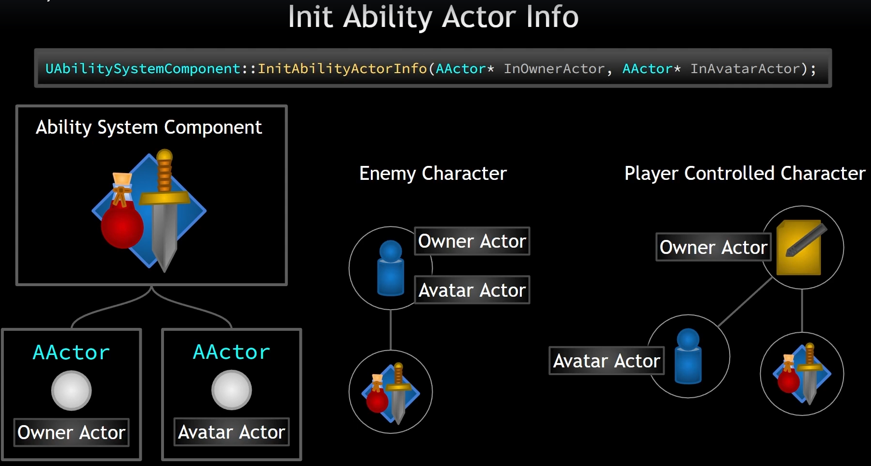
When to call the method:
-it must be done after possesion (the Controller has been set for the Pawn)
For Player-Controlled Character(when ASC lives on character)
For Server it needs to be done in virtual PossessedBy method.
For Client we have method AcknowledgePossession
For Player-Controlled Character(when ASC lives on PlayerState)
For Server it needs to be done in virtual PossessedBy method.
For Client we need to use OnRep_PlayerState because not only Controller needs to be valid but also PlayerState
For AI-Controlled Character
For Server we can use BeginPlay
For Client we can use BeginPlay

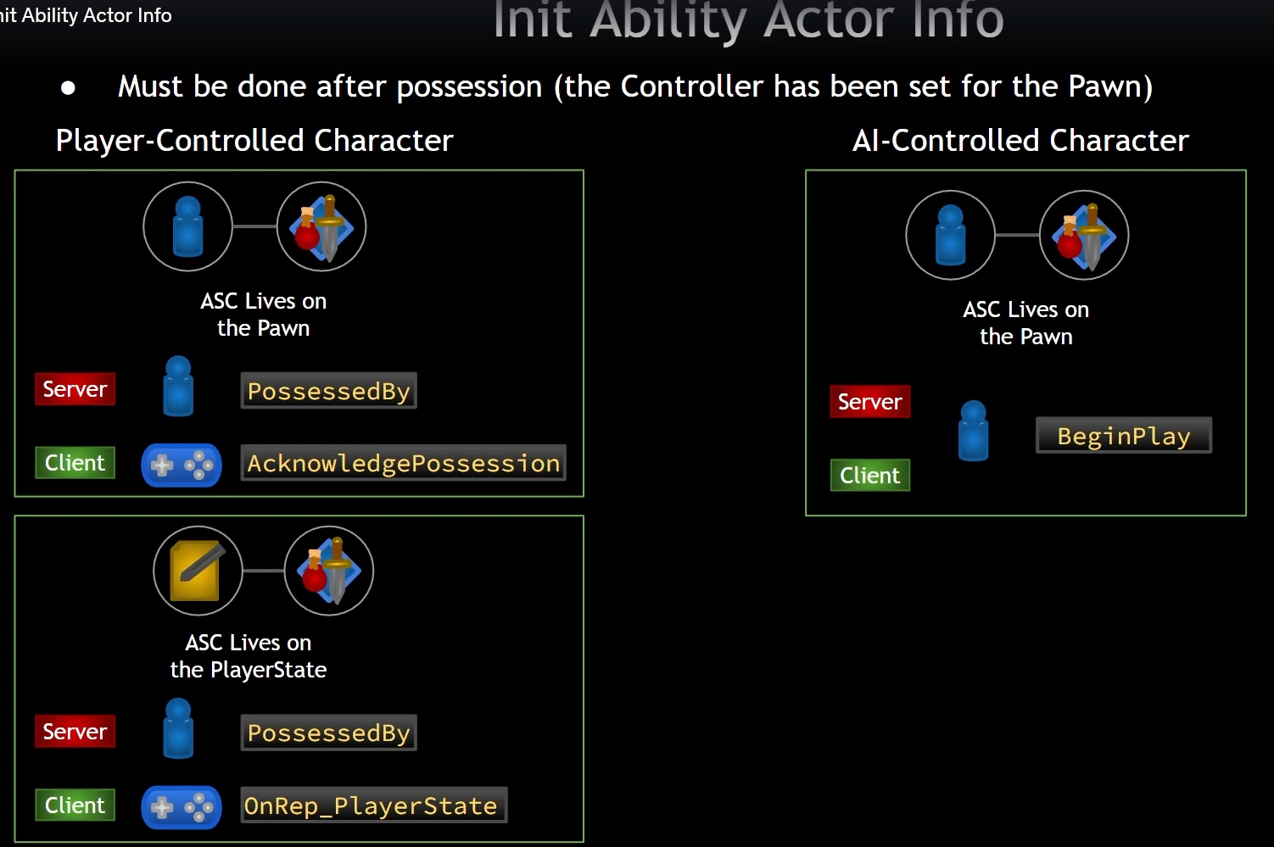

Attributes

Are numerical quantities associated with a given entity in the game such as character. All attributes are floats. They exists within a structure FGameplayAttributeData. Attributes are stored on the AttributeSet and AttributeSet keeps them under close supervision. We can know when an attribute changes and respond to it with any functionality that we like. The attribute values can be set directly in code, but the preffered way to change them is by applying GameplayEffects. Aside form the built in capabilities of gameplay effects, another reason to use them is because GameplayEffects allow us to predict changes to attributes.
Prediction means that the client does not need to wait for the server's permission to change a value. The value can change immediately client-side and the server is informed of the change. The server can roll back changes that are invalid. Prediction is something that makes for a smoother experience in multiplayer. Server still has authority but our client does not have to have a delay.

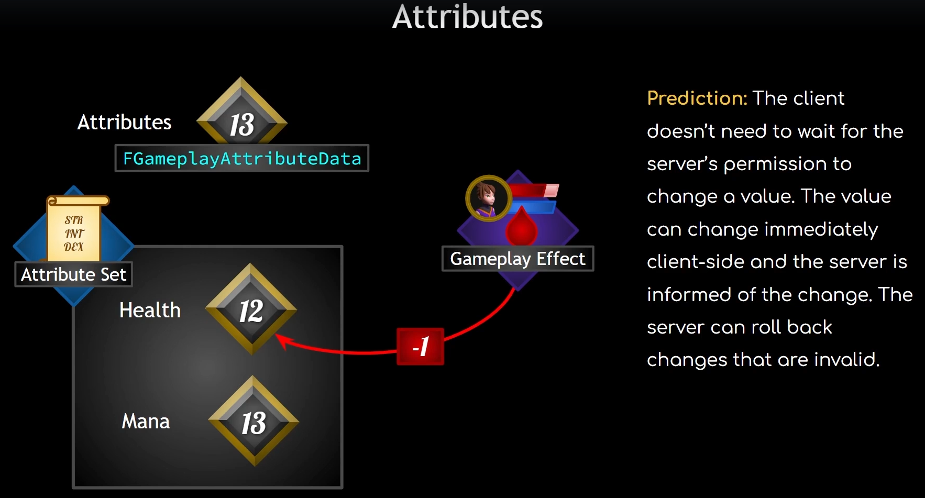
Attributes consist of two values. A base value and a current value.
The base value is the permanent value of an attribute.
The current value is the base value plus any temporary modifications(buffs/debuffs) caused by gameplay.

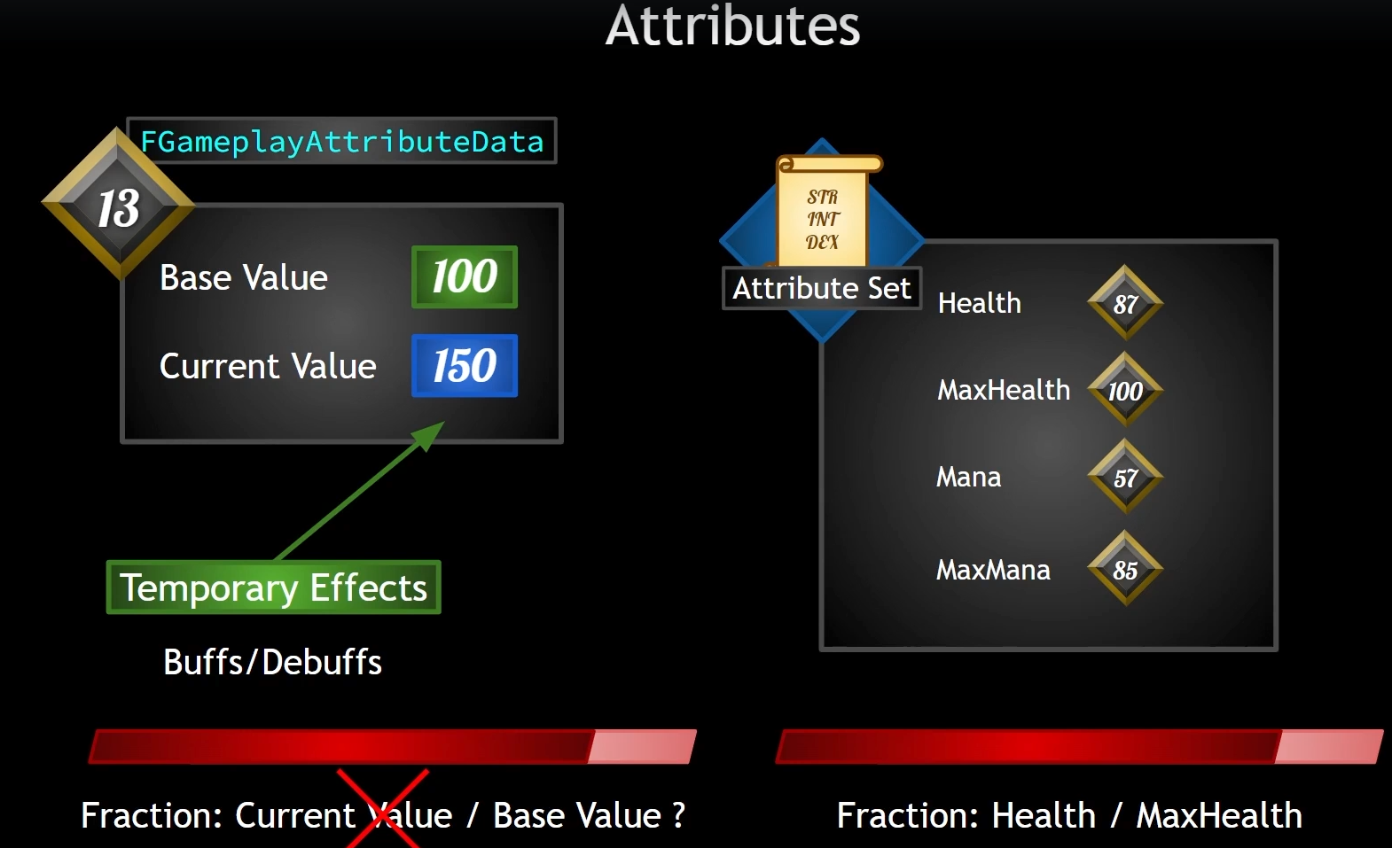

Useful command for debug (tilda):
- showdebug abilitysystem

Game UI Architecture

Overlay UI

The WidgetController is the middleman between the View and Model.
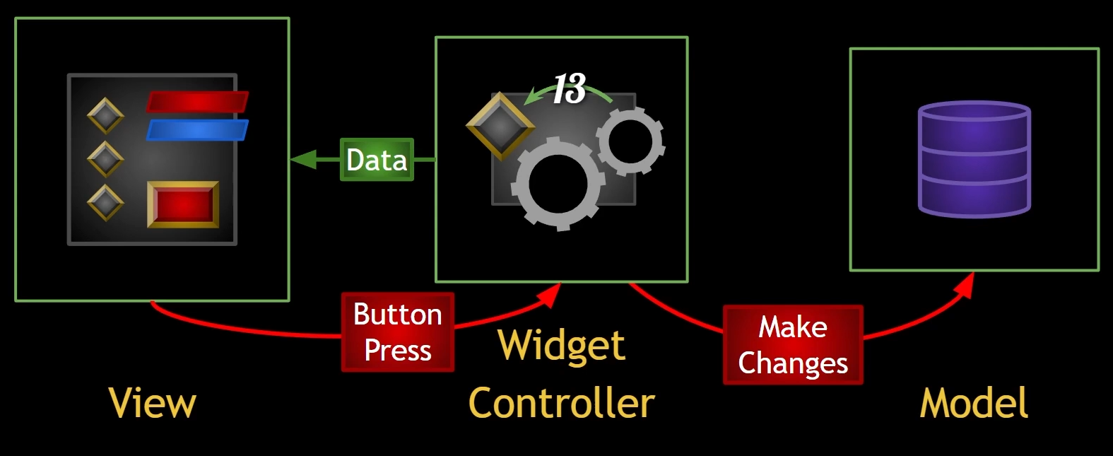
The Model should not know which WidgetControllers are using it.
The WidgetController should not know about how many and which Widgets the applications has
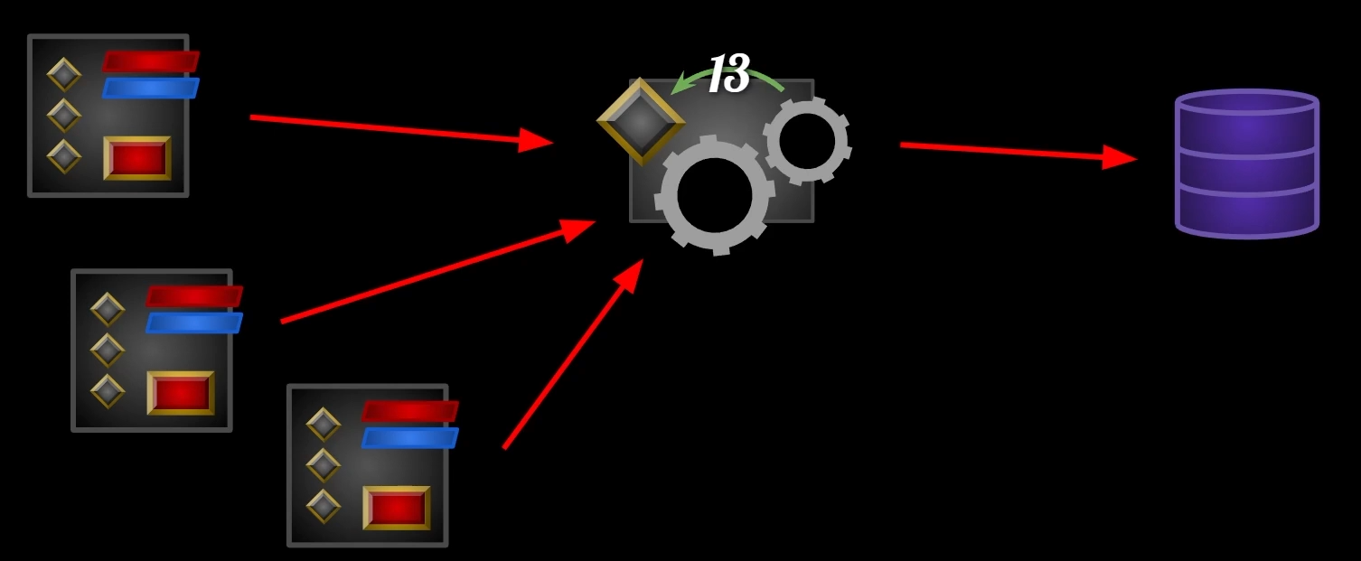

Attribute Menu UI

AttributeMenu is being opened by pressing "Attributes" button on Overlay UI. On click we are also disabling this button, so it cannot be spammed.
In AttributeMenu widget, we have "x" (close) button. When it is pressed we are removing widget from parent. In "Event Destruct" we are broadcasting event dispatcher called "Attribute Menu Closed". In Overlay UI we are assinging logic to this event dispatcher "Attribute Menu Closed" – we are enabling the "Attributes" button.

Plan for displaying Attribute Data.
1.We will need widget controller dedicated to the AttributeMenu.
We could have delegates for each attribute and widgets corresponding to that particular attribute would be updated, but this is not the most scalable pattern because if we add new attributes to our AttributeSet, then we have to actively go into the widget controller and bind some kind of callback or lambda to the delegate broadcast when that new attribute changes and then declare a new delegate and so on.
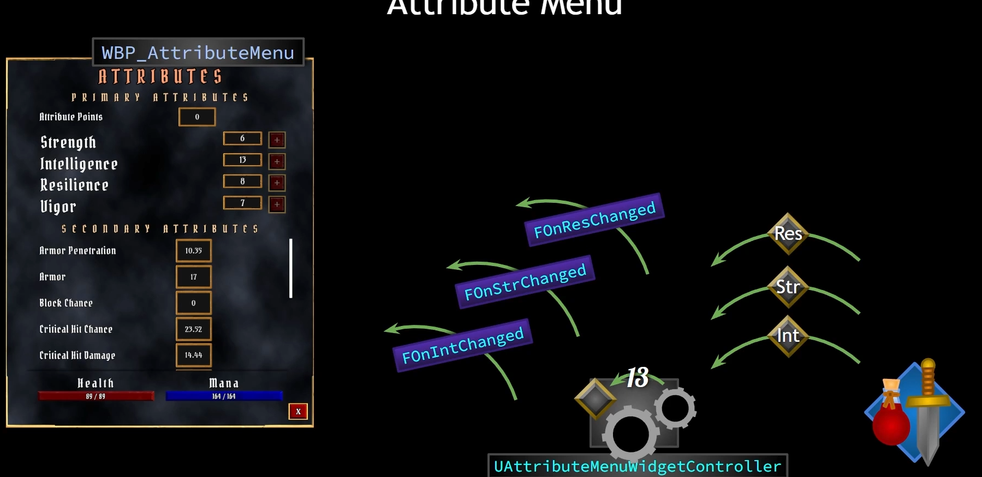
2.Other approach. It will be better to broadcast one generic delegate from controller to the UI. This particular delegate could hold information such as GameplayTag that is associated with the attribute, name of the attribute and its value, maybe description(any info that is needed for a widget).
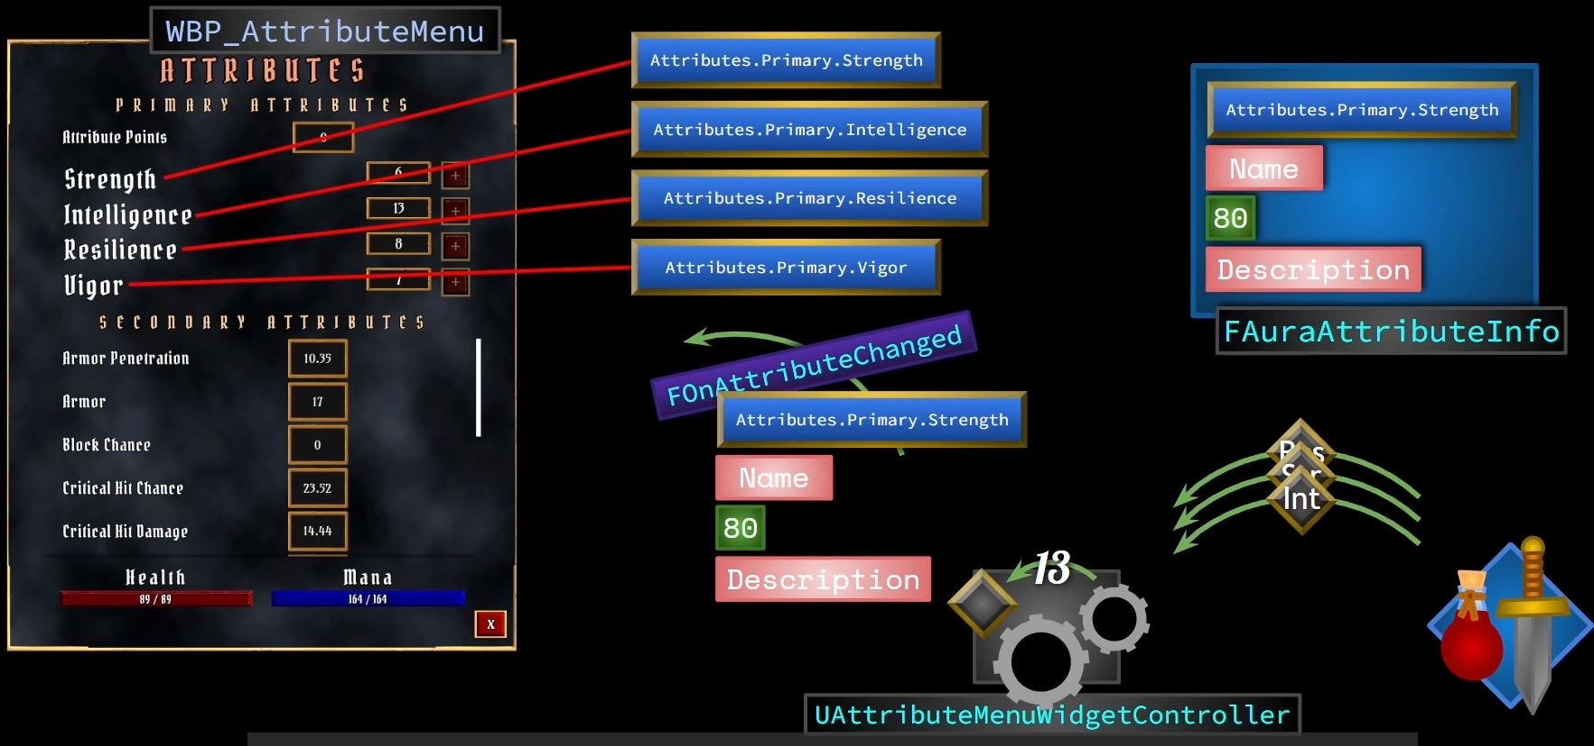
We have our widget controller which will bind to delegates broadcast from the AbilitySystem. When an attribute changes, the widget controller will know about it. Then the widget controller can take that attribute and try to figure out what the GameplayTag is that is associated with that attribute (how to do it?). Once we figure it out, we can then perform some kind of lookup to find the correct struct (FauraAttributeInfo) that has the right attribute name, description, so we can send that data up to the widget. It is data driven so we can have some kind of either DataTable or perhaps a DataAsset taht can package up all the data associated with any given attribute.

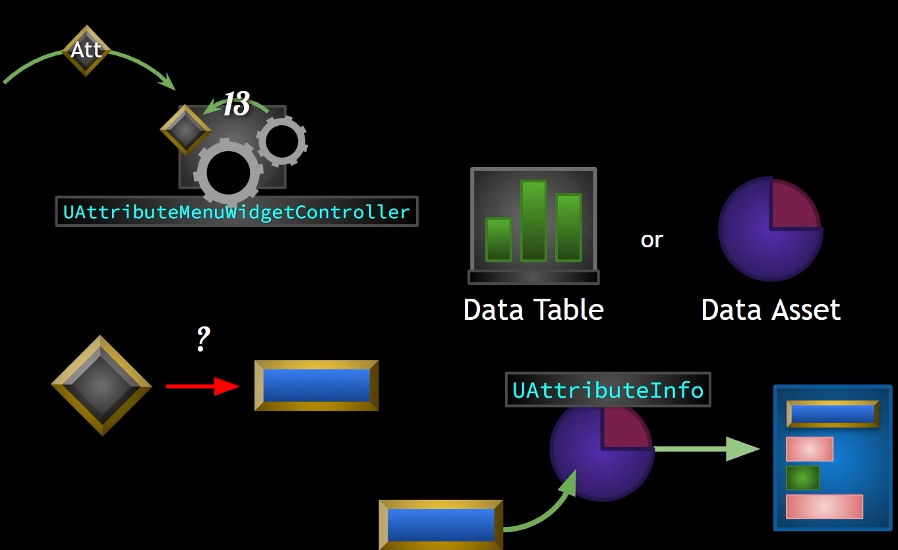

1.Connect delegate broadcast from AbilitySystem to WidgetController
2.Get correct GameplayTag associated with the attribute that has changed
3.Have DataAsset that receives GameplayTag and returns struct info with all necessary data
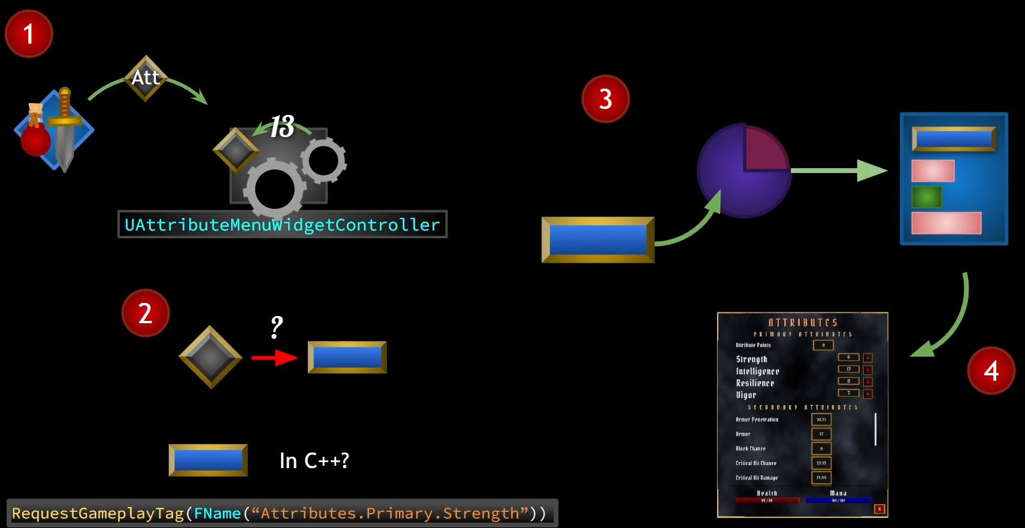
4.Broadcast this struct info to AttributeMenu widget and update correct values
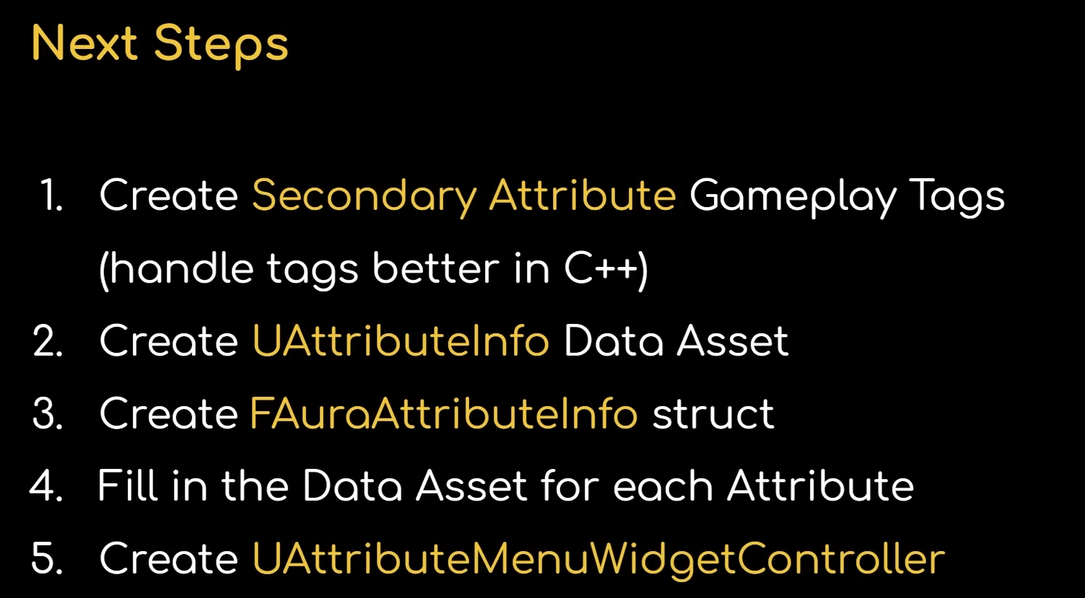

Asset Manager

AssetManager is another singleton and it had to do with loading primary assets, and it is where we can initialize this singleton(FAuraGameplayTags) where we can call this function. The AssetManager is a singleton, so it is only a single one in the whole project and we set that at a project level.

Gameplay Effects

A GameplayEffect is an object of type UGameplayEffect. We use GameplayEffects to change attributes and gameplay tags.
- GameplayEffects are data only. We do not add logic to them.
- We create blueprint based on the UGameplayEffect class
- We do not subclass the GameplayEffect into child classes
- GameplayEffects change attributes through modifiers and executions.
- Modifiers operations: Add, Multiply, Divide, Override.
- Magnitude Calculation Type: Scalable float (or table), attribute based, Custom Calculation Class (MMC – modifier magnitude calculations), Set by Caller
- Executions: Gameplay Effect Execution Calculation (these can change more than one attribute and they can really do anything else we choose to code in them)

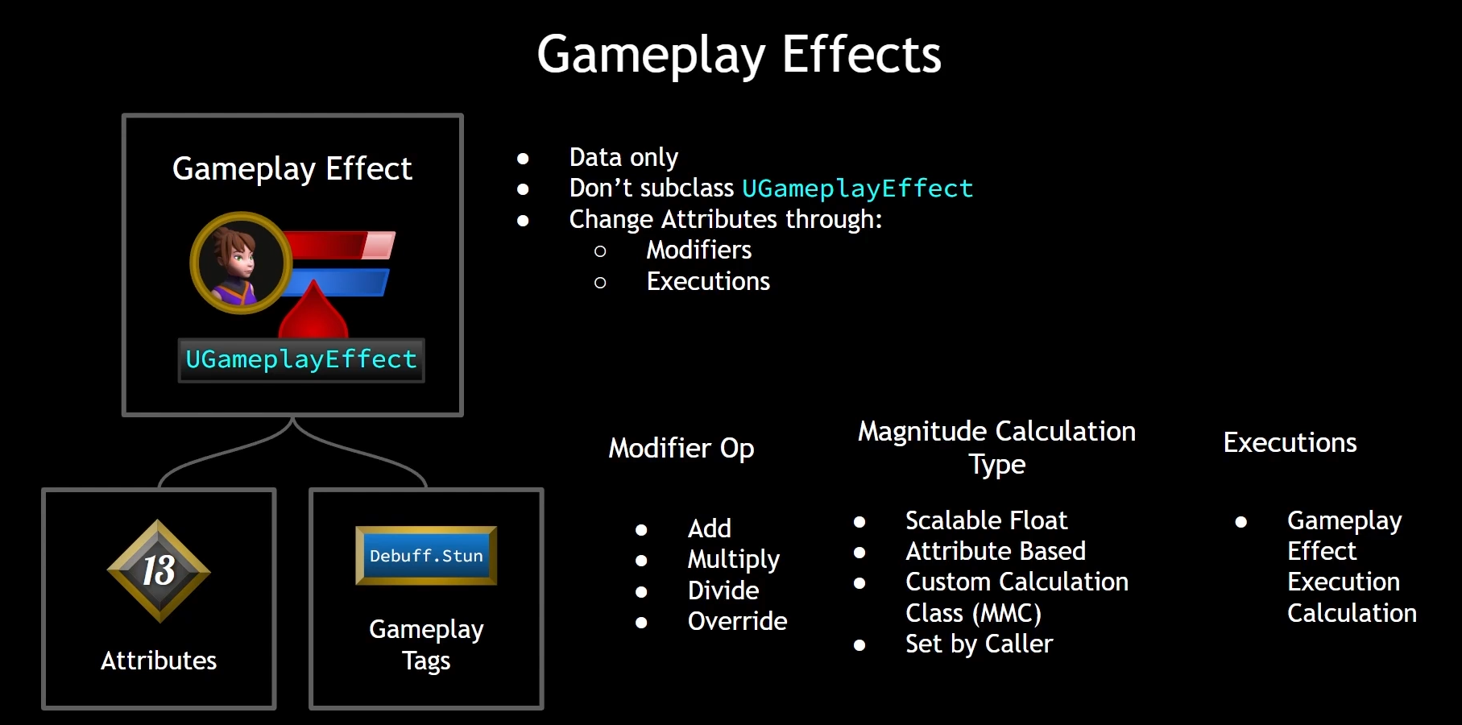

Duration Policy:
-Instant (modifier is applied instantly in an one off action)
-Has Duration (can modify an attribute for a set period of time after which that modification is undone)
-Infinite (they affect an attribute and that effect does not go away. They stay until removed manually)

Stacking

Add Gameplay Tags (GameplayEffects can add GameplayTags)

Grant Abilities

GameplayEffects can be applied directly but usually we create a more lightweight version of them known as GameplayEffectSpec. This concept of a spec is common in GAS and is a form of optimization. The Spec contains the bare bones information needed to perform modifications and the only actual instance of the GameplayEffect class that typically gets instantiated is the class default object (CDO). The EffectSpec carries information with it as well, such as GameplayTags that the effect has and it also has an EffectContext (an additional class that can store more information about the effect being applied). References to the causer and the target of the effect are easily accessed and can be used to determine what happens to the overall magnitude calculation, as well as trigger gameplay mechanics to any actors involved in the effect.

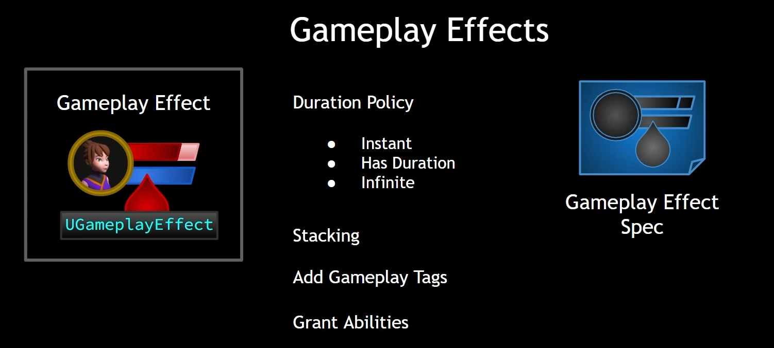

Duration Policy:

Duration Policy:
-Instant (permanent change to the Base Value)
-HasDuration and Infinite (change Current Value, undone if/when the effect is removed)

HasDuration – is removed automatically,
Infinite – needs to be removed manually

HasDuration and Infinite gameplay effects can be converted into Periodic Effect, which means that they execute some kind of change to an attribute periodically, every so often as long as that effect is currently applied. So Periodic Gameplay Effects are a special flavor of duration and infinite but the periodic changes that they execute are treated like Instant Gameplay Effects and that they change the Base Value permanently. The changes are not undone when the effect is removed.

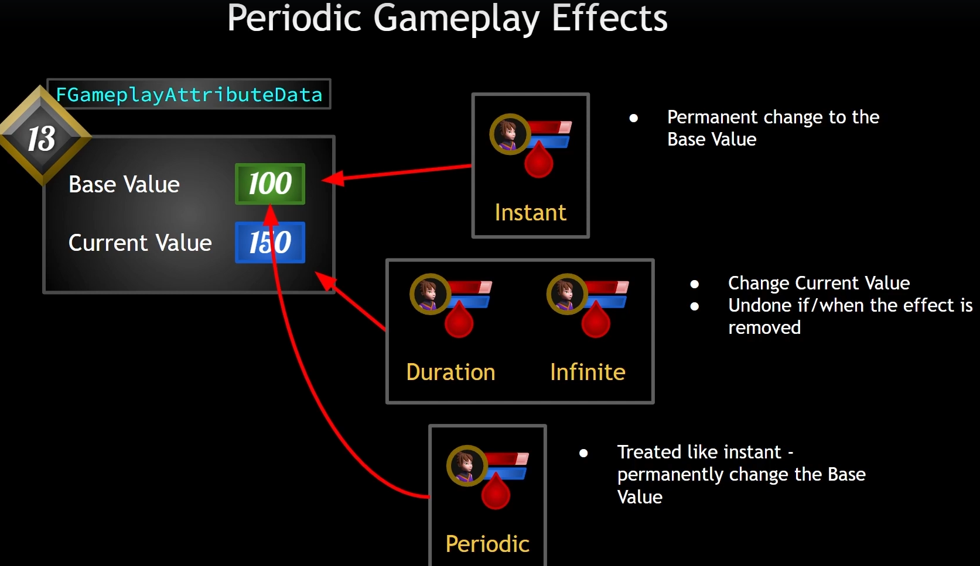
Execute Periodic Effect on Application – effect is applied when GameplayEffect is applied(which could cause additional +1 effect applied).
Periodic Inhibition Policy – policy to what should be done when effect is blocked or not, for example by GameplayTags

Stacking

Stacking set to None is like applying the same GameplayEffect multiple time. For example if there is GameplayEffect that heals 10hp per second and we will pick 3 of those, we will get 30hp per second.

Aggregate by Source – means that stack limit count is enforced per source
Aggregate by Target - means that stack limit count is enforced per target
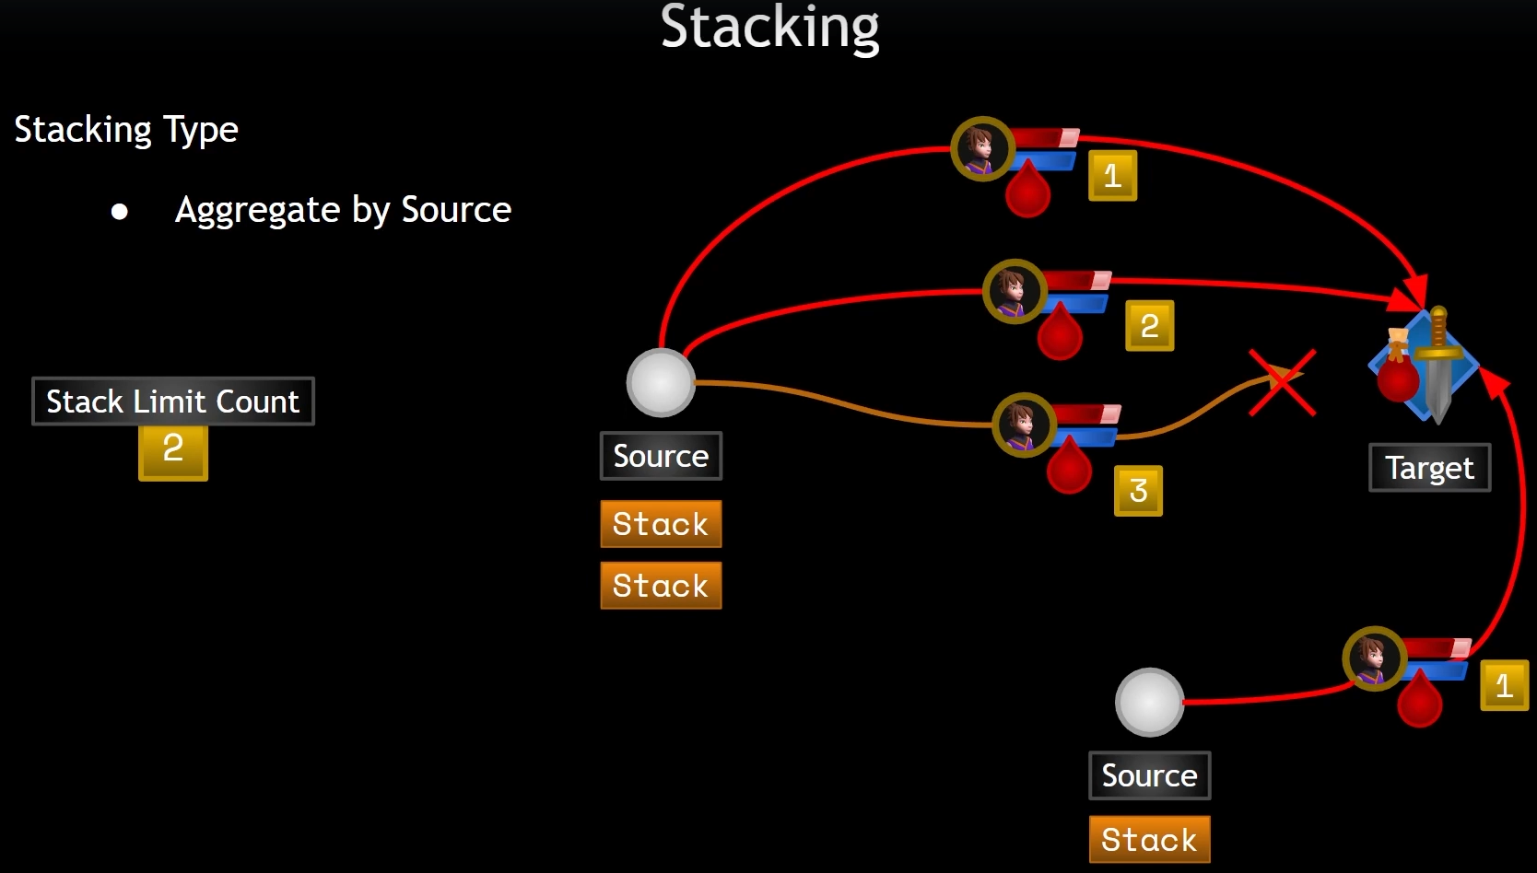
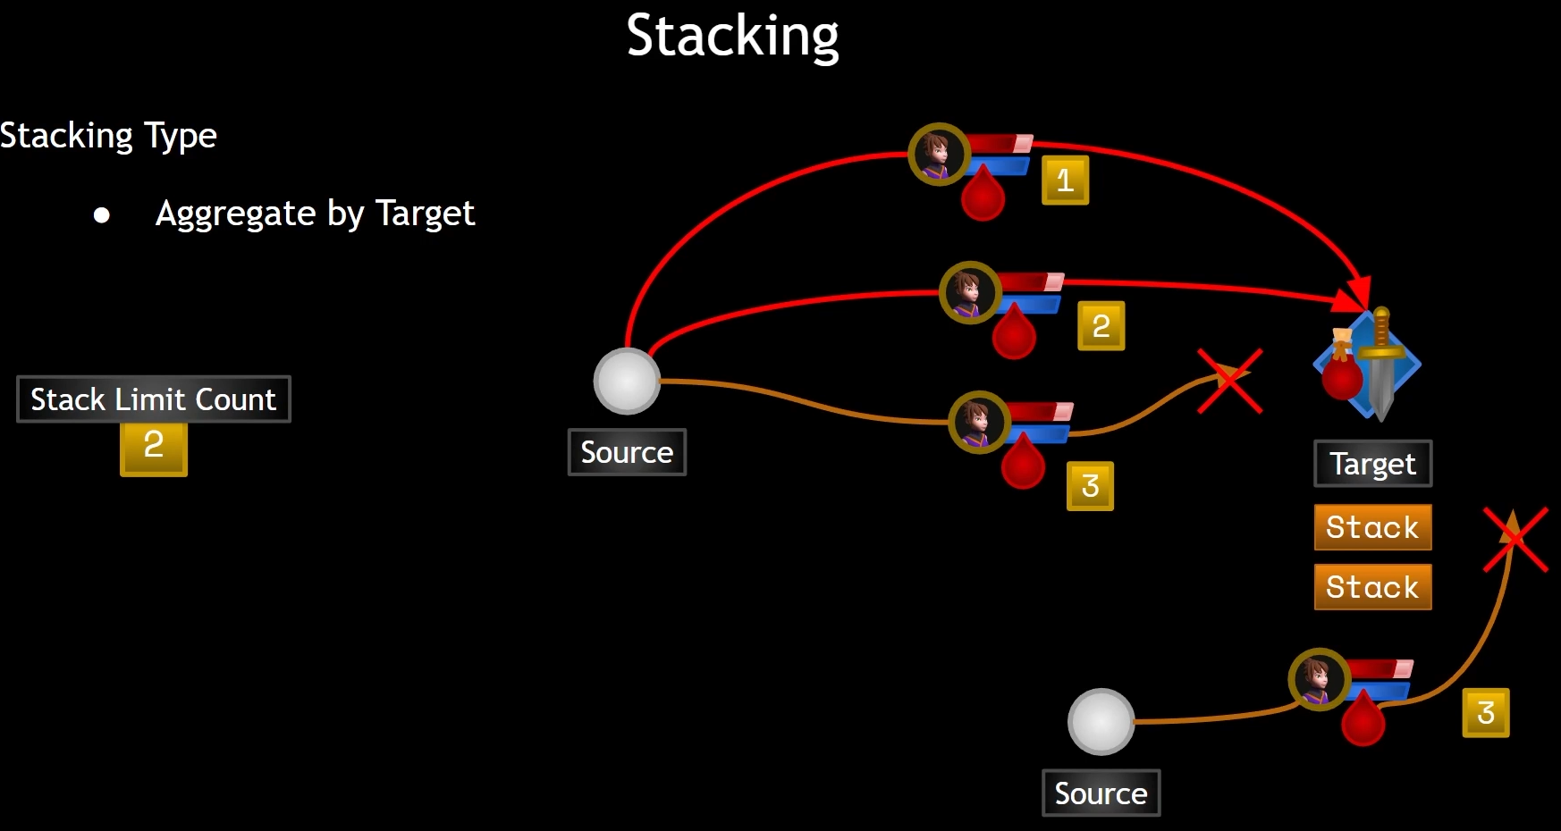

Stack Duration Refresh Policy – if choose "Never Refresh", then even though we are adding stacks, that duration of one second is what prevails. So it does not matter how many stack we have. This effect will expire at the end of a second (duration), no matter what.

Stack Period Reset Policy – similar to StackDurationRefreshPolicy but for period. So if you are waiting for the next periodic change to an attribute, when we stack a new stack of this effect, Reset on Successful Application means reset tha period and start waiting for another full period.

Stack Expiration Policy –
-Clear Entire Stack, which means as soon as this effect expires, all of the stacks are cleared.
-Remove Single Stack and Refresh Duration, which means that as the duration finishes, we remove a single stack and then the duration starts over again. So you can have two of these effects stacked on and when the duration expires, the stack count goes down and then the duration starts over again.
-Refresh Duration, which mean that when this stack expires, refresh the duration, even if it is the one and only stack. This essentially makes the effect infinite in duration because it keeps refreshing. This can be used to manually handle stack decrements via OnStackCountChange callback. So there is a way to respond to when the stack count changes and we will get to that.

Modifiers

ScalableFloat -
AtributeBased - gives the ability to have an attribute change based on other attribute values. This can make it really easy to have an attribute that is derived from other attributes.
BackingAttribute – with operation Add we can for example add value of other attribute to other attribute

Order of operations: modifiers are applied one by one in order
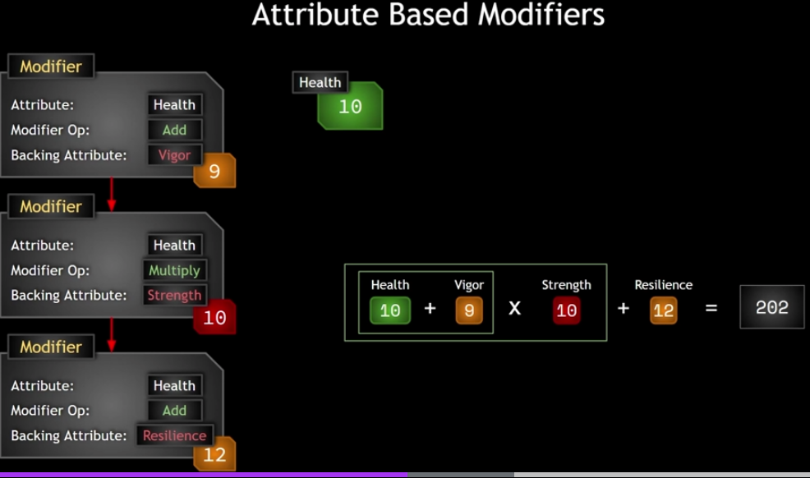Ilustracja 2: Example for order operation for modifiers
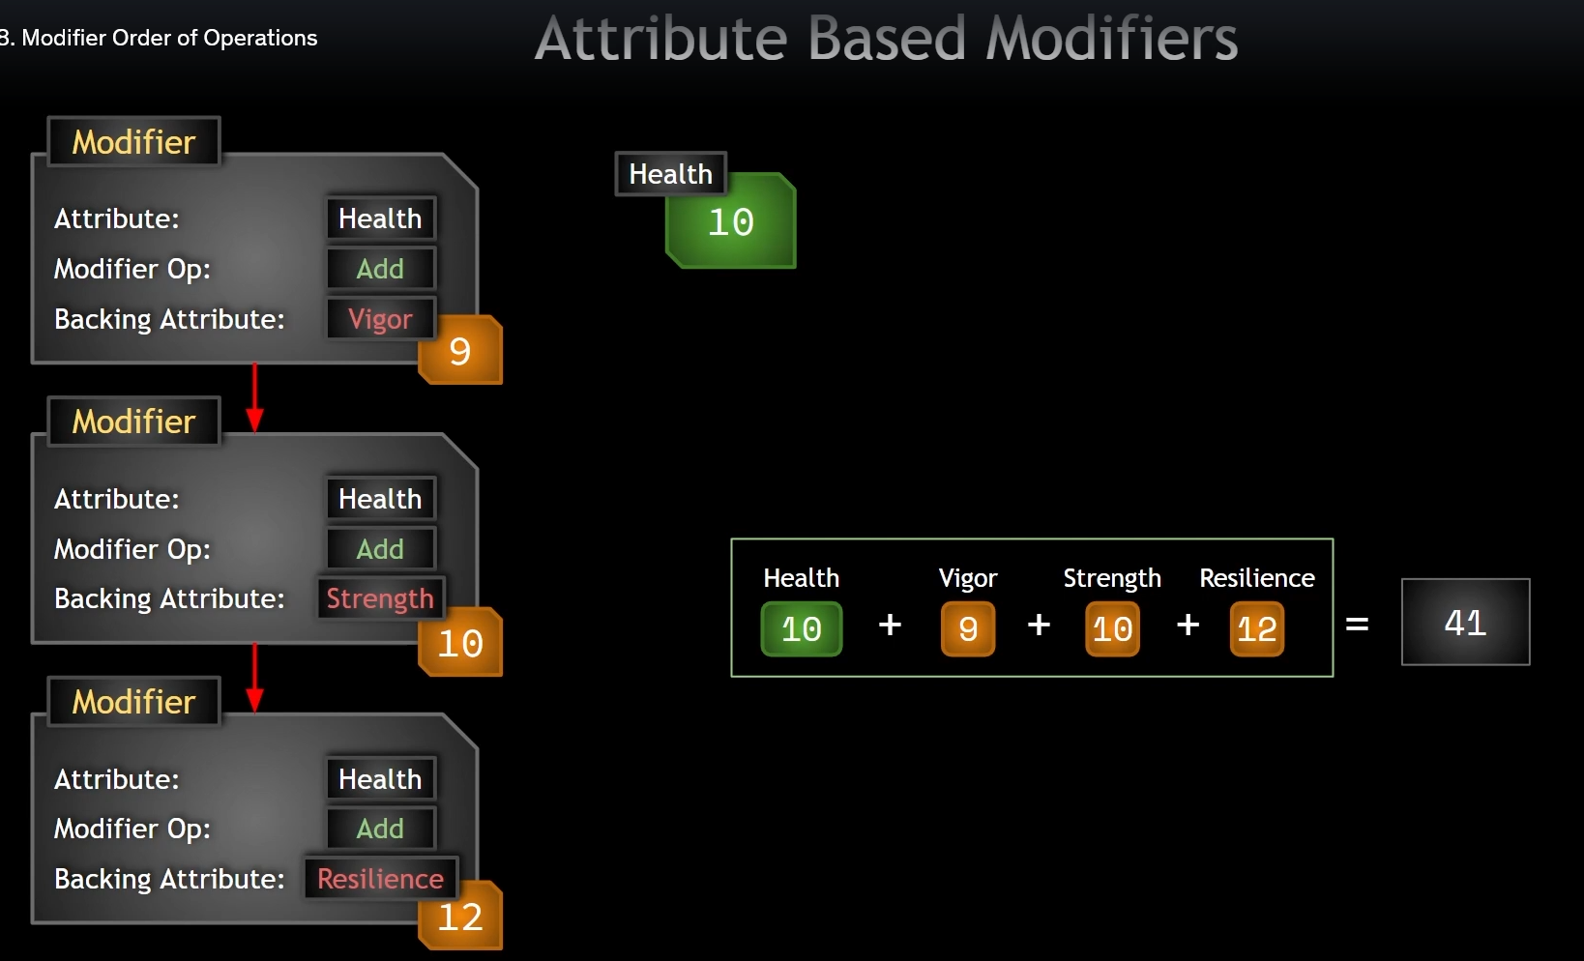Ilustracja 1: Example for order operation for modifiers
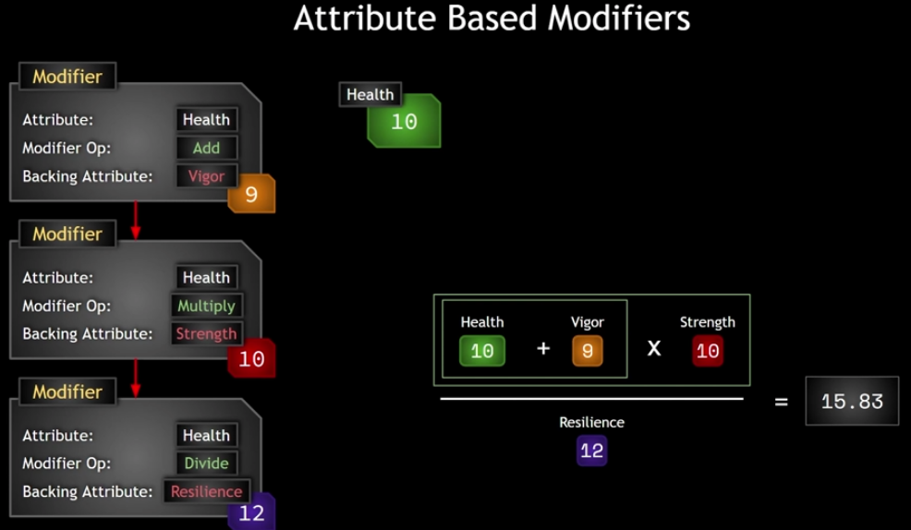Ilustracja 3: Example for order operation for modifiers

a

Coefficients

Coefficient, Pre Multiply Additive Value, Post Multiply Additive Value

Being able to multiply, add, substract or divide an attribute by another attribute isn't quite enough. What if we wanted to add to yout health a value equal to strength times ten or strength times 0.1 or strength times 0.1 plus 12. These are where we can do this kind of thing.

When we have attribute modifier with for example Add operation:
First we add the Pre Multiply Additive Value, then this result is multipled by the Coefficient and the result of that has the Post Multiply Additive Value added to it.
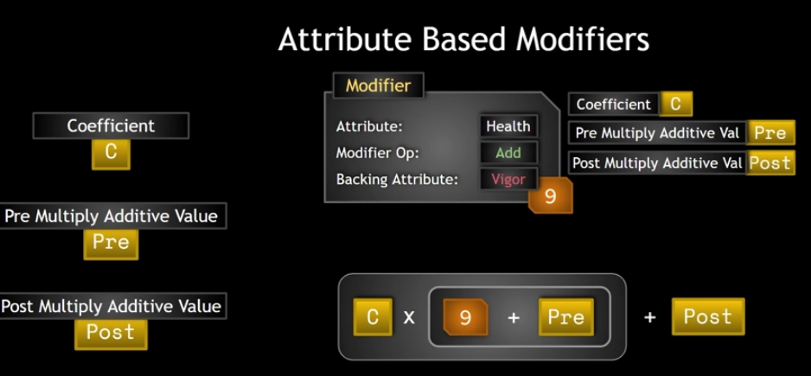
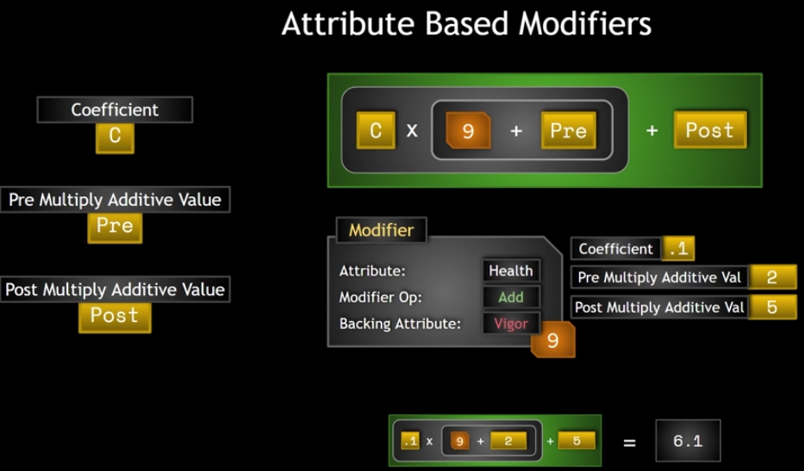
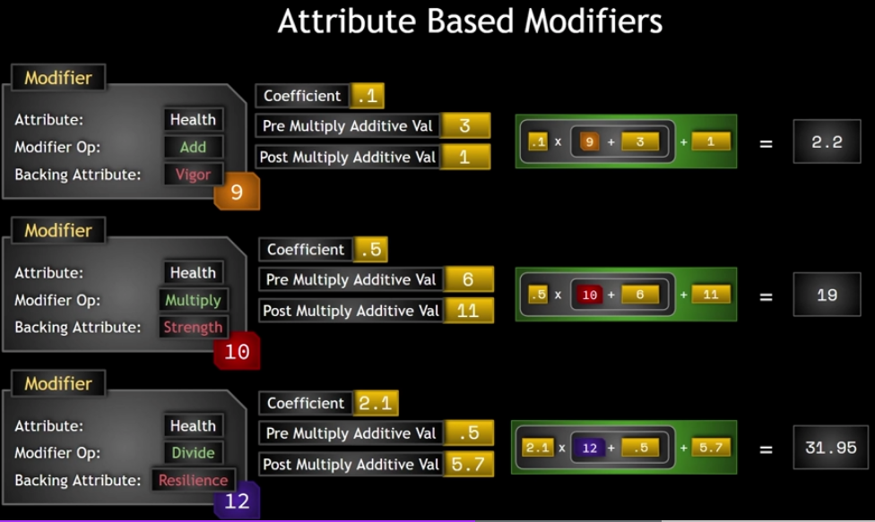
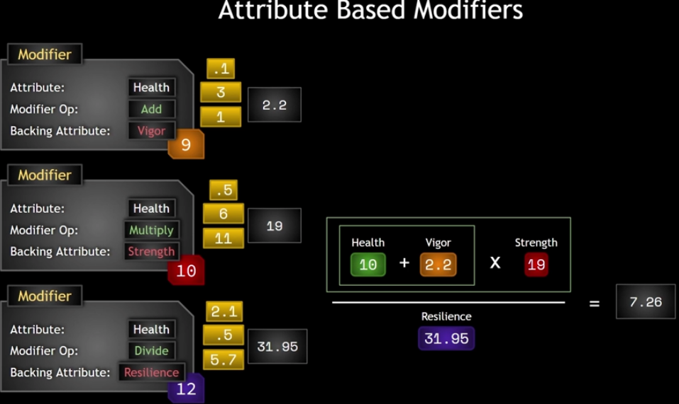
Full example for coefficient:

Derived attributes

Derived Attributes – attributes that depend either partially or entirely on other attributes. If we want to have secondary attribute to be based on calculations that involves the other attributes, it needs to be set to Overrride.
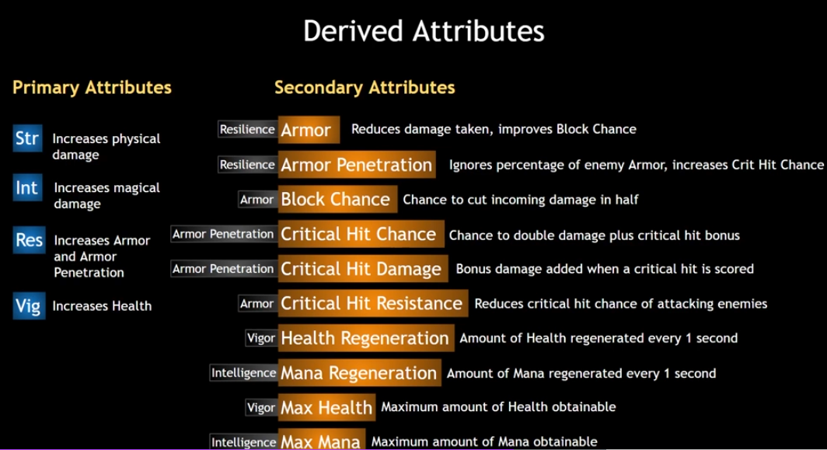

Custom calculations MMC

Custom calculations – in other words, a modifier magnitude calculation(MMC). MMC is a class that we can create that determines the calculation that should be used for the modifier. So we wrap up this calculation into an MMC and set that on the modifier and then we can have any type of calculation that we wish in the MMC itself. Example, why we want to use MMC and not attribute based, because Level is not an attribute. Level is a variable on the PlayerState class. Level could be an attribute. In the course, Level is not an attribute because attributes are numerical values that have these complex interrelationships with other attributes and other phenomena in the gas system, whereas level is more like a counter of your progress.
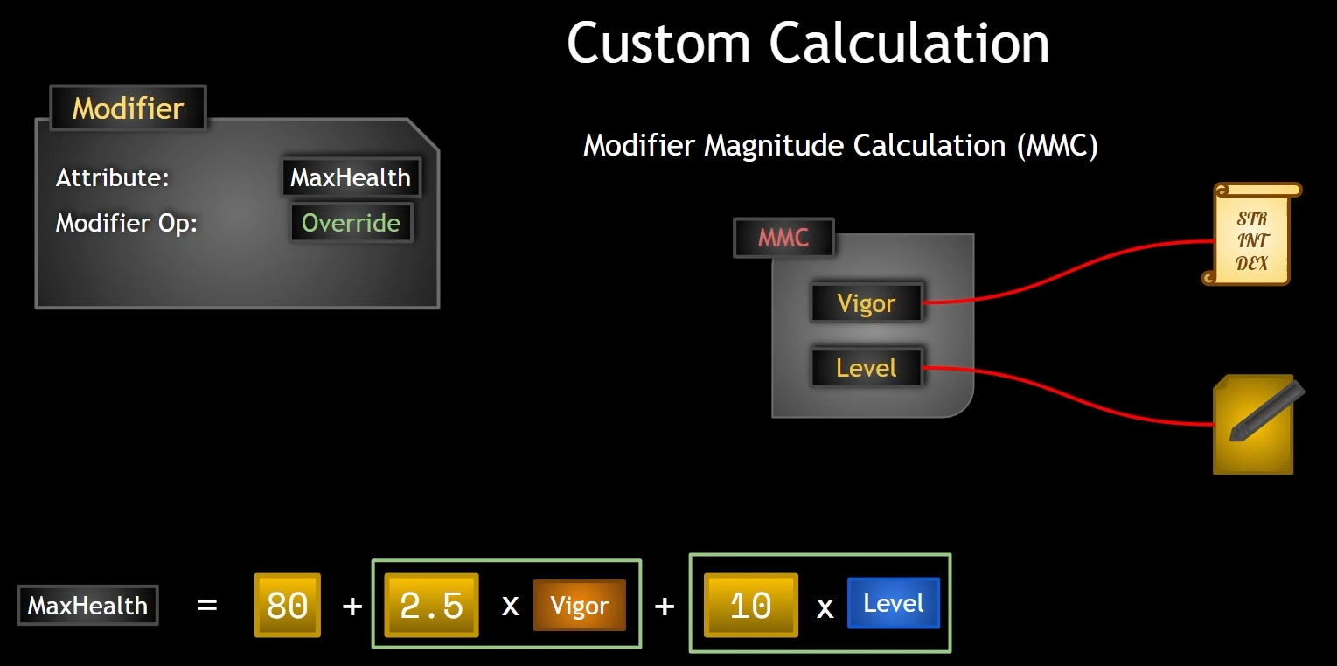
MMC
CalculateBaseMagnitude_Implementation(const FGameplayEffectSpec& Spec)
They have access to all the stuff in the EffectSpec. That is why they are so powerful. But they also have the ability to capture attributes and to capture attributes we have to create a variable for the attribute we want to capture.

Snapshot – is about timing. When do we want to capture the attribute? When the GameplayEffectSpec is created or when the GameplayEffectSpec is applied? Snapshotting is capturing the attribute right away, as soon as the effect spec is created. Not snapshotting is getting the true value at the time of application of effect.

Execution Calculation

This is a class of type UgameplayEffectExecutionCalculation. This is the most powerful way to modify attributes in a GameplayEffect. Its the most custom way. This class allows us to perform calculations using the values of captured attributes. So they can capture attribute values and they can change more than one attribute. This makes it more powerful than the MMC, which can only change a single attribute. Overall, a custom calculation can really do any kind of programmer logic that we code in it. We have complete flexibility.

The GameplayEffect ExecutionCalculation does come with a few caveats.
- it does not support prediction
- only instant or periodic GameplayEffects can use one of these (it cannot be run with an infinite GameplayEffect or a duration based GameplayEffect, unless it executes periodically as those periodic executions are treated like instant)
- capturing these attributes does not run PreAttributeChange, so any clamping done there in PreAttributeChange must be done again here if we want that clamp to be effective
- ExecutionCalculation is only run on the server if we are applying this from GameplayAbility with the LocalPredicted, ServerInitiated and ServerOnly NetExecution Policies. If we activate an ability and apply a GameplayEffect locally with a local predicted GameplayAbility, then that ability will be predicted but the ExecutionCalculation resulting from an applied GameplayEffect will only run on the server. So we are relying on changing things that replicate in and of themselver, like other attributes.

When capturing attributes, we can choose whether or not to snapshot. And this really only matters when we are capturing attributes from the source, the thing that is applying the effect, not the target.

When snapshooting, those attribute values are captured when the GameplayEffectSpec is created.
Not snapshooting, then those attribute values are captured when GameplayEffect is applied.

We do not snapshot for target because we do not know who the target is. For target, the values of those captured attributes are captured on effect application.
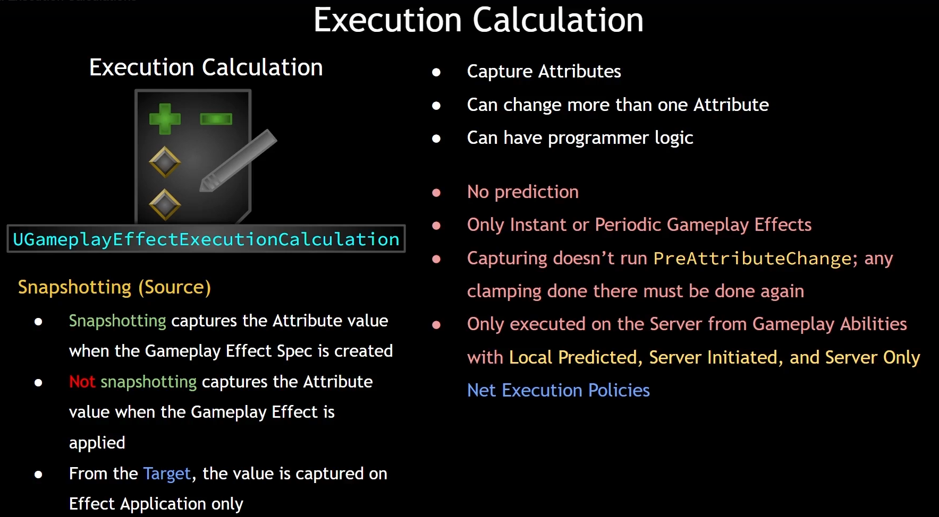
The ExecutionCalculation is capable of retrieving the SetByCaller magnitude by Tag. In the GameplayEffect itself, we can also add calculation modifiers that are backed by attributes.
So once we get to the ExecutionCalculations, if we are capturing that attribute, we will get that captured value after the calculation modifier has changed it.

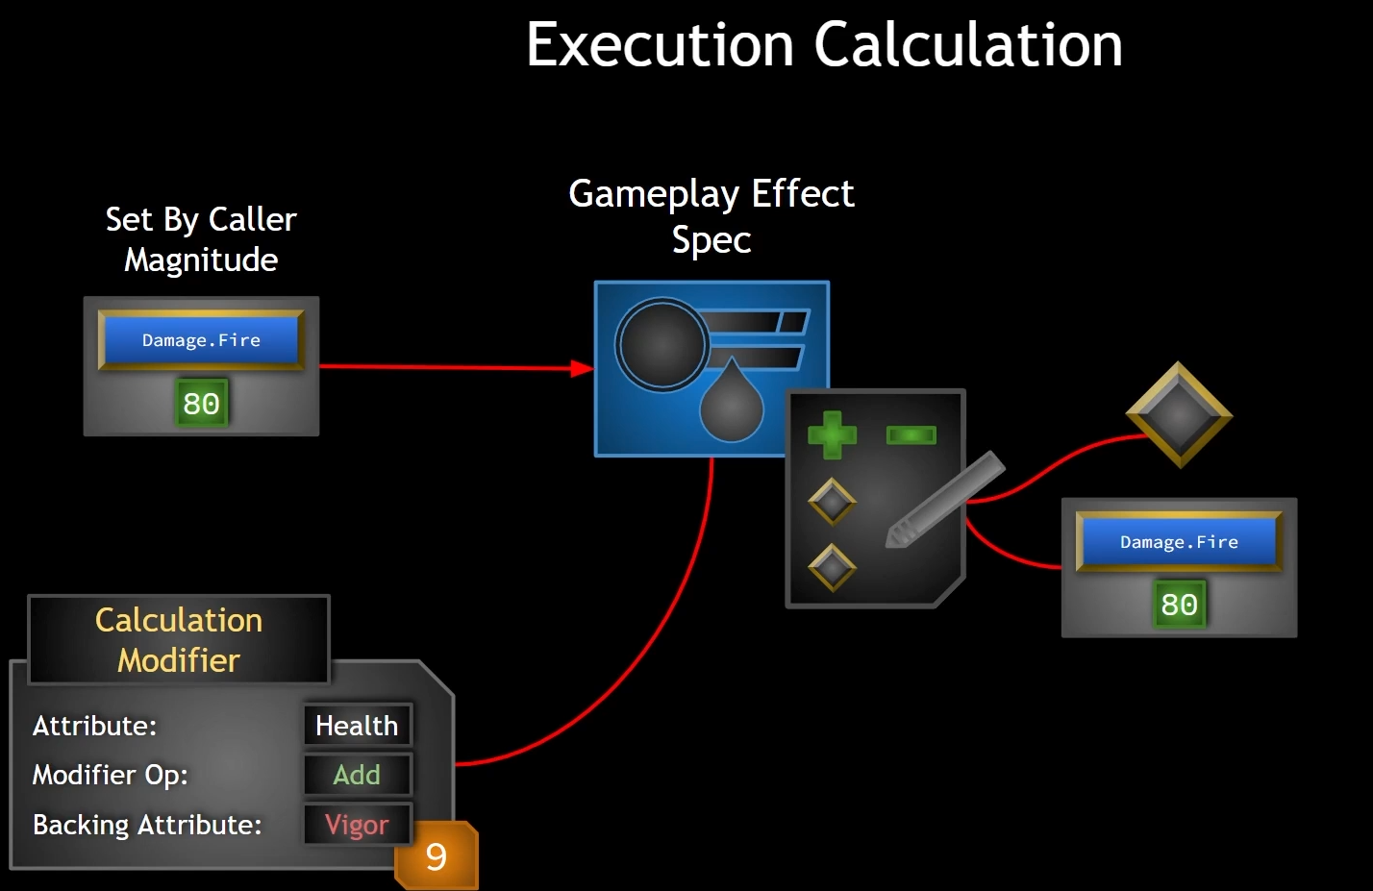

PreAttributeChange

PreAttributeChange:
-place where we can modify the changes to the CurrentValue of an attribute:
-this function is called before the change actually happens
-is triggered by changes to attributes:
-whether that is through attribute accessors like the setters
-or gameplay effects
-this does not permanently change the modifier for a given attribute, just the value returned from querying the modifier (we can clamp changes before the change happens, but there are later operations that happen after PreAttributeChange and these will recalculate the current value from all modifiers involved (we need to clamp again later on).

So PreAttributeChange is not the most attractive choice to implement final clamping changes, but it is there.

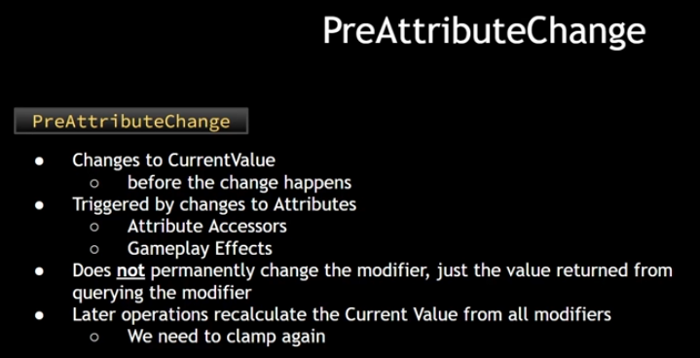
PS:
PreAttributeChange is getting new value from our modifier on the GameplayEffect that's being applied. And then we are clamping it before the attribute changes. But this clamp is not going to permanently change that modifier. It just changes the value that is being returned from querying that modifier. And if we have some other GameplayEffect that's going to have its own modifier queried, its going to recalculate the value from current value. So its kind of like the value was never actually clamped. We clamped it before the attribute changed, but that modifier recalculates.

PostGameplayEffectExecute

PostGameplayEffectExecute

Gameplay Tags

In the API, we have the concept of giving tags to Actors. What we mean by that is that we are giving the tag to an actor's Ability System Component. We then say that that Ability System Component has that tag. The AbilitySystemComponent implements an interface called IgameplayTagAssetInterface. This interface has a number of functions that make it easy to look at all owned tags, see if particular tag is owned, or get all tags that mach a given tag, or even see if any of the owned tags match a specified tag (GetOwnedGameplayTags, HasMatchingGameplayTags, HasAllMatchingGameplayTags, HasAnyMatchingGameplayTags).

Since classes can have multiple GameplayTags, we naturally need to store them in some sort of contasiner. We do not use Tarrays to store our gameplay tags. Instead we use the GameplayTagContainer, which has some GameplayTags specific functionality and some added efficiency. GameplayTagContainers have the concept of a tag map count, meaning you can have more than one instance of a single Tag in the container. This TagMapCount tells us how many of a given tag exists in the container and at times this could be zero depending on whether tag has been added and then subsequently removed, for example.

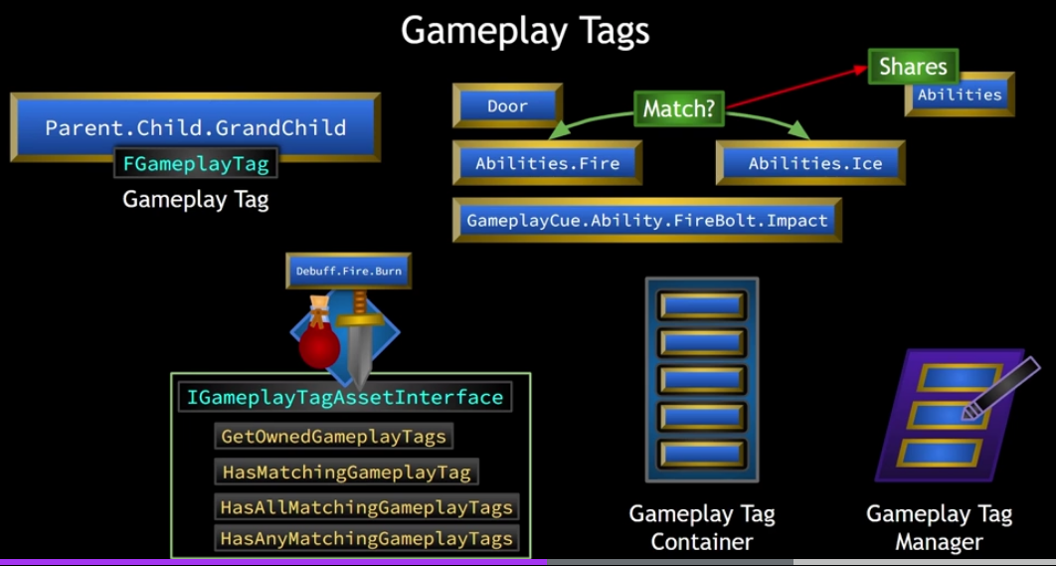
We have actor that applies GameplayEffect (duration GE). This GameplayEffect can have a certain tag that it grants to the AbilitySystemComponent upon application. Now that AbilitySystemComponent has that tag. When the effects duration expires and it removed itself, it removes the tag as well.

Examples:
-the AbilitySystemComponent might block the Ability when it does not have necessary Tags or it blocks Tag.
-the AbilitySystemComponent must have these tags to activate the ability, and if it attempts to activate the ability, it will not be able to do so as it does not meet those tags requirements

Tags can be used to identify inputs, abilities, attributes, damaga types, buffs and debuffs, messages, any type of data or really anything else we can think of.

GameplayTags are project wide. They are registered with the GameplayTagManager and to create them, we have several options, for example: we can create them in the editor. GameplayTags can be stacked. If GE are stacked for example 4 times, we still have only 1 GameplayTag. If GE are not stacked, then GameplayTags are stacked based on how many numbers of GE we applied.

Types of Tags in GameplayEffect:
-GameplayEffectAssetTag=tags that the GE has and does not give to the actor
-GrantedTags in 5.3 called TargetTagsGameplayEffectComponent =these tags are applied to the actor I am applied to. For InstantGameplayEffects, the tag is not applied to the actor. GrantedTags really only mean something when our effect has a duration, because when the effect is gone, the tag is removed.
-GrantedBlockedAbilityTags=
-OngoingTagRequirements=
-ApplicationTagRequirements=
-RemovalTagRequirements=
-RemoveGameplayEffectQuery=
-RemoveGameplayEffectsWithTags=

Gameplay Abilities

GameplayAbilities
Gameplay Abilities are actions or skills that an actor can perform in the game. It is a class derived from UGameplayAbility and it defines what an ability does and the conditions under which it can be used. So rather than implementing an action with a simple funtion, a GAS GameplayAbility is an instanced object running asynchronously. This means that it can be activated at some point in time and run multi-stage tasks that may or may not span across periods of time. These can potentially branch off into different tasks, apply their own GameplayEffects, and once we learn about gameplay queues, we will see that they can kick of those as well. And this all can be conditional. They may be based on player or environmental interaction. GameplayAbilities have built in replication and prediction support, much like GameplayEffects. Gameplay Abilities also have built in concept of cost and cooldown, where attribute resources must be present in a sufficient amount to pay for an ability activation (in our case it will be MANA). And cooldown periods prevent an ability from being activated again until the cooldown period is over.

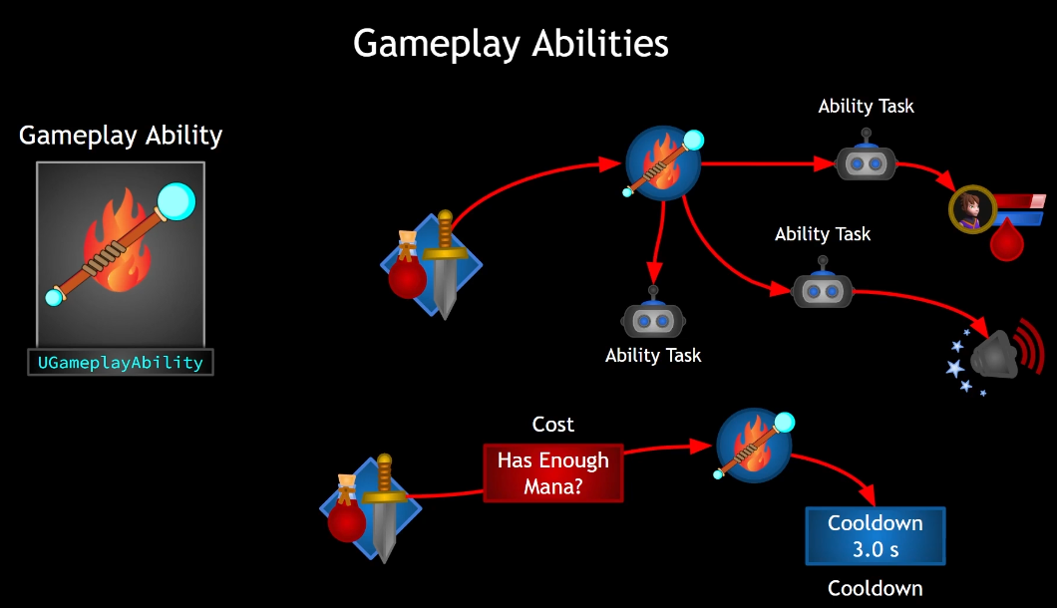

AbilityTasks
GameplayAbilities use Ability Tasks although they do not have to. AbilityTasks are derived from the class UAbilityTask which is a more specialized form of the more general Gameplay Task Class. These perform asynchronous work during a GameplayAbilities execution. They can affect execution flow by broadcasting delegates. These tasks can be used in cpp but they can also appear in blueprint in the form of a specialized blueprint node that can have multiple output execution pins. These are executed as a result of delegate broadcasts made in response to occurences determined by the developer. Basically, something happens in the game. Your AbilityTask will broadcast a delegate and in blueprint this means that tha particular output execution pin on the task node will be executed. This allows us to easily map out an abilities control flow in blueprint and we can still enjoy the benefit of optimal performance of cpp as the work being done by the task is often done on the cpp side, although it does not have to be. But because we can make these AbilityTasks and make them do the bulk of their work in cpp, we gain the flexibility of being able to design the mechanics of a GameplayAbility in the abilities blueprint and allow designers who do not have access to the cpp domain to have more control over the ability without sacrificing performance.

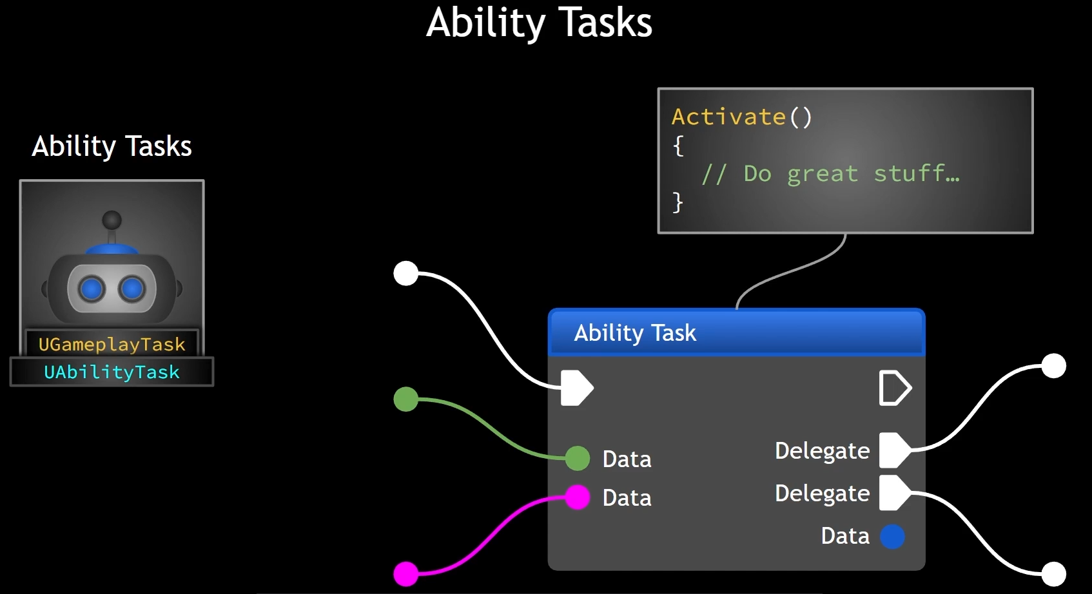
AbilityTasks are sort of like the workers that a GameplayAbility employs to do tasks and things that can be done either instantenously or they may span across some period of time. There are a number of tasks that already exist in the GAS. And we can create our own.

LatentNode means a synchronous or a node that will be executed and depending on what happens later, we have number number of output execution pins that can be executed.

AbilityTask is a cpp class that has a static function that constructs an instance of itself that is blueprint callable exposed to. And the class has a number of delegates that are broadcast based on things that are happening. And it has an activate function in which those delegates have some callbacks bound to them.
We can connect to events by associating GameplayTags in Montages.
We can create custom AnimNotify which will trigger GameplayTag. Then in GameplayAbility in node WaitGameplayEvent we can select GameplayTag for which we are waiting. In case of FireBolt, we will wait to spawn fire bolt projectile.

Granting Abilities
To use the GameplayAbility, the AbilitySystemComponent must be granted the ability. When this happens, a gameplay ability spec is created and the spec defines the details pertaining to that particular ability, including the GameplayAbility class itself, the abilities level and any dynamic information that can be changed at runtime. Abilities are typically granted on the server, but when this happens the AbilitySpec replicates down to the owning client so they can activate it from their.
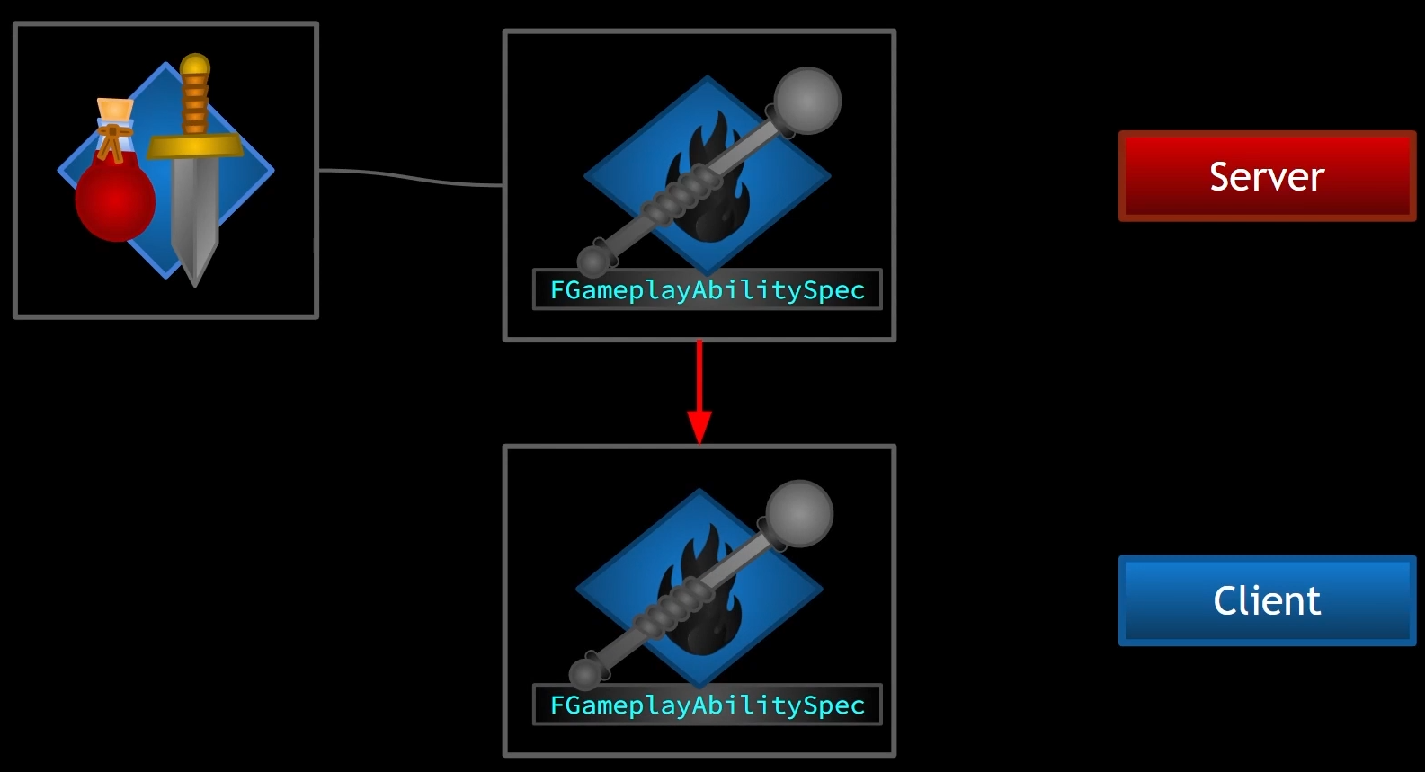
GameplayAbilities have the concept of activation. Once activated, abilities are said to active until they are either ended or canceled. Abilities can end themselves as well as be canceled externally.
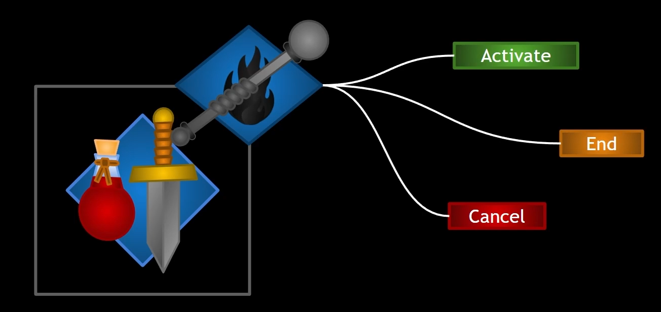
In summary, GameplayAbilities are classes that define given skill or spell or any type of ability that can be performed by an actor. Abilities must be granted to an AbilitySystemComponent to be used, and we do this on the server at which point an AbilitySpec is granted and replicated down to the owning client. To use an ability, it must be activated (and it is considered to be active until it is ended or cancelled). Abilities have the built in concepts of cost and cooldown. Abilities can be run asynchronously and multiple abilities can be active at one time.Abilities can run AbilityTasks which are asynchronous actions that encapsulates behaviors into individual class, each of which can perform their own particular job.

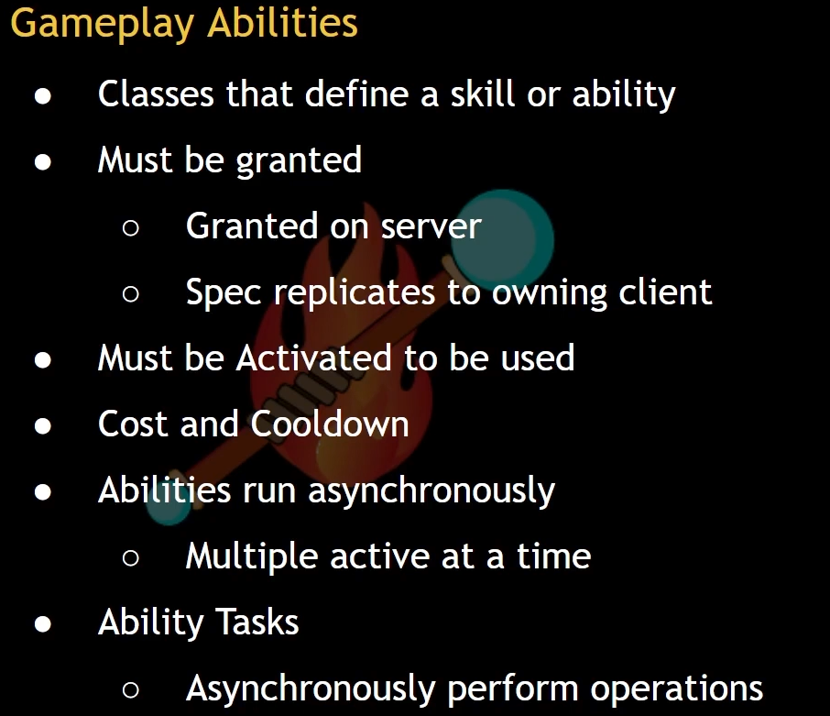

Settings in GameplayAbilities (lesson 99)

Tags:
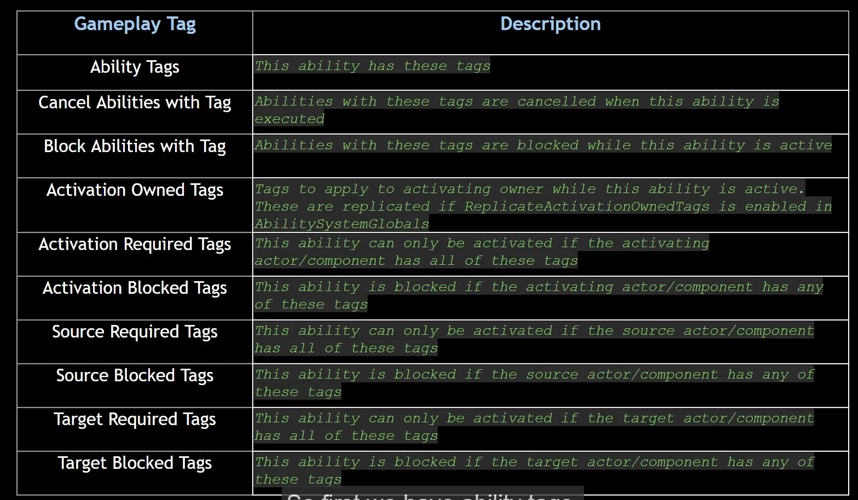
AbilityTags – Abilities have a concept of having tags. We can add any tags we want.
Tags provides us with a really easy way to enforce certain rules pertaining to the activation of a GameplayAbility.

Input:
Replicate Input Directly – if true, this ability will always replicate input press/release events to the server.

Advanced:
ReplicationPolicy- How an ability replicates state/events to everyone on the network. Replication is not required for NetExecutionPolicy.
InstancingPolicy – How the ability is instanced when executed. This limits what an ability can do in its implementation.
-Instanced Per Actor – ability is never destroyed, it is reused, it sticks around. So must be reset manually. More optimized than InstancedPerExecution.
-Instanced Per Execution -abilities created and destroy over and over again. Less performant than InstancedPerActor, and it does not store persistent data between activations. Each activation creates a new instance of this class, a new object.
-Non Instanced – we never actually creates an instance of the GameplayAbility class. We are just using the class default object. No instances are created upon activation. Best performance.
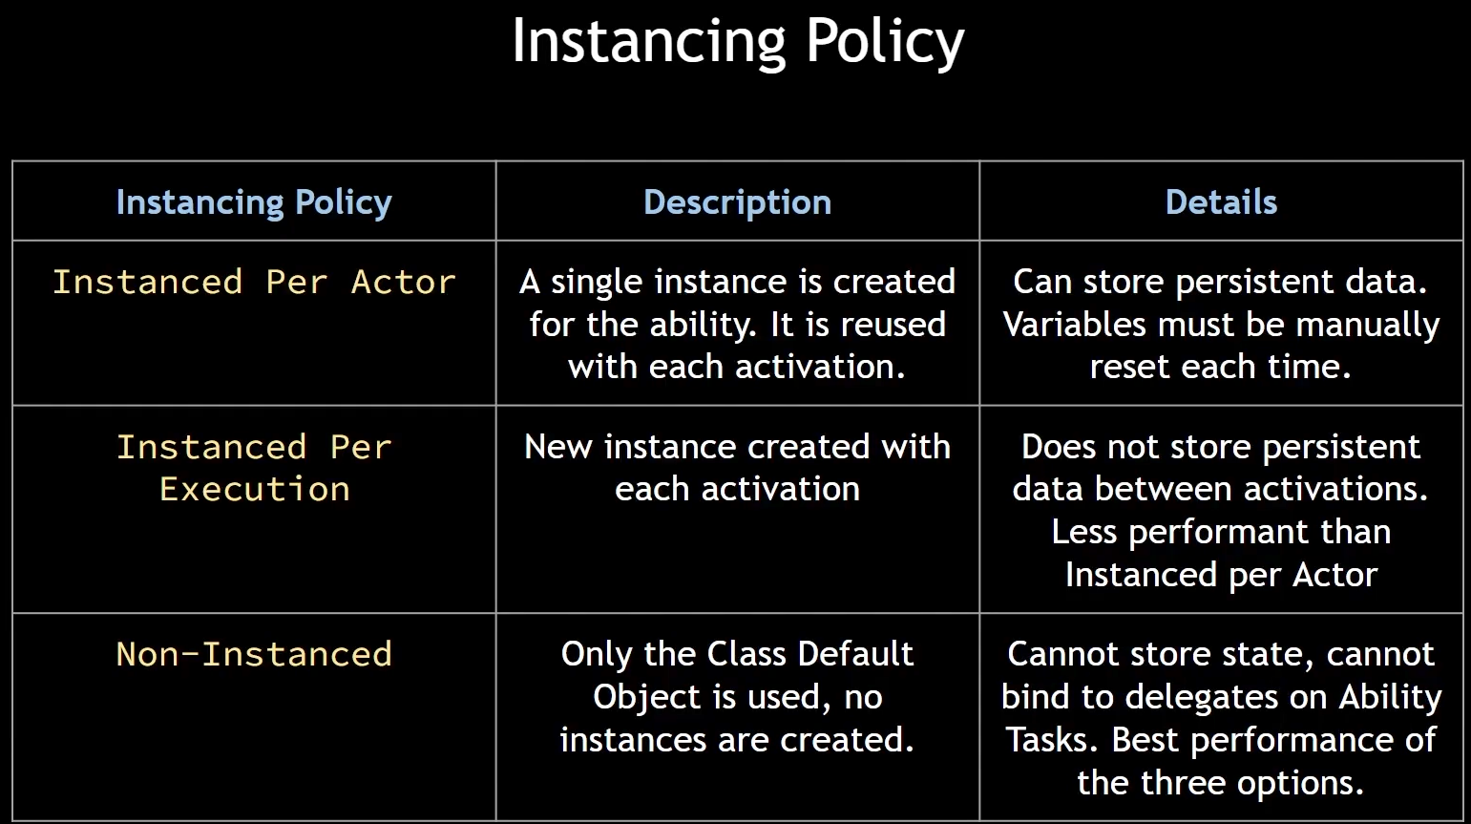
ServerRespectsRemoteAbilityCancellation(default: true)- if set, server-side version of ability can be cancelled by the client-side version. The client-side version can always be cancelled by the server.
RetriggerInstancedAbility – if true, and trying to activate active instanced ability, end it and re-trigger it.
NetSecurityPolicy-is related to whether or not a client is allowed to request changes to the execution of an ability

NetExecutionPolicy-How does an ability execute on the network. Does a client "ask and predict", "ask and wait", "dont ask(just do it)".
-Local Only – this would be good for something perhaps cosmetic that your local client only needs to see. Not really anything that has to do with anyone else in the game. So things that probably arent going to affect gameplay very much.
-Local Predicted – it takes some time to travel up to the server, because client is first. We are using prediction. Server can roll back invalid changes.
-Server Only – this could be something like passive gameplay abilities, something that you want running all the time that will be constantly doing something or listening for something.
-Server Initiated – runs on server, then replicates down to the owning client.
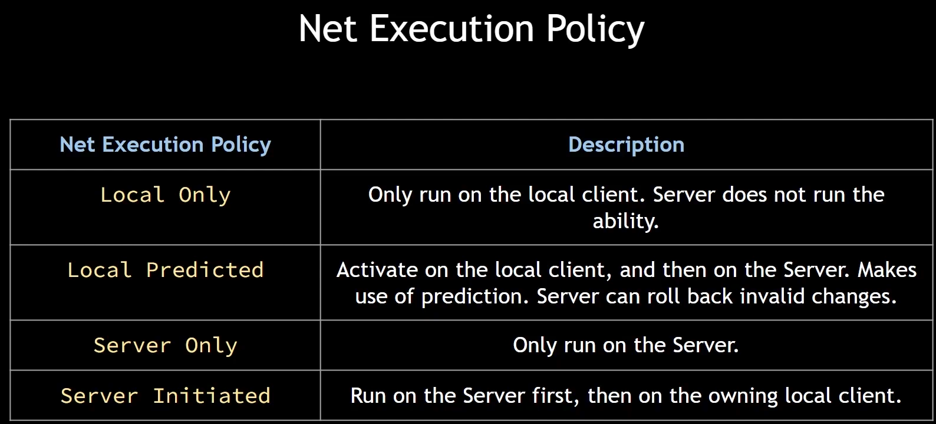

Costs:
Cost GameplayEffect class-GameplayAbilities have the concept of a resource requirement or cost that is directly related to your attributes and costs are implemented in the form of effects. And that cost effect determines what attributes must be used to pay to activate this ability and how much of that resource is going to be consumed.

Triggers:
AbilityTriggers-allow us to execute this ability in response to an event. So in this array, we can add GameplayTag to trigger ability in response to an event or a tag being added.

Cooldowns:
Cooldown GameplayEffect class-are implemented in a form of GameplayEffect. The effect will determine how long the cooldown period must be. In other words, how long do you have to wait before you can activate the ability again.

Things Not to use:

Aaaa
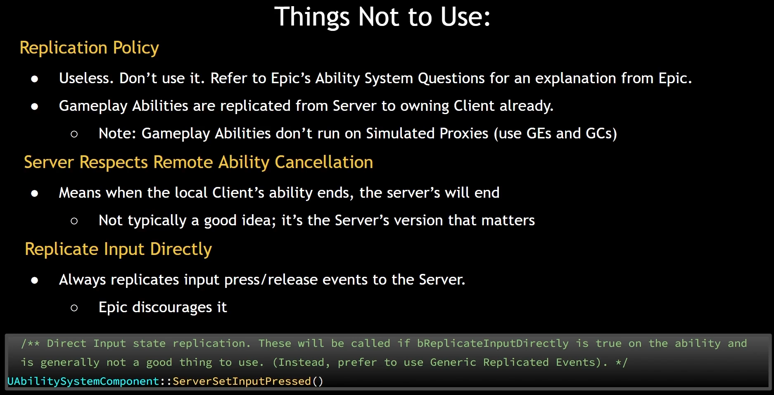

Target Data

Lesson 116:
GAS has a built in mechanism for sending target data to and from the server.

There are a number of types of target data built into gas and they are all based on a struct FgameplayAbilityTargetData. And there are ways to send target data up to the server. For example there is a function called ServerSetReplicatedTargetData(). It sends data up to the server, at which point the server receives it and then takes its TargetSet, which is a delegate and broadcasts that delegate. So if any callbacks are bound to this TargetSet delegate on the server, they can be called in response and receive that TargetData.

Now a map is maintained called AbilityTargetDataMap, and it maps ability specs to TargetData. It also keeps track of other things such as the prediction key.

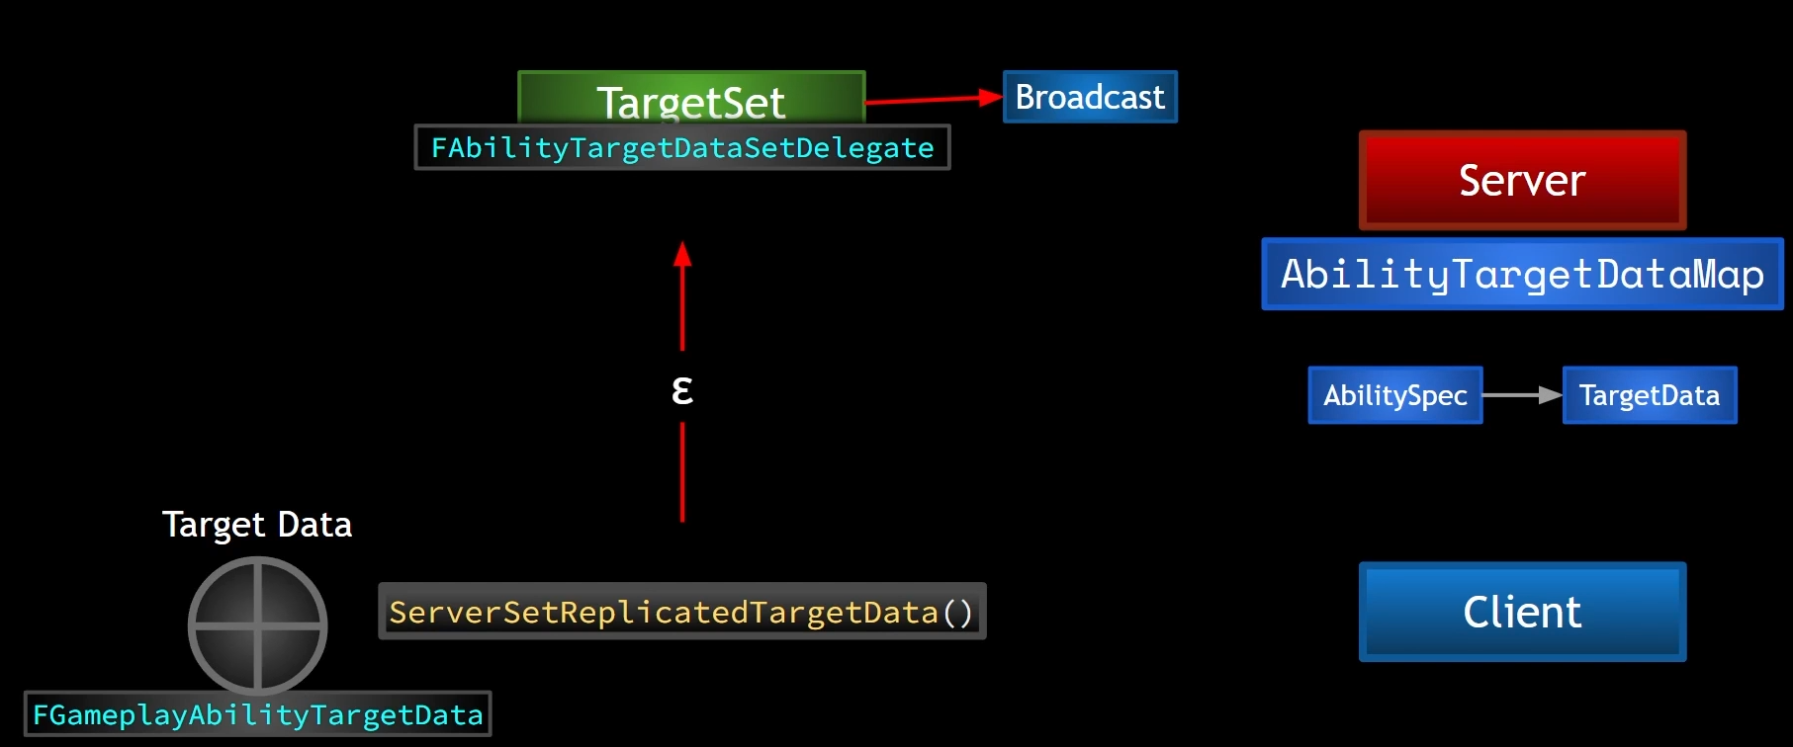
So, what we can do is from our AbilityTask, as soon as we ahve the activate function called, we can use this function ServerSetReplicatedTargetData. This allows us to send TargetData to the server and on the server, when the server is Activate function called we still do not know if the replicated TargetData has reached the server yet or not. So what we can do is bind to that TargetSet delegate. But if we have dones this before, that replicated TargetData has reached the server. In other words, the time that it took for Activate to be called on the server epsilon was less than delta (time that it took for the RPC to get there) then if that is the case, then no problem. Once the TargetData gets there, then the TargetSet Delegate will be broadcast and the server will receive it. In case when we received TargetData before binding to it, we can call this function CallReplicatedTargetDataDelegateIfSet. This is going to provide a safeguard for us if the replicated TargetData gets there first and the delegate is broadcast before the server can bind to the TargetSet delegate, it will force the broadcast of that delegate again and retrieve that TargetData.

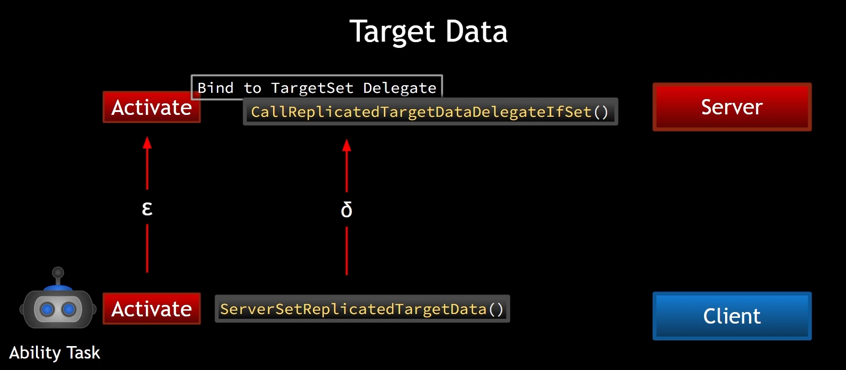

Prediction Key

When it says original prediction key, it is talking about when this ability was originally activated. We can get that from AbilityTask with the function GetActivationPredictionKey().

OriginalPredictionKey – was associated with the activation of the ability.

ScopedPredictionKey -

GameplayEffectContext

GameplayEffectContext is something that lives with a GameplayEffect and seems to carry along some information.

Data that it contains:
-Instigator – is an actor itself. It has PlayerState, AbilitySystemComponent and an AttributeSet.
-EffectCauser – set to BP_AuraCharacter

ASC->MakeEffectContext() is setting the EffectCauser, Instigator and Instigator AbilitySystemComponent for us automatically. This method is creating new GameplayEffectContextHandle.

When setting the GameplayAbility for particular GameplayEffect/GameplayEffectContext, it will fill those info:
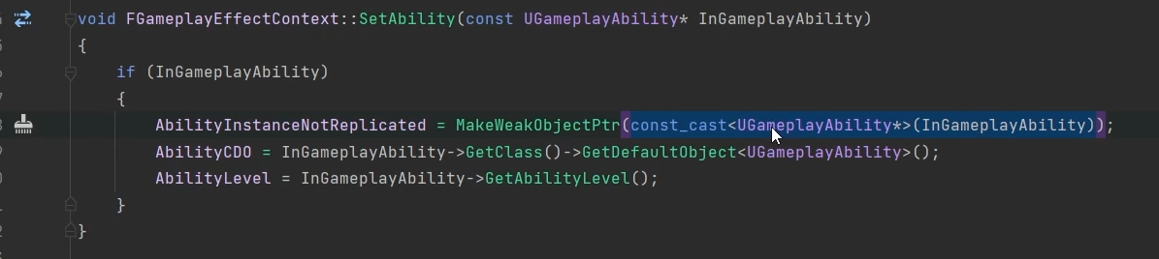
CDO – Class Default Object

GameplayEffectContext has array of actors that can be set for any reason. So if we have an effect and we want to stick an array of actors into it, we can stick that in the GameplayEffectContext. And then later on down the pipeline, we can access it. Same with HitResult.

NetSerialize – this specifies how this GameplayEffectContext struct will be serialized when it has to be sent across the network.

WeakPointers – are smart pointers. They are wrappers that can store pointers and a weak object pointer has the property of not taking ownership of the pointer that it stores. In other words, it does not participate in reference counting.
SmartPointers are reference counted. As soon as an object no longer has any references to it, any pointers that point to it, it's automatically deleted.

ScriptStruct is like a Uclass but for structs, which is generated for a class that is based on UObject. For example we have an Actor, UClass is generated for that for the reflection system.

NetSerialize in GameplayEffectContext

3 arguments in NetSerialize:
-bOutSuccess
-Map (UPackageMap*) - helper map to map indices for network communication. To know when one object starts and another begins
-Ar (FArchive&) - Base class for archives that can be used for loading, saving and garbage collecting in a byte order neutral way

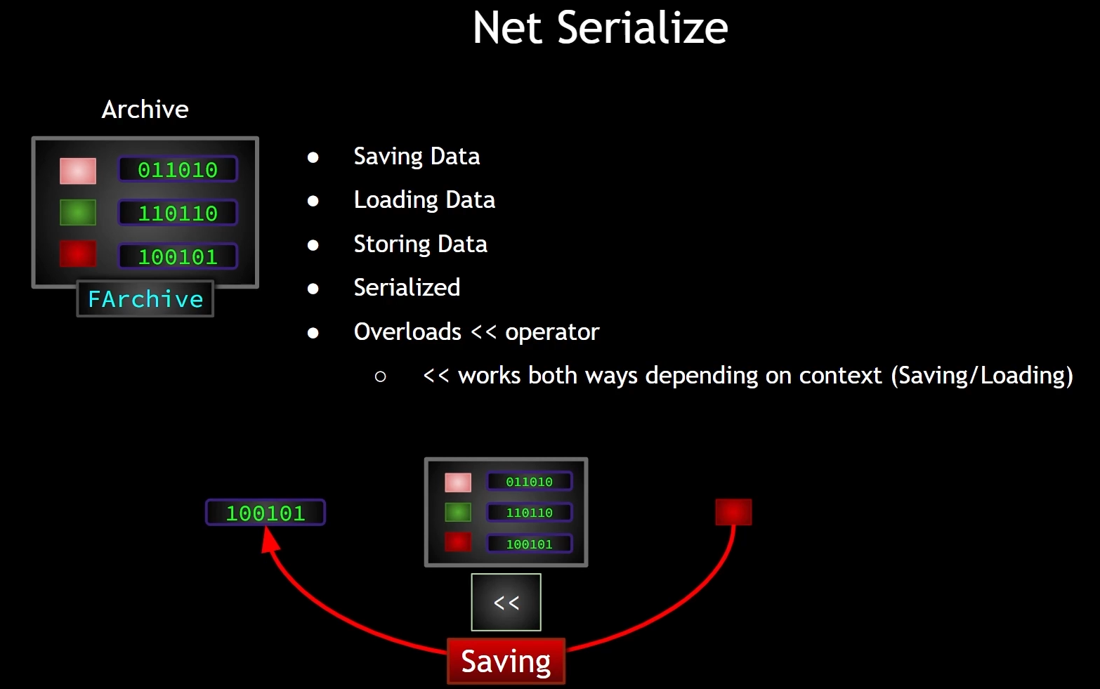
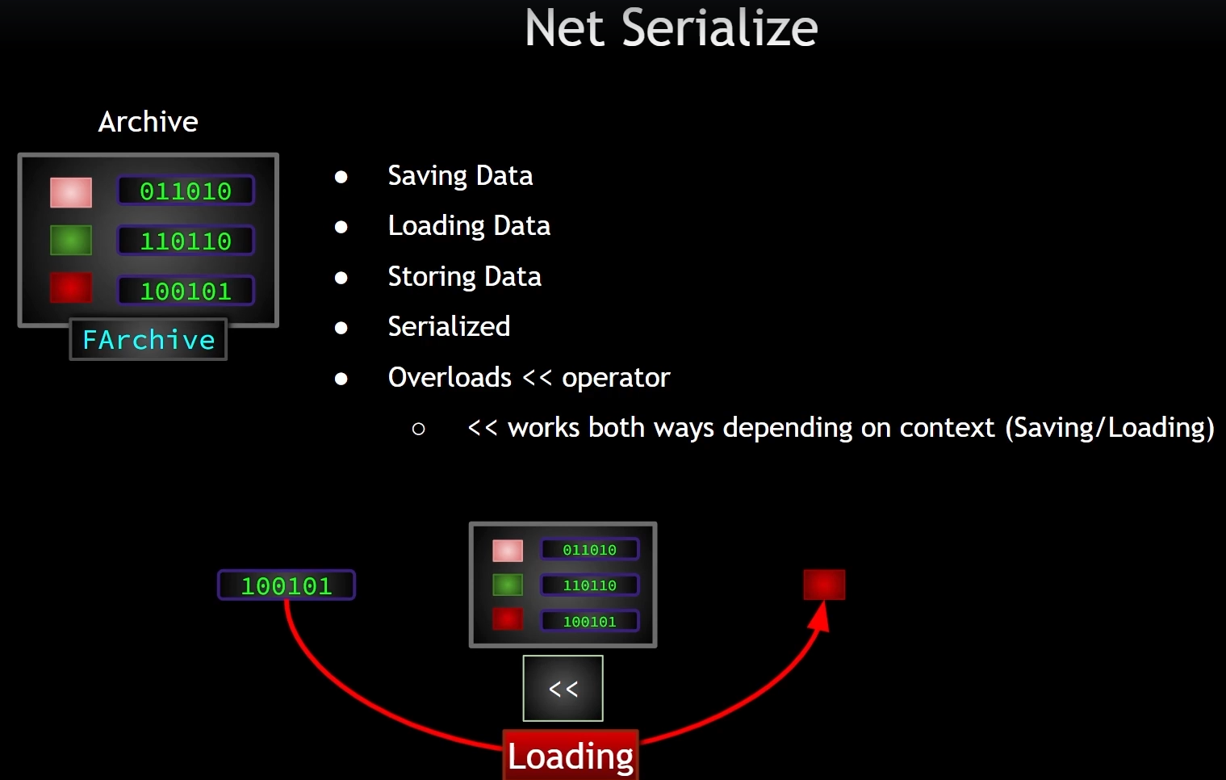
FOR MORE INFO: LESSON 151!

Prediction
In multiplayer games, server should have authority over any significant changes to the game state. If clients can change important factors, then this leaves a vulnerability that cheaters can exploit. However, if clients must wait for confirmation from the server that their requested changes are valid, then a noticeable delay would exist between the client performing an action.
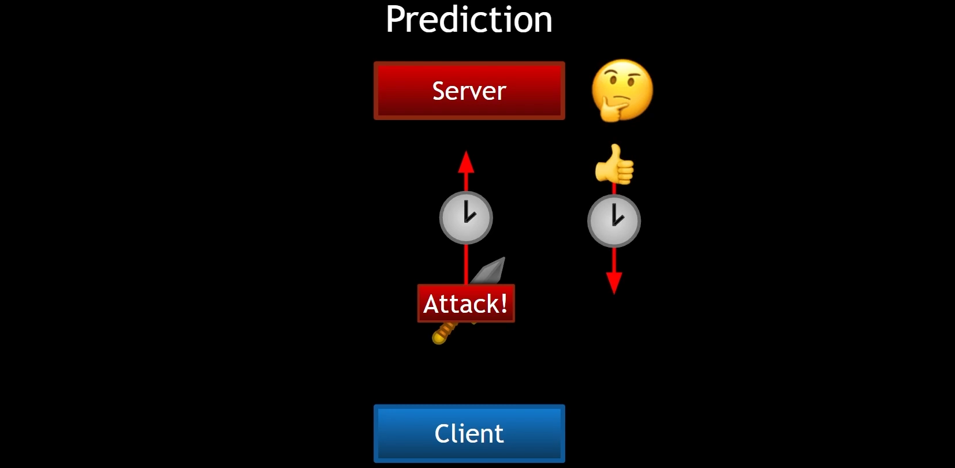
Prediction is when the client goes ahead and makes a change(moving a character, opening a door, shooting a weapon) and informs the server of that change. When the server gets the information, it makes sure that it's valid change. If the change is not avlid, the server undoes those changes.
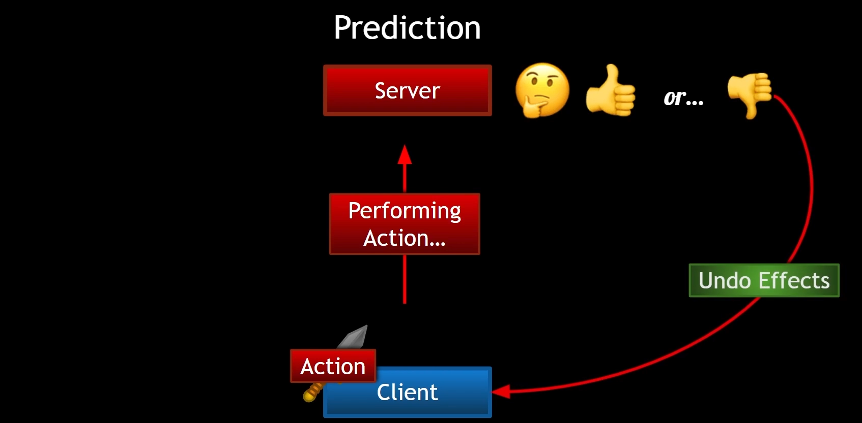
Does not everything needs to be predicted like footsteps, but health or mana changes or damage should be predicted.

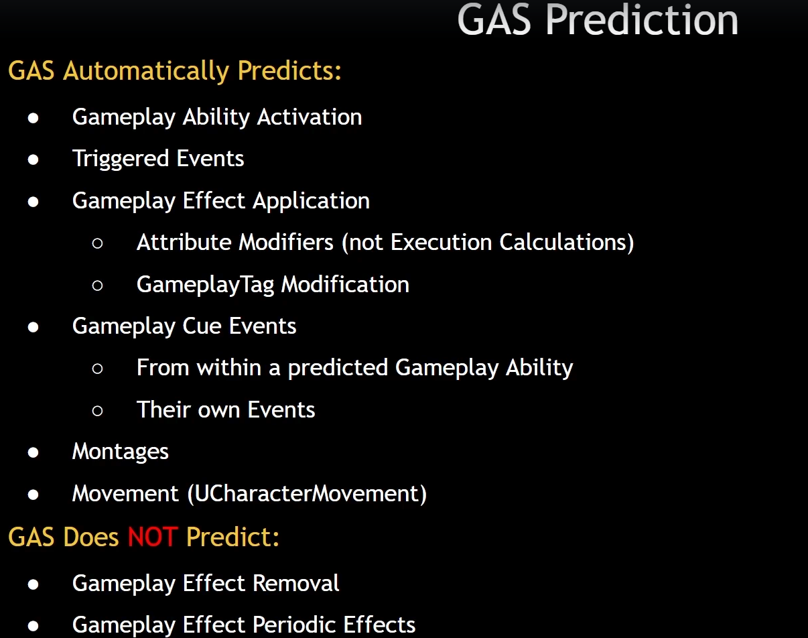

Prediction in GAS
Prediction in GAS is centered around the concept of a prediction key. Prediction keys are based on FpredictionKey. It is simply a unique ID, and those are stored in a central location on the client. When the client performs a predictive action, it will send a prediction key up to the server and associate its client side predictive actions and side effects with that key. The server will receive that key and either accept it or reject it. It will then associate any server side created side effect with that key and will respond to the client informing it that the key has either been accepted or rejected.
An FPredictionKey sent from client to server will always make it to the server. And when a server sends the prediction key back, it will only go back to the client that sent it to the server in the first place. This replication down to clients is done in the FPredictionKey::NetSerialize() function and all other clients will simply receive and invalid key or a key with an ID of zero when that prediction key replicates.
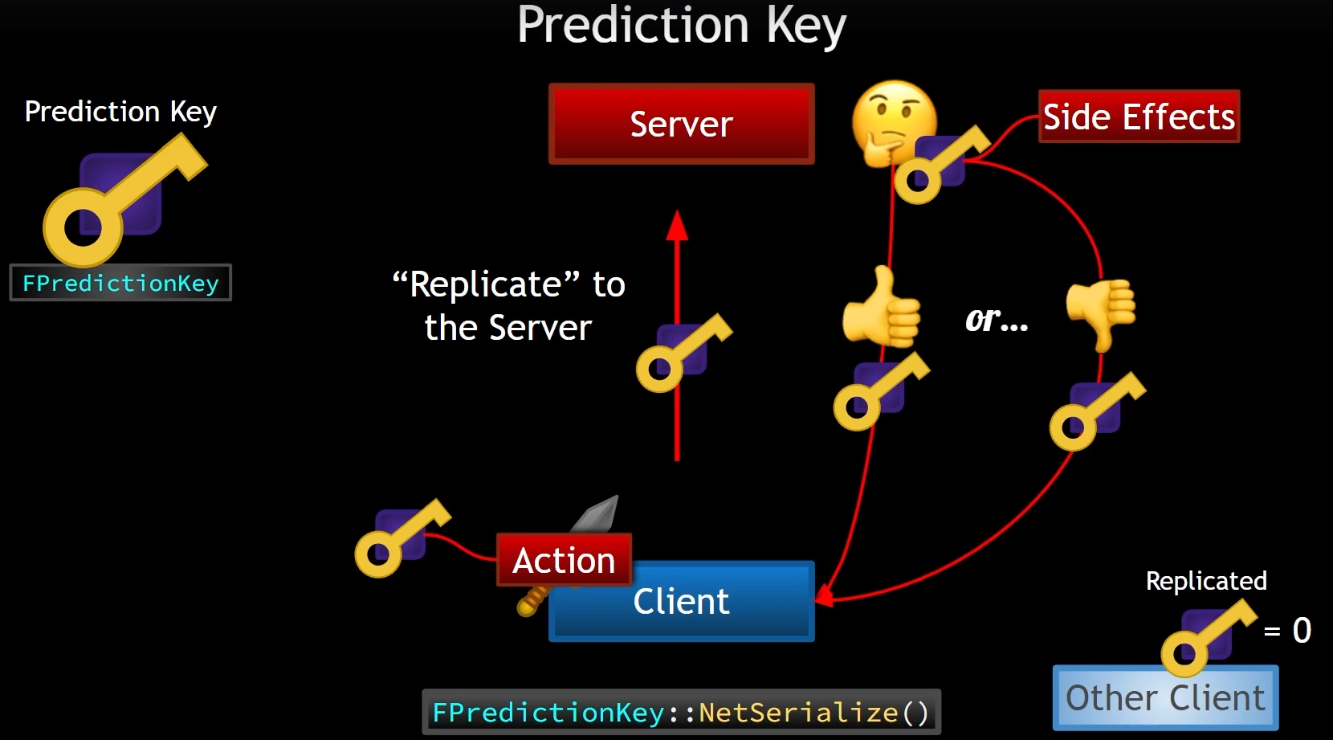

Prediction Window
We say that a GameplayAbility in GAS is a first class predictive action, meaning that whenever a client predictively activates an ability, it explicitly tells the server and the server explicitly responds. Whenever a client predictively activates an ability, there now exists a window in which predictive actions can occur. We refer to this window as a PredictionWindow, and while this window is open, the client can perform important actions that can change the game state such as use up attribute resources without asking the server for permission.
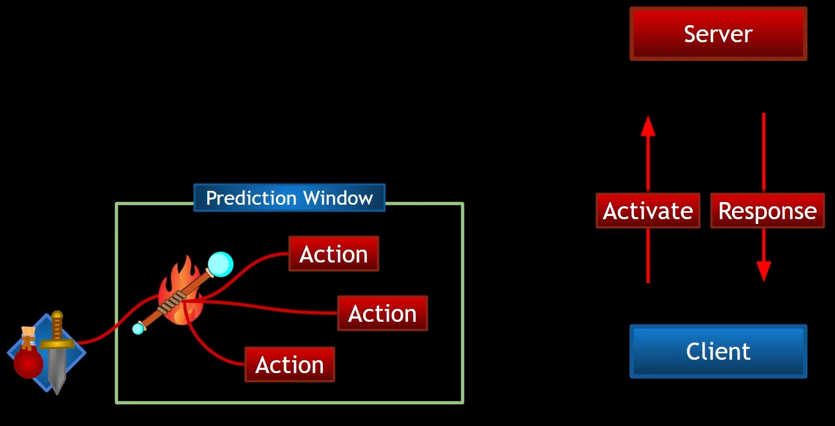

Ability overview regarding prediction
The AbilitySystemComponent has functions for communicating the activation of abilities between clients and server.
TryActivateAbility() - The client calls TryActivateAbility and this results in the generation of a new prediction key(GetActivationPredictionKey function). Then a server RPC is called and that RPC is Server_TryActivateAbility(). After calling this server RPC, the client continues on without waiting for any server confirmation and goes ahead and calls ActivateAbility with the generated prediction key which is now stamped onto that abilities activation and its activation info. While the client is busy doing things and generating side effects, all the side effects have this generated prediction key associated with them. Client calls Server_TryActivateAbility and once the server receives this and this RPC is executed on the server. The server then decides if this ability activation is valid. Once the server makes the determination, it now knows whether or not this client activated ability is a failure or a success, and then it calls one of two client rpcs (ClientActivateAbilityFailed or ClientActivateAbilitySucceeded). Client received the server response and if it receives failure, it kills the ability and then then undo all the side effects associated with the generated prediction key. If success, those those side effects are valid and do not need to be undone. Now, the AbilitySystemComponent has a member variable called ReplicatedPredictionKey, and this is set to the generated prediction key. And as soon it is set, it replicates. Once it catches up to the client, the client can then respond accordingly, such as undoing side effects and so on. And this prediction key has its own RepNotify (OnRep_PredictionKey).
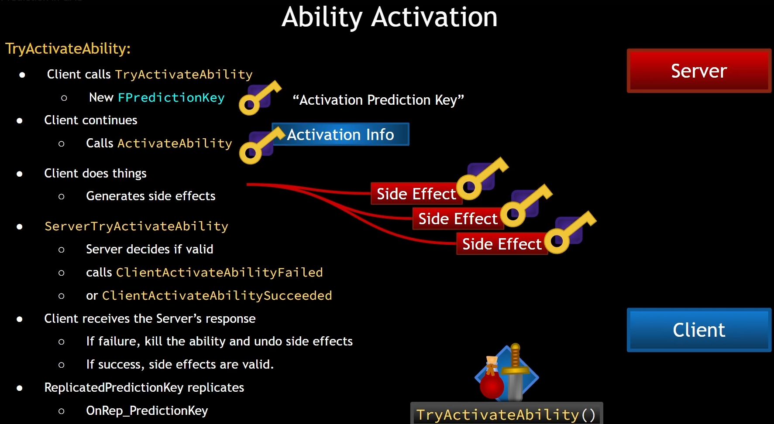

GameplayEffectPrediction
GameplayEffects are side effects. These are not first class predictive actions like abilities are, because they are not explicitly asked about. GameplayEffects are only applied on clients if there is a valid prediction key for the ability applying them. If the GameplayEffect is predicted, then any of the following that the GameplayEffect does, are also predicted (attribute modification, gameplayTag modifications and gameplay cues).

When FActiveGameplayEffect is created, it stores this prediction key.
On the server, the active GameplayEffect gets the same key and this active GameplayEffect is replicated. Now on the client side when it receives that replication, it can then check the key to see if it already has an active gameplay effect with that same key. If they match, then we already know that any logic executed upon effect application has already been done locally and doesn't need to be run again. This helps to avoid duplicate on apply type effects that you can often run into when implementing effects. This does mean however that the local container that stores all active gameplay effects will now have two of the same effect, at least temporarily. The AbilitySystemComponent replicated prediction key variable will be currently replicating down to the client while all this is happening and when it finally arrives, any predicted effects can be removed. And we have OnRep_PredictionKey to do anything that needs to happen once that prediction key arrives.
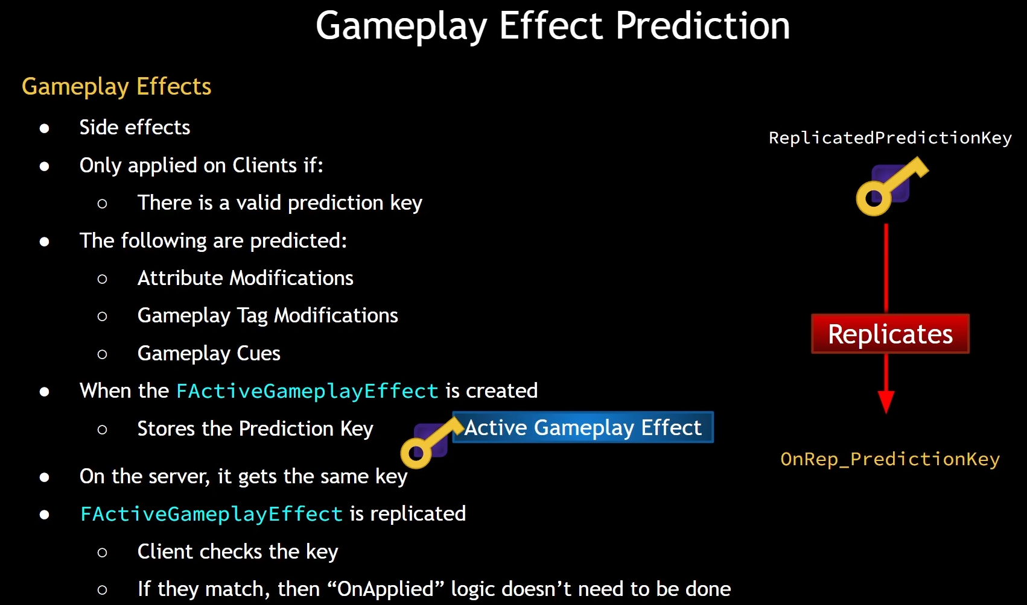

More info we can find in: GameplayPrediction.h header file

Meta Attributes

For damage, there are more calculations than just subtracting from health. And it has to do with attributes both on the attacker and the victim side. For this reason, to keep the mathematics simple, we often use a placeholder attribute that behaves as an intermediary, allowing us to perform all of the math that we need to perform, before actually settings the value of health in case of damage. These intermediary values are referred to as meta attributes.

Difference between MetaAttribute and NormalAttribute.

NormalAttribute:
-is often replicated and it can be changed on the server and replicated down to clients
MetaAttribute:
-is not replicated and it is really just a temporary placeholder, we only use this on the server to perform calculations and after those calculations are performed, we can then apply the change to the real attribute that matters

We can have IncomingDamage as MetaAttribute. Lets say GameplayEffect says I am applying 11 damage to you. Now rather than subtracting 11 from the health of the victim, the GameplayEffect is going to add 11 points to the incoming damage meta attribute. We can react on this meta attribute change in AttributeSet just like for other normal attributes. If it is IncomingDamage (MetaAttribute), we can perform any necessary calculations. We can determine if there was a block by taking in the victims block chance, we can determine if there was a critical hit, if there needs to be an intelligence bonus in the case of magical damage. Whatever the case, we perform any of those calculations to determine the final real amount of damage that should be caused. And then we take the attribute(in this case Health) and subtract that number from the health. So the GameplayEffect is not the actual decider of how much health is substracted from the health attribute. Its the rules that we set based on those mathematical equations that determines the final value.

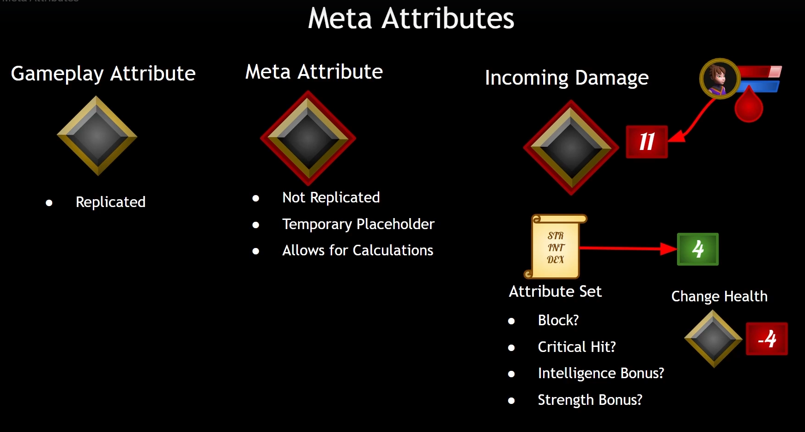
So this IncomingDamage(MetaAttribute) will be set by these Damage GameplayEffects and the attribute set will perform any calculations it needs to and then zero out that incoming damage meta attribute. In a sense, it will consume that value in its calculations and set the value of health and also respond in any other ways that we need to respond in. For example, when taking damage, perhaps we need to show some floating text popping up on the screen. Maybe that floating text is a different color depending on if there was a block or a critical hit. Maybe the attribute set determines that there was a debuff in response. If it was a fire damage, maybe the victim will be burned for a moment. Or if it was lightning damage, the victim will be stunned for a moment. These are the things we can do in response to receiving a change in our IncomingDamage MetaAttribute.

So the MetaAttributes are the way that we often see GAS projects handling damage, and that is how we are going to implement damage in our project.

Gameplay CUEs

GAS has a built in way to replicate those types of effects (cosmetic ones that are not automatically replicated) and that way is via the use of Gameplay CUEs.

Input

Change Input-to-Ability mappings at runtime. We will create a Data Asset that is going to contain Input Actions, but we are going to link up Input Actions with GameplayTags. We will have a GameplayTag for each of our inputs. For example: 1 Key, Left Mouse Button, Right Mouse Button etc. And at runtime we should be able to assign various tags to our GameplayAbilities.

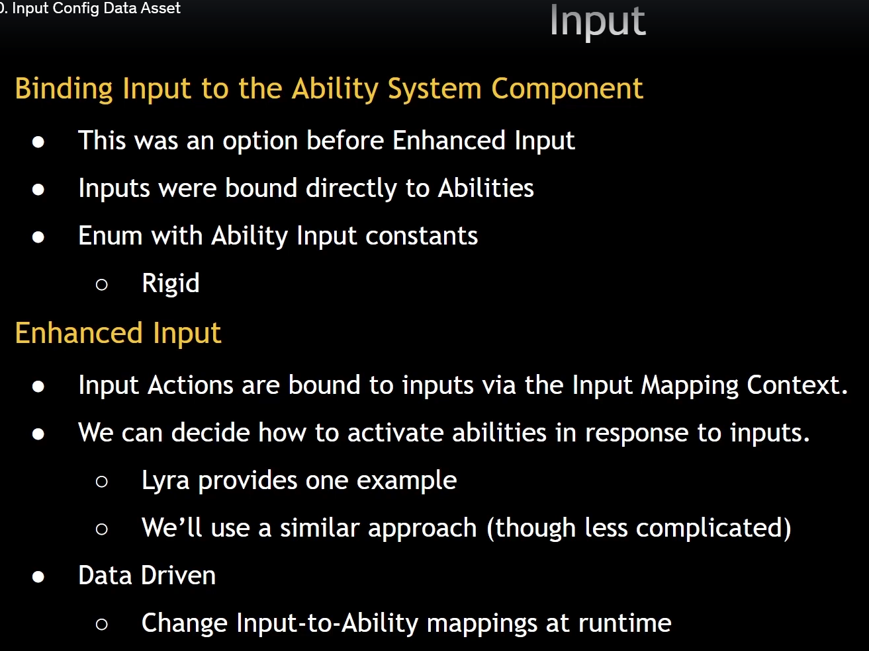

Click to Move

SimpleMoveToLocation from UAIBlueprintHelperLibrary will work fine locally on server for human controlled pawns, but will not work properly on client. SimpleMoveToLocation will work fine for AI controlled pawns which would run on server and be replicated to clients.

AddMovementInput from MovementComponent is replicated automatically. It has prediction. It has built in lag compensation.

SimpleMoveToLocation cant be used if we want to just click and have our character move automatically to a location and just expect that to work in multiplayer.

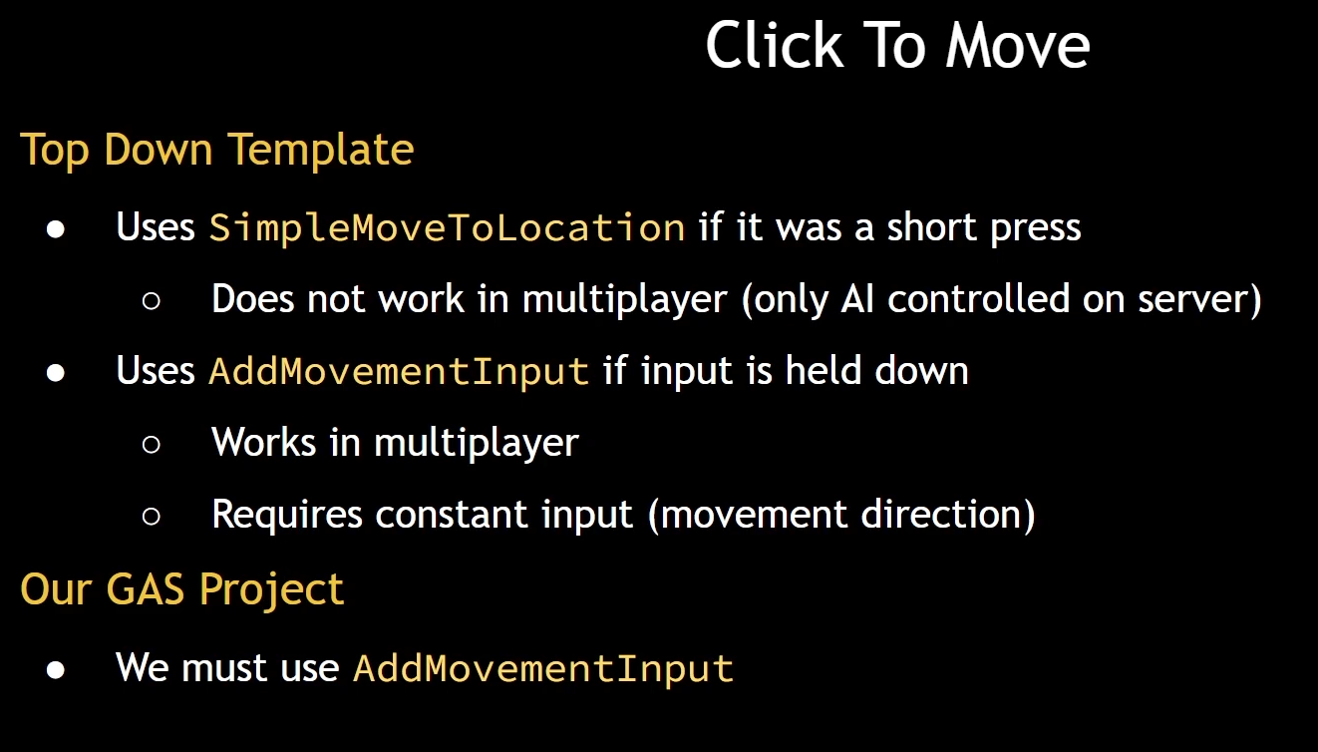
Case 1:
Pawn has location. Position under cursor has world location if we get HitResult underneath it.
We can use AddMovementInput with direction and it will work in multiplayer.
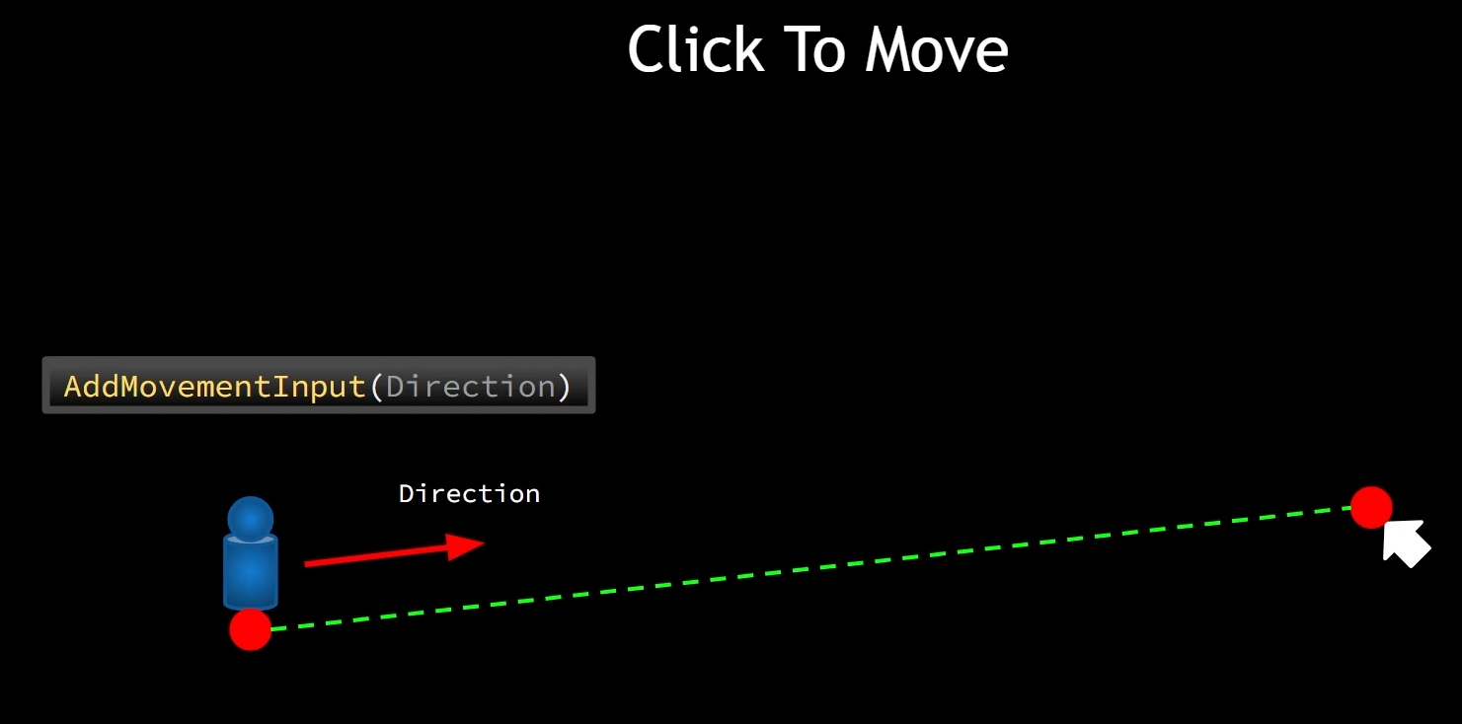

Case 2:
We need a way to find points that will create a path for us that will go around pillar. There are functions that we can use to generate this type of path. We can easily calculate a direction from our character current location to the next point. If we reach it, we change the direction to another point. This can result in an abrupt change in orientation and that can be less than desirable
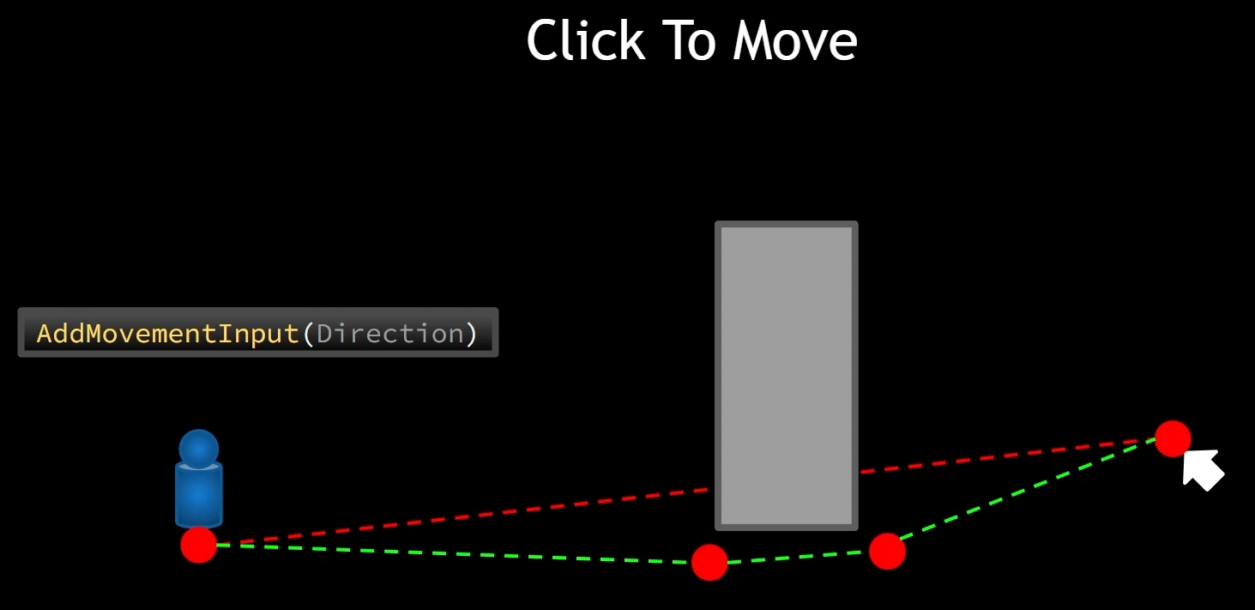
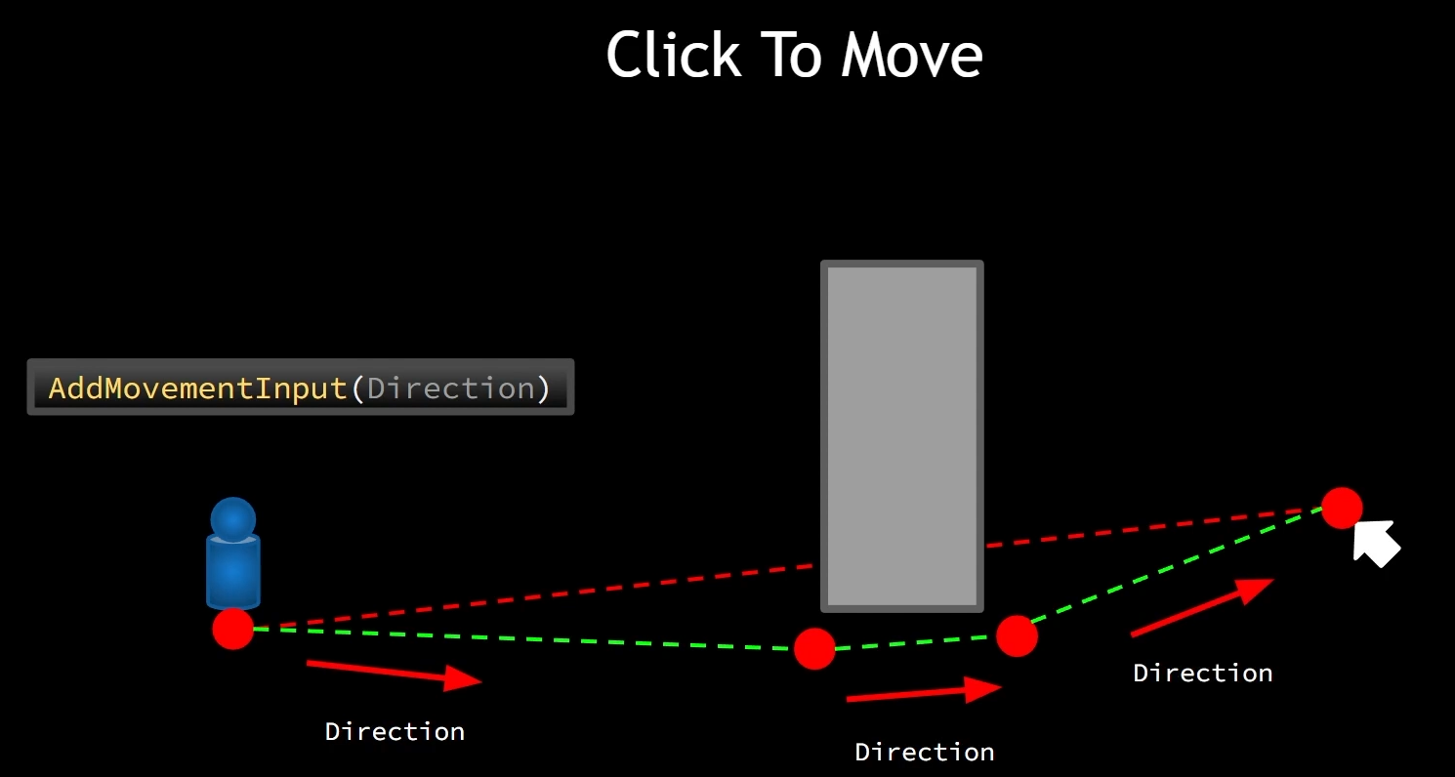
Consider the case where we are looking down on our character from directly above and we can see the top of the obstacle that is in the way, and we generate a path to find our way around it. Now our direction will be from the character's location to the second point in the path, and that is straight line. And as soon as we hit that point, the change in orientation is abrupt. We might even see it appear to snap. And as soon as we reach the next point, our change in direction is abrupt yet again, and this can be less than desirable. It would be nice if we could have a smooth curve for our path.

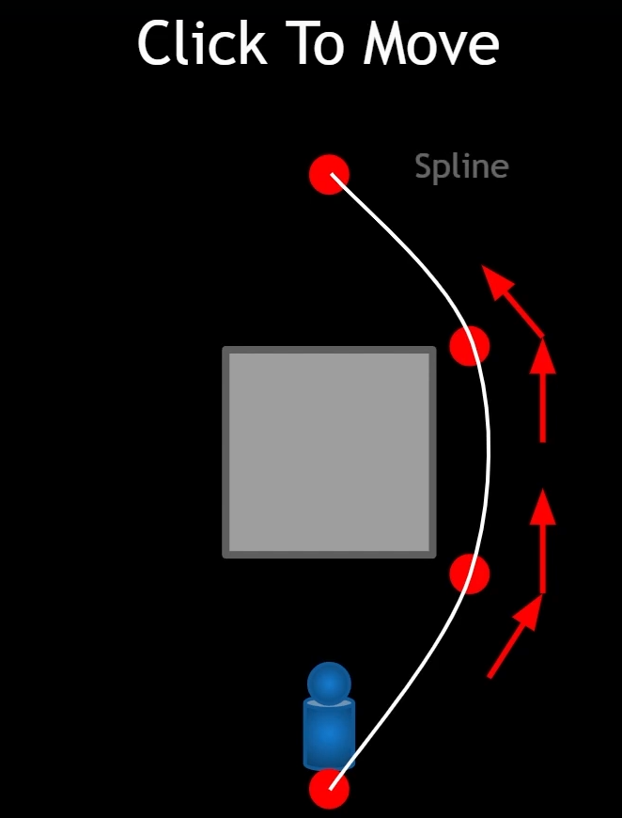
It is possible. We can create a spline out of a system of points that we have generated and a spline is going to smooth itselft out and have a nice round curve like this. If we can generate a spline from some path points, then we have the ability to get the forward direction on the spline at any point and its always going to be tangent to that spline curve. So as we are moving along the spline, that direction can be smooth.

CursorTrace

/**
* Line trace from cursor. There are several scenarios:
* A. LastActor is null && ThisActor is null
* - Do nothing
* B. LastActor is null && ThisActor is valid
* - Highlight ThisActor
* C. LastActor is valid && ThisActor is null
* - UnHighlight LastActor
* D. Both actors are valid, but LastActor != ThisActor
* - UnHighlight LastActor
* - Highlight ThisActor
* E. Both actors are valid, and are the same actor
* - Do nothing
*/

GetHitResultUnderCursor(ECC_Visibility, false, CursorHit);
if (!CursorHit.bBlockingHit) return;

LastActor = ThisActor;
ThisActor = Cast<ITargetInterface>(CursorHit.GetActor());

// CASE A and E - Both actors are the same, either null or valid - do nothing
if (LastActor == ThisActor)
{
return;
}
// CASE C
if (LastActor && ThisActor == nullptr)
{
LastActor->UnHighlightActor();
return;
}
// CASE B
if (LastActor == nullptr && ThisActor)
{
ThisActor->HighlightActor();
return;
}
// CASE D
if (LastActor != ThisActor)
{
LastActor->UnHighlightActor();
ThisActor->HighlightActor();
}

MotionWarping

MotionWarping – relatively new feature that allows us to either move a character through space or orient a character towards a target simply in their montage.

Character Classes

3 types of classes in Aura project:
-warrior (melee eg sword swing, spear thrust)
-ranger(range eg slingshot)
-elementalist(magical spells)

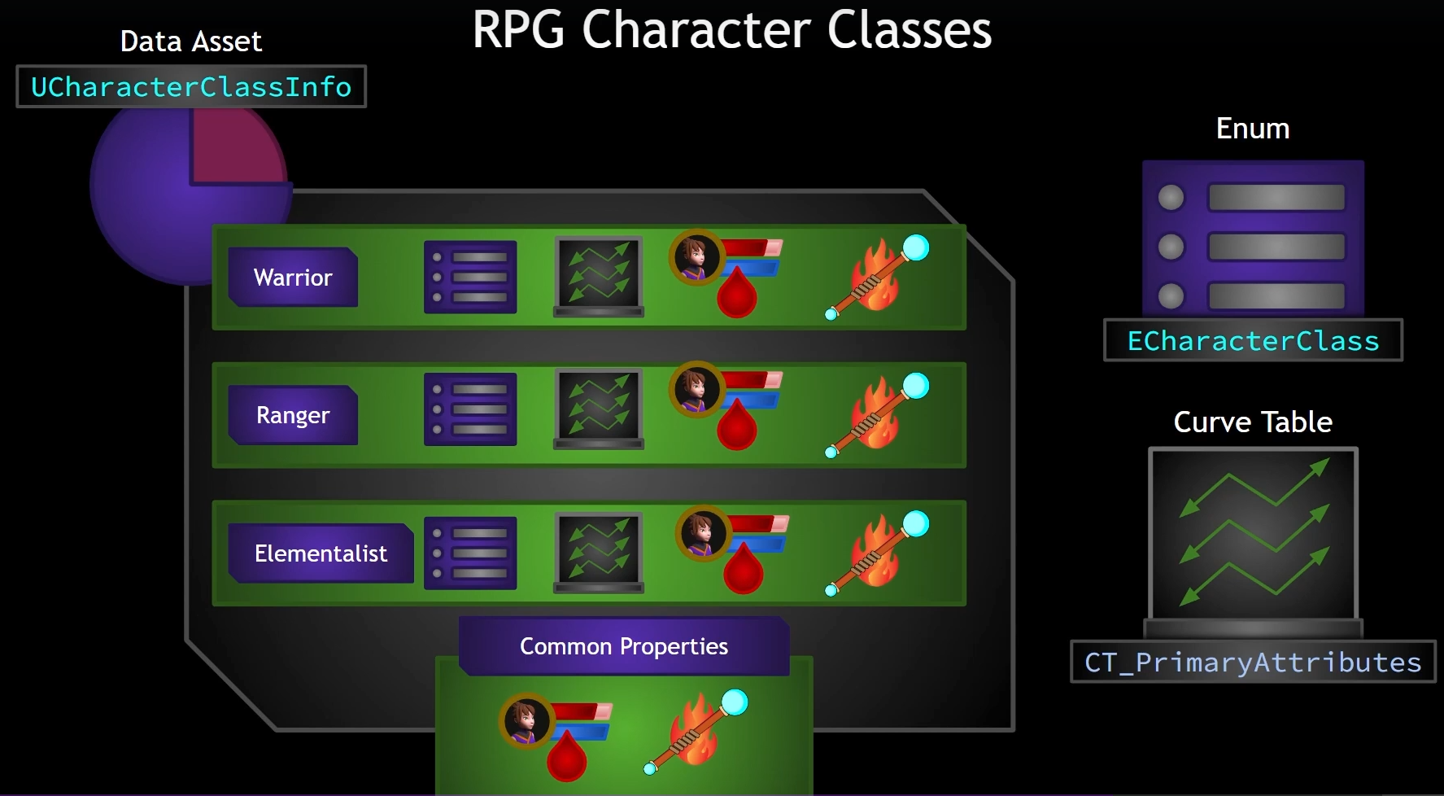
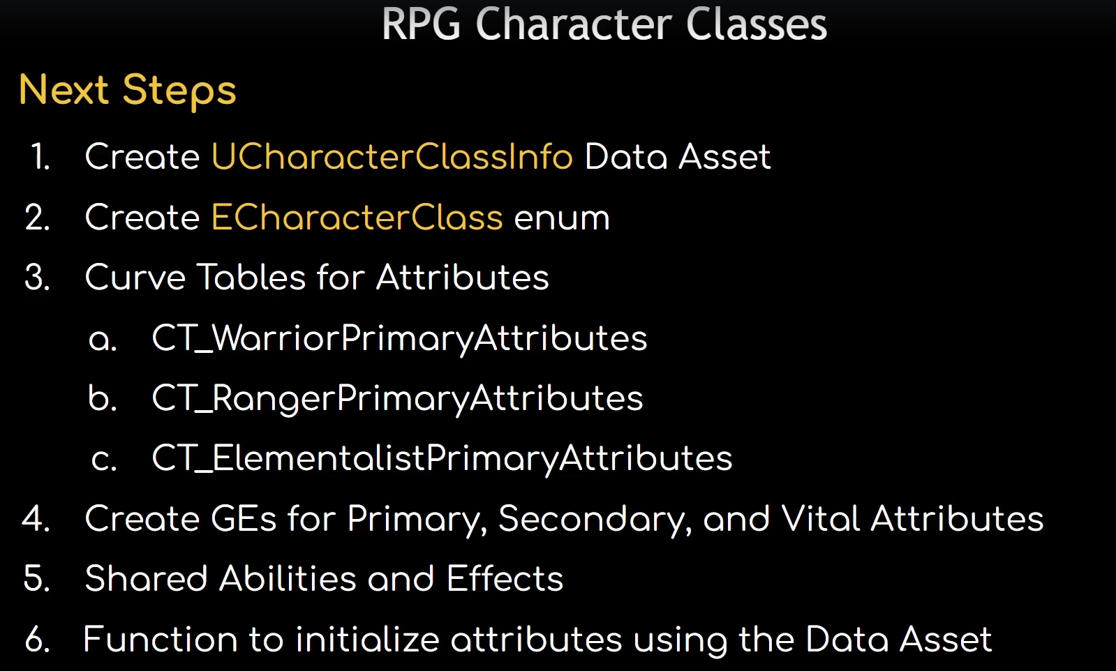

SomeFunctions

IsValid – checks whether pointer is null or not but also checks whether object is pending kill.
RegisterComponent – called on new object. Mostly UE handles it automatically when calling function CreateDefaultSubobject but when we are creating one dynamically, we need to manually register it (eg. object->RegisterComponent()).

Enemy AI

Enemy needs a way to make decisions, a way for it to process logic based on what is going on. We can use behavior trees. Behavior Tree is a nice way to encapsulate AI behavior into a nice tree blueprint where we can easily see the control flow of AI logic. We can also tie this into the enemy via interface function calls or even to the ability system by sending gameplay events, activating abilities and so on.

The BehaviorTree and Blackboard are classes that work closely together with each other.

Our enemy specifically will have BehaviorTree and it is going to have to tell the AIController to use its specific BehaviorTree. Once that BehaviorTreeComponent knows which BehaviorTree is should use, it needs to run it. We can do that by calling method RunBehaviorTree(BehaviorTree).

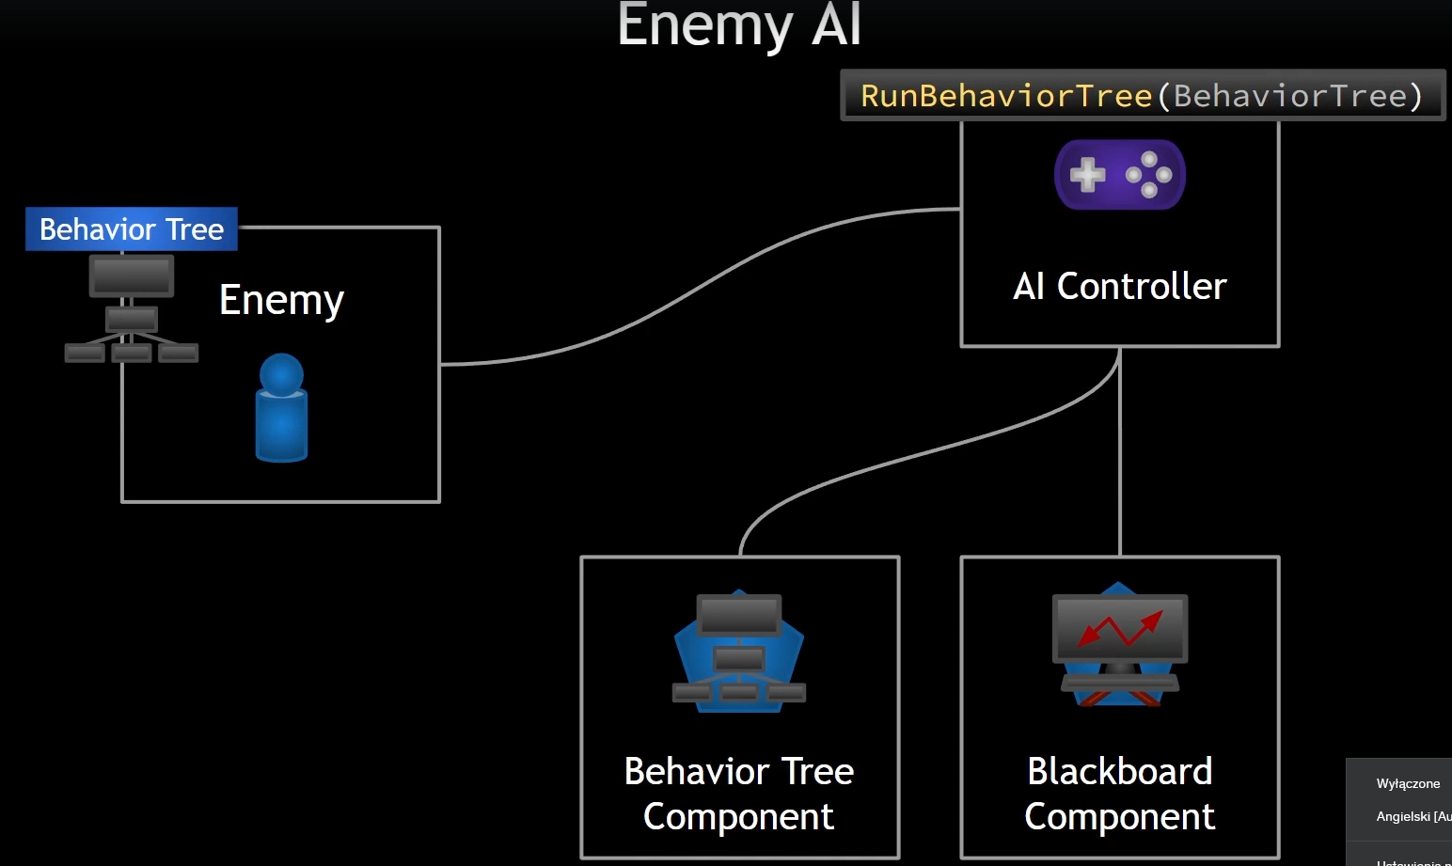
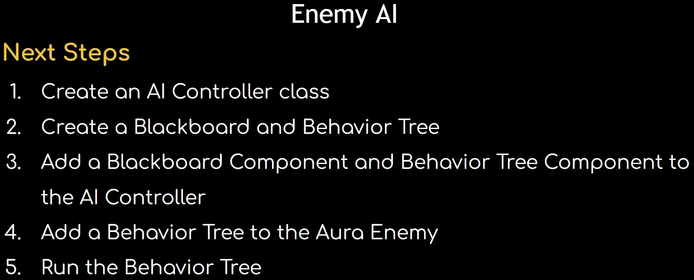
If branch (for example selector node) is being executed, then any services attached to it will be executed and services execute at a frequency that we specify. They have their own tick functionality, but generally in behavior trees, we do not often have things tick every single frame of the game, like your typical tick function.

Decorators can also be attached to the nodes, just like the services and they can provide us with conditions.

EQS-Environment Query System

EQS
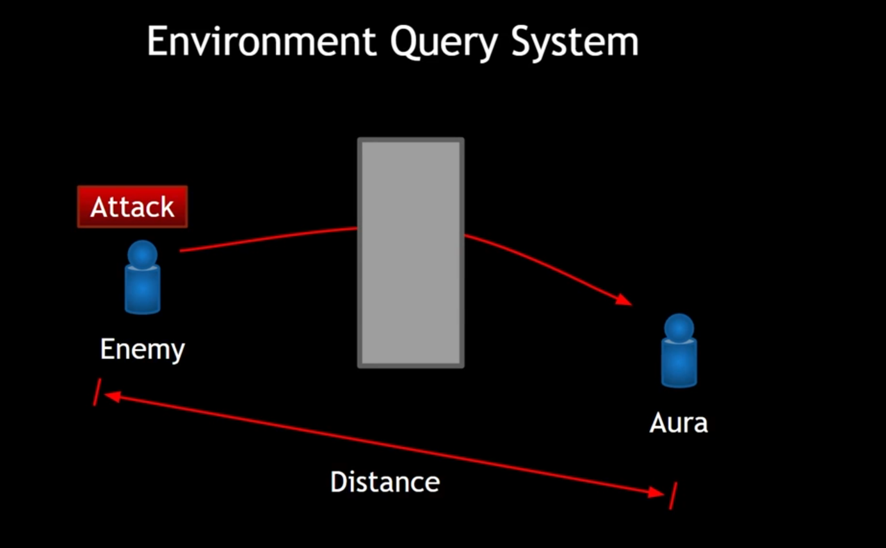
For Range Attackers distance is not enough to check, what happens if there are obstacles in the way. If our enemies just stop and start firing at a wall just because player is on the other side.
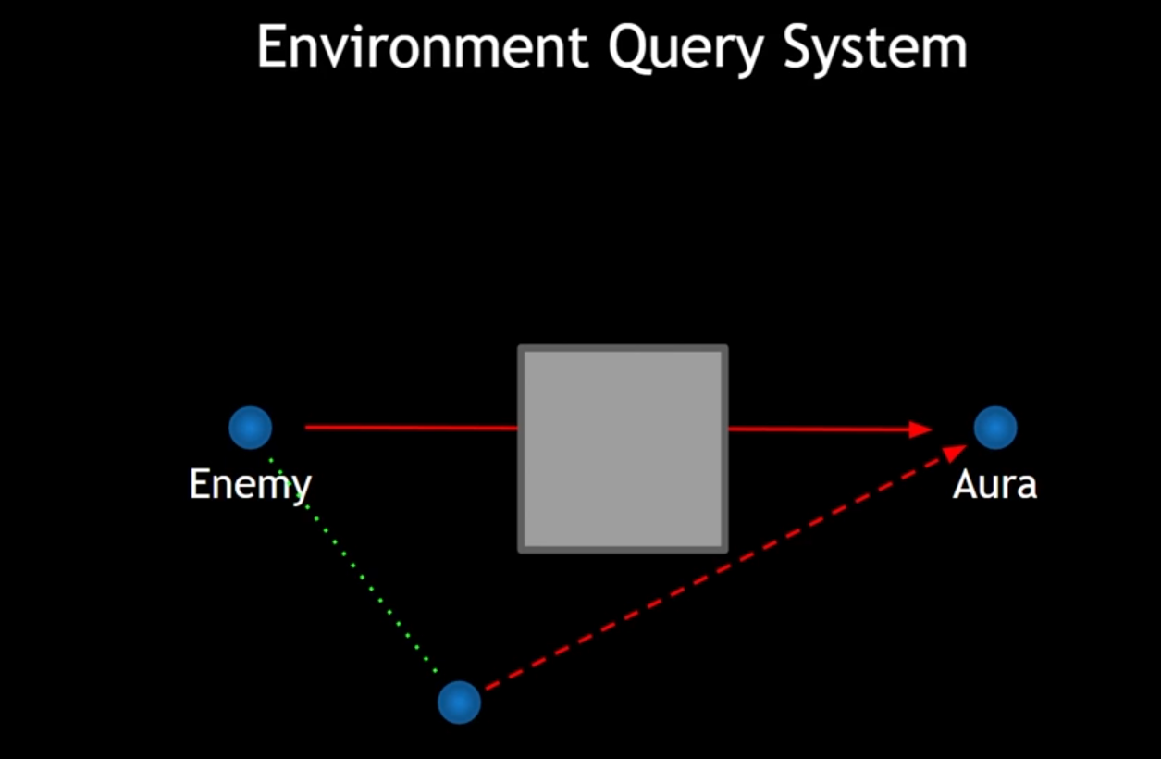
We would like to have that enemy would move slightly just around the corner to be able to hit player. To do this we can use EQS.

We can use environment query. When we run an environment query, we make use of a generator. The environment query system has several different types of built in generators that generate a set of locations or actors around some point. We refer to these locations or actors as items. The system can then ask questions about those items by running a series of user defined tests. Based on these tests, the items can be scored and our environment query will choose the best item filtering out all the others that did not score as well on the tests that we performed.
TRACE: For example, we may run the test that checks to see if each item can see the target by performing a line trace. Those who hit obstacles that might be in the way will not score as favorably as those who hit the character. After filtering out all of the items that cant see the character, we have items left that can and we can only consider these mowing forward.
DISTANCE: We can run additional tests to see which of these remaining items is the best one. For instance, we can check the distance to the character and choose the closest item. Once we have determined which of these items is the best item, we can then set a blackboard key to that item and do whatever we wish in behavior tree, such as move to that location.

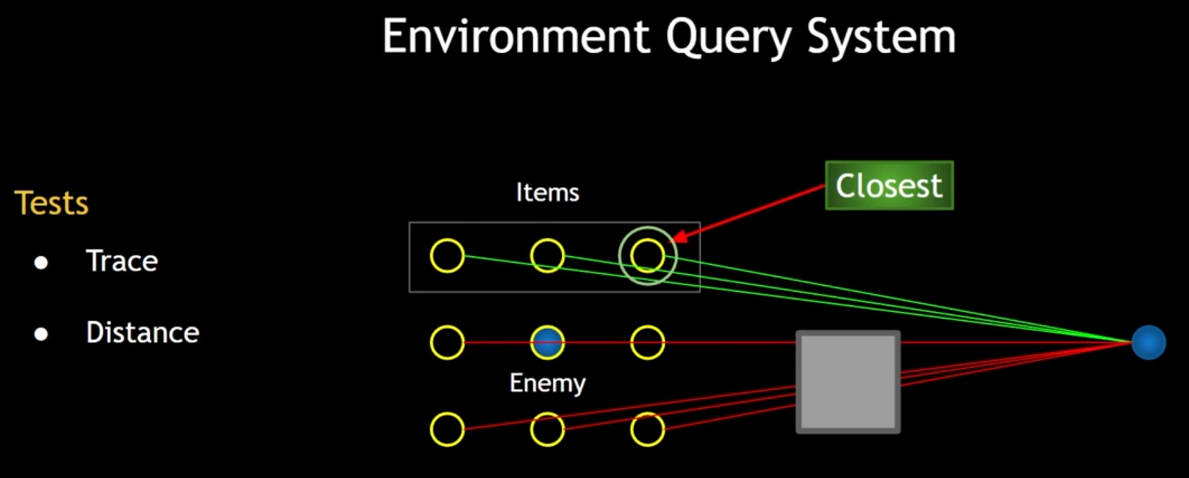
With EQS we will ensure that ranged attackers can move to a good location where they can see the player and attack from a distance.

Experience

Main Experience Plan

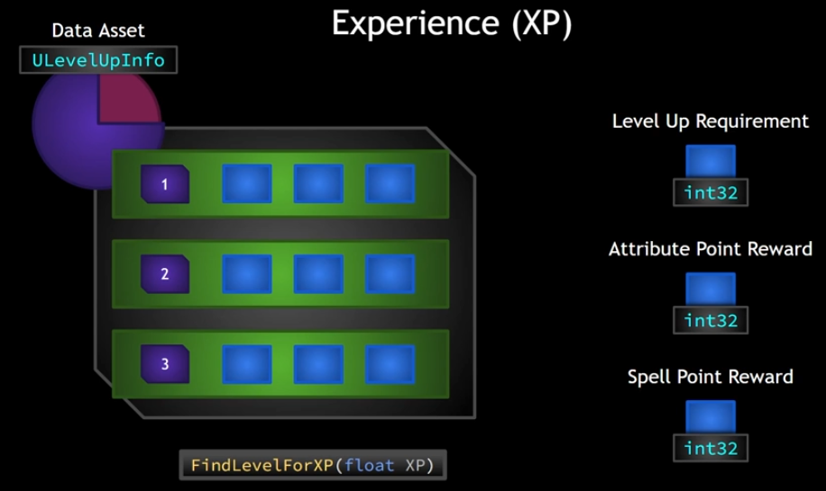
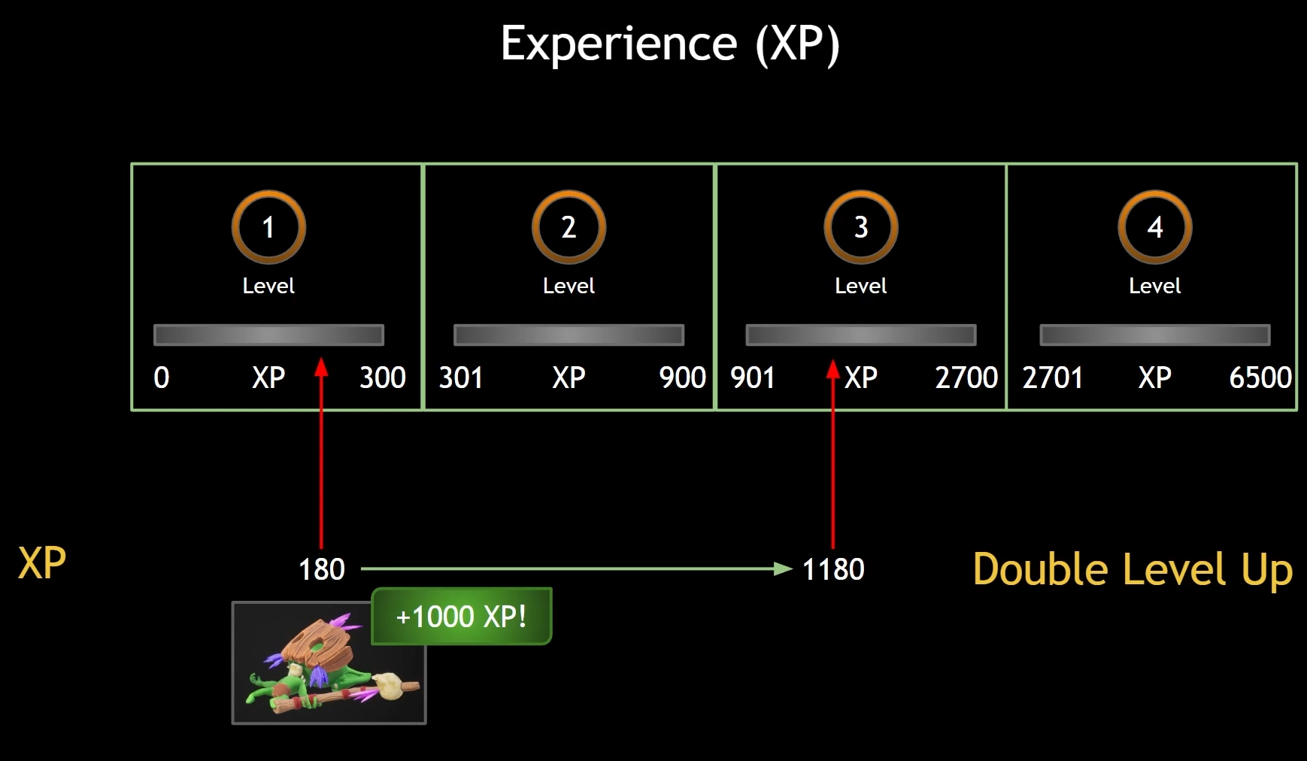
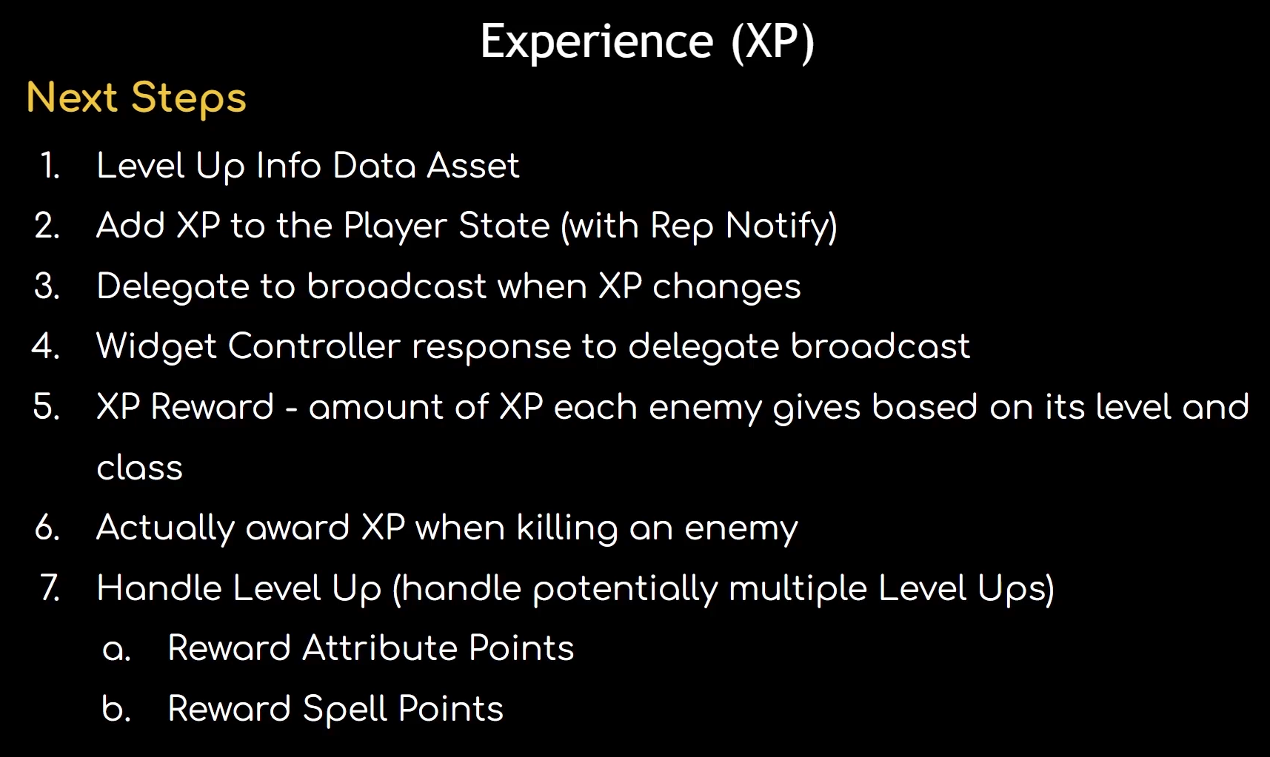

Awarding XP Game Plan

IncomingXP – meta attribute
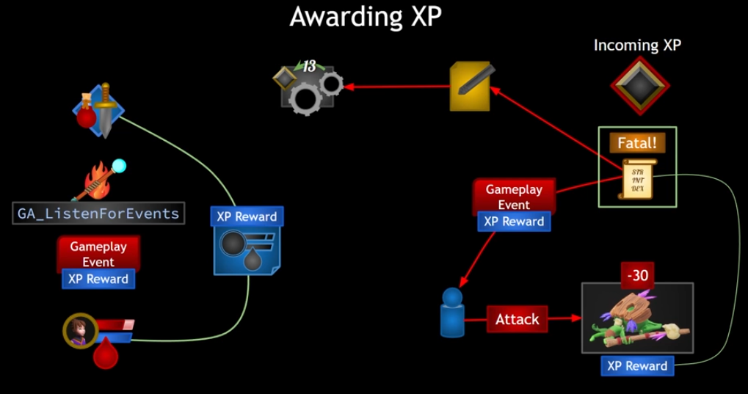
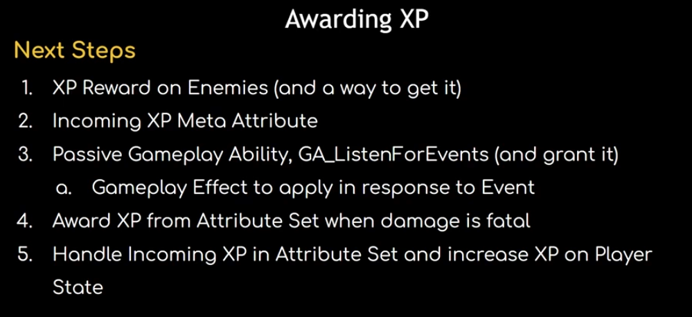

Spell Menu Plan
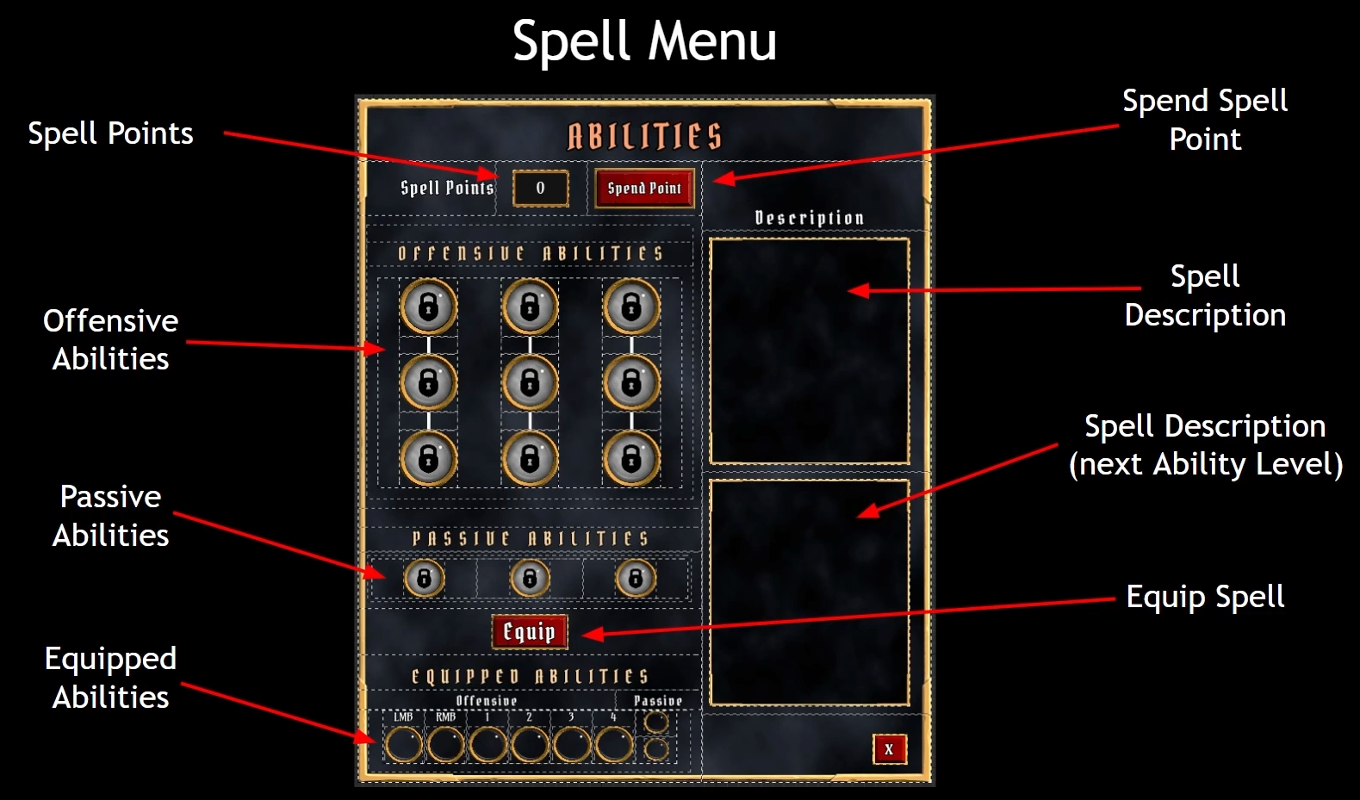

Ability Status



