**CYB220 Lab 2 Format string attack**

**Due: SUNDAY Feb 4th, 11:59pm.**

**Turn in: This lab report**

**Points: 30 points**

(30 points) Write a detailed report about the Format string attack lab. Explain what you have done and what you have observed. Include screenshots for each step.

* (5 points) Task 1 - crash the program
  + 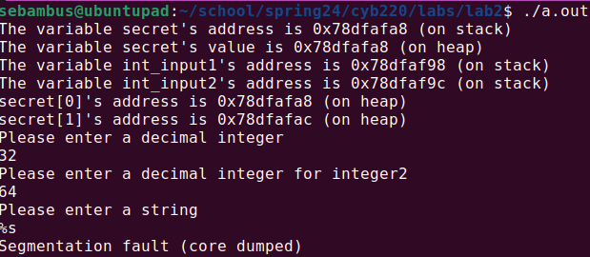
* (5 points) Task 2 - print out 14 values on the stack
  + 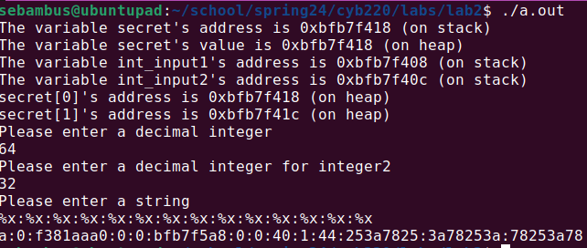
* (10points) Task 3 – Use a string to print out at least one secret values.
  + 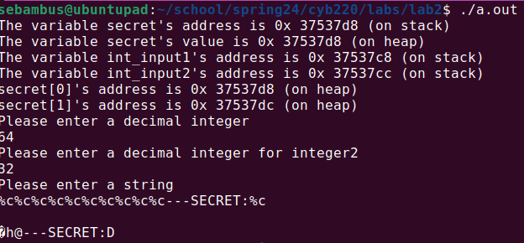
* (10 points) Conclusion
  + What have you learned from this lab? Anything interesting?

It taught me about the dangers of directing a string directly into a function, especially printf. It also got me thinking about how the stack and heap are organized

* + What is format string attack? What is the reason of the format string vulnerability? What are the countermeasures?

The format string attack abuses the fact that printf has an unlimited number of arguments by making it look for arguments that don’t exist using extra format specifiers. This can allow attackers to see other parts of memory