NLP Project (bozza)
Introduction
Exploratory Data Analysis
Performing a Comprehensive Descriptive Analysis
Class Distribution Analysis

Text Feature Analysis Vocabulary Analysis
Text Preprocessing Methodology
Features Analysis
Analysis of N-grams (uni-, bi-, and tri-grams)
Stylometric Features (da rifare bene)

a. Sentiment Analysis b. Emotional Load c. Sentence Length d. Syntactic Complexity 1. Mean Sentiment Top-Left) 2. Emotional Density Top-Right) 3. Average Sentence Length Bottom-Left) 4. Syntactic Complexity Bottom-Right)
Classification Models
Bag of Words and TFIDF

1. Preprocessing 2. Classifiers 3. Evaluation Metrics 4. Saving Results 5. Visualizations
Results and Analysis
Advanced Deep Learning Models distilBERT (va bene per dataset piccoli)
Synthetic data generation
In-depth Analysis
Feature Importance
Detailed Confusion Matrix
Error Analysis
Misclassification Cases Conclusions

Introduction
This paper presents a thesis on the usage of Natural Language Processing methods for text classification, further narrowed down to the complex task of differentiating conspiracy theories from critical thinking within online discourses.
The core problem this review will address is the development of automatic detection and classification methodologies related to conspiracy theories in digitized text. Although generally, conspiracy theories are set up as narratives that explain significant events by secret harmful agents, the technical task lies in the creation and fine-tuning of suitable NLP models which truly distinguish between critical thinking processes and conspiratorial ideation in earnest.
Recent research in this domain has unraveled one important gap: most of the current classification systems can hardly make this critical versus conspiratorial distinction. This lacuna has real-world consequences because misclassifying critical discourse as conspiratorial may potentially push valid skeptics toward conspiracy communities.
This research is based on the dataset collected from Telegram; discussions it englobes have to do with the COVID19 pandemic, in English and Spanish-in which we focus on one of these languages, specifically, an English dataset.
The main objective of this submission is the development and estimation of binary classification models that are capable of distinctly differentiating between conspiratorial and critical texts. It contributes directly to the bigger domain of content moderation and digital discourse analysis by providing a suitable solution to the challenge set by PAN 2024 correctly identifying conspiracy and classifying them while the protection of legitimate critical discourses is guaranteed.

Exploratory Data Analysis
The classification task encompasses a binary distinction between two categories of messages in the public health domain:
1.
Critical messages: These express reasoned questioning of major public health decisions while maintaining a non-conspiracist perspective.
2.
Conspiratorial messages: These interpret pandemic-related events and public health measures as orchestrated by clandestine, influential entities with malevolent intent.
Dataset Composition: The corpus consists of textual entries categorically labeled as either CONSPIRACY or CRITICAL
The dataset follows a structured format detailed below, which facilitates efficient natural language processing and machine learning applications:
{

"id": "91221",

"text": "\" Scientism backed ... not \" \" science - backed \" \" . There is nothing sci
entific about the Covid or childhood vaccine quackery that is slowly but surely killing , maiming and neur
ologically injuring the next generation — just as the Clintons and other Moloch worshippers want . \" ",

"category": "CONSPIRACY",

"annotations": [

{

"span_text": "that is slowly but surely killing , maiming and neurologically injurin
g the next generation",

"category": "NEGATIVE_EFFECT",

"start_char": 128,

"end_char": 219,

}
,

...
}
The dataset is structured as a JSON file, where each entry contains two key fields: a unique identifier ("id") and a categorical label ("category") denoting whether the text is classified as "CRITICAL" or "CONSPIRACY". This standardized format facilitates efficient data processing and model training.

[

{

"id": "6742",

"category": "CRITICAL"

}
,

{

"id": "10596",

"category": "CONSPIRACY"

}
,

....

]

Performing a Comprehensive Descriptive Analysis
I developed a comprehensive exploratory data analysis script to examine the provided dataset in detail.
dataset_anal
y
ze.p
y
The analysis pipeline generates various visualizations and statistical measures to characterize the dataset's properties:
Class Distribution Analysis:
Statistical metrics and visualization of class balance through bar charts, essential for understanding potential dataset biases.
Textual Feature Analysis:
Computation of descriptive statistics for text length and token count distributions.
Distribution visualization through boxplots to identify potential outliers and patterns.
Vocabulary Analysis:
Quantitative assessment of total and unique token frequencies per class, providing insights into lexical diversity.

Class Distribution Analysis
Purpose: Visualizes class frequencies in the dataset using bars, helping identify potential dataset imbalances that could affect model training.
Class Distribution in Train Set:
Dataset Size: 4000
Class | Count | Percentage
CRITICAL | 2621 | 65.525%
CONSPIRACY | 1379 | 34.475%
Class Distribution in Test Set:
Test set size: 1000
Class | Count | Percentage
CRITICAL | 655 | 65.5%
CONSPIRACY | 345 | 34.5%
Train set Test set
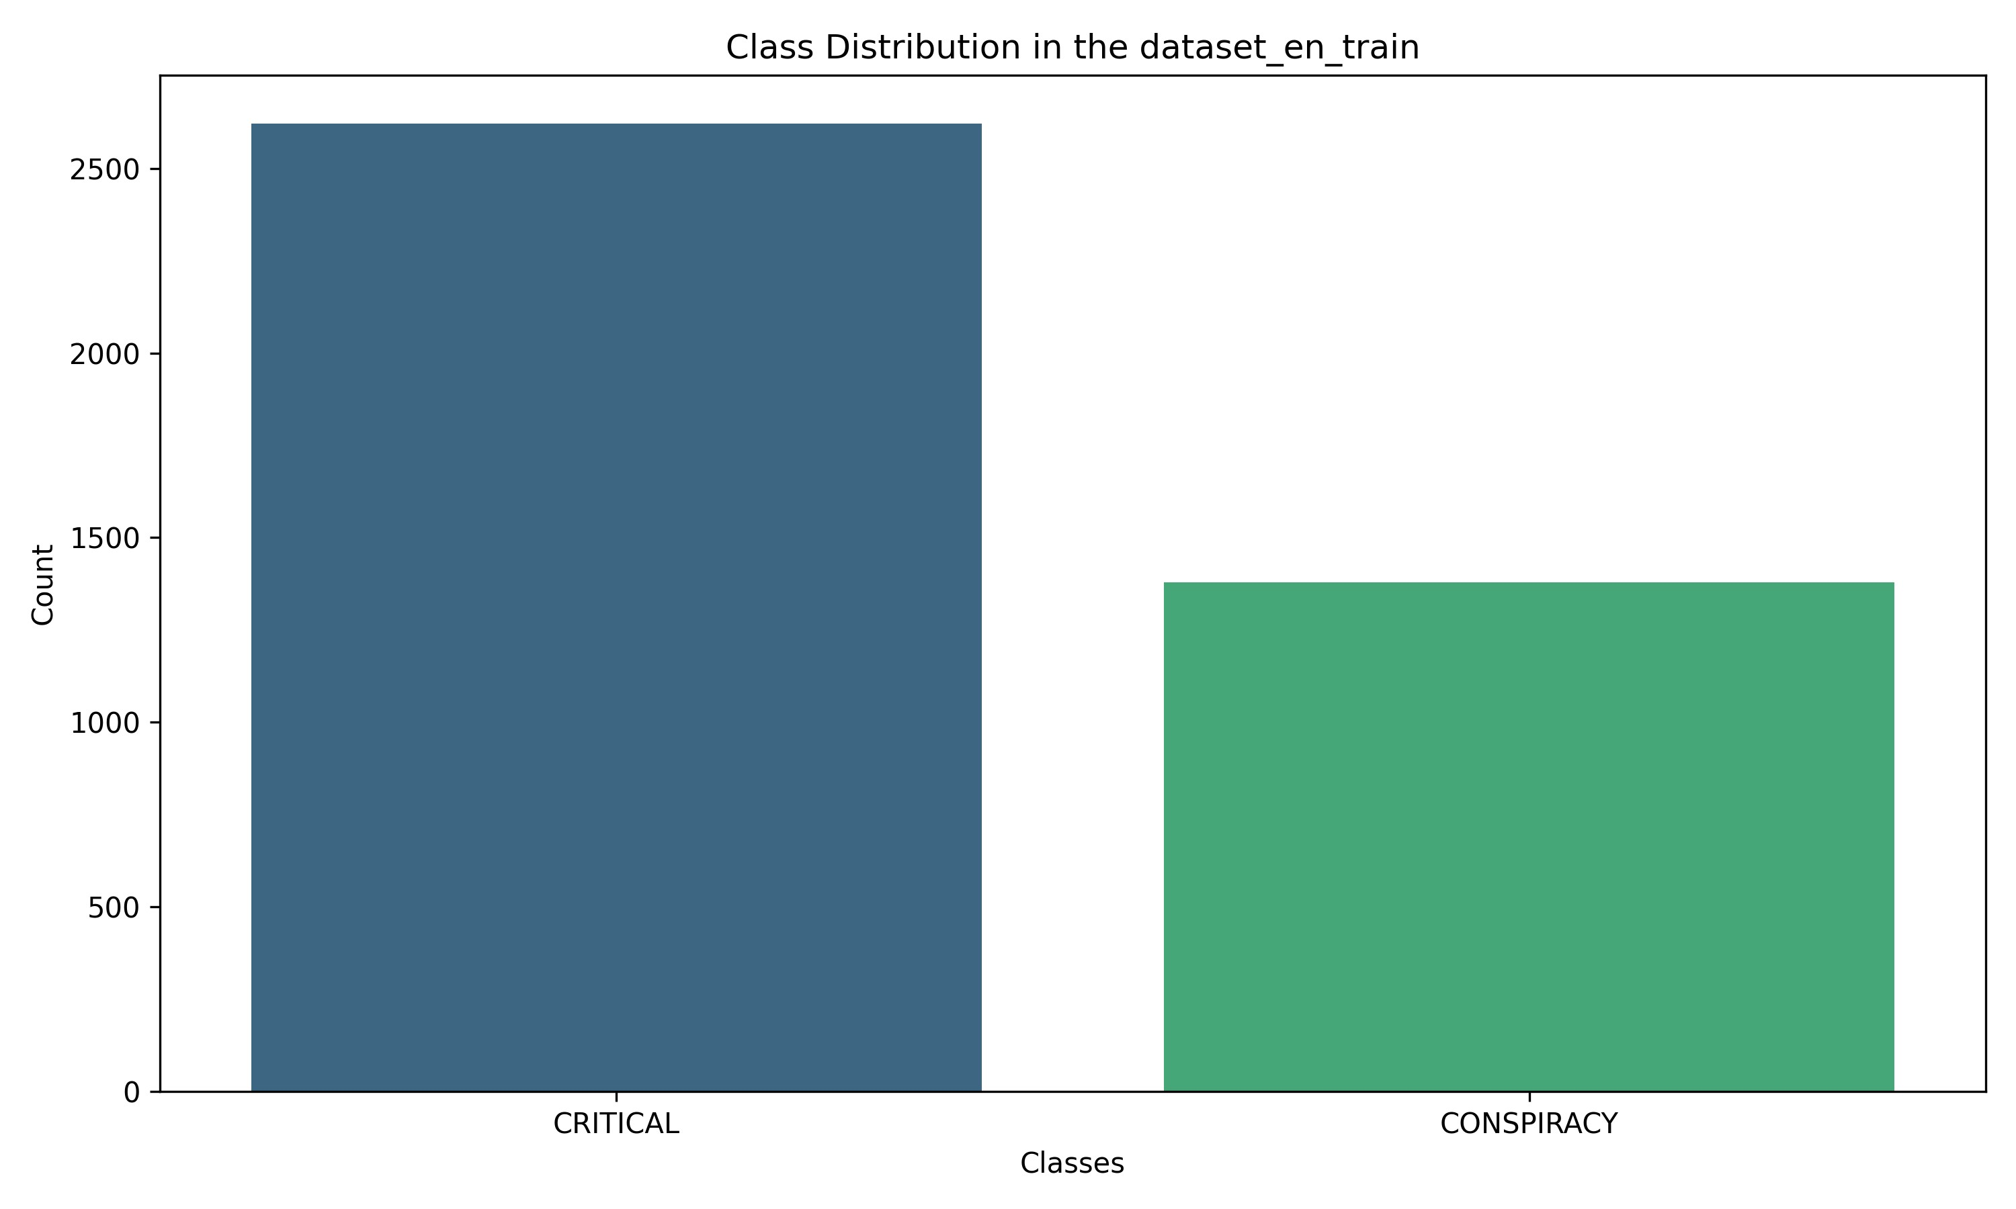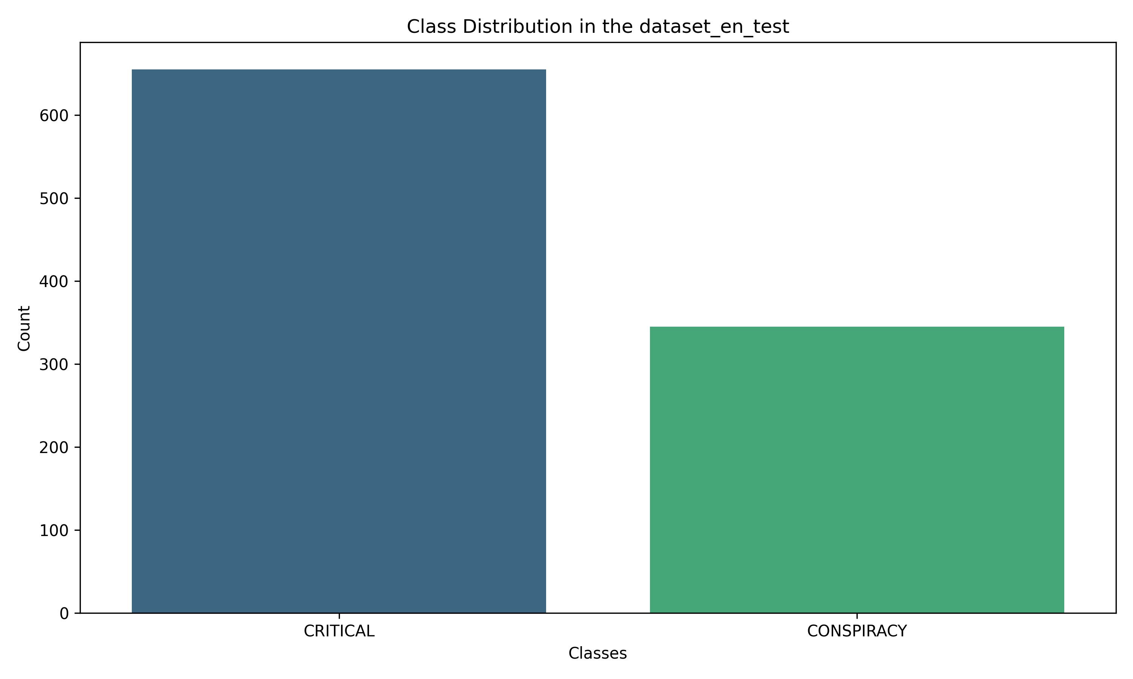

Text Feature Analysis
It displays the distribution in length of the text and word count per class using box plots showing the median, quartiles, and outliers for clear visualization of the pattern in text features.
It can be observed that on average, the CONSPIRACY texts are longer as compared to the CRITICAL texts.
CONSPIRACY texts are longer and more variable in length
Both distributions contain outliers, but those from the CRITICAL are more extreme
Both distributions are right-skewed, CRITICAL more so

Vocabulary Analysis
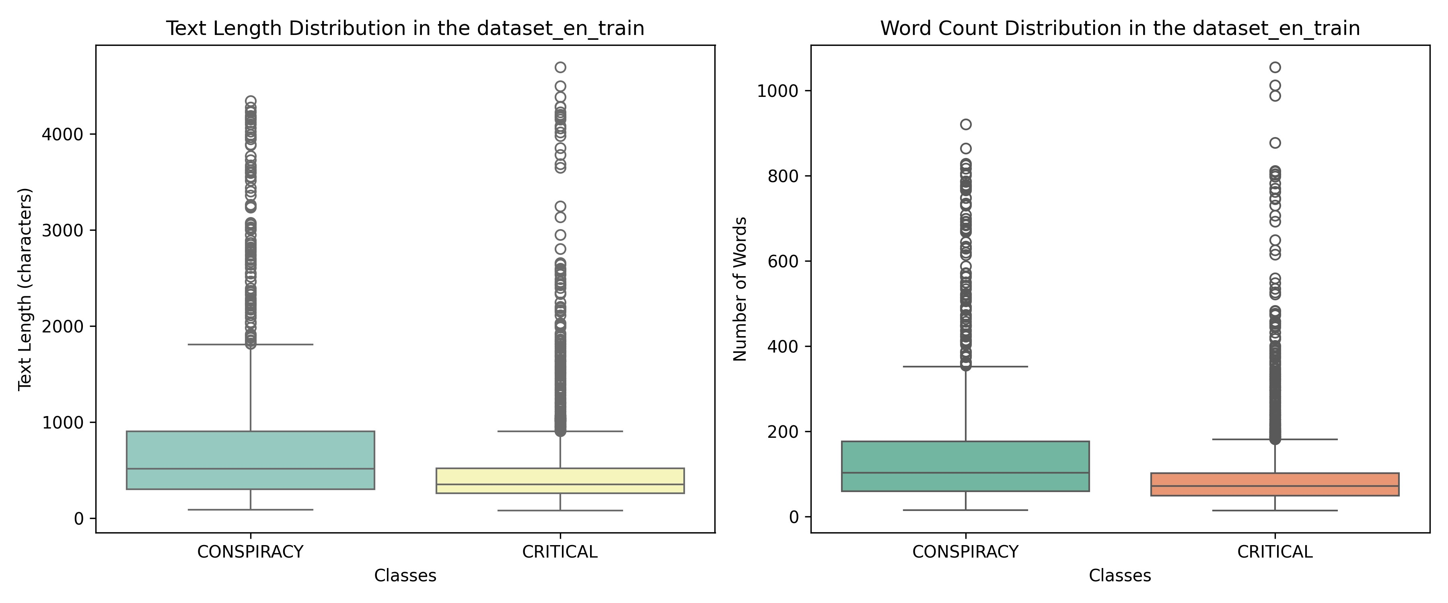
The unique word counts, per class, were provided in tabular form as

representative of linguistic variation and potential need for pre-processing.
Similar pattern in the distribution of word lengths in the text
CONSPIRACY texts are wordy
Outliers in both, but some texts contain many more words in each category.
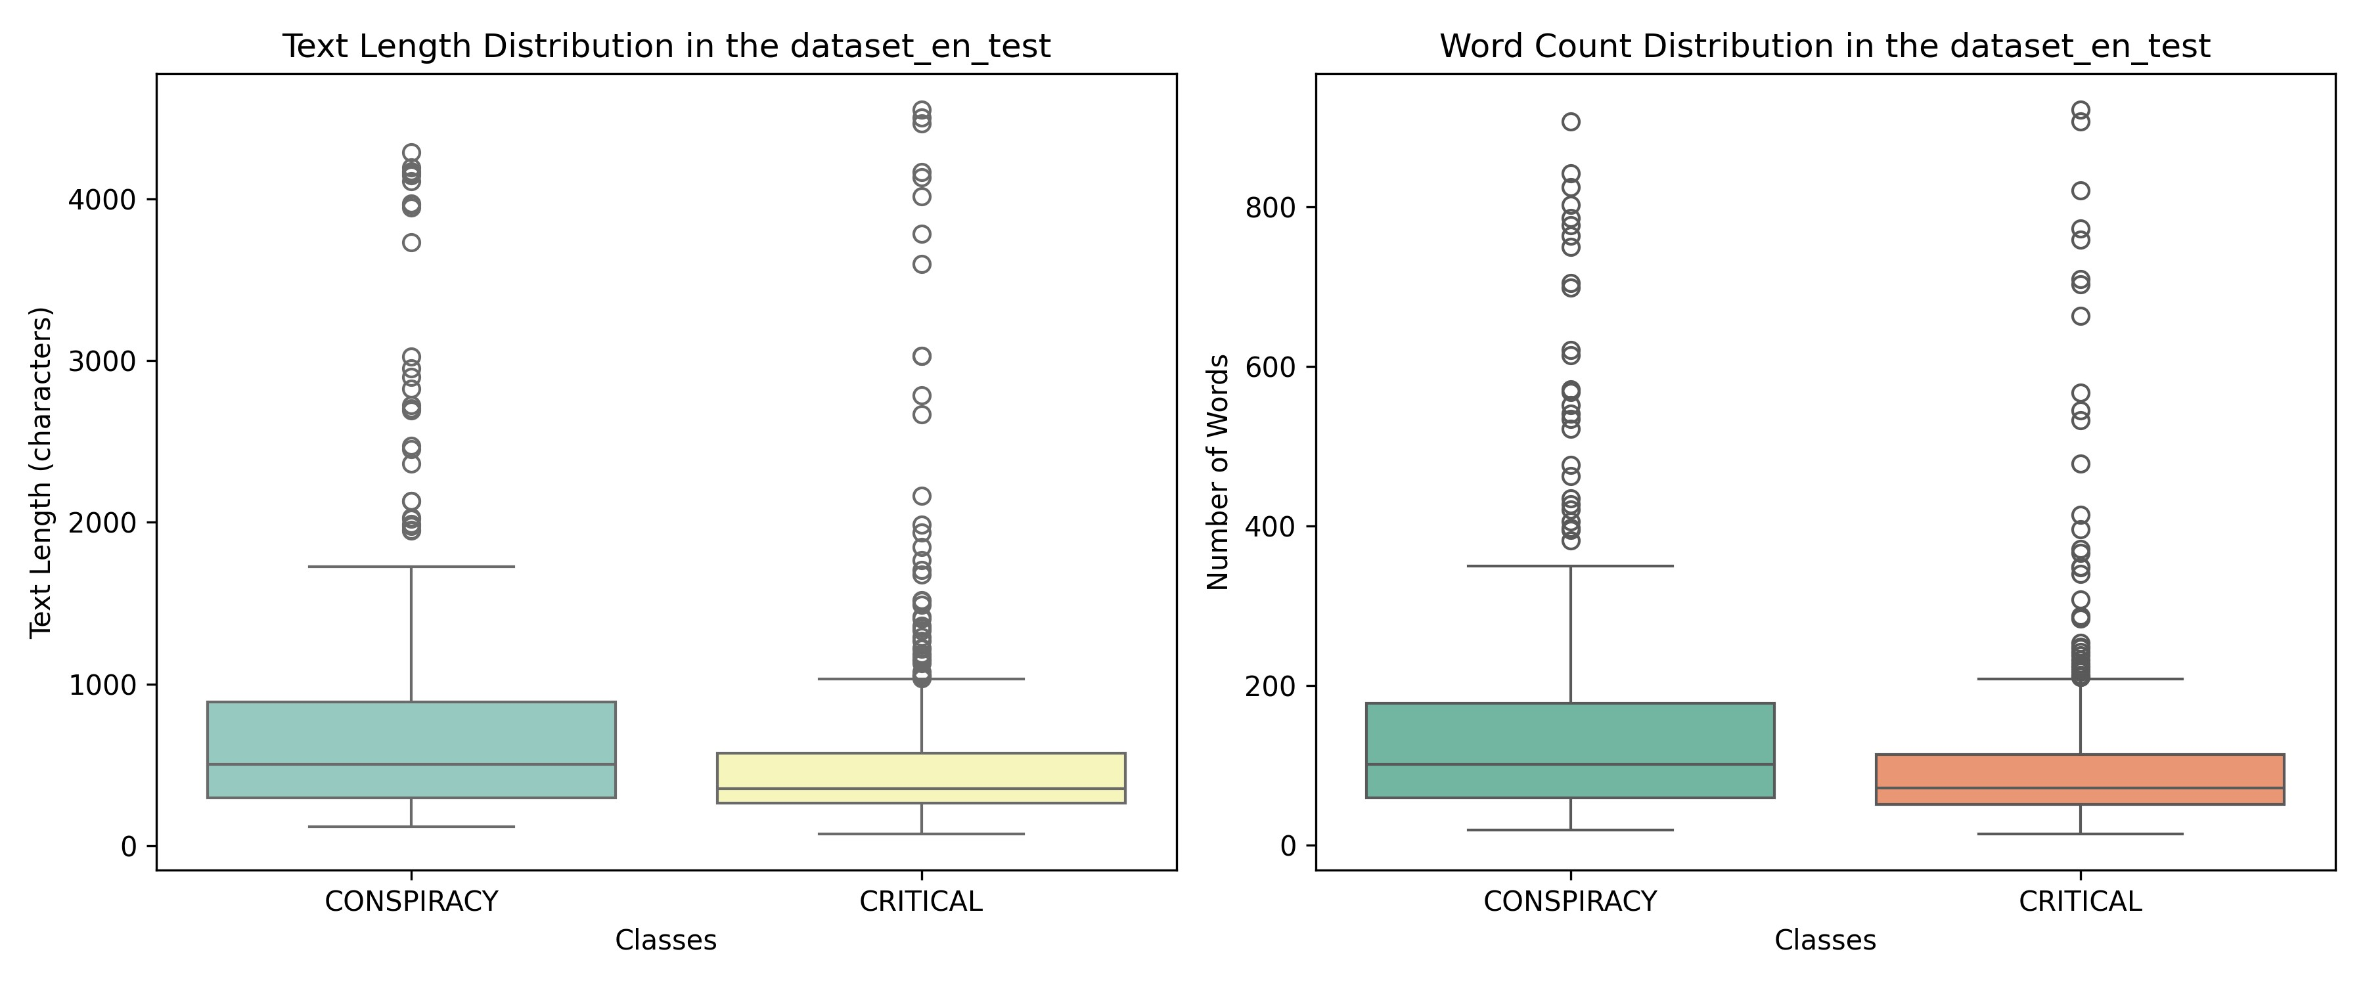

Text Preprocessing Methodology
We apply full text preprocessing at this stage to standardize the raw textual data before processing for N-gram analysis as well as the implementation of most of the classification models.
The script performs an elaborate preprocessing of the text data by doing the following:
 Unicode to ASCII Conversion Normalization of text by conversion of nonASCII characters into the most similar ASCII character improves homogeneity and allows a method to handle text represented using different character encoding.
 Lowercasing The text is then converted to lowercase to maintain consistency and avoid the same word in different cases being treated as different, such as "Apple" versus "apple".
 Stopword Removal Common but uninformative words like "the," "and," and "is" are removed since they don't add anything to the meaning and might introduce noise in further analysis.
 Punctuation Removal All punctuation, such as periods, commas, exclamation points, are to be removed from the text. These usually don't add much in terms of value to our tasks, such as text classification or sentiment analysis.
 Single Letter Removing Single-letter words ("a", "I") have been removed since in most applications text mining does not concern them because they do not generally carry any meaningful information.
 Porter Stemming This script uses the Porter Stemming algorithm, which reduces words to their root forms—for example, "running" to "run"—in order to standardize word variations and reduce the impact of inflections on analysis.
pre
process.p
y
The preprocessing pipeline ingests JSON-formatted data from trainset
( dataset_en_train.json ) and testset( dataset_en_test.json ), applies the aforementioned
cleaning procedures, and outputs a standardized dataset optimized for subsequent natural language processing analysis and machine learning model development. Sample Input Data:
THIS IS MASSIVE Australian Senator Malcolm Roberts exposes nanotech found in the Covid ‘ vaccines ʼ and says they are genocide . He is the first politician to expose this ! SHARE https :// t . me / LauraAbolichannel “
Sample Output data:
massiv australian senat malcolm robert expos nanotech found covid vaccin say genocid politician expos share lauraabolichannel

Features Analysis
Analysis of N-grams (uni-, bi-, and tri-grams)
For the n-grams analyze i created a python script
n_
g
rams.p
y
Both "CONSPIRACY" and "CRITICAL" categories show a strong concentration on key themes:
"Vaccin" (vaccine) is the most frequent term overall
"Covid" and "Covid 19" are consistently present
References to people, health, and global dimensions
 Structural Differences:
CONSPIRACY Category:
More emphasis on concepts like "deep state", "world order"
Presence of terms such as "new world order", "big pharma"
More complex and elaborate theoretical language CRITICAL Category:
More technical and medical focus
Greater references to data ("death", "health", "pfizer")
More mentions of scientific sources NCBI, NLM, NIH  Significant N-grams:
CONSPIRACY
Bigrams like "deep state", "world order"
Trigrams such as "new world order", "biolog chemic weapon"
CRITICAL
More technical bigrams like "covid vaccin", "vaccin passport"
Data-oriented trigrams like "total death injuri"
 Data Distribution:
The data comes from two sets (train and validation), with consistent numbers between them, suggesting stability in the analysis.
 Interesting Observations:
Both categories heavily discuss vaccines and COVID19
"AgentsOfTruth" appears in both datasets, potentially indicating a specific information source or platform
The critical category seems more grounded in scientific and medical terminology

Stylometric Features (da rifare bene)
Among all, stylometric features are mainly used in NLP for:
Text Classification: To distinguish between textual categories, such as conspiracy versus critical texts.
Authorship Analysis: It can be used in finding or analyzing an author's style.
Emotion and Sentiment Analysis: This will show the emotional tone or sentiment expressed within the text.

a. Sentiment Analysis
Uses the VADER Sentiment Analyzer to calculate:
Positivity
Negativity
Neutrality
A composite score, on a scale of 1 (negative) to 1 (positive), measuring the overall tone of the text.

b. Emotional Load
Emotion Detection: This counts the words related to predefined emotions such as joy, sadness, anger, and fear.
Emotional Density: It is the ratio between the number of emotional words and the total number of words.

c. Sentence Length
It calculates the average, minimum, maximum, and standard deviation of sentence lengths within the text.

d. Syntactic Complexity
Dependency Tree Metrics: It calculates the average and maximum depths of sentences' dependency trees to make judgments about the structural complexity.
Readability Metrics: It includes the Flesch Reading Ease, which is a score from a formula used to indicate how easy or hard it will be to understand the text.
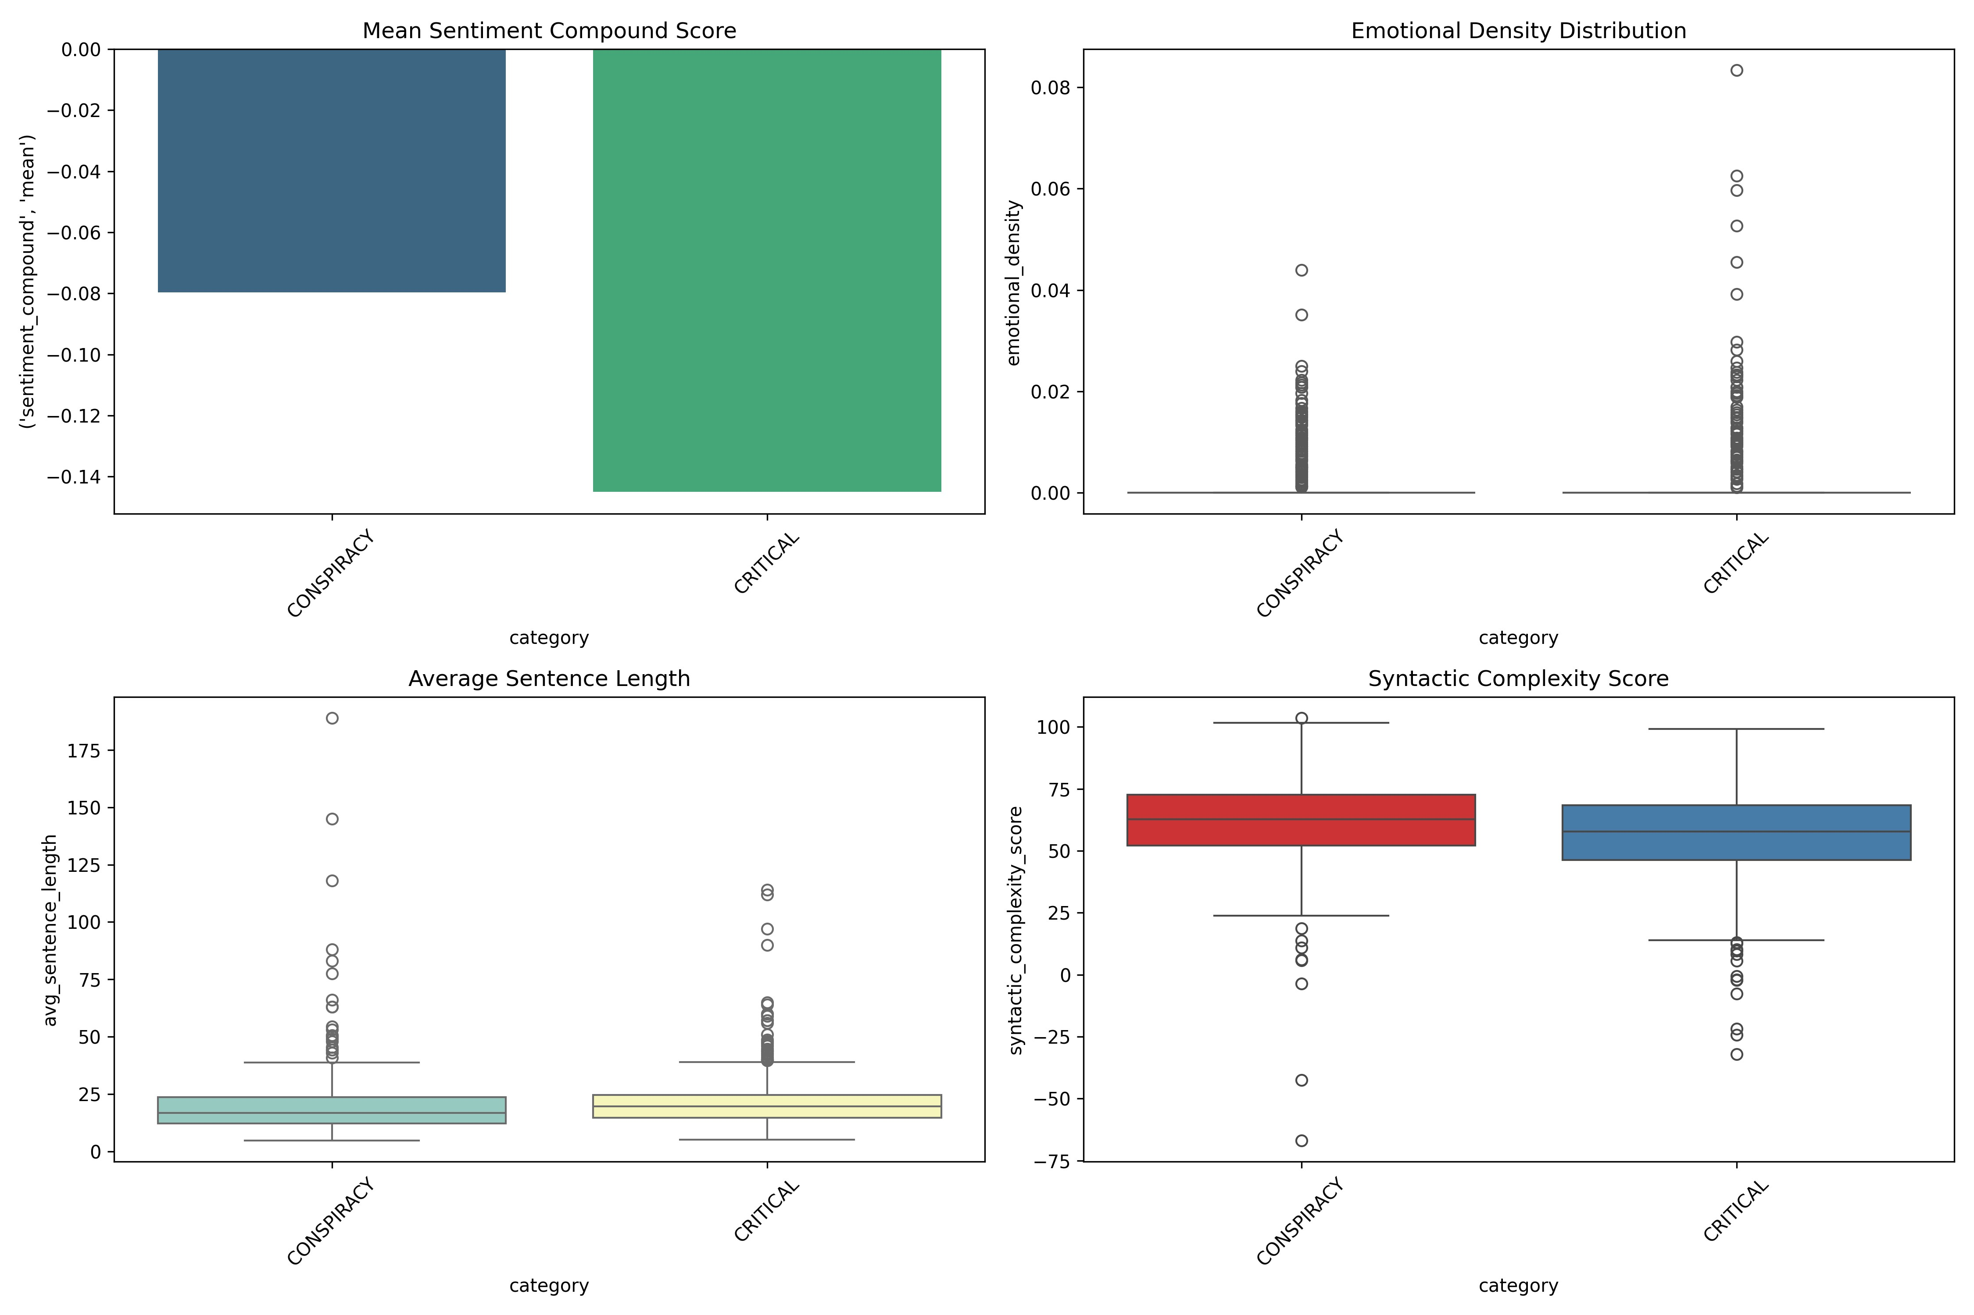

1. Mean Sentiment (Top-Left)
Displays the average composite sentiment score for each category, ranging from 1 (negative) to 1 (positive).
Both categories have negative mean sentiment, with CONSPIRACY being slightly less negative than CRITICAL.

2. Emotional Density (Top-Right)
Shows the proportion of emotional words relative to the total word count.
Most texts exhibit low emotional density, though some outliers indicate higher values.

3. Average Sentence Length (Bottom-Left)
A boxplot representing the average sentence length per category.
Sentences are generally short, but the CRITICAL category includes outliers with longer sentences.

4. Syntactic Complexity (Bottom-Right)
A boxplot illustrating the depth of dependency trees.
Both categories have similar median complexity, but CONSPIRACY shows greater variability.

Classification Models

Bag of Words and TF-IDF
Bag of Words BoW This is a representation that converts text into a term frequency matrix, representing how often each word appears in the documents. It is simple but does not account for word meaning or importance.
TFIDF This is one step higher; it weights each term by its frequency in the document—known as TF—and by its inverse document frequency across the corpus—known as IDF. It gives more importance to important words and lowers the importance of common terms. Comparison of Vectorization Techniques  Bag of Words CountVectorizer):
Simple word frequency representation
Treats all words as equal
Good for smaller datasets
 TFIDF Term Frequency-Inverse Document Frequency):
Considers word importance across the entire corpus
Gives higher weight to rare and more meaningful words
Often performs better on larger or more complex datasets
classif.p
y
This script trains and evaluates four classifiers with scikit-learn using data vectorized with both BoW and TFIDF. The following is a description of how this program works:

1. Preprocessing
Convert the text data to numerical representations using _{CountVectorizer} and
TfidfVectorizer for BoW.
These are various ways of vectorization that are combined with classifiers in scikit-learn pipelines to simplify the workflow.

2. Classifiers
The script is based on four classic models:
Logistic Regression A robust and fast linear model.
Support Vector Machine SVM Suitable for separating classes with wide margins.
Random Forest Tree-based model, great for capturing complex relationships.
Naive Bayes MultinomialNB Suitable for text data, simple, and efficient.
Each model is separately trained for both vectorization techniques.

3. Evaluation Metrics
F1-macro: The weighted average F1 score across all classes.
MCC Matthews Correlation Coefficient): Measures the overall effectiveness of classification.
F1 per class and Confusion Matrix: These provide an idea about the performance of each class.

4. Saving Results
JSON It stores metrics and results in JSON format for analysis at any later point.
Plots: Bar diagrams of the F1-macro and MCC scores of all models, along with confusion matrices.

5. Visualizations
Comparing Vectorization Techniques: Plots depict performance variances between BoW and TFIDF.
Confusion Matrices per Model: Each classifier has a matrix for both vectorization techniques, useful for error interpretation.
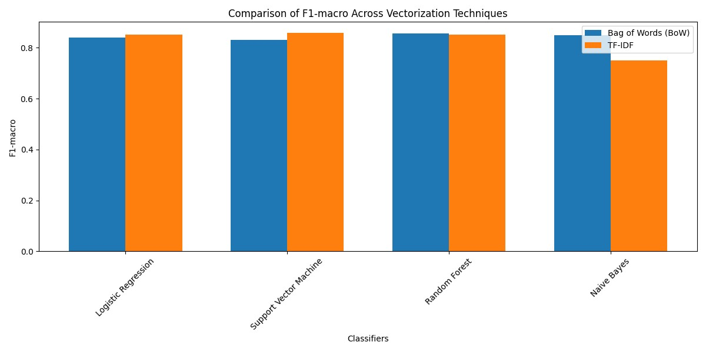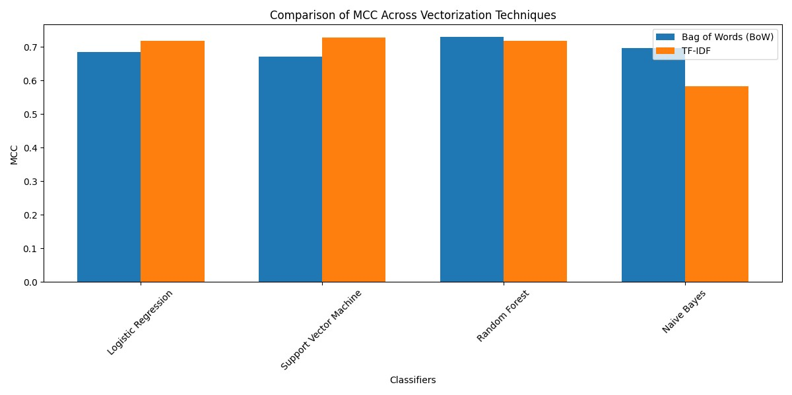
Logistic Regression  Bag of Words Logistic Regression  TFIDF
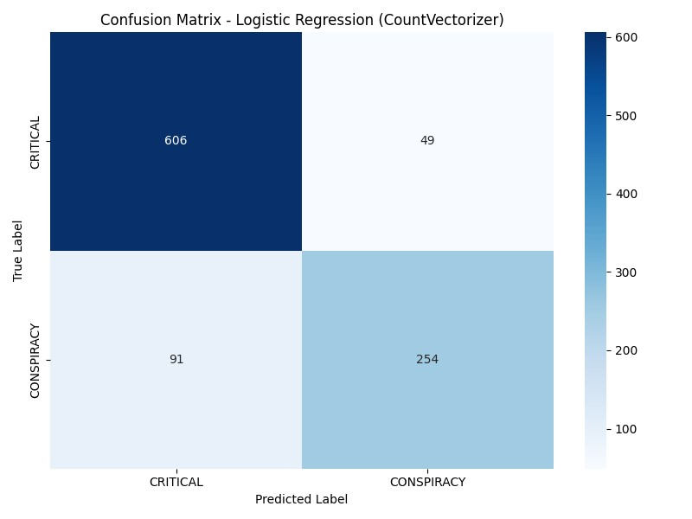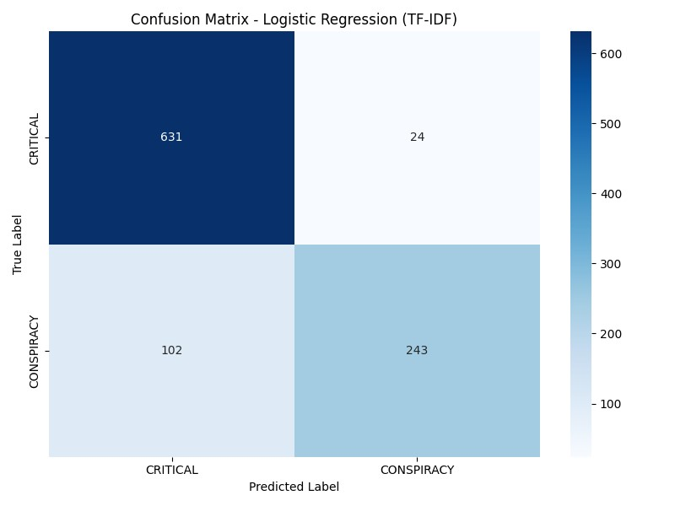
Naive Bayes  Bag of Words Naive Bayes  TFIDF
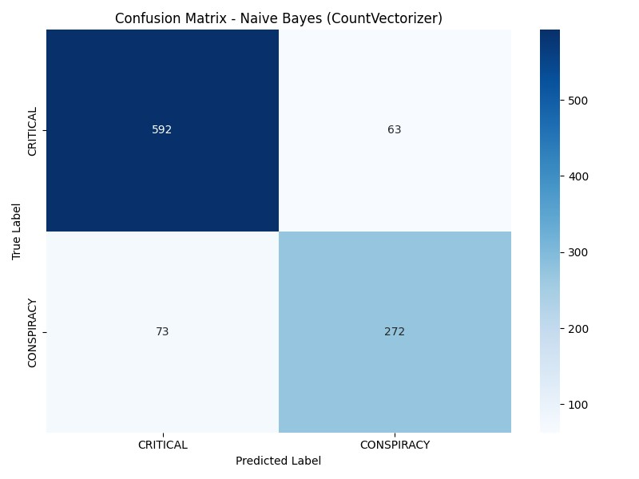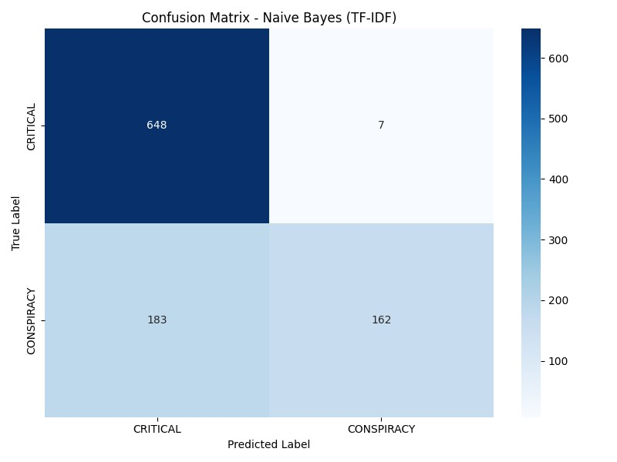
Random Forest  Bag of Words Random Forest  TFIDF
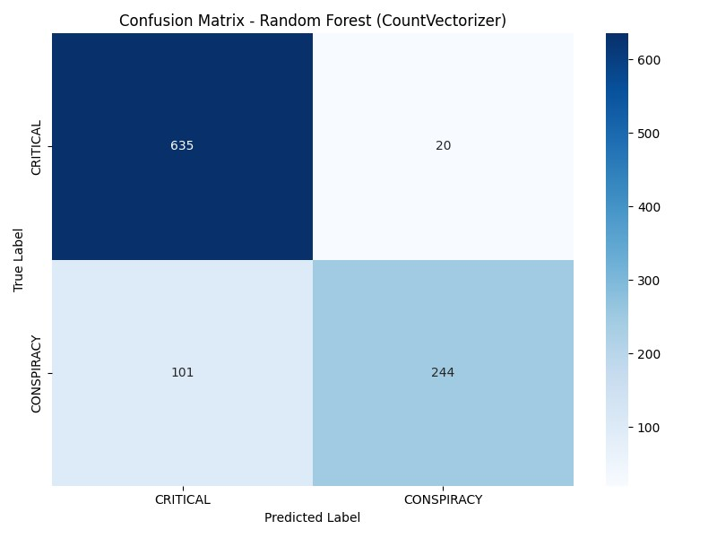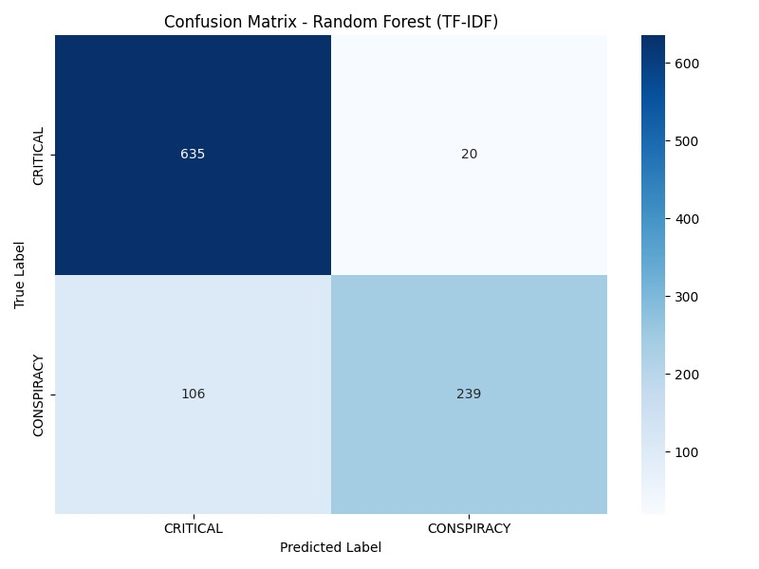
Support Vector Machine  Bag of Support Vector Machine  TFIDF Words
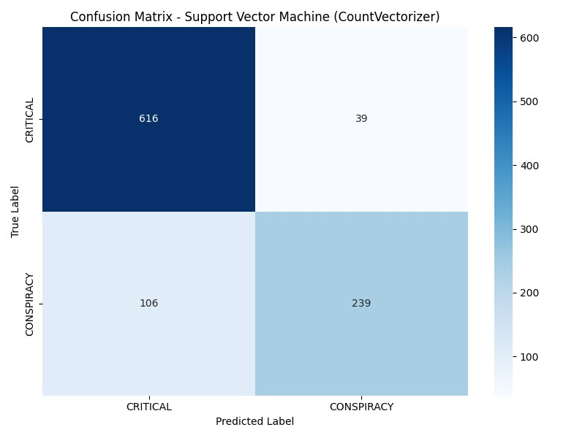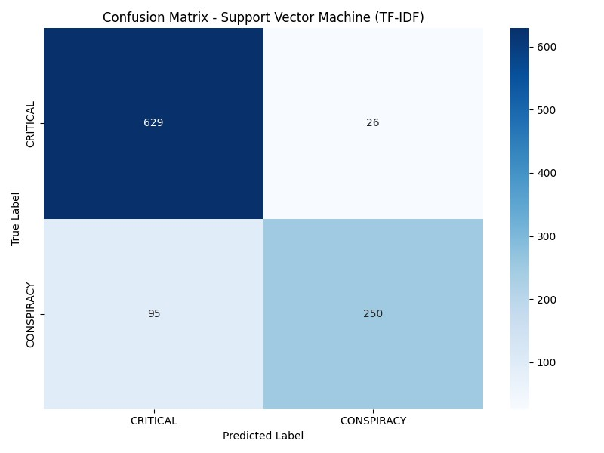

Results and Analysis
The script highlights:
BoW Suitable for smaller, simpler datasets.
TFIDF Ideal for more complex datasets where word significance matters.
Advanced Deep Learning Models
distilBERT (va bene per dataset piccoli)

Synthetic data generation
In questa parte del progetto andremo ad analizzare il comportamento della classificazione con un aumento del training set di 5000 dati sintetici creati con le API di GPT.
Inizialmente i dati sintetici, basati sul dataset di dati reali, son stati creati sostituendo solo alcune parole e l’ordine dei periodi delle frasi reali. Questo non ha variato i risultati di classificazione.
Successivamente si è optato di usare le API di GPT che hanno dato risultati interessanti. Si son creati 5000 dati sintetici e ho eseguito le stesse analisi svolte per il dataset iniziale. Ci son stati miglioramenti a partire dalla distribuzione delle classi che era un po’ sbilanciata inizialmente e tutte le accuratezze son incrementato usando un dataset composto sia da dataset reali che sintetici, quindi un dataset mixato. Il codice del progetto crea tutte le matrici di confusione corrispondenti.

Vectorizzatore | Modello | F1-macro | F1-critical | F1-conspiracy | MCC
CountVectorizer | Logistic Regression | 0.8761 | 0.9205 | 0.8318 | 0.7575
 | Support Vector Machine | 0.9102 | 0.9441 | 0.8764 | 0.8315
 | Random Forest | 0.9178 | 0.9481 | 0.8875 | 0.8441
 | Naive Bayes | 0.9193 | 0.9442 | 0.8944 | 0.8386
TF-IDF | Logistic Regression | 0.9013 | 0.9381 | 0.8644 | 0.8121
 | Support Vector Machine | 0.9788 | 0.9856 | 0.9719 | 0.9580
 | Random Forest | 0.9213 | 0.9503 | 0.8924 | 0.8509
 | Naive Bayes | 0.9081 | 0.9425 | 0.8736 | 0.8265
Daset mixato

Vectorizzatore | Modello | F1-macro | F1-critical | F1-conspiracy | MCC
CountVectorizer | Logistic Regression | 0.8402 | 0.8964 | 0.7840 | 0.6842
 | Support Vector Machine | 0.8310 | 0.8947 | 0.7673 | 0.6719
 | Random Forest | 0.8572 | 0.9130 | 0.8013 | 0.7298
 | Naive Bayes | 0.8485 | 0.8970 | 0.8000 | 0.6972
TF-IDF | Logistic Regression | 0.8517 | 0.9092 | 0.7941 | 0.7175
 | Support Vector Machine | 0.8587 | 0.9123 | 0.8052 | 0.7284
 | Random Forest | 0.8506 | 0.9097 | 0.7914 | 0.7186
 | Naive Bayes | 0.7512 | 0.8721 | 0.6304 | 0.5821
Dataset originale

Confronto Complessivo
I valori delle metriche nel dataset originale sono generalmente inferiori rispetto al daset mixato con dati sintetici per tutti i modelli e vectorizzatori

CountVectorizer(BoW)
Modello | Differenza F1-macro | Differenza F1-critical | Differenza F1-conspiracy | Differenza MCC
Logistic Regression | +0.0359 | +0.0241 | +0.0488 | +0.0733
Support Vector Machine | +0.0792 | +0.0494 | +0.1091 | +0.1596
Random Forest | +0.0606 | +0.0351 | +0.0862 | +0.1143
Naive Bayes | +0.0708 | +0.0473 | +0.0944 | +0.1414
Tutte le metriche aumentano nel nuovo dataset, con il modello Support Vector Machine che registra gli aumenti più significativi.

TF-IDF
Modello | Differenza F1-macro | Differenza F1-critical | Differenza F1-conspiracy | Differenza MCC
Logistic Regression | +0.0496 | +0.0289 | +0.0703 | +0.0946
Support Vector Machine | +0.1201 | +0.0734 | +0.1668 | +0.2296
Random Forest | +0.0708 | +0.0406 | +0.1010 | +0.1324
Naive Bayes | +0.1568 | +0.0704 | +0.2432 | +0.2444
L’aumento è particolarmente pronunciato per Support Vector Machine e Naive Bayes, specialmente in F1-conspiracy e MCC.

In-depth Analysis Feature Importance Detailed Confusion Matrix Error Analysis Misclassification Cases
Il codice fornito è un esempio di un flusso di lavoro per l'elaborazione del linguaggio naturale NLP che include il caricamento di un dataset, la generazione di embedding utilizzando modelli di word embedding e transformer, e l'addestramento di vari classificatori per la classificazione del testo. Ecco una panoramica delle principali sezioni del codice:
 Caricamento del Dataset Utilizza una funzione per caricare dati da file JSON, estraendo testi e etichette.
 Generazione di Embedding:
Word2Vec e FastText Vengono addestrati modelli di word embedding per generare vettori di parole medi.
Transformers BERT e RoBERTa) Viene utilizzato un tokenizer e un modello per generare embedding basati su transformer.
 Combinazione di Embedding Gli embedding generati da Word2Vec, FastText, BERT e RoBERTa vengono combinati in un'unica matrice di embedding.
 Classificazione Viene creato e addestrato un insieme di classificatori SVM, Random Forest, Gradient Boosting, Naive Bayes e Logistic Regression) utilizzando gli embedding combinati.
 Valutazione Per ogni classificatore, viene generato un report di classificazione che include metriche come precisione, richiamo e F1-score.
 Visualizzazione dei Risultati Si fa riferimento alla possibilità di aggiungere analisi aggiuntive, come matrici di confusione e importanza delle caratteristiche.

Conclusions

