Maria_Ignacio_flow_analysis

Sam Bankston

December 11, 2018

Load packages

library(tidyverse)  
library(lubridate)

Read in data

all_flow <- read_csv("maria_ygnacio_flow.csv") %>% mutate(date_time = paste(Date, " ", Time), date_time = mdy_hms(date_time)) %>% rename(flow = Flow) %>% select(date_time, flow) %>% mutate(Day = date(date_time), Year = year(date_time))

Summary of daily flow values

daily_flow_summary <- all_flow %>% filter(month(date_time) >= 1 & month(date_time) < 6) %>% group_by(Year, Day) %>% summarize(mean_daily_flow = mean(flow, na.rm = TRUE)) %>% ungroup()

Calculate low and high flow thresholds

low_high <- daily_flow_summary %>% summarize(low_flow = quantile(.$mean_daily_flow, probs = .50, na.rm = TRUE), high_flow = quantile(.$mean_daily_flow, probs = 0.99, na.rm = TRUE)) %>% print()

## # A tibble: 1 x 2  
## low_flow high_flow  
## <dbl> <dbl>  
## 1 0. 146.

top 20 mean daily flow values

top_20 <- daily_flow_summary %>% top_n(n = 20, wt = mean_daily_flow) %>% arrange(desc(mean_daily_flow))   
  
top_20

## # A tibble: 20 x 3  
## Year Day mean_daily_flow  
## <dbl> <date> <dbl>  
## 1 1995. 1995-03-10 958.  
## 2 1992. 1992-02-15 632.  
## 3 1995. 1995-01-10 628.  
## 4 2001. 2001-03-05 581.  
## 5 2005. 2005-01-09 558.  
## 6 1992. 1992-02-12 492.  
## 7 2001. 2001-03-04 468.  
## 8 2011. 2011-03-20 446.  
## 9 2017. 2017-02-17 399.  
## 10 1993. 1993-03-25 378.  
## 11 2005. 2005-01-10 367.  
## 12 1991. 1991-03-18 339.  
## 13 1998. 1998-02-23 324.  
## 14 1998. 1998-02-03 322.  
## 15 2008. 2008-01-27 302.  
## 16 1991. 1991-03-17 277.  
## 17 1998. 1998-02-07 270.  
## 18 1995. 1995-01-24 256.  
## 19 2005. 2005-02-21 250.  
## 20 1998. 1998-02-02 226.

histogram of mean daily flow

daily_flow_summary %>% ggplot(aes(x = mean_daily_flow)) + geom_histogram(binwidth = 10) + theme_bw()

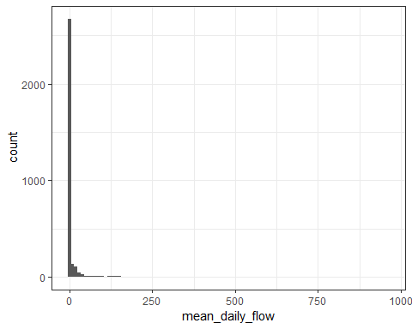

Flow summary statistics

mean_daily_flow <- mean(daily_flow_summary$mean_daily_flow, na.rm = TRUE) %>% print()

## [1] 7.164166

percent_days_zero <- mean(daily_flow_summary$mean_daily_flow == "0") %>% print()

## [1] 0.5880049

num_days_zero <- sum(daily_flow_summary$mean_daily_flow == "0") %>% print()

## [1] 2402

num_days_total <- n_distinct(daily_flow_summary$Day) %>% print()

## [1] 4085

num_years <- n_distinct(daily_flow_summary$Year) %>% print()

## [1] 30