Mission_Creek_flow_analysis

Sam Bankston

December 11, 2018

Load packages

library(tidyverse)  
library(lubridate)

Read in data

all_flow <- read_csv("mission_creek_flow.csv") %>% mutate(date_time = paste(Date, " ", Time), date_time = mdy_hms(date_time)) %>% rename(flow = Flow) %>% select(date_time, flow) %>% mutate(Day = date(date_time), Year = year(date_time))

Summary of daily flow values

daily_flow_summary <- all_flow %>% filter(month(date_time) >= 1 & month(date_time) < 6) %>% group_by(Year, Day) %>% summarize(mean_daily_flow = mean(flow, na.rm = TRUE)) %>% ungroup()

Calculate low and high flow thresholds

low_high <- daily_flow_summary %>% summarize(low_flow = quantile(.$mean_daily_flow, probs = .50, na.rm = TRUE), high_flow = quantile(.$mean_daily_flow, probs = 0.99, na.rm = TRUE)) %>% print()

## # A tibble: 1 x 2  
## low_flow high_flow  
## <dbl> <dbl>  
## 1 0.260 104.

top 20 mean daily flow values

top_20 <- daily_flow_summary %>% top_n(n = 20, wt = mean_daily_flow) %>% arrange(desc(mean_daily_flow))   
  
top_20

## # A tibble: 20 x 3  
## Year Day mean_daily_flow  
## <dbl> <date> <dbl>  
## 1 2005. 2005-01-09 556.  
## 2 1998. 1998-02-03 519.  
## 3 2005. 2005-01-10 470.  
## 4 2001. 2001-03-05 439.  
## 5 1998. 1998-02-02 407.  
## 6 2011. 2011-03-20 389.  
## 7 2017. 2017-02-17 344.  
## 8 2005. 2005-02-21 302.  
## 9 2006. 2006-04-04 261.  
## 10 2005. 2005-01-08 258.  
## 11 2001. 2001-03-06 232.  
## 12 2005. 2005-01-11 230.  
## 13 2003. 2003-03-15 184.  
## 14 2005. 2005-01-03 181.  
## 15 2010. 2010-02-27 177.  
## 16 1998. 1998-02-04 171.  
## 17 2005. 2005-02-22 169.  
## 18 2017. 2017-02-18 168.  
## 19 2008. 2008-01-27 166.  
## 20 2008. 2008-01-23 160.

histogram of mean daily flow

daily_flow_summary %>% ggplot(aes(x = mean_daily_flow)) + geom_histogram(binwidth = 10) + theme_bw()

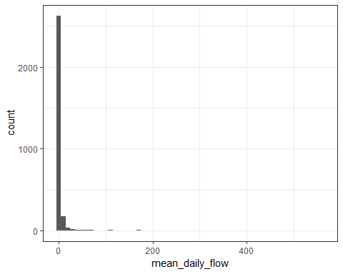

Flow summary statistics

mean_daily_flow <- mean(daily_flow_summary$mean_daily_flow, na.rm = TRUE) %>% print()

## [1] 4.601974

percent_days_zero <- mean(daily_flow_summary$mean_daily_flow == "0") %>% print()

## [1] 0.0006858711

num_days_zero <- sum(daily_flow_summary$mean_daily_flow == "0") %>% print()

## [1] 2

num_days_total <- n_distinct(daily_flow_summary$Day) %>% print()

## [1] 2916

num_years <- n_distinct(daily_flow_summary$Year) %>% print()

## [1] 21