# Snake_pygame
sudo apt-get install python3-tk
# Installation

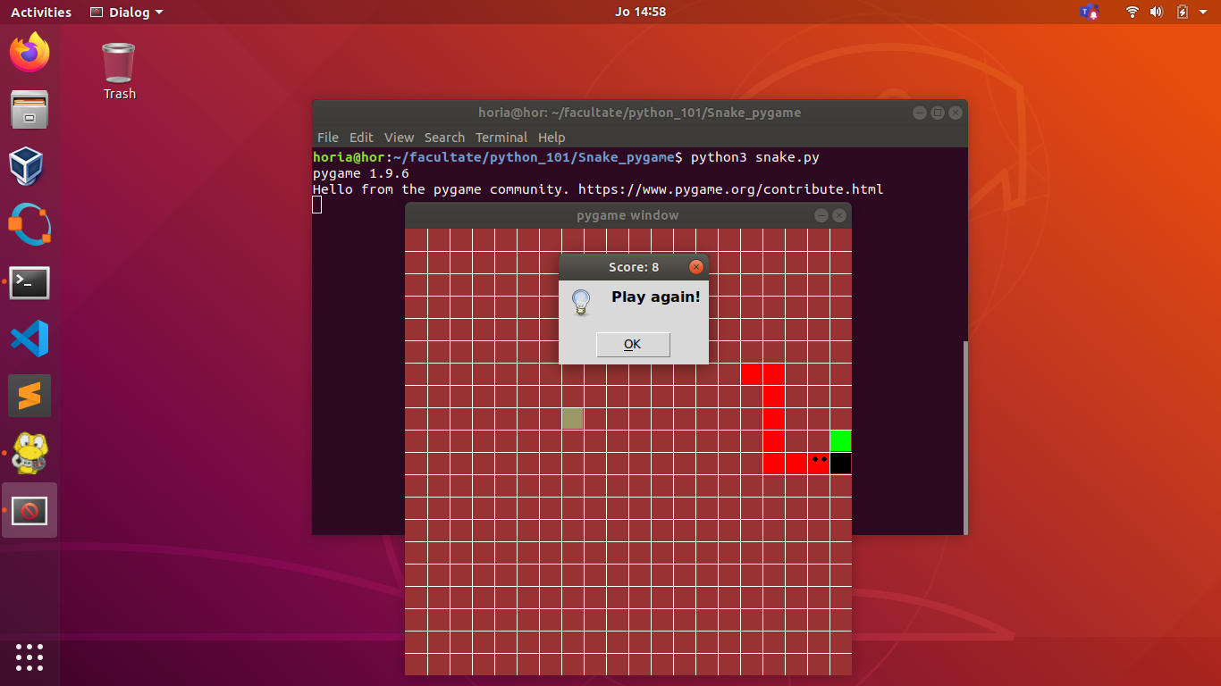

Before you run the game, you need to be sure you have installed Python3 and
Pygame. In case you haven't, here are some simple instructions to follow:

1. Install Python3: sudo apt-get install python3
2. Install Pygame: sudo apt-get install python-pygame
3. Install tkinter module: sudo apt-get install python3-tk

# Running the program(on Ubuntu/Linux)

There are few steps left before your journey begins. Make sure to follow
the next steps:

1.Clone the repo: git clone ~~https://github.com/sebapitur/Snake_pygame.git~~
2.Go to the directory you cloned the repo (in your terminal)
3.Use the command in terminal: python3 snake.py

# How to test your Snake skills - instructions

Just enjoy our game using the arrows, and feel free to press the
'Play again' button as many times as you want.

# Creators

Ignat Andrei-Horia and Pitur Sebastian

# Contribution

We appreciate any contribution to this project regarding the bugs you may find.

