Legal and Economic Mechanisms to Address Water Complexities in Mendoza, Argentina

30 December, 2020

# Summary

The difficulties of managing water resources are accentuated in scarcity-context and require an in-depth analysis of the circumstances that will contribute to a more resilient management system. Considering the characteristics of the irrigation system in the province of Mendoza and the relevance of the General Irrigation Department (DGI), the *Potrerillos Fund* conceptually consists of the opportunity cost of recovering the water that is lost due to infiltration in the canals due to lack of investment.

The economic analysis allows the design of efficient tools to improve water governance in the context of conflict of interest and high transaction costs (Gómez et al. 2018; MAGyP 2011). Historically, the elements of economic policy have not been extensively applied in the management of water resources (Gruère, Ashley, and Cadilhon 2018) as they are not always adapted to the management of assets as complex as irrigation water (Gruère and Le Boëdec 2019). Lago and Mysiak (2015) affirms that the main reasons are uncertainty, high transaction costs, legislative reforms and a correct estimate of the impact of the measures.

It is desirable to consider *integral tools* from the economic and legal point of view that aim to solve the challenge of water supply with increasing demands in periods of scarcity in arid and semi-arid climates (Pittock 2016).

# Legal and Economic Aspects

The DGI, through the Honorable Administrative Tribunal (HTA), contemplated the creation of a Fund infrastructure financing when the Potrerillos Dam was built (1999-2002). The *Potrerillos* *Fund* seeks to mitigate the effect of clear waters and the relative scarcity by waterproofing channels. This mechanism, however, envisioned that waterproofing generated a saving in water that allowed the incorporation of new users, assigning the cost of the works to them (Resolution 175/99 HTA). In this way, the regulation of a complex socioeconomic relationship is generated, where the actors with greater financial power can contribute the necessary resources for water saving actions that the agricultural sector cannot always assume; and at the same time, generates water savings to cover the new social needs. The study of the practical application experience of the Potrerillos Fund can provide numerous lessons learned in relation to its strengths and failures, and provide elements to expand its application to other cases.

A preliminary exploration of the subject allows us to observe that its application is exclusively linked to the expansion of residential consumptions that demand reduced volumes that present high economic value, and that administrative practice has been reluctant in the full application of the regulated system, and therefore in all the cases in which this institute applied the struggle between bidders that contemplates the regulation to obtain a greater pecuniary contribution has been excepted, limiting the contribution to the basic cost of the resource.

It appears as an essential problem of knowledge to determine the economic conditions that contextualize the application of this regime and its limits, where aspects such as land use planning, the value of water, the economic capacity of the different social sectors, and the externalities linked to the destination of the water resource mutate from variables of interest to key-aspects for development.

It is intended to dismember investments in lining of canals by estimating the change in the volume of water transported in such a way that it is possible to approximate the real cost of increasing the supply of water. Despite the financing source of the water infrastructure investment, the executing units optimize their resources and/or there is a tender, which ensures price competition. The water saving is calculated according to the following formula,

# Mendoza River Subdelegation

The water savings for the year $i$ ($A_{i}^{O}$) is equivalent to the decrease in losses due to infiltration by infrastructure works. It is calculated considering the linear meters of lining, the annual average flow per channel ($j$) weighted by the change in the lost volume. The conveyance efficiency values ($EfC_{j}$) correspond to secondary information from surveys and gauging carried out by the DGI where flow volumes, infiltration losses and channel characteristics were considered (Cuneo et al. 2016). In the case of the Mendoza River, since 2017 11.287 meters.

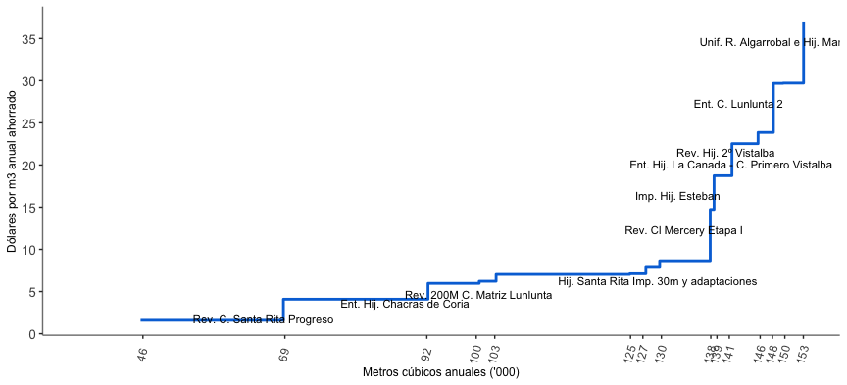

Curva de ahorro de agua enfoque eficiencia de conducción

The so-called loss approach considers the value of conveyance efficiency in earth channels calculated for each management unit; this calculation generalizes the values of $EfC_{j}$ possibly underestimating the performance of the management unit (UM).

# Final comments

In a context of complete availability of information and perfect competition between the companies and institutions that carry out the infrastructure works, the estimation of the additional supply curve is equivalent to the $Marginal Cost (MC)$ of saving water due to the reduction of infiltration losses. This approach considers only the concept of conveyance efficiency ($EfC$) for the estimation of the curve.

This applied theoretical framework takes into account the changes in the availability of water for irrigation and interacts with the real needs for irrigation. The real increases in water availability for irrigation require infrastructure investment; therefore, the correct estimation, application and interpretation of it supports of the real cost of increasing the water available for irrigation.

# Referencias bibliográficas

Cuneo, Guillermo, J Ferrer, A Laudadío, N Ortíz, M Roselló, and Juan Gustavo Satlari. 2016. “Eficiencia de conducción en la cuenca del río Mendoza.” 2008. Vol. 8. Mendoza: Departamento General de Irrigación.

Gómez, Carlos Mario, Carlos Dionisio Pérez-Blanco, David Adamson, and Adam Loch. 2018. “Managing Water Scarcity at a River Basin Scale with Economic Instruments.” *Water Economics and Policy* 04 (01): 1750004. <https://doi.org/10.1142/s2382624x17500047>.

Gruère, Guillaume, Colette Ashley, and Jean-Joseph Cadilhon. 2018. “Reforming water policies in agriculture. Lessons from past reforms.” OECD Food, Agriculture and Fisheries. Paris: OECD. <https://doi.org/10.1787/1826beee-en>.

Gruère, Guillaume, and Hélène Le Boëdec. 2019. “Navigating pathways to reform water policies in agriculture.” OECD Food, Agriculture and Fisheries Papers. Paris: OECD. <https://doi.org/10.1787/906cea2b-en>.

Lago, Manuel, and Jaroslav Mysiak. 2015. *Use of Economic Instruments in Water Policy*. Edited by Manuel Lago, Jaroslav Mysiak, Carlos M. Gómez, Gonzalo Delacámara, and Alexandros Maziotis. Vol. 14. Global Issues in Water Policy, March. Cham: Springer International Publishing. <https://doi.org/10.1007/978-3-319-18287-2>.

MAGyP. 2011. “Balance hídrico como herramienta de decisión.” In *Herramientas Para La Evaluación Y Gestión Del Riesgo Climático En El Sector Agropecuario*, 1st ed., 55–63. Buenos Aires, Argentina: MAGyP.

Pittock, Jamie. 2016. “The Murray–Darling Basin: Climate Change, Infrastructure, and Water.” In *Increasing Resilience to Climate Variability and Change*, edited by Cecilia Tortajada, 1st ed., 41–59. Springer. <https://doi.org/10.1007/978-981-10-1914-2_3>.