A660 _ REVIEW _1_231225

FRONT END

1. Doctor images, name, spec to change as actual
Home page and https://www.kpsrirampai.com/doctors ( or this can put hidden)

2. Opening hours - footer – to check

3. Reschedule button to be placed https://www.kpsrirampai.com/booking

4. SMS and Whatsapp – API to activated for real testing.

BACKEND

1. Status and action item

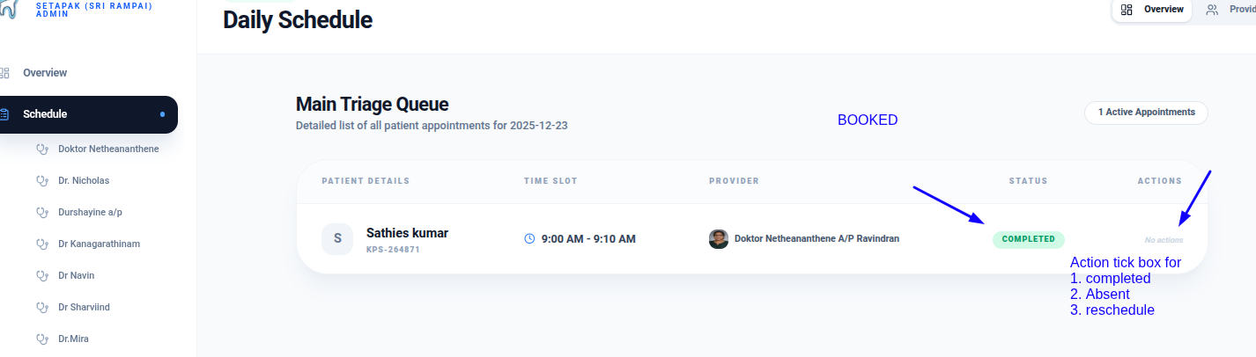

2. Access control only for Admin ( rest all for reception user)

https://www.kpsrirampai.com/admin/doctors
https://www.kpsrirampai.com/admin/receptionists
( hire receptionist = Add user )
https://www.kpsrirampai.com/admin/reminders

3. Treatment plan
https://www.kpsrirampai.com/admin/care
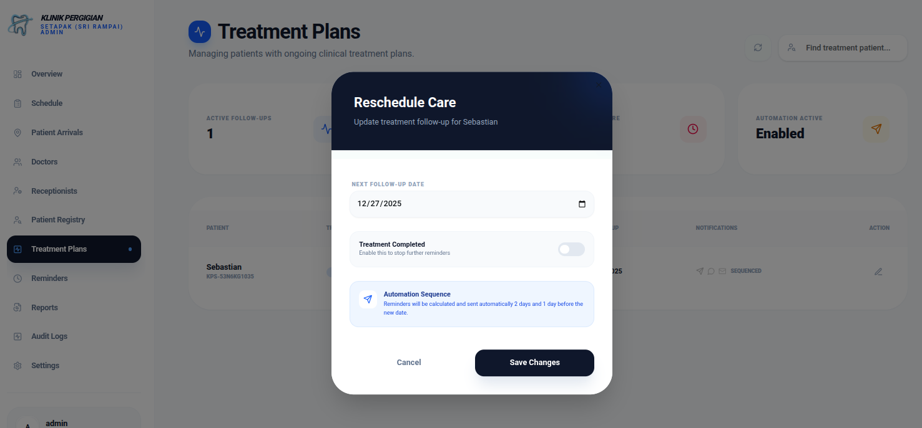
Field to be added
Start date
Duration of the treatment
Reminder to send for booking = _____ days once

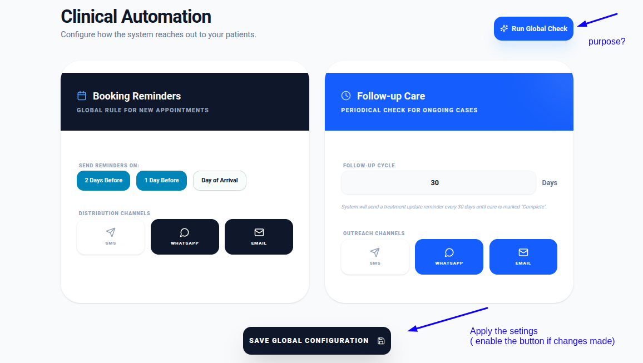
4. Reminders
https://www.kpsrirampai.com/admin/reminders

5. Reports
https://www.kpsrirampai.com/admin/reports

remove this status bar
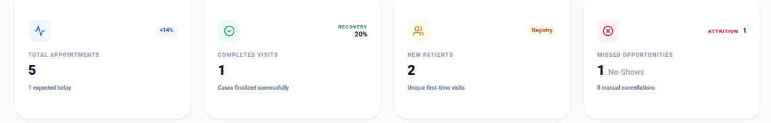

Report view format can be with following data selection and listings

