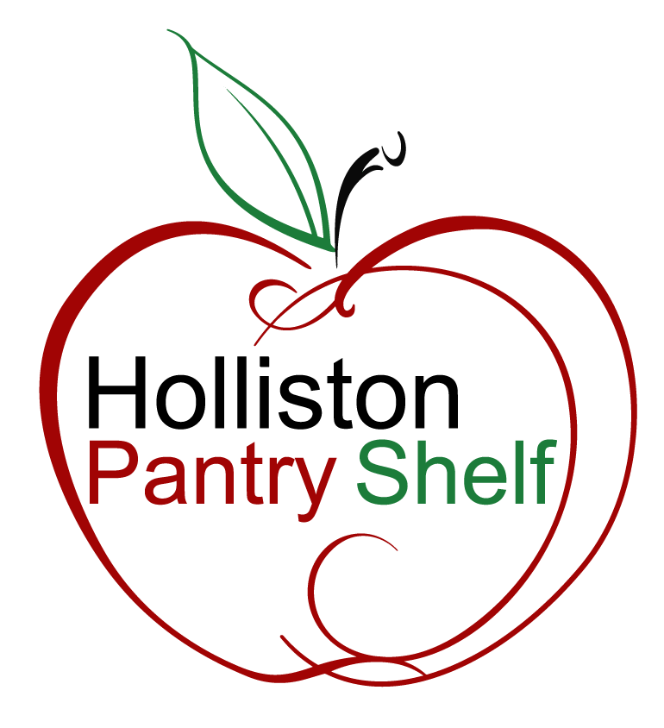
Content Editor Guide
Holliston Pantry Shelf Website
March 2026

Table of Contents
Table of Contents 2
Chapter 1: How the Website Works 3
Chapter 2: Global Elements (Site Settings) 4
Announcement Header 4
Navigation Menu 4
Social Links 4
Chapter 3: Page 6
Chapter 4: Page Sections 7
Hero Section 7
Text with Image Section 8
Icon Grid Section 9
Card 10
Contact Section 10
News List Section 11
News Post 12
Chapter 5: Reusable Elements — Button / Link 14
Chapter 6: Background Styles 15
Chapter 7: Available Icons 16
Chapter 8: Common Tasks 17
Add or update an announcement banner 17
Publish a new news post 17
Add a new section to a page 17
Change a navigation link 17
Update the site-wide contact phone or email 18
Reorder sections on a page 18

Chapter 1: How the Website Works
The website is made up of pages, and each page is composed of a stack of sections. You pick which sections to include, in what order, and Contentful (https://contentful.com) assembles the page automatically. Most sections support a few options (background color, image position, etc.) that let you vary the visual design without touching code.

Here is how the content types relate to each other:

Site Settings ─── Announcement Header
├── Navigation Menu ── Button / Link
└── Social Link

Page ── Sections ─── Hero Section ─────────── Button / Link
├── Text with Image ─────── Button / Link
├── Icon Grid ─────────── Card ── Button / Link
│ └── Button / Link (bottom)
├── Contact Section ────── Button / Link
├── News List ─────────── News Post entries
└── News Post (auto routed)

News Post ── (standalone page at /news/[slug])

Chapter 2: Global Elements (Site Settings)
Site Settings is a singleton entry — there is only one, and it controls elements that appear on every page: the announcement banner, the navigation header, and the footer.

The announcement banner and sticky navigation header — controlled via Site Settings.

Announcement Header
The yellow/beige banner that appears at the very top of the page, above the navigation.

Field | Type | Purpose
Is Active | Yes/No | Master on/off switch. Turn off to hide without deleting the entry.
Text | Text (markdown) | The message. Bold, italic, and links are supported.
Link URL | Text | Optional URL shown as a clickable link next to the message.
Link Text | Text | Label for the link. Defaults to "Details" if left blank.
Start Date | Date | Banner will not appear before this date.
End Date | Date | Banner automatically disappears after this date.

Tip: Use Start/End dates for time-sensitive announcements (food drives, holiday closures). Set them up in advance and they appear and disappear automatically.

Navigation Menu
Controls the links shown in the header navigation bar. Each item in Menu Items is a Button / Link entry (see Chapter 5). The style of each button entry controls whether it appears as a plain nav link, or as the gold Contact button.

Note: Any Button / Link with URL #contact automatically becomes the gold Contact button in navigation.

Social Links
Each Social Link entry appears in the footer.

Field | Purpose
Platform Name | Facebook, Instagram, YouTube, etc. The icon is selected automatically.
URL | Full link to the social media profile. Opens in a new tab.

Chapter 3: Page
A Page entry is the container for an entire page on the website. Currently the site has one main page (homepage) and one news listing page.

Field | Purpose
Title | Internal name — not shown on the website.
Slug | The URL path. Use / for the homepage or /news for the news page.
Sections | An ordered list of section entries. Drag to reorder. Add or remove sections here.

Tip: To add a section — open the Page entry, click Add existing entry in the Sections field, select or create a section, drag to position, then publish.

Chapter 4: Page Sections
Each page is built from a stack of sections. Add, remove, and reorder sections directly in the Page entry. The sections below are the available types.

Hero Section
Content type: Section - Hero
The large banner at the top of a page. Typically, the first section on any page. Supports a headline, description, up to two buttons, and various background styles.

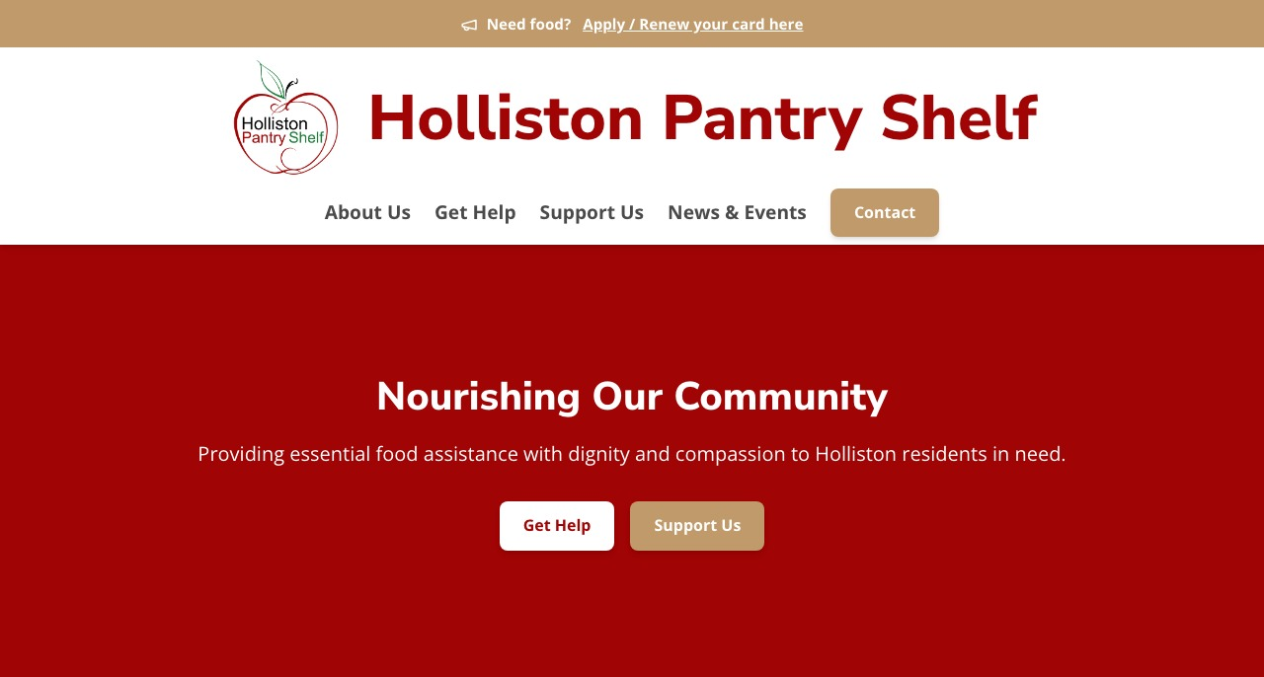
Hero with Red Background style — headline, description, and two buttons.

Field | Type | Notes
Headline | Text | Large bold heading. Keep it short and impactful.
Description | Text | One or two sentences below the headline.
Primary Button | Button / Link | Main call to action (e.g., Get Help).
Secondary Button | Button / Link | Optional second action (e.g., Support Us).
Background Style | Dropdown | Controls the section colour/image. See Chapter 6.
Background Image | Image | Only used when Background Style is Image Background.

Tip: The hero is typically the first section on any page.

Text with Image Section
Content type: Section – Text with Image
A two-column section with a block of text on one side and a photo on the other. Great for Regular Content, About Us, mission statements, or any explanatory content.

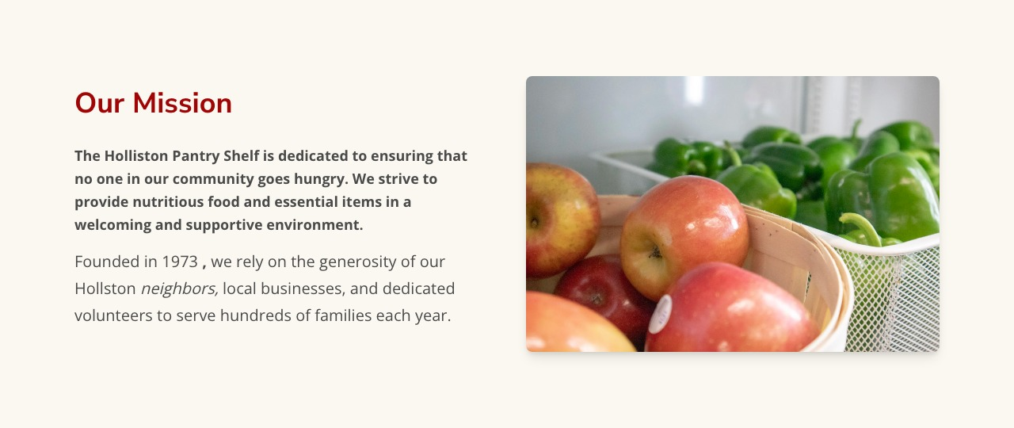
Our Mission — title, bold lead paragraph, body text and photo side by side.

Field | Type | Notes
Title | Text | Section heading (shown in red).
Lead Paragraph | Text | Bold intro sentence displayed above the body text.
Body | Rich Text | Full content. Supports headings, lists, bold, italic, and links.
Image | Image | Photo displayed alongside the text.
Image Position | Dropdown | Left or Right — which side the photo appears on.
Optional Link | Button / Link | Optional CTA below the body text.
Background Style | Dropdown | Default Background or Beige Background.

Tip: Alternate Image Position (Left / Right) across multiple Text with Image sections to create visual rhythm as the visitor scrolls down.

Icon Grid Section
Content type: Section – Icon Grid
A section with an icon and heading at the top, followed by a grid of Cards, and an optional button at the bottom. Use this to present a set of related options, services, or calls to action side by side.

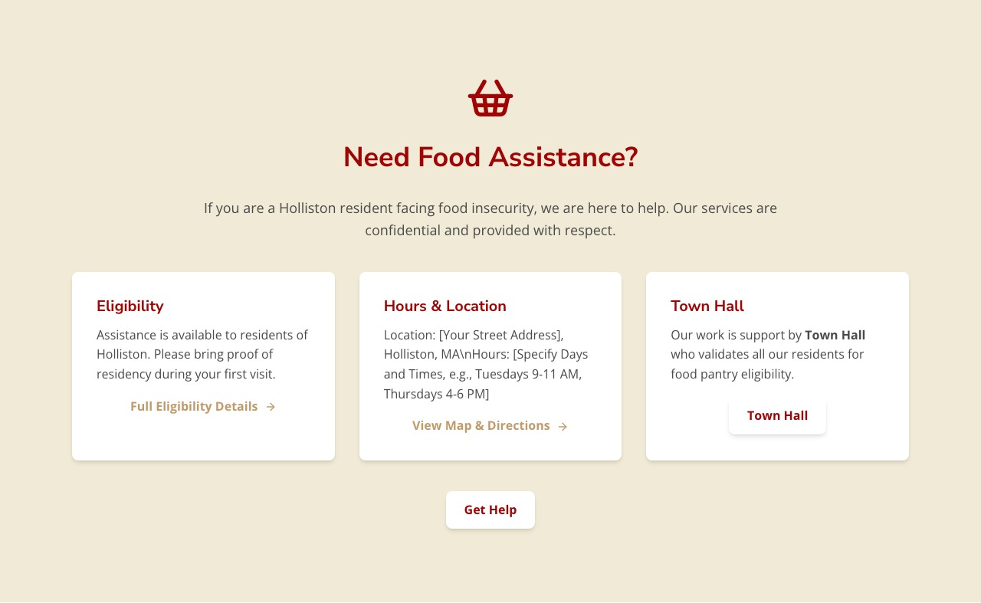
Need Food Assistance? — icon, heading, three cards and a bottom button.
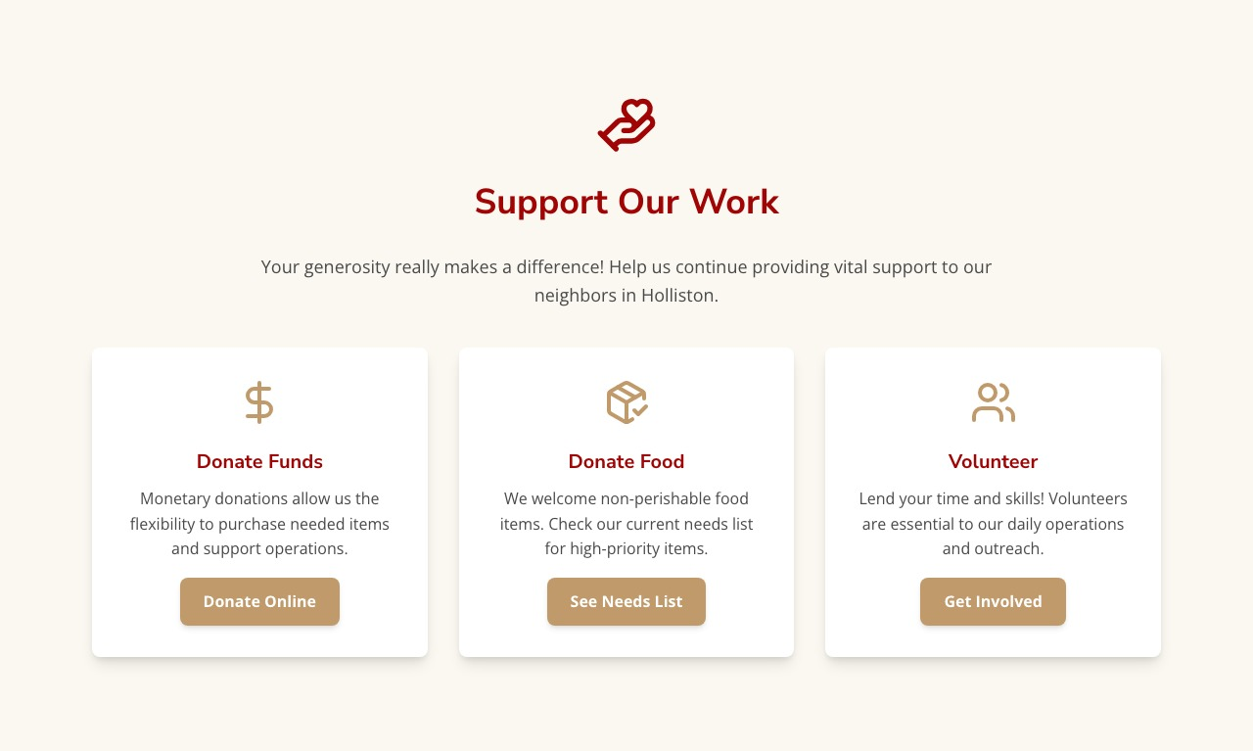
Support Our Work — three cards each with their own call-to-action button.

Field | Type | Notes
Section Icon | Icon name | Icon centered above the title. See Chapter 7 for available names.
Title | Text | Section heading.
Lead Paragraph | Text | Optional intro sentence below the title.
Grid Items | Cards | 2-3 Card entries shown in a row. See Card below.
Optional Bottom Button | Button / Link | A button centered below all the cards.
Background Style | Dropdown | Default Background or Beige Background.

Note: Grid layout — 2 cards displays side by side. 3 cards displays three columns across the full width.

Card
Cards live inside an Icon Grid Section. Each card is a self-contained content block.

Field | Type | Notes
Icon | Icon name | Small icon shown at the top of the card. See Chapter 7.
Title | Text | Card heading (shown in red).
Description | Text (markdown) | Card body. Supports bold, italic, and links.
Optional Button Link | Button / Link | An optional action button at the bottom of the card.

Contact Section
Content type: Section - Contact
Displays the organization’s phone number, email address, and a Send Email button. Can use the site-wide contact info from Site Settings, or a custom phone/email for a specific context.

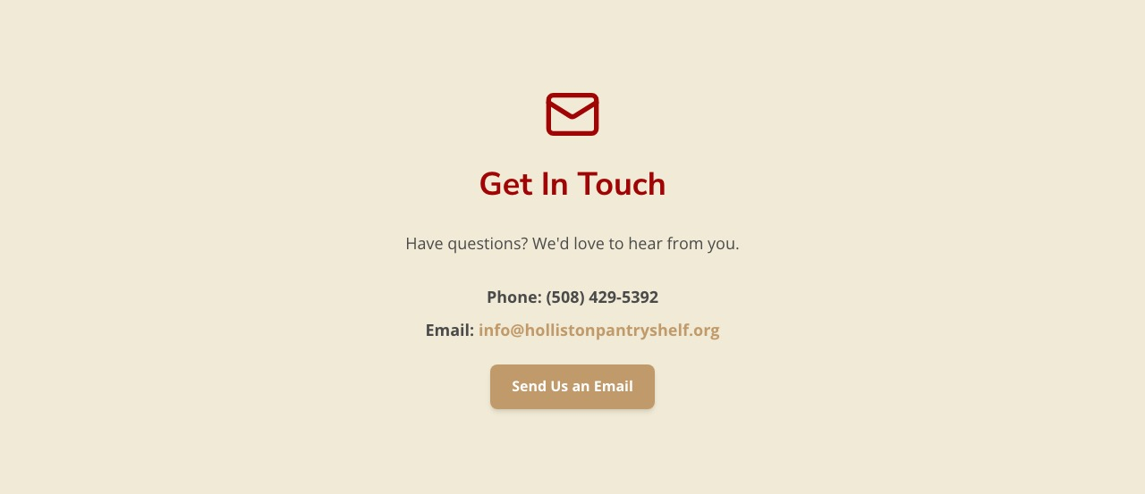
Get In Touch — icon, contact details, and email button.
Field | Type | Notes
Section Icon | Icon name | Icon centered above the title.
Title | Text | Section heading.
Lead Paragraph | Text | One-line intro below the title.
Contact Info Source | Dropdown | Custom uses fields below. Any other pulls from Site Settings.
Custom Phone | Text | Only used when Contact Info Source is Custom.
Custom Email | Text | Only used when Contact Info Source is Custom.
Button | Button / Link | Typically Send Us an Email. URL set to mailto:[email] automatically.
Background Style | Dropdown | Default Background or Beige Background.

Tip: Any Contact Section using Site Settings as its source updates automatically when you change the site-wide phone/email — no need to update individual sections.

News List Section
Content type: Section - News List
Shows a list or grid preview of News Post entries. Used on the /news page.

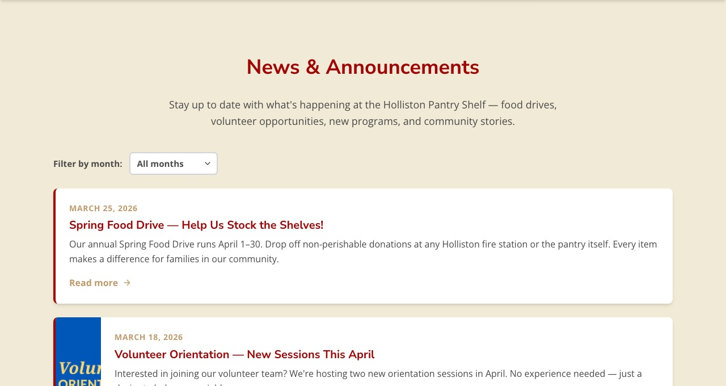
News list with month filter, paginated post entries and “Read more” links.
Field | Type | Notes
Title | Text | Section heading.
Lead Paragraph | Text | Intro text below the heading.
Posts | News Posts | Link to all News Post entries you want to appear here.
Display Limit | Number | Posts per page in list mode (default: 10).
Display Style | Dropdown | List — paginated with month filter. Grid — shows 3 most recent as preview cards.
Background Style | Dropdown | Default Background or Beige Background.

Tip: Use Grid display style to show 3 recent posts as a preview on the homepage, and List display style on the dedicated news page.

News Post
Content type: News Post
Each news item is its own News Post entry. When you publish a post, it automatically gets its own page at /news/[slug].

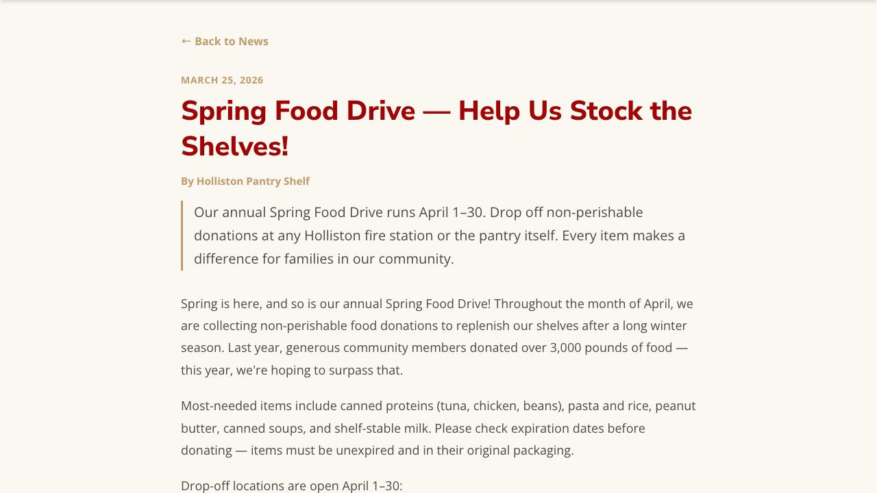
A full news post: date, title, author, summary blockquote, and body.

Field | Type | Notes
Title | Text | The post headline.
Slug | Text | URL identifier — no spaces, use hyphens (e.g., spring-food-drive-2026).
Summary | Text | Short excerpt shown on the list page and as a blockquote at the top of the post.
Publish Date | Date | Displayed on the post. Posts are ordered newest-first in the list.
Author | Text | Displayed below the title (e.g., Holliston Pantry Shelf).
Featured Image | Image | Optional photo shown at the top of the post page.
Body | Rich Text | Full content. Supports headings, lists, bold, italic, links, and embedded images.

Tip: Slug tip — match the headline in lowercase with hyphens. Example: Spring Food Drive 2026 becomes spring-food-drive-2026.

Important: After publishing a new post, also open the News List Section entry, add the post to its Posts field, and publish. The post won't appear in the news listing until you do this.

Chapter 5: Reusable Elements — Button / Link
A shared entry type used in many places: navigation, hero buttons, card buttons, and section CTAs (Call to Action). You can reuse the same Button / Link entry in multiple places or create a new one each time.

Field | Type | Notes
Text Label | Text | The visible button or link text.
URL | Text | Destination. Use #section-id for same-page scroll, or a full URL for external links.
Style | Dropdown | Controls the visual appearance (see table below).
Open in New Tab | Yes/No | Set to Yes for external links (donation pages, Google Maps, etc.).

Style Value | Appearance | Best used for
Primary Button | White with red border and text | Main CTA (Call to Action) on a colored/dark background
Secondary Button | Gold/beige filled | Secondary action alongside a Primary Button
Subtle Link | Plain text with arrow | Inline links in cards or below text blocks

Chapter 6: Background Styles
Most sections have a Background Style field. Use these to create visual separation between sections:

Value | Appearance | Use for
Default Background | Off-white / light cream | Most sections
Beige Background | Warm beige | Alternating sections for visual rhythm
Red Background | Pantry red, white text | Hero sections only
Gray Background | Neutral grey, white text | Hero sections only
Image Background | Full-bleed photo with dark overlay | Hero sections only — requires a Background Image

Chapter 7: Available Icons
Icons are selected by entering the icon name exactly as shown. Used in Icon Grid Sections, Cards, and Contact Sections.

Icon | Icon Name | Description
 | ShoppingBasket | Shopping basket
 | HandHeart | Hand holding a heart
 | Users | Two people silhouette
 | Mail | Envelope
 | DollarSign | Dollar sign $
 | PackageCheck | Package with checkmark
 | Apple | Apple fruit
 | Info | Information circle
 | Phone | Phone handset

Tip: Contact your administrator if you need additional icons. The full list of icons that can be made available can be found here: https://lucide.dev/icons/

Chapter 8: Common Tasks
Step-by-step instructions for the most common content operations.

Add or update an announcement banner
1. Go to Site Settings > Announcement Header.
2. Set Is Active to Yes. Write the Text; add a Link URL and Link Text if needed.
3. Set Start Date and End Date for automatic show/hide.
4. Publish.

Tip: To hide the banner temporarily, set Is Active to No and publish. The content is preserved for re-enabling later.

Publish a new news post
1. Create a new News Post entry. Fill in Title, Slug, Summary, Publish Date, Author, and Body.
2. Publish the News Post entry.
3. Open the News List Section entry on the news page.
4. Add the new post to the Posts field.
5. Publish the News List Section.

Note: The post gets its own URL (/news/[slug]) when published, but won't appear in the listing until added to the News List Section.

Add a new section to a page
1. Create and publish the new section entry.
2. Open the Page entry.
3. Click Add existing entry in the Sections field and select the new section.
4. Drag it to the desired position.
5. Publish the Page.

Change a navigation link
1. Go to Site Settings > Navigation Menu > Menu Items.
2. Open the Button / Link entry you want to change.
3. Update the Text Label or URL, then publish.

Update the site-wide contact phone or email
1. Go to Site Settings.
2. Update the Phone and Email fields and publish.

Tip: Any Contact Section using Site Settings as its source will reflect the new details automatically.

Reorder sections on a page
1. Open the Page entry.
2. In the Sections field, drag the section cards into the desired order.
3. Publish the Page.

