MUST: WE USE MUST WHEN WE FEEL AN OBLIGATION TO DO SOMETHING
EXAMPLE: I MUST PHONE MY SISTER FOR HER BIRTHDAY

MUSTN’T: WE USE MUSTN’T WHEN WE ARE NOT ALLOWED TO DO SOMETHING
EXAMPLE: YOU MUSTN’T EAT IN CLASS

HAVE TO: WE USE HAVE TO WHEN THE OBLIGATION COMES FROM EXTERNAL FACTORS
EXAMPLE: I HAVE TO PAY TAXES

DON’T HAVE TO: WE USE DON’T HAVE TO WHEN WE ARE NOT OBLIGED TO DO SOMETHING
EXAMPLE: I DON’T HAVE TO WRITE A LONG LETTER.

CAN: WE USE CAN TO TALK ABOUT OUR ABILITY TO DO SOMETHING
EXAMPLE: I CAN SWIM
CHOOSE THE RIGHT OPTION

1- I MUST / HAVE TO VISIT MY FRIEND. IT IS HER BIRTHDAY.
2- SAM HAS TO / MUST WEAR UNIFORM AT SCHOOL.
3- YOU DON’T HAVE TO/ HAVE TO GO TO THE SUPERMARKET. I’LL DO IT.
4- YOU DON’T HAVE TO / MUSTN’T SWIM IN THIS PART OF THE RIVER. IT IS VERY DANGEROUS
5- YOU MUST / DON’T HAVE TO DRINK A LOT OF WATER IN HOT WEATHER.
6- I CAN / MUSTN’T SWIM VERY FAST.
7- SHE DOESN’T HAVE TO / CAN’T BRING AN UMBRELLA. IT ISN’T RAINING.
8- I HAVE TO / MUST TIDY MY ROOM THIS WEEKEND.
9- WE HAVE TO /MUSTN’T ARRIVE LATE AT SCHOOL.
10- HE CAN / HAVE TO SPEAK ITALIAN
REWRITE THE SENTENCES USING THE WORDS GIVEN

1- YOU ARE NOT ALLOWED TO TALK DURING THE TEST (MUSTN’T)
YOU MUSTN´T TALK DURING THE TEST

2- IT ISN’T NECESSARY TO BRING FOOD (DON’T HAVE TO)
YOU DON´T HAVE TO BRING FOOD

3- I’M OBLIGED TO FINISH THIS LETTER BEFORE MIDDAY (HAVE TO)
I HAVE TO FINISH THIS LETTER BEFORE MIDDAY

4- YOU ARE NOT ALLOWED TO LEAVE THE CLASSROOM WITHOUT PERMISSION (MUSTN’T)
YOU MUSNT´N LEAVE THE CLASSROOM WITHOUT PERMISSION

5- IT ISN’T NECESSARY TO PAY FOR THE TICKETS. THEY ARE FREE (DON’T HAVE TO)
IT DON´T HAVE TO PAY FOR THE TICKETS. THEY ARE FREE

CHOOSE THE RIGHT OPTION

YOU …………. SMOKE IN THIS ROOM I ……….. STUDY HARD FOR THE TEST
CAN MUST MUSTN’T CAN MUST MUSTN’T

I ………… DANCE YOU………….. TO BRING SANDWICHES.I HAVE MADE SOME
HAVE TO MUST CAN DON’T HAVE TO MUSTN’T CAN

YOU………….. USE YOUR MOBILE PHONE YOU …………… EAT IN CLASS
ON THE PLANE DON’T HAVE TO CAN MUSTN’T
MUSTN’T MUST CAN

I ………… WEAR A UNIFORM AT WORK I ……….. PUT THE RUBBISH IN THE BIN
HAVE TO MUST MUSTN’T DON’T HAVE TO HAVE TO MUST

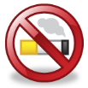
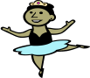

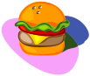
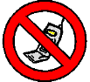

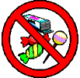
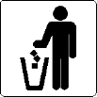

MATCH THE SENTENCES WIH THE PICTURES

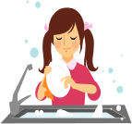 1. You mustn’t ride your bike here.

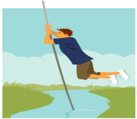 2. I have to tidy my room.

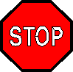 3. I must help my mum with the cores.

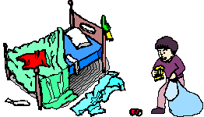 4. I can jump high.

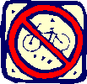 5. I have to do my homework.

 6. You must stop here.

