Used libraries for script:

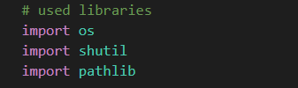

1. os- “provides a portable way of using operating system dependent functionality.”

Source: <https://docs.python.org/3/library/os.html>

Used functions:

* getcwd- returns current working directory of a process
* listdir- returns a list containing the names of the entries in the directory given by path
* walk- generates the file names in a directory tree by walking the tree either top-down or bottom-up
* makedirs- recursive directory creation function

1. shutil- “offers a number of high-level operations on files and collections of files. In particular, functions are provided which support file copying and removal.”

Source: <https://docs.python.org/3/library/shutil.html>

Used functions:

* move- recursively moves a file or directory (source) to another location (destination)

1. pathlib- “This module offers classes representing filesystem paths with semantics appropriate for different operating systems.”

Source: <https://docs.python.org/3/library/pathlib.html>

Used functions:

* Path

Step 1. Run the script!

Before running the script

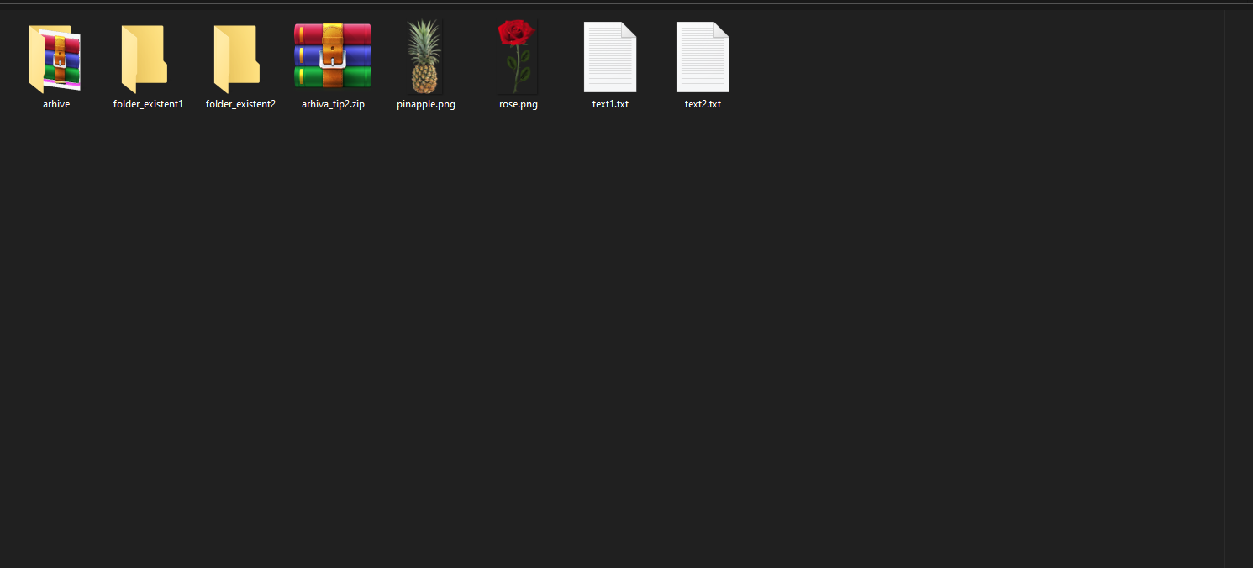

Step 2. The script shows the current existing folders in ‘path’ directory and asks for user input in order to assign files to

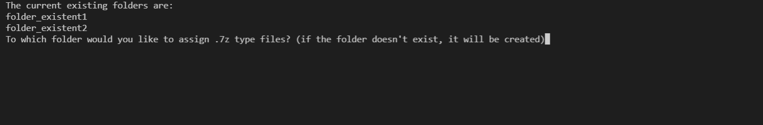

Step. 3 After the input is given, it will go to the next iteration (extension) and so on until there aren’t any extensions left

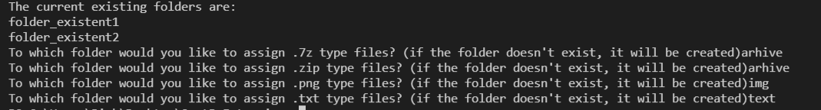

Final output:

