# 

# 

Prototyping, Usability and Feedback analysis

# 

|  |  |
| --- | --- |
| Project | MoPad - A mobile gamepad for browser-based games |
| Team | Janina Trost (s0541227)  Jonas Hartweg (s0541124)  Sebastian Alfers (s0541025) |
| Lecture | Hochschule für Technik und Wirtschaft (Department 4)  Internationale Medieninformatik (Master)  Web Development Project |
| Examiner | Dr. Karl Beecher |

# Table of Contents

1 Prototyping

2 User experience

2.1 Usability

2.2 Accessibility

3 Feedback

Appendix: Screenshots

Controller

GameCenter

Game

GameAdmin

GameAdmin Homepage

Login in security area

Dashboard: Overview about managed entity Game

List all Games

Create a Game

Edit a Game

Delete a Game

# 

# 

# 1 Prototyping

Since our software system has a lot of dependencies between its components (Controller, Bridge, GameCenter, GameAdmin) all these components have been developed in parallel. However, the controller works independently from a WebSocket connection. This decision has been made to improve and accelerate testing on a mobile device.

The Twitter Bootstrap (http://twitter.github.com/bootstrap/) front-end framework helps to establish a rapid development cycle, while maintaining a decent, consistent visual appearance.

For the fast implementation of the GameAdmin (game administration) we used the framework Symfony2 ([www.symfony.com](http://www.symfony.com), written in PHP). With the Sonata AdminBundle (www.sonata-project.org/bundles/admin/) it generated based on the Game entity the CRUD views (create, update, delete) and List view. For the authentication in GameAdmin is Symfony2 also extendable.

# 2 User experience

## 2.1 Usability

Usability is a crucial part of software development and a defining factor for software quality. Especially when it comes to gaming fun is key. A steep learning curve, ease of use and visual attractiveness enhance the user experience fundamentally, which is why they play an important role in our project. A basic, rough usability guideline is offered by Jakob Nielsen, who defined 10 heuristics for usability (compare http://www.nngroup.com/articles/ten-usability-heuristics/).

Considered aspects include:

* User Control and Freedom: When a certain amount of players for a game is picked and submitted, the selection can be canceled (Screenshot)
* Aesthetic and minimalist design: Twitter Bootstrap provides a streamlined and consistent visual experience
* ...

### 2.1.1 Usability from GameAdmin

For the GameAdmin homepage we use the well proven consistent design of Symfony with common icons.  
All forms, the login, the create and edit form for Game entity, give the user feedback about the actions. It gives error messages in red color or information about successfully action in green. The color design supports the content. The button for deleting a Game entity is also in red. That give the user the information to be attentive with this action. If you want to delete a Game you will asked before “Are you sure?”. This is helpful for user since the action can not be undone.

After successfully login the user is guided to the GameAdmin dashboard and after logout back to the homepage.  
On the GameAdmin page all button have speaking name. This tells the user which action to expect. Also, the button names are translated and are thus internationalized.

We have set the MoPad logo and named the header, so the user knows where he is.   
The links from the homepage have tooltips to explain whither the user will directed.

The GameAdmin have breadcrumb navigation. So you can find out where you are on every page.

Please find the screentshot in the appendix.

## 2.2 Accessibility

To provide good readability for screen readers, close attention has been paid on generating valid HTML. This also improves cross-browser compatibility and indexation by search engines.

Additionally element-naming (id’s and classes) represents the elements contextual meaning. Buttons and link should have tooltip or link title to describe more precisely the expected action.

On a website, you should always go with a tab in the main input field, for example search input field. Also in forms should be sensible move from one entry field to another with the tab. And pictures should always have a caption.

Colors should be used to support the content. But the relationship must not depend solely on the color, as blind or color blind people can not perceive it.

# 3 Feedback

The main point of critique was the extensiveness of the specification. While not all aspects of the specification might appear in the final documentation, our team shares the opinion that a decent specification helps to get a grasp of the whole software systems and all components involved. It also provides a good guideline for the development process, where everyone works towards the same goal.

We have shown our mock other students.

In the GameCenter the handling of the slider for the number of players was not intuitive. So we changed it that the slider starts with one player and the input field for the player name can be seen already at the beginning.

On the homepage of GameAdmin we added the tooltips for the links and we activated the label translation.

# Appendix: Screenshots

## Controller

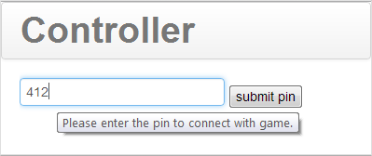

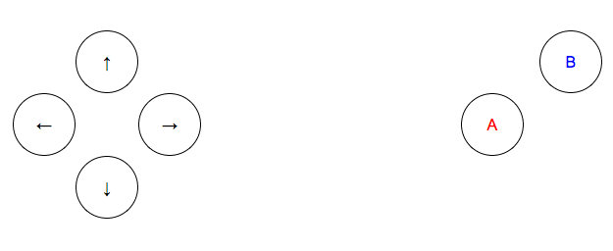

## 

## 

## GameCenter

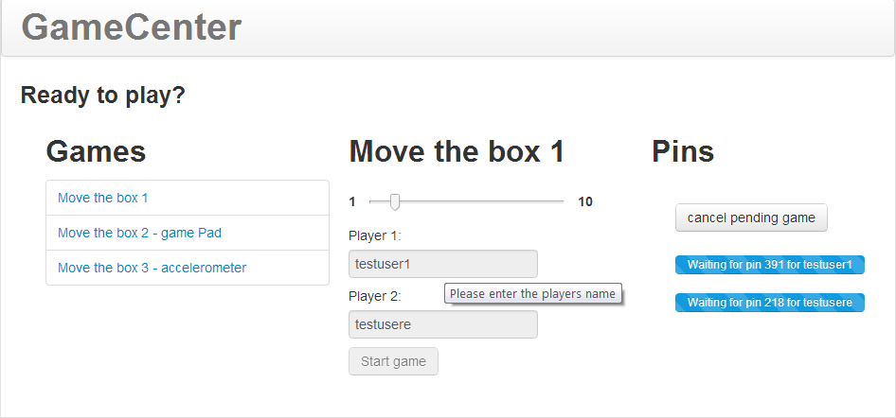

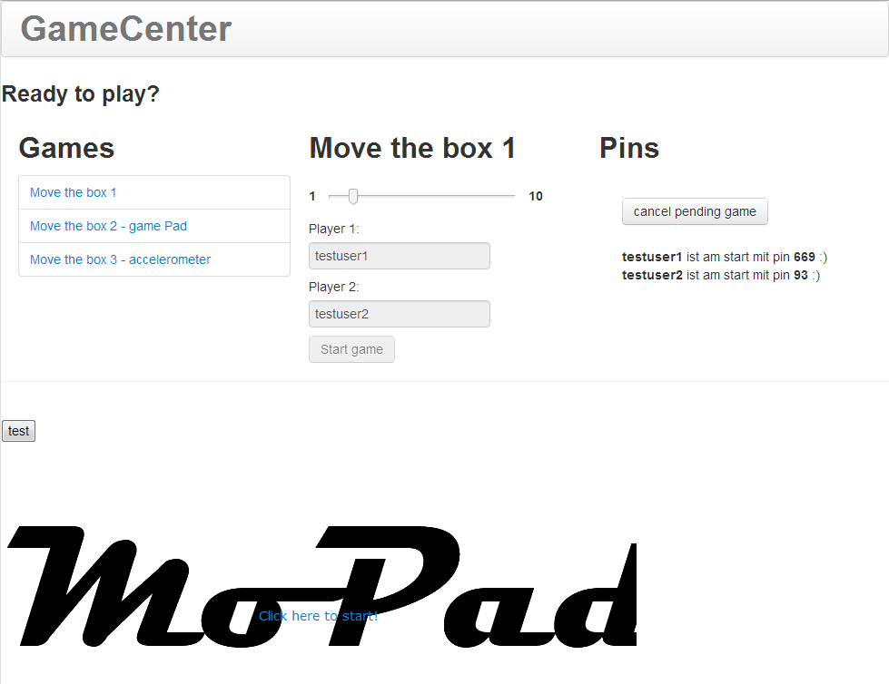

## Game

## 

## 

## 

## GameAdmin

### GameAdmin Homepage

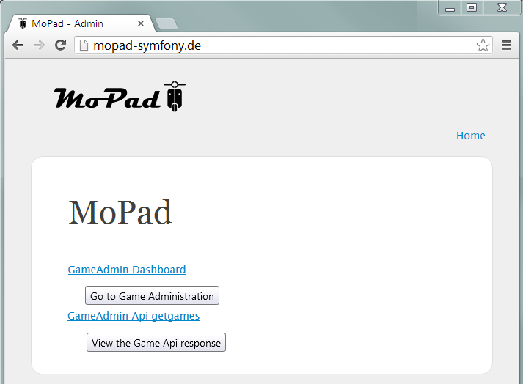

### Login in security area

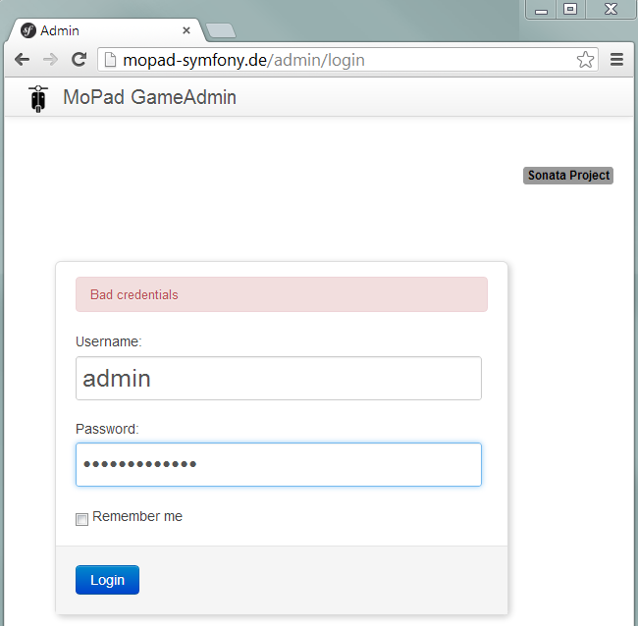

### Dashboard: Overview about managed entity Game

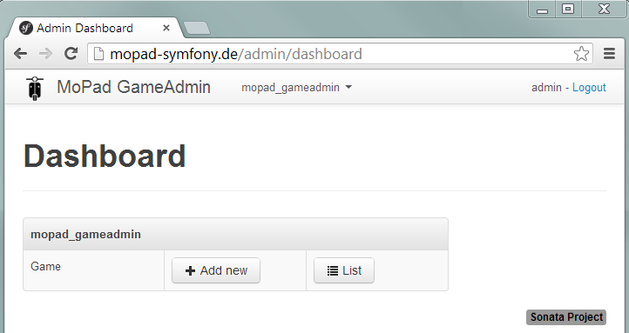

### List all Games

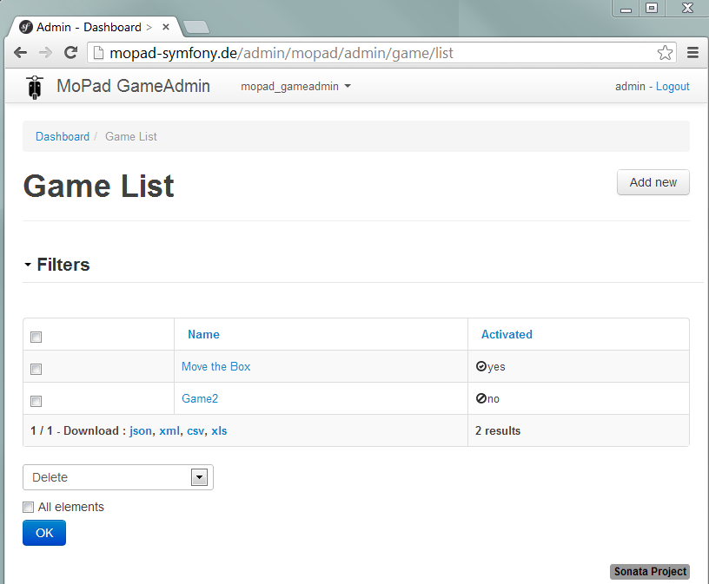

### Create a Game

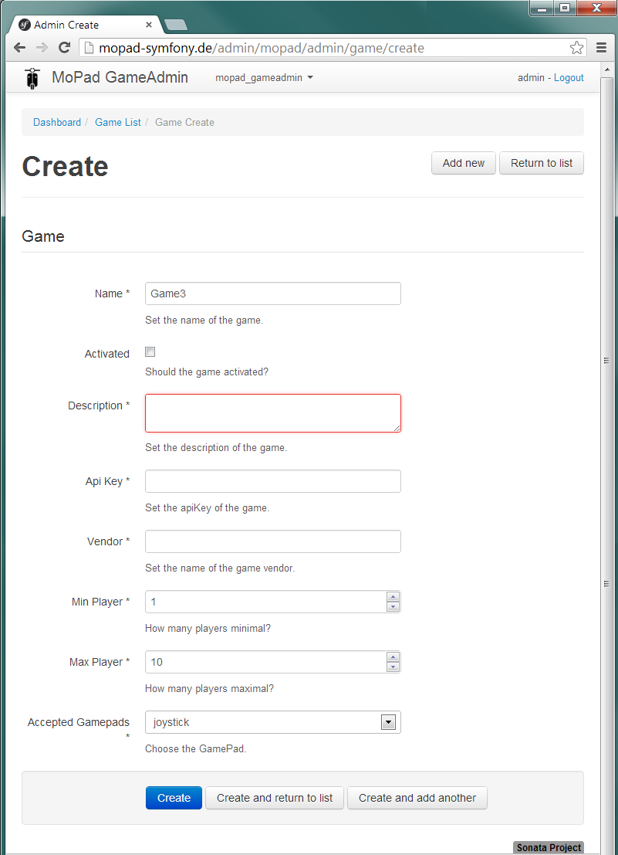

### Edit a Game

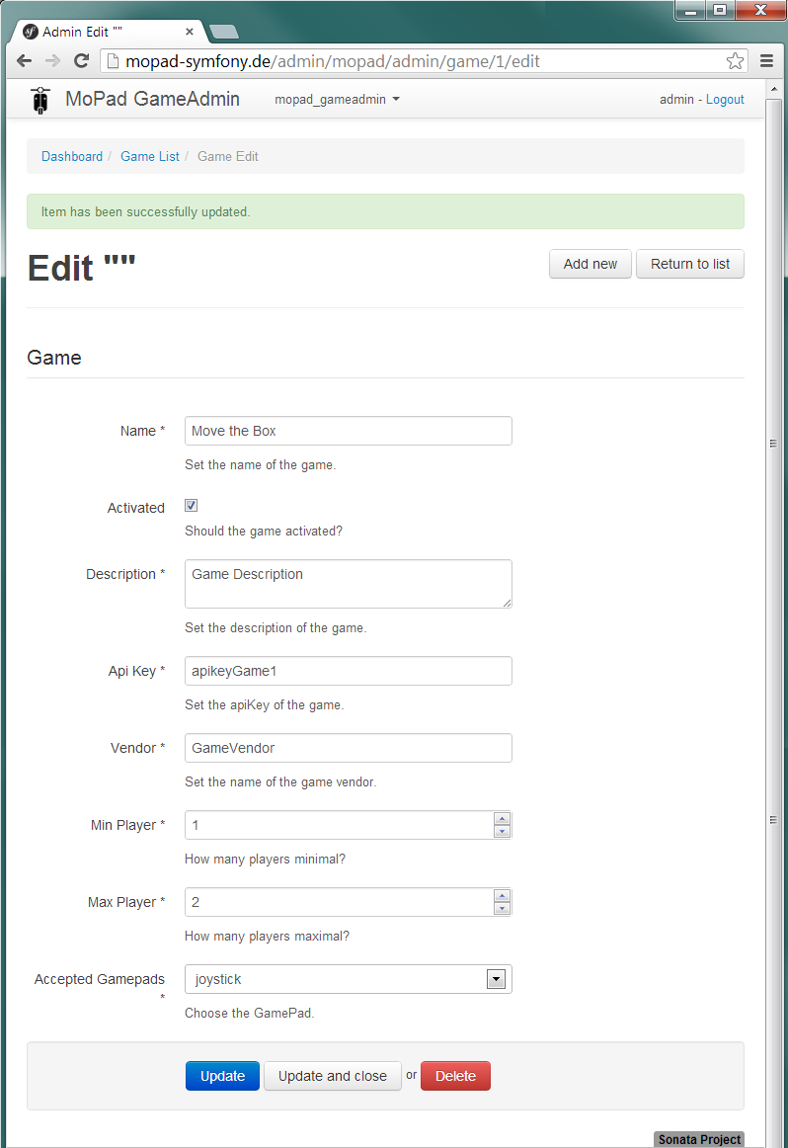

### Delete a Game

