**You can not believe this!**

|  |  |
| --- | --- |
| This is just random text and the sense of it does not matter. This is just random text and the sense of it does not matter. This is just random text and the sense of it does not matter. This is just random text and the sense of it does not matter. This is just random text and the sense of it does not matter. This is just random text and the sense of it does not matter. | This is just random text and the sense of it does not matter.  **IMPORTANT WORDS COME HERE**  This is just random text and the sense of it does not matter. This is just random text and the sense of it does not matter. This is just random text and the sense of it does not matter. This is just random text and the sense of it does not matter. |

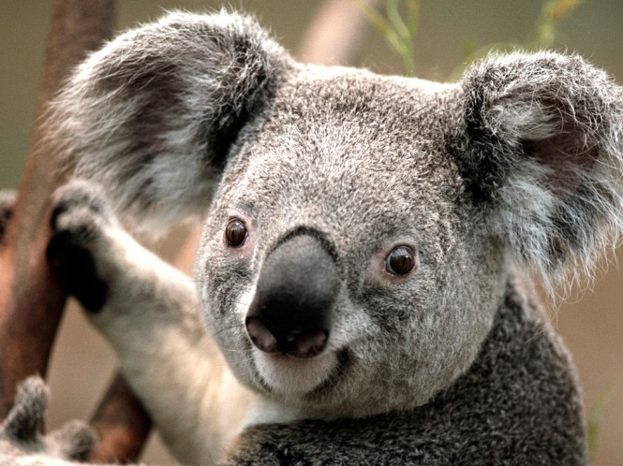

Wow, he is cute, isn´t he? Where can I buy this kind of animal for my daughter? She will love this. For sure, it does not cost much!

Travel to **India**! Klick [here](http://www.india.com/)

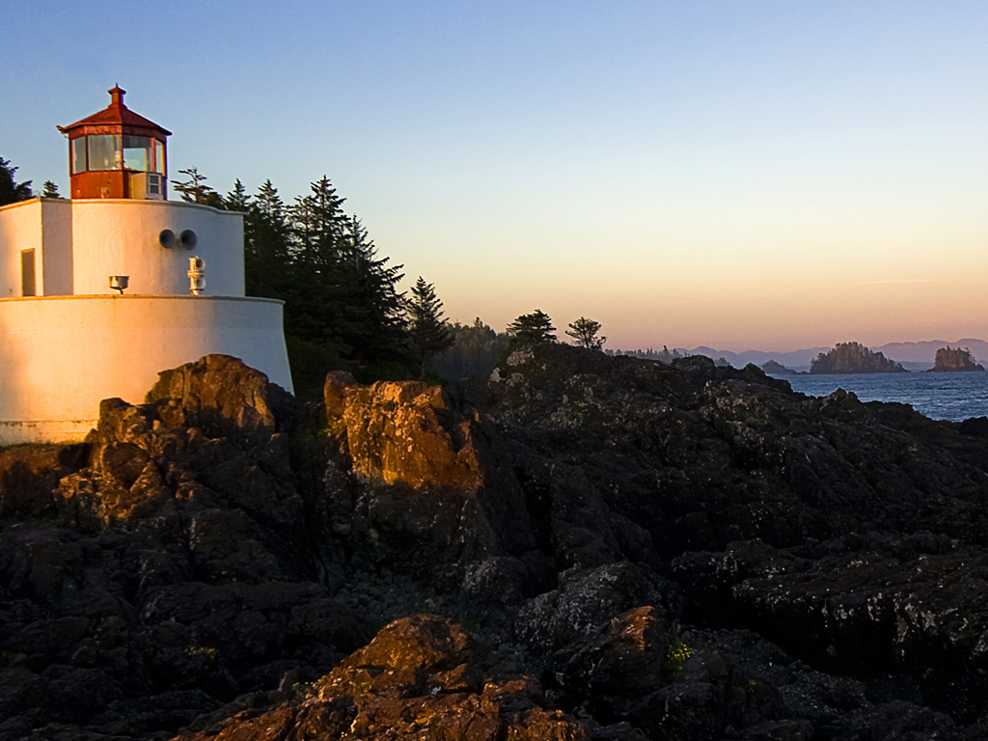

Wow, jea. It is right. Out of the streets, there you can find free, homeless water bottles. And they are empty.

Wow, jea. It is right. Out of the streets, there you can find free, homeless water bottles. And they are empty.

Wow, jea. It is right. Out of the streets, there you can find free, homeless water bottles. And they are empty.

ALERT! Free water bottles

**Here some more breaking news**

|  |  |
| --- | --- |
| Beside all this amazing stuff, here comes more empty words. Beside all this amazing stuff, here comes more empty words. Beside all this amazing stuff, here comes more empty words. Beside all this amazing stuff, here comes more empty words. Beside all this amazing stuff, here comes more empty words. Beside all this amazing stuff, here comes more empty words. | Beside all this amazing stuff, here comes more empty words. Beside all this amazing stuff, here comes more empty words. Beside all this amazing stuff, here comes more empty words. Beside all this amazing stuff, here comes more empty words. Beside all this amazing stuff, here comes more empty words. Beside all this amazing stuff, here comes more empty words. |

only

9€ +

This can change **[1]**

1. From 1.3.2013 – E.S.Tibet