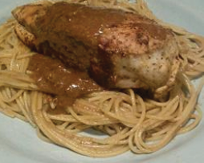

Ingredients

* 2 tablespoons olive oil
* 2 tablespoons butter
* ¼ onion, minced
* 2 tablespoons balsamic vinegar
* 2 teaspoons chicken bouillon granules
* 1 cup heavy cream
* ½ cup grated parmesan cheese

Balsamic

Cream

Sauce

The vinegar and cream go very well together. Best when chicken and asparagus is added to the mix. An all-time favorite paste sauce.

1. Heat olive **oil** and **butter** in a saucepan over medium low heat.
2. Stir in the **onion**, and cook until it has caramelized to a dark, golden brown, about 15 minutes.
3. Stir in the **balsamic** **vinegar**, and cook for 1 minute before stirring in the **chicken bouillon** and **cream**.
4. Bring to a simmer, then remove from the heat and stir in the **parmesan cheese** until melted.

Preparation 5 minutes

Cooking 20 minutes

Ready in 25 minutes ✓