**Changes in forest spatial structure due to beech bark disease, a novel forest pathogen**

2021-12-09

Michael Mahoney

Ph.D. Student

Graduate Program in Environmental Science,

State University of New York College of Environmental Science and Forestry,

mjmahone@esf.edu

**Abstract**

Beech bark disease is a novel disease system formed by the combination of both scale insects (*Cryptococcus fagisuga* and *Xylococculus betulae*) and fungal pathogens (*Neonectria faginata* and *Neonectria ditissima*). Over the last 100 years, beech bark disease has steadily advanced westward across the continent, altering forest structure and composition wherever it goes. As a way of understanding this disease, we conducted an exploratory study into the impacts of beech bark disease on the spatial arrangement of trees within a forest stand in New York’s Adirondack Park. Using measurements from 1985, 2000, and 2009, we investigated changes both in the forest’s spatial arrangement as a whole as well as that of individual species. We found that beech bark disease has caused a dramatic shift in forest spatial arrangement, as well as in the arrangement of some species, although this shift is not uniform across all subpopulations. These shifts provide a useful lens for understanding the impacts of this disease system on forest ecosystems. These results both clarify the impacts of beech bark disease within the northeastern United States, and suggest that ecologists should make use of spatial arrangement as a method for understanding complicated systems and how they evolve over time.

# 

# **1 Introduction**

Beech bark disease, a decline disease resulting from the combined effects of both scale insects (*Cryptococcus fagisuga* and *Xylococculus betulae*) and fungal pathogens (*Neonectria faginata* and *Neonectria ditissima*), has fundamentally restructured North American forests following its appearance in the late 19th century (Cale et al. 2017). While the disease itself only targets beech (referring exclusively in this report to American beech, *Fagus grandifolia*), the rapid mortality of this typically long-lived foundational species and the heavy regeneration typically produced following beech mortality frequently has dramatic impacts on stand structure and composition for the entire forest community, not solely beech (Cale et al. 2013; Forrester, McGee, and Mitchell 2003). These changes in turn result in negative impacts to many other ecosystem processes, both economic and non-economic, through a reduction in merchantable timber, food stocks for wildlife, and forest aboveground biomass (Busby and Canham 2011; Cale et al. 2017; Nyland et al. 2006). Despite these changes, the impacts of beech bark disease are fundamentally understudied due to the dominant view of beech as a “nuisance species.”

Among the understudied aspects of beech bark disease is how the total restructuring of forest communities shifts the spatial relationships between tree species, particularly given the mortality of many of the longest-lived individuals and heavy beech regeneration that is typically associated with the progression of beech bark disease. These spatial patterns are useful tools for predicting the future development of a stand and its probable economic and ecological value, and may be significantly impacted by the restructuring associated with beech bark disease’s entry into an area (Stoyan and Penttinen 2000). The spatial distribution of individuals may also impact the available seed stock and space for regeneration within the stand following the disease disturbance. However, the degree to which the spatial relationships within a stand are impacted, if they are at all, is largely unknown.

For this reason, we conducted an exploratory investigation into changes in the spatial relationships of a stand in the Huntington Wildlife Forest (HWF), a research forest located in the center of New York’s Adirondack Park (Johnson and Lindberg 1992). This stand, measured three times over the span of 25 years, reflects initially the “advance front” stage of beech bark disease, where scale insect proliferates in the absence of fungal pathogen and beech mortality is relatively low, while the final survey represents an “aftermath forest” following a peak of beech mortality and reduced disease activity. As such, this data set presents a unique opportunity to investigate changes in the spatial structure of the forest throughout the progression of beech bark disease. By investigating the changes in L-function for all trees within the stand as well as the cross-L function with random labeling for the four most common species across measurement periods, we aimed to identify potential changes in spatial structure associated with the progression of beech bark disease, in order to begin to understand how these changes may impact stand development and our ability to predict such for years to come.

# 

# **2 Literature Review**

Giencke et al. (2014), whose data was used for this study, investigated the spatial relationships between “parent” beech (surviving which had been present on the site in 2000) and beech saplings, as well as between beech saplings and beech or sugar maple mortality since 2000. Through a cross-L function using toroidal shifts, they identified beech recruitment as being clustered around recent mortality, as well as being associated with highly-diseased surviving canopy beech.

Morin and Liebhold (2015) showed how beech bark disease may impact forest stand structure and composition using USDA Forest Inventory and Analysis plot measurements from 2000 through 2010. Their results indicate that beech mortality increases notably following the introduction of beech bark disease, while net growth decreases in the following years. Importantly, their results indicate that other species potentially display compensatory growth following beech mortality, taking advantage of the reduced competition for space and other resources. This may potentially present a method for changes in stand spatial structure to result in changes in stand size structure and composition, as the limited resources of space and light may not be freed up uniformly throughout the stand.

McCullough and Wieferich (2015) similarly investigated beech bark disease impacts on forest stands, tracking the disease’s advancing front in locations across Michigan. They note that non-beech seedlings see faster growth in areas impacted by beech bark disease but without beech thickets, given the sudden availability of light and space to grow into. More relevant to the Northeast, where beech thickets are common, is their finding that thickets suppress non-beech species, resulting in limited regeneration except for beech saplings.

Gratzer and Waagepetersen (2018) investigated the impact of spatial arrangement on forest regeneration within an old-growth forest in Austria. Through a point-process model they identified seed dispersal as being significantly impacted by spatial arrangement, and additionally dispersal as a driver of gap regeneration separate from seed density and niche partitioning. This study points to the importance of forest spatial arrangements in sustaining ecosystem processes, and to potential impacts of beech bark disease on these systems.

# 

# **3 Study Area**

Data for this study were collected within a forest stand in the Huntington Wildlife Forest (HWF) in New York’s Adirondack Park at approximately 43°59’N, 74°14’W. The HWF is an experimental field station maintained by the SUNY College of Environmental Science and Forestry, and as such is not subject to the same restrictions as other state forest land within the Park; that said, there was no harvesting or other management activity on the plot across the 24-year span of the data. Elevation at HWF ranges from 450-820 m above sea level, with mean temperatures of 4.8°C and mean annual precipitation of 108.7 (Giencke et al. 2014). Tree locations within each measurement period are shown in Figure 1.

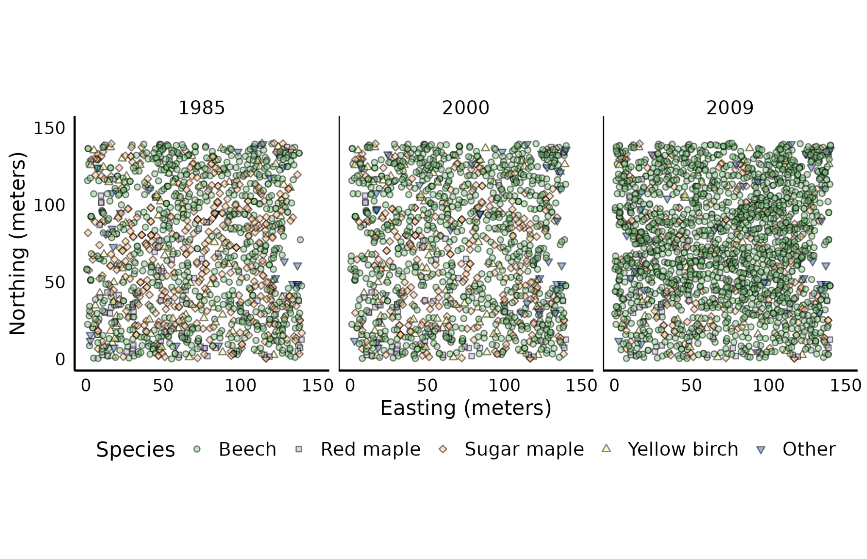

**Figure 1**: Map of the study area. Point shapes and colors represent differing species. Eastings and northings are measured in meters from the bottom-left corner of the plot.

# 

# **4 Datasets**

Data used in this study were originally collected in 1985 as part of the Integrated Forest Study, a national investigation of the impacts of atmospheric nutrient deposition, and then remeasured in 2000 and 2009 (Johnson and Lindberg 1992; Forrester, McGee, and Mitchell 2003; Giencke et al. 2014). The measured site consists of a 140 meter square located within Huntington Wildlife Forest in New York’s Adirondack Park (Figure 1). All trees with diameter at breast height (DBH) of 5 cm were identified at the species level and had their positions recorded using a Topcon total station in units of meters from the lower left corner of the square; if a tree’s measured position varied across two or more measurements, the most recent measurement was assumed to be correct for all study periods. This study used only data reflecting live trees during each measurement period; measurements of dead tree species and position were discarded. The measured stand was dominated across all years by beech and sugar maple, with notable inclusions of red maple and yellow birch alongside a small number of 12 other species.

# 

# **5 Methods and Results**

**5.1 Methods**

In order to assess the impacts of beech bark disease on stand structure, we investigated changes in Ripley’s univariate L-function values for the entire stand across the three measurement periods. The L-function is a rescaling of Ripley’s K-function, which summarizes the spatial patterns in a dataset at a given distance *h* through equation (1) (from Bailey and Gatrell (1995)):

(1)

Where *R* is the total area of the sampled area, *n* the number of observations within that area, and *Ih(dij)* an indicator function returning the number of events (in this situation, trees) within at most *h* distance from each other. By rescaling this value by the total circular area searched at a point when using distance *h*, we obtain Ripley’s L-function as shown in equation (2):

(2)

We calculated the L-function values for our observed data and compared it to 100 Monte Carlo simulations using random point locations within the same study area, in order to assess both if the location of trees were completely spatially random during any measurement period and if the overall spatial structure shifted at any point during the measurement period. The stand was deemed completely spatially random at a given distance if the observed L value was less extreme than that observed in any Monte Carlo simulation.

We additionally investigated the impacts of beech bark disease on the spatial structure of individual species with respect to the total forest. To do so, we made use of Ripley’s cross-L function with random labeling, which is similarly a transformation of Ripley’s cross-K function shown as equation (3):

(3)

Where *n1* now represents the number of observations in one subpopulation (here, of a given species), *n2* the number of observations in another subpopulation (here, all other tree species), and *Ih(dij)* an indicator function returning the number of events from one subpopulation within a maximum distance of *h* from an event from the other subpopulation. Rescaling this cross K-function by the total circular area searched at a point for a distance *h* gives us Ripley’s cross L-function:

(4)

Similarly to the univariate case, we calculated *Lij* for both the observed case as well as 100 Monte Carlo simulations using random labeling, where tree locations were preserved but each individual was assigned to a random subpopulation. Our objective was to assess both if individual species were spatially independent, as well as if the spatial relationship of the subpopulation changed over the measurement period. Species were deemed spatially independent at a given distance if their cross L-value was less extreme than observed in any random simulation.

Univariate L-function values were calculated using all live trees within each measurement period as a single group. Cross L-function values were calculated separately for each of four species (beech, red maple, sugar maple, and yellow birch). For each calculation, all other species (that is, all but the one being studied) were combined into an “other species” category. All analyses were performed using only live trees for each measurement period, using MATLAB R2021b (MATLAB).

## **5.2 Results**

Stand composition and structure changed dramatically over the study period, with the total number of trees in the stand increasing from 1,279 in 1985 to 1,856 in 2009 (Table 1). This trend was driven entirely by beech regeneration following beech bark disease related mortality; while beech prevalence more than doubled from 688 stems in 1985 to 1,488 in 2009, all other major species saw year-over-year declines. As a result, beech progressed from a co-dominant species in the stand to an outright dominant species, increasing from 53.79% of all stems in 1985 to 80.17% in 2009 (Table 1).

# **Table 1:** Number of trees per species per measurement year.

| **Species** | 1985 | 2000 | 2009 |
| --- | --- | --- | --- |
| Beech | 688 | 806 | 1488 |
| Red maple | 79 | 63 | 53 |
| Sugar maple | 385 | 262 | 227 |
| Yellow birch | 97 | 78 | 50 |
| Other | 30 | 37 | 38 |
| **Total** | **1279** | **1246** | **1856** |

As might be expected, this restructuring is associated with large shifts in stand spatial arrangement across the 24 year period (Figure 2). In the original 1985 measurement period stems exhibit some spatial regularity between distances of 1 to 5 meters, but are otherwise randomly distributed. By the 2000 measurement period, this has shifted such that stems are now regularly distributed between 1 and 3 meters, and are randomly distributed beyond that; by 2009, stems are only very weakly regular at a distance of 2 meters, and are clustered at distances beyond 7 meters.

This presents an interesting result, given the high amounts of mortality and regeneration seen in the stand. In a typical functioning forest, stems are generally regularly distributed as a result of founder effects, where any regeneration located too close to the well-established “parent” tree will likely be out-competed for light and resources and die as a result. This likely explains the regularity seen in the earlier measurements, reflecting normal regeneration dynamics for the northern forest. However, following large-scale mortality in the older generation, there is no longer the same suppressing effect preventing saplings from growing too close to their parent; instead, new stems are competing with one another as equals, and have not yet thinned out enough to enforce a regular distribution throughout the stand. This alteration of normal stand dynamics may be directly caused by the sudden disturbance to typical mortality and regeneration patterns.

Similarly, the clustering at further distances in the 2009 period is likely a direct result of the regeneration patterns of beech following beech bark disease. Beech saplings tend to concentrate themselves around recently deceased (or soon-to-be deceased) canopy trees, effectively replacing the original stem with a collection of saplings (Giencke et al. 2014). These canopy trees are frequently regularly distributed throughout the stand, having out-competed and excluded any neighbors they interacted with, resulting in a roughly even spacing between individuals in the mature stand. The observed clustering at further distances likely represents the intense regeneration focused on these locations following the non-random mortality of these successful individuals.

This spatial arrangement represents a very different stand than was present before beech bark disease related mortality. The loss of a certain minimum spacing between trees, alongside the uptick in clustering at further distances, suggests a stand with high competition for space between individuals (and as a correlate, for the nutrients, water, and light that sessile individuals can only capture by controlling space). This likely suppresses further regeneration in the stand, due to the limited resources available to new seedlings; due to beech’s domination of these patches (Table 1), this will likely result in other species being less prevalent or even completely excluded from the next generation. While these patches of beech regeneration will naturally thin themselves, with less-competitive individuals dropping out of the population as mortality, beech’s tolerance for low-light environments and tendency towards long lifespans may pose serious challenges to the regeneration of other species at this site without human intervention.

Trends within individual species are somewhat more complicated. Based upon Ripley’s cross L-function, beech exhibits slight regularity at near distances compared to the overall population across all measurement periods, though this regularity exists from 0-50 meters in both the 1985 and 2000 periods but only between 0-40 meters in 2009. Red maple, meanwhile, exhibits spatial regularity from 5 to 125 meters in all measurement periods, with minimal changes in spatial arrangement across measurement periods. Sugar maple exhibits regularity between 0-20 meters in 1985, as well as between 0-30 meters in 2000, while by 2009 it has become entirely independently distributed. Yellow birch, meanwhile, is spatially independent at all distances across all years. All of these patterns are displayed as Figure 3, with Figure 4 representing the same across a narrower range of distances.

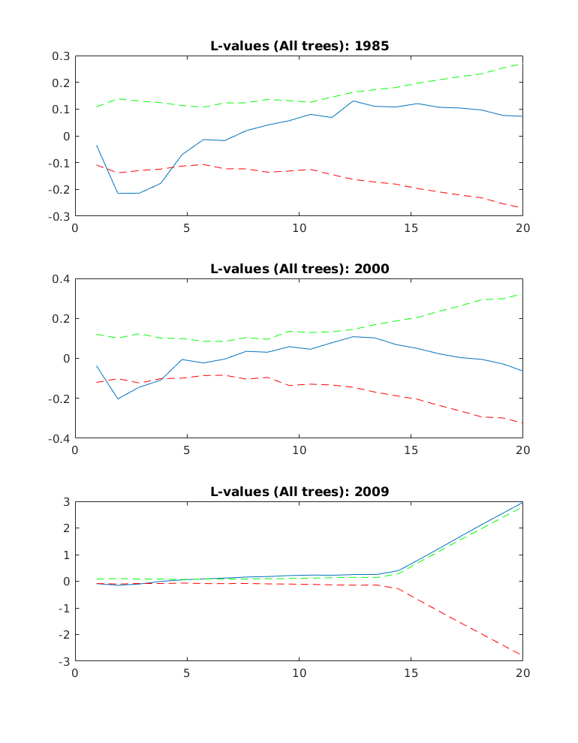**Figure 2:** L-function values (y-axis) for all live trees (blue) within each measurement period. Green and red lines represent the upper and lower (respectively) boundaries of 100 Monte-Carlo simulations using random labeling. The x-axis represents distance in meters. Observed (blue) values above the green line indicate clustering, below the red line indicate regularity, and between the two indicate spatial randomness. Graphs are truncated at the 20 meter mark, as all measurement periods exhibit spatial randomness beyond this point.

We are able to understand some of these trends by considering species separately. Yellow birch, for instance, is a relatively minor inclusion in the stand, ranging from 2.69% - 7.58% of all stems across the three measurement periods. While it has some slight mortality over the study period (Table 1), yellow birch does not see the same massive shifts in population as the other species, and as such does not see much change in its spatial arrangement. Meanwhile, yellow birch stems are primarily located on the edges of the plot (Figure 1). It is possible that, were we to slide our study area across the landscape, we would discover some trends in birch spatial arrangement which are not present in this beech-dominated plot.

Similarly, red maple comprises between 2.86% - 6.18% of all stems in each measurement period (Table 1), spread evenly throughout the plot. While red maple loses stems throughout the measurement periods, as a proportion of its original population red maple loses markedly fewer individuals than either yellow birch or sugar maple (~33% vs ca. 48% of yellow birch, 41% of sugar maple). As such, it makes sense that red maple does not see a large change in its spatial arrangement throughout the measurement periods, remaining regularly distributed across roughly the same range of distances for the entire 24 year period.

More complicated are the changes in beech and sugar maple spatial patterns over the study periods. The regular distribution of sugar maple at distances of 0-20 meters in 1985 may be explained as the normal space-partitioning of forest communities (as discussed for the univariate L-function), wherein mature trees exclude their competitors from a given space (and as a result given the sessile nature of plants, from the light, water, and nutrients within that space) causing mortality, with the end result being a roughly evenly spaced generation of mature trees. This regular distribution extending to 0-30 meters in 2000, however, likely reflects the combined effects of beech regeneration suppressing sugar maple seedlings while mature trees die. Beech bark disease is the only major pathogen known to be active in this stand over the course of the measurement period, meaning that sugar maple mortality is likely still effectively a random function of competitive fitness. As a result, as trees are removed from the population at effectively random locations without being replaced by new sugar maple regeneration (between 1985 and 2000) the distance between individuals increases, but the overall pattern does not change. This produces the increased range of the regular distribution seen in the 2000 measurement period. However, after a point subsequent mortality without replacement begins to alter the spatial arrangement of stems, resulting in the species becoming independently distributed in the 2009 period.

The change in beech distribution throughout the study periods is slight, with beech being regularly distributed from 0-50 meters in both 1985 and 2000 but only from 0-40 meters in 2009. Some of this change may be a result of beech’s increasing dominance over the stand, increasing from 53.79% of all stems in 1985 to 80.17% in 2009 (Table 1). There simply may not be many other individuals of other species at distances beyond 40 meters in the 2009 sample, as they’ve been largely excluded through the combination of natural mortality and suppressed regeneration.

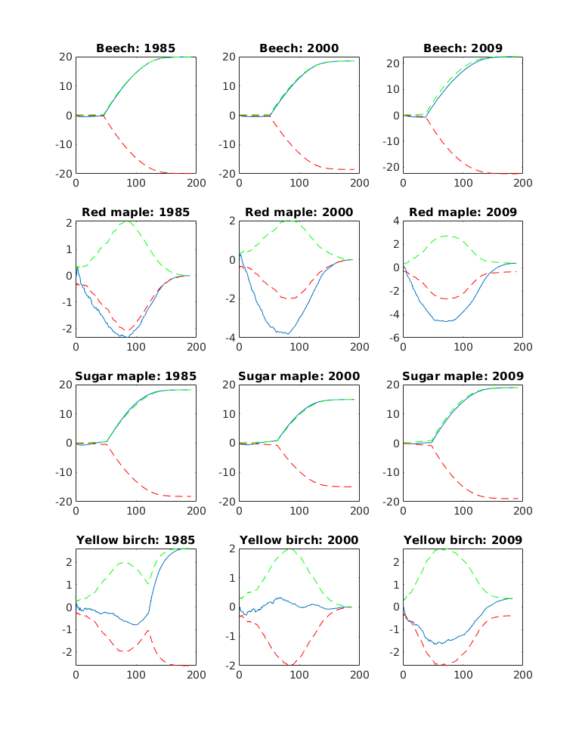**Figure 3:** Cross-L function (y-axis) values using random labelling for each species compared to all other species (blue) for each measurement period, for distances between 0 and 200 meters. Green and red lines represent the upper and lower (respectively) boundaries of 100 Monte-Carlo simulations using random labeling. The x-axis represents distance in meters.

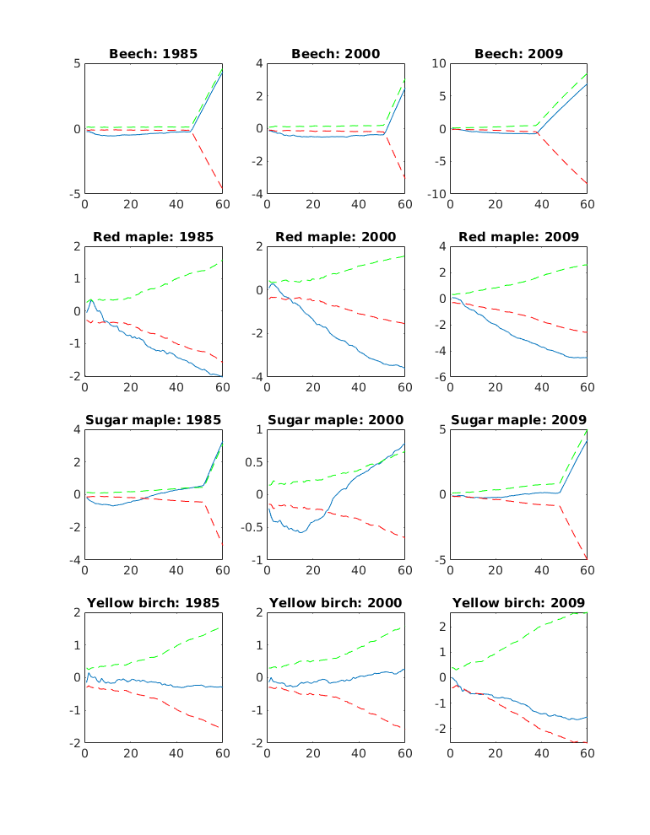

**Figure 4:** Cross-L function (y-axis) values using random labelling for each species compared to all other species (blue) for each measurement period, as in Figure 3, for distances between 0 and 60 meters. Green and red lines represent the upper and lower (respectively) boundaries of 100 Monte-Carlo simulations using random labeling. The x-axis represents distance in meters.

Forests which have been previously impacted by beech bark disease are frequently referred to as “aftermath forests”, given the outsized impacts on stand composition and structure associated with the disease. These forests are characterized by the near-complete absence of large beech, with survivors badly marred and generally in ill health, as well as by the presence of dense “beech thickets” which compete with themselves and suppress the regeneration of other species (Cale 2017). The results of this investigation suggest that these forests may also be characterized by notable changes in spatial arrangement, with the typical patterns of mature forests replaced by novel structures. Whereas pre-disease stands will typically see trees be regularly distributed at close distances, reflecting the exclusion of competitors by established mature stems, this study found stems randomly distributed at closer distances and clustered at further reaches. Similarly, while the impacts of stand restructuring on individual subpopulations were mixed, we found that the combination of natural stem mortality combined with the suppression of regeneration by beech thickets altered the spatial arrangement of sugar maple, originally an important codominant.

As always in ecology, the interpretation of the impact of these changes is dependent upon one’s values. For instance, Mahoney and Stella (2020) suggest that beech bark disease is among the reasons beech are more heavily utilized by beaver in the Adirondack Park than in other regions; harvesting is encouraged by the presence of more stems in the ideal size class for foraging and hauling (2 - 7 cm) following disease introduction. Similarly, beech thickets provide a source of young forest habitat and can be an important component of biodiversity across a landscape, particularly in regions (such as the Adirondack Park) where young forest is particularly rare (Cale et al. 2013). Beech can also provide unique aesthetic values, both as live stems and as wood products (Bekhta et al. 2014). While there are few (if any) calls for introducing beech bark disease to regions as a method to promote young forests and wildlife benefits, it is worth acknowledging the benefits associated with these novel systems.

However, traditionally the discussion of beech (and particularly of beech-dominated stands within aftermath forests) views beech as a problem to be solved. The high-density beech thickets (which result in the shift from a regular distribution to a random distribution at short distances, Figure 2) produce an understory environment which shades out the majority of competitors, suppressing regeneration for all species except beech. These thickets tend to persist in the understory for a number of years, given the high shade tolerance of beech, meaning that it can be many years before competitor species are able to regenerate. Meanwhile, even when the thickets do finally thin out, the lingering *Neonectria* and scale insects (*Cryptococcus* and *Xylococculus*) will quickly reinfect and kill the successful beech, triggering the production of new root sprouts and a new beech thicket to quickly replace the first. In concert, these patterns can quickly work to remove co-dominants and minor inclusions from a forest stand, replacing dynamic communities with beech-dominated stands in a constant cycle of disease and death.

With this change comes a number of changes to the ecosystem services and values provided by the forest. The loss of mature beech results in the loss of beech nuts, an important food for many fauna, as well as the loss of many wildlife trees (those that provide habitat for one or more animals) as the larger trees die and fall. Meanwhile, beech does not provide many economic services to humans, with its wood being largely useless for construction and furniture making. The same cannot be said for its common co-dominants of red maple and sugar maple, both of which produce valuable timber (to say nothing of sugaring), or of common early-successional species such as black cherry which would typically establish following disease mortality but are suppressed by beech thickets. Unfortunately, our results do not suggest that these typical dynamics are reasserting themselves in the aftermath forest; instead, we see the spatial arrangements of previously important codominant species such as sugar maple shifting to resemble those of minor inclusions such as yellow birch, with regularity at closer distances being supplanted by spatial independence. Similarly, the shift from regularity to randomness in the univariate L-function suggests a stand with intense competition for resources, an environment in which the stress-tolerant beech is likely to succeed.

A core limitation of using solely spatial arrangement to investigate the changes in a stand over time is the lack of other types of information about the system. In particular, we have needed to rely upon the image of the stand as a typical aftermath forest, with heavy mortality in the larger size classes and intensive beech regeneration which suppresses all other species, as described by Giencke et al. (2014) and Cale et al. (2017), in order to fully interpret our results in an ecological context. Other methods of investigation -- including models of stem mortality and regeneration composition -- would be essential to building a full understanding of this system and any potential management avenues. Similarly, we’ve attempted to discuss this stand in a values-free manner, without contextualizing any changes in structure, composition, or spatial arrangement as normatively “good” or “bad”; making decisions about what the stand “should” look like would require additional information and investigation into landowner values and goals. In particular, given the location of our study site within an experimental field station and wildlife forest within the Adirondack Park, the largest protected area in the continental United States, viewing this particular stand through the basis of economic values might be a mistake.

Despite this, our results present changes in the spatial arrangement of a forest stand as an interesting and useful lens through which to view changes in stand structure and composition. Changes in stand competitiveness are reflected as changes in spatial arrangement at closer distances, as regeneration establishes and stems begin to compete for space and other resources. Meanwhile, the fall of sugar maple from codominant status to a minor inclusion in the stand is reflected in its arrangement as a subpopulation, shifting from being regularly distributed at closer distances (similarly to beech itself) to being randomly distributed, similarly to yellow birch. In combination with an ecological understanding of forest dynamics, these changes allow us to understand stand trajectory and predict what challenges the future will hold. In this way, spatial arrangement can be a useful guide for forest management, helping us identify what problems exist and potentially leading us to methods for creating the future we wish to see.

# **6 Conclusions**

Beech bark disease is capable of fundamentally restructuring forest stands, removing many of the largest individuals and suppressing the regeneration of non-beech species. We investigated the effects of these impacts on the spatial arrangement of trees within a stand in New York’s Adirondack Park, and found that beech bark disease dramatically impacts how stems are arranged throughout the forest. The typical regular distribution of stems throughout the stand, where trees growing too close to a larger individual are out-competed and die off, is replaced by a random distribution following intensive beech regeneration, while sugar maple similarly saw its subpopulation move from being regularly distributed to being spatially independent following overstory mortality without regeneration to replace it.

While not sufficient for understanding this system in a vacuum, investigating the impacts of beech bark disease on a forest stand through spatial arrangement of trees and species presents a useful method for understanding the disease’s impact. When combined with other sources of information, tracking changes in spatial arrangement allows us to understand the changes in forest structure and the relative importance of species. Compared to alternative metrics, spatial arrangement allows us to determine if impacts are uniform across the measured area, and to infer the degree to which changes affect regular stand function. However, they do not provide a perfect window into the impacts of the disease; supplementing spatial statistics with information about stem size classes, species composition, and mortality is essential for a full understanding of the impacts of beech bark disease upon this stand.

# 

# **7 Future Work**

# Ecologists are still just beginning to understand what forest dynamics look like in the wake of beech bark disease. Research into these dynamics -- including further monitoring of the site at Huntington Wildlife Forest used in this study -- will remain essential for years to come in helping environmental managers and stakeholders understand aftermath forest trajectories and to steer forests in ways that maximize ecosystem services or economic values. This research should incorporate questions about spatial arrangement, and how it changes as beech thickets begin to thin themselves out. While our snapshot of 24 years of disease progression suggests beech are excluding other species from the stand without much hope for the original community composition, it is possible future research would show a path forward through which these systems might reach a healthier future.

# 

# **References**

Bailey, Trevor C., and Anthony C Gatrell. 1995. *Interactive spatial data analysis*. London, UK: Longman.

Bekhta, Pavlo, Stanisław Proszyk, Barbara Lis, and Tomasz Krystofiak. 2014. "Gloss of thermally densified alder (Alnus glutinosa Goertn.), beech (Fagus sylvatica L.), birch (Betula verrucosa Ehrh.), and pine (Pinus sylvestris L.) wood veneers." *European Journal of Wood and Wood Products* 72(6): 799-808.

Busby, Posy E., and Charles D. Canham. 2011. “An Exotic Insect and Pathogen Disease Complex Reduces Aboveground Tree Biomass in Temperate Forests of Eastern North America.” *Canadian Journal of Forest Research* 41 (2): 401–11.<https://doi.org/10.1139/X10-213>.

Cale, Jonathan A., Mariann T. Garrison-Johnston, Stephen A. Teale, and John D. Castello. 2017. “Beech Bark Disease in North America: Over a Century of Research Revisited.” *Forest Ecology and Management* 394: 86–103.<https://doi.org/10.1016/j.foreco.2017.03.031>.

Cale, Jonathan A., Stacy A. McNulty, Stephen A. Teale, and John D. Castello. 2013. “The Impact of Beech Thickets on Biodiversity.” *Biological Invasions* 15: 699–706.<https://doi.org/10.1007/s10530-012-0319-5>.

Forrester, Jodi A., Gregory G. McGee, and Myron J. Mitchell. 2003. “Effects of Beech Bark Disease on Aboveground Biomass and Species Composition in a Mature Northern Hardwood Forest, 1985 to 2000.” *The Journal of the Torrey Botanical Society* 130 (2): 70–78.<http://www.jstor.org/stable/3557531>.

Giencke, Lisa M., Martin Dovčiak, Giorgos Mountrakis, Jonathan A. Cale, and Myron J. Mitchell. 2014. “Beech Bark Disease: Spatial Patterns of Thicket Formation and Disease Spread in an Aftermath Forest in the Northeastern United States.” *Canadian Journal of Forest Research* 44 (9): 1042–50.<https://doi.org/10.1139/cjfr-2014-0038>.

Goreaud, Francois, and Raphael Pélissier. 2003. “Avoiding misinterpretation of biotic interactions with the intertype *K12*-function: population independence vs. random labelling hypotheses.” *Journal of Vegetation Science*, 14: 681-692.<https://doi.org/10.1111/j.1654-1103.2003.tb02200.x>

Gratzer, Georg, and Rasmus P. Waagepetersen. 2018. “Seed Dispersal, Microsites or Competition—What Drives Gap Regeneration in an Old-Growth Forest? An Application of Spatial Point Process Modelling.” *Forests*, 9(5): 230. <https://doi.org/10.3390/f9050230>

Johnson, Dale W., and Steve E. Lindberg, eds. 1992. *Atmospheric Deposition and Forest Nutrient Cycling: A Synthesis of the Integrated Forest Study*. New York: Springer-Verlag.

Mahoney, Michael J., and John C. Stella. 2020. “Stem size selectivity is stronger than species preference for beaver, a central place forager.” *Forest Ecology and Management*, 475: 118331. <https://doi.org/10.1016/j.foreco.2020.118331>

MATLAB. (2021). *Version R2021b*. Natick, Massachusetts: The MathWorks Inc.

McCullough, Deborah G., and James B. Wieferich. 2015. Beech bark disease in Michigan: Spread of the advancing front and stand-level impacts. Chapter 11 in K.M. Potter and B.L. Conkling, eds., Forest Health Monitoring: National Status, Trends and Analysis, 2014. General Technical Report SRS-209. Asheville, North Carolina: U.S. Department of Agriculture, Forest Service, Southern Research Station. p. 125-132.

Morin, Randall S., and Andrew M. Liebhold. 2015. “Invasions by two non-native insects alter regional forest species composition and successional trajectories.” *Forest Ecology and Management* 341: 67-74. <https://doi.org/10.1016/j.foreco.2014.12.018>

Nyland, Ralph D., Amy L. Bashant, Kimberly K. Bohn, and Jane M. Verostek. 2006. “Interference to Hardwood Regeneration in Northeastern North America: Ecological Characteristics of American Beech, Striped Maple, and Hobblebush.” *Northern Journal of Applied Forestry* 23 (1): 53–61.<https://doi.org/10.1093/njaf/23.1.53>.

Stoyan, Dietrich, and Antti Penttinen. 2000. “Recent Applications of Point Process Methods in Forestry Statistics.” *Statistical Science* 15 (1): 61–78.<http://www.jstor.org/stable/2676677>.