Simulating data from summary statistics with stats2data

Overview
stats2data simulates raw datasets whose summary statistics match reported summary statistics (the targets). Each module defines an objective, the discrepancy between the summary statistics of a candidate dataset and the targets, and minimizes it with simulated annealing. A run stops once the best objective value falls below the convergence threshold thresh or once the iteration budget is spent. In this vignette, a run whose best objective value is below thresh is called converged.
Convergence is a statement about the optimization only, that is, the simulated summary statistics reproduce the targets to within thresh. Many different datasets share the same summary statistics, and a simulated dataset is one of them. The results below are therefore described in terms of the optimization objective values, target-vs-simulated differences, run-to-run variability.
The vignette works through four examples:
- the Descriptives module (optim_vec()), using summary statistics of a simulated dataset with continuous and integer variables;
- the ANOVA module (optim_aov()), using the reported cell means and F-statistics of Reynolds and Besner (2008);
- the MLR module (optim_mlr()), using the reported descriptives, correlations, and regression estimates of Bardwell et al. (2003, 2007);
- the parallel workflow (parallel_optim()), using the MLR example.
Across the examples, the following functions are demonstrated:
- the optimization functions optim_vec(), optim_aov(), optim_mlr(), and parallel_optim(), and the refinement step hill_climb();
- the GRIM check check_grim();
- the inspection methods print(), summary(), get_stats(), get_rmse(), and coef();
- the plotting functions plot_convergence(), plot_cooling(), plot_fit(), plot_stability(), and the plot() methods;
- the Shiny interface run_app().

Installation
# release version from CRAN
install.packages("stats2data")
# development version from GitHub
# install.packages("remotes")
remotes::install_github("sebastian-lortz/stats2data")

Setup
library(stats2data)
library(ggplot2)

1. Descriptives module: simulated example
optim_vec() simulates one vector per variable that reproduces a target mean and SD within given bounds. To illustrate its use, the targets are computed from a small simulated dataset with two continuous variables and one integer-valued variable.

1.1 Encoding the targets
set.seed(2026)
N <- 150
example_data <- data.frame(
x1 = rnorm(N, mean = 100, sd = 15), # continuous, symmetric
x2 = rgamma(N, shape = 2, scale = 3), # continuous, right-skewed
x3 = rbinom(N, size = 20, prob = 0.3) # integer-valued
)
The targets are the means and SDs rounded to two decimals, as they would typically be reported. The bounds are the observed minimum and maximum, rounded outward:
target_mean <- round(sapply(example_data, mean), 2)
target_sd <- round(sapply(example_data, sd), 2)
range <- rbind(lower = floor(sapply(example_data, min)),
upper = ceiling(sapply(example_data, max)))
integer <- c(FALSE, FALSE, TRUE)
target_mean
#> x1 x2 x3
#> 99.65 6.25 6.15
target_sd
#> x1 x2 x3
#> 15.36 4.15 2.26
range
#> x1 x2 x3
#> lower 61 0 1
#> upper 140 23 13
range holds one column of lower and upper bounds per variable; a vector of length two applies the same bounds to all variables. integer marks which variables are integer-valued.

1.2 GRIM check
For integer-valued data, not every mean is attainable: the sum of N integers divided by N can only take values on a grid of width 1 / N. The GRIM test (Brown & Heathers, 2017) checks whether a reported mean, rounded to decimals, lies on that grid:
check_grim(n = N, target_mean = target_mean[["x3"]], decimals = 2)
#> $test
#> [1] TRUE
#>
#> $grim_mean
#> [1] 6.15
For a mean that fails, grim_mean returns the nearest attainable mean (hypothetical values):
check_grim(n = 7, target_mean = 3.45, decimals = 2)
#> $test
#> [1] FALSE
#>
#> $grim_mean
#> [1] 3.43

1.3 Running the optimizer
For continuous variables, optim_vec() starts from a vector whose mean lies within thresh of the target mean and anneals the values toward the target SD; the moves keep the mean fixed. For integer variables, it draws a distribution from SPRITE (Heathers et al., 2018) via rsprite2 whose mean and SD match the targets at the number of decimals given by sprite_prec. The objective of each variable is the absolute difference between its simulated and target SD.
Both statistics are given to two decimals, so sprite_prec = c(2, 2), and thresh = 0.005 is set to half a unit of the last decimal (both are the defaults). The remaining arguments are at their defaults (max_iter = 5e5, init_temp = 1e-3, cooling_rate = NULL, i.e. (max_iter - 10) / max_iter, max_starts = 3).
set.seed(2026)
result_vec <- optim_vec(
N = N,
target_mean = target_mean,
target_sd = target_sd,
range = range,
integer = integer,
sprite_prec = c(2, 2),
thresh = 0.005
)

1.4 Inspecting the result
print() shows the sample size and the best objective value per variable:
result_vec
#> stats2data Descriptives result
#> Variables: 3
#> N: 150
#> Best objective per variable:
#> x1: 0.002753
#> x2: 0.004366
#> x3: 0.0003847
The best objective values are below thresh = 0.005 for all three variables. summary() adds the target and simulated means and SDs and their RMSEs; the largest absolute difference between a simulated and a target mean is 0.00499:
summary(result_vec)
#> stats2data Descriptives Summary
#> -----------------------------------------------
#> N: 150 | Variables: 3
#>
#> Best objective per variable:
#> x1: 0.002753
#> x2: 0.004366
#> x3: 0.0003847
#>
#> RMSE
#> Means: 0.004505
#> SDs: 0.002988
#>
#> Target vs. Simulated:
#> variable target_mean sim_mean target_sd sim_sd
#> x1 99.65 99.645 15.36 15.357
#> x2 6.25 6.255 4.15 4.146
#> x3 6.15 6.147 2.26 2.260
get_stats() returns the simulated statistics and get_rmse() the RMSEs between simulated and target statistics:
get_stats(result_vec)
#> $mean
#> x1 x2 x3
#> 99.645019 6.254995 6.146667
#>
#> $sd
#> x1 x2 x3
#> 15.357247 4.145634 2.259615
get_rmse(result_vec)
#> $rmse_mean
#> [1] 0.004504504
#>
#> $rmse_sd
#> [1] 0.002988441
If SPRITE finds no distribution for an integer variable, the reason is stored per variable in error_msgs (NULL when SPRITE succeeded):
result_vec$error_msgs
#> [[1]]
#> NULL
#>
#> [[2]]
#> NULL
#>
#> [[3]]
#> NULL

1.5 Diagnostics
plot_convergence() shows the best objective value across iterations. For a stats2data_vec result, run selects the variable. log_y = TRUE uses a logarithmic y axis, and the shaded band marks the region below thresh.
plot_convergence(result_vec, run = 1, log_y = TRUE)
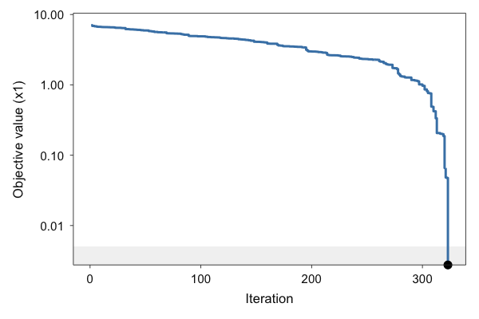
The trajectory of x1 has 323 iterations. Integer variables are drawn by SPRITE without annealing, so their trajectory consists of a single value.
plot_cooling() shows the temperature schedule implied by init_temp, cooling_rate, and max_iter:
plot_cooling(result_vec)
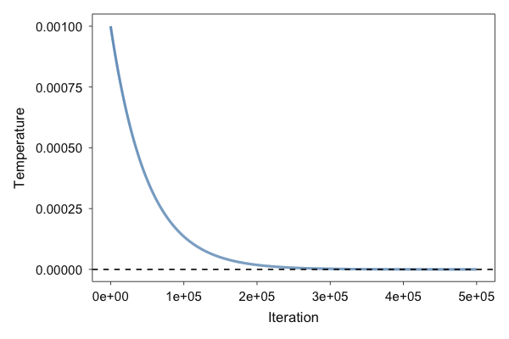

1.6 Target vs. simulated statistics
plot_fit() plots the difference between simulated and target statistics. With standardised = FALSE, the differences are on the original scale; the shaded band marks +/- thresh. order = "fit" sorts the statistics by absolute difference.
plot_fit(result_vec, standardised = FALSE, order = "fit")
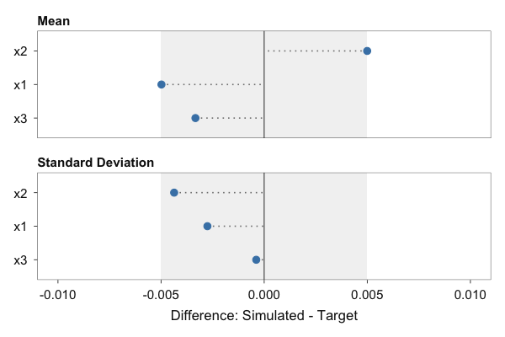
The same plots are available through plot(), with which selecting the panel:
plot(result_vec) # plot_convergence()
plot(result_vec, which = "cooling") # plot_cooling()
plot(result_vec, which = "fit") # plot_fit()

1.7 Simulated data
The simulated data are stored in result_vec$data, one column per variable:
data_vec <- result_vec$data
head(data_vec)
#> x1 x2 x3
#> 1 108.56228 6.043737 9
#> 2 109.49172 1.140020 9
#> 3 93.02921 8.372150 6
#> 4 94.24471 1.906615 6
#> 5 98.47697 1.315124 6
#> 6 76.09617 7.676196 9
data_long <- data.frame(
variable = factor(rep(names(data_vec), each = nrow(data_vec)), levels = names(data_vec)),
value = unlist(data_vec, use.names = FALSE)
)
ggplot(data_long, aes(x = value)) +
geom_histogram(bins = 15, fill = "grey60", colour = "grey20") +
facet_wrap(~ variable, scales = "free") +
labs(x = NULL, y = "Count") +
theme_minimal()
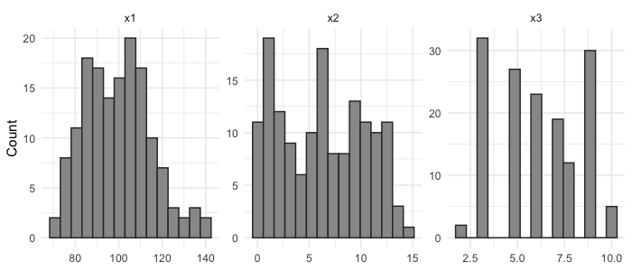

2. ANOVA module: Reynolds and Besner (2008)
Reynolds and Besner (2008, Experiment 5) examined how contextual predictability affects response times in word and nonword naming; the study was among those replicated by the Open Science Collaboration (2015). To our knowledge, the raw data are not publicly available.

2.1 Reported summary statistics
The study reports a 2 x 2 within-subjects design (S = 16) with four cell means, indexed by stimulus type (Factor1) and switch condition (Factor2): 543, 536, 614, and 618 ms. It reports MSE = 3070 for the Factor1 effect, F(1, 15) = 30.5 (partial eta squared .670) for Factor1, and F < 1 for Factor2 (.002) and the interaction (.015).
S <- 16
mse <- 3070
target_group_means <- c(543, 536, 614, 618)
eta2 <- c(0.002, 0.015) # Factor2, Factor1:Factor2
df_err <- S - 1
The numerator mean squares implied by the cell means of the balanced 2 x 2 within-subjects design are:
m_cell <- matrix(target_group_means, nrow = 2, byrow = TRUE) # rows: Factor1, cols: Factor2
m_grand <- mean(m_cell)
ms_f1 <- S * 2 * sum((rowMeans(m_cell) - m_grand)^2)
ms_f2 <- S * 2 * sum((colMeans(m_cell) - m_grand)^2)
ms_int <- S * sum((m_cell - outer(rowMeans(m_cell), colMeans(m_cell), "+") + m_grand)^2)
c(ms_f1 = ms_f1, ms_f2 = ms_f2, ms_int = ms_int)
#> ms_f1 ms_f2 ms_int
#> 93636 36 484
The reported Factor1 statistics are consistent with each other: the implied mean square divided by the reported MSE gives F = 30.5, and F / (F + df_error) gives the reported partial eta squared of .670.
stopifnot(round(ms_f1 / mse, 1) == 30.5)
stopifnot(round(30.5 / (30.5 + df_err), 3) == 0.670)
For the two effects reported as F < 1, the F-statistics are set from the reported partial eta squared via F = eta^2 * df_error / (1 - eta^2) (one numerator degree of freedom). The modules require bounds for the outcome, which the study does not report; the range of the reported cell means is extended by four times sqrt(MSE), the residual SD implied by the MSE, and rounded outward. The summary statistics are encoded in one list of optim_aov() arguments:
F_value_derived <- c(round(ms_f1 / mse, 1), round(eta2 * df_err / (1 - eta2), 3))
sumstats <- list(
S = S,
levels = c(2, 2),
factor_type = c("within", "within"),
formula = "outcome ~ Factor1 * Factor2 + Error(ID / (Factor1 * Factor2))",
integer = FALSE,
target_f_list = list(
effect = c("Factor1", "Factor2", "Factor1:Factor2"),
F_value = F_value_derived
),
target_group_means = target_group_means,
range = c(floor(min(target_group_means) - 4 * sqrt(mse)),
ceiling(max(target_group_means) + 4 * sqrt(mse)))
)
sumstats$target_f_list$F_value
#> [1] 30.500 0.030 0.228
sumstats$range
#> [1] 314 840
target_group_means lists the cells with Factor1 varying slowest (11, 12, 21, 22). Between-subjects and mixed designs are specified through factor_type (and, for unequal group sizes, subgroup_sizes).

2.2 Simulating a dataset
optim_aov() is called with its default hyperparameters (max_iter = 3e4, thresh = 0.005, max_starts = 3, init_temp = 1e-3, cooling_rate = NULL, i.e. (max_iter - 10) / max_iter). The objective is the RMSE between the simulated and target F-statistics.
set.seed(2026)
result_aov <- do.call(optim_aov, sumstats)

2.3 Inspecting the output
result_aov
#> stats2data ANOVA result
#> Design: 2 x 2 (within, within)
#> Subjects: 16
#> Effects: Factor1, Factor2, Factor1:Factor2
#> Best objective: 0.00346117
summary(result_aov)
#> stats2data ANOVA Summary
#> -----------------------------------------------
#> Design: 2 x 2 (within, within)
#> Subjects:
#> Best objective: 0.00346117
#>
#> RMSE
#> F-statistics: 0.003461
#> Group means: 9.747e-13
#>
#> -----------------------------------------------
#> F-values (Target vs. Simulated):
#> effect target_F sim_F
#> Factor1 30.500 30.49911
#> Factor2 0.030 0.02408
#> Factor1:Factor2 0.228 0.22774
#>
#> -----------------------------------------------
#> Group Means (Target vs. Simulated):
#> cell target_mean sim_mean
#> F1=1, F2=1 543 543
#> F1=1, F2=2 536 536
#> F1=2, F2=1 614 614
#> F1=2, F2=2 618 618
The simulated F-statistics are 30.499, 0.024, 0.228 for Factor1, Factor2, and Factor1:Factor2 (targets 30.5, 0.030, 0.228); the F-statistic RMSE is 0.003 and the cell-mean RMSE 0.000000000000975.
Before the annealing, optim_aov() may shift the target cell means by less than thresh so that the means and F-statistics can be matched jointly. The values used are stored in adjusted_targets:
result_aov$adjusted_targets
#> $group_means
#> [1] 543 536 614 618
#>
#> $F_values
#> [1] 30.500 0.030 0.228
get_stats() returns the ANOVA table of the simulated data (fitted with afex), the F-statistics, and the cell means; get_rmse() returns the two RMSEs:
get_stats(result_aov)
#> $model
#> Anova Table (Type 3 tests)
#>
#> Response: outcome
#> num Df den Df MSE F ges Pr(>F)
#> Factor1 1 15 3070.1 30.4991 0.43050 5.852e-05 ***
#> Factor2 1 15 1495.2 0.0241 0.00029 0.8788
#> Factor1:Factor2 1 15 2125.2 0.2277 0.00389 0.6401
#> ---
#> Signif. codes: 0 '***' 0.001 '**' 0.01 '*' 0.05 '.' 0.1 ' ' 1
#>
#> $F_value
#> [1] 30.49911423 0.02407665 0.22773815
#>
#> $mean
#> 1_1 1_2 2_1 2_2
#> 543 536 614 618
get_rmse(result_aov)
#> $rmse_F
#> [1] 0.003461175
#>
#> $rmse_mean
#> [1] 9.746616e-13

2.4 Diagnostics
The convergence trajectory (first_iter = 1 skips the first iteration) and the target-vs-simulated differences are obtained with:
plot_convergence(result_aov, first_iter = 1, log_y = TRUE)
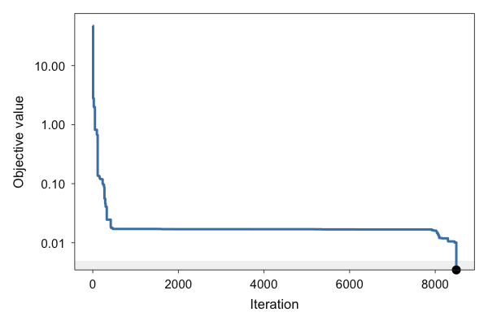
plot_fit(result_aov, standardised = FALSE)
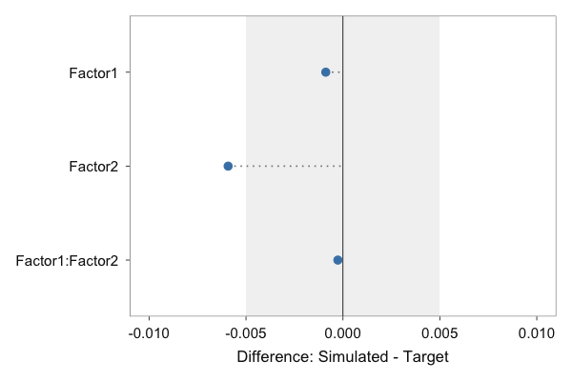
first_iter = 5000 plots from iteration 5000 onwards:
plot_convergence(result_aov, first_iter = 5000)
plot_cooling() shows the temperature schedule:
plot_cooling(result_aov)
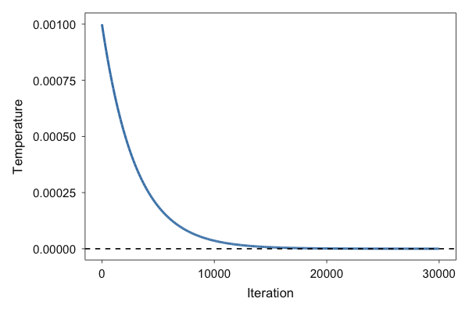

2.5 Simulated data
The data are stored in long format, one row per subject and cell. The simulated observations lie within range; the second line checks whether any observation equals one of the bounds:
range(result_aov$data$outcome)
#> [1] 469.2889 735.7955
any(result_aov$data$outcome %in% sumstats$range)
#> [1] FALSE
data_aov <- result_aov$data
head(data_aov)
#> ID Factor1 Factor2 outcome
#> 1 1 1 1 526.5609
#> 2 1 1 2 594.2713
#> 3 1 2 1 641.5214
#> 4 1 2 2 551.0167
#> 5 2 1 1 535.8782
#> 6 2 1 2 549.8449
aggregate(outcome ~ Factor1 + Factor2, data = data_aov, FUN = mean)
#> Factor1 Factor2 outcome
#> 1 1 1 543
#> 2 2 1 614
#> 3 1 2 536
#> 4 2 2 618
ggplot(data_aov, aes(x = interaction(Factor1, Factor2, sep = "-"), y = outcome)) +
geom_jitter(width = 0.1, colour = "grey40") +
stat_summary(fun = mean, geom = "point", shape = 4, size = 4) +
labs(x = "Cell (Factor1-Factor2)", y = "Outcome") +
theme_minimal()
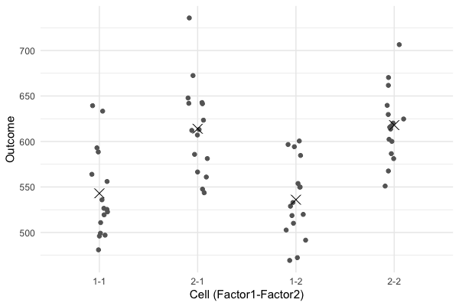
Crosses mark the simulated cell means.

3. MLR module: Bardwell et al. (2003)
Bardwell et al. (2003) examined whether depressive symptoms or apnea severity better predict fatigue in N = 60 patients with obstructive sleep apnea. This example uses the statistics reported there:
- means, SDs, and ranges from Table 1;
- the regression of fatigue on both apnea indices and depressive symptoms (Step 2) from Table 2;
- the correlations of the three predictors with fatigue from the Results section.
The same descriptives and coefficients are reprinted in Bardwell et al. (2007), with ranges rounded to integers. The variables are the respiratory disturbance index (RDI), the percentage of time with oxygen saturation below 90% (SaO2), the Center for Epidemiological Studies Depression Scale score (CESD), and the fatigue-inertia subscale of the Profile of Mood States (Fatigue). To our knowledge, the raw data are not publicly available.

3.1 Encoding the targets
N <- 60
target_mean <- c(RDI = 48.8, SaO2 = 17.3, CESD = 12.6, Fatigue = 10.8)
target_sd <- c(RDI = 27.1, SaO2 = 20.1, CESD = 11.3, Fatigue = 7.3)
range <- rbind(lower = c(RDI = 15, SaO2 = 0, CESD = 0, Fatigue = 0),
upper = c(RDI = 111, SaO2 = 80.9, CESD = 49, Fatigue = 28))
integer <- c(FALSE, FALSE, TRUE, TRUE)
RDI and SaO2 are treated as continuous, CESD and Fatigue as integer-valued sum scores. Both means pass the GRIM check:
vapply(c("CESD", "Fatigue"), function(v) {
check_grim(n = N, target_mean = target_mean[[v]], decimals = 1)$test
}, logical(1))
#> CESD Fatigue
#> TRUE TRUE
target_cor holds the upper triangle of the correlation matrix of all variables in target_mean, in the order of target_mean. Unreported correlations are NA and excluded from the objective:
vars <- names(target_mean)
cor_mat <- matrix(NA_real_, 4, 4, dimnames = list(vars, vars))
cor_mat["RDI", "Fatigue"] <- 0.11
cor_mat["SaO2", "Fatigue"] <- 0.20
cor_mat["CESD", "Fatigue"] <- 0.68
target_cor <- cor_mat[upper.tri(cor_mat)]
target_cor
#> [1] NA NA NA 0.11 0.20 0.68
target_reg and target_se follow the terms of reg_equation, intercept first. The intercept is not reported; it is derived from the means and slopes via b0 = mean(Fatigue) - sum(b * mean(X)), and its standard error is set to NA:
reg_equation <- "Fatigue ~ RDI + SaO2 + CESD"
b <- c(RDI = 0.023, SaO2 = 0.008, CESD = 0.438)
b0 <- target_mean[["Fatigue"]] - sum(b * target_mean[names(b)])
target_reg <- c("(Intercept)" = round(b0, 3), b)
target_se <- c(NA, 0.034, 0.048, 0.066)
target_reg
#> (Intercept) RDI SaO2 CESD
#> 4.020 0.023 0.008 0.438
The arguments are collected in one list, which is reused in Section 4:
args_mlr <- list(
N = N,
target_mean = target_mean,
target_sd = target_sd,
range = range,
integer = integer,
sprite_prec = c(1, 1),
reg_equation = reg_equation,
target_cor = target_cor,
target_reg = target_reg,
target_se = target_se,
thresh = 0.005
)

3.2 Running the optimizer
optim_mlr() first calls optim_vec() to simulate the marginals and then optimizes the values of the predictors with simulated annealing, followed by hill climbing (hill_climbs). In the marginal step, thresh applies to the continuous variables; the integer variables are matched by SPRITE to the precision given by sprite_prec. The objective is weight * correlation error + (1 - weight) * regression error, where the regression error includes the standard errors when target_se is given.
The call uses thresh = 0.005, the default of optim_mlr(), which equals half a unit of the second decimal, the precision of the reported correlations. A stricter threshold would demand more precision than the reported statistics carry. The coefficients are reported to three decimals, but they depend on means and SDs rounded to one decimal. For example, the rounding of the SDs of Fatigue (7.3) and CESD (11.3) alone leaves the CESD slope (0.438) uncertain by about +/- 0.005.
All other arguments are sprite_prec = c(1, 1) (one reported decimal) and the defaults (weight = 0.5, max_iter = 1e5, max_starts = 3, hill_climbs = 1e4; init_temp = NULL is calibrated from the objective changes of random swaps, cooling_rate = NULL is (max_iter - 10) / max_iter).
set.seed(2026)
result_mlr <- do.call(optim_mlr, args_mlr)

3.3 Inspecting the result
result_mlr
#> stats2data MLR result
#> N: 60
#> Equation: Fatigue ~ RDI + SaO2 + CESD
#> Best objective: 0.00264369
The best objective value is 0.00264, which is not below thresh = 0.001.
summary(result_mlr)
#> stats2data MLR Summary
#> -----------------------------------------------
#> N: 60 | Model: Fatigue ~ RDI + SaO2 + CESD
#> Best objective: 0.00264369
#>
#> RMSE
#> Correlations: 0.0001228
#> Regression Coefficients: 0.001257
#> Standard Errors: 0.007754
#>
#> Descriptives (Target vs. Simulated):
#> variable target_mean sim_mean target_sd sim_sd
#> RDI 48.8 48.80 27.1 27.10
#> SaO2 17.3 17.30 20.1 20.10
#> CESD 12.6 12.62 11.3 11.34
#> Fatigue 10.8 10.75 7.3 7.35
#>
#> Coefficients (Target vs. Simulated):
#> term target_reg sim_reg target_se sim_se
#> (Intercept) 4.020 4.020111 NA 1.68535
#> RDI 0.023 0.022763 0.034 0.02645
#> SaO2 0.008 0.007072 0.048 0.03691
#> CESD 0.438 0.435678 0.066 0.06532
#>
#> Correlations (Target vs. Simulated):
#> pair target_cor sim_cor
#> RDI-SaO2 NA 0.06857
#> RDI-CESD NA 0.03695
#> SaO2-CESD NA 0.26025
#> RDI-Fatigue 0.11 0.11007
#> SaO2-Fatigue 0.20 0.20000
#> CESD-Fatigue 0.68 0.68020
get_stats() returns the fitted lm object, the coefficients, standard errors, correlations (upper triangle in the order predictors, outcome), means, and SDs of the simulated data. coef() refits the regression and returns the coefficients:
stats_mlr <- get_stats(result_mlr)
names(stats_mlr)
#> [1] "model" "reg" "se" "cor" "mean" "sd"
summary(stats_mlr$model)
#>
#> Call:
#> stats::lm(formula = frm, data = d)
#>
#> Residuals:
#> Min 1Q Median 3Q Max
#> -12.1842 -3.1674 0.0075 3.1851 15.5366
#>
#> Coefficients:
#> Estimate Std. Error t value Pr(>|t|)
#> (Intercept) 4.020111 1.685345 2.385 0.0205 *
#> RDI 0.022763 0.026451 0.861 0.3932
#> SaO2 0.007072 0.036912 0.192 0.8488
#> CESD 0.435678 0.065315 6.670 1.21e-08 ***
#> ---
#> Signif. codes: 0 '***' 0.001 '**' 0.01 '*' 0.05 '.' 0.1 ' ' 1
#>
#> Residual standard error: 5.491 on 56 degrees of freedom
#> Multiple R-squared: 0.4702, Adjusted R-squared: 0.4419
#> F-statistic: 16.57 on 3 and 56 DF, p-value: 7.949e-08
coef(result_mlr)
#> (Intercept) RDI SaO2 CESD
#> 4.020110974 0.022762616 0.007071768 0.435678377
get_rmse(result_mlr)
#> $rmse_cor
#> [1] 0.0001227945
#>
#> $rmse_reg
#> [1] 0.001257002
#>
#> $rmse_se
#> [1] 0.007754376
The marginal result of the internal optim_vec() call is stored in result_mlr$optim_vec and supports the methods of Section 1:
get_rmse(result_mlr$optim_vec)
#> $rmse_mean
#> [1] 0.02658335
#>
#> $rmse_sd
#> [1] 0.0314791
plot_fit(result_mlr$optim_vec, standardised = FALSE)
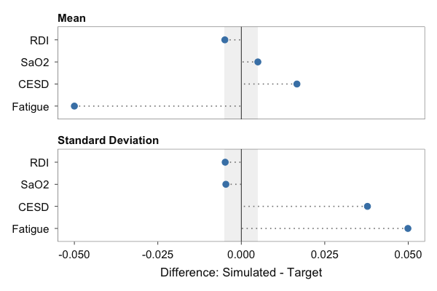
The RMSEs exceed thresh because thresh applies only to the continuous variables RDI and SaO2, whereas the integer variables CESD and Fatigue are matched by SPRITE only to the reported precision (sprite_prec = c(1, 1), i.e. within +/- 0.05).

3.4 Diagnostics
plot_convergence() shows the best objective value across the annealing iterations; first_iter skips leading iterations, here the first 10%:
n_iter_mlr <- length(result_mlr$track_objective)
plot_convergence(result_mlr, log_y = TRUE, first_iter = floor(n_iter_mlr / 10))
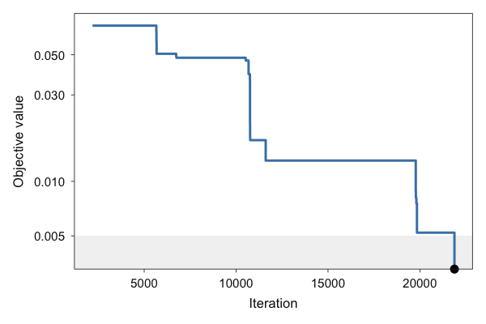
With ratio = TRUE, the plot shows the ratio of the correlation error to the regression error of the best candidate, with lines at its mean, median, and final value (show_mean, show_median, show_final). A ratio above 1 means that the correlation component is the larger of the two.
plot_convergence(result_mlr, ratio = TRUE)
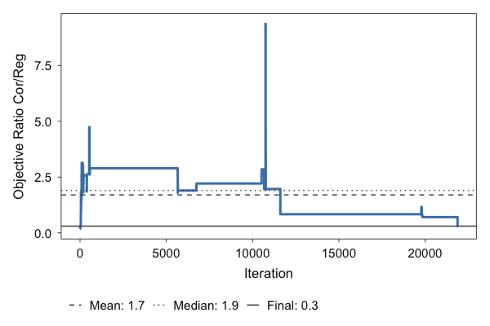
The final ratio is 0.253.
plot_cooling() uses the stored init_temp and cooling_rate, i.e. the values calibrated during the run:
result_mlr$inputs$init_temp
#> [1] 0.02971333
plot_cooling(result_mlr)
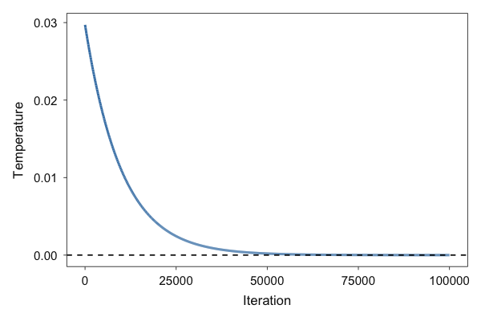

3.5 Balancing the objective with weight
weight sets how much the correlation and the regression components contribute to the objective. Objective values obtained with different weights are on different scales and are not compared directly; the unweighted RMSEs of get_rmse() are. The optimization is repeated with weight = 0.05:
set.seed(2026)
result_mlr_w05 <- do.call(optim_mlr, modifyList(args_mlr, list(weight = 0.05)))
rbind(
"weight = 0.5" = unlist(get_rmse(result_mlr)),
"weight = 0.05" = unlist(get_rmse(result_mlr_w05))
)
#> rmse_cor rmse_reg rmse_se
#> weight = 0.5 0.0001227945 0.001257002 0.007754376
#> weight = 0.05 0.0045908802 0.001160531 0.005647967
The table shows how the RMSEs of the correlations, coefficients, and standard errors change with weight in this example. Which balance is preferable depends on which targets matter most for the intended use of the data. The remainder of this section continues with the weight = 0.5 result.

3.6 Target vs. simulated statistics
plot_fit(result_mlr, standardised = FALSE)
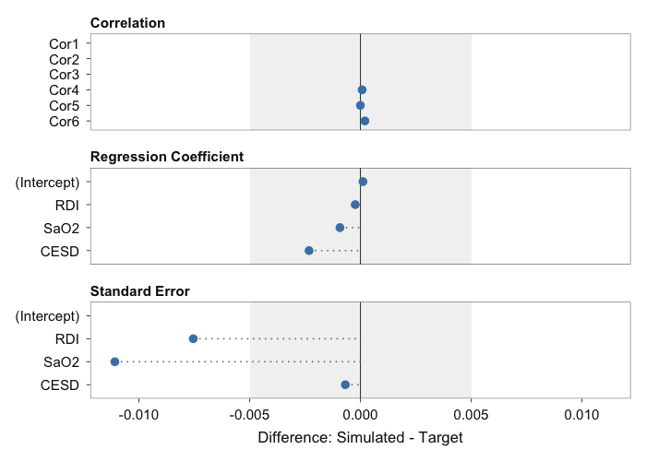
With the default standardised = TRUE, the differences are divided by the target values (for targets of zero, the unstandardised difference is shown). The plot() method offers the same panels, including which = "ratio":
plot(result_mlr, which = "fit")
plot(result_mlr, which = "ratio")

3.7 Refinement with hill_climbs
After the annealing, optim_mlr() refines the best candidate by hill climbing: it repeatedly swaps pairs of values within a predictor column and keeps a swap only if it lowers the objective. hill_climbs sets the number of hill-climbing iterations (default 1e4); hill_climbs = 0 skips the refinement. The optimization is repeated without refinement and with a longer refinement. With the same seed, the annealing is identical across the calls, so differences reflect the refinement only:
set.seed(2026)
result_mlr_hc0 <- do.call(optim_mlr, modifyList(args_mlr, list(hill_climbs = 0)))
set.seed(2026)
result_mlr_hc5e4 <- do.call(optim_mlr, modifyList(args_mlr, list(hill_climbs = 5e4)))
rbind(
"hill_climbs = 0" = c(best_objective = result_mlr_hc0$best_objective,
unlist(get_rmse(result_mlr_hc0))),
"hill_climbs = 1e4" = c(best_objective = result_mlr$best_objective,
unlist(get_rmse(result_mlr))),
"hill_climbs = 5e4" = c(best_objective = result_mlr_hc5e4$best_objective,
unlist(get_rmse(result_mlr_hc5e4)))
)
#> best_objective rmse_cor rmse_reg rmse_se
#> hill_climbs = 0 0.003278107 0.0013256098 0.001369679 0.007831782
#> hill_climbs = 1e4 0.002643694 0.0001227945 0.001257002 0.007754376
#> hill_climbs = 5e4 0.002643691 0.0001227945 0.001256523 0.007754468
track_objective covers the annealing only, so the effect of the refinement is visible in best_objective and the RMSEs, not in plot_convergence().

3.8 Simulated data
data_mlr <- result_mlr$data
head(data_mlr)
#> RDI SaO2 CESD Fatigue
#> 1 41.84422 0.27991433 0 7
#> 2 58.46773 30.75049710 26 15
#> 3 25.72880 4.52863153 25 19
#> 4 68.41232 0.05619894 5 17
#> 5 41.67719 0.43914902 1 1
#> 6 102.26432 69.17220026 29 19

4. Parallel workflow: Bardwell et al. (2003)
Each run of an optimizer is subject to randomness, and many datasets share the same summary statistics, so repeated runs return different datasets. parallel_optim() repeats the optimization with the same arguments and collects the runs; seed gives each run its own reproducible random-number stream.
To keep the build time of this vignette short, the MLR optimization of Section 3 is repeated 10 times with a reduced iteration budget and run sequentially (cores = 1). For applied use, the default budget and more runs are recommended.
result_par <- parallel_optim(
FUN = optim_mlr, # MLR module
args = args_mlr, # reported summary statistics
runs = 10, # number of optimization runs
cores = 1, # number of parallel workers
seed = 2026 # reproducible seed per run
)
With cores > 1, parallel_optim() sets up a future::multisession plan (Bengtsson, 2021) and restores any previous plan on exit. Because every run has its own random-number stream derived from seed, the results do not depend on cores:
result_par <- parallel_optim(FUN = optim_mlr, args = args_mlr,
runs = 10, cores = 2, seed = 2026)

4.1 Inspecting the parallel output
result_par
#> stats2data parallel result
#> Module: mlr
#> Runs: 10
#> Best objective (across runs): 0.00228711
#> Mean objective (across runs): 0.00274523
10 of 10 runs have a best objective value below thresh = 0.005. Across runs, the best objective values range from 0.00229 to 0.00433.
summary() lists the best and mean objective values, the RMSE against the targets and between runs, and the target statistics aggregated across runs:
summary(result_par)
#> stats2data Parallel Summary
#> -----------------------------------------------
#> Module: mlr | Runs: 10
#> Best objective: 0.00228711
#> Mean error: 0.00274523
#> SD error: 0.000580672
#>
#> Target RMSE (across runs):
#> metric mean sd min max
#> rmse_cor 7.378e-05 4.468e-05 6.659e-06 0.0001273
#> rmse_reg 2.668e-03 2.355e-03 1.581e-03 0.0093152
#> rmse_se 7.410e-03 5.210e-04 6.351e-03 0.0080696
#>
#> Between-run RMSE:
#> metric mean sd min max
#> rmse_cor 7.005e-05 4.753e-05 1.395e-05 0.0001376
#> rmse_reg 1.713e-03 2.259e-03 2.361e-04 0.0080360
#> rmse_se 5.663e-04 3.038e-04 2.493e-04 0.0012951
#>
#> Aggregated Statistics:
#> reg:
#> mean median sd min max
#> (Intercept) 4.02015 4.020089 0.0002547 4.019917 4.02078
#> RDI 0.02412 0.024690 0.0017863 0.019207 0.02523
#> SaO2 0.00911 0.007692 0.0049782 0.006183 0.02303
#> CESD 0.43402 0.434693 0.0023258 0.427696 0.43564
#>
#> se:
#> mean median sd min max
#> (Intercept) 1.72038 1.71646 0.0581560 1.65041 1.83167
#> RDI 0.02679 0.02668 0.0005108 0.02613 0.02760
#> SaO2 0.03742 0.03711 0.0007734 0.03648 0.03907
#> CESD 0.06534 0.06534 0.0006975 0.06446 0.06662
#>
#> cor:
#> mean median sd min max
#> 1 -0.006879 -0.03858 1.869e-01 -0.27574 0.29908
#> 2 0.032333 0.03081 1.580e-02 0.01915 0.07404
#> 3 0.261333 0.26687 2.825e-02 0.22405 0.30655
#> 4 0.109995 0.11000 1.046e-05 0.10998 0.11001
#> 5 0.199998 0.20000 6.225e-06 0.19998 0.20001
#> 6 0.680030 0.68006 1.516e-04 0.67979 0.68022
#>
#> mean:
#> mean median sd min max
#> RDI 48.80 48.80 0.005120 48.80 48.80
#> SaO2 17.30 17.30 0.005217 17.30 17.30
#> CESD 12.59 12.57 0.035180 12.55 12.65
#> Fatigue 10.82 10.82 0.031866 10.77 10.85
#>
#> sd:
#> mean median sd min max
#> RDI 27.10 27.095 0.0003689 27.095 27.096
#> SaO2 20.10 20.095 0.0001811 20.095 20.096
#> CESD 11.33 11.337 0.0278298 11.251 11.343
#> Fatigue 7.33 7.336 0.0199513 7.283 7.346
get_stats() aggregates each statistic across runs (mean, median, SD, minimum, maximum):
get_stats(result_par)
#> $reg
#> mean median sd min max
#> (Intercept) 4.020145063 4.020088687 0.0002546794 4.019916846 4.02078193
#> RDI 0.024120181 0.024689534 0.0017862506 0.019207276 0.02523387
#> SaO2 0.009110307 0.007691792 0.0049781837 0.006183078 0.02303050
#> CESD 0.434019977 0.434692563 0.0023257688 0.427695768 0.43564156
#>
#> $se
#> mean median sd min max
#> (Intercept) 1.72038191 1.71645712 0.0581560486 1.65040915 1.83166902
#> RDI 0.02679426 0.02667578 0.0005107587 0.02613099 0.02759996
#> SaO2 0.03742251 0.03710502 0.0007734497 0.03647782 0.03907427
#> CESD 0.06533820 0.06534047 0.0006975178 0.06446112 0.06662433
#>
#> $cor
#> mean median sd min max
#> 1 -0.006878798 -0.03857665 1.869290e-01 -0.27574371 0.29908398
#> 2 0.032333038 0.03081066 1.580210e-02 0.01914988 0.07404278
#> 3 0.261333328 0.26687071 2.824516e-02 0.22404602 0.30655193
#> 4 0.109995376 0.10999585 1.046459e-05 0.10998005 0.11000857
#> 5 0.199997513 0.19999935 6.224539e-06 0.19998464 0.20000540
#> 6 0.680029542 0.68005780 1.516061e-04 0.67979132 0.68021950
#>
#> $mean
#> mean median sd min max
#> RDI 48.79900 48.79505 0.005120115 48.79501 48.80497
#> SaO2 17.30000 17.30000 0.005216553 17.29503 17.30495
#> CESD 12.58833 12.57500 0.035180312 12.55000 12.65000
#> Fatigue 10.81833 10.82500 0.031865845 10.76667 10.85000
#>
#> $sd
#> mean median sd min max
#> RDI 27.095391 27.095306 0.0003689375 27.095015 27.096093
#> SaO2 20.095230 20.095209 0.0001810819 20.095019 20.095546
#> CESD 11.329446 11.337397 0.0278298090 11.250750 11.343370
#> Fatigue 7.329582 7.335733 0.0199513034 7.283194 7.345759
get_rmse() returns two RMSEs per run and metric: target_rmse, against the targets, and between_rmse, against the across-run mean of the simulated statistics. The per-run values are in raw:
par_rmse$target_rmse
#> metric mean sd min max
#> 1 rmse_cor 7.377821e-05 4.468013e-05 6.659295e-06 0.0001273365
#> 2 rmse_reg 2.668242e-03 2.355461e-03 1.580961e-03 0.0093151644
#> 3 rmse_se 7.409951e-03 5.210048e-04 6.351348e-03 0.0080696073
par_rmse$between_rmse
#> metric mean sd min max
#> 1 rmse_cor 7.005012e-05 0.0000475252 1.395325e-05 0.0001375668
#> 2 rmse_reg 1.712825e-03 0.0022587654 2.360688e-04 0.0080360047
#> 3 rmse_se 5.662507e-04 0.0003037709 2.492625e-04 0.0012950694
The run-to-run RMSE quantifies how much the simulated statistics vary between runs; it does not compare the runs with the original data.

4.2 Stability and fit across runs
plot_stability() shows the distributions of both RMSEs across runs, faceted by metric:
plot_stability(result_par)
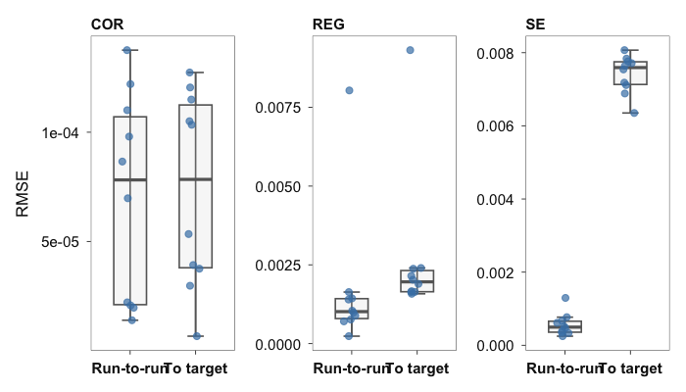
plot_fit() shows the across-run mean difference per statistic, with error bars for the across-run range (error_type = "range", default) or mean +/- SD (error_type = "sd"); dots mark the individual runs.
plot_fit(result_par, standardised = FALSE)
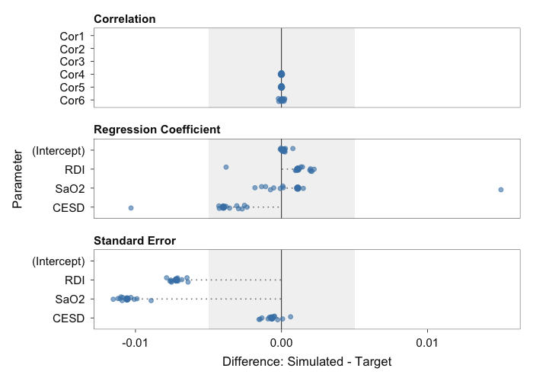
plot_fit(result_par, standardised = TRUE)
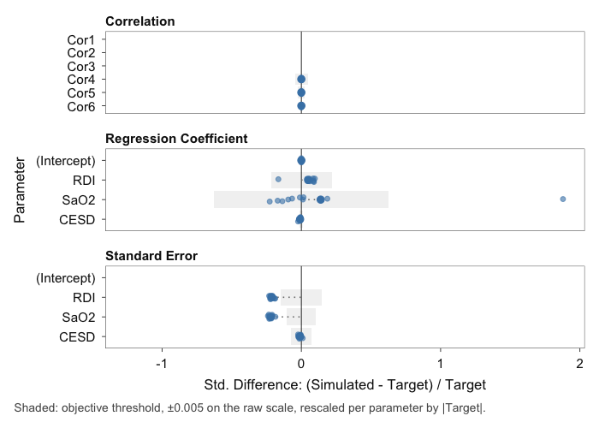
plot() draws plot_stability() by default and plot_fit() with which = "fit":
plot(result_par)
plot(result_par, which = "fit", standardised = FALSE)

4.3 Individual runs
The run with the lowest best objective value is stored in best; all runs are in results. Both are ordinary stats2data_mlr objects and support the methods of Section 3:
result_par$best
#> stats2data MLR result
#> N: 60
#> Equation: Fatigue ~ RDI + SaO2 + CESD
#> Best objective: 0.00228711
get_rmse(result_par$best)
#> $rmse_cor
#> [1] 3.754068e-05
#>
#> $rmse_reg
#> [1] 0.002400624
#>
#> $rmse_se
#> [1] 0.006351348
head(result_par$results[[2]]$data)
#> RDI SaO2 CESD Fatigue
#> 1 110.99972 4.911643e-05 20 19
#> 2 57.21455 3.990472e-03 11 19
#> 3 26.15128 1.667972e+01 15 6
#> 4 15.00154 3.793747e+01 17 15
#> 5 16.38092 3.470481e+01 22 10
#> 6 77.74864 3.457109e+00 17 10

4.4 Stopping at the first converged run
With stop_conv = TRUE, parallel_optim() stops launching runs once a run has converged, i.e. its best objective value is below thresh. The example repeats the MLR optimization of Section 3 with its full iteration budget:
result_first <- parallel_optim(
FUN = optim_mlr,
args = args_mlr,
runs = 10,
cores = 1,
seed = 2026,
stop_conv = TRUE
)
result_first
#> stats2data parallel result
#> Module: mlr
#> Runs: 1 of 10 (stopped early)
#> Converged: TRUE (thresh = 0.005 )
#> Best objective (across runs): 0.00262738
#> Mean objective (across runs): 0.00262738
1 of 10 requested runs were completed. With cores > 1, runs are dispatched in batches of cores, so a whole batch completes before the check.

Shiny interface
All three modules and the parallel workflow are also available in a point-and-click interface:
run_app()
The tabs Descriptives, ANOVA, and Linear Regression correspond to optim_vec(), optim_aov(), and optim_mlr(). The inputs of each tab correspond to the arguments of the function (the info icon of each input names the argument), and setting Number of Runs above one calls parallel_optim(). The results panel offers the plots and summaries shown in this vignette. The Download button exports the result object, the simulated data, and the R code of the function call, which reproduces the result in R.

References
- Bardwell, et al. (2007). https://doi.org/10.1016/j.jad.2006.06.013
- Bardwell, et al. (2003). https://doi.org/10.1176/appi.ajp.160.2.350
- Bengtsson (2021). https://doi.org/10.32614/RJ-2021-048
- Brown & Heathers (2017). https://doi.org/10.1177/1948550616673876
- Heathers, et al. (2018). https://doi.org/10.7287/peerj.preprints.26968v1
- Open Science Collaboration (2015). https://doi.org/10.1126/science.aac4716
- Reynolds & Besner (2008). https://doi.org/10.1037/0278-7393.34.1.50

