**Hierarchical Network Design**

Three-tier model:

- enterprise networks

- core layer: high-speed backbone layer between dispersed networks

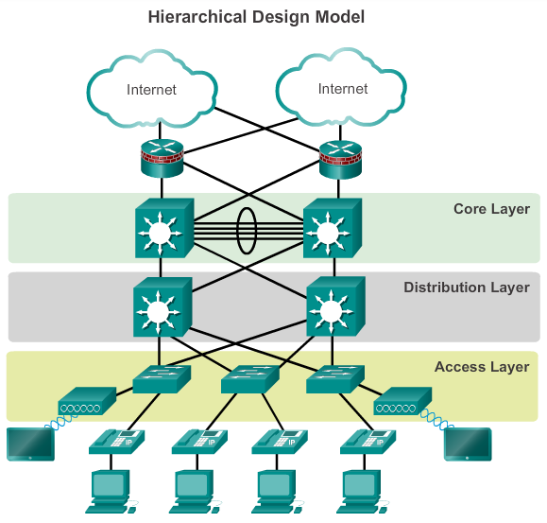

Two-tier model:

- smaller enterprise networks

- core and distribution layers are collapsed into one layer

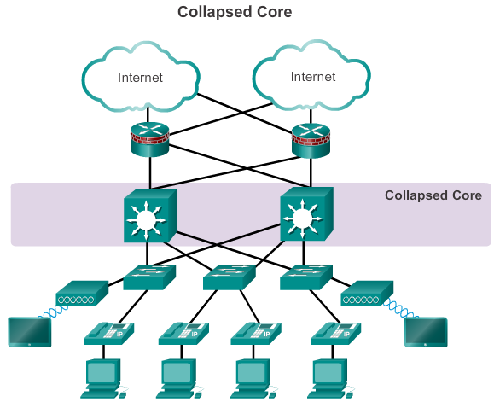

Cisco Enterprise Architecture

- core layer module-> high-speed interconnectivity between:

- distribution layer modules

- data center server farms

- the enterprise edge

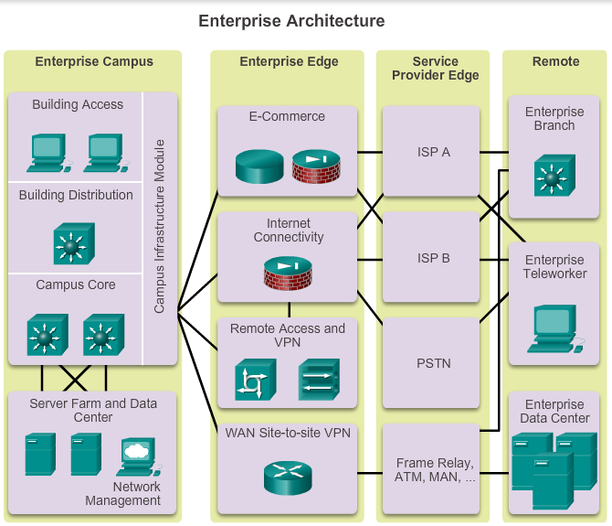

**Choosing devices**

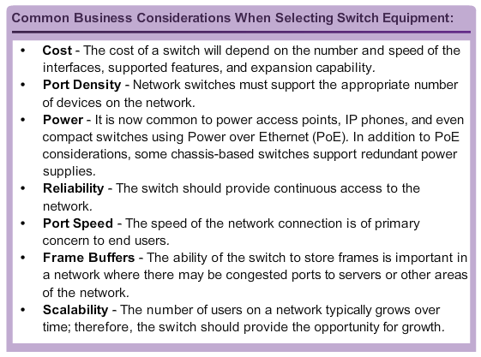

1. Fixed Configuration Switches
2. Modular Configuration Switches
3. Stackable Configuration Switches: Cisco StackWise technology allows the interconnection of up to nine switches (fault tolerance and bandwidth availability)

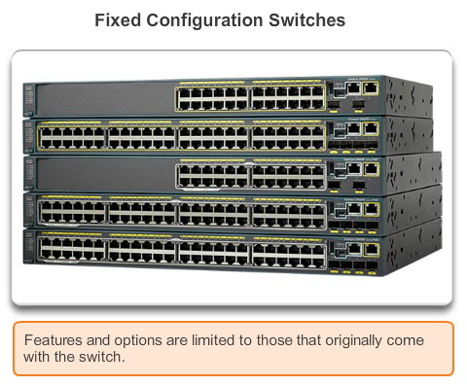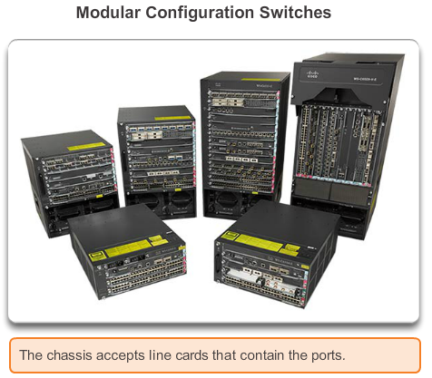

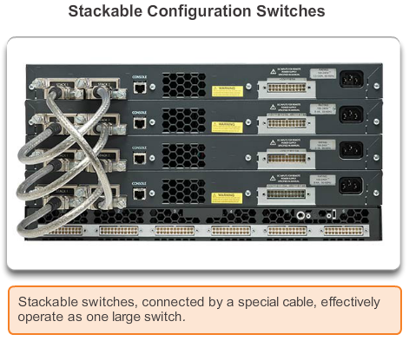

**Switches:**

1. Layer 2 switch
2. Layer 3 switch
3. “form factor” switches
4. modular switches
5. Switching speed: millions of packets per second
6. Backplane speed: how fast traffic can be transmitted between modules in a switch
7. Buffer size
8. Management and monitoring

<http://www.enterprisenetworkingplanet.com/reports/index.php/28911/Enterprise+Ethernet+Switch+Buyers+Guide.htm>

*Example:*

Cisco Enterprise: <http://www.cisco.com/c/en/us/products/switches/index.html>

**Design concepts for Meeting 3**

|  |  |  |
| --- | --- | --- |
| **VLANs** | IP Phones |  |
| Wireless |  |
| Date | *Departament1* |
| *Departament2* |
| *.....* |
| **IP addressing** | Subnet/VLAN | *WiFi VLAN : 192.168.0.0/24*  *Data VLANs : 192.168.i.0/24, where i is the VLAN number* |

|  |  |  |
| --- | --- | --- |
| **Switch** | Layer 3 | *Inter-VLAN Routing Management* |
| Layer 2 | *VLANs*  *Management* |

|  |  |  |
| --- | --- | --- |
| **AP Wi-Fi** | 802.1X, WPA Enterprise | *AP Controller, Authentification Server* |
| Acoperire cladire |

|  |  |  |
| --- | --- | --- |
| **Firewall** **Hardware** | Firewall | *Ex. Cisco ASA, Check Point Safe, Juniper Security* |
| VPN |
| IPS |
| Processing power |

|  |  |
| --- | --- |
|  | http://www.cisco.com/en/US/docs/solutions/Enterprise/Campus/HA_campus_DG/hacampusdg.html |