1. **Rack U**

* alegere model/tip rack
* accesorii – organizatoare cabluri/prelungitoare/rafturi

<http://www.dell.com/html/us/products/rack_advisor/index.html>

<http://www.comms-express.com/categories/server-cabinets-server-racks/>

1. **UPS (**Uninterruptible Power Supply**)**

* Masurat in VA
* Se va tine cont de puterea consumata a sistemelor conectate (Putere >Sarcina)
* Se va considera redundanta (N+1)
* Unitati separate / categorie de echipamente
  + Echipamente retea
  + Servere

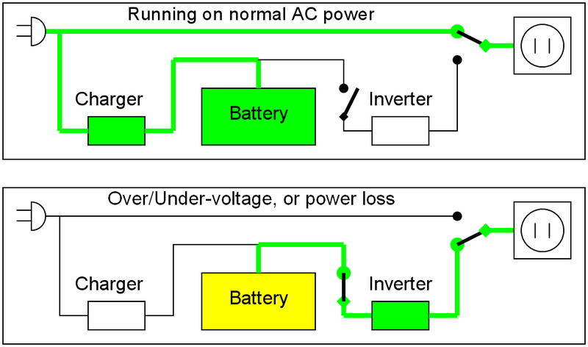

[www.apc.com/](http://www.apc.com/)

<http://www.apc.com/tools/ups_selector/index.cfm>

1. **Capacitate de Racire (**HVAC system**)**

- BTU (British Thermal Unit) measures heat (energy)

- KiloWatt (1000 watts) measures power (energy per unit time).

*BTU per hour (BTU/ h) – putere termica*

1 BTU = 0.0002928 kilowatt-hour

1 kW = 3412.1416 BTU/h (~ 3*103 BTU/ h)

* Online convertors
* Alegere sistem de racire => *marja de aprox 50%* (randamentul scade in timp/adaugare echipamente)