



**Apartment**

**COMPUTER SCIENCE**

**SOFTWARE ENGINEERING**

*SECOND LEVEL*

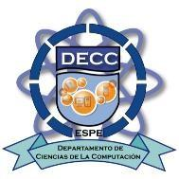

***Members:***

*Zapata Zapata Sebastian Alexander*

*Yaguarshungo Avendaño Bryan Deniss*

*Yugsi Ordoñez Roberth Eduardo*

*Zambranoo Loor David Alexander*

***Tutor:***

*Phd.* *Jorge Edison Lascano*

*Quito  
20**20*

***DT BRO SEDA*L***

# **Title**

*"Didactic Test"*

# **Defining and justifying the problem**

This project, is a program that will carry out a test that will help us with the recognition of the skills and qualities of young graduates and university students, solving the problem of today in the face of the choice of a higher level career ; for this we will need to carry out research on how to identify the Psychological Process of Vocational Orientation.

This project is based on the uncertainty that young peopleuelen manifest when choosing a career for their future and when choosing an option, this is random, which causes neophyte students to defect andunsubscribe in one or more careers,until theyfind the right career to their skills and attitudes, the one that satisfiesthem.

# **Goal system**

## **Overall goal**

Implement a program that recognizes qualities, tastes, skills and attitudes; motivating students (high schools, college students) through a didactic interaction and more attached to each area of learning, showing the good and the bad of each career to choose.

## **Specific goals**

* Identify the functional requirements that this program has to meet at each stage of development.
* Perform unit tests and implement solutions to those errors.
* Perform the documentation, representing each progress and process generated until reaching the final version of the project.
* Associate the results of the teaching tests as well as the questions that were asked after each, giving a general result according to the data that is stored of each interaction.

# **Reach**

# This project describes the development and implementation of new didactic and interactive ways of recognizing the traits, inclinations and affinities that are embodied in each person, or also, for its part, you can select in the same way:

# It will be portable only on desktops or laptops.

# **Theoretical framework**

## **Java programming language**

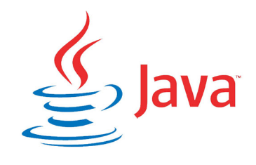

For the development of the project we will use Java since it uses OOP methodologies, and it is present everywhere and can be used practically on all platforms.

The Java virtual machine translates the code, that is, it is executable on a specific platform, capable of interpreting and executing statements expressed in a special binary code (the Java bytecode), that run on virtually any system. This makes it extremely versatile for video game development

## **Scrum**

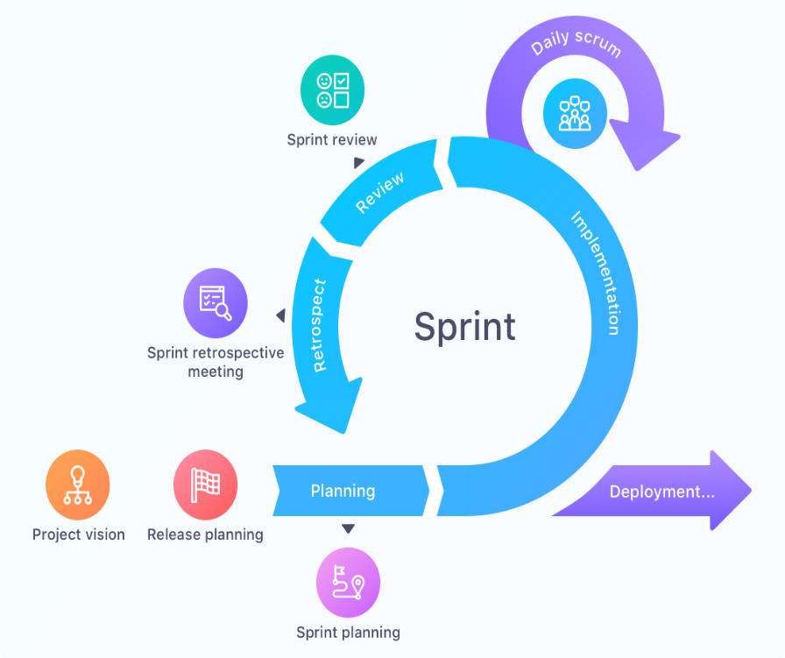Scrum is an agile methodology that fulfills a key function, which is to work collaboratively, as a team, and obtain the best possible result from a project.

Scrum achieves partial (Sprints) and regular deliveries of the final product, prioritized by the benefit they bring to the project receiver. Therefore, Scrum is especially adjusted for projects in complex environments, where results need to be achieved early, where requirements are scarce, changing or poorly defined, where competitiveness, innovation, flexibility and productivity are paramount.

Figure 1 ScRUM Agile Methodology Map

## **Functional and non-functional requirements**

**5.3.1 Functional requirements**

Functional requirements are declarations of the services that the system will provide, so that the system will react to program inputs and outputs. In some cases, functional requirements also explicitly clarify what the system should not do.

**5.3.2 Non-functional requirements**

They are those requirements that define the specific properties or qualities that the system delivers, which are often referred to as "Quality Attributes". Therefore the non-functional requirements are equally the restrictions or conditions imposed by the customer.

* 1. **Psychological Vocational Guidance Process (PPOV)**

In the psychological field, in the part of vocational orientation we must always take into account some details such as: the demands of the career that we aspire to pursue and the skills in which we develop best.

Kids or parents come to the appointment asking us to help them solve their doubts and problems.

A powerful tool we offer in the Vocational Guidance Workshops is the possibility that the young person can work with as much information as enough information.

Based on the different moments of decision-making or conflict resolution, in successive meetings we try to ensure that students live the following stages:

**1.- Meet to decide**

Stage of recognition in which the aspects of the person are explored, re-discovered and entrenched: What things they like and which do not; what are your skills and your least positive points; their modes of reaction to certain situations; their defense mechanisms; their way of feeling and thinking, their study habits, their fears, myths and prejudices.

**2.- Explore to plan**

Exploration stage, in which, after knowing his skills and preferences, his competences and interests, the subject investigates existing professional and tertiary careers, dictated subjects, years of course, career plans, venues and dictation sites. He also learns how to review job offers, existing jobs in the job market and in the design of his resume and in the drafting of his cover letter.

Through different activities, he participates in the search and exploration.

**3.- Integrate to commit**

Time to integrate personal identity with job and professional offers. The young student has, in this instance, a range of possibilities to choose according to his preferences, skills and the way he is.

**4.- Execution and project**

In the course of meetings, through interviews, projective techniques, psychometric, verbal and other activities, the children identify, evaluate possible courses of action and choose the implementation of one of them. Attempts are made to promote resources to design your unique life project.

* 1. **USER STORIES (HU)**

User stories are an instrument for the lifting of requirements for the development of a software, which has emerged with the emergence of new agile development frameworks, such as Scrum or the different techniques that comprise Extreme Programming (XP).

# **Ideas to be defended**

* Propose an agile interface so that the user can use it easily, and that there is no impediment.
* Propose an estimated test time with the user's permission, to other people, before delivery of the product.
* Demonstrate attitudes, traits, inclinations and affinities; can give a better concept about our vocation.
* That the way of interacting with the user is oriented to a more didactic way and to be able to solve different doubts, that a person has when making decisions about his academic preparation.
* Orient the user so that in this way he has his clearest ideas and has a more direct and specific representation about the possible options that he will have in his academic life.

1. **Project Requirements**
   1. **Requirements Functions.**

The programme shall:

* Recognize the data entered by the user.
* Validate the data entered by the user.
* Display a menu of the different study areas.
* Recognize the option by which the user wants to start.
* Analyze and interact with that user option.
* Fake menu when choosing the option you want bounces to an option that is random.
* Present at the end of each interaction a vocational test according to each option chosen.
* Recognize and analyze stored test and interaction data.
* Generate a result according to the stored data.
* Finish the test with all the options set in the menu.
* Generate a file in which the results obtained are detailed.
  1. **Non-Functional Requirements**

The programme shall:

* Being able to operate up to 50 users with concurrent sessions
* Qprovide an error message and end-user-oriented
* Implement a help with respect to the result taken.
* Give a graphical response with respect to the higher percentage response mentioned above.

# **Expected results**

* Obtain and deliver a fully functional and quality product, going through the entire process of development and testing.
* Implementation of a guide to the way of conducting the test, in which you can also identify the skills, attitudes, traits, inclinations and affinities that the program has recognized through the data previously entered.

# **Viability**

## **Technical**

## **Human**

### **Business Tutor**

Jorge Edison Lascano.

### **Academic Tutor**

### **Students**

# Zapata Sebastian

# Yahuarshungo Deniss

# Yugsi Roberth

# Zambrano David

# **Annexes**

# **Bibliography**

* PMOinformatica (2019). Dropped from: <http://www.pmoinformatica.com/2013/04/que-son-las-historias-de-usuario-7.html>
* Iivvo. Dropped from: <http://www.orientacionvocacional.com/index.php/blogs/item/235-la-orientacion-vocacional-como-proceso-en-la-toma-de-decisiones>