Specifying software requirements

|  |
| --- |
|  |

Project: Didactic Test

|  |  |  |
| --- | --- | --- |
|  |  | 25/06/2020 |

**Instructions for using this format**

This format is a standard template for software requirements documents.

It is based and compliant with the IEEE Std 830-1998 standard.

Sections not considered to be applicable to the system described may be justifiedly indicated as non-applicable (NA).

Notes:

Blue texts are indications that should be deleted and, where appropriate, replaced by the contents described in each section.

The bracketed texts of type "" allow the direct inclusion of text with the appropriate color and style to the section, by clicking on them with the mouse pointer.

The titles and subtitles of each section are defined as MS Word styles, so that their consecutive numbering is automatically generated according to the styles "Title1, Title2 and Title3".

The indentation of the texts within each section is automatically generated by pressing Enter at the end of the title line. (Indented Normal Styles1, Indented Normal 2 and Indented Normal 3).

The document index is a table of contents that MS Word updates based on document titles.

Once it's finished writing, you should instruct Word to update all of its content to reflect the final content.

From the document formatting template © & Coloriuris http://www.qualitatis.org

.

Revision History

|  |  |  |  |
| --- | --- | --- | --- |
| **Date** | **Review** | **Description** | **Author** |
| 04/06/2020 | 1.0 | "Interface Requirements" | DT BRO SEDA |
| 13/06/2020 | 1.2 | "Interface Requirements" | DT BRO SEDA |
| 20/06/2020 | 1.3 | "Interface Requirements" | DT BRO SEDA |
| 22/06/2020 | 2.0 | "Interface Requirements" | DT BRO SEDA |

Document validated by theparties to date: 22.06.20

|  |  |
| --- | --- |
| By the customer | By the supplying company |
|  |  |
| PhD. Edison Lascano | --------------- |

Content

Document sheet 3

Contents 4

1 Introduction 6

1.1 Purpose 6

1.2 Scope 6

1.3 Personnel involved 6

1.4 Definitions, acronyms and abbreviations 6

1.5 References 6

1.6 Summary 6

2 Overview 7

2.1 Product Outlook 7

2.2 Product functionality 7

2.3 User Features 7

2.4 Restrictions 7

2.5 Assumptions and Dependencies 7

2.6 Predictable evolution of the system 7

3 Specific requirements 7

3.1 Common interface requirements 8

3.1.1 User Interfaces 8

3.1.2 Hardware interfaces 8

3.1.3 Software interfaces 8

3.1.4 Communication interfaces 8

3.2 Functional requirements 8

3.2.1 Functional requirement 1 9

3.2.2 Functional requirement 2 9

3.2.3 Functional requirement 3 9

3.2.4 Functional requirement n 9

3.3 Non-functional requirements 9

3.3.1 Performance Requirements 9

3.3.2 Security 9

3.3.3 Reliability 9

3.3.4 Availability 9

3.3.5 Maintainingability 10

3.3.6 Portability 10

3.4 Other requirements 10

4 Appendices 10

# Introduction

This document is a Software Requirements Specification (SRS), for the assignment system, location of relief services, this software does not belong to any specific company.

This specification has been structured based on guidelines given by the IEEE Standard Recommended Practice for ANSI/IEEE 830 Software Requirements Specifications.

## Purpose

The application aims to help young students decide on an optimalcareer, in which the youngster ara develops his skills and attitudes..

## Reach

This project describes the development and implementation of new teaching and interactive ways of recognizing the traits, inclinations and affinities that are embodied in each person, or also, for its part, you can select in the same way:

• It will be portable only on desktop or laptop computers.

## Personnel involved

|  |  |
| --- | --- |
| Name | Sebastian Zapata |
| Role | Analyst, designer and developer |
| Professional category | Ing. Software - Student |
| Responsibilities | DT informationanalysis, design and programming |
| Contact information | [sazapata2@espe.edu.ec](mailto:sazapata2@espe.edu.ec) |
|  |  |
| Name | Bryan Yaguarshungo |
| Role | Analyst, designer and developer |
| Professional category | Ing. Software - Student |
| Responsibilities | DT informationanalysis, design and programming |
| Contact information | [bdyahuarshungo@espe.edu.ec](mailto:bdyahuarshungo@espe.edu.ec) |
|  |  |
| Name | Zambrano Loor David Alexander |
| Role | Analysis, designer and developer |
| Professional category | Ing. Software - Student |
| Responsibilities | DT informationanalysis, design and programming |
| Contact information | [dazambrano9@espe.edu.ec](mailto:dazambrano9@espe.edu.ec) |
|  |  |
| Name | Yugsi Ordoñez Roberth Eduardo |
| Role | Analysis, designer and developer |
| Professional category | Ing. Software - Student |
| Responsibilities | DT informationanalysis, design and programming |
| Contact information | [reyugsi1@espe.edu.ec](mailto:reyugsi1@espe.edu.ec) |

## Definitions, acronyms and abbreviations

|  |  |
| --- | --- |
| **Name** | **Description** |
| Dt | Didactic Test |
| User | Person who will use the system |
| Ers | Specification de Software Requirementse Software |
| Rf | Functional Requirements |
| Rnf | Non-Functional Requirements |

## References

|  |  |
| --- | --- |
| **Document Title** | **References** |
| Standard IEEE 830 | Ieee. 22/10/2008. |
| Specifying software requirements | Qualitatis. 12/04/2010. Dropped from: <http://www.qualitatis.org> |
|  |  |

## Summary

This document consists of three sections. In the first section, a

introduction to it and provides an overview of the system resource specification.

The second section of the document provides an overview of the system, in order to understand the main functions that the system must perform, the associated data and the factors, constraints, assumptions and dependencies that affect development, without going into excessive detail.

Finally, the third section of the document is the section in which

the requirements that the system must meet.

# Overview

## Product outlook

Academic preparation is a topic of great interest and important in the lives of young people and in general people, however it is not always clear the vision about what you want to prepare yourself in and whether you have attitudes, qualities, affinities or without attribute numbers that will help you for what you want to study then is when we are inclined to opt for something that generates income , or have more jobs and what you really wanted is set aside.

That is why the "Didactic Test" system has as its main perspective to guide, instruct and help to find that vocation, that option of most successful academic preparation, which will define you as a professional in a work and personal field, will do so in a more dynamic, interactive and interesting way and end with the most successful results depending on the records in the questionnaires, "Didactic Test" is aimed at being an educational system and academic support.

## Product functionality

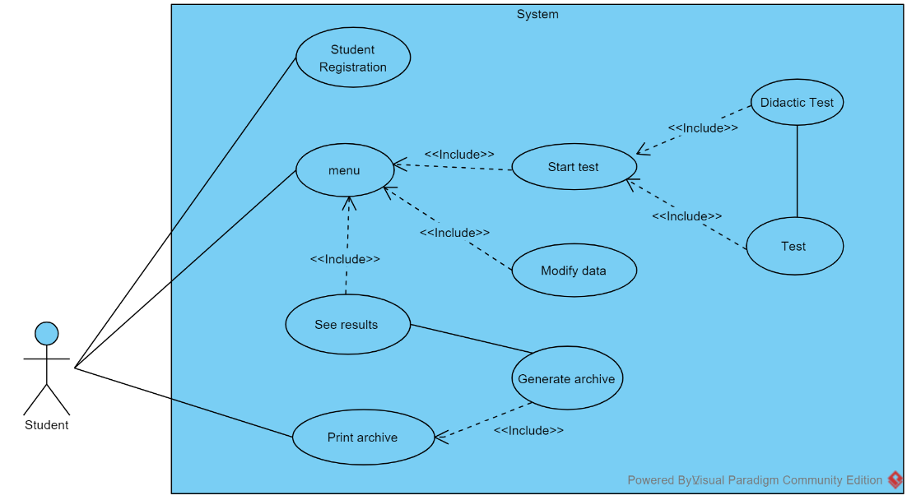

## 2.3 User Features

|  |  |
| --- | --- |
| Type of user | Student |
| Training | Bachelor's or Superior |
| Activities | Take the test |

.

## Restrictions

* Language of use: Java
* Information about users i.e. their income and egress should be stored on a csvbasis.
* Interface that will only be portable on computers.
* The program should be able to attend interventions concurrently.
* The system must have a simple, platform- or programming language-independent design and implementation.

## Assumptions and dependencies

* It is assumed that the requirements described here are stable.
* Computers on which the system is to be run must meet the above requirements to ensure successful system execution.

## Predictable system evolution

* Modification for a better display of the program startup execution. Using a graphical console.

# Specific requirements

FUNCTIONAL REQUIREMENTS

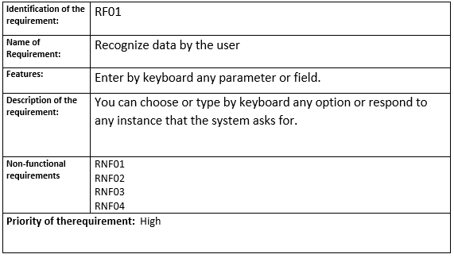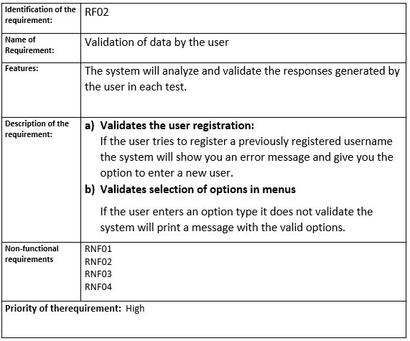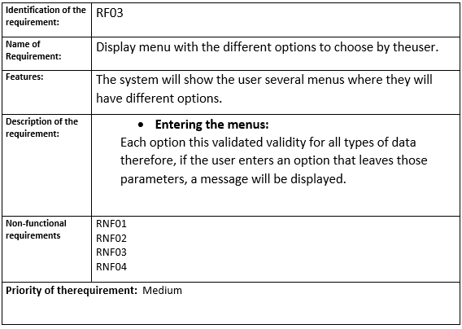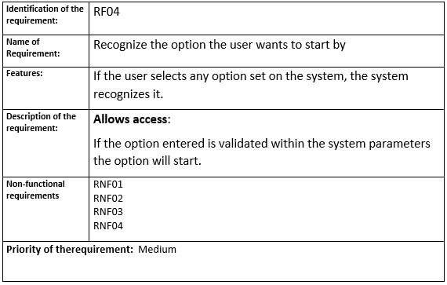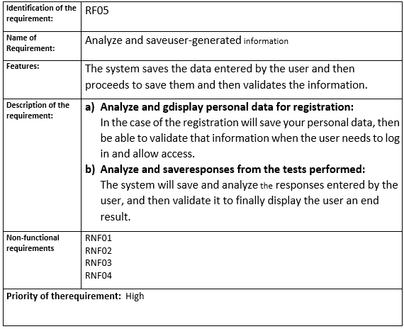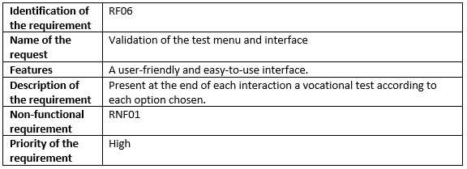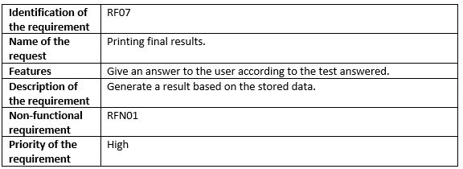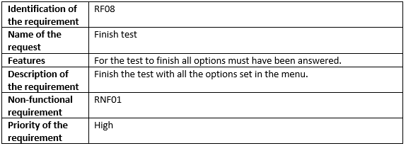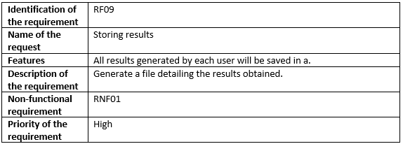

NON-FUNCTIONAL REQUIREMENTS.

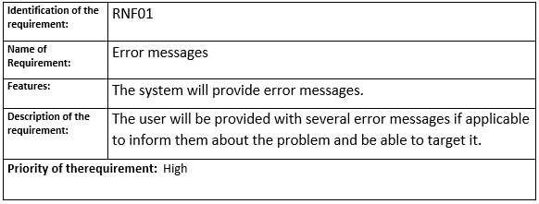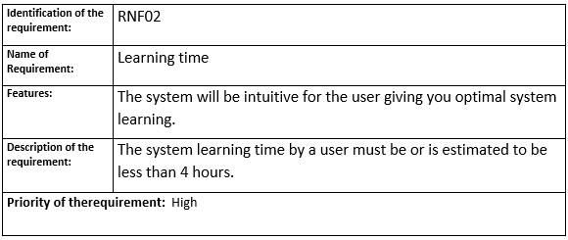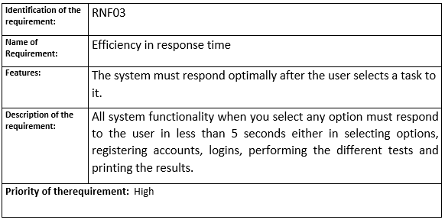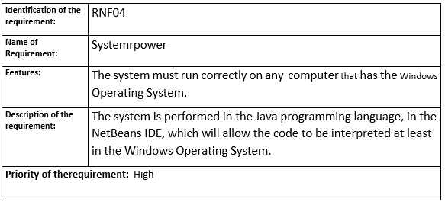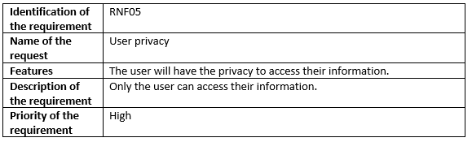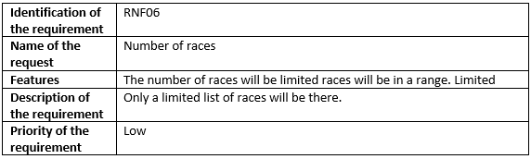

## Common interface requirements

### User interfaces

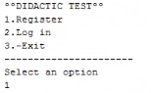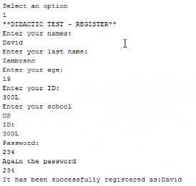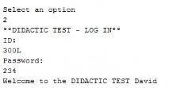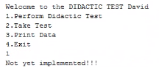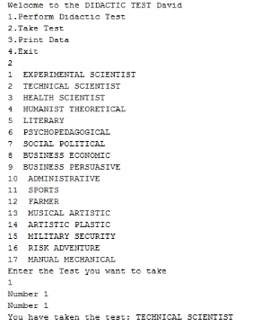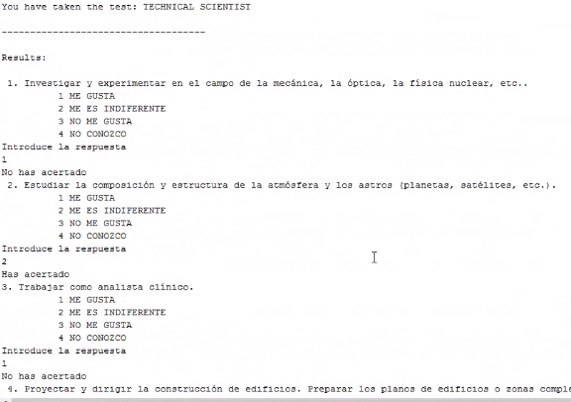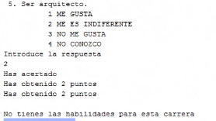

### Hardware interfaces

It will be necessary to have computer equipment in perfect condition with the following characteristics:

* Network adapters.
* Processor 1.66GHz or higher.
* Minimum memory of 256Mb.
* Mouse. ·
* Keyboard.
* Mobile device.

### Software interfaces

* Operating system: Windows
* Execution environment: JRE

## Functional requirements.

### Functional requirement 1

* + **Recognize the data entered by the user:** You can enter by keyboard any parameter or field that the system asks you, either for registration as a new user or selection of options..

### Functional requirement 2

* + **Validate the data entered by the user:**

The system will analyze and validate the responses generated by the user in each test.

1. **Validates user registration:** If the user tries to register a previously registered username the system will show you an error message and give you the option to enter a new user.
2. **Validates option selection in the menus** If the user enters an option type does not validate the system will print a message with valid options.

### Functional requirement 3

* + **Display a menu of the different options to choose from the**user:

The system will show the user several menus where they will have different options.

1. **Entering the** menus: Each option this validated validity for all types of data therefore, if the user enters an option that leaves those parameters will be shown a message

### Functional requirement 4

• **Recognize the option the user wants to start by:** If the user selects any option set on the system, the system will recognize it and if the system is validated it will initiate the option.

### Functional requirement 5

• **Analyze and interact with that user option:** The system saves the data entered by the user and then proceeds to save it and then validates the information.

1. **Analyze and save personal data for registration:**

In the case of the registration will save your personal data, then be able to validate that information when the user needs to log in and allow access.

1. **Analyze and save responses from the tests performed:**

The system will save and analyze the responses entered by the user, and then validate it to finally display the user an end result.

### Functional requirement 6

* **Validation of the test menu and interface:**

The user will be able to interact with the system more effectively so that there are no losses in the management of the system in addition that they can understand it and learn its usability more quickly.

### Functional requirement 7

* + **Printing Final Results:**

When the user finishes performing the Tests, the results will be displayed on the screen, validating their responses and analyzing them.

### Functional requirement 8

**•Finish the test with all the options set in the menu:**

The user must go through all the parameters set by the system after that, the last thing will be to perform the test to display the results.

### Functional requirement 9

• **Storing results**

The system will allow the storage of the results this will be used to be able to validate information give access and generate results for allusers.

## Non-functional requirements

### Performance requirements

* + Ensure that query design or other processes do not affect the performance of saved data.

### Security

* + Ensure system security with respect to the information and data that is handled such documents, files and passwords.
  + Ensure the reliability, security and performance of the computer system to different users. In this sense the stored information or records made may be consulted and updated permanently and simultaneously, without affecting the response time.

### Reliability

* + The system must have an intuitive and simple user interface.

### Availability

* + System availability should be continuous with a level of service for users of 7 days for 24 hours, ensuring an adequate scheme that allows the possible failure in any of its components, having a contingency, generating alarms

### Maintainability

* + The interface must be complemented by a good help system (management can fall on staff with little experience in using computer applications).
  + The system must have easily updated documentation that allows maintenance operations to be carried out with the least possible effort

### Portability

* The system will be deployed under the Windows and Mac platform.