**REPORTE DE OPERATIVIDAD DEL PEDESTAL**

**CONFIGURACIÓN ESTABLECIDA**

"name": "HYO@2024-12-22T00-00-34",

"latitude": -12.04042,

"longitude": -75.29591,

"altitude": 40.0,

"heading": 0.0,

"online": {

"polarimetric": [

"W",

"V",

"Z"

],

"range": 60.0,

"mask": 0.8

},

"pedestal": {

"arraylength": 6,

"axis": [

"azimuth", "azimuth", "azimuth", "azimuth", "azimuth", "azimuth"

],

"speed": [

5.0, 5.0, 5.0, 5.0, 5.0, 5.0

],

"bottom": 0.0,

"top": 80.0,

"table": [

0.9, 2.5, 4.2, 8.0, 12.0, 18.0

]

**PARÁMETROS RELEVANTES:**

* 5 Secuencias de movimiento, PPI 0.9, 2.5, 4.2, 8.0, 12.0, 18.0
* Mask SNR Threshold: 0.8

**HUANCAYO 2024:**

**VARIACIÓN DE LA VELOCIDAD 7PM DIA ANTERIOR A 7PM DEL DIA ACTUAL**

**Dia 2024-12-21 Dia 2024-12-24**

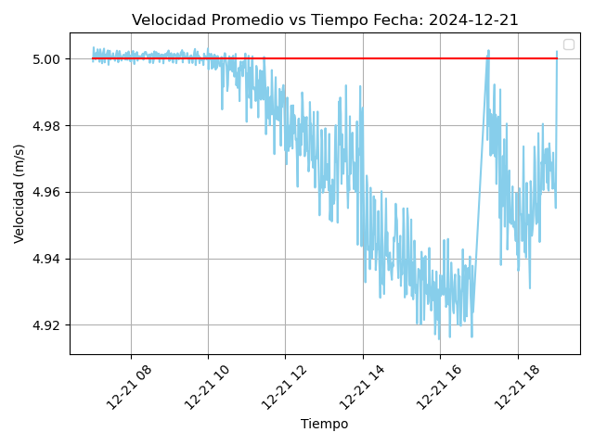 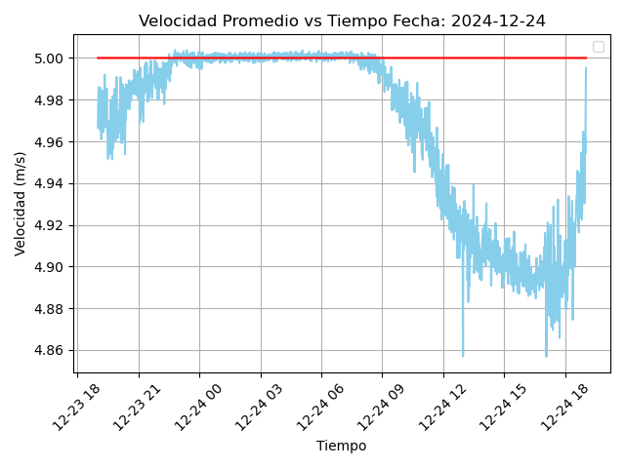

**Dia 2024-12-22 Dia 2024-12-25**

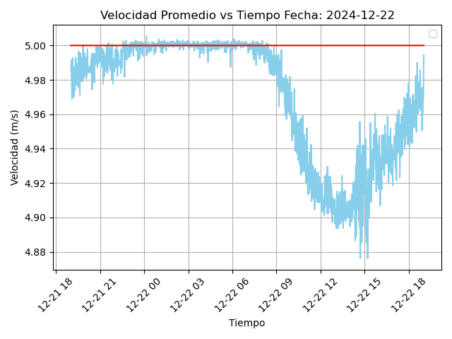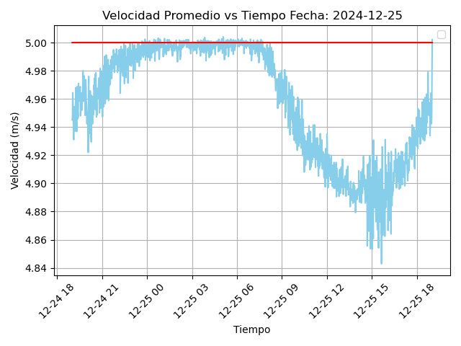

**Dia 2024-12-23 Dia 2024-12-26**

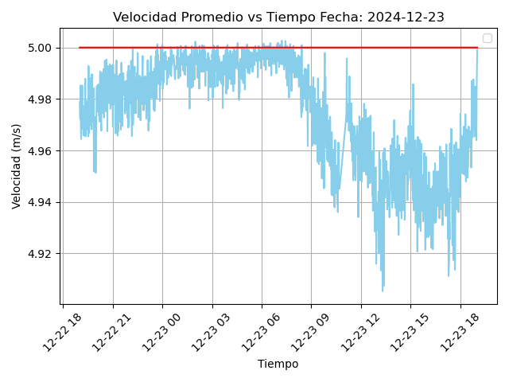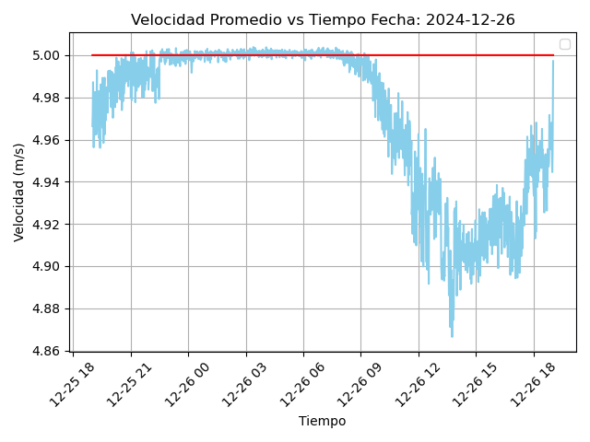

**Dia 2024-12-27 Dia 2024-12-28**

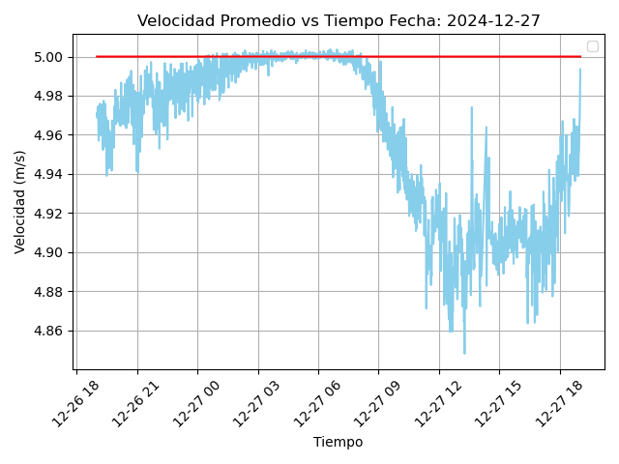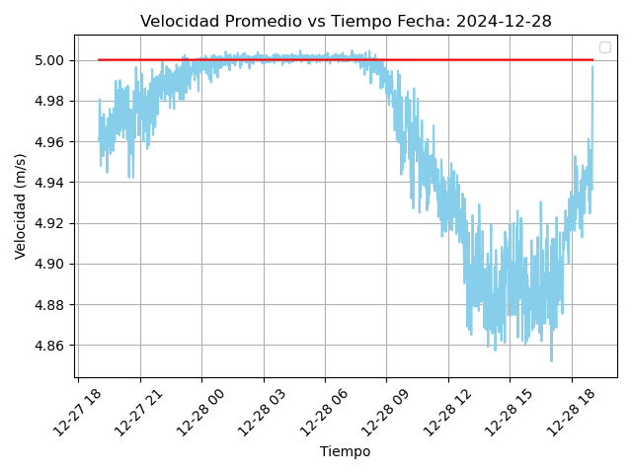

**Dia 2024-12-29 Dia 2024-12-31**

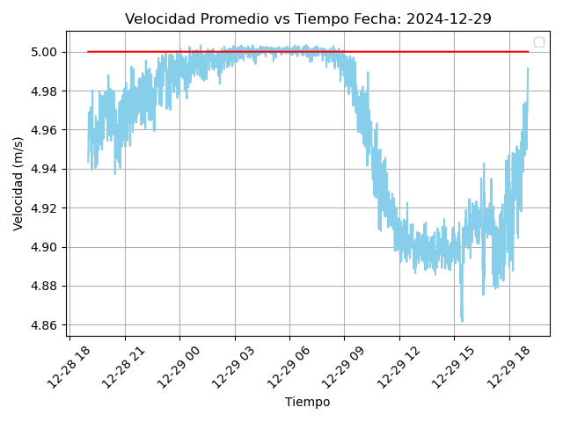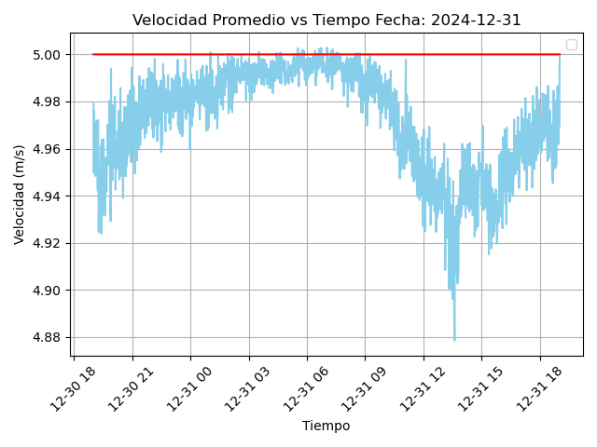

**HUANCAYO 2025**

**VARIACIÓN DE LA VELOCIDAD 7PM DIA ANTERIOR A 7PM DEL DIA ACTUAL**

**Dia 2025-01-03 Dia 2025-01-04**

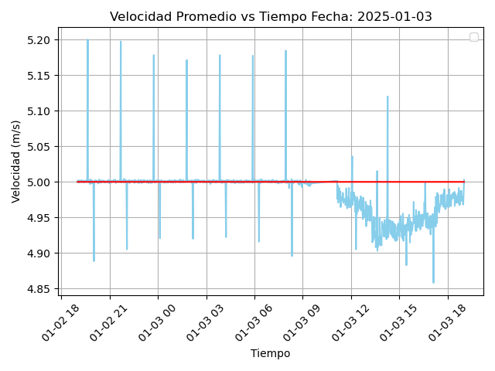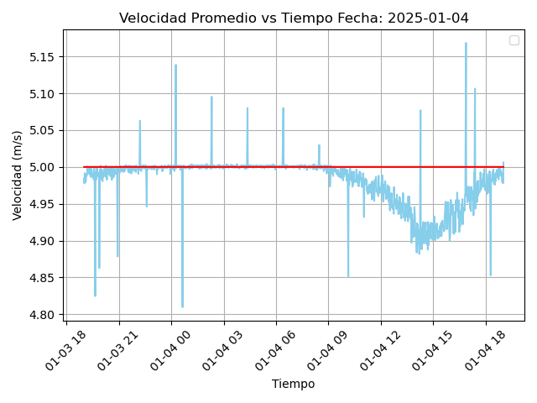

**Dia 2025-01-05 Dia 2025-01-06**

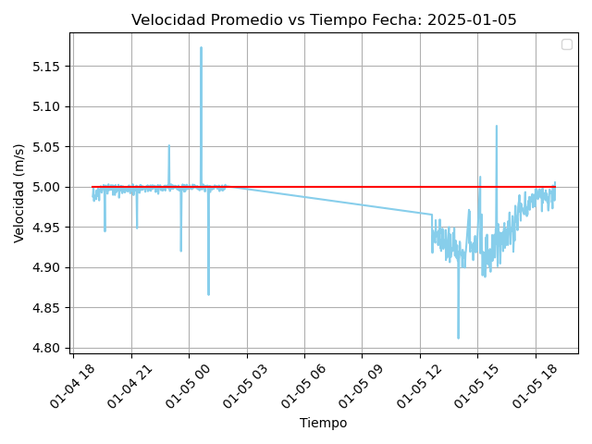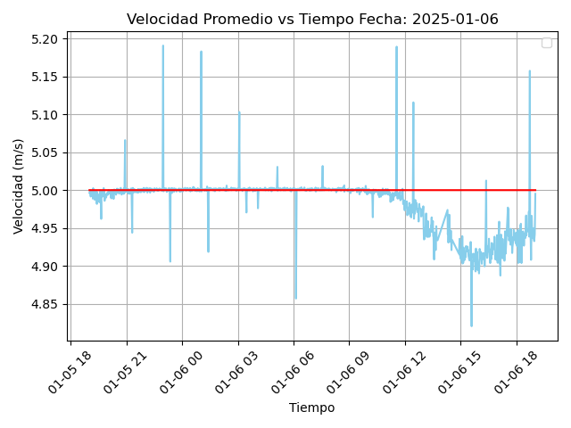

**Dia 2025-01-07 Dia 2025-01-08**

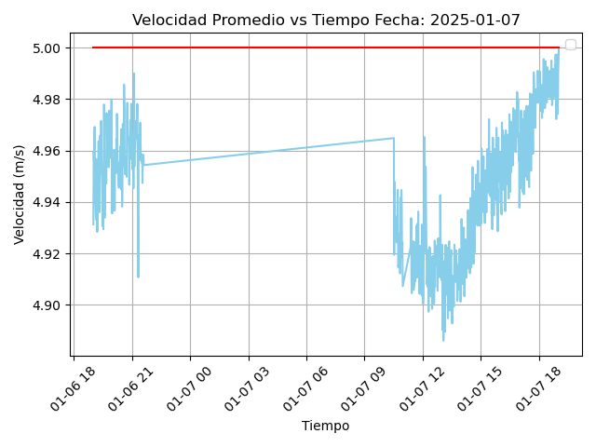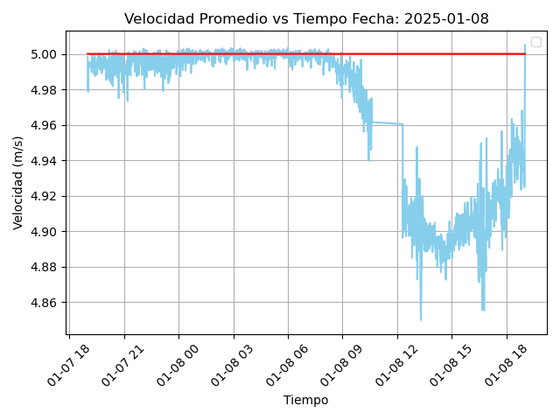

**Dia 2025-01-10 Dia 2025-01-11**

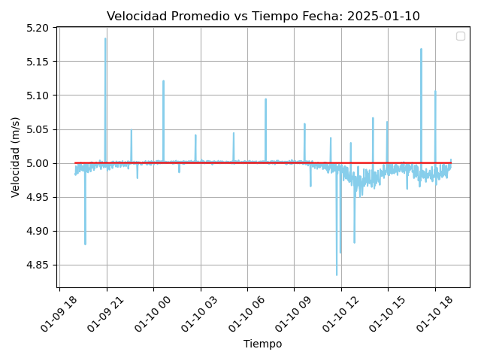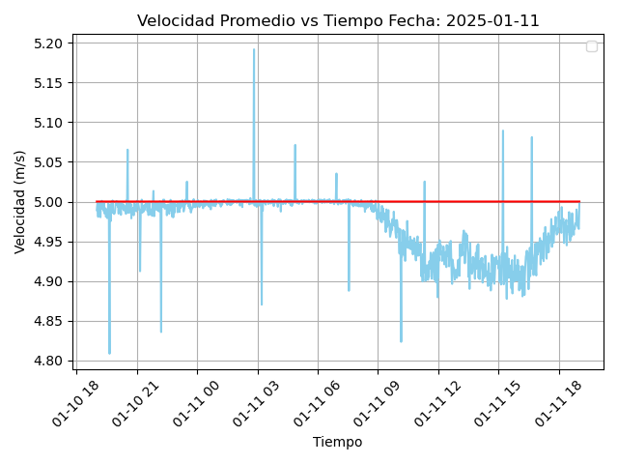

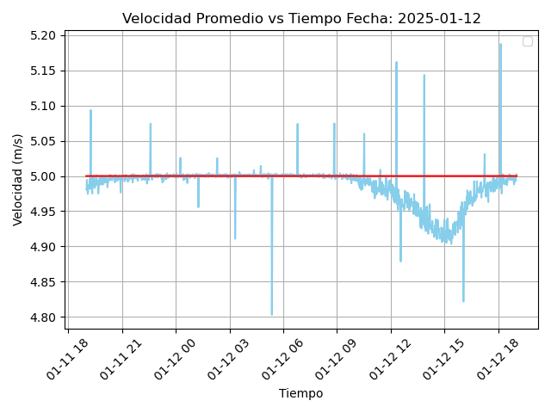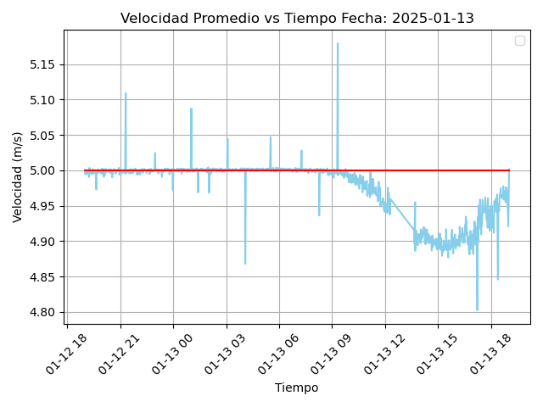

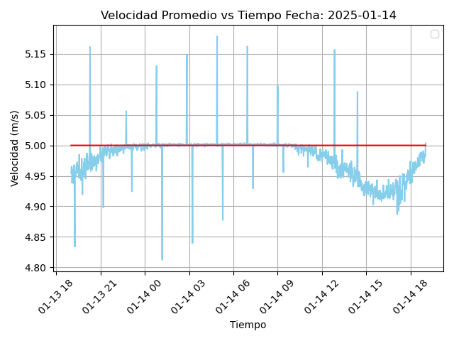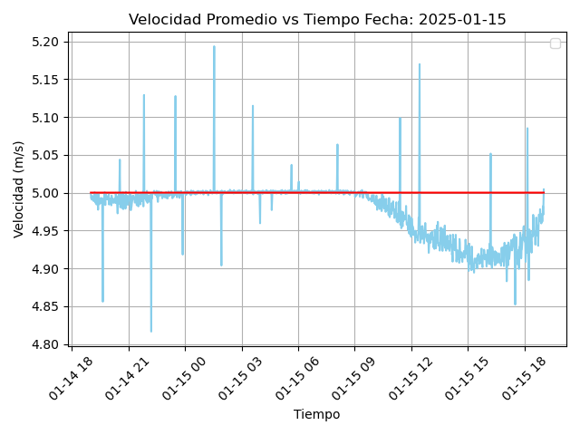

Resumen

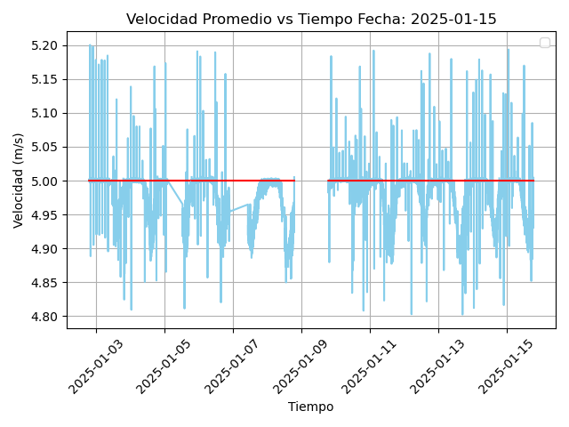

Data

* Spectro

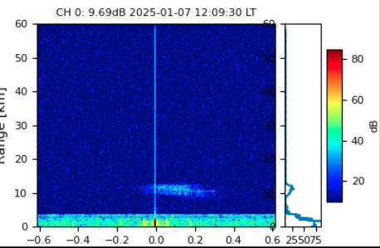

* RTI

