Data Structure and Algorithm

Laboratory Activity No. 3

Translating Algorithm to Program

|  |  |
| --- | --- |
| *Submitted by:* | *Instructor:* |
| Acebedo, Sebastian C. | Engr. Maria Rizette H. Sayo |

August 3, 2025

# Objectives

Introduction

Data structure is a systematic way of organizing and accessing data, and an algorithm is a step-by-step procedure for performing some tasks in a finite amount of time. These concepts are central to computing, but to be able to classify some data structures and algorithms as “good,” we must have precise ways of analyzing them.

This laboratory activity aims to implement the principles and techniques in:

* Writing a well-structured procedure in programming
* Writing algorithm that best suits to solve computing problems
* Writing an efficient Python program from translated algorithms

# Methods

• Design an algorithm and the corresponding flowchart (Note: You may use LucidChart or any application) for adding the test scores as given below if the number is even: 26,49,98,87,62,75

• Translate the algorithm to a Python program (using Google Colab)

• Save your source codes to GitHub

# Result

**ALGORITHM**

* **Start**
* Set the list of scores: scores = [26, 49, 98, 87, 62, 75]
* Initialize even_sum = 0
* For each score in scores:
  + If score % 2 == 0 (even), then:
    - Add score to even_sum
* Display even_sum
* **End**

**FLOWCHART:**

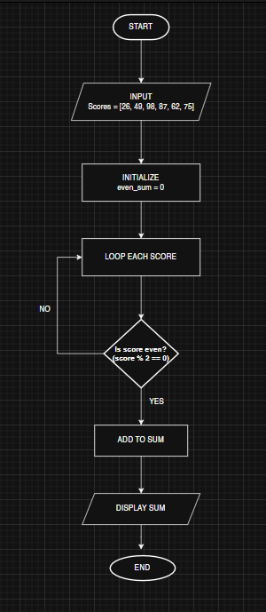

Figure 1 Screenshot of program

**PYTHON PROGRAM:**

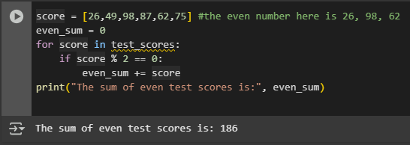

# Conclusion

In summary, we translated the algorithm and flowchart for adding only even in test scores (26, 49, 98, 87, 62, and 75) into a working Python program. The algorithm helped break down the problem step by step, and the flowchart gave a clear visual representation of the process, showing how the program checks if each number is even before adding it to the total. This task improved my understanding of how an algorithm and flowchart can be transformed into a real program and emphasized the importance of proper planning before coding.

**References**

[1] Co Arthur O.. “University of Caloocan City Computer Engineering Department Honor Code,” UCC-CpE Departmental Policies, 2020.