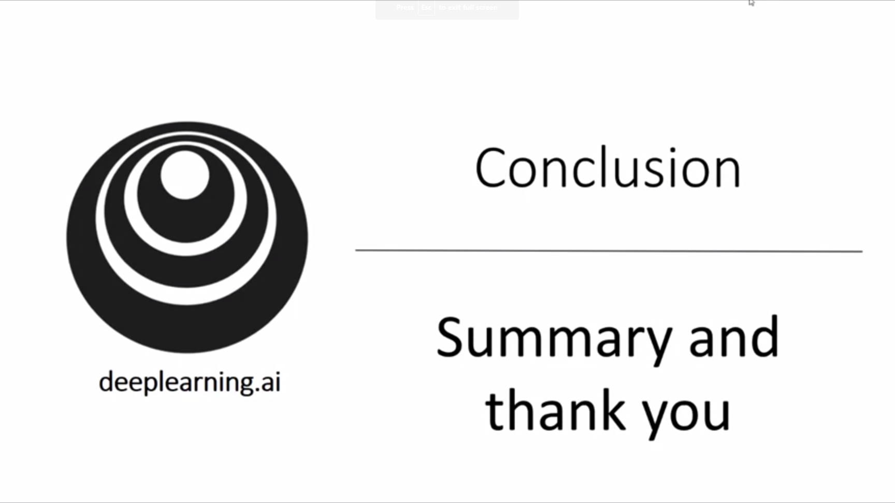

Final thoughts for the deep learning specialization.

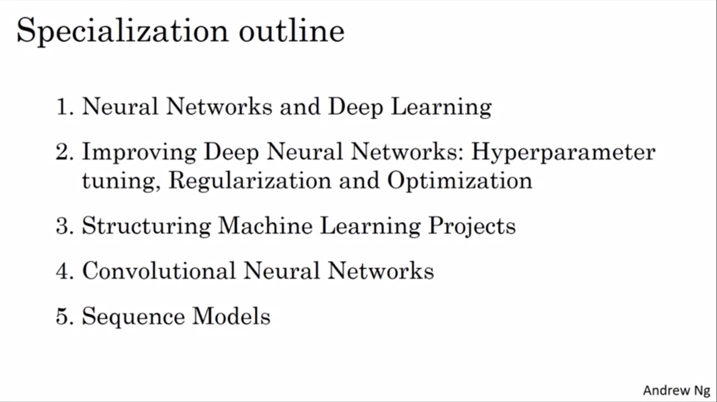

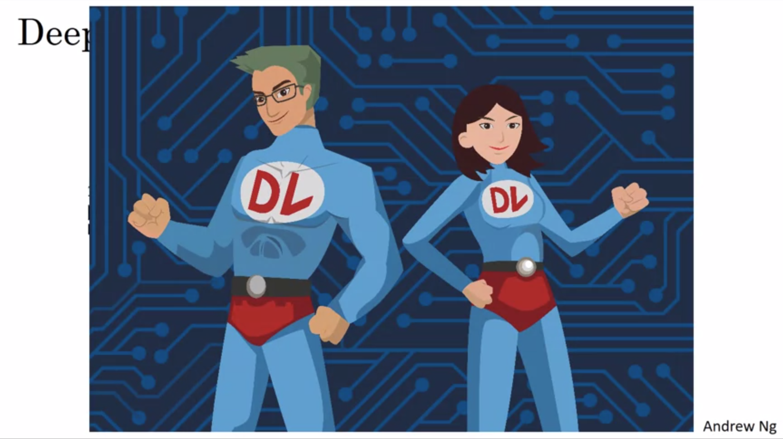

Deep learning is a superpower. With deep learning we can make a computer see, synthesize novel art, synthesize novel music. We can make a computer translate from one language to another. We can have a computer give a medical diagnosis by looking at a radiology image. We can build parts of an autonomous driving system. If that is not a superpower, what is?

Objective: use these ideas to move humanity forward and make the world a better place.