**Poker probability**

**simulation**

Juan Sebastian Carrillo

Prof. Fernando Ruiz

Universidad industrial de Santander

simulation

Bucaramanga-Colombia

2018

Poker probability

In the poker game there are some possible hands to win, but what is the probability to get every single one? The question is simple, if you have 5 poker cards what is the probability of getting a pair, two pairs, a trio, a Full or a poker? There are some more examples in the other document.

Pair = two different cards of the same rank

Trio = three different cards of the same rank

Full = a pair and a trio

Poker = four different cards of the same rank

To calculate the probability its possible use a analytical method and simulation method.

In order to show both, we will show you an analytical answer compared with simulation answer

How many hands could we have?(total)

C52, 5 = 2598960

From 52 cards choose 5.

**1 pair**

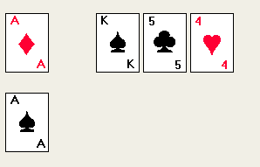

 C4, 2 = 6 ways to make a pair of “A”, from 4 possibilities(suite) choose 2 cards.C4, 2

We have 13 ranks and 6 ways to obtain a pair of every rank so

13\*6=78 ways to make a pair of cards(every rank)

C12, 3 = 220 to choose the other three cards we have 12 cards to choose (the 13 card is a pair card so we can choose it) so from 12 possibilities choose 3.C12, 3

Talking about the last 3 cards every card has 4 possibilities (suite) so 4\*4\*4=64

How many ways to get a pair? 78\*220\*64=1098240 pair hands

Analytical answer 1098240/C52, 5  = 0.42256902761

The simulation answer 

**2 pair**

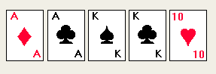

C4, 2 = 6 ways to make a pair of “A”. From 4 possibilities(suite) choose 2 cards.C4, 2

The same to “k”

6\*6=36 both “A” and “K” 36 possibilities to have 2 pairs of “A” and ”k”

To include the other possibilities(other possible pair) we multiplied by C13, 2 = 78 from 13 cards choose 2 every single one is one pair

To fill the missing space we choose form 44 cards(52-4-4)taking out the two pair ranks

How many ways to get tow pair? 36\*44\*78 = 123552

Analytical answerIMG_256

The simulation answer 

**Trio**

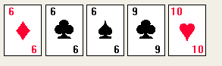

In order to fill the two free position C48, 2 = 1128 possible ways

13 cards to make a trio

C4, 3 = 4  possibilities to choose the rank of the trio, from 4 cards(suite) choose 3

4\*1128\*13=58656 “trios” but we have to take out the full possibilities

FULL=3744

Analytical answer IMG_256

Simulation answer 

**FULL**

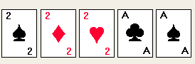

C4, 3 \* 13= 52 possibilities of trio

12 × C4, 2 = 72 possibilities of pair

Analytical answer 

Simulation answer 

**Poker**

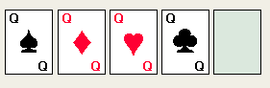

Choose the leftover card, 52-4 =48 possibilities

13 ways to choose a rank of the trio

Analytical answer 

Simulation answer 