CS172 – Lab 11
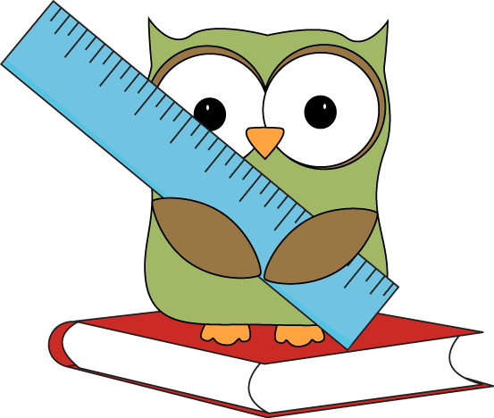
Cleaning with Dicts
You are trying to write a script to clean some data by converting all measurements to centimeters, instead of the wide variety of measurements (inches, millimeters, etc.) they are currently in. Starter code is provided in cleanUnits.py.
- Read the conversions.txt file into a dict. They key should be the unit (feet, inches, etc.) and the value should be the conversion factor
- Fill in the first TODO to initialize the dict
- Fill in the second TODO to add the conversion to the dict
- Fill in the third TODO to use the dict the convert each measurement from measurements.txt to centimeters and print it to the screen. The example output would be:
304.8 centimeters
119.38 centimeters
1706.88 centimeters
…
  - If the measurement is not in the dict, you should print a message stating the unit is unknown (make sure to include the name of the unit in your message!). It would be a little silly to do this for centimeters, though, so you should make sure that case works.

