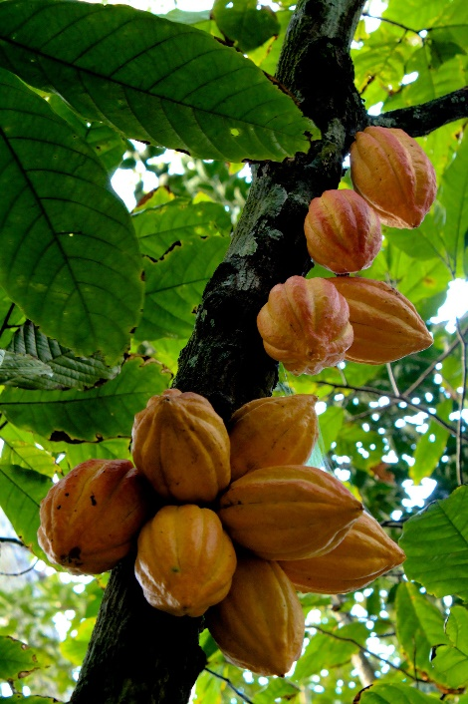
DATA/CS 172 – Lab 14
The Best Cacao

Chocolate has been consumed for centuries, and has many health benefits in addition to being delicious. Some of it is even grown right here on the Big Island – the Hilo side is particularly good for cacao plants!

When customers select a finished chocolate bar, one of the main things they look at is the “cacao percentage” – this indicates how much of the actual cacao plant is in the bar (vs other ingredients such as sugar and milk). So a 100% bar would be pure cacao, which is usually very strong and bitter.

You are given a CSV file containing ratings of different chocolate bars on a scale of 0-5. Each bar also reports the cacao percent it contains (in 5% ranges).

Your task is to write a script which will analyze the CSV file and print out each percentage range alongside the average rating for that range in a readable format. Make sure to use good style surrounding the CSV reading, making sure your script is robust to things like re-ordering columns.
Then answer the following question:

Q: Do the reviews seem biased towards giving high scores to certain kinds of chocolate? Why or why not?

Hint: I would suggest two dictionaries. One that stores the percent range (key) mapping to the total of all scores for the range (value), and one that stores the percent range (key) mapping to the count of all scores for the range (value). Then you can go back through the keys and divide the value that comes back from the total by the count to get the average. You could also use a dict of tuples if you prefer.

It’s okay if the percentages are printed out of order (to fix this, see the bonus).
Bonus: +1 points Use the sorted() function to ensure the percentages are printed in order.

Source: https://www.kaggle.com/rtatman/chocolate-bar-ratings

