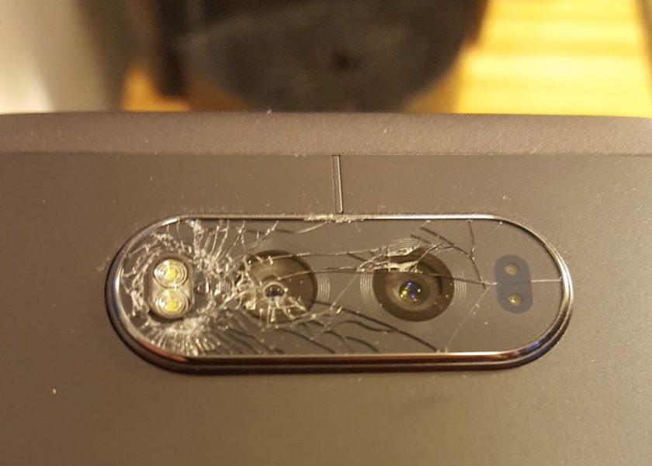
DATA/CS 172 – Lab 9
This Photo by Unknown Author is licensed under CC BY-SA
“Broken Sensor Redux”

In this lab we will practice using functions to better organize code. Your solution will work the same way as Lab 7 (same output will be printed), but this time a function will be used to extract the sensor information.

Arguments: The function should take one argument: a string containing the sensor name and sensor readings, separated by semicolons (Note that this is the same format as each line in the file)

Return Value: The function should return two elements: The name of the sensor (Sensor-XXX) and a bool, which is True if the sensor values contain an error, and False otherwise.

Make sure to include a comment for your function indicating it purpose, and give it an appropriate name. Remember, your function should not do any printing. And it should have good style, for instance no commands other than imports should occur before your function.

Don’t forget to test your code again to be sure it works with the new function! The output should be the same as lab 7, that is, it should only print the name of the errored sensors.

