Sebastian Lee

A12041475

02/09/18

**Lab 2: Data Sampling & Characterization**

1. **Introduction**

As the title implies, Lab 2’s purpose was to teach us the basics of sampling and analyzing what we sample. We first start off with an introduction to polling and timer based interrupts, finding that interrupts are better because they give us real time data. We are then introduced to the Arduino onboard sensors, the accelerometer & gyroscope, which we use to sample data that we will then analyze. To put all of it together, we will create a game that measures a player’s reaction time.

1. **Objective 1: Polling Sensors from Arduino**

In this objective, data was sampled. The data was continuously readable so as to detect changes in the sensor output. Using delays, we attempted to poll at a rate of 100Hz (unable to get a perfect 100Hz rate though). Using Fig. 1, we can determine that this is not a good data collection strategy since our time difference changes.

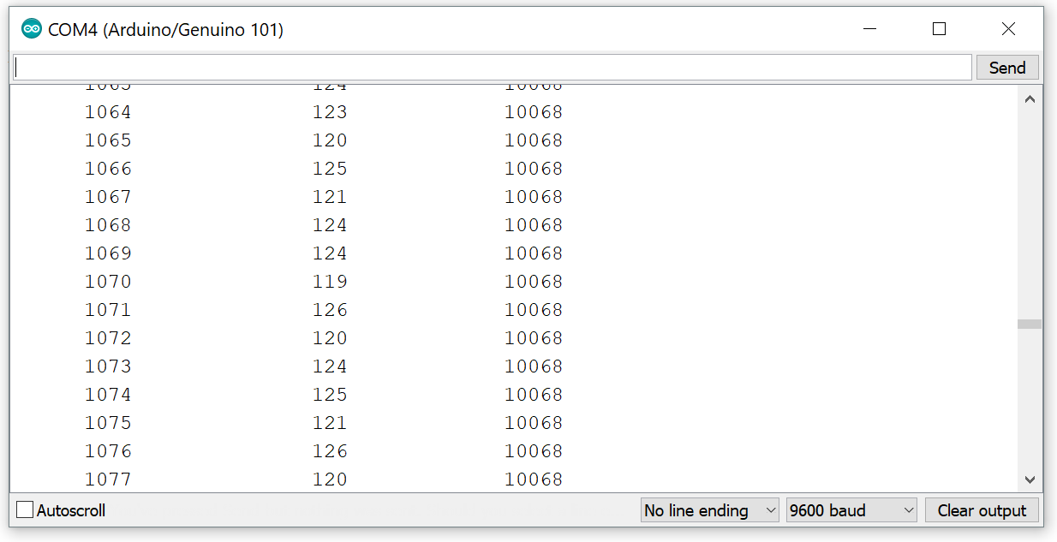

Fig. 1: Sample number (left), Votlage output (middle), Time Difference (output)

1. **Objective 2: ISR with Sensors and Arduino**

Here, we started using the Curie Timer One. This allowed us to capture information evenly spaced out by providing timer based interrupts, a very powerful tool for homogeneous sampling. This approach is better at data collection because by using a timer, we can guarantee that data will be sampled at a constant time we give it. This is also shown in Fig. 2.

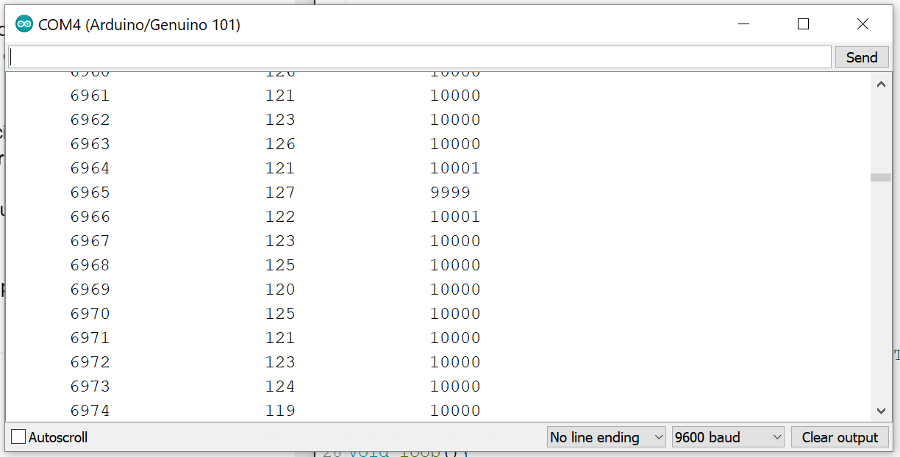

Fig. 2: Serial Monitor displaying messages sent by Arduino after resetting the board

1. **Objective 3: Timing sensor readings from the Arduino**

In Objective 3, we were introduced to the sensors that are embedded unto the Arduino: the Accelerometer and Gyroscope. To first be able to sample this data correctly, we printed out how fast it took for data to be read using the function micros(). This was done for each sensor, including an analog pin. Fig. 3 shows the recorded times.

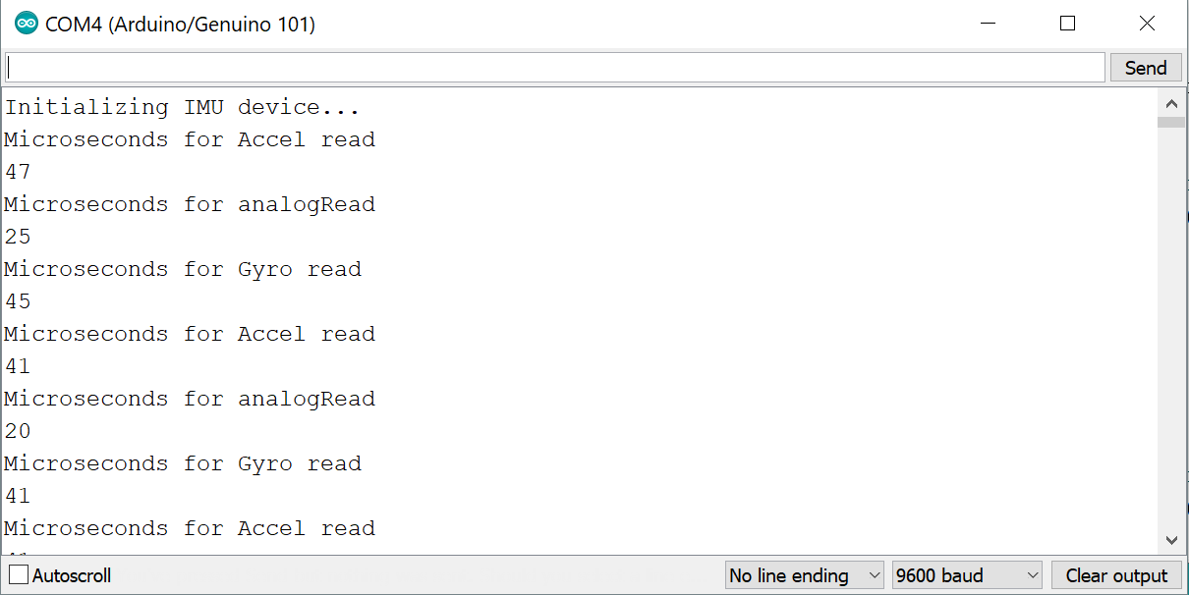

Fig. 3: Serial Monitor displaying messages after inputting a random message.

The maximum theoretical rate for each sensor would be the average of the times recorded (each sensor separate), inversed. If it took 47+41 microseconds for the accelerometer readings, then we could probably sample them at about 22500Hz to be safe (1/44microseconds). For Gyro and analog would be 23250Hz and 44400Hz respectively.

1. **Objective 4: Arduino Orientation applet**

Now we are using the onboard sensors, specifically the accelerometer, to determine the orientation of the Arduino. Using the data that I messed around with in Objective 3 (not shown), I determined the parameters needed to figure out what orientation the Arduino was in.

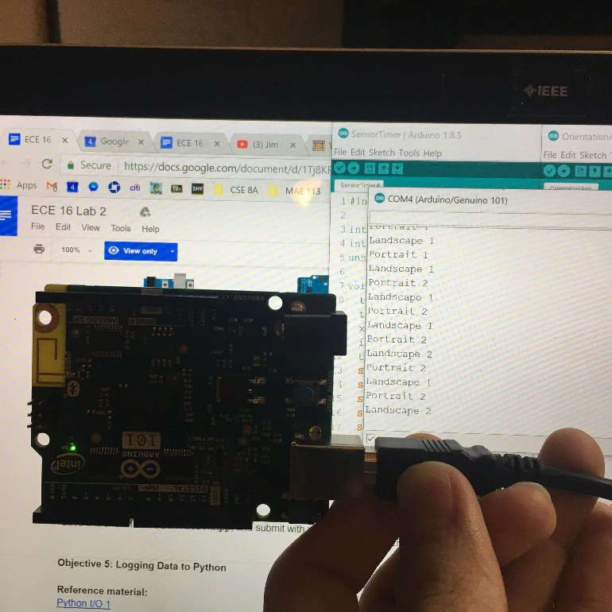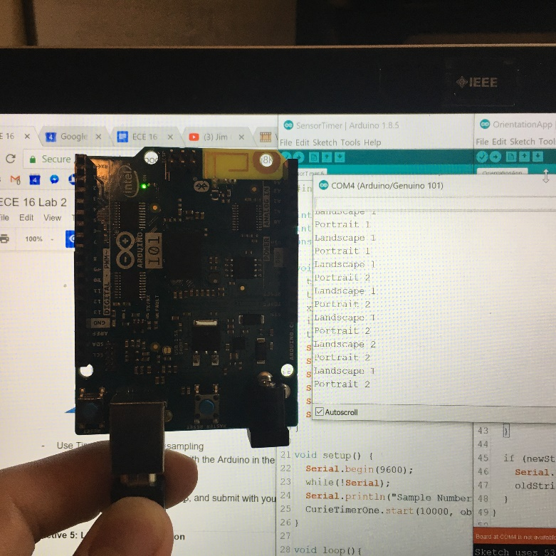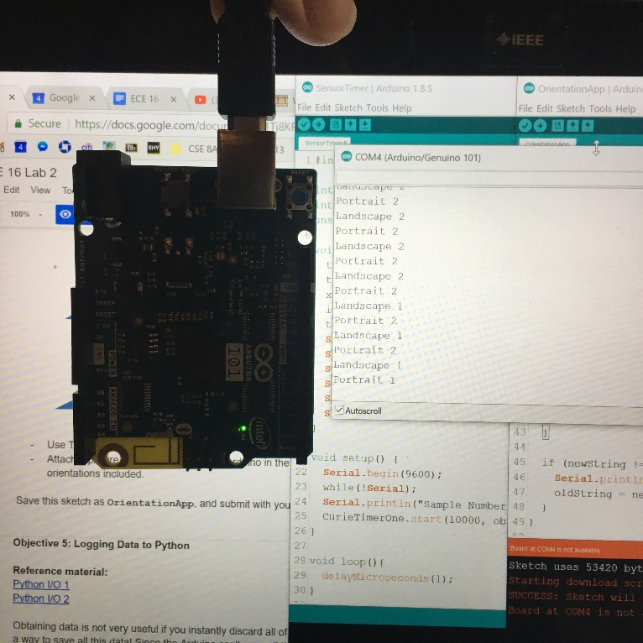

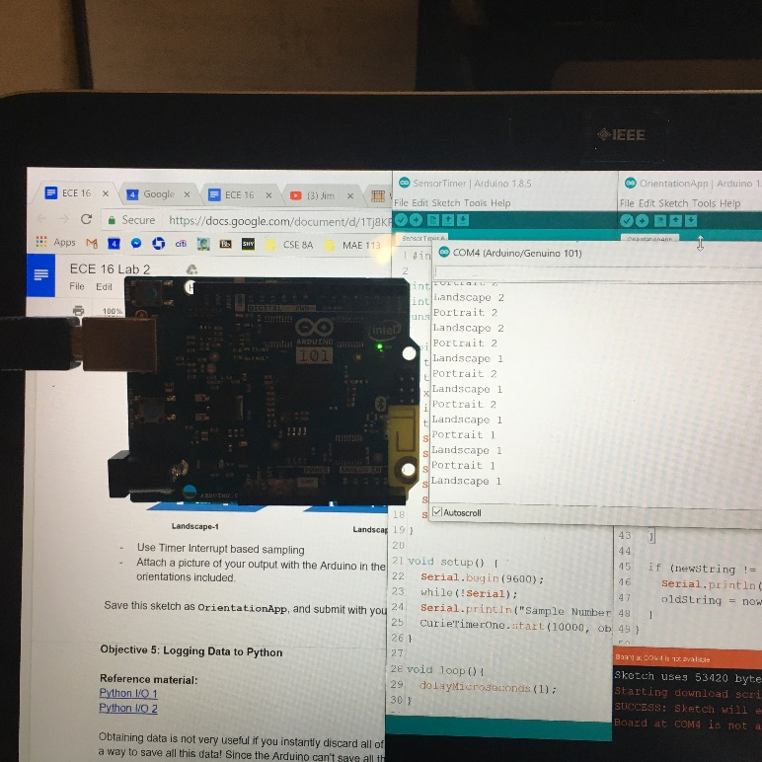

Fig. 4: s[0][0] = Portrait-1, s[1][0] = Landscape-1, s[0][1] = Portrait-2, s[1][1] = Landscape-2

1. **Objective 5: Logging Data to Python**

After playing with Arduino’s sensors and the data collected from these sensors, the next step was to write and save this data in real-time. To do so, we use Python to write into Serial, which runs an Arduino sketch (not turned in or shown). After inputting 1, 2, or 3, Arduino reads the input and prints out data depending on the input (accel, gyro, analog). The sketch samples at a fixed 200 Hz using timer based interrupts for 5000 samples. Python then reads the data in Serial and writes it into the respective filename.txt file. Inside the same git repo as this word doc are 3 text files.

1. **Objective 6: Arduino Serial Plotter**

In Objective 6, we use an Arduino sketch to ask the user which sensor’s magnitude they want to measure. We calculate magnitude using the function sq() and sqrt(). The Serial Monitor and Serial Plotter do not match in the pictures below.

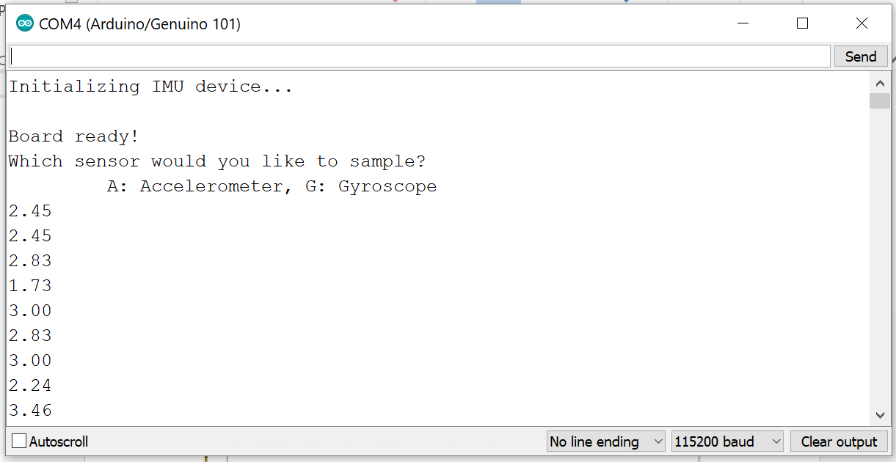

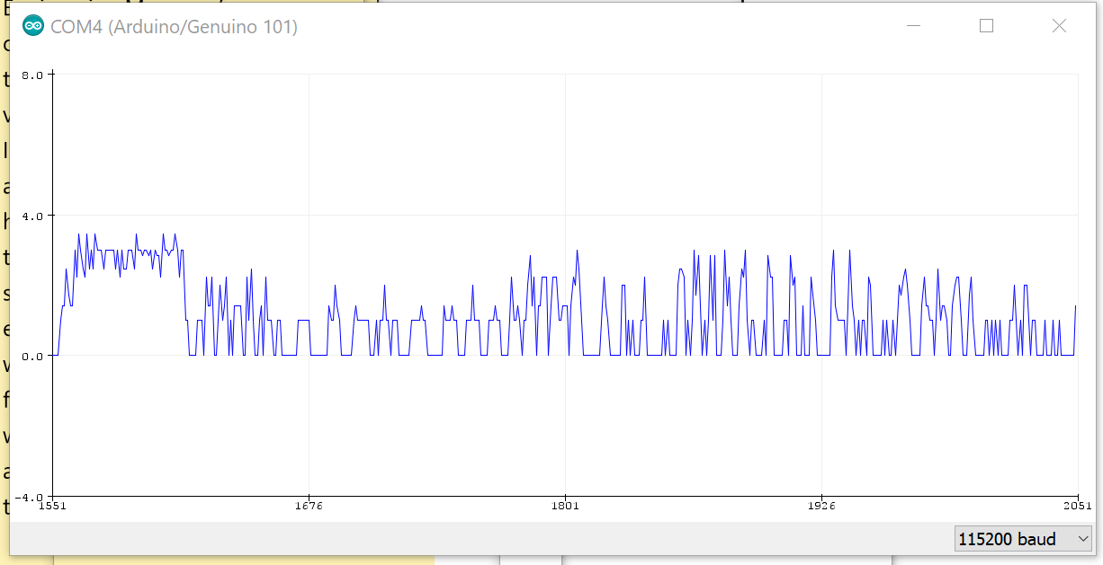

Fig. 5: Serial Plotter and Serial Monitor output for Accelerometer.

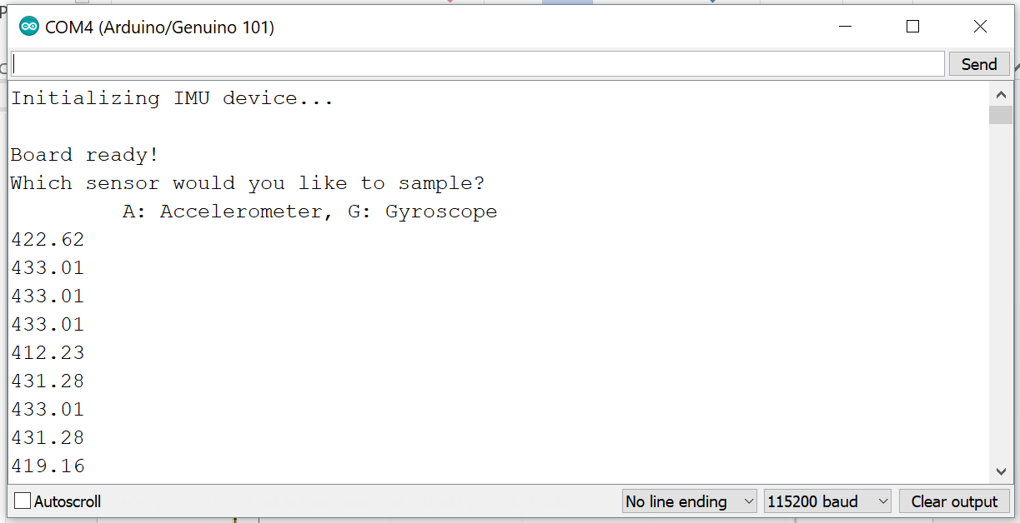

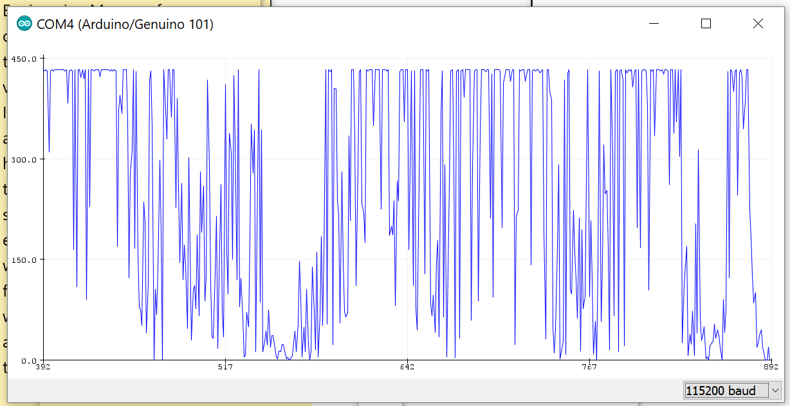

Fig. 6: Serial Plotter and Serial Monitor output for Gyroscope.

1. **Objective 7:**

Now it was time to put it all together. First, we wrote a sketch in Arduino that would make the user play a game. In this game, the Arduino measures the time it takes the user to move or rotate the Arduino, depending on whether they chose the accelerometer or the gyroscope. We use Python as the user interface, in which we can control how many times we want to play the game by specifying the number of iterations n. Along with the Word doc, files response_time.py, responseTime.ino, gyro_response_time.txt, and accel_response_time.txt are within the repository.

1. **Objective 8: Data Analysis**

For the last challenge, objective 8 asked us to write a python script that reads and analyzes data in the text files from Objective 5 and 7. In the Obj5 text files, we determined:

* If any samples were missing
* Number of samples analyzed
* Mean time difference
* Standard deviation of time difference
* Maximum time difference
* Minimum time difference

In the Obj7 text files, we determined:

* Mean response time
* Standard deviation
* Max response time
* Min response time

If successful, outputs from obj5 analysis would give a mean, max, and min of 5ms. Outputs from obj7 would all depend on how good the player was at reacting quickly.

1. **Problems and Issues**

It was EZ PZ. Jk.

There were a LOT of issues. At first I didn’t really understand how an interrupt worked and what an ISR was. Even harder was the idea of implementing the timer based interrupt. Using flags and what not would get confusing once we introduce more while and for loops. For a good while, I was stuck on Obj5, in which I was very stagnant because there was too much time spent on trying to find the right code to use. So to combat that, I ended up giving up and started all over by first creating a Pythong and Arduino cheat sheet, and then finally starting from a brand new file and coding all of it from the ground up. Another hard part was the formatting of writing and reading files. Whenever I did a readline(), I wasn’t sure how to edit the incoming string, so when it came time to analyze or use it, it was really tedious. Using the sensors and numpy were both relatively easy compared to the underlying concepts we had to understand in order to write working code.

1. **Conclusion**

Lab 2 built up on top of the concepts and code we used in Lab 1. In addition to using our knowledge in serial communication using Arduino and Python, we learned how to sample better. We also learned how to use the on board Arduino sensors and even collected data that we analyzed. Through coding up a game, we learned how to synthesize all the knowledge that was presented to us these past two weeks, including timer based interrupts, new sensors, serial plotter, saving data to txt files, and finally analyzing data.