# Chapter 1

-habits does not add up, they compound

-improve 1% everyday

-Plateau of latent potential (success threshold)

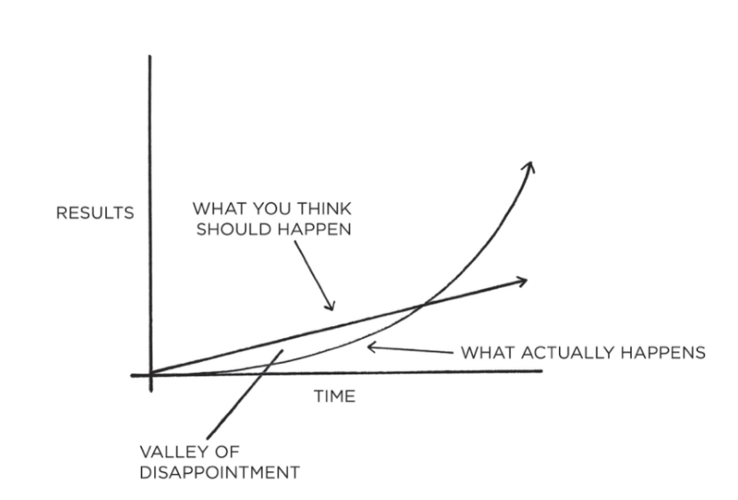

-Forget about goals, focus on systems instead

# Chapter2

-align your beliefs with who you want to be

-Every action you take is a vote for the person you wish to become

-Decide the person you want to be and prove it to yourself with small wins

-the focus should always be on becoming that type of person rather than getting a particular outcome

# Chapter3

-Habit loop: cue, craving, response, reward

-The four laws of human behavior:

For good habits:

Cue / make it obvious

Craving / make it attractive

Response / make it easy

Reward / make it satisfying

For bad habits:

Cue / make it invisible

Craving / make it unattractive

Response / make it difficult

Reward / make it unsatisfying

# Chapter4

-You don’t need to be aware of the cue for a habit to begin

-make a habit scorecard

-the process of behavior change always starts with awareness

-Pointing-and-calling raises your level of awareness

-most common cues are tile and location

-people who make a specific plan for when and where they will perform a new habit are more likely to follow through

-this is called implementation intention. Say when and where you will perform an action

-I will (behavior) at (time) in (location)

-we often say yes to little requests because we are not clear enough about what we need to be doing instead

-no behavior happens on isolation. Each action becomes a cue that triggers the next behavior

-you can identify a habit and stack a new behavior on top

-after (current habit), I will (new habit)

-environment is the invisible hand that shapes human behavior

-You can be de architect of your environment

-habits can be easier to change in a new environment

-it is important to have a different environment for every task (study, cooking, sleeping, relaxing)

-In the short run, you can overcome temptation. In the long run, you become a product of the environment you live in

-Once a habit is formed, it is unlikely to be forgotten

-it is easier to avoid temptation than resist it

-Dopamine is released not only when you experience pleasure, but also when you anticipate it. It makes us take action.

-we need to make our habit attractive because it’s the expectation of a rewarding experience that motivates us to act.

-temptation building works by linking an action you want to do with an action you need to do.

-one of the best ways to build a habit is to join a culture where that habit is normal.

-surround yourself with people with habits you want for yourself

-We tend to imitate the habits of three groups of people: the close, the many and the powerful

-Change your mindset. You don’t have to, you get to. Highlight the benefits instead of rather than the drawbacks.

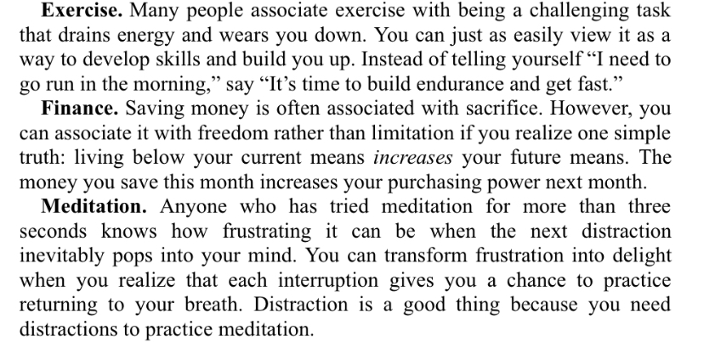

-planning and learning are useful, but it doesn’t bring results by itself. You must take action.

-sometimes we plan because it makes us feel that we are making a progress without the risk of failure

-every time you repeat an action, a neural circuit is activated

-habits form based on frequency, not time

-every habit is just an obstacle to getting what you want

-make the good habits the path with less resistance

-when you start a new habit, it should take less than 2 minutes

-a new habit should not feel like a challenge

-you may not be able to do automate the entire process, but you can make the first action mindless

-divide the habit in phases based on difficulty

-a commitment device is a choice you make in the precent that locks in better behavior in the future (make it difficult or impossible)

-the more immediate pleasure you get from an action, the more strongly you should question whether it aligns with your long-term goals

-immediate rewards are essential. They keep you excited while the delayed rewards accumulate in the background

-habit tracking: track your progress

-how to stick with a habit: never miss twice

-when and when not to track a habit: when the measures become the target, it ceases to be a good measure. Focus in a larger picture

-the feeling of making progress is one of most satisfying feelings

-inversion of the 4th law: make it immediately unsatisfying

-behavior only shifts if the punishment is painful enough and reliably enforced.

-the habit contract: put a penalty for the moment you miss a habit, a sign a contract with another person

-knowing that someone is “watching” can be a powerful motivator

-you must link your habits to your personality and abilities.

-play the games where the odds are in your favor

-how to know what game to play? (What is the right habit?).

-explore/exploit and trade-off: explore the beginning of new activities, if you are winning, keep exploiting, if you are losing, keep exploring.

-what feels like fun for me but work for others? -What make me lose track of time?

-Where do I get greater returns than the average person?

-by combining your skills, you reduce the competition. If you do not find a game where you are one of the best, create one by combining fields.

-how to maintain motivation?

-goldilocks rule: humans experience peak motivation when facing challenges just at the edges of their current abilities. Not too hard, not too easy.

-Annalise your progress over time, check the details of the habits

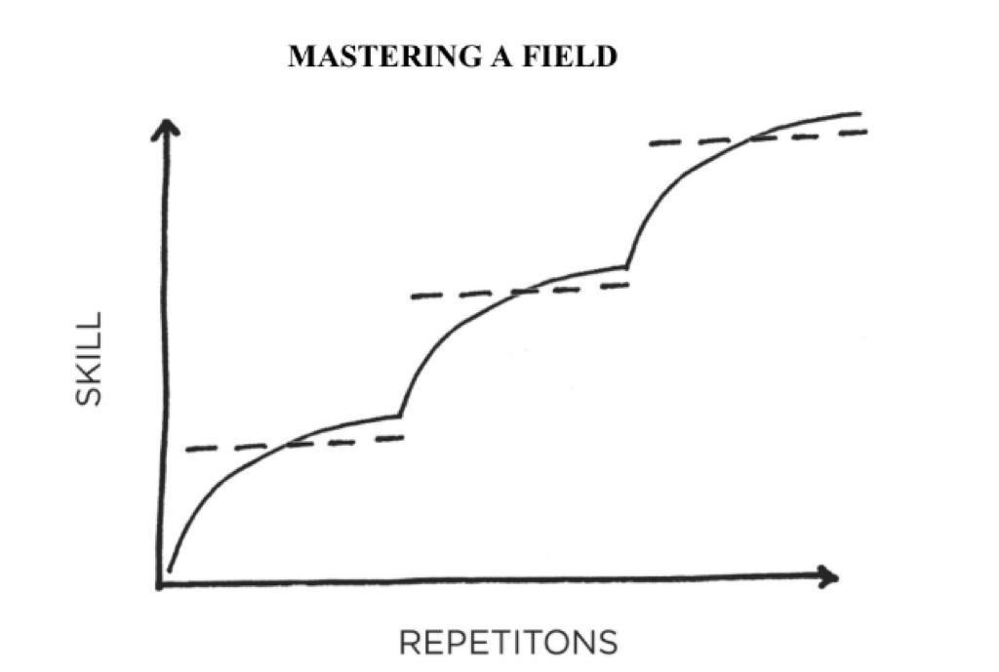

-Annual report: what went well this year? What did not go so well? What did I learn? (December and July)

-integrity report: what are the core values that drive my life and work? How I’m I living with integrity? How can I set a higher standard?

-if you base your identity about one thing, and you lose it, who are you? Make your identity bigger, flexible and adapt to your environment.