Code that is working :

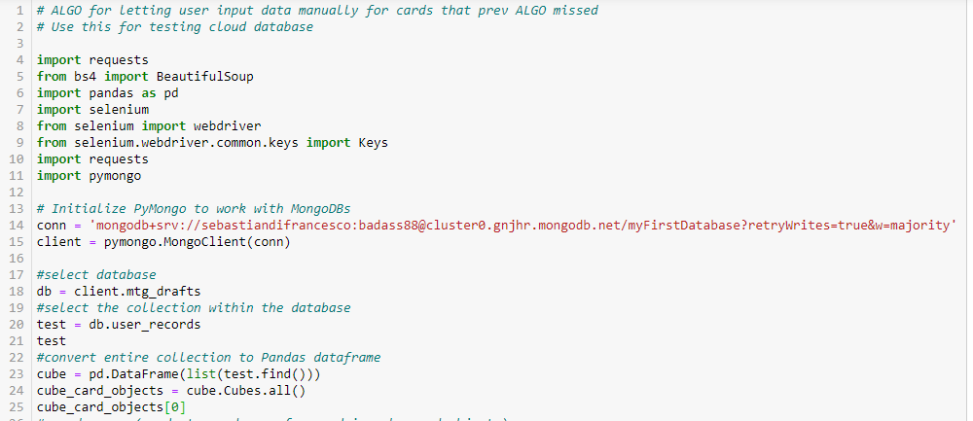

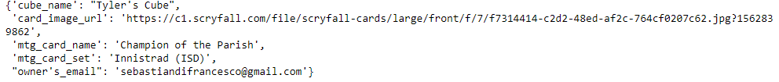

Code that is not working:

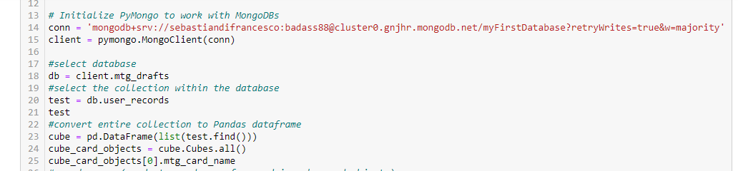

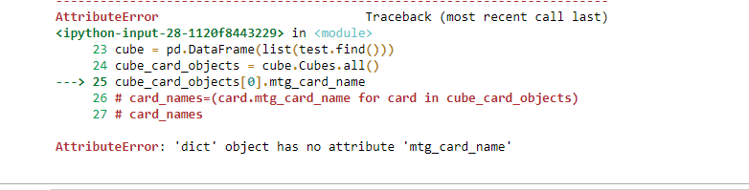

Why am I getting this error when trying to call the mtg_card_name attribute from the cube_card_objects[0]?