Software Design Document (SDD)
Module: ADC Driver
Version: 1.0
Author: Lugo Muñiz Luis Angel 37915, Lizalde Herrera Sebastian 38241, Araiza Quintana Carlos Humberto 36986, Garcia Veliz Oskar Liborio 38265

1. Introduction
1.1. Purpose
This document describes the software design and architecture of the ADC (Analog-to-Digital Converter) driver module developed for the STM32F411RE microcontroller, as part of the Microcontrollers and Embedded Systems course at CETYS Universidad. The design is based on the requirements defined in SRS-ADC_Driver v1.0 and provides details on data structures, enumerations, register-level algorithms, and control flow to guide implementation and testing.
1.2. Scope
The ADC driver is a low-level software component for embedded systems. It abstracts STM32F411RE ADC1 hardware to provide a clean, validated API for analog signal acquisition. The driver:
- Configures ADC1 clock (RCC->APB2ENR) and GPIOA clock (RCC->AHB1ENR); sets PA1 in analog mode via adc_init().
- Powers on ADC1 by setting ADON in CR2 via adc_enableAdc().
- Supports regular channel selection (CH0–CH18) via adc_setChannel() and injected channel selection (CH1–CH4) via adc_setInjectedChannel().
- Supports single conversion (adc_startSingleConversion()), continuous conversion (adc_startContinuousConversion()), and software-triggered injected conversion (adc_startInjectedConversion()).
- Returns 12-bit conversion results from DR via adc_readData() and from JDR[0..3] via adc_readInjectedChannelData() using polling.
- Validates all input arguments and returns ADC_Status_t error codes, satisfying NFR-2 (error handling).
- Does not depend on HAL or LL libraries — all hardware interaction uses direct MCU register access through the CMSIS ADC_TypeDef structure.

1.3. Definitions, Acronyms, and Abbreviations
Term | Definition
ADC | Analog-to-Digital Converter — peripheral that converts an analog voltage to a 12-bit digital value.
DR | Data Register — holds the result of the most recent regular conversion.
JDR | Injected Data Register — holds result of an injected conversion (JDR1–JDR4).
SQR | Sequence Register — defines the order and length of the regular conversion sequence.
JSQR | Injected Sequence Register — defines the injected conversion sequence.
SR | Status Register — contains EOC and JEOC flags indicating conversion completion.
CR2 | Control Register 2 — controls ADON, CONT, SWSTART, and JSWSTART bits.
EOC | End Of Conversion — flag in SR set by hardware when a regular conversion finishes.
JEOC | End Of Injected Conversion — flag in SR set when an injected conversion finishes.
ADON | ADC ON bit (bit 0 of CR2) — enables the ADC from power-down state.
CONT | Continuous mode bit (bit 1 of CR2) — ADC auto-restarts after each conversion when set.
SWSTART | Software Start bit (bit 30 of CR2) — triggers a regular conversion by software.
JSWSTART | Injected Software Start bit (bit 22 of CR2) — triggers an injected conversion by software.
RCC | Reset and Clock Control — manages peripheral clocks via AHB1ENR and APB2ENR registers.
FR-x | Functional Requirement x — defined in SRS-ADC_Driver v1.0.
NFR-x | Non-Functional Requirement x — defined in SRS-ADC_Driver v1.0.
HAL | Hardware Abstraction Layer — NOT used; driver uses direct register access.
CMSIS | Cortex Microcontroller Software Interface Standard — provides ADC_TypeDef.
MCU | Microcontroller Unit — refers to the STM32F411RE in this document.
API | Application Programming Interface — the public function set exposed by the adc_driver module.

1.4. Requirements
All requirements for this module are allocated in SRS-ADC_Driver v1.0. This document covers FR-1 through FR-9 and NFR-1 through NFR-3:
Req. ID | Type | Description
FR-1 | Functional | adc_init() shall enable GPIOA and ADC1 clocks and configure PA1 in analog mode.
FR-2 | Functional | adc_enableAdc() shall power on ADC1 by setting ADON bit in CR2.
FR-3 | Functional | adc_setChannel() shall configure the regular sequence for one channel (0–18) and return ADC_ERROR for invalid inputs.
FR-4 | Functional | adc_setInjectedChannel() shall configure the injected sequence for one channel (1–4) and return ADC_ERROR for invalid inputs.
FR-5 | Functional | adc_startSingleConversion() shall clear CONT and set SWSTART to trigger exactly one regular conversion.
FR-6 | Functional | adc_startContinuousConversion() shall set CONT and SWSTART to start continuous regular conversions.
FR-7 | Functional | adc_startInjectedConversion() shall set JSWSTART to trigger one injected conversion.
FR-8 | Functional | adc_readData() shall poll the EOC flag and return the 12-bit result from DR.
FR-9 | Functional | adc_readInjectedChannelData() shall poll JEOC and return the 12-bit result from the correct JDR register.
NFR-1 | Non-Functional | The driver shall be lightweight: all hardware interaction uses direct MCU register access through CMSIS structures; no HAL or LL dependency.
NFR-2 | Non-Functional | The driver shall validate all input arguments before any hardware register access and return ADC_Status_t error codes.
NFR-3 | Non-Functional | The driver shall meet real-time constraints: no dynamic memory allocation; all operations complete in bounded time except the polling loops in adc_readData() and adc_readInjectedChannelData().

2. System Architecture
2.1. High-Level Design
- Layered Architecture:
- Application Layer: Contains main.c or user application code, which calls the ADC driver API (or an optional intermediate module API). Never accesses ADC registers directly.
- Peripheral Module Layer: Optional modules (e.g., a voltage sensor module) that use the adc_driver API to abstract hardware details from the application.
- ADC Driver Layer: Contains adc.c / adc.h. The only layer that accesses STM32F411RE ADC1 registers and configures GPIOA for analog input. Implements FR-1 through FR-9.
- Hardware Layer: STM32F411RE ADC1 peripheral registers and RCC, accessed through the CMSIS ADC_TypeDef structure.

2.2. Module Interfaces
Public API: Functions declared in adc.h. adc_init() and adc_enableAdc() return void; adc_setChannel() and adc_setInjectedChannel() return ADC_Status_t; conversion start functions return void; result-reading functions return uint16_t.
Dependencies: adc.h (CMSIS-style ADC_TypeDef, enumerations, macros, prototypes); gpio.h (included in adc.c for RCC and GPIOA access); stdint.h (uint16_t, uint32_t).
Internal Design: No private helper functions. All public functions directly access ADC1 registers through the ADC_TypeDef pointer. Input validation is performed inline at the start of each function that accepts parameters.

3. Detailed Design
3.1. Module Description
A. ADC Driver Module (adc.c / adc.h)
Responsible for all direct register access to the STM32F411RE ADC1 peripheral. Provides the complete public API for clock initialization, GPIO configuration, channel selection, conversion triggering, and result reading. All nine public functions write directly to CMSIS-mapped registers through the ADC1 pointer defined as ((ADC_TypeDef *) 0x40012000UL). No global mutable state is exposed; all state is held in hardware registers.
B. Application / Module Layer
Calls adc_init() once at startup, then adc_enableAdc(). For each measurement: calls adc_setChannel() or adc_setInjectedChannel(), starts the conversion, and reads the result. Never accesses ADC registers directly.
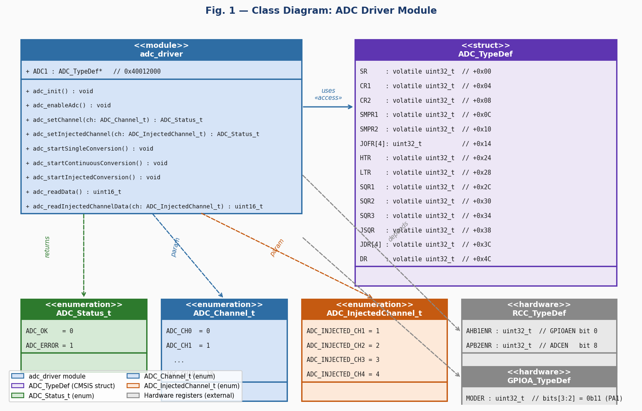
Fig. 1 — Class Diagram: ADC Driver Module

3.2. Module Behavior
Initial State
After reset, ADC1 clocks are off and registers are undefined. adc_init() enables GPIOA and ADC1 clocks and configures PA1 in analog mode. adc_enableAdc() then powers on ADC1 (ADON=1) making it ready for conversions.
Event: Regular Conversion (Single)
adc_setChannel(ADC_CH1) writes SQR1=0 and SQR3=1. adc_startSingleConversion() clears CONT and sets SWSTART. Hardware performs one conversion and sets EOC. adc_readData() polls EOC, reads DR & 0x0FFF, and returns the 12-bit result.
Event: Continuous Conversion
adc_startContinuousConversion() sets CONT then SWSTART. ADC restarts automatically after each conversion. The application reads the latest result at any time via adc_readData().
Event: Injected Conversion
adc_setInjectedChannel(ADC_INJECTED_CH1) writes JSQR=0 then sets JSQ4. adc_startInjectedConversion() sets JSWSTART. Hardware completes the injected conversion and sets JEOC. adc_readInjectedChannelData(ADC_INJECTED_CH1) polls JEOC and reads JDR[0] & 0x0FFF.
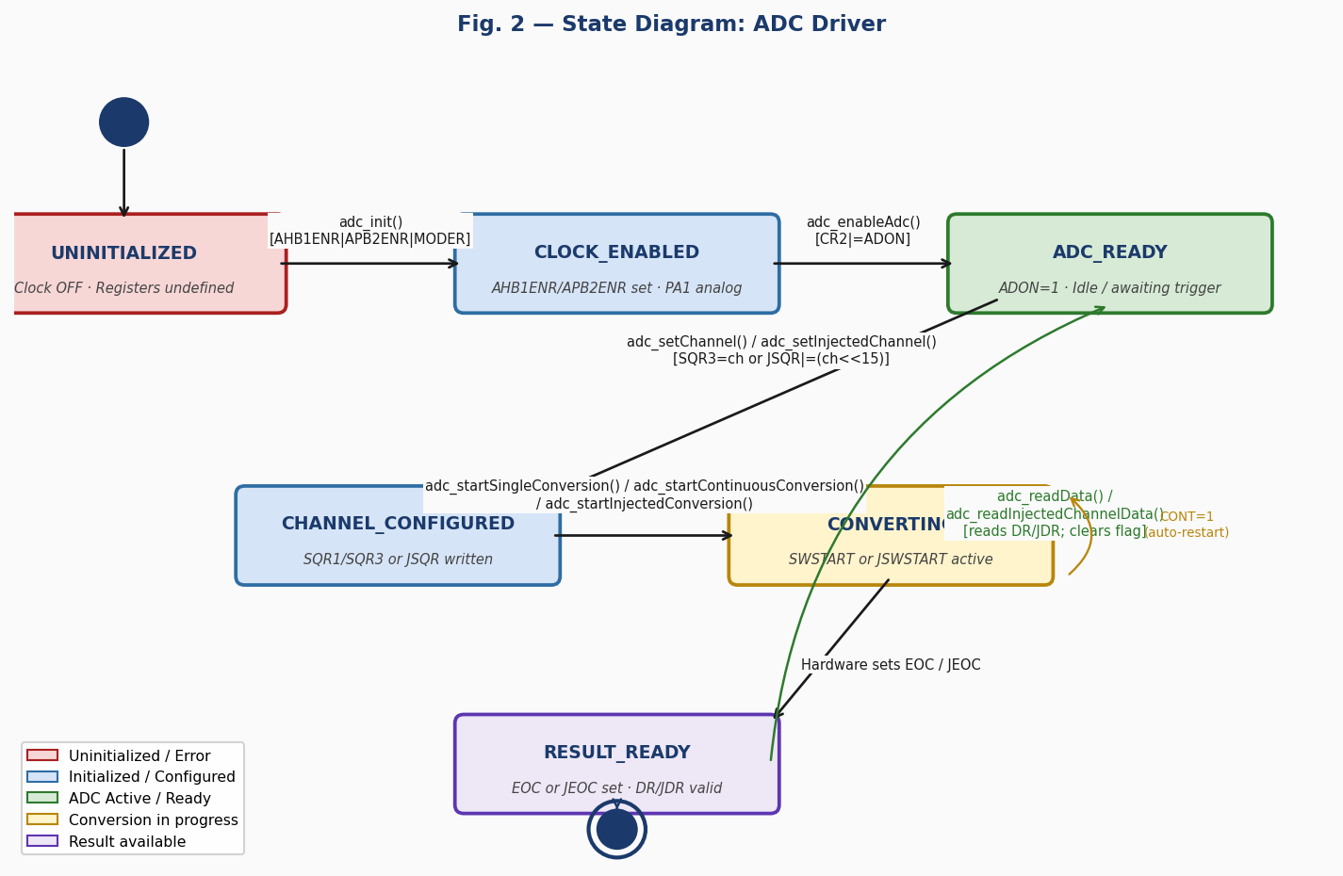
Fig. 2 — State Diagram: ADC Driver

3.2.1. Per-Function Sequence and Activity Diagrams

adc_init() — FR-1: Clock and GPIO Initialization
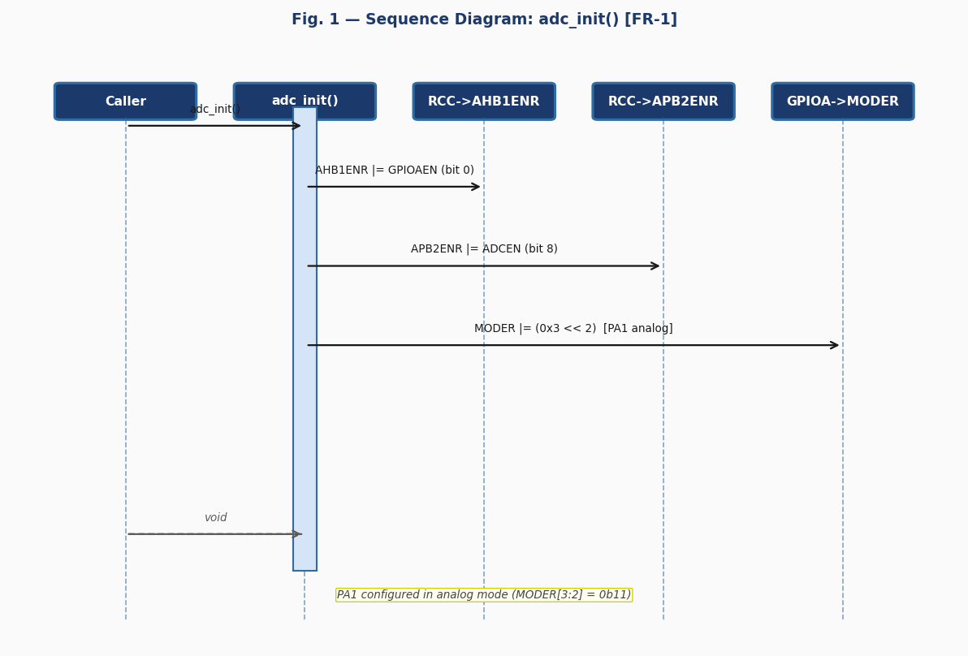
Fig. 3 — Sequence Diagram: adc_init() [FR-1]

The sequence diagram for adc_init() shows three hardware register targets: RCC->AHB1ENR, RCC->APB2ENR, and GPIOA->MODER. The function takes no parameters and returns void. It performs three sequential writes: enabling GPIOA clock (bit 0 of AHB1ENR), enabling ADC1 clock (bit 8 of APB2ENR), and setting PA1 to analog mode (MODER bits [3:2] = 0b11). No error branch exists because clock enable and MODER writes always succeed at the hardware level.
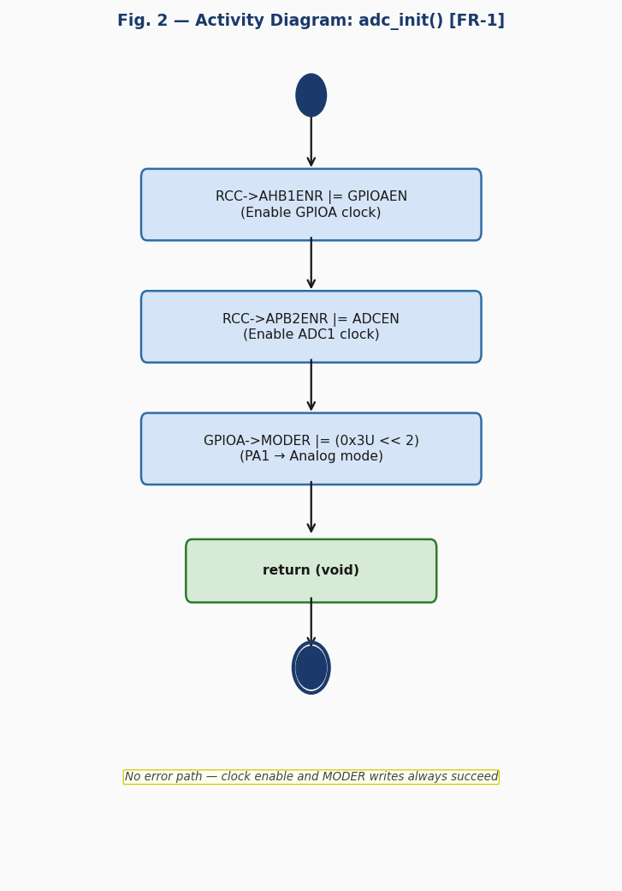
Fig. 4 — Activity Diagram: adc_init() [FR-1]

The activity diagram for adc_init() is a purely linear sequence of three actions with no decision nodes. The absence of decision diamonds confirms this is a straight-line initialization function that always returns void after the last register write.
adc_enableAdc() — FR-2: ADC Power-On
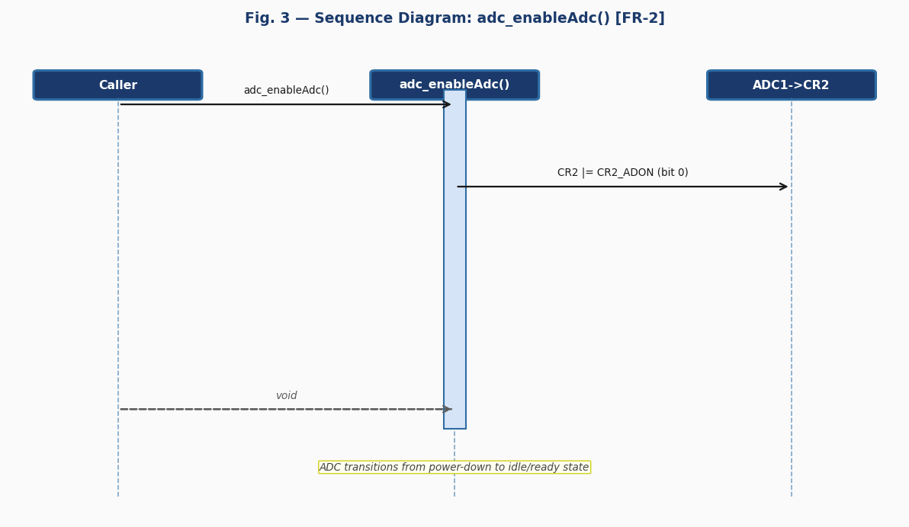
Fig. 5 — Sequence Diagram: adc_enableAdc() [FR-2]

The sequence diagram for adc_enableAdc() shows a single write to ADC1->CR2 setting the ADON bit (bit 0). The function takes no parameters and returns void. This transitions the ADC from powered-down to idle/ready state. adc_init() must be called first to provide the APB2 clock.
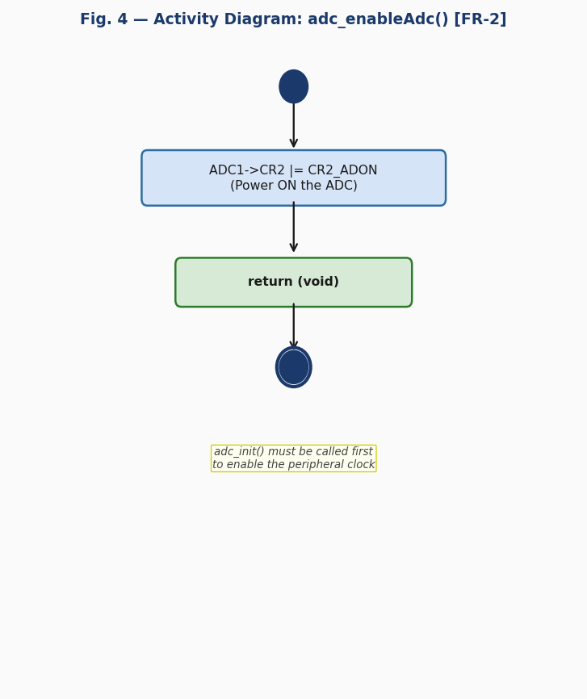
Fig. 6 — Activity Diagram: adc_enableAdc() [FR-2]

The activity diagram for adc_enableAdc() contains a single action node (CR2 |= CR2_ADON) with no decision logic, reflecting the unconditional register write.
adc_setChannel() — FR-3: Regular Channel Selection
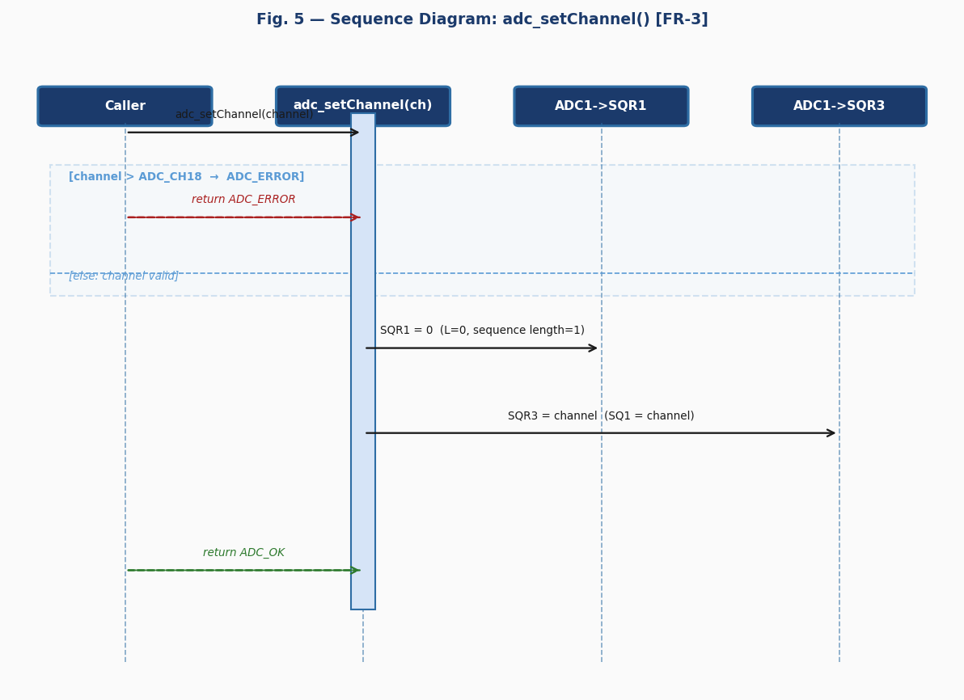
Fig. 7 — Sequence Diagram: adc_setChannel() [FR-3]

The sequence diagram shows an alt combined fragment. If channel > ADC_CH18 (18), ADC_ERROR is returned immediately without touching any register. On the valid path, SQR1=0 (L=0, sequence length=1) is written first, then SQR3=channel (SQ1 field). Full assignment avoids residual bits from prior configurations.
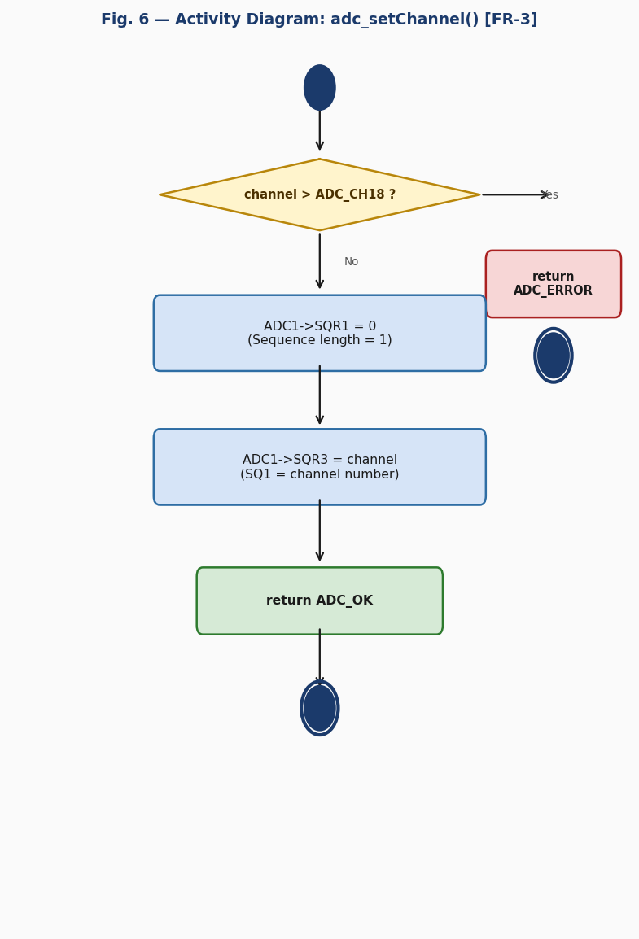
Fig. 8 — Activity Diagram: adc_setChannel() [FR-3]

The activity diagram has one decision node: [channel > ADC_CH18?]. The error branch exits immediately with ADC_ERROR without modifying any register. The valid path writes SQR1=0 then SQR3=channel before returning ADC_OK.
adc_setInjectedChannel() — FR-4: Injected Channel Selection
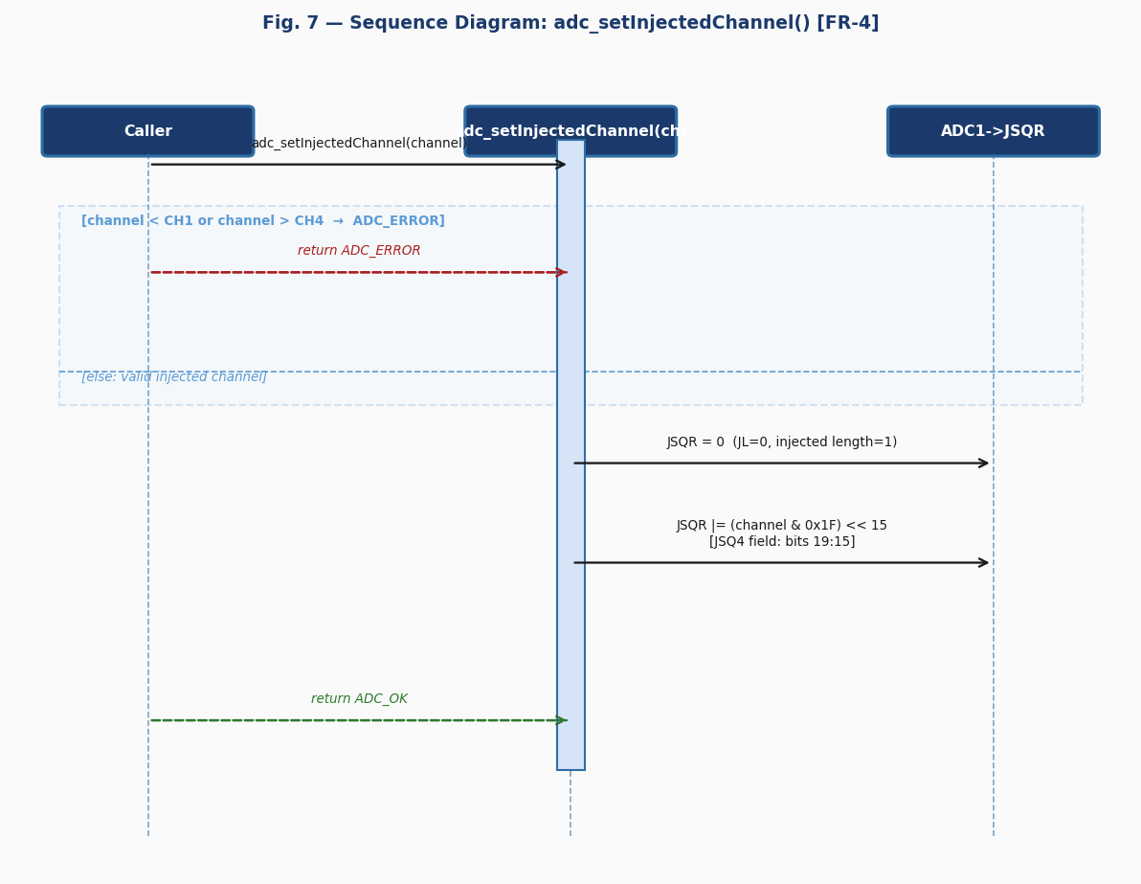
Fig. 9 — Sequence Diagram: adc_setInjectedChannel() [FR-4]

The sequence diagram shows validation against ADC_INJECTED_CH1 (1) and ADC_INJECTED_CH4 (4). If out of range, ADC_ERROR is returned. On the valid path, JSQR=0 (JL=0, length=1) is written first, then the channel is OR-written into the JSQ4 field (bits [19:15]) by masking and shifting left 15 positions. JSQ4 is always the active slot when JL=0 on STM32F4.
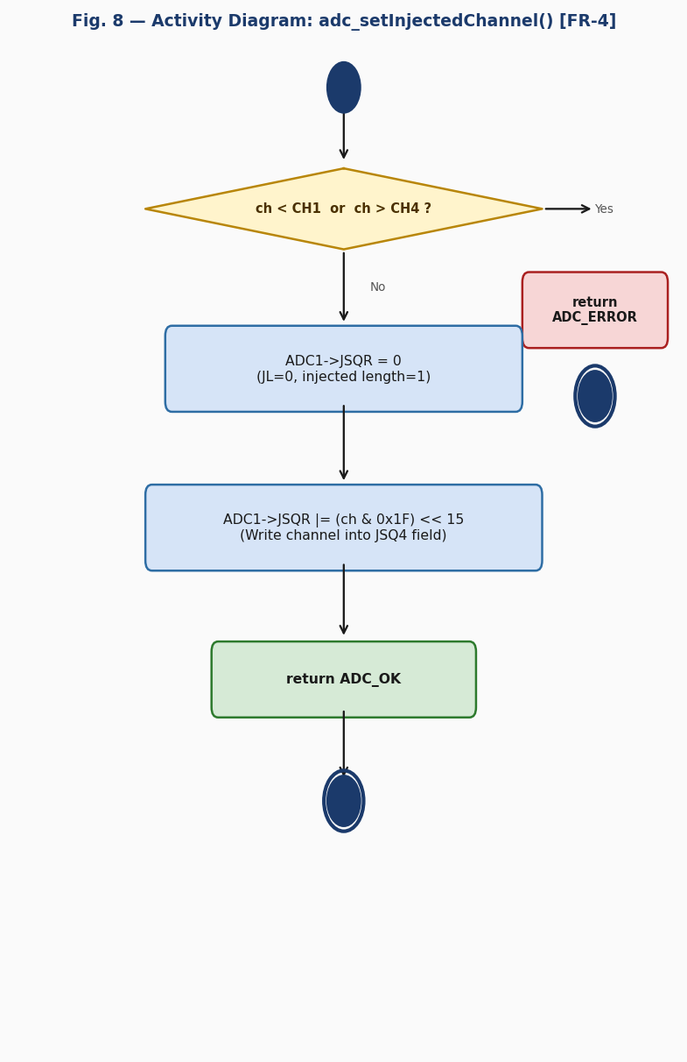
Fig. 10 — Activity Diagram: adc_setInjectedChannel() [FR-4]

The activity diagram has one decision node checking both bounds. The valid path clears JSQR first to guarantee JL=0, then OR-writes the masked channel into JSQ4, and returns ADC_OK.
adc_startSingleConversion() — FR-5: Single Conversion Trigger
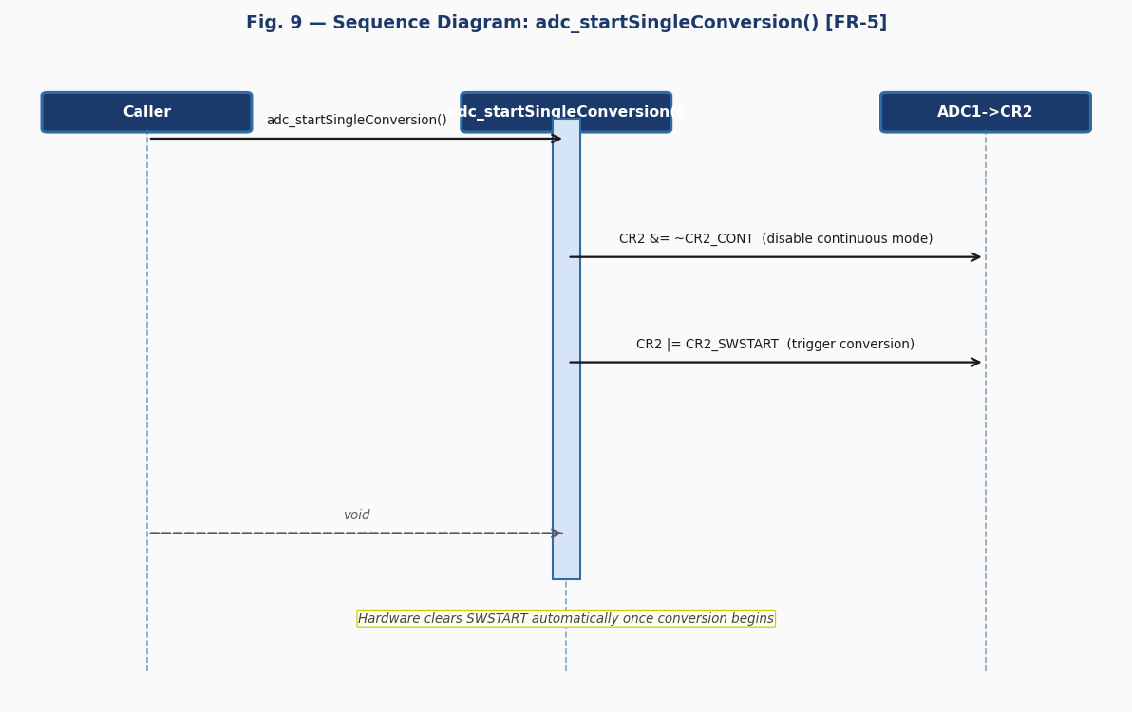
Fig. 11 — Sequence Diagram: adc_startSingleConversion() [FR-5]

The sequence diagram shows two sequential writes to ADC1->CR2: CR2 &= ~CR2_CONT to disable continuous mode, then CR2 |= CR2_SWSTART to trigger the conversion. Hardware clears SWSTART automatically once the conversion begins and sets EOC when complete.
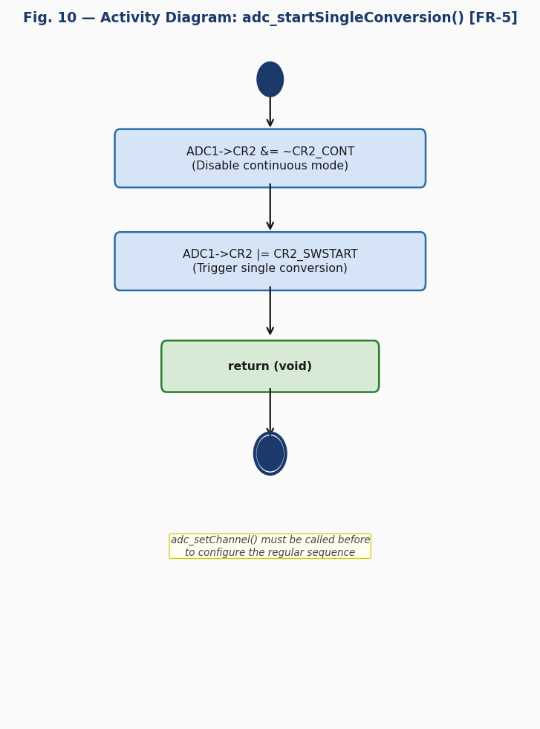
Fig. 12 — Activity Diagram: adc_startSingleConversion() [FR-5]

The activity diagram is a linear two-action sequence with no decision nodes: clear CONT, then set SWSTART. adc_setChannel() and adc_enableAdc() must be called before.
adc_startContinuousConversion() — FR-6: Continuous Conversion
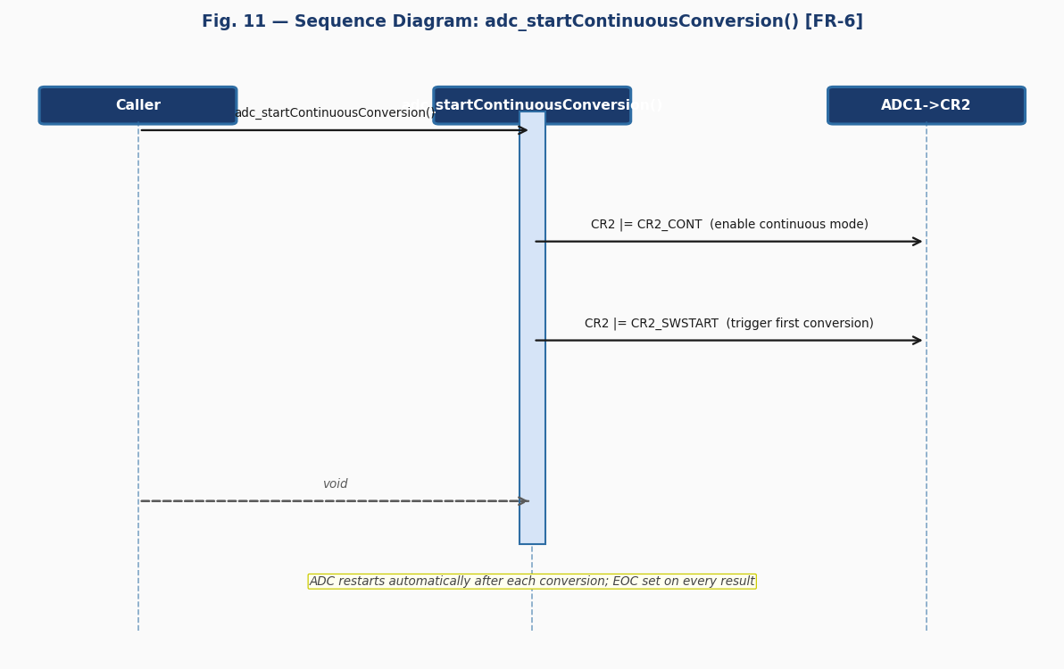
Fig. 13 — Sequence Diagram: adc_startContinuousConversion() [FR-6]

The sequence diagram shows CR2 |= CR2_CONT to enable continuous mode, then CR2 |= CR2_SWSTART to trigger the first conversion. The ADC hardware restarts automatically after each conversion, setting EOC after every result.
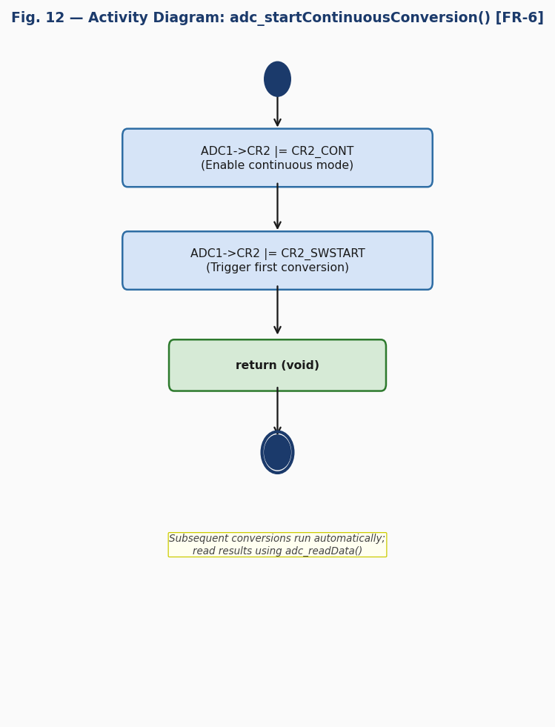
Fig. 14 — Activity Diagram: adc_startContinuousConversion() [FR-6]

The activity diagram contains two sequential action nodes (enable CONT, then SWSTART) with no branching. To stop, the application must disable ADON or clear CONT without retriggering.
adc_startInjectedConversion() — FR-7: Injected Conversion Trigger
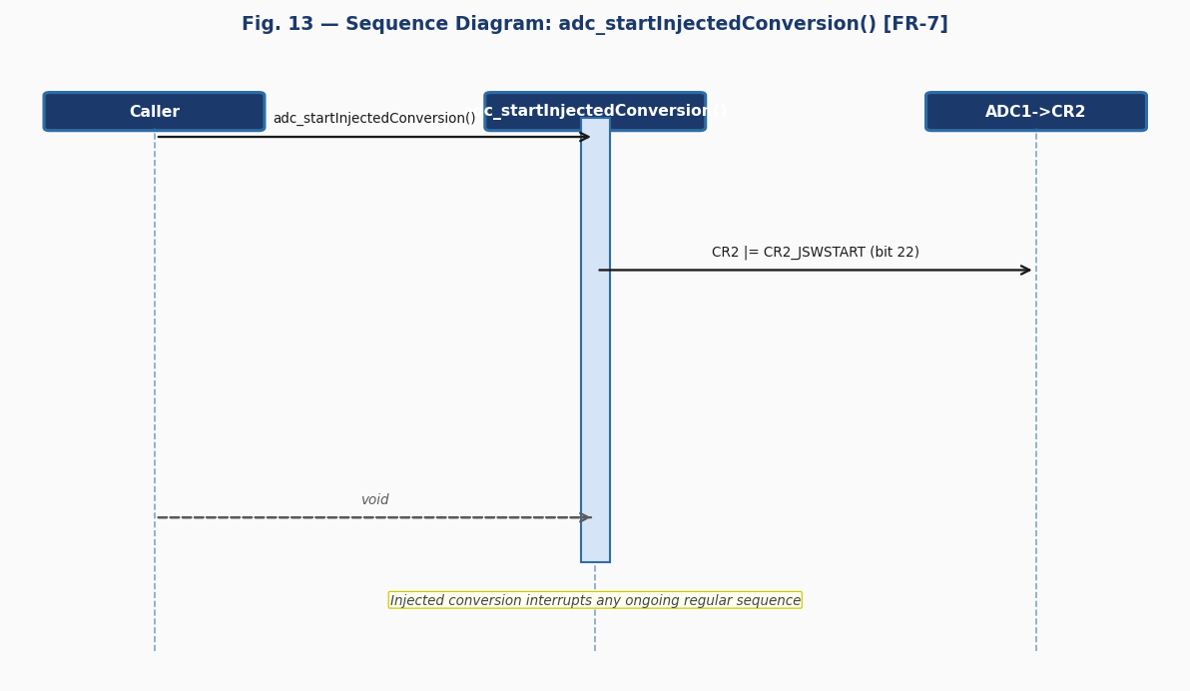
Fig. 15 — Sequence Diagram: adc_startInjectedConversion() [FR-7]

The sequence diagram shows a single write: CR2 |= CR2_JSWSTART (bit 22). Injected conversions have higher priority than regular conversions and can interrupt an ongoing regular sequence. JEOC in SR is set when the conversion completes.
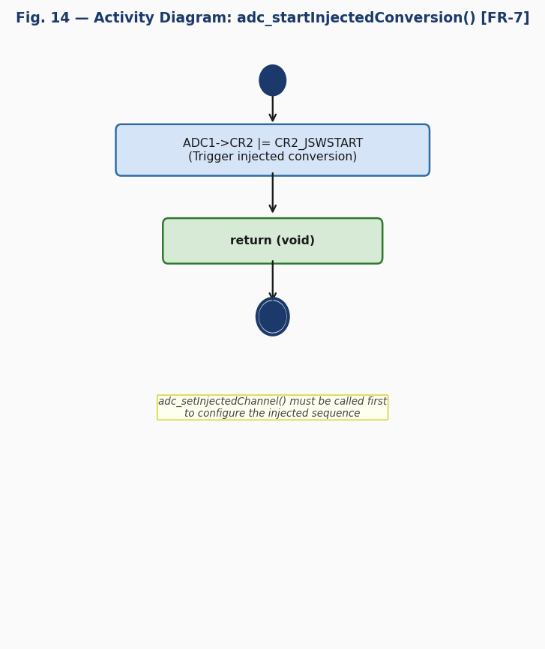
Fig. 16 — Activity Diagram: adc_startInjectedConversion() [FR-7]

The activity diagram contains a single action node with no decision logic. adc_setInjectedChannel() must have been called first.
adc_readData() — FR-8: Regular Conversion Result
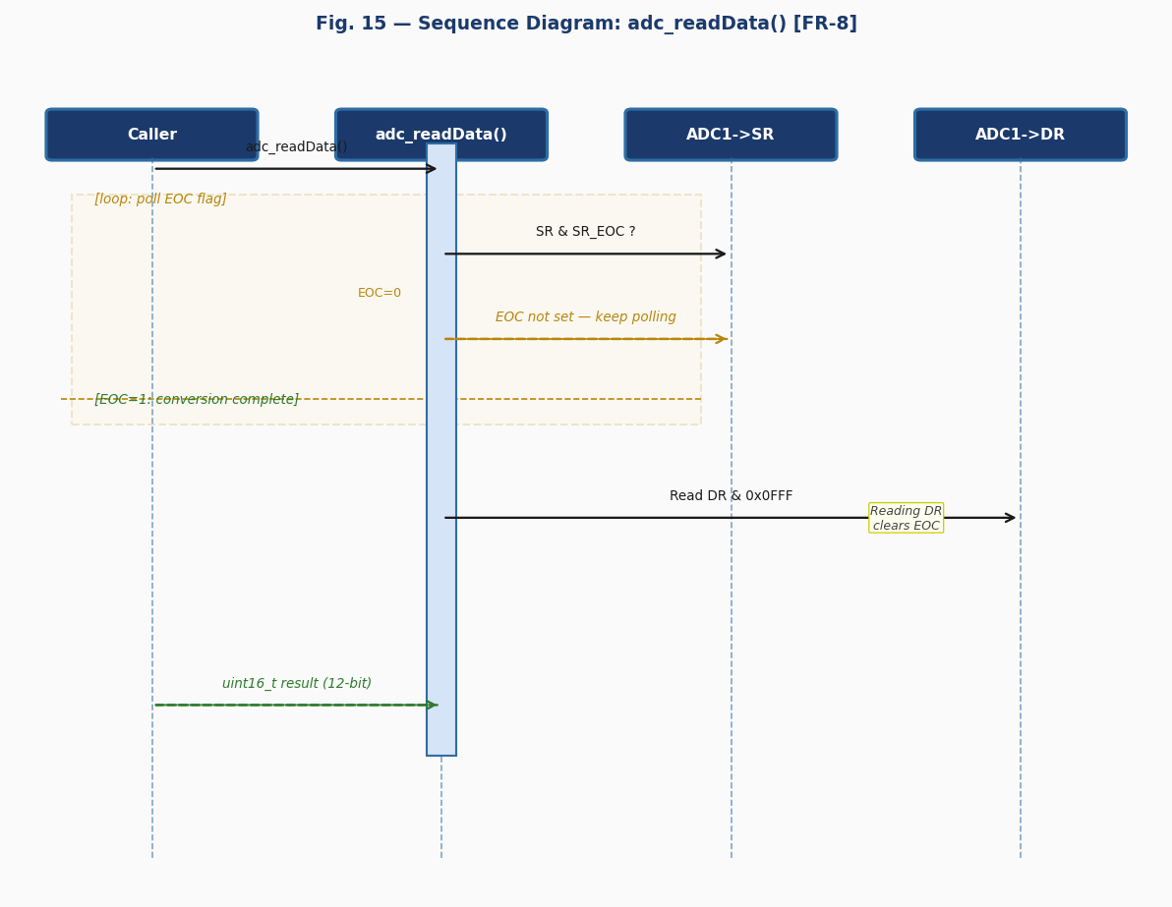
Fig. 17 — Sequence Diagram: adc_readData() [FR-8]

The sequence diagram shows a polling loop reading ADC1->SR until EOC (bit 1) is set by hardware. Once set, ADC1->DR is read and bits [11:0] are returned as uint16_t masked with 0x0FFF. Reading DR automatically clears EOC on STM32F4 devices.
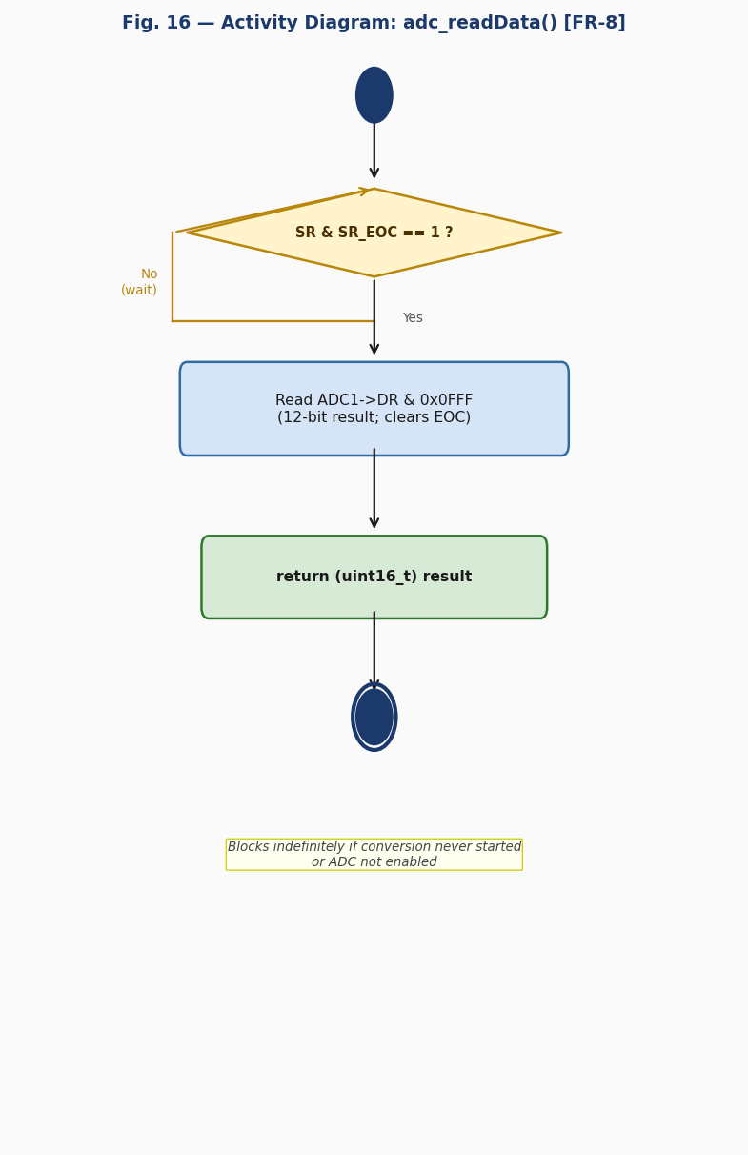
Fig. 18 — Activity Diagram: adc_readData() [FR-8]

The activity diagram has one decision/loop node: [SR & SR_EOC == 1?]. The No branch loops back (busy-wait). The Yes branch reads DR, applies the 12-bit mask, and returns the result. The function blocks indefinitely if no conversion was triggered or the ADC is not enabled.
adc_readInjectedChannelData() — FR-9: Injected Conversion Result
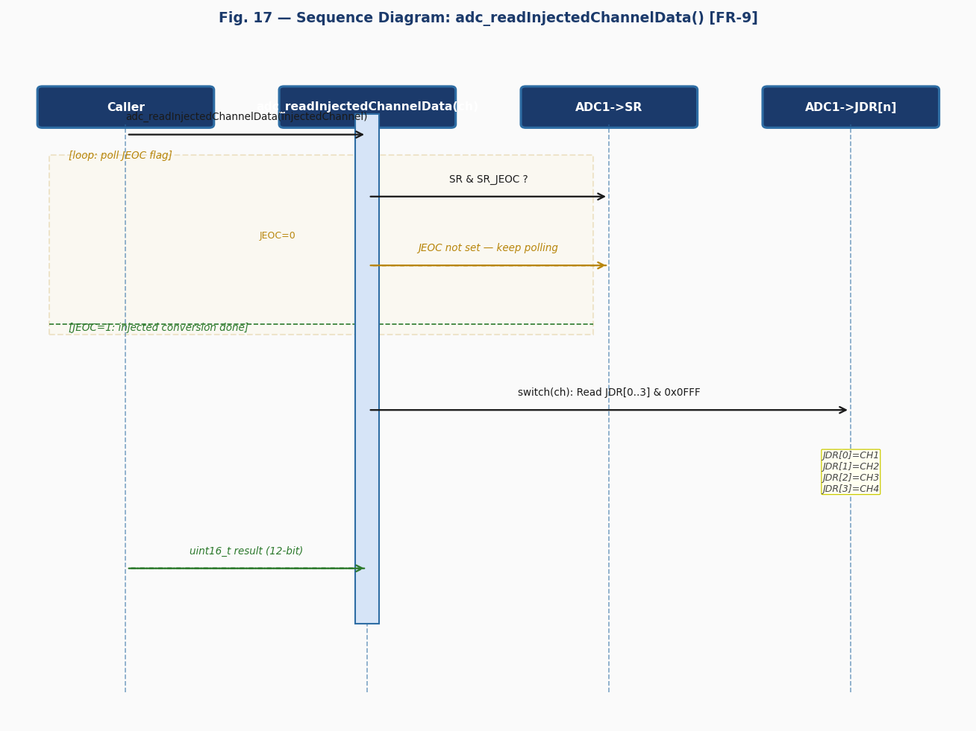
Fig. 19 — Sequence Diagram: adc_readInjectedChannelData() [FR-9]

The sequence diagram shows a polling loop on JEOC (bit 2 of SR). Once set, a switch statement selects JDR[0]–JDR[3] based on injectedChannel (CH1=JDR[0], CH2=JDR[1], CH3=JDR[2], CH4=JDR[3]). The result is masked with 0x0FFF and returned as uint16_t.
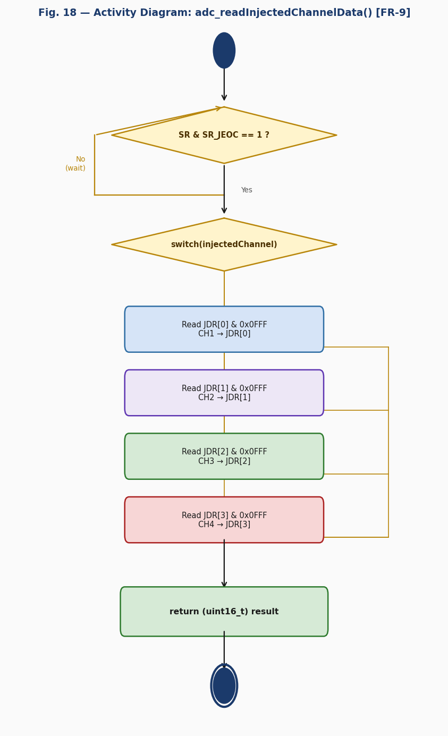
Fig. 20 — Activity Diagram: adc_readInjectedChannelData() [FR-9]

The activity diagram has two decision nodes: the JEOC polling loop and the switch on injected channel with four branches selecting JDR[0] through JDR[3]. A default returns 0 for invalid channel values as a safeguard.
3.3. ADC Driver
The ADC driver is a hardware abstraction module written in C targeting the STM32F411RE microcontroller (RM0383 reference manual). It provides a clean, validated API allowing upper-layer code to control ADC1 without accessing hardware registers directly. It complies with SRS-ADC_Driver v1.0, implementing FR-1 through FR-9, documented by the sequence and activity diagrams in Section 3.2.1 (Figs. 3–20).
Internal Data Structures
The driver exposes no mutable global state. All hardware state is held in the STM32F411RE peripheral registers (ADC_TypeDef) accessed through the ADC1 macro pointer defined in adc.h as ((ADC_TypeDef *) 0x40012000UL).
Initialization Flow
System initialization is a two-step process. In the first step, adc_init() (FR-1, Figs. 3–4) enables the GPIOA clock on AHB1, enables the ADC1 clock on APB2, and configures PA1 in analog mode (MODER bits [3:2] = 0b11). In the second step, adc_enableAdc() (FR-2, Figs. 5–6) sets ADON (bit 0 of CR2), transitioning ADC1 from powered-down to idle/ready state.
Channel Configuration
adc_setChannel() (FR-3) writes SQR1=0 (L=0) then SQR3=channel to configure a single regular conversion. adc_setInjectedChannel() (FR-4) writes JSQR=0 (JL=0) then OR-writes the channel into JSQ4 (bits [19:15]). Full register assignment before the OR-write prevents stale configuration from prior calls.
Conversion Control
adc_startSingleConversion() (FR-5) clears CONT then sets SWSTART for a one-shot conversion. adc_startContinuousConversion() (FR-6) sets CONT then SWSTART for continuous operation. adc_startInjectedConversion() (FR-7) sets JSWSTART to trigger a high-priority injected conversion that can interrupt a regular sequence.
Result Reading and Polling
adc_readData() (FR-8) spin-waits on EOC (SR bit 1) before reading DR & 0x0FFF. adc_readInjectedChannelData() (FR-9) spin-waits on JEOC (SR bit 2) before selecting the correct JDR register via a switch statement. The 12-bit mask guarantees only valid bits are returned.
Error Handling and Safety Model
adc_setChannel() and adc_setInjectedChannel() return ADC_Status_t (ADC_OK or ADC_ERROR). Input validation is performed before any register access (NFR-2). Polling loops block indefinitely if called without a prior conversion trigger — callers are responsible for correct call sequence.
Design Decisions and Rationale
The 12-bit mask (0x0FFF) on DR and JDR reads guarantees only valid result bits are returned. Writing SQR1=0 before SQR3, and JSQR=0 before the JSQ4 OR-write, prevents stale sequence configuration. PA1 is hard-coded in adc_init() as the primary analog input on the NUCLEO-64 A0 header; future versions may accept pin and channel as parameters.
4. Application Programming Interfaces
4.1. Data Types and Macros
ADC_Status_t: Return type enumeration for functions with input validation. Values: ADC_OK=0 (success), ADC_ERROR=1 (invalid parameter).
ADC_Channel_t: Enum identifying the regular channel to convert. Values: ADC_CH0=0 through ADC_CH18=18. Maps directly to the SQ1 field in ADC1->SQR3.
ADC_InjectedChannel_t: Enum identifying the injected channel to convert. Values: ADC_INJECTED_CH1=1 through ADC_INJECTED_CH4=4. Maps to the JSQ4 field (bits [19:15]) in ADC1->JSQR.
Key macros: ADC1_BASE=0x40012000UL, GPIOAEN=(1U<<0), ADCEN=(1U<<8), SR_EOC=(1U<<1), SR_JEOC=(1U<<2), CR2_ADON=(1U<<0), CR2_CONT=(1U<<1), CR2_SWSTART=(1U<<30), CR2_JSWSTART=(1U<<22), ADC1=((ADC_TypeDef*)ADC1_BASE).
ADC_TypeDef Structure (key members used by this driver):
Member Name | Type | Offset | Notes / Definition
SR | volatile uint32_t | +0x00 | Status register — EOC (bit 1), JEOC (bit 2) set by hardware on conversion completion.
CR1 | volatile uint32_t | +0x04 | Control 1 — not directly used by this driver; reserved for future configuration.
CR2 | volatile uint32_t | +0x08 | Control 2 — ADON (bit 0), CONT (bit 1), JSWSTART (bit 22), SWSTART (bit 30).
SMPR1 | volatile uint32_t | +0x0C | Sampling time CH10–CH18 — not configured by this driver (uses reset default).
SMPR2 | volatile uint32_t | +0x10 | Sampling time CH0–CH9 — not configured by this driver (uses reset default).
SQR1 | volatile uint32_t | +0x2C | Sequence length L field [23:20]; written to 0 for single regular conversion.
SQR3 | volatile uint32_t | +0x34 | SQ1 field [4:0] — first (and only) channel in the regular sequence.
JSQR | volatile uint32_t | +0x38 | JL [21:20] — injected length; JSQ4 bits [19:15] — injected channel number.
JDR[4] | volatile uint32_t | +0x3C | Injected data registers: JDR[0]=CH1, JDR[1]=CH2, JDR[2]=CH3, JDR[3]=CH4.
DR | volatile uint32_t | +0x4C | Regular conversion result — bits [11:0] contain 12-bit value; reading DR clears EOC.

Register Map Used by this Driver:
Register | Address | Access | Used by Function(s) | Purpose in Driver
RCC->AHB1ENR | 0x40023830 | R/W | adc_init() | Enable GPIOA clock (bit 0 = GPIOAEN).
RCC->APB2ENR | 0x40023844 | R/W | adc_init() | Enable ADC1 clock (bit 8 = ADCEN).
GPIOA->MODER | 0x40020000 | R/W | adc_init() | PA1 analog mode — bits [3:2] = 0b11.
ADC1->CR2 | 0x40012008 | R/W | adc_enableAdc(), adc_startX() | ADON (0), CONT (1), JSWSTART (22), SWSTART (30).
ADC1->SR | 0x40012000 | R/W | adc_readData(), adc_readInjectedChannelData() | EOC (bit 1), JEOC (bit 2) polling flags.
ADC1->SQR1 | 0x4001202C | R/W | adc_setChannel() | L field cleared to 0 (sequence length = 1).
ADC1->SQR3 | 0x40012034 | R/W | adc_setChannel() | SQ1 field [4:0] = regular channel number.
ADC1->JSQR | 0x40012038 | R/W | adc_setInjectedChannel() | JL = 0; JSQ4 bits [19:15] = injected channel.
ADC1->DR | 0x4001204C | R | adc_readData() | 12-bit regular result; reading DR clears EOC flag.
ADC1->JDR[] | 0x4001203C | R | adc_readInjectedChannelData() | 12-bit injected results: JDR[0..3].

4.2. Error Codes
The ADC driver public API uses ADC_Status_t as a unified return type for functions with input validation:
Code | Integer Value | Returned By | Trigger Condition
ADC_OK | 0 | adc_setChannel(), adc_setInjectedChannel() | Operation completed successfully. All arguments valid; hardware register written correctly.
ADC_ERROR | 1 | adc_setChannel(), adc_setInjectedChannel() | Invalid parameter: channel > ADC_CH18 or injected channel outside [1..4]. No register was modified.

4.3. Public Function Definitions
adc_init
Function Name
 | adc_init
Syntax |  | void adc_init(void)
Parameters (in) |  | N/A
Parameters (inout) | N/A | N/A — This function has no input/output parameters.
Parameters (out) | N/A | N/A — This function has no output parameters.
Return value | void | void — no return value.
Description |  | Enables GPIOA peripheral clock (RCC->AHB1ENR bit 0) and ADC1 peripheral clock (RCC->APB2ENR bit 8). Configures PA1 in analog mode (GPIOA->MODER bits [3:2] = 0b11). Must be called once at startup before any other ADC driver function (FR-1).
Constraints |  | Safe to call multiple times (OR-writes to clock enable bits are idempotent). Must precede adc_enableAdc(). No error conditions — clock and MODER writes always succeed.
Available via |  | adc.h

adc_enableAdc
Function Name
 | adc_enableAdc
Syntax |  | void adc_enableAdc(void)
Parameters (in) |  | N/A
Parameters (inout) | N/A | N/A — This function has no input/output parameters.
Parameters (out) | N/A | N/A — This function has no output parameters.
Return value | void | void — no return value.
Description |  | Powers on ADC1 by setting the ADON bit (bit 0) in ADC1->CR2 (FR-2). Transitions the ADC from powered-down to idle/ready state. Does not start a conversion.
Constraints |  | adc_init() must be called first to enable the APB2 clock. Allow a stabilization delay after ADON is set before triggering the first conversion.
Available via |  | adc.h

adc_setChannel
Function Name
 | adc_setChannel
Syntax |  | ADC_Status_t adc_setChannel(ADC_Channel_t channel)
Parameters (in) |  | channel — ADC_Channel_t: Regular channel to convert. Valid range: ADC_CH0 (0) to ADC_CH18 (18).
Parameters (inout) | N/A | N/A — This function has no input/output parameters.
Parameters (out) | N/A | N/A — This function has no output parameters.
Return value | ADC_Status_t | ADC_OK if channel is valid; ADC_ERROR if channel > ADC_CH18.
Description |  | Configures a single regular conversion sequence (FR-3). Writes SQR1=0 (L=0, length=1) then SQR3=channel (SQ1 field bits [4:0]). No register is modified if the channel is invalid.
Constraints |  | adc_enableAdc() must be called before starting a conversion. Channel must correspond to a pin configured in analog mode; PA1 (CH1) is the default configured by adc_init().
Available via |  | adc.h

adc_setInjectedChannel
Function Name
 | adc_setInjectedChannel
Syntax |  | ADC_Status_t adc_setInjectedChannel(ADC_InjectedChannel_t channel)
Parameters (in) |  | channel — ADC_InjectedChannel_t: Injected channel to convert. Valid range: ADC_INJECTED_CH1 (1) to ADC_INJECTED_CH4 (4).
Parameters (inout) | N/A | N/A — This function has no input/output parameters.
Parameters (out) | N/A | N/A — This function has no output parameters.
Return value | ADC_Status_t | ADC_OK if channel is valid; ADC_ERROR if channel < ADC_INJECTED_CH1 or > ADC_INJECTED_CH4.
Description |  | Configures a single injected conversion sequence (FR-4). Writes JSQR=0 (JL=0, length=1) then JSQR |= (channel & 0x1FU) << 15 to place the channel in the JSQ4 field. JSQ4 is always the active slot when JL=0.
Constraints |  | Must be called before adc_startInjectedConversion(). No register is modified if the channel is invalid.
Available via |  | adc.h

adc_startSingleConversion
Function Name
 | adc_startSingleConversion
Syntax |  | void adc_startSingleConversion(void)
Parameters (in) |  | N/A
Parameters (inout) | N/A | N/A — This function has no input/output parameters.
Parameters (out) | N/A | N/A — This function has no output parameters.
Return value | void | void — no return value.
Description |  | Initiates exactly one regular conversion (FR-5). Clears CONT bit (CR2 &= ~CR2_CONT) to disable continuous mode, then sets SWSTART (CR2 |= CR2_SWSTART). Hardware clears SWSTART automatically once the conversion begins.
Constraints |  | adc_setChannel() and adc_enableAdc() must be called first. Follow with adc_readData() to retrieve the result.
Available via |  | adc.h

adc_startContinuousConversion
Function Name
 | adc_startContinuousConversion
Syntax |  | void adc_startContinuousConversion(void)
Parameters (in) |  | N/A
Parameters (inout) | N/A | N/A — This function has no input/output parameters.
Parameters (out) | N/A | N/A — This function has no output parameters.
Return value | void | void — no return value.
Description |  | Starts uninterrupted regular conversions (FR-6). Sets CONT (CR2 |= CR2_CONT) then SWSTART (CR2 |= CR2_SWSTART). ADC automatically restarts after each conversion; EOC is set on every result.
Constraints |  | adc_setChannel() must be configured. To stop, disable ADON or clear CONT without retriggering SWSTART.
Available via |  | adc.h

adc_startInjectedConversion
Function Name
 | adc_startInjectedConversion
Syntax |  | void adc_startInjectedConversion(void)
Parameters (in) |  | N/A
Parameters (inout) | N/A | N/A — This function has no input/output parameters.
Parameters (out) | N/A | N/A — This function has no output parameters.
Return value | void | void — no return value.
Description |  | Triggers a software-initiated injected conversion (FR-7) by setting JSWSTART (bit 22) in ADC1->CR2. Injected conversions have higher priority than regular conversions and can interrupt an ongoing regular sequence. JEOC in SR is set when the conversion completes.
Constraints |  | adc_setInjectedChannel() must be called first. Follow with adc_readInjectedChannelData() to retrieve the result.
Available via |  | adc.h

adc_readData
Function Name
 | adc_readData
Syntax |  | uint16_t adc_readData(void)
Parameters (in) |  | N/A
Parameters (inout) | N/A | N/A — This function has no input/output parameters.
Parameters (out) | N/A | N/A — This function has no output parameters.
Return value | uint16_t | uint16_t — 12-bit conversion result (0–4095). Bits [15:12] are always zero.
Description |  | Blocks in a polling loop until EOC (bit 1 of SR) is set by hardware (FR-8). Reads ADC1->DR and returns bits [11:0] masked with 0x0FFF. Reading DR clears EOC automatically on STM32F4.
Constraints |  | Blocks indefinitely if a conversion was never started or ADC is not enabled. Call only after adc_startSingleConversion() or adc_startContinuousConversion().
Available via |  | adc.h

adc_readInjectedChannelData
Function Name
 | adc_readInjectedChannelData
Syntax |  | uint16_t adc_readInjectedChannelData(ADC_InjectedChannel_t injectedChannel)
Parameters (in) |  | injectedChannel — ADC_InjectedChannel_t: Injected channel whose result to read. Valid values: ADC_INJECTED_CH1 (1) through ADC_INJECTED_CH4 (4).
Parameters (inout) | N/A | N/A — This function has no input/output parameters.
Parameters (out) | N/A | N/A — This function has no output parameters.
Return value | uint16_t | uint16_t — 12-bit injected result (0–4095). Returns 0 for invalid channel values as safeguard.
Description |  | Blocks in a polling loop until JEOC (bit 2 of SR) is set by hardware (FR-9). Selects JDR[0]–JDR[3] via switch on injectedChannel and returns bits [11:0] masked with 0x0FFF.
Constraints |  | Blocks indefinitely if no injected conversion was started. Must be called after adc_startInjectedConversion(). injectedChannel must match the channel configured with adc_setInjectedChannel().
Available via |  | adc.h

4.4. Internal Function Definitions
The ADC driver does not expose private helper functions in adc.h. All input validation and register access is performed inline within each public function. The two implicit internal operations are described below for completeness:

Inline Input Validation (no separate function)
Function Name
 | (inline validation)
Syntax |  | if (channel > ADC_CH18) { return ADC_ERROR; } if (channel < ADC_INJECTED_CH1 || channel > ADC_INJECTED_CH4) { return ADC_ERROR; }
Parameters (in) |  | channel — ADC_Channel_t or ADC_InjectedChannel_t: The user-supplied channel parameter to validate.
Parameters (inout) | N/A | N/A — This function has no input/output parameters.
Parameters (out) | N/A | N/A — This function has no output parameters.
Return value | ADC_Status_t | ADC_ERROR if the channel is out of valid range. Execution continues normally if valid.
Description |  | Input validation is performed inline at the top of adc_setChannel() and adc_setInjectedChannel() before any hardware register access. For regular channels: channel must be <= ADC_CH18 (18). For injected channels: channel must be >= ADC_INJECTED_CH1 (1) and <= ADC_INJECTED_CH4 (4). If invalid, the function returns ADC_ERROR immediately without modifying any register, satisfying NFR-2.
Constraints |  | Static guard at function entry. No register is modified if validation fails. This pattern satisfies NFR-2 (error handling before hardware access).

ADC1 Register Access Macro
Function Name
 | ADC1 (macro, not a function)
Syntax |  | #define ADC1 ((ADC_TypeDef *) ADC1_BASE) // ADC1_BASE = 0x40012000UL
Parameters (in) |  | N/A — compile-time constant pointer.
Parameters (inout) | N/A | N/A — This function has no input/output parameters.
Parameters (out) | N/A | N/A — This function has no output parameters.
Return value | ADC_TypeDef * | Pointer to the memory-mapped ADC1 register structure at address 0x40012000.
Description |  | All public functions access ADC1 hardware exclusively through this CMSIS-style macro pointer. The macro resolves to a volatile ADC_TypeDef* cast of the ADC1 base address, providing direct register access with no runtime overhead. This is the only mechanism used to interact with ADC1 hardware, satisfying NFR-1 (no HAL or LL dependency).
Constraints |  | Defined in adc.h. Not callable — used as a pointer to the peripheral register struct. Requires adc_init() to have enabled the APB2 clock before any register read or write.

5. Future Enhancements
- Interrupt-driven conversions: Add adc_enableInterrupt() and adc_disableInterrupt() to configure EOC and JEOC interrupts in the NVIC and register callback functions, eliminating the polling loops in adc_readData() and adc_readInjectedChannelData() for non-blocking operation.
- DMA transfer support: Add configuration functions for DMA requests triggered by ADC conversions, enabling automatic memory transfer of results without CPU intervention for high-speed continuous sampling.
- Configurable sampling time: Expose an API to set the per-channel sampling time through SMPR1 and SMPR2 registers, allowing the application to trade conversion speed for accuracy based on source impedance.
- Multi-channel regular sequence: Extend adc_setChannel() or add adc_setSequence() to configure sequences longer than one channel, enabling automatic scan mode across multiple analog inputs with a single trigger.
- Analog watchdog support: Add functions to configure the HTR and LTR threshold registers and enable the analog watchdog for out-of-range voltage detection with optional interrupt notification.

