Software Design Document (SDD)
Module: TIM Driver
Version: 1.0
Author: Lugo Muñiz Luis Angel 37915, Lizalde Herrera Sebastian 38241, Araiza Quintana Carlos Humberto 36986, Garcia Veliz Oskar Liborio 38265

1. Introduction
1.1. Purpose
This document describes the software design and architecture of the TIM (Timer) driver module developed for the STM32F411RE microcontroller, as part of the Microcontrollers and Embedded Systems course at CETYS Universidad. The design is based on the requirements defined in SRS-TIM_Driver v1.1 and provides details on data structures, enumerations, register-level algorithms, and control flow to guide implementation and testing. This SDD also serves as a reference for maintenance, testing, and future improvements of the TIM driver firmware.
1.2. Scope
The TIM driver is a low-level software component for embedded systems. It abstracts STM32 hardware timer registers (PSC, ARR, CNT, CCRx, CCMRx, CR1, SR, CCER, BDTR) and provides a clean C API for higher-level modules such as the Timer module and the PWM module. The system performs the following specific operations:
  - Configures TIM4 as a one-shot delay timer for the Timer module (timer_init / timer_delay_ms), generating delays from 1 ms to 65535 ms.
  - Configures TIM2 Channel 1 in PWM Mode 1 on PA5 ("SCK/D13", CN5 pin 6) with Alternate Function 1 (AF1) for the PWM module (pwm_init).
  - Enables and manages peripheral clocks via RCC->APB1ENR (TIM2–TIM5) and RCC->APB2ENR (TIM1, TIM9–TIM11) registers.
  - Computes PSC and ARR values from TIM_SYSCLK_HZ = 16000000UL for both millisecond-based (tim_setTimerMs) and frequency-based (tim_setTimerFreq) configuration.
  - Validates all input arguments and returns TIM_Status_t error codes, satisfying NFR-2 (error handling for invalid timer or channel inputs).
  - Uses modular firmware architecture: tim_driver, timer, pwm, led, and main modules — no cross-layer register access.
  - Does not depend on HAL or LL libraries — all hardware interaction uses direct MCU register access through CMSIS TIM_TypeDef and RCC_TypeDef.
1.3. Definitions, Acronyms, and Abbreviations
Term | Definition
TIM | Timer peripheral in STM32 microcontrollers
PSC | Prescaler register — divides input clock; counter clock = TIM_SYSCLK_HZ / (PSC+1)
ARR | Auto-Reload Register — defines timer period; counter resets and sets UIF when CNT reaches ARR
CCR | Capture/Compare Register — stores the threshold for compare and PWM operations (CCR1–CCR4)
PWM | Pulse Width Modulation — periodic signal with configurable duty cycle generated via TIM compare mode
Channel | Capture/Compare channel within a timer (CH1–CH4, availability depends on timer variant)
RCC | Reset and Clock Control — manages TIM peripheral clocks via APB1ENR, APB2ENR, APB1RSTR, APB2RSTR registers
FR-x | Functional Requirement x — defined in SRS-TIM_Driver v1.1
NFR-x | Non-Functional Requirement x — defined in SRS-TIM_Driver v1.1
HAL | Hardware Abstraction Layer — NOT used; driver uses direct register access
CMSIS | Cortex Microcontroller Software Interface Standard — provides TIM_TypeDef and RCC_TypeDef
MCU | Microcontroller Unit — refers to the STM32F411RE in this document
API | Application Programming Interface — the public function set exposed by the tim_driver module
CEN | Counter Enable bit in TIMx->CR1; starts (1) or stops (0) the counter
UIF | Update Interrupt Flag in TIMx->SR; set by hardware on counter overflow (CNT == ARR)
UG | Update Generation bit in TIMx->EGR; forces immediate shadow-register reload of PSC and ARR
ARPE | Auto-Reload Preload Enable bit in TIMx->CR1; synchronizes ARR updates to the next update event
MOE | Main Output Enable bit in TIM1->BDTR; required to enable TIM1 capture/compare channel outputs
OCxM | Output Compare Mode bits in CCMRx; selects frozen/active/inactive/toggle/force/PWM mode per channel
OCxPE | Output Compare Preload Enable bit in CCMRx; synchronizes CCRx updates to the next update event
1.4. Requirements
All requirements for this module are allocated in SRS-TIM_Driver v1.1. This document covers FR-1 through FR-11 (functional) and NFR-1 through NFR-3 (non-functional).
Req. ID | Type | Description
FR-1 | Functional | tim_init() shall configure all supported TIM peripherals (TIM1–TIM5, TIM9–TIM11) to a default disabled state via the RCC reset sequence.
FR-2 | Functional | tim_initTimer() shall enable the peripheral clock for a single specified timer and return TIM_ERR_INVALID_TIMER for an out-of-range timer ID.
FR-3 | Functional | tim_setTimerMs() shall configure PSC and ARR so the timer period equals the requested milliseconds (max 65535 ms for 16-bit timers; unlimited for TIM2/TIM5).
FR-4 | Functional | tim_setTimerFreq() shall iterate PSC from 0 to 0xFFFF to find the smallest PSC giving ARR ≤ arr_max at the requested frequency, maximising CCRx resolution.
FR-5 | Functional | tim_enableTimer() shall start the counter by setting TIMx->CR1 |= TIM_CR1_CEN and return immediately without waiting for a counter event.
FR-6 | Functional | tim_disableTimer() shall stop the counter by clearing TIM_CR1_CEN, freezing CNT at its current value.
FR-7 | Functional | tim_waitTimer() shall block execution in a spin loop polling TIMx->SR until UIF is set by hardware on counter overflow, then clear UIF and return TIM_OK.
FR-8 | Functional | tim_setTimerCompareChannelValue() shall write the given value to CCR1–CCR4 for the specified channel; values > ARR produce 100% duty cycle in PWM Mode 1.
FR-9 | Functional | tim_setTimerCompareMode() shall write OCxM bits to CCMRx, set OCxPE, and set TIM_CR1_ARPE to enable glitch-free live CCRx updates.
FR-10 | Functional | tim_enableTimerCompareChannel() shall set the CCxE bit in CCER and, for TIM1 only, also set MOE in TIM1->BDTR.
FR-11 | Functional | tim_disableTimerCompareChannel() shall clear the CCxE bit in CCER; counter and compare events continue internally.
NFR-1 | Non-Functional | The driver shall be lightweight and efficient: all hardware interaction uses direct MCU register access through CMSIS TIM_TypeDef and RCC_TypeDef; no HAL or LL dependency.
NFR-2 | Non-Functional | The driver shall validate all input arguments before any hardware register access and return a TIM_Status_t error code (TIM_ERR_INVALID_TIMER, TIM_ERR_INVALID_CHANNEL, TIM_ERR_INVALID_PARAM, TIM_ERR_CHANNEL_UNSUP) on failure.
NFR-3 | Non-Functional | The driver shall meet real-time performance constraints: no dynamic memory allocation; all operations complete in bounded time; tim_waitTimer() is the only blocking call.

2. System Architecture
2.1. High-Level Design
- Layered Architecture:
  - Application Layer: Contains main.c, which calls the Timer and PWM module APIs. Never accesses TIM registers or the TIM driver directly. Initializes all modules at startup and enters an infinite loop that blinks LED2 (PC7) via timer_delay_ms(500) and sweeps LED1 (PA5) duty cycle 25→50→75→100 % via pwm_setSignal() every 4 seconds.
  - Peripheral Module Layer: Contains Timer module (timer.c / timer.h) which uses TIM4 for precise blocking delays, and PWM module (pwm.c / pwm.h) which uses TIM2_CH1 on PA5 (AF1) for continuous PWM generation. Both modules exclusively use the TIM driver public API — never access hardware registers directly.
  - TIM Driver Layer: Contains tim_driver.c / tim_driver.h. The only layer that accesses STM32F411RE TIM peripheral registers (PSC, ARR, CNT, CCRx, CCMRx, CR1, SR, CCER, BDTR) and RCC clock registers (APB1ENR, APB2ENR, APB1RSTR, APB2RSTR). Provides a clean, validated C API to all upper layers, satisfying NFR-1, NFR-2, and NFR-3.
  - Hardware Layer: STM32F411RE TIM peripheral registers and RCC, accessed through CMSIS TIM_TypeDef and RCC_TypeDef structs from stm32f4xx.h. Not directly visible to any software layer above the TIM driver.
2.2. Module Interfaces
- Public API: Functions declared in tim_driver.h with the tim_ prefix. All functions except tim_init() return TIM_Status_t for error propagation to the caller.
- Dependencies: stm32f4xx.h (CMSIS device header providing TIM_TypeDef, RCC_TypeDef, and peripheral base addresses for all supported timers), stdint.h. No HAL, LL, or vendor middleware required (NFR-1).
- Internal Functions: prv_getTimer(), prv_validateTimer(), prv_validateChannel(), and prv_maxChannels() — declared static in tim_driver.c, not exposed in the public API.

3. Detailed Design
3.1. Module Description
A. TIM Driver Module (tim_driver.c / tim_driver.h)
Responsible for all direct register access to the STM32F411RE TIM peripherals. Provides the complete hardware abstraction for timer initialization, period configuration (ms and Hz), enable/disable, update event polling, PWM mode configuration, and capture/compare channel control. Validates all input arguments and returns TIM_Status_t error codes. Never called by the application layer directly.
B. Timer Module (timer.c / timer.h)
Responsible for generating precise blocking delays using TIM4 as a one-shot timer. Uses only the TIM driver public API — never accesses hardware registers directly. Exposes timer_init() which enables TIM4 via tim_initTimer(TIM_ID_4), and timer_delay_ms(ms) which calls tim_setTimerMs, tim_enableTimer, tim_waitTimer, and tim_disableTimer in sequence to produce a blocking delay of exactly ms milliseconds.
C. PWM Module (pwm.c / pwm.h)
Responsible for generating a continuous PWM output on PA5 ("SCK/D13", CN5 pin 6) using TIM2_CH1 in PWM Mode 1 with Alternate Function 1 (AF1). Configures PA5 via the gpio_driver (gpio_setAlternateFunction with AF=1). Uses tim_setTimerFreq for frequency, tim_setTimerCompareMode for PWM1 mode, tim_setTimerCompareChannelValue for duty cycle (CCR1 = duty% × (ARR+1) / 100), tim_enableTimerCompareChannel and tim_enableTimer to start, and their disable counterparts to stop.
D. Main Application (main.c)
Coordinates all modules. Never accesses hardware registers directly. Startup sequence: (1) Calls gpio_init() to reset all GPIO ports to default state; (2) led_init() — configures PC7 ("PWM/D9", CN9 pin 2) as push-pull output; (3) timer_init() — enables TIM4 via tim_initTimer; (4) pwm_init(1000) — configures TIM2_CH1 at 1 kHz on PA5; (5) Infinite loop: led_toggle() + timer_delay_ms(500) blinks LED2 at 1 Hz via TIM4; pwm_setSignal() advances duty 25→50→75→100 % every 4 s.
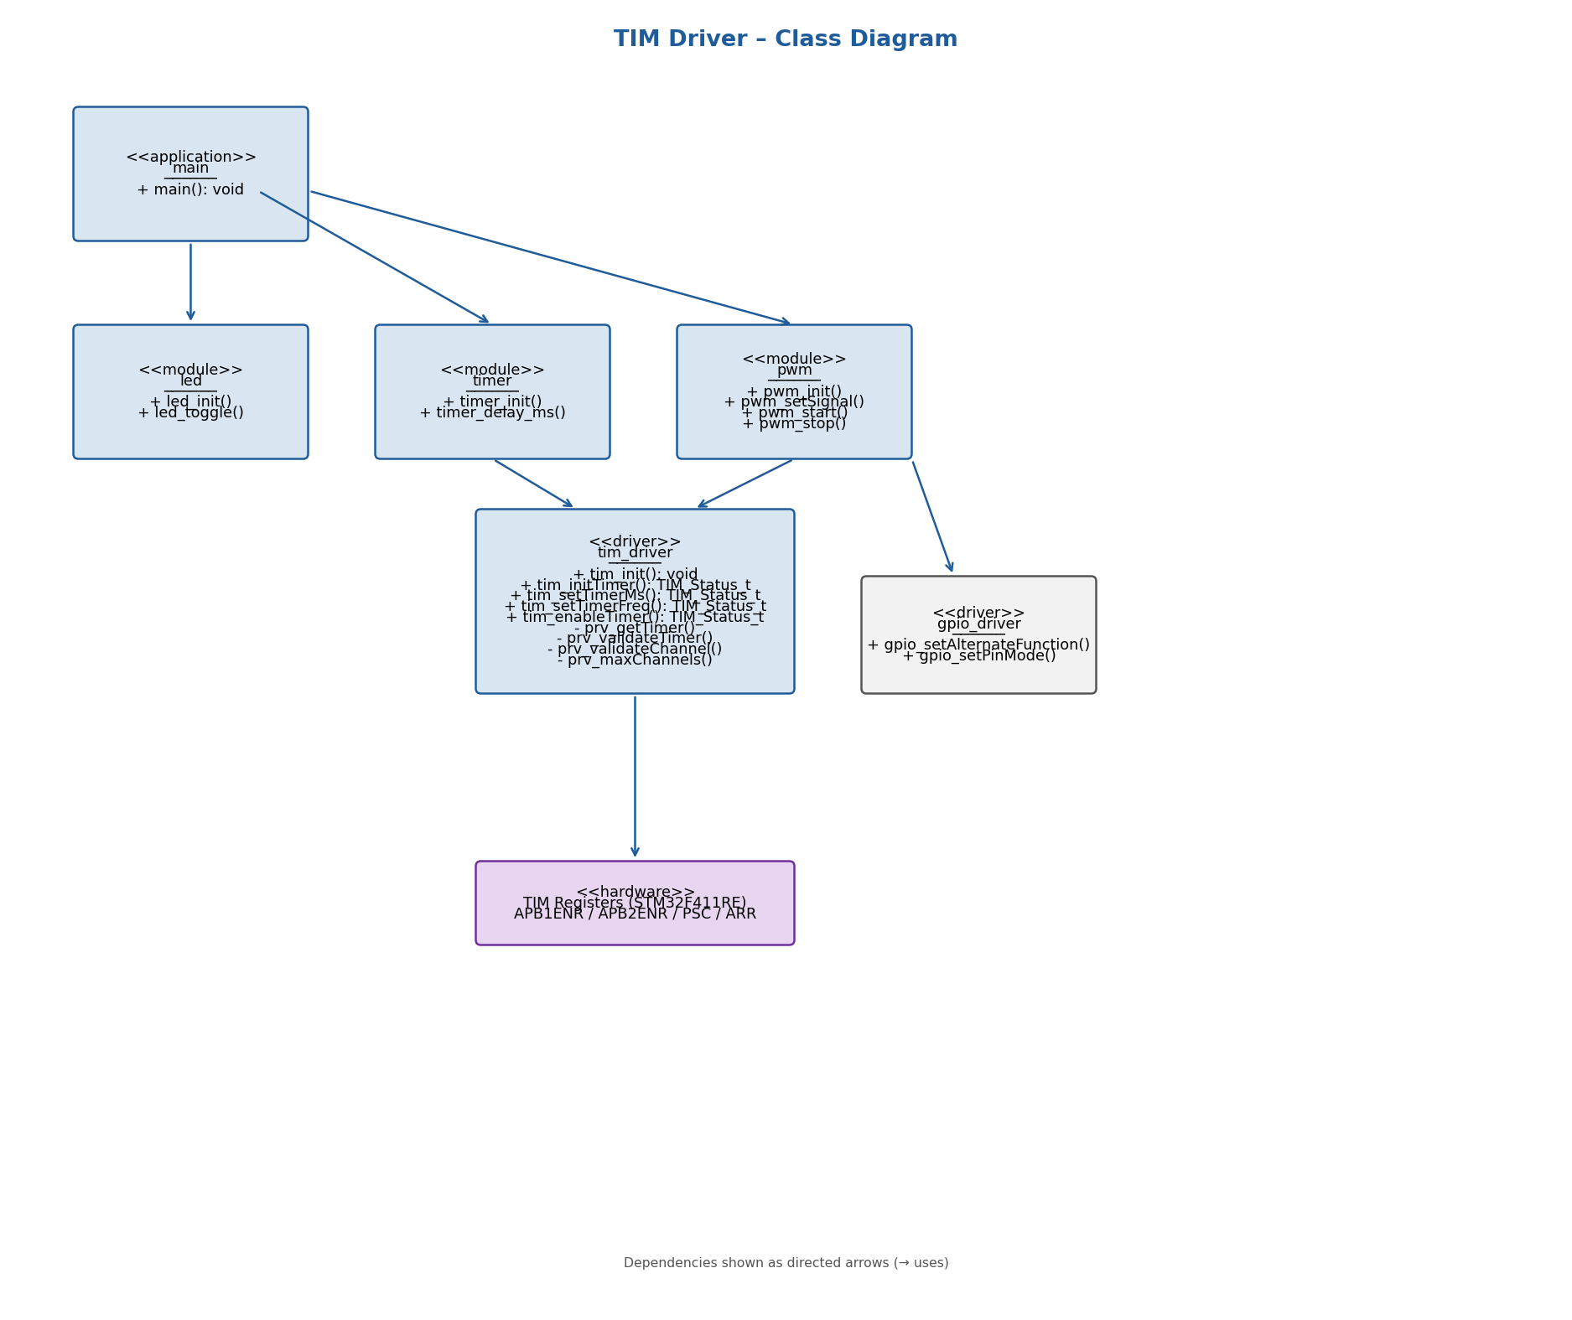
Fig. 1 — Class Diagram: TIM Driver Module
Class diagram showing the five software components of the TIM Control System and their dependency relationships. The tim_driver is the only class that accesses TIM hardware registers directly. The timer and pwm modules depend on it through the public API. main depends on led, timer, and pwm. The four private helper methods are shown with a minus prefix.
As shown in Fig. 1, the class diagram captures the five main software components: main.c depends on led, timer, and pwm modules. timer depends exclusively on tim_driver for all register operations. pwm depends on both tim_driver and the gpio_driver for the Alternate Function pin configuration. tim_driver is the only class that accesses the Hardware Layer — the STM32F411RE TIM peripheral registers. Private helpers prv_getTimer, prv_validateTimer, prv_validateChannel, and prv_maxChannels are shown with a minus sign prefix, indicating they are internal to tim_driver.c and not part of the public API.

3.2. Module Behavior
Initial State
After calling tim_init(), all supported timers (TIM1–TIM5, TIM9–TIM11) are reset to their hardware default state through the RCC reset sequence. All counters are stopped (CEN=0), prescalers are zero, ARR holds its hardware reset value, and no capture/compare channels are active. TIM_SYSCLK_HZ = 16000000UL (16 MHz HSI, no PLL) is assumed throughout.
Event: Timer Delay (TIM4)
When timer_delay_ms(N) is called, tim_setTimerMs(TIM_ID_4, N) programs PSC=15999 and ARR=N-1, yielding a period of exactly N milliseconds at 16 MHz HSI. tim_enableTimer(TIM_ID_4) sets CEN=1 and the counter starts. tim_waitTimer(TIM_ID_4) polls SR until TIM_SR_UIF is set by hardware on counter overflow, then clears UIF and returns. tim_disableTimer(TIM_ID_4) clears CEN. The CPU is blocked during the entire delay period.
Event: PWM Output (TIM2_CH1)
After pwm_init(1000) is called, TIM2 runs freely at 1 kHz with CCR1 = duty% × (ARR+1) / 100 producing the requested duty cycle. The output on PA5 (AF1) toggles automatically in hardware — HIGH while CNT < CCR1, LOW while CNT >= CCR1. pwm_setSignal() updates CCR1 on the fly without stopping the timer. OCxPE (preload enable, set by tim_setTimerCompareMode) synchronizes the CCR1 update to the next overflow event, preventing glitches on the PWM output signal.
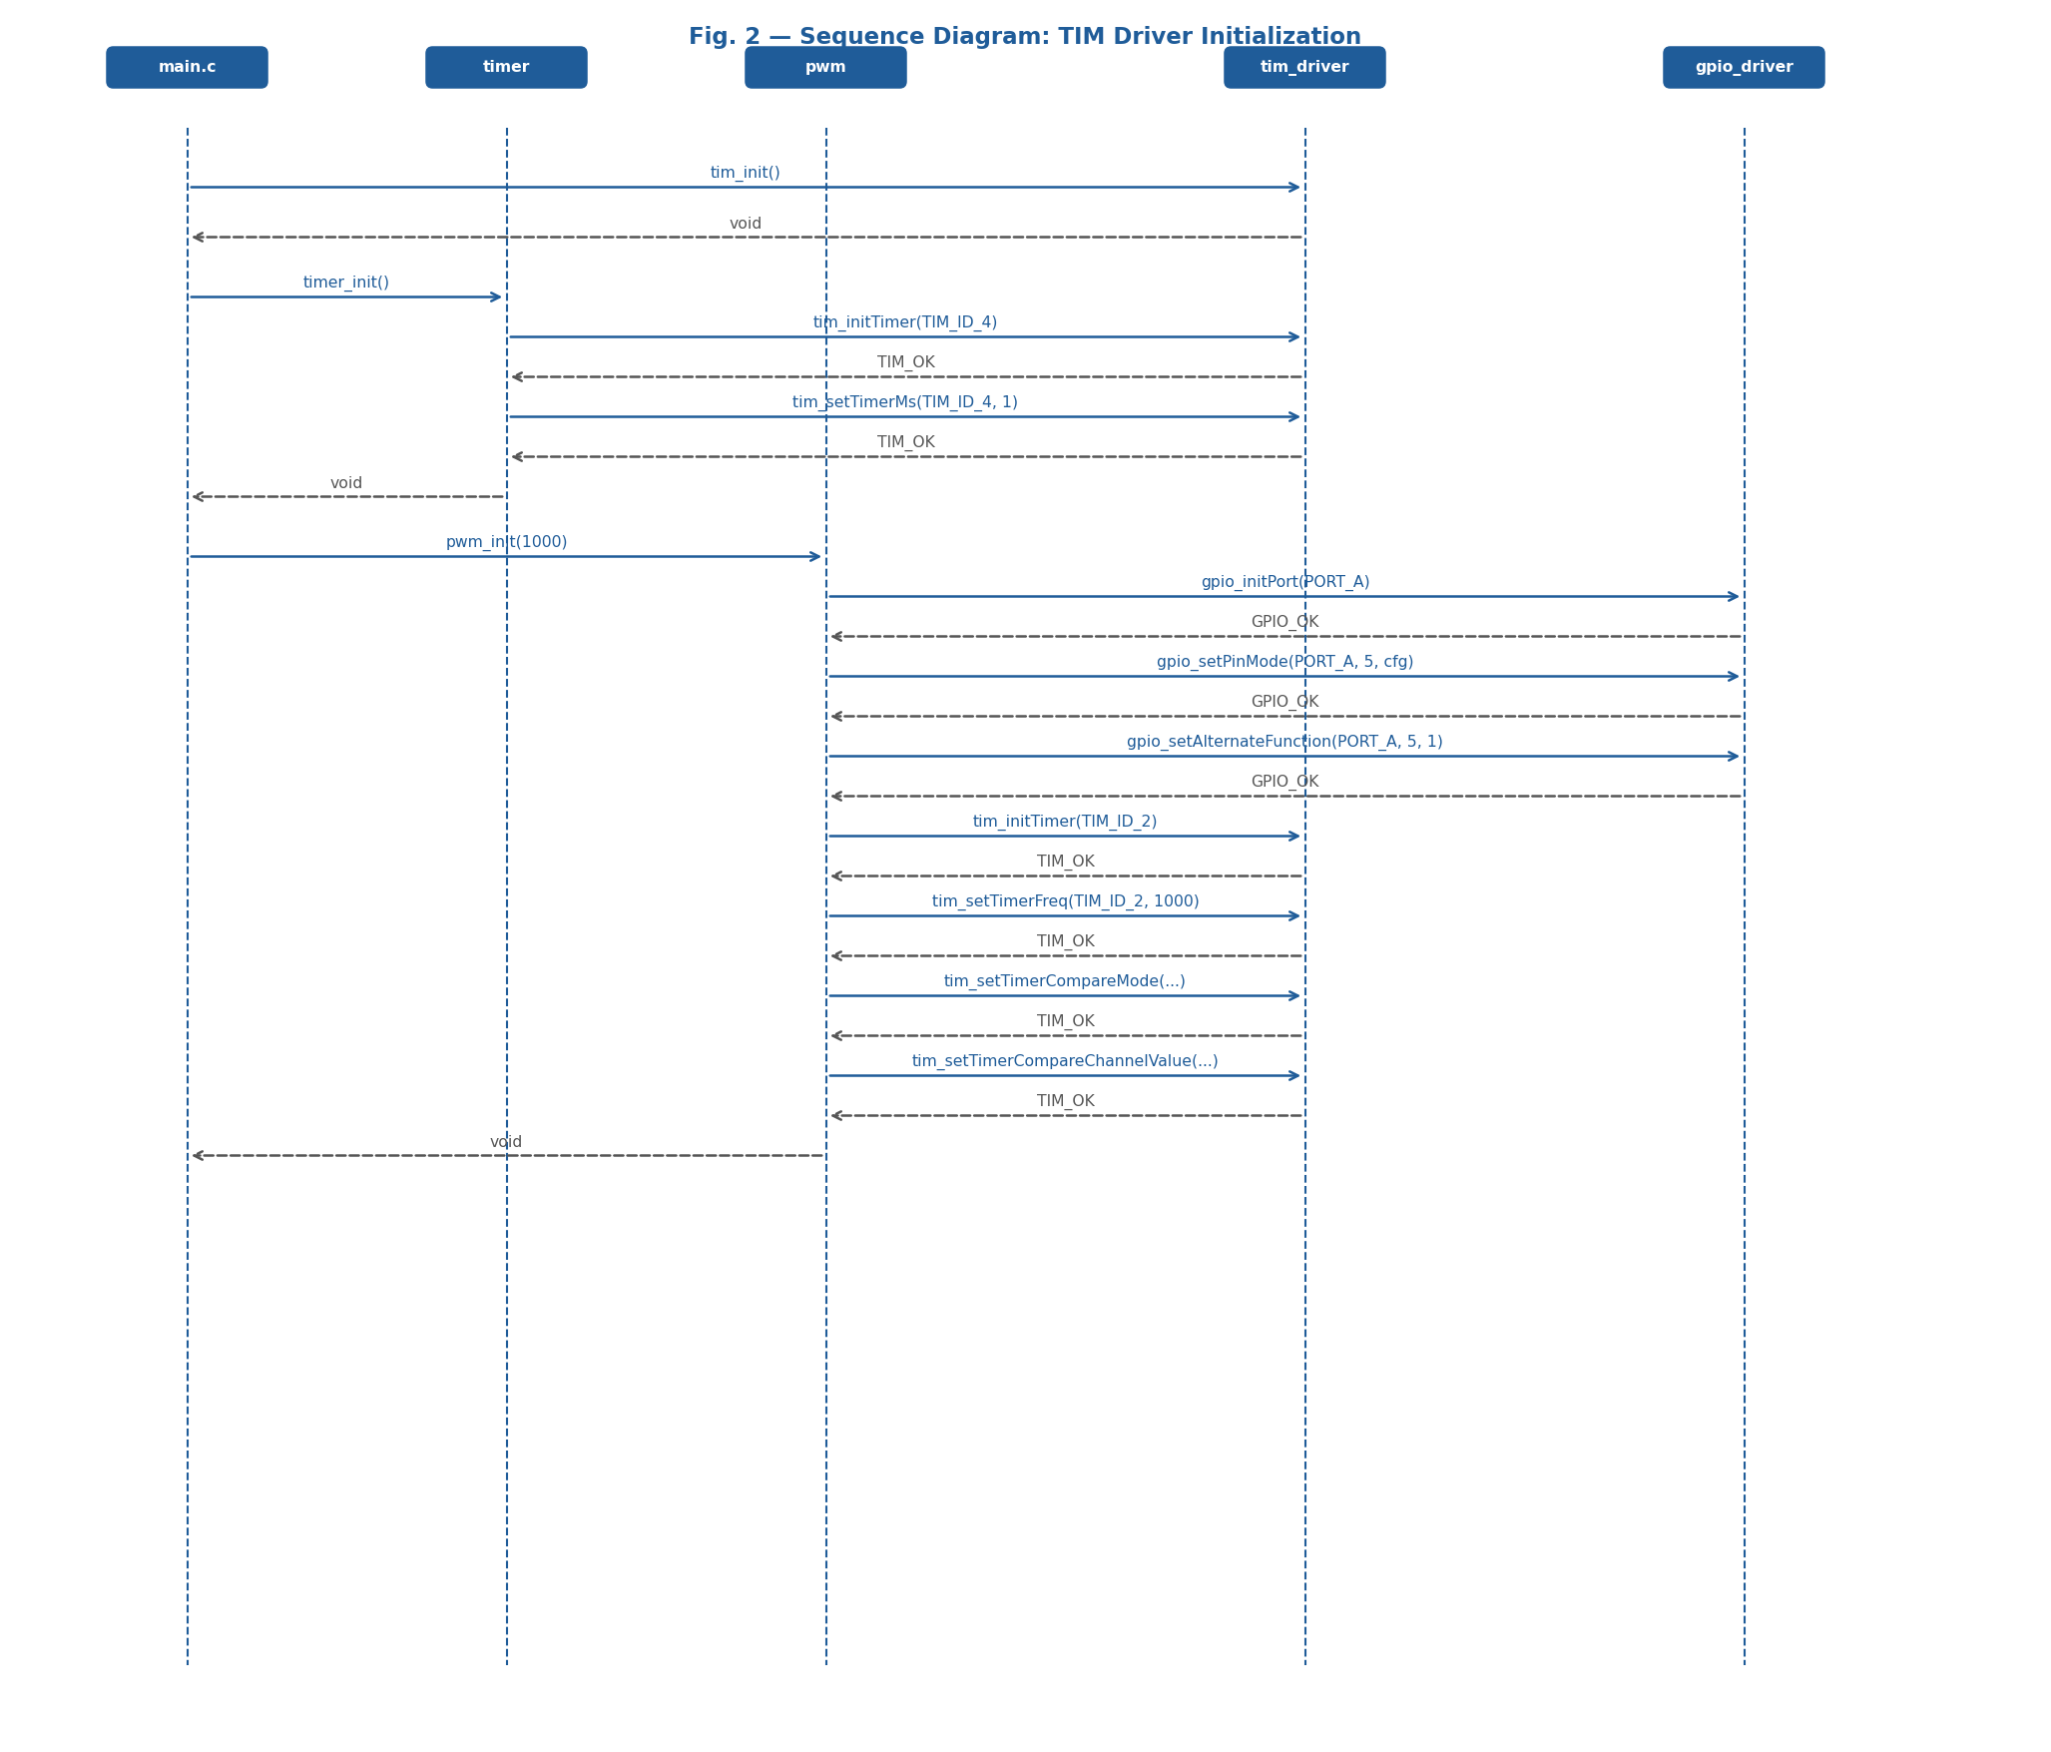
Fig. 2 — Sequence Diagram: TIM Driver Initialization
Sequence diagram showing the ordered call chain during system startup. main.c calls tim_init() to reset all timers via the RCC RSTR sequence, then timer_init() — which internally calls tim_initTimer(TIM_ID_4) and tim_setTimerMs(TIM_ID_4, 1) — and finally pwm_init(1000), which calls the gpio_driver to configure PA5 in AF1 mode, then calls tim_initTimer(TIM_ID_2), tim_setTimerFreq(TIM_ID_2, 1000), tim_setTimerCompareMode(TIM_ID_2, TIM_CH_1, PWM1), and tim_setTimerCompareChannelValue(TIM_ID_2, TIM_CH_1, 0) in sequence.
Fig. 2 shows the message sequence during the initialization phase. main.c orchestrates startup without knowing any hardware details. The first message is tim_init(), which resets all TIM peripherals via the RCC RSTR sequence. timer_init() then triggers tim_initTimer(TIM_ID_4) to enable the TIM4 clock and tim_setTimerMs(TIM_ID_4, 1) to pre-configure the 1 ms tick. pwm_init(1000) triggers the full PWM configuration sequence on the gpio_driver (pin mode and AF1) and the TIM driver (frequency, compare mode, and initial CCR1=0). Activation boxes on each lifeline show the time each object is actively executing.
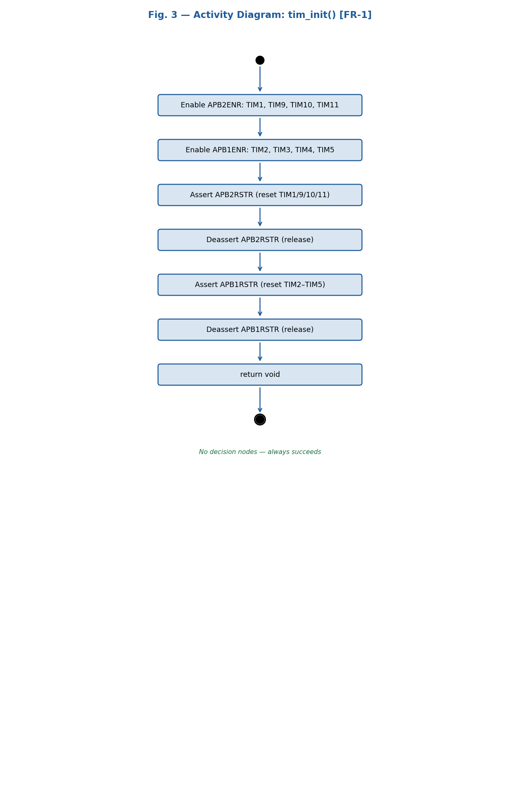
Fig. 3 — Activity Diagram: tim_init() [FR-1]
Activity diagram detailing the sequential steps of tim_init(). The function enables all APB2 timer clocks (TIM1, TIM9, TIM10, TIM11) and APB1 timer clocks (TIM2, TIM3, TIM4, TIM5) in two single OR-writes to the respective ENR registers, then asserts and deasserts the RSTR bits for both buses to reset all TIM registers to their hardware default state. No decision nodes — the function always succeeds and returns void.
Fig. 3 details the internal activity flow of tim_init(). The function begins by enabling peripheral clocks via OR-writes to RCC->APB2ENR (TIM1|TIM9|TIM10|TIM11) and RCC->APB1ENR (TIM2|TIM3|TIM4|TIM5). It then asserts the corresponding RSTR bits on both APB buses to force a peripheral reset, clearing all TIM registers, and immediately deasserts them to release the timers into a clean default state (CEN=0, PSC=0). The absence of decision diamonds confirms that tim_init() always succeeds and requires no error handling from the caller.
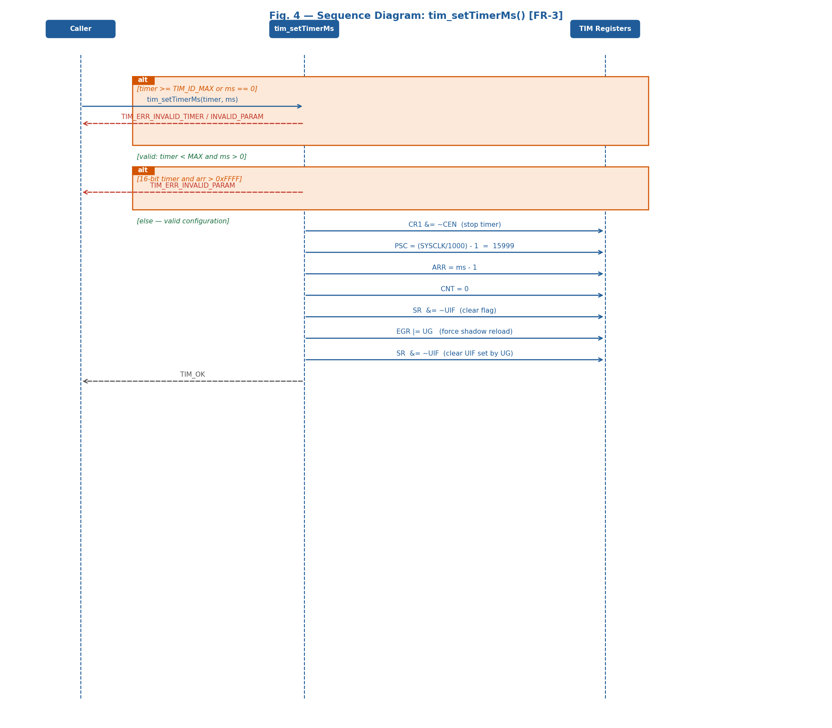
Fig. 4 — Sequence Diagram: tim_setTimerMs() with Conditional [FR-3]
Sequence diagram for tim_setTimerMs() showing two alt combined fragments. The first handles invalid timer ID (timer >= TIM_ID_MAX) and ms==0, returning TIM_ERR_INVALID_TIMER or TIM_ERR_INVALID_PARAM immediately without any hardware access. The second checks the 16-bit ARR limit (arr > 0xFFFF) for non-32-bit timers (all except TIM2 and TIM5). The normal path shows seven sequential register writes: CR1 &= ~TIM_CR1_CEN, PSC=15999, ARR=ms-1, CNT=0, SR &= ~TIM_SR_UIF, EGR |= TIM_EGR_UG, SR &= ~TIM_SR_UIF.
Fig. 4 uses UML alt combined fragments to show conditional branching inside tim_setTimerMs(). The upper guard [timer >= TIM_ID_MAX or ms==0] is the early-exit path — returns the corresponding error code before touching any hardware register (NFR-2). The middle guard [!TIM2/TIM5 and arr > 0xFFFF] checks the 16-bit ARR limit. The lower [else] guard is the normal path: PSC = (TIM_SYSCLK_HZ/1000) - 1 = 15999 and ARR = ms - 1 are written to the timer. The EGR UG write forces shadow registers to load the new PSC/ARR immediately. UIF is cleared twice — before UG and after — because UG sets UIF as a side effect; without the second clear, tim_waitTimer() would return immediately on its next call instead of waiting a full period.
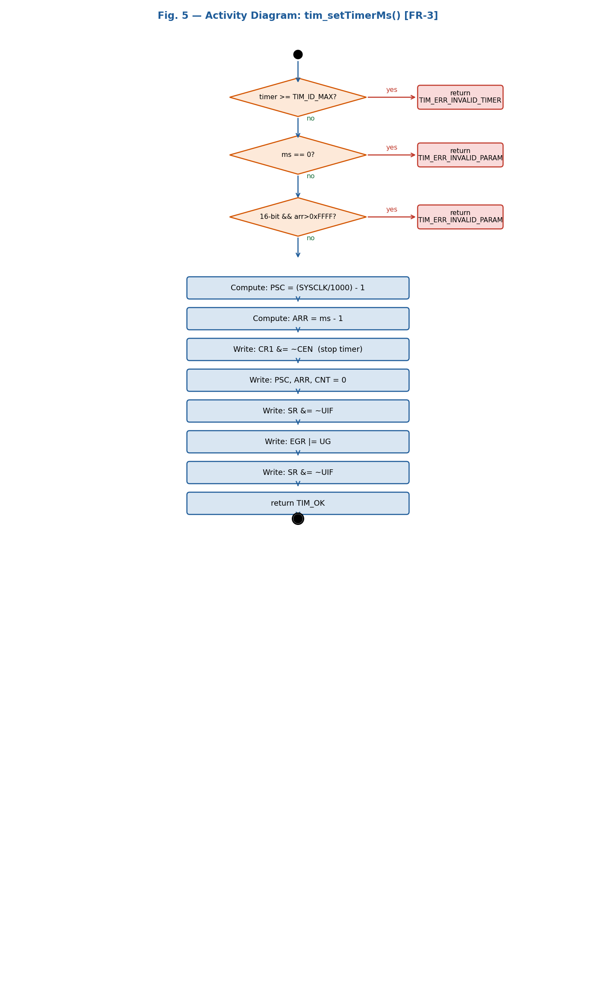
Fig. 5 — Activity Diagram: tim_setTimerMs() with Conditional [FR-3]
Activity diagram for tim_setTimerMs() showing three decision nodes before reaching the register writes: [timer >= TIM_ID_MAX?], [ms == 0?], and [!TIM2/TIM5 and arr > 0xFFFF?]. Error paths from all three decision nodes return the appropriate TIM_Status_t code without accessing any hardware register, satisfying NFR-2.
Fig. 5 complements the sequence diagram of Fig. 4 by showing the full activity flow as a flowchart. If all validations pass, the function computes PSC = (TIM_SYSCLK_HZ/1000) - 1 = 15999 and ARR = ms - 1, then performs the seven-step register write sequence: CR1 &= ~TIM_CR1_CEN (stop timer), PSC, ARR, CNT=0, SR &= ~TIM_SR_UIF, EGR |= TIM_EGR_UG (force shadow reload), SR &= ~TIM_SR_UIF (clear UIF set by UG), and returns TIM_OK.
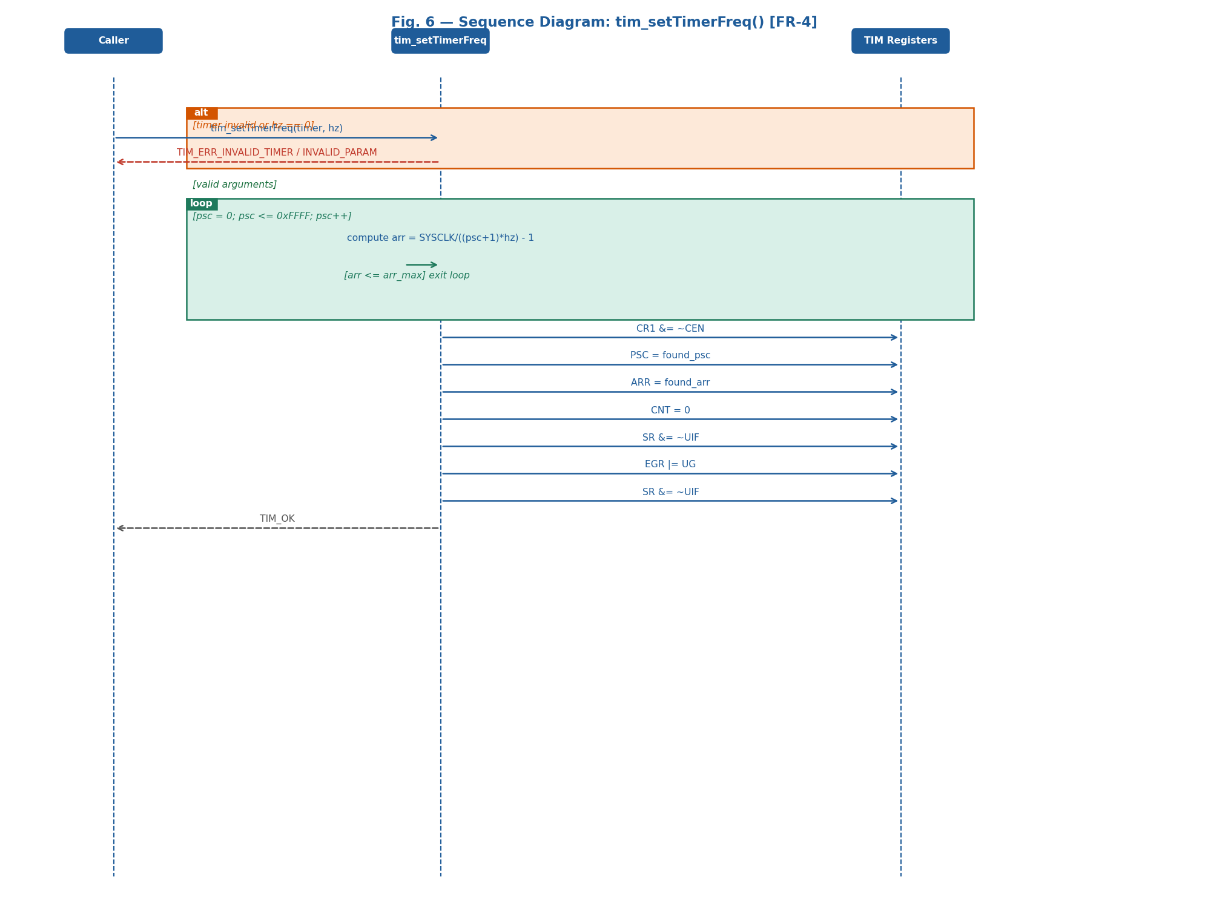
Fig. 6 — Sequence Diagram: tim_setTimerFreq() with Loop [FR-4]
Sequence diagram for tim_setTimerFreq() showing the loop combined fragment that iterates psc from 0 to 0xFFFF. On each iteration, arr = (TIM_SYSCLK_HZ / ((psc+1)*hz)) - 1 is computed. The loop exits as soon as arr <= arr_max (0xFFFF for 16-bit timers, 0xFFFFFFFF for TIM2 and TIM5). If no valid (PSC, ARR) pair is found after 65536 iterations, TIM_ERR_INVALID_PARAM is returned.
Fig. 6 uses a UML loop combined fragment to model the greedy PSC search algorithm inside tim_setTimerFreq(). The loop guard [psc = 0; psc <= 0xFFFF; psc++] indicates the ARR calculation repeats up to 65536 times. The first iteration satisfying arr <= arr_max exits the loop. The found PSC/ARR pair is then written using the same register sequence as tim_setTimerMs(): CR1 &= ~CEN, PSC, ARR, CNT=0, SR &= ~UIF, EGR |= UG, SR &= ~UIF, return TIM_OK.
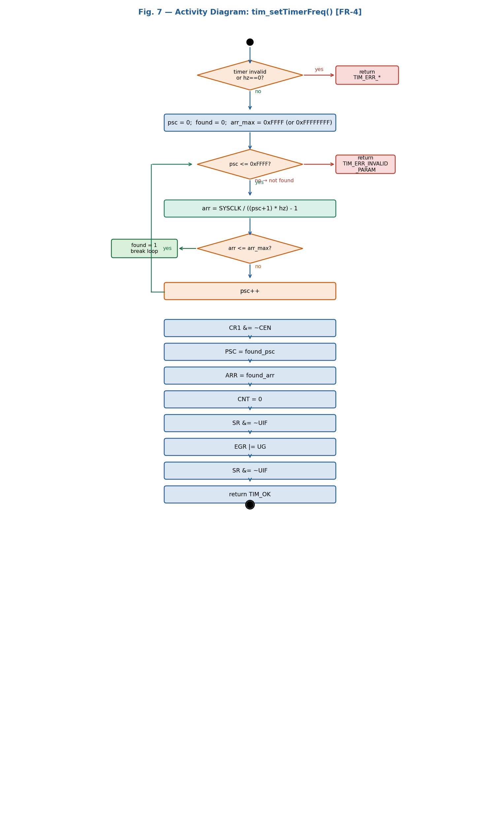
Fig. 7 — Activity Diagram: tim_setTimerFreq() with Loop [FR-4]
Activity diagram for tim_setTimerFreq() detailing the PSC search loop. Each iteration computes arr = TIM_SYSCLK_HZ/((psc+1)*hz) - 1 and checks arr <= arr_max. After the loop, a [found?] decision node returns TIM_ERR_INVALID_PARAM if no valid pair was found, or proceeds to write the timer registers.
Fig. 7 provides the activity-level view of the PSC search loop. The loop decision node [psc <= 0xFFFF?] drives up to 65536 iterations. Inside each iteration, arr is computed from current psc and hz. If arr <= arr_max, the found flag is set and the loop exits early via the right branch. Otherwise psc is incremented and the loop continues. The [found?] decision node after the loop routes to TIM_ERR_INVALID_PARAM or to the seven-step register write sequence, then returns TIM_OK.
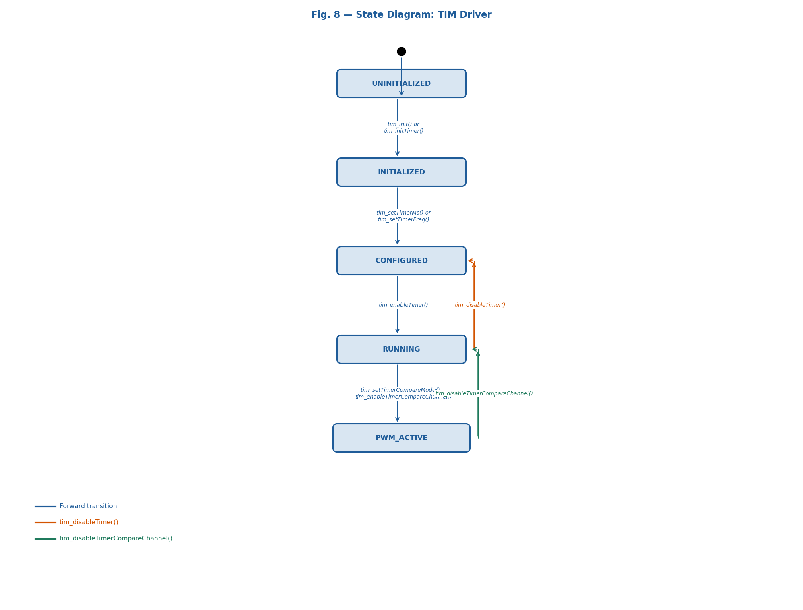
Fig. 8 — State Diagram: TIM Driver
State diagram of the TIM driver showing the five timer states and the transitions triggered by each driver function. A timer begins in UNINITIALIZED, advances to INITIALIZED after clock enable, to CONFIGURED after PSC/ARR are programmed, to RUNNING after CEN=1, and to PWM_ACTIVE after a capture/compare channel is enabled in PWM mode.
Fig. 8 captures the runtime behavior of a TIM peripheral as a state machine. UNINITIALIZED: peripheral clock is off, registers hold undefined power-on values. tim_init() or tim_initTimer() moves to INITIALIZED (clock on, registers at hardware reset defaults, CEN=0). tim_setTimerMs() or tim_setTimerFreq() moves to CONFIGURED (PSC/ARR programmed, counter stopped, CEN=0). tim_enableTimer() moves to RUNNING (CEN=1, counter active, TIM_SR_UIF set by hardware on each overflow). tim_setTimerCompareMode() + tim_enableTimerCompareChannel() moves to PWM_ACTIVE (GPIO output toggles automatically at each CCRx match). tim_disableTimerCompareChannel() returns to RUNNING. tim_disableTimer() from RUNNING returns to CONFIGURED.
3.2.1. Per-Function Sequence and Activity Diagrams

tim_init() — FR-1: TIM Subsystem Initialization
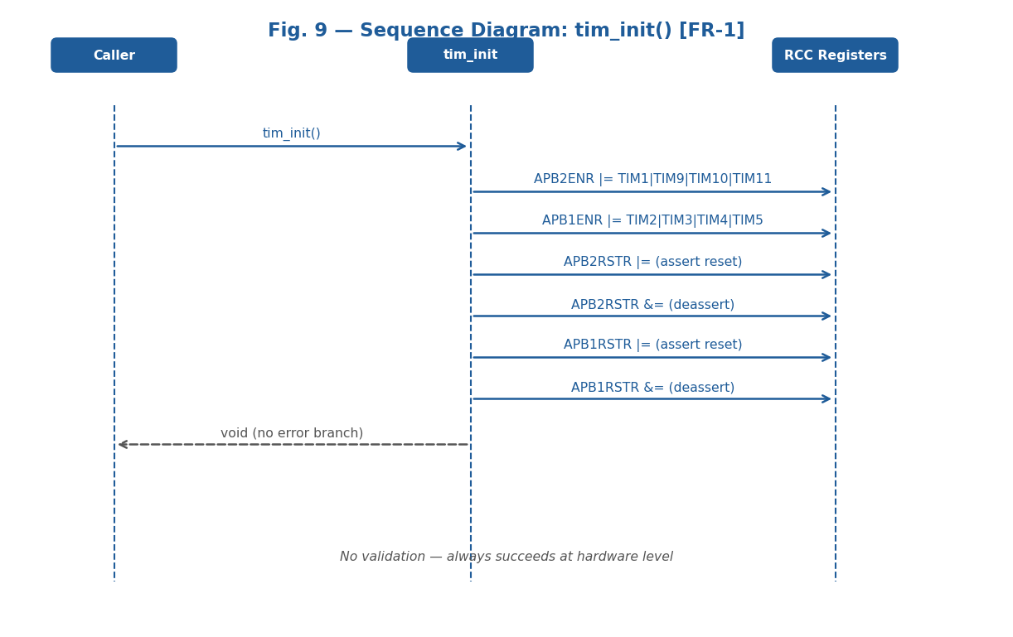
Fig. 9 — Sequence Diagram: tim_init() [FR-1]

The sequence diagram for tim_init() shows that the function takes no parameters and returns void. The only external actor is the Caller. Internally, the function OR-writes RCC->APB2ENR with TIM1EN|TIM9EN|TIM10EN|TIM11EN and RCC->APB1ENR with TIM2EN|TIM3EN|TIM4EN|TIM5EN. It then asserts APB2RSTR and APB1RSTR to force a peripheral reset, clearing all TIM registers, and deasserts them immediately. No alt fragment exists because the operation always succeeds at the hardware level.
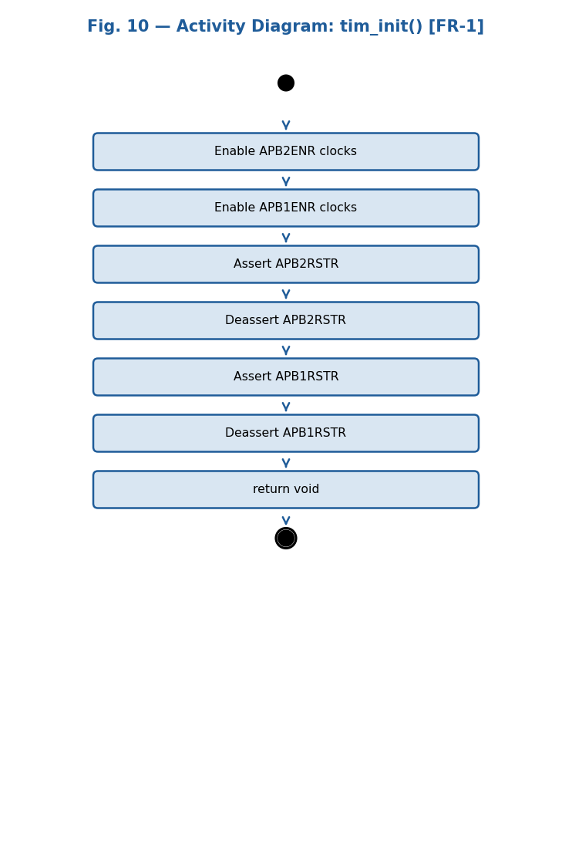
Fig. 10 — Activity Diagram: tim_init() [FR-1]

The activity diagram for tim_init() shows a purely linear sequence of six actions with no decision nodes: (1) RCC->APB2ENR |= TIM1|TIM9|TIM10|TIM11 clocks, (2) RCC->APB1ENR |= TIM2|TIM3|TIM4|TIM5 clocks, (3) Assert APB2RSTR, (4) Deassert APB2RSTR, (5) Assert APB1RSTR, (6) Deassert APB1RSTR. The absence of decision diamonds confirms that tim_init() always succeeds and returns void with no error handling needed.

tim_initTimer() — FR-2: Individual Timer Initialization
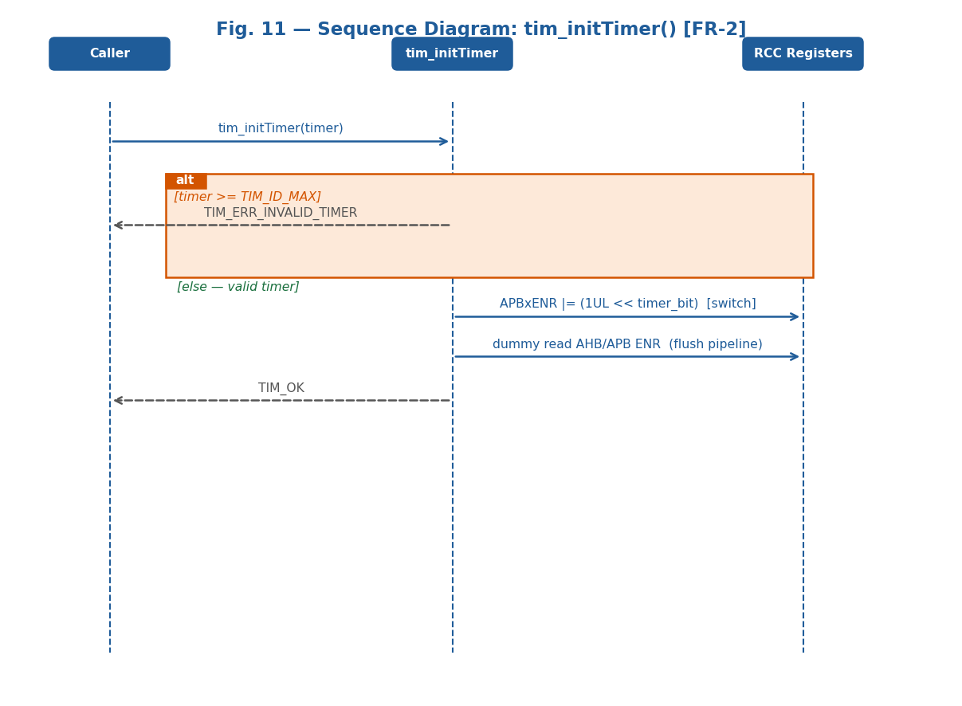
Fig. 11 — Sequence Diagram: tim_initTimer() [FR-2]

The sequence diagram for tim_initTimer() shows three participants: Caller, tim_initTimer, and RCC Registers. The first action is delegating to prv_validateTimer(). The alt combined fragment shows two paths: if timer >= TIM_ID_MAX, TIM_ERR_INVALID_TIMER is returned immediately without touching any hardware register. On the valid path, a switch selects the correct APB bus and writes the corresponding ENR bit (APB2ENR for TIM1/TIM9/TIM10/TIM11, APB1ENR for TIM2–TIM5). A dummy read-back of both RCC->APB1ENR and RCC->APB2ENR flushes the bus pipeline before returning TIM_OK.
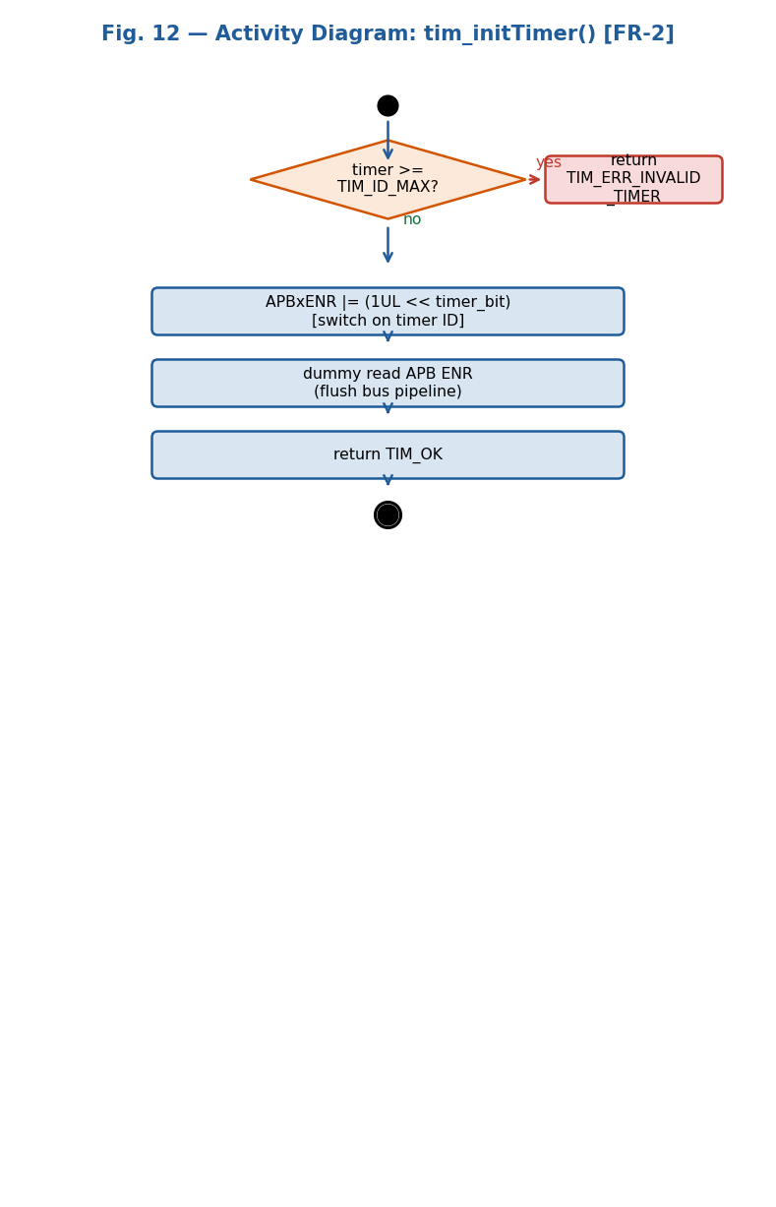
Fig. 12 — Activity Diagram: tim_initTimer() [FR-2]

The activity diagram for tim_initTimer() presents the first decision node of the TIM driver: [timer >= TIM_ID_MAX?]. The error branch returns TIM_ERR_INVALID_TIMER and terminates without hardware access. The valid branch uses a switch node to select the correct APB ENR register and bit position, then writes the clock enable OR-mask. A dummy read-back of both APB ENR registers flushes the bus pipeline, ensuring the clock is stable before any subsequent timer register access. Returns TIM_OK.

tim_setTimerCompareChannelValue() — FR-8: Set Compare Threshold
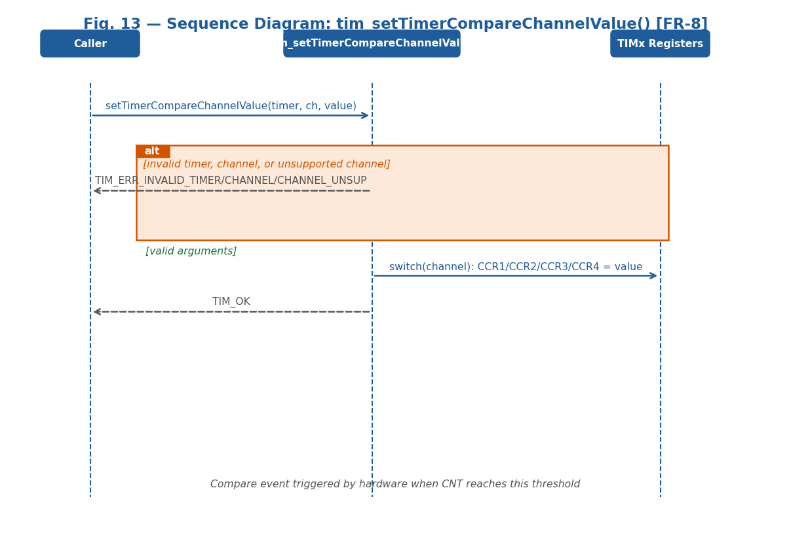
Fig. 13 — Sequence Diagram: tim_setTimerCompareChannelValue() [FR-8]

The sequence diagram for tim_setTimerCompareChannelValue() shows the function receiving timer, channel, and value. It delegates validation to prv_validateChannel() — which internally calls prv_validateTimer() and prv_maxChannels(). The alt combined fragment shows three error exits: TIM_ERR_INVALID_TIMER (timer >= TIM_ID_MAX), TIM_ERR_INVALID_CHANNEL (ch < TIM_CH_1 or ch > TIM_CH_4), and TIM_ERR_CHANNEL_UNSUP ((uint8_t)ch > prv_maxChannels()). On the valid path, a switch statement writes value directly to CCR1, CCR2, CCR3, or CCR4. A compare event is triggered by hardware when CNT reaches this threshold in PWM Mode 1.

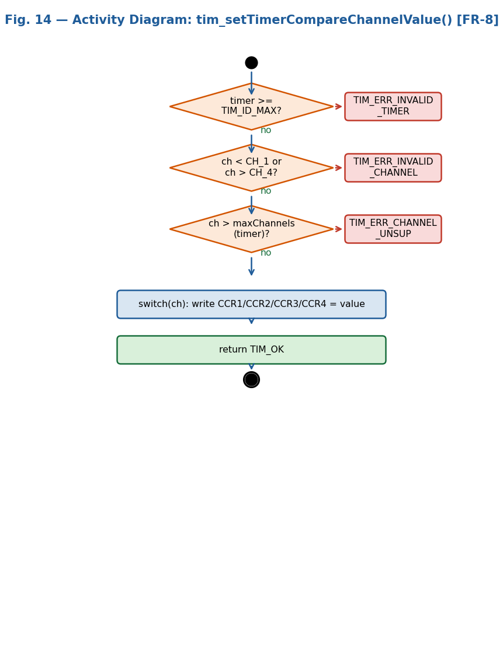
Fig. 14 — Activity Diagram: tim_setTimerCompareChannelValue() [FR-8]

The activity diagram for tim_setTimerCompareChannelValue() shows two validation decision nodes before the register write: [timer invalid?] and [channel invalid or unsupported?]. The channel check includes the per-timer limit enforced by prv_maxChannels(): TIM10/TIM11 = 1 channel, TIM9 = 2 channels, all others = 4 channels. Both error branches exit without any hardware access (NFR-2). The valid branch uses a switch to select CCR1–CCR4 and writes value. Returns TIM_OK.

tim_setTimerCompareMode() — FR-9: Configure Compare/PWM Mode
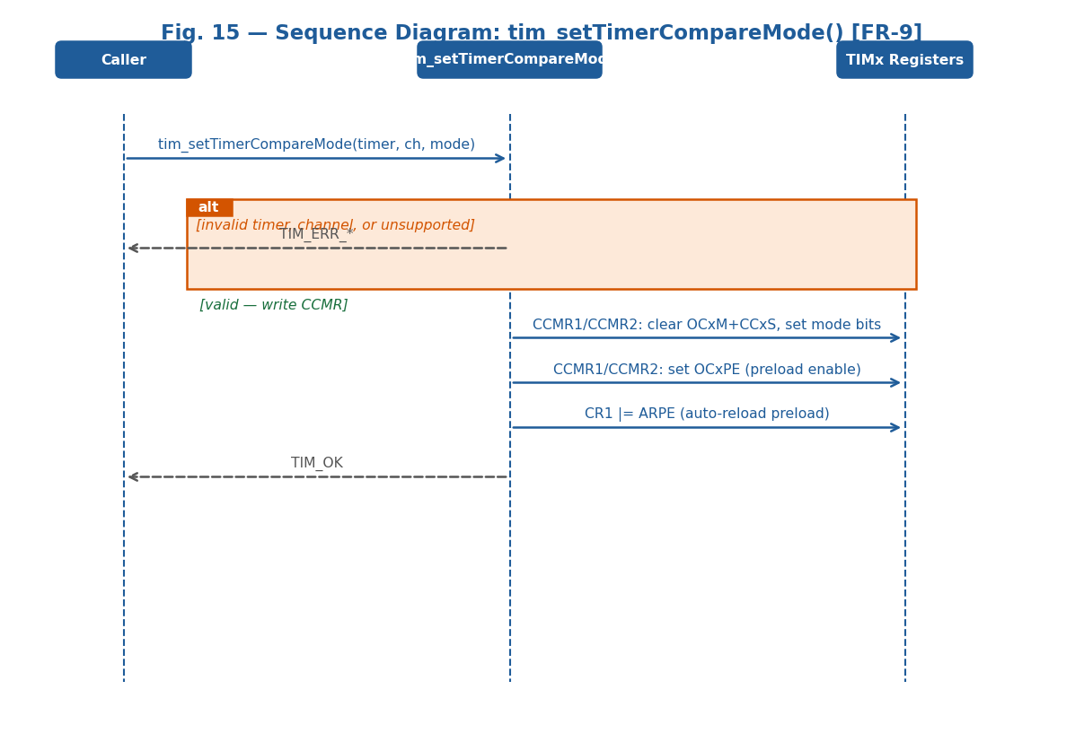
Fig. 15 — Sequence Diagram: tim_setTimerCompareMode() [FR-9]

The sequence diagram for tim_setTimerCompareMode() shows that after prv_validateChannel() passes, a switch selects the correct CCMR register and bit field: CH1 — CCMR1 bits [6:4] OC1M + bit [3] OC1PE; CH2 — CCMR1 bits [14:12] OC2M + bit [11] OC2PE; CH3 — CCMR2 bits [6:4] OC3M + bit [3] OC3PE; CH4 — CCMR2 bits [14:12] OC4M + bit [11] OC4PE. The function clears OCxM+CCxS with an AND mask, ORs in the new mode value and sets OCxPE. Finally CR1 |= TIM_CR1_ARPE enables auto-reload preload. Returns TIM_OK.

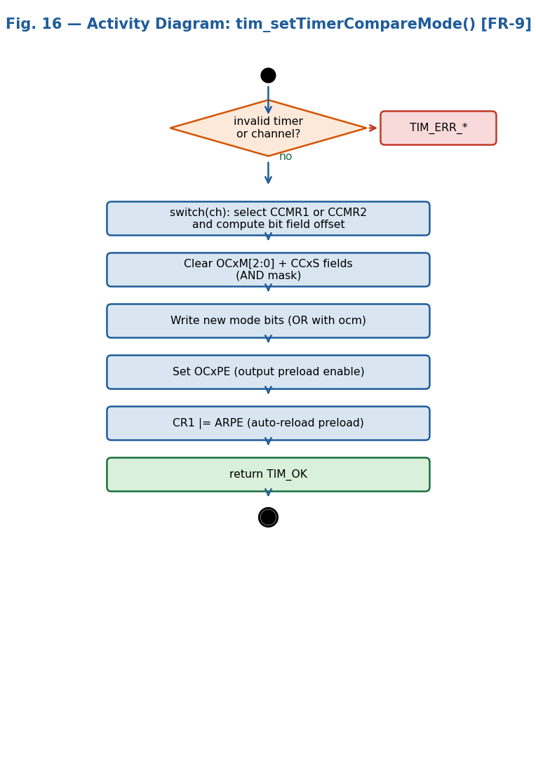
Fig. 16 — Activity Diagram: tim_setTimerCompareMode() [FR-9]

The activity diagram for tim_setTimerCompareMode() shows the validation node, then a switch node routing to one of four CCMR configuration paths (CH1–CH4). All paths converge at the CR1 ARPE write. For TIM_COMPARE_MODE_PWM1 (ocm = 0x6U, OCxM = 0b110): output is HIGH while CNT < CCRx and LOW while CNT >= CCRx. OCxPE ensures CCRx updates take effect only at the next update event, preventing glitches on a running PWM signal. Returns TIM_OK.

tim_enableTimerCompareChannel() — FR-10: Enable Channel Output
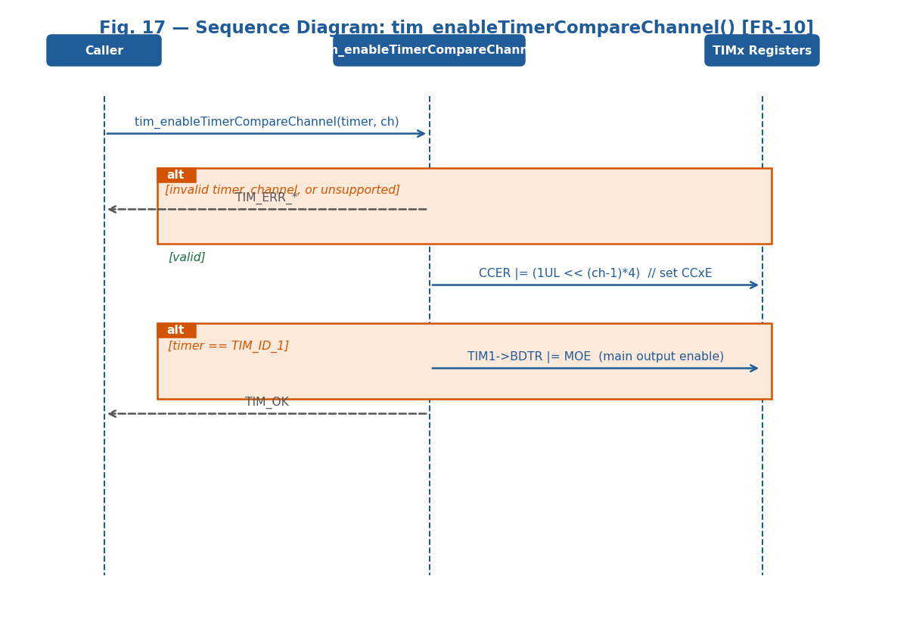
Fig. 17 — Sequence Diagram: tim_enableTimerCompareChannel() [FR-10]

The sequence diagram for tim_enableTimerCompareChannel() shows that after prv_validateChannel() passes, the function computes shift = ((uint32_t)(channel - 1U)) * 4U and writes TIMx->CCER |= (1UL << shift) to set the CCxE bit. An additional conditional message to the BDTR register shows that if timer == TIM_ID_1, TIM1->BDTR |= TIM_BDTR_MOE must also be set — without MOE, TIM1 channel outputs are suppressed regardless of CCER state. Returns TIM_OK.

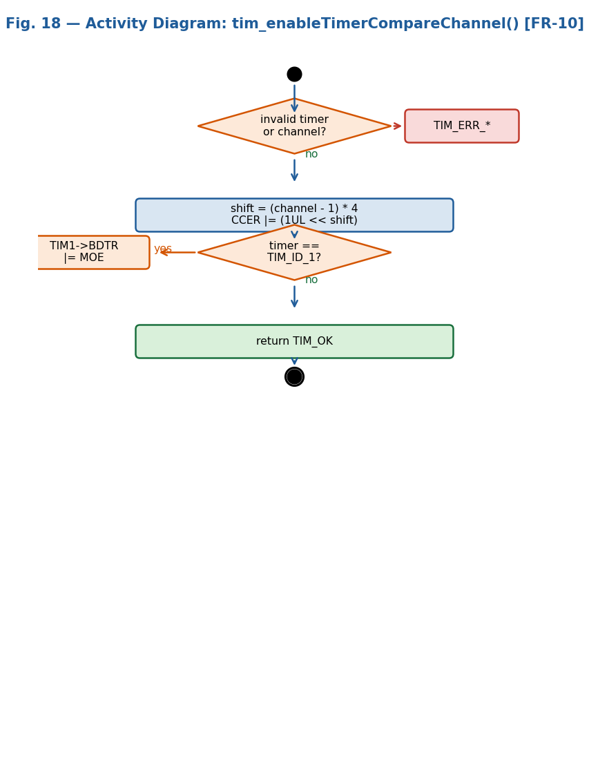
Fig. 18 — Activity Diagram: tim_enableTimerCompareChannel() [FR-10]

The activity diagram for tim_enableTimerCompareChannel() shows the validation node, then the CCER write using shift = ((uint32_t)(channel - 1U)) * 4U, then a decision node [timer == TIM_ID_1?]. If yes, TIM1->BDTR |= TIM_BDTR_MOE is written — required only for TIM1 (advanced-control timer with a separate output enable gate). Both branches converge at TIM_OK. Note: for the PWM signal to appear on the physical pin, the pin must already be configured in Alternate Function mode by the gpio_driver before this function is called.

tim_disableTimerCompareChannel() — FR-11: Disable Channel Output
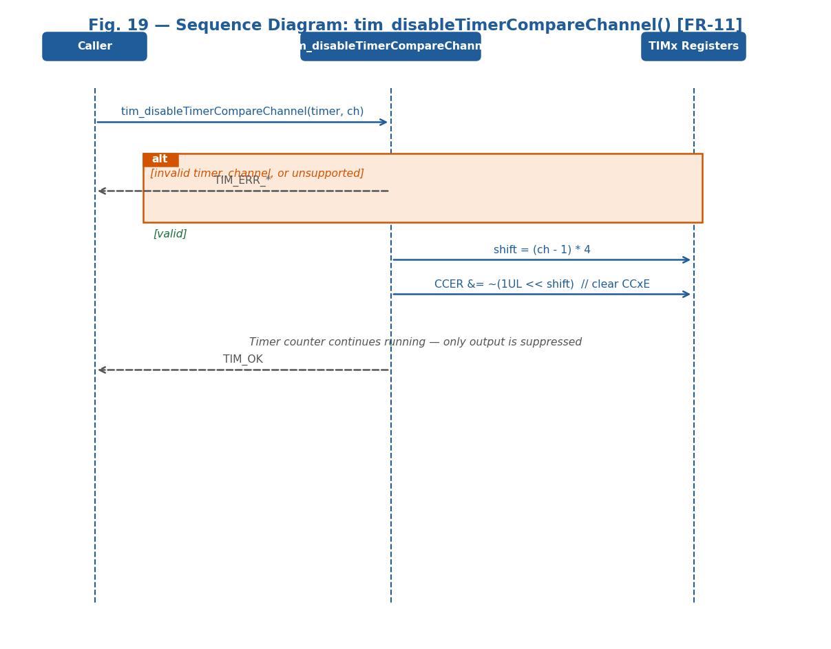
Fig. 19 — Sequence Diagram: tim_disableTimerCompareChannel() [FR-11]

The sequence diagram for tim_disableTimerCompareChannel() is symmetric to tim_enableTimerCompareChannel(). After prv_validateChannel() passes, the function computes shift = ((uint32_t)(channel - 1U)) * 4U and clears TIMx->CCER &= ~(1UL << shift). No BDTR write is needed on disable — other active channels on TIM1 remain unaffected. The timer counter continues running; only the pin output connection is suppressed. Returns TIM_OK.

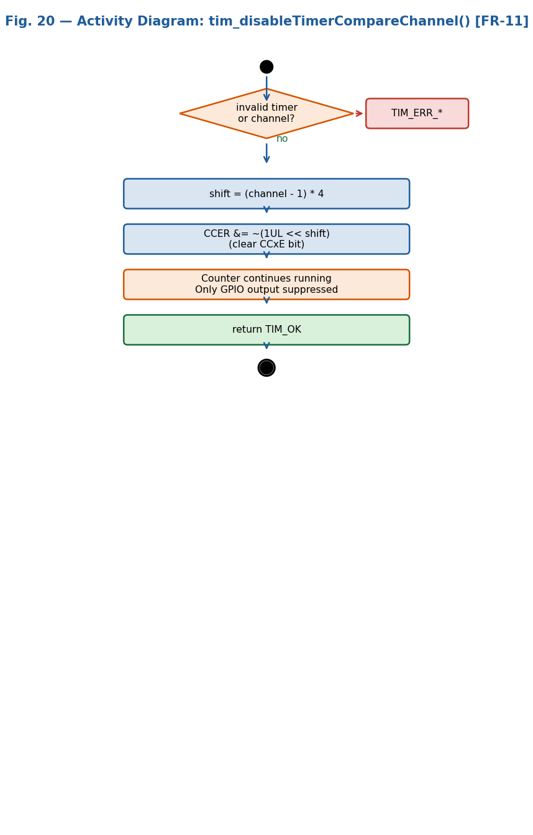
Fig. 20 — Activity Diagram: tim_disableTimerCompareChannel() [FR-11]

The activity diagram for tim_disableTimerCompareChannel() follows the same validate-then-act pattern: validation node checks timer and channel, then CCER &= ~(1UL << shift) clears the CCxE bit. The counter, PSC, ARR, and CCRx values remain unchanged — only the channel output enable is cleared. Both error branches exit without hardware access (NFR-2). Returns TIM_OK.

tim_enableTimer() / tim_disableTimer() / tim_waitTimer() — FR-5, FR-6, FR-7
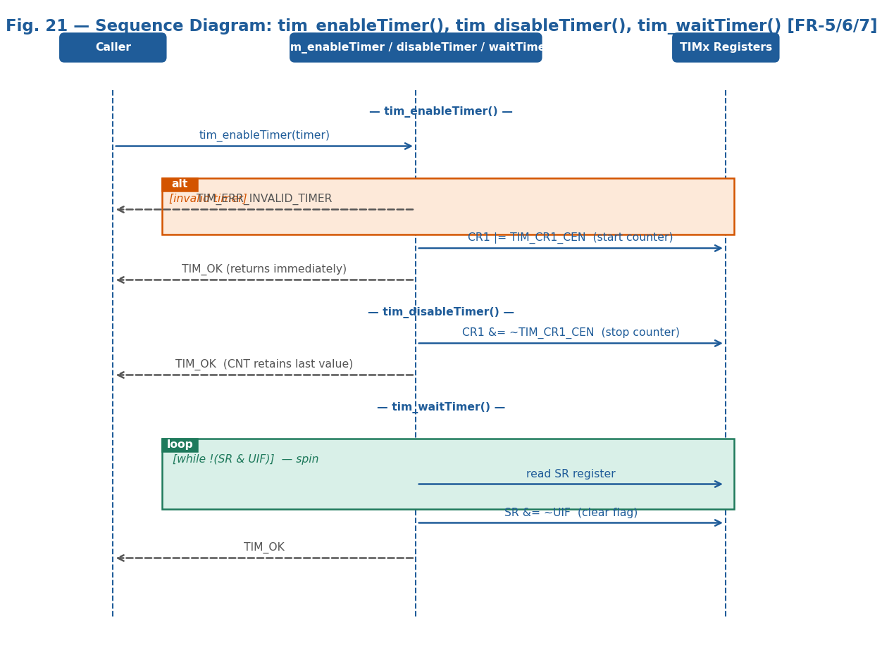
Fig. 21 — Sequence Diagram: tim_enableTimer(), tim_disableTimer(), tim_waitTimer() [FR-5/6/7]

The sequence diagram shows all three functions. tim_enableTimer(): after prv_validateTimer(), writes prv_getTimer(timer)->CR1 |= TIM_CR1_CEN and returns TIM_OK immediately without waiting for any event. tim_disableTimer(): writes prv_getTimer(timer)->CR1 &= ~TIM_CR1_CEN; the counter freezes at current CNT, returns TIM_OK. tim_waitTimer(): after prv_validateTimer(), enters a spin loop: while (!(TIMx->SR & TIM_SR_UIF)) { } until hardware sets UIF on counter overflow; then TIMx->SR &= ~TIM_SR_UIF and returns TIM_OK.
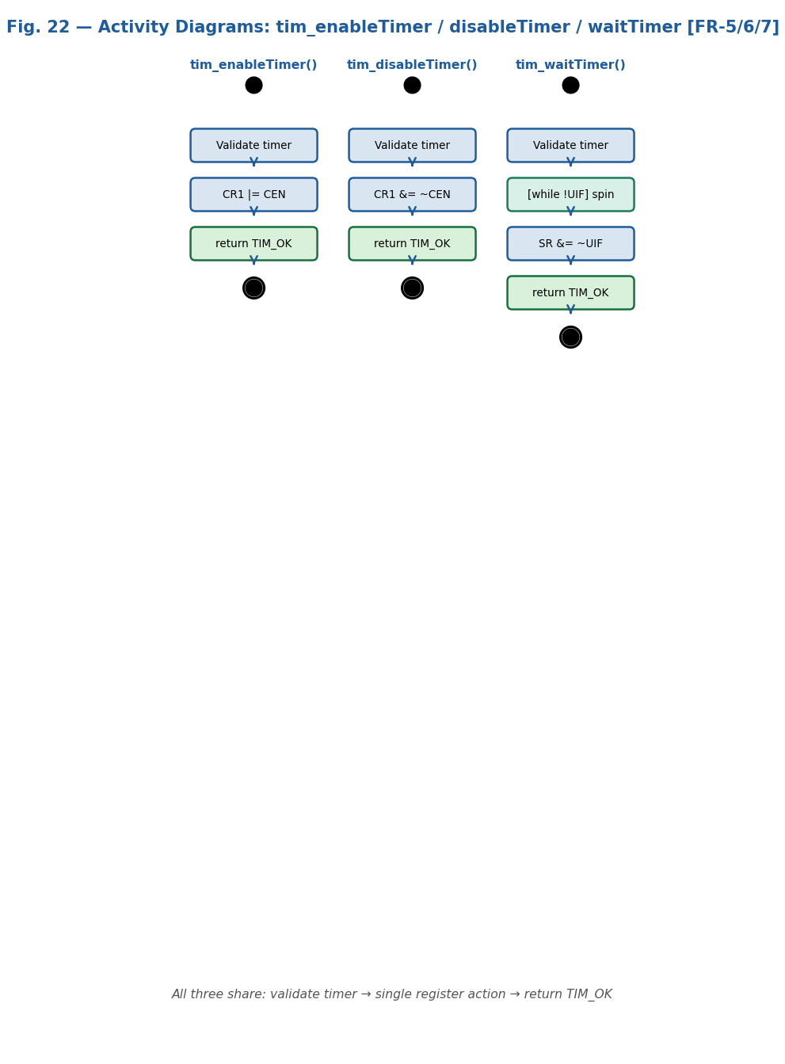
Fig. 22 — Activity Diagram: tim_enableTimer(), tim_disableTimer(), tim_waitTimer() [FR-5/6/7]

The activity diagrams for the three functions share the validate-then-act pattern. tim_enableTimer(): single action CR1 |= TIM_CR1_CEN, returns TIM_OK immediately — does not wait. tim_disableTimer(): single action CR1 &= ~TIM_CR1_CEN; CNT retains its last value without reset. tim_waitTimer(): polling loop [while !(SR & TIM_SR_UIF)] spins until hardware sets UIF on counter overflow (CNT == ARR), then clears UIF and returns TIM_OK. Calling tim_waitTimer() on a stopped timer (CEN=0) causes an infinite spin — the timer must be running before this call.

3.3. TIM Driver
The TIM driver is a hardware abstraction module written in C targeting the STM32F411RE microcontroller (RM0383). It provides a clean, validated API allowing upper-layer modules (Timer module, PWM module) to control any supported timer without accessing hardware registers directly. Complies with SRS-TIM_Driver v1.1, implementing FR-1 through FR-11, documented by the sequence and activity diagrams in Section 3.2.1 (Figs. 9–22).
Internal Data Structures
The driver exposes no mutable global state. All hardware state is held in the STM32F411RE peripheral registers (TIM_TypeDef, RCC_TypeDef) accessed through stm32f4xx.h at fixed APB1/APB2 base addresses. Four private (static) helper functions encapsulate internal lookup and validation logic:
prv_getTimer(TIM_Id_t timer) — Returns a TIM_TypeDef* corresponding to the requested timer enum using a switch over TIM_ID_1 through TIM_ID_11. Returns (TIM_TypeDef *)0 for unrecognized values as an additional runtime safeguard. Never called before prv_validateTimer() succeeds.
prv_validateTimer(TIM_Id_t timer) — Returns TIM_ERR_INVALID_TIMER if timer >= TIM_ID_MAX, TIM_OK otherwise. Called by every public function before any hardware register access (NFR-2). prv_maxChannels(TIM_Id_t timer) — Returns 1U for TIM_ID_10/TIM_ID_11, 2U for TIM_ID_9, 4U for all other timers. prv_validateChannel(TIM_Id_t timer, TIM_Channel_t ch) — Calls prv_validateTimer(), then checks ch < TIM_CH_1 or ch > TIM_CH_4 (returns TIM_ERR_INVALID_CHANNEL), then (uint8_t)ch > prv_maxChannels() (returns TIM_ERR_CHANNEL_UNSUP).
Initialization Flow
System initialization is a two-stage process. In the first stage, tim_init() (FR-1, Figs. 9–10) enables all timer clocks in single OR-writes to RCC->APB2ENR (TIM1RST|TIM9RST|TIM10RST|TIM11RST) and RCC->APB1ENR (TIM2RST|TIM3RST|TIM4RST|TIM5RST), then asserts and deasserts both RSTR registers to reset all timer hardware. tim_init() returns void and requires no error handling from the caller.
In the second stage, tim_initTimer() (FR-2, Figs. 11–12) enables the clock for a single timer on demand using a switch statement to select the correct APB ENR bit. A dummy read-back of both RCC->APB1ENR and RCC->APB2ENR after the write flushes the APB bus pipeline, preventing bus-not-ready faults on the immediately following timer register access.
Timer Period Configuration
tim_setTimerMs() (FR-3) uses the fixed strategy: PSC = (TIM_SYSCLK_HZ / 1000UL) - 1UL = 15999 (one counter tick = 1 ms at 16 MHz HSI) and ARR = ms - 1UL. Maximum period is 65535 ms for 16-bit timers (TIM1, TIM3, TIM4, TIM9–TIM11). TIM2/TIM5 (32-bit) support longer periods. tim_setTimerFreq() (FR-4) uses a greedy PSC search: iterates psc from 0 to 0xFFFF, computing arr = (TIM_SYSCLK_HZ / ((psc+1UL)*hz)) - 1UL until arr <= arr_max. Minimizing PSC maximizes ARR, giving the finest CCRx duty cycle resolution for PWM.
Register write sequence for both period configuration functions: 1. TIMx->CR1 &= ~TIM_CR1_CEN — stop counter before reconfiguring. 2. TIMx->PSC = psc — write prescaler. 3. TIMx->ARR = arr — write auto-reload value. 4. TIMx->CNT = 0U — reset counter. 5. TIMx->SR &= ~TIM_SR_UIF — clear any pending update flag. 6. TIMx->EGR |= TIM_EGR_UG — force shadow register reload of PSC/ARR. 7. TIMx->SR &= ~TIM_SR_UIF — clear UIF set as side effect of UG write.
Validation occurs before any register write: prv_validateTimer() checks the timer ID, then ms==0U or hz==0U is checked, and for tim_setTimerMs() the 16-bit ARR limit (arr > 0xFFFFUL) is verified for non-32-bit timers. As shown in Figs. 4–7, all error paths terminate before any hardware is touched (NFR-2, NFR-3).
Timer Enable / Disable / Wait
tim_enableTimer() (FR-5) starts the counter by writing prv_getTimer(timer)->CR1 |= TIM_CR1_CEN. Returns immediately — does not wait for any counter event. tim_disableTimer() (FR-6) clears TIM_CR1_CEN, freezing the counter at its current CNT value without resetting it. tim_waitTimer() (FR-7) polls SR in a spin loop: while (!(TIMx->SR & TIM_SR_UIF)) { } — UIF is set by hardware when CNT reaches ARR (overflow). Clears TIMx->SR &= ~TIM_SR_UIF before returning TIM_OK.
tim_waitTimer() blocks the CPU for the remainder of the timer period and must only be called with a running timer (CEN=1). Calling it on a stopped timer or a timer whose counter never reaches ARR causes an infinite spin. The function is safe in single-threaded contexts where no ISR modifies the same timer SR register during the wait.
PWM Mode Configuration
tim_setTimerCompareChannelValue() (FR-8) writes value to CCRx directly. In PWM Mode 1: output HIGH while CNT < CCRx, LOW while CNT >= CCRx. Duty cycle: CCR1 = (duty_percent * (ARR + 1U)) / 100U. Can be called while the timer is running to update duty cycle on the fly. OCxPE (set by tim_setTimerCompareMode) synchronizes CCRx updates to the next update event, preventing glitches on the PWM output signal.
Capture/Compare Channel Control
tim_setTimerCompareMode() (FR-9) clears OCxM+CCxS with an AND mask, ORs in the new mode value, sets OCxPE (output preload enable), and sets TIMx->CR1 |= TIM_CR1_ARPE (auto-reload preload enable). tim_enableTimerCompareChannel() (FR-10) sets CCxE in CCER at bit position (channel-1)*4. For TIM_ID_1, also sets TIM1->BDTR |= TIM_BDTR_MOE — without MOE, no TIM1 channel output reaches a physical pin regardless of CCER. tim_disableTimerCompareChannel() (FR-11) clears CCxE at the same position; the counter continues running and compare events still occur internally — only the physical pin output is suppressed.
Error Handling and Safety Model
All public functions except tim_init() return a TIM_Status_t error code (NFR-2). The error handling strategy follows a validate-before-access pattern: all argument checks are performed before any hardware register is written, guaranteeing invalid inputs never corrupt timer registers. Error codes: TIM_OK=0, TIM_ERR_INVALID_TIMER=-1, TIM_ERR_INVALID_CHANNEL=-2, TIM_ERR_INVALID_PARAM=-3, TIM_ERR_CHANNEL_UNSUP=-4.
Design Decisions and Rationale
The choice to write TIMx->EGR |= TIM_EGR_UG after PSC/ARR was driven by NFR-3 (real-time constraints): without UG, the new period takes effect only after the current period completes, making the first delay incorrect. TIMx->SR &= ~TIM_SR_UIF is cleared twice — before UG and after — because UG sets UIF as a side effect; without the second clear, tim_waitTimer() would return immediately on its first call instead of waiting a full period. The greedy PSC search in tim_setTimerFreq() (smallest PSC first) maximizes ARR, giving the finest possible CCRx granularity for PWM duty cycle control.

4. Application Programming Interfaces
4.1. Data Types and Macros
- TIM_Status_t: Return type enumeration for all public functions except tim_init(), which returns void. TIM_OK=0 on success; negative values: TIM_ERR_INVALID_TIMER=-1, TIM_ERR_INVALID_CHANNEL=-2, TIM_ERR_INVALID_PARAM=-3, TIM_ERR_CHANNEL_UNSUP=-4.
- TIM_Id_t: Enum identifying the target timer peripheral. Values: TIM_ID_1=0 (advanced, APB2), TIM_ID_2=1 (32-bit GP, APB1), TIM_ID_3=2 (16-bit GP, APB1), TIM_ID_4=3 (16-bit GP, APB1), TIM_ID_5=4 (32-bit GP, APB1), TIM_ID_9=5 (16-bit, APB2), TIM_ID_10=6 (16-bit, APB2), TIM_ID_11=7 (16-bit, APB2), TIM_ID_MAX=8 (sentinel for boundary validation in prv_validateTimer).
Member Name | Type | Notes/Definition
CR1 | uint32_t | Control register 1 — CEN bit (0) starts/stops counter; ARPE bit (7) enables auto-reload preload
SR | uint32_t | Status register — UIF bit (0) set by hardware on counter overflow; cleared by TIMx->SR &= ~TIM_SR_UIF
EGR | uint32_t | Event generation — UG bit (0) forces immediate shadow register reload of PSC and ARR
PSC | uint32_t | Prescaler — counter clock = TIM_SYSCLK_HZ/(PSC+1); always 16-bit register width
ARR | uint32_t | Auto-reload period; counter resets when CNT==ARR; 32-bit for TIM2/TIM5, 16-bit for all others
- TIM_Channel_t: Enum identifying the capture/compare channel. TIM_CH_1=1, TIM_CH_2=2, TIM_CH_3=3, TIM_CH_4=4. Channel availability per timer: TIM_ID_10 and TIM_ID_11 support only TIM_CH_1; TIM_ID_9 supports TIM_CH_1 and TIM_CH_2; all other timers support TIM_CH_1 through TIM_CH_4 (enforced by prv_maxChannels).
- TIM_CompareMode_t: Maps directly to the 3-bit OCxM hardware field in CCMRx. Values: TIM_COMPARE_MODE_FROZEN=0x0U, ACTIVE=0x1U, INACTIVE=0x2U, TOGGLE=0x3U, FORCE_LOW=0x4U, FORCE_HIGH=0x5U, PWM1=0x6U (HIGH while CNT<CCRx — used for LED dimming on PA5), PWM2=0x7U (LOW while CNT<CCRx).
- TIM_SYSCLK_HZ (macro): System clock frequency used for all PSC/ARR calculations. Defined as 16000000UL (16 MHz HSI, no PLL). Must be updated to match SystemCoreClock if the system clock is reconfigured via PLL.
- TIM_TypeDef Structure (key members used by this driver): CR1 (+0x00) — CEN bit (0), ARPE bit (7); SR (+0x10) — UIF flag (0); EGR (+0x14) — UG bit (0); CCMR1 (+0x18) — OC1M/OC1PE for CH1, OC2M/OC2PE for CH2; CCMR2 (+0x1C) — OC3M/OC3PE for CH3, OC4M/OC4PE for CH4; CCER (+0x20) — CCxE at bit (channel-1)*4; CNT (+0x24), PSC (+0x28), ARR (+0x2C); CCR1–CCR4 (+0x34–+0x40) — compare thresholds; BDTR (+0x44) — MOE bit (15), TIM1 only.
- RCC register map used by this driver: RCC->APB1ENR (0x40023840) — enables TIM2–TIM5 clocks; RCC->APB2ENR (0x40023844) — enables TIM1, TIM9–TIM11 clocks; RCC->APB1RSTR (0x40023820) — resets TIM2–TIM5; RCC->APB2RSTR (0x40023824) — resets TIM1, TIM9–TIM11.
- The driver interacts exclusively with TIM_TypeDef (per-timer registers) and RCC_TypeDef (clock enable/reset registers), both defined in stm32f4xx.h and mapped at fixed APB1/APB2 addresses. No other peripheral register structures are accessed by this driver.

Register Map Structures
The driver interacts with TIM_TypeDef and RCC_TypeDef register structures defined in the CMSIS header stm32f4xx.h, mapped directly to STM32F411RE peripheral register addresses via ARM Cortex-M4 memory-mapped I/O.
Register | Offset | Access | Used by Function(s) | Purpose in Driver
RCC->APB2ENR | 0x40023844 | R/W | tim_init(), tim_initTimer() | Enable TIM1, TIM9, TIM10, TIM11 peripheral clocks via OR-write; each timer has its own dedicated ENR bit.
RCC->APB1ENR | 0x40023840 | R/W | tim_init(), tim_initTimer() | Enable TIM2, TIM3, TIM4, TIM5 peripheral clocks via OR-write.
RCC->APB2RSTR / APB1RSTR | 0x40023824 / 0x40023820 | R/W | tim_init() | Assert and deassert timer reset bits to clear all TIM registers to hardware default state (CEN=0, PSC=0).
TIMx->CR1 | +0x00 | R/W | tim_enableTimer(), tim_disableTimer(), tim_setTimerMs(), tim_setTimerFreq(), tim_setTimerCompareMode() | CEN bit (0) starts/stops counter; ARPE bit (7) enables auto-reload preload for glitch-free PWM.
TIMx->SR | +0x10 | R/W | tim_waitTimer(), tim_setTimerMs(), tim_setTimerFreq() | UIF flag (bit 0) set by hardware on counter overflow; cleared by SR &= ~TIM_SR_UIF.
TIMx->EGR | +0x14 | W | tim_setTimerMs(), tim_setTimerFreq() | UG bit (0) forces immediate shadow register update; written after PSC/ARR to apply new values now.
TIMx->CCMR1 | +0x18 | R/W | tim_setTimerCompareMode() | OC1M[6:4]+OC1PE[3] for CH1; OC2M[14:12]+OC2PE[11] for CH2. OCxM=0b110 = TIM_COMPARE_MODE_PWM1.
TIMx->CCMR2 | +0x1C | R/W | tim_setTimerCompareMode() | OC3M[6:4]+OC3PE[3] for CH3; OC4M[14:12]+OC4PE[11] for CH4. Same layout as CCMR1.
TIMx->CCER | +0x20 | R/W | tim_enableTimerCompareChannel(), tim_disableTimerCompareChannel() | CCxE bit at position (channel-1)*4 enables/disables the channel output connection to the GPIO pin.
TIMx->PSC | +0x28 | R/W | tim_setTimerMs(), tim_setTimerFreq() | Prescaler; counter clock = TIM_SYSCLK_HZ/(PSC+1). PSC=15999 gives 1 ms tick at 16 MHz HSI.

TIM_TypeDef Structure (CMSIS)
The TIM_TypeDef structure from stm32f4xx.h maps the complete register set of one TIM peripheral at consecutive 32-bit word offsets. The driver uses: CR1 for CEN and ARPE bits; SR for UIF flag; EGR for UG bit; CCMR1/CCMR2 for OCxM mode fields and OCxPE preload bits; CCER for CCxE enable bits; CNT, PSC, ARR for timing; CCR1–CCR4 for compare thresholds; BDTR for MOE (TIM1 only). TIM2 and TIM5 have 32-bit PSC and ARR; all other supported timers use 16-bit registers.
Member | Type | Offset | Description
MODER | uint32_t | +0x00 | Mode register — 2 bits per pin (16 pins = 32 bits).
OTYPER | uint32_t | +0x04 | Output type — 1 bit per pin; upper 16 bits reserved.
OSPEEDR | uint32_t | +0x08 | Output speed — 2 bits per pin.
PUPDR | uint32_t | +0x0C | Pull-up/pull-down — 2 bits per pin.
IDR | uint32_t | +0x10 | Input data — 16 lower bits read actual pin levels.
ODR | uint32_t | +0x14 | Output data — 16 lower bits drive output pins.
BSRR | uint32_t | +0x18 | Bit set/reset — write-only; [15:0]=set, [31:16]=reset.
LCKR | uint32_t | +0x1C | Lock register — not used by this driver.
AFR[2] | uint32_t[2] | +0x20–0x24 | Alternate function — AFR[0] pins 0–7, AFR[1] pins 8–15.

4.2. Error Codes
The TIM driver public API uses TIM_Status_t as a unified return type for all functions except tim_init(), which returns void because it always succeeds at the hardware level. Negative error codes allow a simple (result < 0) check to detect any failure condition.
Code | Integer Value | Returned By | Trigger Condition
TIM_OK | 0 | All functions (except tim_init()) | Operation completed successfully. All arguments valid; hardware register written correctly.
TIM_ERR_INVALID_TIMER | -1 | All public functions except tim_init() | The timer argument is >= TIM_ID_MAX (value 8). Valid range is TIM_ID_1=0 through TIM_ID_11=7.
TIM_ERR_INVALID_CHANNEL | -2 | tim_setTimerCompareChannelValue(), tim_setTimerCompareMode(), tim_enableTimerCompareChannel(), tim_disableTimerCompareChannel() | The channel argument is < TIM_CH_1 or > TIM_CH_4. Valid range is TIM_CH_1=1 through TIM_CH_4=4.
TIM_ERR_INVALID_PARAM | -3 | tim_setTimerMs(), tim_setTimerFreq() | A numeric parameter is invalid: ms==0U, hz==0U, or computed ARR > 0xFFFF for a 16-bit timer.
TIM_ERR_CHANNEL_UNSUP | -4 | All capture/compare channel functions | The requested channel is not supported by the specified timer: TIM10/TIM11 support only TIM_CH_1; TIM9 supports TIM_CH_1 and TIM_CH_2 only.
— | — | — | No additional error codes defined. TIM_ERR_CHANNEL_UNSUP (-4) is the last error code in this driver.

4.3. Function Definitions
tim_init
Function Name | tim_init
Syntax | void tim_init(void)
Parameters (in) | N/A | N/A — This function takes no input parameters.
Parameters (inout) | N/A | N/A — This function has no input/output parameters.
Parameters (out) | N/A | N/A — This function has no output parameters.
Return value | void | void — Always succeeds; returns no status code.
Description | Initializes the TIM subsystem (FR-1). Enables clocks for TIM1, TIM9, TIM10, TIM11 via RCC->APB2ENR and TIM2–TIM5 via RCC->APB1ENR. Then asserts and deasserts both RSTR registers to reset all TIM registers to hardware default state (CEN=0, PSC=0). Must be called once before any other TIM driver function.
Constraints | Does not configure PSC, ARR, or any timer parameter — only enables clocks and resets registers. Does not validate arguments because it has none.
Available via | tim_driver.h
tim_initTimer
Function Name | tim_initTimer
Syntax | TIM_Status_t tim_initTimer(TIM_Id_t timer)
Parameters (in) | port | timer — TIM_Id_t: Identifies the timer peripheral whose clock shall be enabled. Valid: TIM_ID_1 through TIM_ID_11.
Parameters (inout) | N/A | N/A — This function has no input/output parameters.
Parameters (out) | N/A | N/A — This function has no output parameters.
Return value | TIM_Status_t | TIM_Status_t — TIM_OK on success. TIM_ERR_INVALID_TIMER if timer >= TIM_ID_MAX.
Description | Enables the peripheral clock for a single specific timer (FR-2). Calls prv_validateTimer() first. Selects RCC->APB1ENR or RCC->APB2ENR based on timer ID via a switch statement. Performs a dummy read-back of both APB ENR registers to flush the bus pipeline before returning TIM_OK.
Constraints | Does not reset timer registers — use tim_init() for a full reset. Does not configure PSC, ARR, or any other timer parameter.
Available via | tim_driver.h
tim_setTimerMs
Function Name | tim_setTimerMs
Syntax | TIM_Status_t tim_setTimerMs(TIM_Id_t timer, uint32_t ms)
Parameters (in) | port | timer — TIM_Id_t: Target timer identifier.  ms — uint32_t: Desired period in milliseconds. Must be > 0. Max 65535 for 16-bit timers.
Parameters (inout) | N/A | N/A — This function has no input/output parameters.
Parameters (out) | N/A | N/A — This function has no output parameters.
Return value | TIM_Status_t | TIM_Status_t — TIM_OK. TIM_ERR_INVALID_TIMER. TIM_ERR_INVALID_PARAM if ms==0 or arr > 0xFFFF for 16-bit timer.
Description | Configures a timer period in milliseconds (FR-3). Fixed strategy: PSC = (TIM_SYSCLK_HZ/1000) - 1 = 15999 and ARR = ms - 1. Sequence: CR1 &= ~TIM_CR1_CEN, PSC, ARR, CNT=0, SR &= ~TIM_SR_UIF, EGR |= TIM_EGR_UG (force shadow reload), SR &= ~TIM_SR_UIF.
Constraints | Maximum period for 16-bit timers is 65535 ms. TIM2/TIM5 (32-bit) support longer periods. Does not start the timer — call tim_enableTimer() separately.
Available via | tim_driver.h
tim_setTimerFreq
Function Name | tim_setTimerFreq
Syntax | TIM_Status_t tim_setTimerFreq(TIM_Id_t timer, uint32_t hz)
Parameters (in) | port | timer — TIM_Id_t: Target timer identifier.  hz — uint32_t: Desired update event frequency in Hz. Must be > 0.
Parameters (inout) | N/A | N/A — This function has no input/output parameters.
Parameters (out) | N/A | N/A — This function has no output parameters.
Return value | TIM_Status_t | TIM_Status_t — TIM_OK. TIM_ERR_INVALID_TIMER. TIM_ERR_INVALID_PARAM if hz==0 or no valid PSC/ARR pair found.
Description | Configures a timer update event frequency in Hz (FR-4). Greedy PSC search: iterates psc from 0 to 0xFFFF, computing arr = TIM_SYSCLK_HZ/((psc+1)*hz) - 1 each step, selecting the first pair where arr <= arr_max. Applies same 7-step register write sequence as tim_setTimerMs().
Constraints | Very low frequencies (<1 Hz) may be unachievable on 16-bit timers. Greedy strategy minimizes PSC to maximize ARR resolution for PWM. Does not start the timer.
Available via | tim_driver.h
tim_enableTimer
Function Name | tim_enableTimer
Syntax | TIM_Status_t tim_enableTimer(TIM_Id_t timer)
Parameters (in) | port | timer — TIM_Id_t: Timer to start.
Parameters (inout) | N/A | N/A — This function has no input/output parameters.
Parameters (out) | N/A | N/A — This function has no output parameters.
Return value | TIM_Status_t | TIM_Status_t — TIM_OK. TIM_ERR_INVALID_TIMER.
Description | Starts the specified timer counter by writing CR1 |= TIM_CR1_CEN (FR-5). The counter begins incrementing from its current CNT value at TIM_SYSCLK_HZ/(PSC+1). Returns immediately without waiting for any counter event.
Constraints | PSC and ARR must be configured before calling this function. Calling without prior period configuration results in undefined timer behavior.
Available via | tim_driver.h
tim_disableTimer
Function Name | tim_disableTimer
Syntax | TIM_Status_t tim_disableTimer(TIM_Id_t timer)
Parameters (in) | port | timer — TIM_Id_t: Timer to stop.
Parameters (inout) | N/A | N/A — This function has no input/output parameters.
Parameters (out) | N/A | N/A — This function has no output parameters.
Return value | TIM_Status_t | TIM_Status_t — TIM_OK. TIM_ERR_INVALID_TIMER.
Description | Stops the specified timer counter by writing CR1 &= ~TIM_CR1_CEN (FR-6). The counter freezes at its current CNT value. No further update events are generated. Returns immediately.
Constraints | CNT retains its last value after this call. Caller must write CNT=0 explicitly if a fresh count is required for the next use.
Available via | tim_driver.h
tim_waitTimer
Function Name | tim_waitTimer
Syntax | TIM_Status_t tim_waitTimer(TIM_Id_t timer)
Parameters (in) | port | timer — TIM_Id_t: Running timer to wait on. Must have CEN=1 before calling.
Parameters (inout) | N/A | N/A — This function has no input/output parameters.
Parameters (out) | state | N/A — Blocks until UIF is set; synchronizes the caller to the timer period.
Return value | TIM_Status_t | TIM_Status_t — TIM_OK after the update event. TIM_ERR_INVALID_TIMER.
Description | Blocks execution until the specified timer generates an update event (FR-7). Spin loop: while (!(TIMx->SR & TIM_SR_UIF)) { }. UIF is set by hardware when CNT reaches ARR (overflow). Clears SR &= ~TIM_SR_UIF before returning TIM_OK.
Constraints | Timer must be running (CEN=1) before calling. Calling on a stopped timer causes an infinite spin. Not interrupt-safe — no other code may clear UIF during the wait.
Available via | tim_driver.h
tim_setTimerCompareChannelValue
Function Name | tim_setTimerCompareChannelValue
Syntax | TIM_Status_t tim_setTimerCompareChannelValue(TIM_Id_t timer, TIM_Channel_t channel, uint32_t value)
Parameters (in) | port | timer — TIM_Id_t: Target timer.  channel — TIM_Channel_t: Target channel (TIM_CH_1 to TIM_CH_4).  value — uint32_t: CCRx threshold value.
Parameters (inout) | N/A | N/A — This function has no input/output parameters.
Parameters (out) | N/A | N/A — This function has no output parameters.
Return value | TIM_Status_t | TIM_Status_t — TIM_OK. TIM_ERR_INVALID_TIMER. TIM_ERR_INVALID_CHANNEL. TIM_ERR_CHANNEL_UNSUP.
Description | Writes value to CCR1, CCR2, CCR3, or CCR4 for the specified channel via a switch statement (FR-8). In PWM Mode 1: output HIGH while CNT < CCRx, LOW while CNT >= CCRx. Duty cycle formula: CCR = (duty_percent * (ARR+1U)) / 100U.
Constraints | Values > ARR produce 100% duty cycle (output always HIGH in PWM Mode 1). Can be called while the timer is running. OCxPE must be set via tim_setTimerCompareMode() for glitch-free live updates.
Available via | tim_driver.h
4.4. Internal Function Definitions
prv_validateTimer
Function Name |  | prv_validateTimer
Syntax | static TIM_Status_t prv_validateTimer(TIM_Id_t timer)
Parameters (in) | timer — TIM_Id_t: Timer identifier to validate. Must be strictly less than TIM_ID_MAX (value 8).
Parameters (inout) | N/A | N/A — This function has no input/output parameters.
Parameters (out) | N/A | N/A — This function has no output parameters.
Return value | TIM_Status_t | TIM_Status_t — TIM_OK if timer < TIM_ID_MAX; TIM_ERR_INVALID_TIMER otherwise.
Description | N/A | Centralised argument validator called by every public function before any hardware register access. A single comparison (timer >= TIM_ID_MAX) covers all out-of-range values. Satisfies NFR-2.
Constraints | N/A | Static in tim_driver.c. Not part of the public API. Called before prv_getTimer() in all public functions.
prv_getTimer
Function Name |  | prv_getTimer
Syntax | static TIM_TypeDef *prv_getTimer(TIM_Id_t timer)
Parameters (in) | timer — TIM_Id_t: Pre-validated timer identifier. Should always be called after prv_validateTimer() returns TIM_OK.
Parameters (inout) | N/A | N/A — This function has no input/output parameters.
Parameters (out) | N/A | N/A — This function has no output parameters.
Return value | N/A | TIM_TypeDef* — CMSIS pointer to TIM1, TIM2, TIM3, TIM4, TIM5, TIM9, TIM10, or TIM11. Returns (TIM_TypeDef*)0 for unrecognized values as an additional runtime safeguard.
Description | N/A | Resolves TIM_Id_t enum to the hardware register base address pointer using a switch statement over TIM_ID_1 through TIM_ID_11. Called by every public function after successful validation to obtain the TIM_TypeDef* for register reads/writes.
Constraints | Static in tim_driver.c. Not part of the public API. Returns null pointer for invalid inputs, but this path is never reached after prv_validateTimer() succeeds.

5. Future Enhancements
- Interrupt-driven timer events: Add tim_enableTimerInterrupt() and tim_disableTimerInterrupt() to configure the TIM Update Interrupt in the NVIC, enabling non-blocking delays without CPU polling in tim_waitTimer().
- DMA support: Add configuration functions for DMA requests triggered by timer compare events, enabling high-speed waveform generation without CPU intervention during PWM operation.
- Input capture mode: Add tim_setTimerInputCaptureMode() to support measuring external signal frequencies and pulse widths via the timer ICC (Input Capture Channel), extending the driver to full bidirectional TIM usage.
- PLL clock support: Add a runtime update function to set TIM_SYSCLK_HZ from SystemCoreClock, ensuring correct PSC/ARR calculations when the system clock is reconfigured via PLL beyond the default 16 MHz HSI.

