Software Design Document (SDD)
Module: UART Driver
Version: 1.0
Author: Lugo Muñiz Luis Angel 37915, Lizalde Herrera Sebastian 38241, Araiza Quintana Carlos Humberto 36986, Garcia Veliz Oskar Liborio 38265

1. Introduction
1.1. Purpose
This document describes the software design and architecture of the UART driver module developed for the STM32F411RE microcontroller, as part of the Microcontrollers and Embedded Systems course at CETYS Universidad. The design is based on the requirements defined in SRS-UART_Driver v1.0 and provides details on data structures, register-level algorithms, and control flow to guide implementation and testing.
1.2. Scope
The UART driver is a low-level software component for embedded systems. It abstracts STM32F411RE USART2 hardware to provide a clean API for serial communication. The driver:
- Configures USART2 on PA2 (TX) and PA3 (RX) with Alternate Function AF7 via uart_init().
- Sets a fixed communication format of 115200-8N1 (115200 bps, 8 data bits, no parity, 1 stop bit).
- Transmits a single character via uart_write() using polling on the TXE flag.
- Transmits a null-terminated string via uart_sendString() by iterating over uart_write().
- Receives a single character via uart_receiveChar() using polling on the RXNE flag.
- Connects to the ST-Link Virtual COM Port on the NUCLEO-64: PA2 -> TX, PA3 -> RX.
- Does not depend on HAL or LL libraries — all hardware interaction uses direct register access through the CMSIS USART_TypeDef structure.

1.3. Definitions, Acronyms, and Abbreviations
Term | Definition
UART | Universal Asynchronous Receiver-Transmitter — serial communication protocol without a shared clock.
USART | Universal Synchronous/Asynchronous Receiver-Transmitter — extends UART with synchronous mode support.
SR | Status Register — contains TXE, TC, and RXNE flags indicating USART peripheral state.
DR | Data Register — holds the byte to transmit (write) or the byte received (read).
BRR | Baud Rate Register — configures the communication speed; BRR=0x008B gives 115200 bps at 16 MHz.
CR1 | Control Register 1 — contains UE (USART enable), TE (transmitter enable), RE (receiver enable).
CR2 | Control Register 2 — bits [13:12] configure stop bits; 0b00 = 1 stop bit.
TXE | Transmit Data Register Empty flag (SR bit 7) — set when DR is ready for a new byte to send.
TC | Transmission Complete flag (SR bit 6) — set when the last byte has fully shifted out.
RXNE | Receive Data Register Not Empty flag (SR bit 5) — set when a received byte is ready in DR.
UE | USART Enable bit (CR1 bit 13) — activates the USART peripheral.
TE | Transmitter Enable bit (CR1 bit 3) — enables the TX path.
RE | Receiver Enable bit (CR1 bit 2) — enables the RX path.
AF | Alternate Function — GPIO mode that connects a pin to an internal peripheral (USART2 = AF7).
AF7 | Alternate Function 7 — the AF code for USART2 on PA2 (TX) and PA3 (RX) of STM32F411RE.
RCC | Reset and Clock Control — enables clocks to GPIOA (AHB1ENR) and USART2 (APB1ENR).
APB1 | Advanced Peripheral Bus 1 — the bus that USART2 is connected to (max 42 MHz on STM32F411RE).
FR-x | Functional Requirement x — defined in SRS-UART_Driver v1.0.
NFR-x | Non-Functional Requirement x — defined in SRS-UART_Driver v1.0.
HAL | Hardware Abstraction Layer — NOT used; driver uses direct register access.
CMSIS | Cortex Microcontroller Software Interface Standard — provides USART_TypeDef.
MCU | Microcontroller Unit — refers to the STM32F411RE in this document.
API | Application Programming Interface — the public function set exposed by the uart_driver module.
VCP | Virtual COM Port — the USB-serial bridge provided by the ST-Link on the NUCLEO-64 board.

1.4. Requirements
All requirements for this module are allocated in SRS-UART_Driver v1.0. This document covers FR-1 through FR-5 and NFR-1 through NFR-2:
Req. ID | Type | Description
FR-1 | Functional | uart_init() shall configure USART2 for 115200-8N1 operation on PA2 (TX) and PA3 (RX) with AF7.
FR-2 | Functional | uart_write() shall transmit one character by polling TXE and writing to DR.
FR-3 | Functional | uart_sendString() shall transmit a null-terminated string by calling uart_write() for each character.
FR-4 | Functional | uart_write() shall wait until the Transmit Data Register is empty (TXE flag) before writing to the data register.
FR-5 | Functional | uart_write() shall write the 8-bit character to the USART2 data register for transmission.
NFR-1 | Non-Functional | The driver shall be lightweight: all hardware interaction uses direct MCU register access through CMSIS structures; no HAL or LL dependency.
NFR-2 | Non-Functional | The driver shall be lightweight and efficient: direct register access only, no HAL or middleware, no dynamic memory allocation, and CR1 configured in a single atomic write to avoid transient intermediate states.

2. System Architecture
2.1. High-Level Design
- Layered Architecture:
- Application Layer: Contains main.c or user application code that calls the UART driver API. Never accesses USART2 registers directly.
- UART Driver Layer: Contains uart.c / uart.h. The only layer that accesses STM32F411RE USART2 registers and configures GPIOA for alternate function. Implements FR-1 through FR-5.
- Hardware Layer: STM32F411RE USART2 peripheral registers and RCC, accessed through the CMSIS USART_TypeDef structure. Physically connected to the ST-Link VCP on the NUCLEO-64.

2.2. Module Interfaces
Public API: Four functions declared in uart.h — uart_init() (void→void), uart_write() (char→void), uart_sendString() (const char*→void), uart_receiveChar() (void→char). All functions are stateless: no global mutable variables are exposed.
Dependencies: uart.h (USART_TypeDef, UART_Status_t, macros, prototypes); gpio.h (included in uart.c for GPIO_Init() to configure PA2/PA3 in AF mode); stdint.h (uint32_t).
Internal Design: No private helper functions. All configuration and data transfer is performed inline within each public function. GPIO configuration delegates to GPIO_Init() from the GPIO driver.

3. Detailed Design
3.1. Module Description
A. UART Driver Module (uart.c / uart.h)
Responsible for all direct register access to the STM32F411RE USART2 peripheral. Provides the complete public API for serial port initialization, character transmission, string transmission, and character reception. All four public functions interact with USART2 hardware through the USART2 pointer macro defined as ((USART_TypeDef *) 0x40004400UL). No global mutable state is exposed.
B. GPIO Driver Dependency (gpio.c / gpio.h)
uart_init() calls GPIO_Init() from the GPIO driver to configure PA2 and PA3 in Alternate Function mode with AF7 (USART2). This avoids direct GPIOA register manipulation inside the UART driver, maintaining modular separation.
C. Application Layer
Calls uart_init() once at startup. Then calls uart_write(), uart_sendString(), or uart_receiveChar() as needed. Never accesses USART2 registers directly.
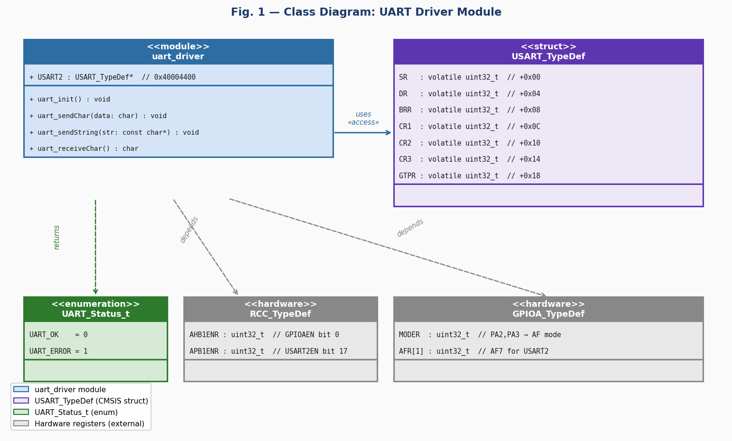
Fig. 1 — Class Diagram: UART Driver Module

3.2. Module Behavior
Initial State
After reset, USART2 clocks are off, PA2 and PA3 are in default GPIO mode, and the peripheral is unpowered. uart_init() enables clocks, configures the pins as AF7, programs BRR for 115200 bps, and enables the USART with TX and RX active.
Event: Character Transmission
uart_write(data) spins on the TXE flag in SR until the transmit data register is empty, then writes the 8-bit character to DR. Hardware shifts it out serially at 115200 bps and sets TXE again when DR is ready for the next byte.
Event: String Transmission
uart_sendString(str) iterates through the null-terminated string calling uart_write() for each character until the null terminator is reached. The loop is sequential — each character is fully enqueued before the next is processed.
Event: Character Reception
uart_receiveChar() spins on the RXNE flag in SR until a byte arrives from the RX pin. When RXNE is set, it reads DR & 0xFF and returns the received character. Reading DR clears RXNE automatically.
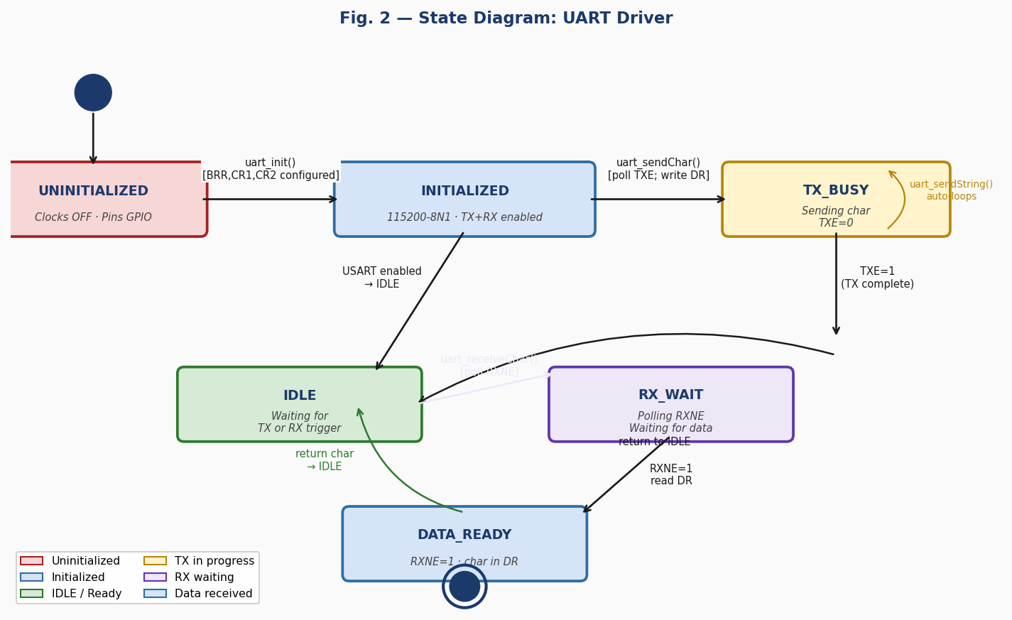
Fig. 2 — State Diagram: UART Driver

3.2.1. Per-Function Sequence and Activity Diagrams

uart_init() — FR-1: USART2 Initialization
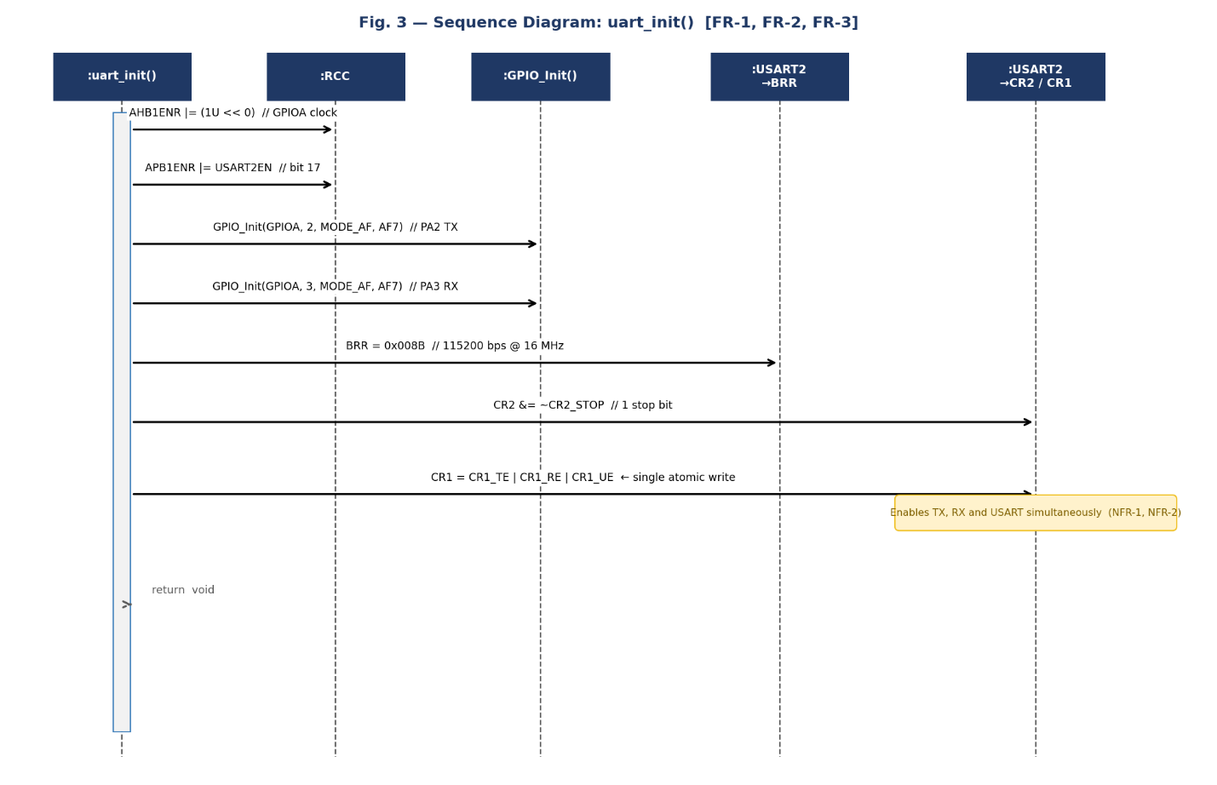
Fig. 3 — Sequence Diagram: uart_init()

The sequence diagram for uart_init() shows five hardware targets: RCC (clock enables), GPIOA (via GPIO_Init() for PA2 and PA3), USART2->BRR, and USART2->CR2/CR1. The function takes no parameters and returns void. It executes seven steps in order: (1) enable GPIOA clock on AHB1; (2) enable USART2 clock on APB1; (3) configure PA2 as TX via GPIO_Init() with AF7; (4) configure PA3 as RX via GPIO_Init() with AF7; (5) set BRR=0x008B for 115200 bps at 16 MHz; (6) clear CR2 STOP bits for 1 stop bit; (7) write CR1 = CR1_TE | CR1_RE | CR1_UE in a single atomic write — enabling transmitter, receiver, and USART simultaneously (NFR-1, NFR-2). No error branch exists as these register writes always succeed.
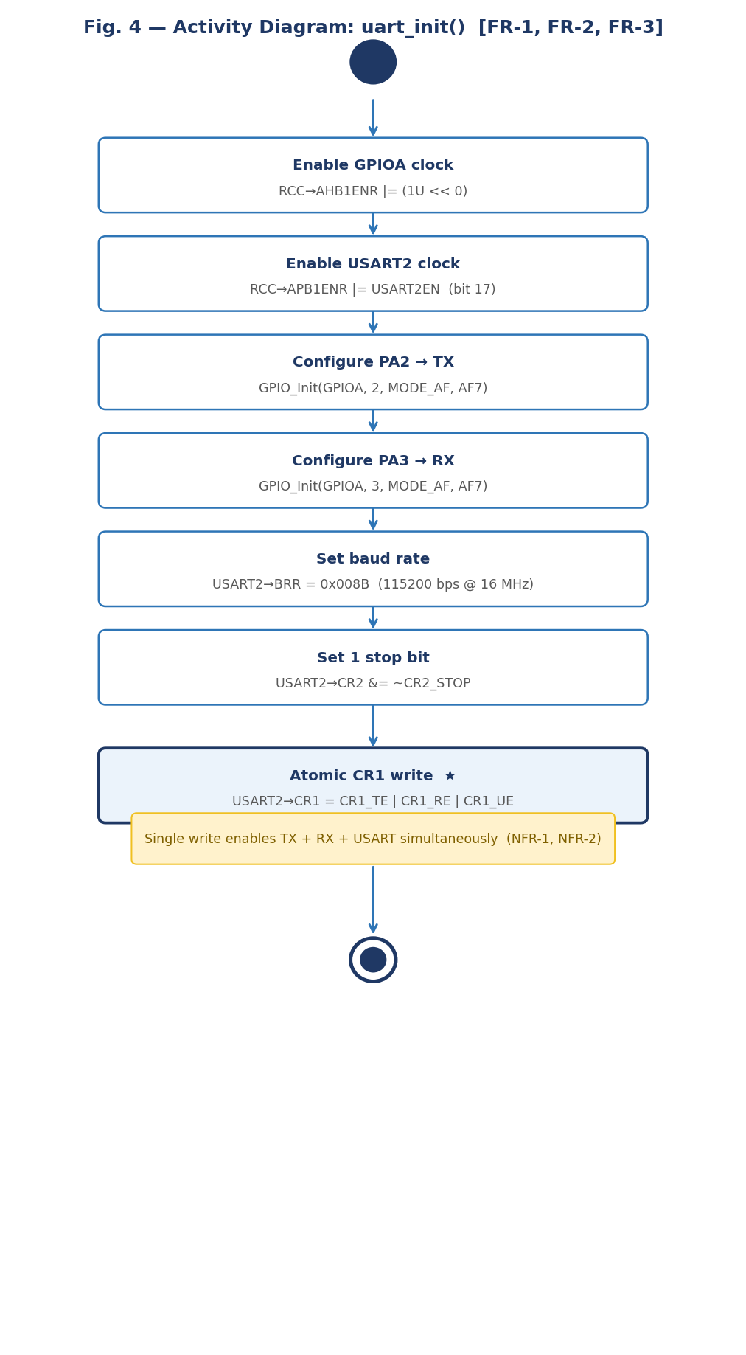
Fig. 4 — Activity Diagram: uart_init()

The activity diagram for uart_init() is a purely linear sequence of seven actions with no decision nodes: (1) enable GPIOA clock, (2) enable USART2 clock, (3) configure PA2 as TX with AF7, (4) configure PA3 as RX with AF7, (5) set BRR for 115200 bps, (6) clear CR2 STOP bits, (7) atomic CR1 write enabling TE, RE, and UE simultaneously. The absence of decision diamonds confirms this is a straight-line initialization function. The single CR1 write in step 7 satisfies NFR-1 and NFR-2 by avoiding transient intermediate states.
uart_write() — FR-2: Single Character Transmission
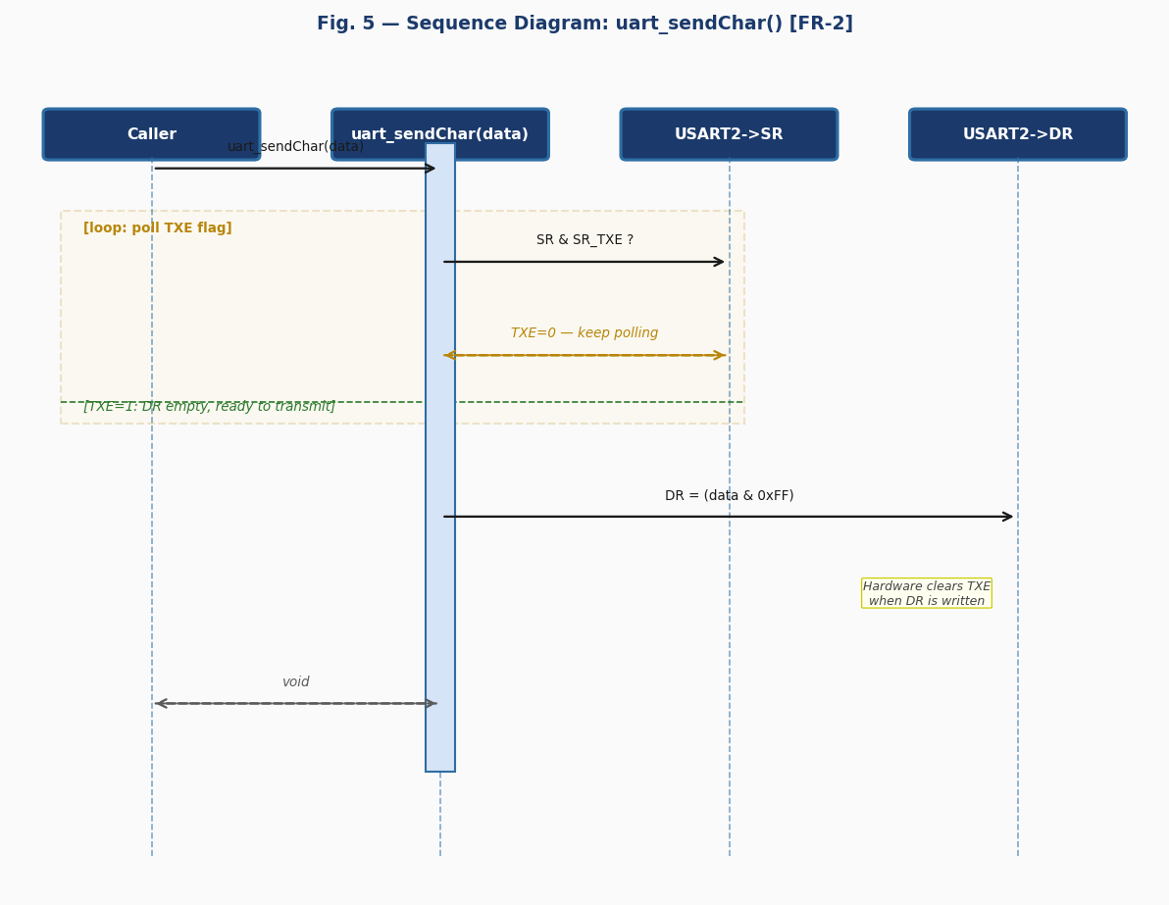
Fig. 5 — Sequence Diagram: uart_write()

The sequence diagram shows a polling loop (loop combined fragment) on USART2->SR reading the TXE flag (bit 7). While TXE=0, the function spins. Once TXE=1, the character is written to USART2->DR masked to 8 bits (data & 0xFF). Hardware automatically shifts the byte out at 115200 bps and re-asserts TXE when DR is ready for the next byte.
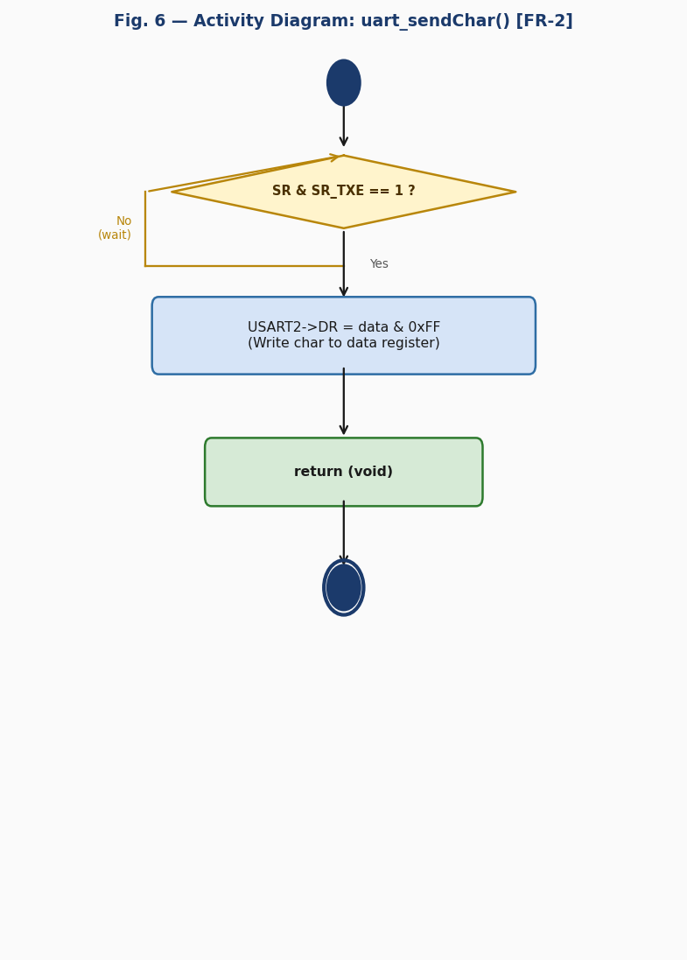
Fig. 6 — Activity Diagram: uart_write()

The activity diagram contains one decision/loop node: [SR & SR_TXE == 1?]. The No branch loops back (busy-wait). The Yes branch writes DR and returns void. The function blocks indefinitely if USART is not initialized or TX is disabled.
uart_sendString() — FR-3: String Transmission
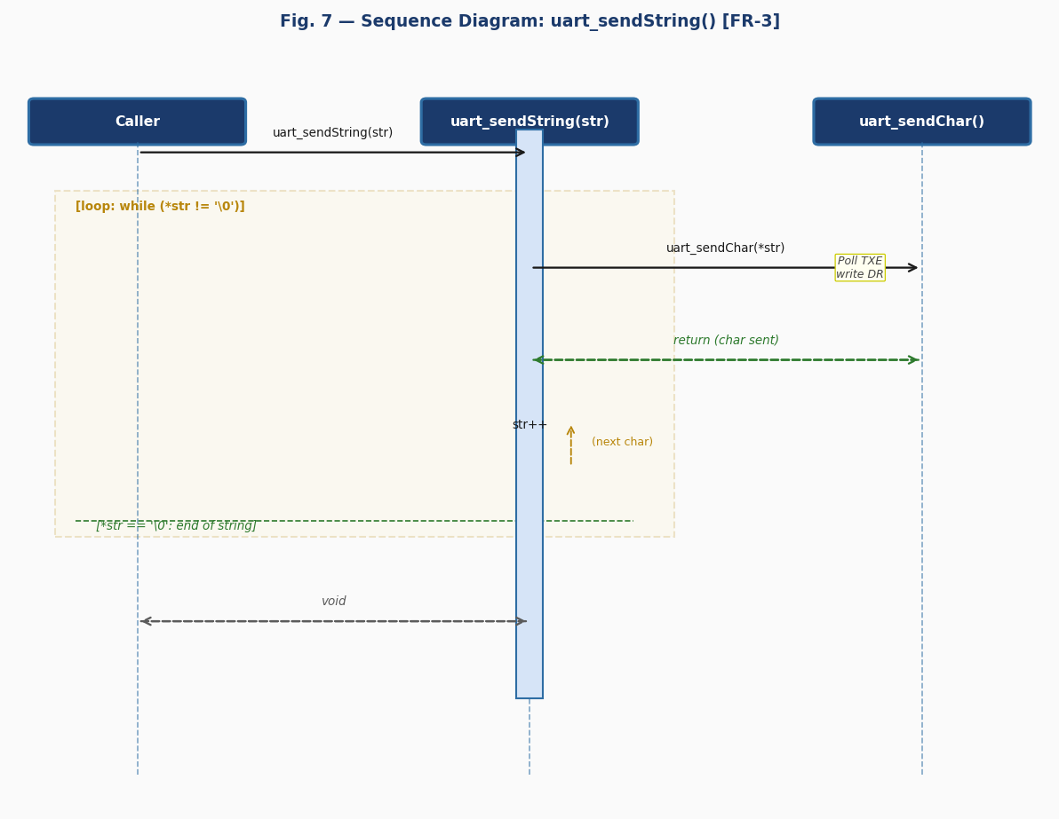
Fig. 7 — Sequence Diagram: uart_sendString()

The sequence diagram shows a loop combined fragment driven by the null-terminator check (*str != '\0'). For each iteration, uart_write(*str) is called, which internally polls TXE and writes DR. After each character is dispatched, str is incremented. When the null terminator is reached, the loop exits and the function returns void.
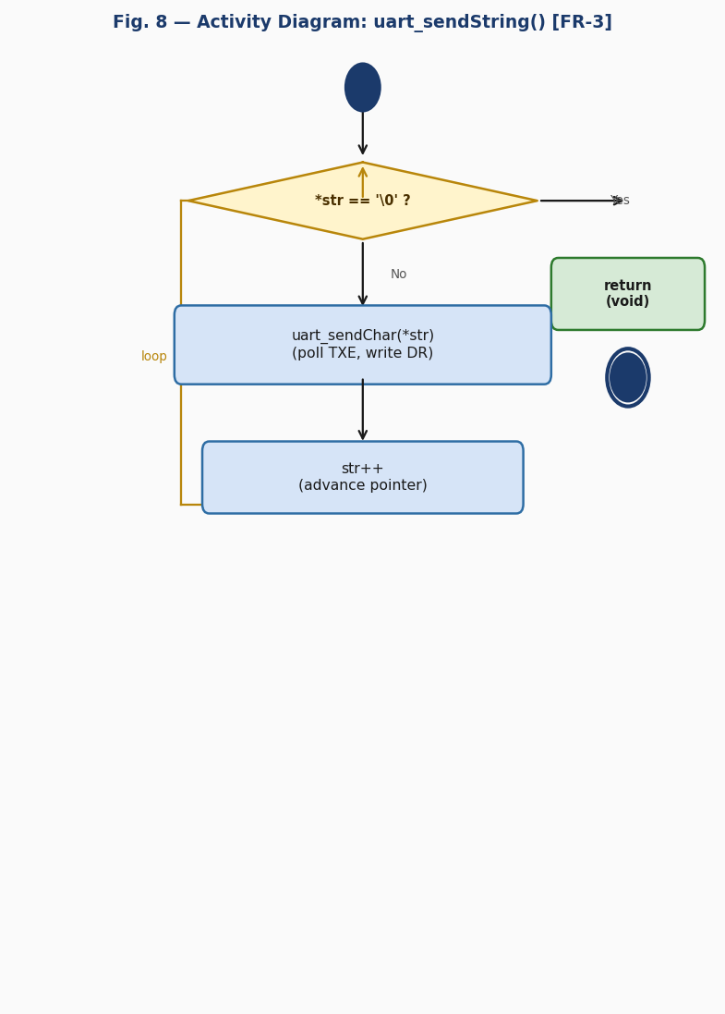
Fig. 8 — Activity Diagram: uart_sendString()

The activity diagram has one decision node: [*str == '\0'?]. The Yes branch exits immediately with void. The No branch calls uart_write(*str), advances str++, and loops back to the check. Design rationale: delegating to uart_write() reuses the TXE-polling logic, avoids code duplication, and satisfies NFR-1 (no HAL dependency).
uart_receiveChar() — Extension: Single Character Reception
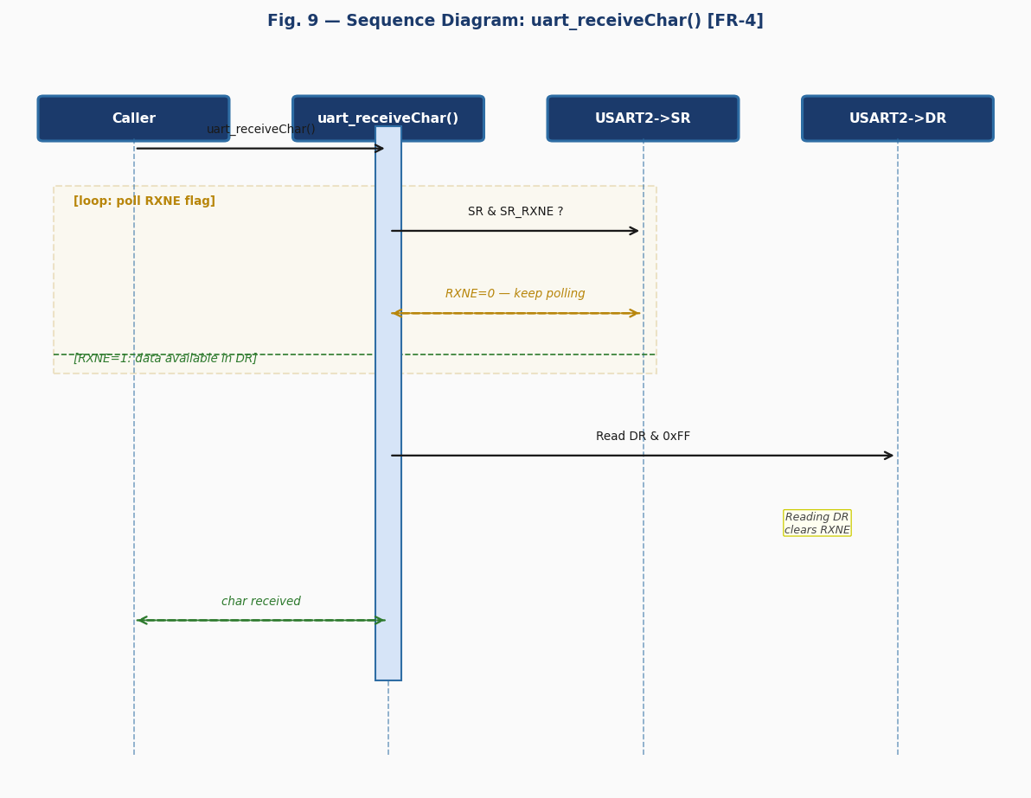
Fig. 9 — Sequence Diagram: uart_receiveChar()

The sequence diagram shows a polling loop on USART2->SR reading the RXNE flag (bit 5). While RXNE=0, the function spins waiting for incoming data. Once RXNE=1 (a byte arrived), USART2->DR is read and masked to 8 bits (DR & 0xFF), returning the received character. Reading DR automatically clears RXNE on STM32F4.
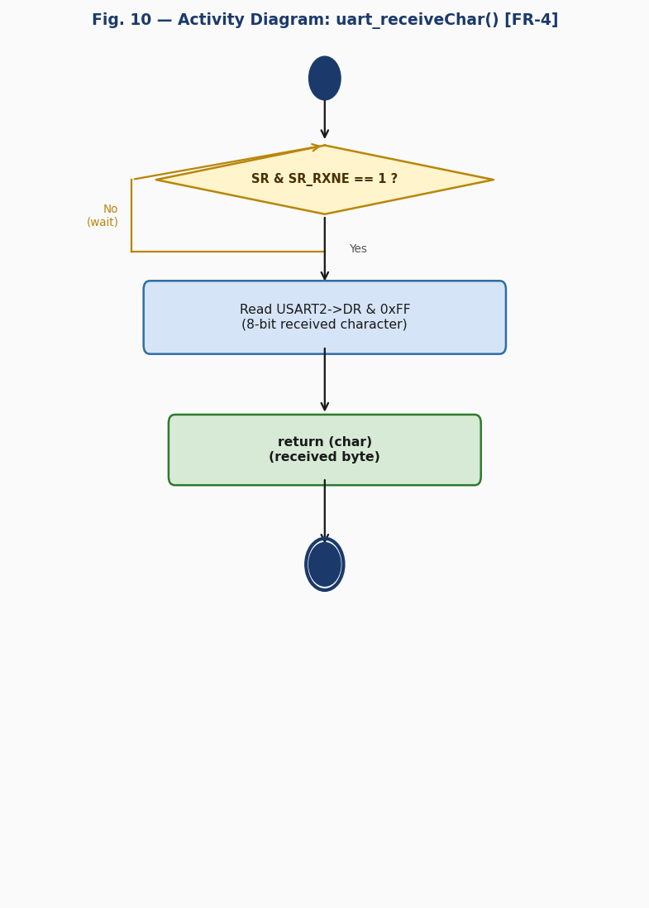
Fig. 10 — Activity Diagram: uart_receiveChar()

The activity diagram has one decision/loop node: [SR & SR_RXNE == 1?]. The No branch busy-waits. The Yes branch reads DR & 0xFF and returns the character. The function blocks indefinitely if no data arrives — callers must ensure the remote sender transmits before calling this function.
3.3. UART Driver
The UART driver is a hardware abstraction module written in C targeting the STM32F411RE microcontroller (RM0383 reference manual). It provides a clean API allowing upper-layer code to perform serial communication without accessing USART2 registers directly. It complies with SRS-UART_Driver v1.0, implementing FR-1 through FR-5, documented by the sequence and activity diagrams in Section 3.2.1 (Figs. 3–10).
Internal Data Structures
The driver exposes no mutable global state. All hardware state is held in the USART2 peripheral registers accessed through the USART2 macro pointer ((USART_TypeDef *) 0x40004400UL). The USART_TypeDef struct defined in uart.h maps SR, DR, BRR, CR1, CR2, CR3, and GTPR at consecutive 4-byte offsets.
Initialization Flow
uart_init() (FR-1, Figs. 3–4) performs a fixed six-step initialization: (1) enable GPIOA clock on AHB1; (2) enable USART2 clock on APB1; (3) configure PA2 (TX) as AF7; (4) configure PA3 (RX) as AF7; (5) set BRR=0x008B for 115200 bps; (6) enable TX, RX, and USART in a single atomic CR1 write (CR1_TE | CR1_RE | CR1_UE), and select 1 stop bit via CR2 (NFR-1, NFR-2).
Baud Rate Calculation
BRR = fAPB1 / baud = 16,000,000 / 115,200 ≈ 138.9 → mantissa = 8, fraction = 11 → BRR = (8 << 4) | 11 = 0x008B. This uses the default oversampling-by-16 mode (OVER8=0 in CR1).
TX Polling Strategy
uart_write() (FR-2) uses a spin-wait on SR_TXE (bit 7). TXE is set by hardware when the shift register has loaded DR and DR is ready for the next byte. Writing DR clears TXE immediately. This ensures no data is overwritten before it is fully enqueued for transmission.
RX Polling Strategy
uart_receiveChar() (extension) uses a spin-wait on SR_RXNE (bit 5). RXNE is set by hardware when a complete byte has been received into DR from the shift register. Reading DR clears RXNE automatically, readying the peripheral for the next byte.
Design Decisions and Rationale
The 8-bit mask (0xFF) on DR reads and writes ensures only the valid data bits are transferred, regardless of reserved bits in the 32-bit register. CR1 is set in a single atomic write (CR1_TE | CR1_RE | CR1_UE) to avoid transient intermediate states while guaranteeing clean initial configuration with 8-bit word length and no parity (M=0, PCE=0 at reset). CR2 stop bits are explicitly cleared even though they reset to 0, for defensive initialization. GPIO pin configuration is delegated to GPIO_Init() to keep the UART driver free of MODER/AFR manipulation code, satisfying NFR-1.
4. Application Programming Interfaces
4.1. Data Types and Macros
UART_Status_t: Return type enumeration (not yet used in current function signatures but provided for future error-returning variants). Values: UART_OK=0, UART_ERROR=1.
Key macros: USART2_BASE=0x40004400UL, USART2EN=(1U<<17) — APB1ENR bit for USART2, AF7_USART2=7U, SR_TXE=(1U<<7), SR_TC=(1U<<6), SR_RXNE=(1U<<5), CR1_UE=(1U<<13), CR1_TE=(1U<<3), CR1_RE=(1U<<2), CR2_STOP=(3U<<12), UART_BRR_115200=0x008BU.
USART_TypeDef Structure (key members used by this driver):
Member Name | Type | Offset | Notes / Definition
SR | volatile uint32_t | +0x00 | Status register — TXE (bit 7), TC (bit 6), RXNE (bit 5).
DR | volatile uint32_t | +0x04 | Data register — write to transmit, read to receive; read clears RXNE.
BRR | volatile uint32_t | +0x08 | Baud rate — mantissa[15:4] | fraction[3:0]; 0x008B gives 115200 @ 16 MHz.
CR1 | volatile uint32_t | +0x0C | Control 1 — UE (13), TE (3), RE (2); M=0 (8-bit), PCE=0 (no parity).
CR2 | volatile uint32_t | +0x10 | Control 2 — STOP bits [13:12]; 0b00 = 1 stop bit.
CR3 | volatile uint32_t | +0x14 | Control 3 — not used by this driver (flow control, DMA, IrDA).
GTPR | volatile uint32_t | +0x18 | Guard time / prescaler — not used by this driver.

Register Map Used by this Driver:
Register | Address | Access | Used by Function(s) | Purpose in Driver
RCC->AHB1ENR | 0x40023830 | R/W | uart_init() | Enable GPIOA clock (bit 0 = GPIOAEN).
RCC->APB1ENR | 0x40023840 | R/W | uart_init() | Enable USART2 clock (bit 17 = USART2EN).
GPIOA->MODER | 0x40020000 | R/W | uart_init() via GPIO_Init() | PA2, PA3 → Alternate Function mode (MODER=0b10).
GPIOA->AFR[] | 0x40020020 | R/W | uart_init() via GPIO_Init() | PA2, PA3 → AF7 (USART2) in AFR[0].
USART2->BRR | 0x40004408 | R/W | uart_init() | Baud rate 0x008B = 115200 bps at 16 MHz APB1.
USART2->CR1 | 0x4000440C | R/W | uart_init() | Zero then set UE(13), TE(3), RE(2).
USART2->CR2 | 0x40004410 | R/W | uart_init() | Clear STOP bits [13:12] for 1 stop bit.
USART2->SR | 0x40004400 | R | uart_write(), uart_receiveChar() | TXE (bit 7) and RXNE (bit 5) polling flags.
USART2->DR | 0x40004404 | R/W | uart_write(), uart_receiveChar() | Write=transmit byte; Read=receive byte; clears RXNE.

4.2. Error Codes
The current UART driver functions all return void or char and do not return UART_Status_t. The enumeration is provided for future versions that may add error handling for timeout or framing errors:
Code | Integer Value | Returned By | Trigger Condition
UART_OK | 0 | (reserved for future use) | Operation completed successfully.
UART_ERROR | 1 | (reserved for future use) | An error condition was detected (e.g. framing error, overrun).

4.3. Public Function Definitions
uart_init
Function Name
 | uart_init
Syntax |  | void uart_init(void)
Parameters (in) |  | N/A
Parameters (inout) | N/A | N/A — This function has no input/output parameters.
Parameters (out) | N/A | N/A — This function has no output parameters.
Return value | void | void — no return value.
Description |  | Initializes USART2 for 115200-8N1 operation (FR-1). Enables GPIOA and USART2 clocks, configures PA2 as TX and PA3 as RX with AF7, sets BRR=0x008B (115200 bps at 16 MHz APB1), enables UE+TE+RE in a single atomic CR1 write (NFR-2), and clears CR2 STOP bits for 1 stop bit.
Constraints |  | Must be called once at startup before any uart_write(), uart_sendString(), or uart_receiveChar() call. GPIO driver must be available (GPIO_Init() is called internally). No error conditions — all register writes always succeed.
Available via |  | uart.h

uart_write
Function Name
 | uart_write
Syntax |  | void uart_write(char data)
Parameters (in) |  | data — char: The character to transmit (8-bit value).
Parameters (inout) | N/A | N/A — This function has no input/output parameters.
Parameters (out) | N/A | N/A — This function has no output parameters.
Return value | void | void — no return value.
Description |  | Transmits a single character over USART2 (FR-4, FR-5). Spins in a polling loop on the TXE flag (SR bit 7) until the transmit data register is empty (FR-4), then writes data & 0xFF to USART2->DR (FR-5). Hardware shifts the byte out serially and re-asserts TXE when ready.
Constraints |  | uart_init() must be called first. Blocks indefinitely if USART2 is not enabled or TX path is disabled. The 0xFF mask ensures only 8 bits are written regardless of the char argument width.
Available via |  | uart.h

uart_sendString
Function Name
 | uart_sendString
Syntax |  | void uart_sendString(const char *str)
Parameters (in) |  | str — const char*: Pointer to a null-terminated string to transmit.
Parameters (inout) | N/A | N/A — This function has no input/output parameters.
Parameters (out) | N/A | N/A — This function has no output parameters.
Return value | void | void — no return value.
Description |  | Transmits a null-terminated string over USART2 (FR-3). Iterates through the string calling uart_write(*str++) for each character until the null terminator '\0' is reached. The string pointer must remain valid for the duration of the call.
Constraints |  | uart_init() must be called first. str must not be NULL and must be null-terminated; passing a non-terminated array causes an infinite loop. Transmission is sequential — each character is fully enqueued before the next.
Available via |  | uart.h

uart_receiveChar
Function Name
 | uart_receiveChar
Syntax |  | char uart_receiveChar(void)
Parameters (in) |  | N/A
Parameters (inout) | N/A | N/A — This function has no input/output parameters.
Parameters (out) | N/A | N/A — This function has no output parameters.
Return value | char | char — the received 8-bit character (DR & 0xFF).
Description |  | Receives a single character from USART2 (extension, not in SRS). Spins in a polling loop on the RXNE flag (SR bit 5) until a byte has been received into DR by hardware. Reads USART2->DR & 0xFF and returns the character. Reading DR clears RXNE automatically.
Constraints |  | uart_init() must be called first. Blocks indefinitely until a byte arrives — callers must ensure a sender is active. The 0xFF mask ensures only the 8-bit data portion of DR is returned.
Available via |  | uart.h

4.4. Internal Function Definitions
The UART driver does not define private static helper functions. All logic is implemented inline within the four public functions. Two implicit internal operations are documented below for completeness:

Inline TXE Polling (no separate function)
Function Name
 | (inline TXE polling — uart_write)
Syntax |  | while (!(USART2->SR & SR_TXE)) {}
Parameters (in) |  | N/A — reads USART2->SR bit 7 in a spin loop.
Parameters (inout) | N/A | N/A — This function has no input/output parameters.
Parameters (out) | N/A | N/A — This function has no output parameters.
Return value | void | void — exits when TXE=1 (DR is empty and ready).
Description |  | Busy-wait loop that checks the TXE flag before writing to DR. Ensures that no byte is written to DR before the previous byte has been loaded into the USART shift register. Implemented as a single while loop at the top of uart_write(). Satisfies NFR-2 (bounded time per byte given an active USART at ~87 us/byte at 115200 bps).
Constraints |  | Static guard within uart_write(). Will spin indefinitely if USART2 is not enabled or CR1_TE is not set. Not a callable function — inline polling pattern only.

Inline RXNE Polling (no separate function)
Function Name
 | (inline RXNE polling — uart_receiveChar)
Syntax |  | while (!(USART2->SR & SR_RXNE)) {}
Parameters (in) |  | N/A — reads USART2->SR bit 5 in a spin loop.
Parameters (inout) | N/A | N/A — This function has no input/output parameters.
Parameters (out) | N/A | N/A — This function has no output parameters.
Return value | void | void — exits when RXNE=1 (a byte has been received into DR).
Description |  | Busy-wait loop that checks the RXNE flag before reading DR. Ensures the driver does not read DR until hardware has written a valid received byte into it. Implemented as a single while loop at the top of uart_receiveChar(). Reading DR after RXNE=1 automatically clears the flag, preparing the peripheral for the next byte.
Constraints |  | Static guard within uart_receiveChar(). Will spin indefinitely until a byte is received — by design for a blocking receive API. Not a callable function — inline polling pattern only.

5. Future Enhancements
- Interrupt-driven reception: Add uart_enableRxInterrupt() to register an RXNE interrupt handler, eliminating the blocking spin-wait in uart_receiveChar() and allowing the application to receive data asynchronously without stalling the CPU.
- DMA transfer support: Add configuration functions to enable DMA for both TX and RX paths, enabling high-throughput transfers of large buffers without CPU polling overhead.
- Circular receive buffer: Implement an interrupt-driven ring buffer for RX to store incoming bytes automatically, decoupling reception from application processing and preventing data loss at high baud rates.
- Configurable baud rate and frame format: Extend uart_init() or add uart_configure() to accept baud rate, word length, parity, and stop-bit parameters, removing the hard-coded 115200-8N1 constraint.
- Error detection and reporting: Add UART_Status_t return values to transmission and reception functions, and check framing error (FE), overrun (ORE), and noise (NE) flags in SR to report hardware faults rather than silently ignoring them.

