1. Install jenkins

2. Install Maven

3. Install Java

4. Install Cucumber, Bitbucket (or other vcs) plugins

5. Jenkins: navigate to Manage Jenkins > Global Tool Configuration and configure Java_home, Maven_home

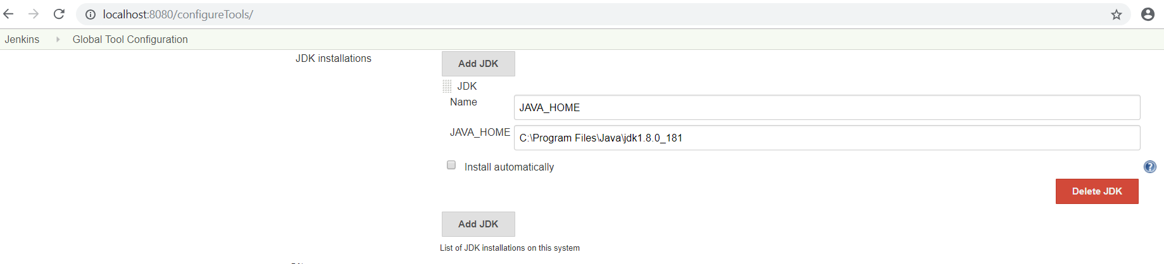

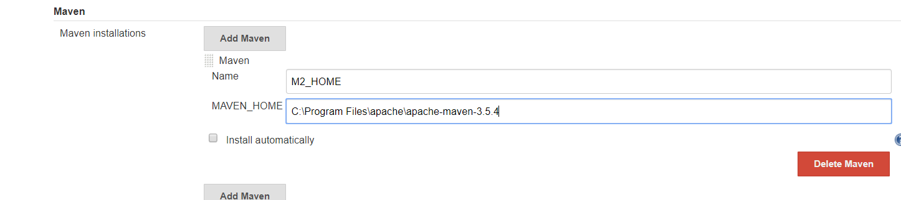

6. Create a new Jenkins job

7. In the new job, add the repository and credentials

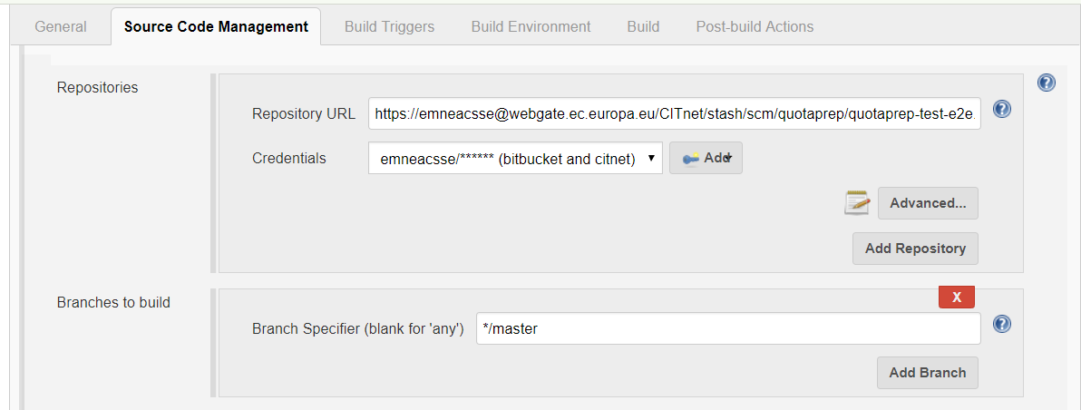

8. Add a Windows batch command build step

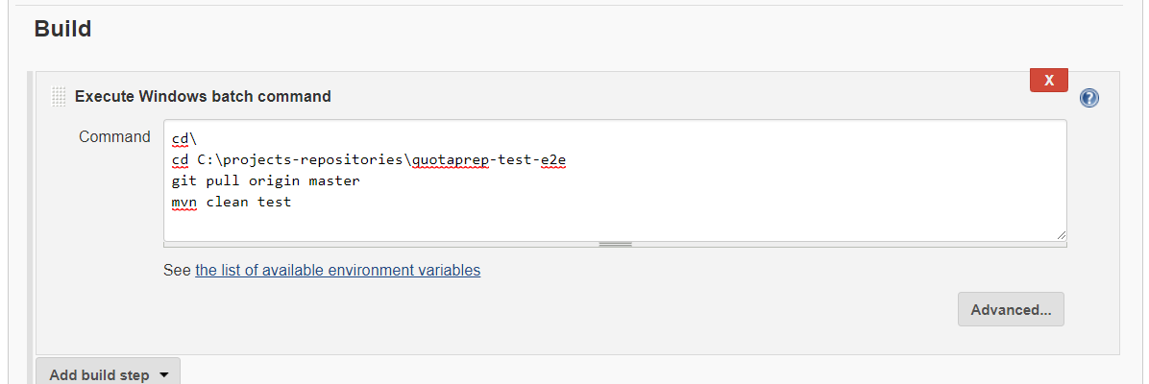

9. Define the job trigger. E.g. Once a day. Or “0 0 * * *” for midnight

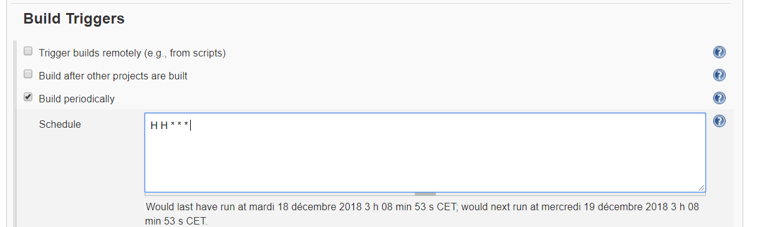

10. Download and unzip Chromedriver. Add it’s location to the Path environment variable:

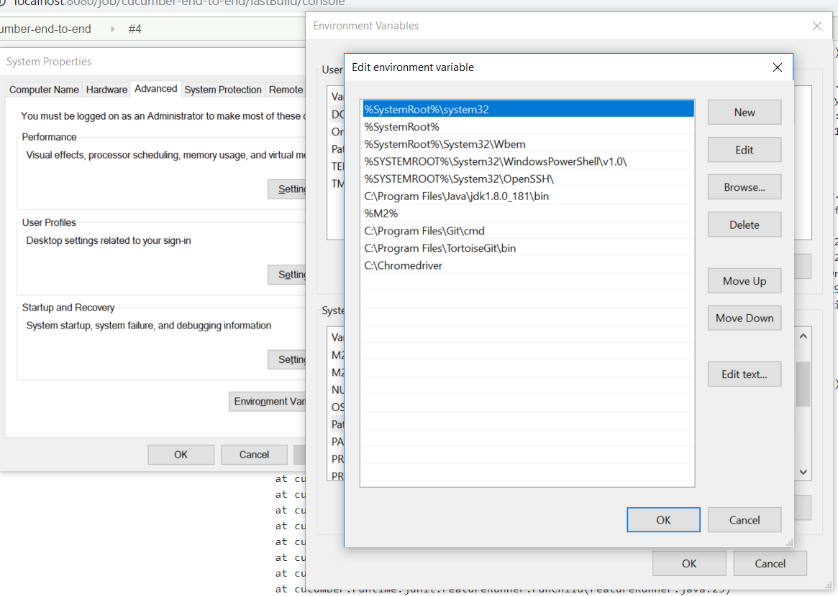

11. Make sure that you have the json type reports added to your cucumber runner:

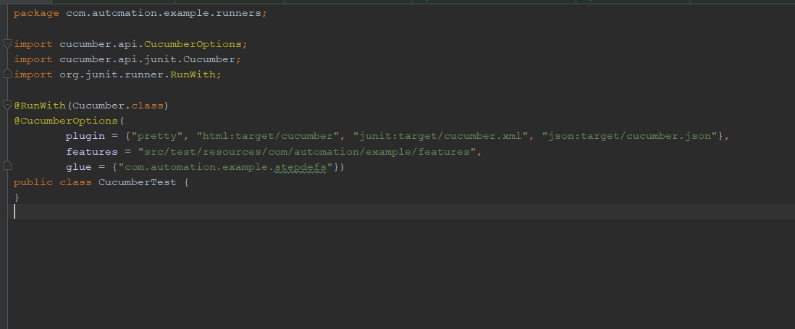

12. Add the cucumber reports as a post build action:

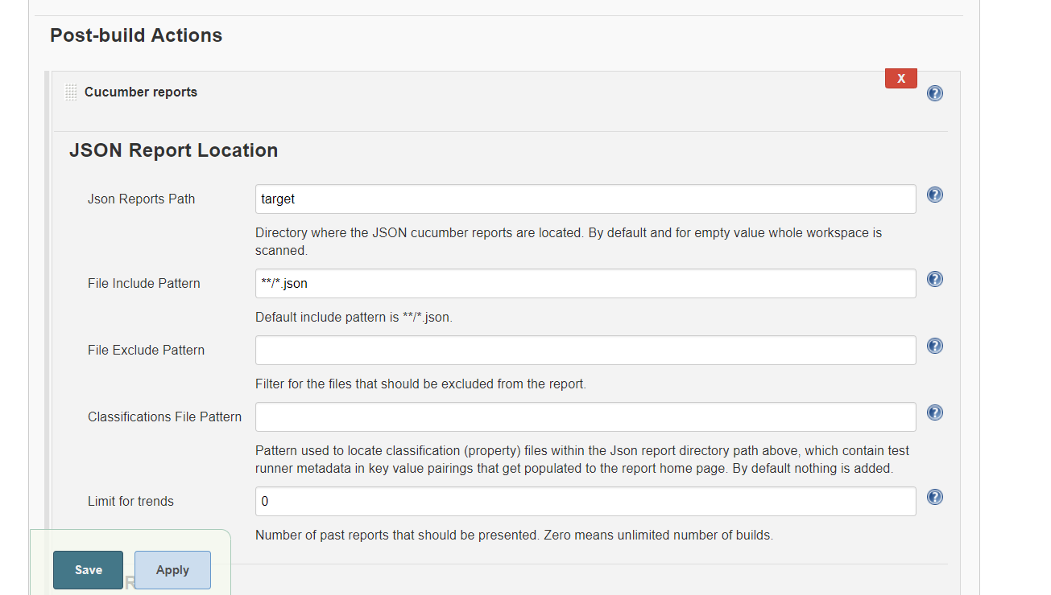

Or with absolute path: 