**README.DOCX**

1. Navigate to folder “nodeapi” on cmd prompt and npm install

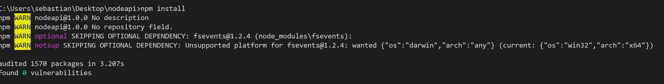

2. Run command nodemon app.js --ignore db.json ( we ignore this file to prevent looping when seeding the lokijs database since we are using nodemon which will monitor for any changes in our source and automatically restart the server )

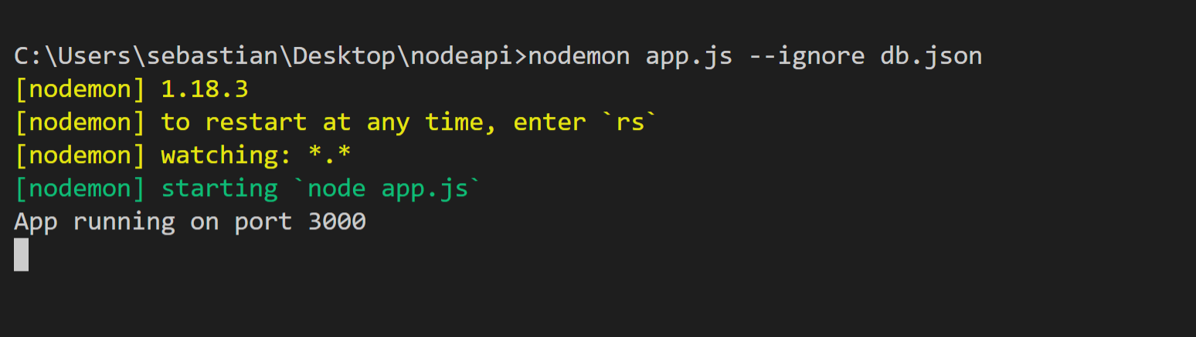

3. Make Postman request Body

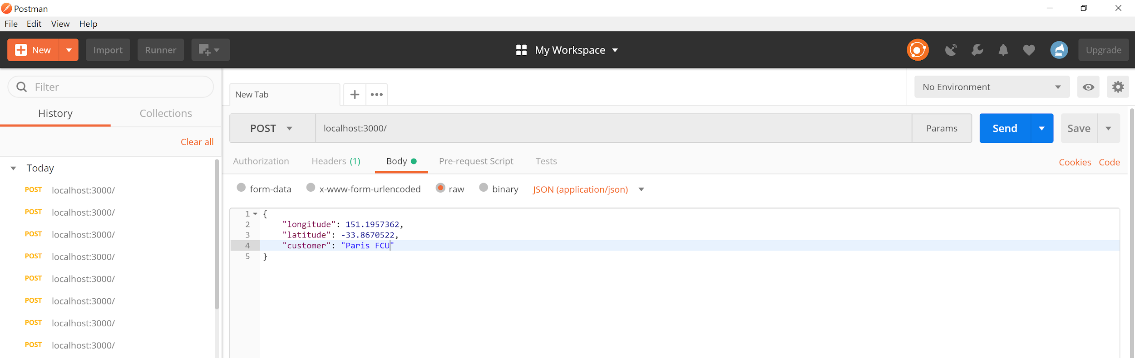

4. Include Postman Request Header and send request

