Full Stack Development V8
Assignment 13 — Database Task: MongoDB CRUD Operations
Course / Program | Full Stack Development V8
Assignment Number | Assignment 13 — “Database Task”
Database Name | inventoryDB
Collection Name | items
Environment | MongoDB Shell (mongosh) / Compass Interface

1. Task Overview & Database Setup
This database assignment demonstrates foundational database manipulation skills using MongoDB CRUD queries. As specified in the assignment guidelines, the task is strictly database-only with no backend integration. All eight essential CRUD methods are executed on the 'items' collection within the 'inventoryDB' database, verifying proper insertion, querying, update modifiers, and deletions with confirmation.
Database & Collection Initialization Queries:
use inventoryDB
db.createCollection("items")
2.1 Insert Operation 1: insertOne()
Query Description: Inserts a single document into the 'items' collection with fields: name, category, price, quantity, inStock, and tags array.
Query Command:
db.items.insertOne({
name: "Wireless Mouse",
category: "Electronics",
price: 25.99,
quantity: 150,
inStock: true,
tags: ["accessories", "wireless", "computer"]
})

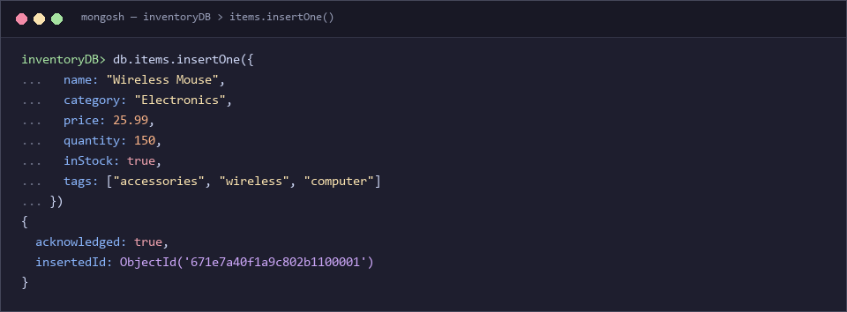
Figure: Input query & output result for Insert Operation 1: insertOne()
Output Observation & Result: Result confirms successful insertion with acknowledged: true and a generated ObjectId ('671e7a40f1a9c802b1100001').
2.2 Insert Operation 2: insertMany()
Query Description: Inserts multiple documents (5 distinct items across different categories) in a single batch operation into the collection.
Query Command:
db.items.insertMany([
{ name: "Mechanical Keyboard", category: "Electronics", price: 89.99, quantity: 75, inStock: true, tags: ["gaming", "rgb"] },
{ name: "Gaming Monitor 27-inch", category: "Electronics", price: 299.99, quantity: 30, inStock: true, tags: ["display", "144hz"] },
{ name: "USB-C Hub Multiport", category: "Electronics", price: 34.50, quantity: 120, inStock: true, tags: ["adapter", "usb-c"] },
{ name: "Noise-Cancelling Headphones", category: "Audio", price: 149.99, quantity: 45, inStock: true, tags: ["audio", "bluetooth"] },
{ name: "Desk Mat Extended", category: "Office Supplies", price: 19.99, quantity: 200, inStock: true, tags: ["desk", "pad"] }
])

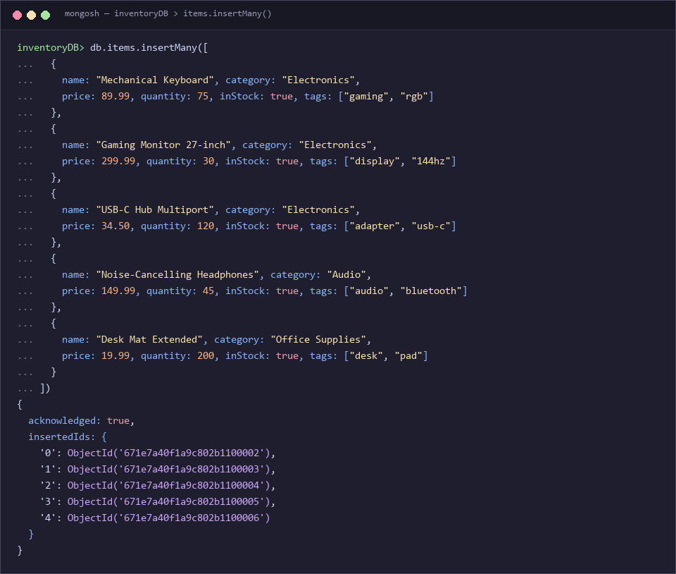
Figure: Input query & output result for Insert Operation 2: insertMany()
Output Observation & Result: Batch insertion returned acknowledged: true with 5 sequential ObjectIds mapped to indices 0 through 4.
2.3 Read Operation 1: find()
Query Description: Retrieves all documents matching multiple filter criteria: category 'Electronics' and inStock equal to true.
Query Command:
db.items.find({ category: "Electronics", inStock: true })

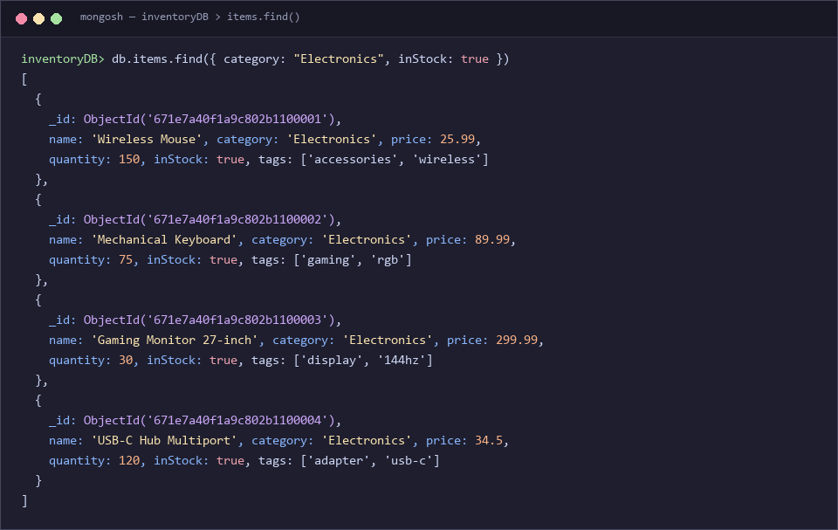
Figure: Input query & output result for Read Operation 1: find()
Output Observation & Result: Returned 4 matching documents: Wireless Mouse, Mechanical Keyboard, Gaming Monitor 27-inch, and USB-C Hub Multiport.
2.4 Read Operation 2: findOne()
Query Description: Retrieves exactly one document matching the query condition where name is 'Mechanical Keyboard'.
Query Command:
db.items.findOne({ name: "Mechanical Keyboard" })

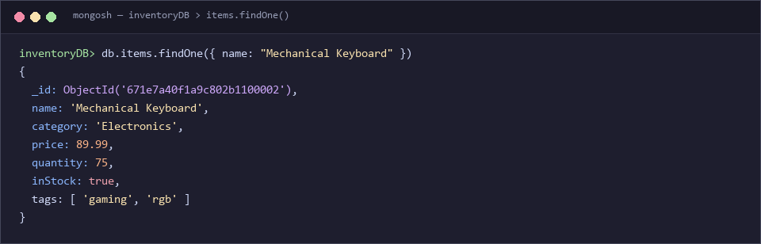
Figure: Input query & output result for Read Operation 2: findOne()
Output Observation & Result: Returns the exact document object matching the specified filter.
2.5 Update Operation 1: updateOne()
Query Description: Modifies a single document ('Wireless Mouse') by updating price to 22.99, updating quantity to 140, and setting the lastModified timestamp using $currentDate. Modification is confirmed with findOne().
Query Command:
db.items.updateOne(
{ name: "Wireless Mouse" },
{ $set: { price: 22.99, quantity: 140 }, $currentDate: { lastModified: true } }
)

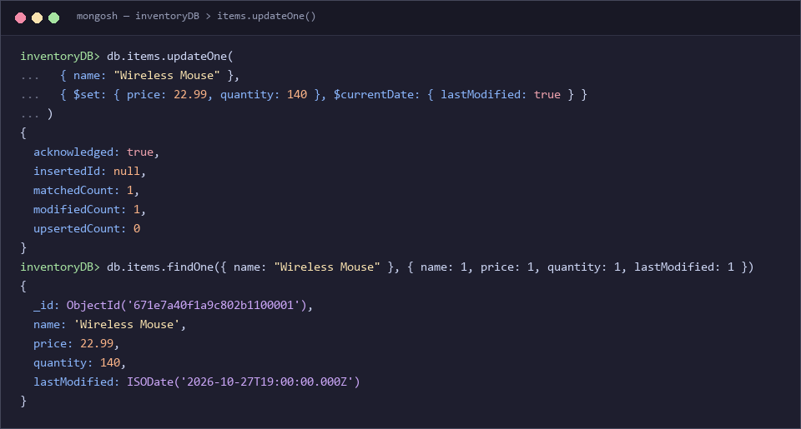
Figure: Input query & output result for Update Operation 1: updateOne()
Output Observation & Result: Output shows matchedCount: 1 and modifiedCount: 1. A follow-up query verifies updated field values.
2.6 Update Operation 2: updateMany()
Query Description: Updates all documents where category is 'Electronics' by setting an onSale flag to true and incrementing quantity by 10 using the $inc operator.
Query Command:
db.items.updateMany(
{ category: "Electronics" },
{ $set: { onSale: true }, $inc: { quantity: 10 } }
)

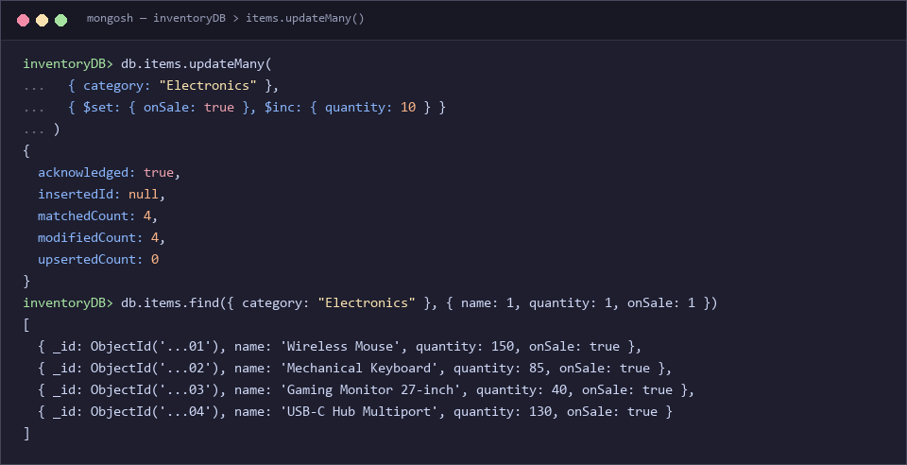
Figure: Input query & output result for Update Operation 2: updateMany()
Output Observation & Result: Output shows matchedCount: 4 and modifiedCount: 4. Subsequent projection query confirms all 4 items received the update.
2.7 Delete Operation 1: deleteOne()
Query Description: Deletes a single document ('Desk Mat Extended') from the collection. Deletion is verified via find() returning empty.
Query Command:
db.items.deleteOne({ name: "Desk Mat Extended" })
// Verification query:
db.items.find({ name: "Desk Mat Extended" })

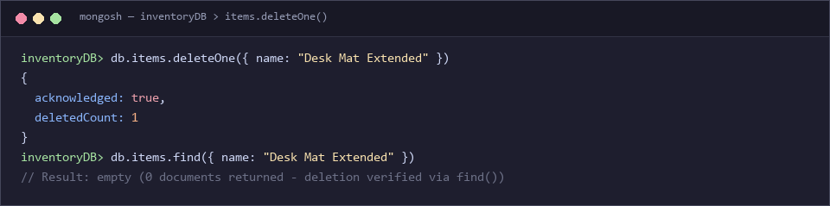
Figure: Input query & output result for Delete Operation 1: deleteOne()
Output Observation & Result: Output confirms acknowledged: true with deletedCount: 1. The verification find() query returns 0 documents, confirming deletion.
2.8 Delete Operation 2: deleteMany()
Query Description: Deletes all documents matching the filter criteria category: 'Audio'. Deletion is verified via find() returning empty.
Query Command:
db.items.deleteMany({ category: "Audio" })
// Verification query:
db.items.find({ category: "Audio" })

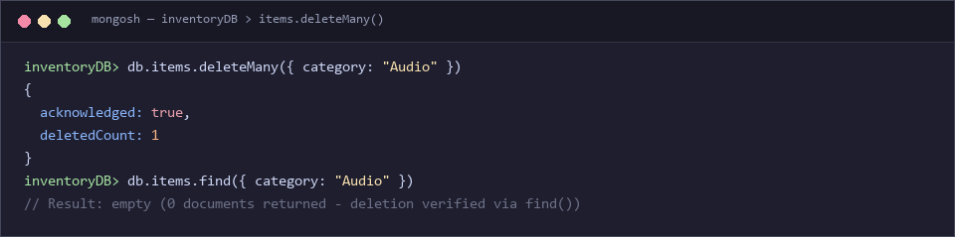
Figure: Input query & output result for Delete Operation 2: deleteMany()
Output Observation & Result: Output confirms acknowledged: true with deletedCount: 1. The verification find() query returns 0 documents, confirming complete removal.
3. Summary of Demonstrated Operations
Sl No. | CRUD Method | Target Filter / Details | Execution Status
1 | insertOne() | Single document (Wireless Mouse) | Verified (acknowledged: true)
2 | insertMany() | 5 batch documents across categories | Verified (5 ObjectIds)
3 | find() | category: 'Electronics', inStock: true | Verified (4 records matched)
4 | findOne() | name: 'Mechanical Keyboard' | Verified (single record)
5 | updateOne() | name: 'Wireless Mouse' ($set, $currentDate) | Verified (modifiedCount: 1)
6 | updateMany() | category: 'Electronics' ($set, $inc) | Verified (modifiedCount: 4)
7 | deleteOne() | name: 'Desk Mat Extended' | Verified via find() (count: 0)
8 | deleteMany() | category: 'Audio' | Verified via find() (count: 0)

