MongoDB shell queries

1.)

Query:

| db.listingsAndReviews.find({  $and: [  { beds: { $gt: 3 } },  { "address.country_code": "PT" },  { price: { $lt: 75 } }  ] }) |
| --- |

Skärmdump:

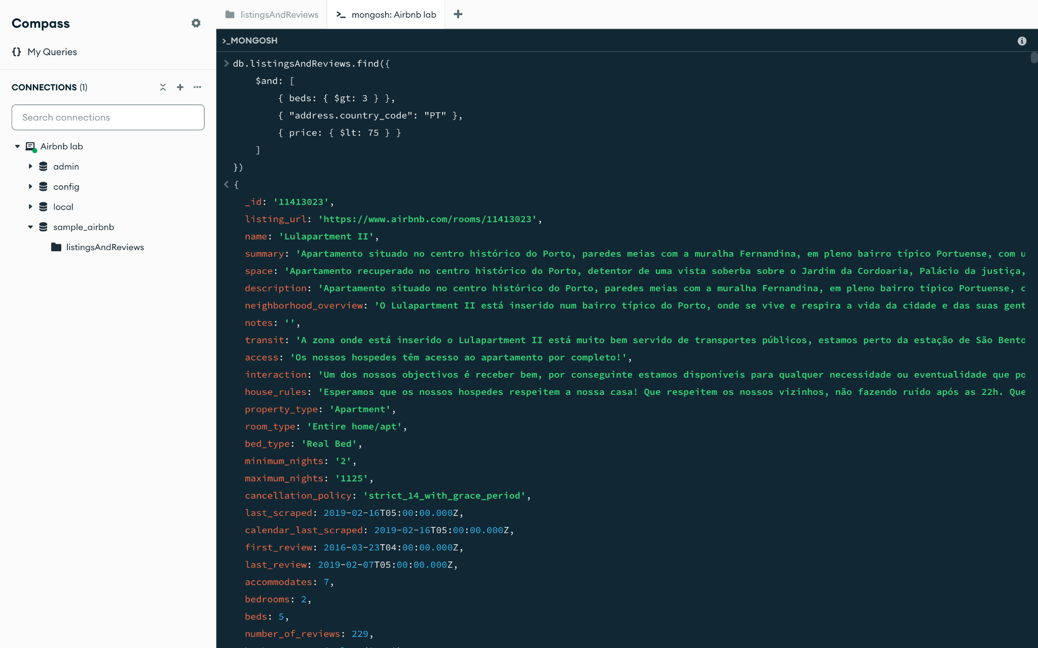

2.)

Query:

| db.listingsAndReviews.find(  { "review_scores.review_scores_cleanliness": { $gt: 8 } },  {  _id: 0,  name: 1,  summary: 1,  "address.country": 1,  price: 1  } ).sort(  { price: 1 } ); |
| --- |

Skärmdump:

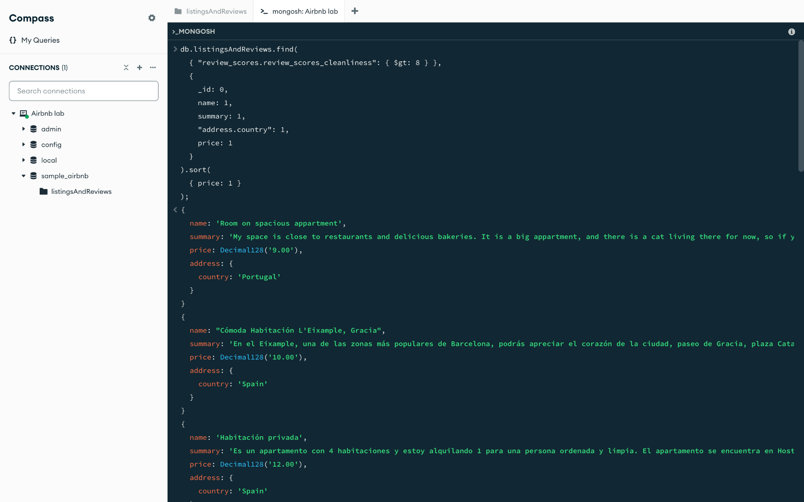

3.)

Query:

| db.listingsAndReviews.updateOne(  { description: {$regex: "mountain view", $options: "i"} },  { $set: {price: NumberDecimal("90.00")} } ); |
| --- |

Såg att dem andra priserna stod som Decimal128, för att behålla databasens integritet, använder vi oss av NumberDecimal.

Skärmdump:

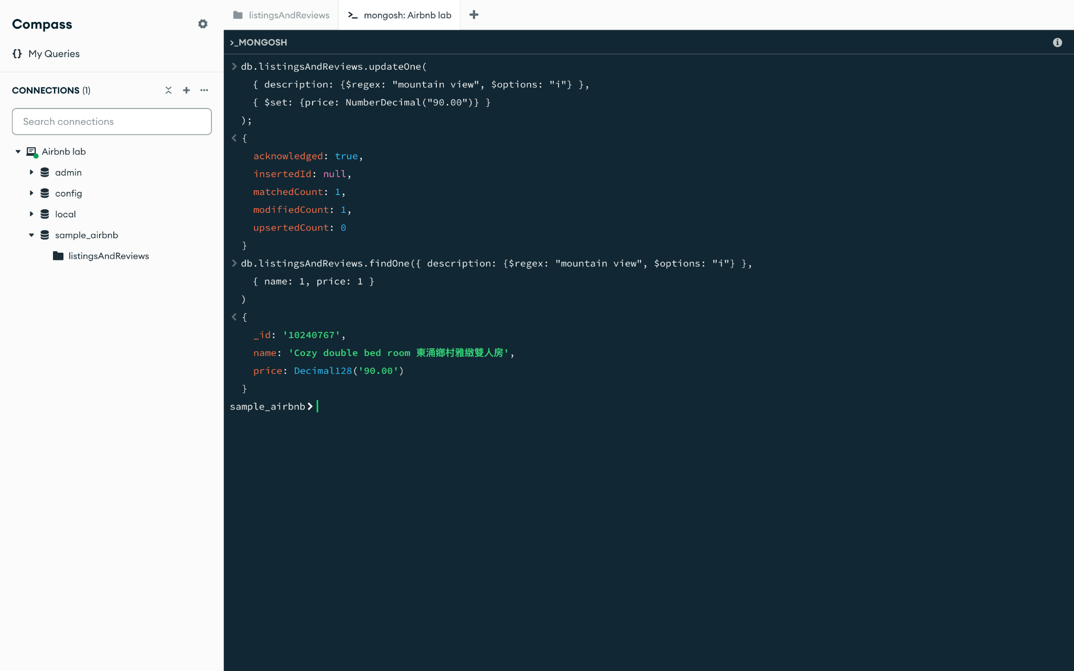

4.)

Query:

| db.listingsAndReviews.updateMany(  { "address.country_code": "TR" },  { $set: {isactive: false} } ); |
| --- |

Skärmdump:

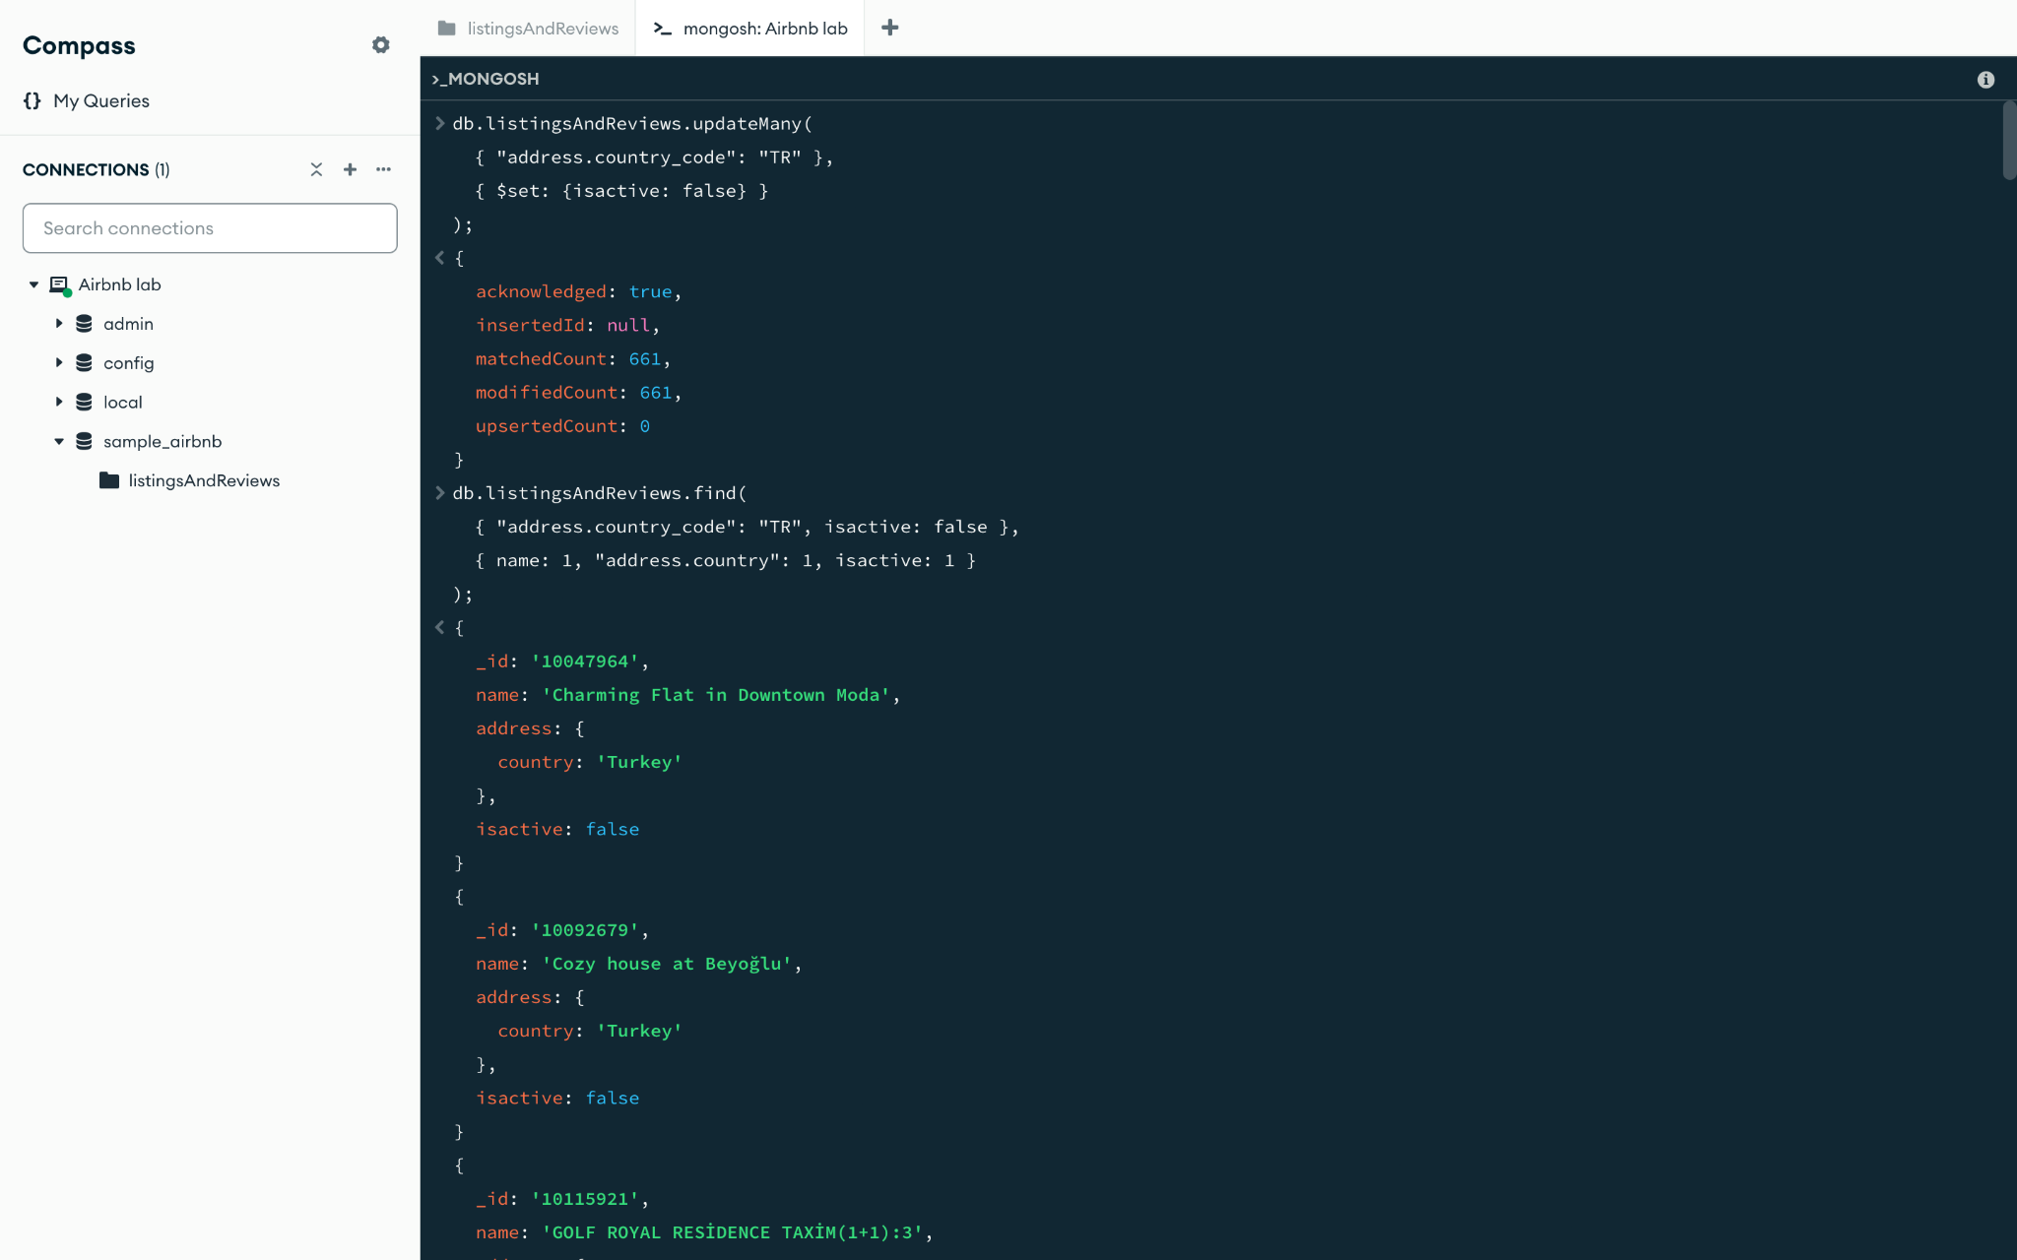

5.)

Query:

| db.listingsAndReviews.deleteMany(  { "review_scores.review_scores_rating": { $lt: 21 } } ); |
| --- |

Skärmdump:

