20260922 - Introduction to statistical modeling

Welcome!

Quick start
Load R packages:
Use Alt+Command+I to Insert a Code Chunk:
library(tidyverse)
── Attaching core tidyverse packages ──────────────────────── tidyverse 2.0.0 ──
✔ dplyr 1.2.1 ✔ readr 2.2.0
✔ forcats 1.0.1 ✔ stringr 1.6.0
✔ ggplot2 4.0.3 ✔ tibble 3.3.1
✔ lubridate 1.9.5 ✔ tidyr 1.3.2
✔ purrr 1.2.2
── Conflicts ────────────────────────────────────────── tidyverse_conflicts() ──
✖ dplyr::filter() masks stats::filter()
✖ dplyr::lag() masks stats::lag()
ℹ Use the conflicted package (<http://conflicted.r-lib.org/>) to force all conflicts to become errors
library(easystats)
# Attaching packages: easystats 0.7.6.3
✔ bayestestR 0.19.0 ✔ correlation 0.8.8
✔ datawizard 1.4.0 ✔ effectsize 1.0.3
✔ insight 1.5.4 ✔ modelbased 0.17.0
✔ performance 0.18.2 ✔ parameters 0.29.3
✔ report 0.6.4 ✔ see 0.14.2
Load data:
d <- read.csv("https://vincentarelbundock.github.io/Rdatasets/csv/palmerpenguins/penguins.csv")
head(d) # see the first few rows, the "head" of the table
rownames species island bill_length_mm bill_depth_mm flipper_length_mm
1 1 Adelie Torgersen 39.1 18.7 181
2 2 Adelie Torgersen 39.5 17.4 186
3 3 Adelie Torgersen 40.3 18.0 195
4 4 Adelie Torgersen NA NA NA
5 5 Adelie Torgersen 36.7 19.3 193
6 6 Adelie Torgersen 39.3 20.6 190
body_mass_g sex year
1 3750 male 2007
2 3800 female 2007
3 3250 female 2007
4 NA 2007
5 3450 female 2007
6 3650 male 2007
First Modelling:
m1 <- lm(body_mass_g ~ bill_length_mm, data = d) # Control+Enter
model_parameters(m1)
Parameter | Coefficient | SE | 95% CI | t(340) | p
---------------------------------------------------------------------------
(Intercept) | 362.31 | 283.35 | [-195.02, 919.64] | 1.28 | 0.202
bill length mm | 87.42 | 6.40 | [ 74.82, 100.01] | 13.65 | < .001
Uncertainty intervals (equal-tailed) and p-values (two-tailed) computed
using a Wald t-distribution approximation.
$R^{2}$: The (percentage) amount of explained variance of the model - “goodness” of the model.
r2(m1)
# R2 for Linear Regression
R2: 0.354
adj. R2: 0.352
Standardized coefficients:
effectsize::standardize_parameters(m1, method = "refit") # oder "basic"
# Standardization method: refit
Parameter | Std. Coef. | 95% CI
-------------------------------------------
(Intercept) | 3.79e-16 | [-0.09, 0.09]
bill length mm | 0.60 | [ 0.51, 0.68]
Visualize the model:
library(ggpubr) #control+enter
Attache Paket: 'ggpubr'
Die folgenden Objekte sind maskiert von 'package:datawizard':
mean_sd, median_mad
ggscatter(d,
x = "bill_length_mm",
y = "body_mass_g",
color = "species",
add = "reg.line",
conf.int = TRUE,
cor.coef = TRUE,
alpha = 0.6,
xlab = "Schnabellänge (mm)",
ylab = "Körpermasse (g)")
Warning: Removed 2 rows containing non-finite outside the scale range
(`stat_smooth()`).
Warning: Removed 2 rows containing non-finite outside the scale range
(`stat_cor()`).
Warning: Removed 2 rows containing missing values or values outside the scale range
(`geom_point()`).
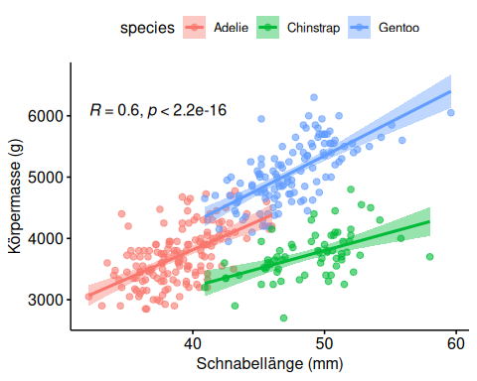

Exercise
Choose and run your own model, just as above. Try to understand the result.

Descriptives statistics
Control+Shift+I – insert code chunk
Mind the pipe! “|>”
d |> # Control+Shift+M - the "pipe" - "and then do ..."
select(bill_length_mm, body_mass_g, sex) |>
describe_distribution(by = "sex") |>
print_md()
sex | Variable | Mean | SD | IQR | Range | Skewness | Kurtosis | n | n_Missing
 | bill_length_mm | 41.30 | 4.63 | 7.70 | (34.10, 47.30) | -0.18 | -1.50 | 9 | 2
 | body_mass_g | 4005.56 | 679.36 | 1300.00 | (2975.00, 4875.00) | -0.16 | -1.45 | 9 | 2
female | bill_length_mm | 42.10 | 4.90 | 8.60 | (32.10, 58.00) | 0.05 | -0.78 | 165 | 0
female | body_mass_g | 3862.27 | 666.17 | 1212.50 | (2700.00, 5200.00) | 0.45 | -1.12 | 165 | 0
male | bill_length_mm | 45.85 | 5.37 | 9.45 | (34.60, 59.60) | -0.11 | -1.13 | 168 | 0
male | body_mass_g | 4545.68 | 787.63 | 1437.50 | (3250.00, 6300.00) | 0.38 | -1.20 | 168 | 0

