TECHNICAL REFERENCE | RELEASE 2026.3
MANAGERV2
Comprehensive Technical Documentation
Architecture • Modules • Security • Data • Integrations • Operations
Project information
Repository | github.com/sebastiansoja12/managerv2
Project version | 2026.3
Document date | 22 August 2026
Source: https://github.com/sebastiansoja12/managerv2
Prepared as an engineering reference for development, review, deployment, and operations.

Table of Contents
Executive Summary 0
Key Architectural Conclusions 0
1. Purpose, Audience, and Documentation Scope 0
1.1 Purpose 0
1.2 Intended Audience 0
1.3 Documentation Scope 0
1.4 Method of Analysis 0
1.5 Terminology 0
2. Product and Domain Overview 0
2.1 Product Scope 0
2.2 Core Business Capabilities 0
2.3 Typical End-to-End Scenario 0
2.4 Domain Ownership Principles 0
2.5 Non-Functional Characteristics 0
3. Repository and Build Organization 0
3.1 Root Maven Reactor 0
3.2 Common Module Layout 0
3.3 Parent Version and Dependency Management 0
3.4 Maven Profiles 0
3.5 Build Outputs 0
3.6 Distribution Management 0
4. Architectural Overview 0
4.1 Architectural Style 0
4.2 API/Impl Separation 0
4.3 Dependency Direction 0
4.4 Main Application Assembly 0
4.5 Orchestration Versus Domain Logic 0
4.6 Synchronous and Asynchronous Boundaries 0
4.7 Transaction Boundaries 0
5. Runtime Topology and Infrastructure 0
5.1 Logical Topology 0
5.2 Main Application 0
5.3 Gateway 0
5.4 Eureka Server 0
5.5 Supporting Services and Default Ports 0
5.6 Datastores 0
5.7 Kafka and ZooKeeper 0
5.8 External Services 0
6. Main Application Bootstrap and Configuration 0
6.1 Bootstrap Class 0
6.2 Application Identity and Web Context 0
6.3 Configuration Profiles 0
6.4 Configuration Areas 0
6.5 Internal API Prefixes 0
6.6 CORS Configuration 0
6.7 Cookie Configuration 0
6.8 Seed Data 0
6.9 Caching and Scheduling 0
7. Security, Authentication, Authorization, and Multi-Tenancy 0
7.1 Security Model Overview 0
7.2 Authentication Endpoints 0
7.3 JWT Validation 0
7.4 Access and Refresh Tokens 0
7.5 CSRF Protection 0
7.6 HTTP Authorization Rules 0
7.7 Method-Level Authorization 0
7.8 Operator-Aware Identity 0
7.9 Data Isolation Patterns 0
7.10 Device Authentication 0
7.11 Internal Read-Synchronization Authentication 0
8. Domain and Supporting Modules 0
8.1 Reading the Module Catalog 0
8.2 Application 0
8.3 Authorization 0
8.4 OrganisationStructure 0
8.5 DepartmentService 0
8.6 ShipmentManagement 0
8.7 DeliveryOperation 0
8.8 LogisticsOrchestrator 0
8.9 ProcessHub 0
8.10 CrossLogistics 0
8.11 Device 0
8.12 SupplierServiceManagement 0
8.13 TransportAssets 0
8.14 DriverHub 0
8.15 PathFinder 0
8.16 DestinationDetermination 0
8.17 GeocodingService 0
8.18 DocumentManager 0
8.19 MessageProvider 0
8.20 MailService 0
8.21 Common 0
8.22 Utility 0
8.23 AssetConverter 0
8.24 ExceptionHandler 0
8.25 ManagerTools 0
8.26 ArchitectureTest 0
8.27 E2E 0
8.28 Gateway and EurekaServer 0
8.29 Standalone Service Directories 0
9. Persistence and Database Evolution 0
9.1 Main Persistence Stack 0
9.2 Schema Ownership 0
9.3 Liquibase Changelog Strategy 0
9.4 Operator Scoping in the Database 0
9.5 Read Models 0
10. Messaging and External Integrations 0
10.1 Messaging Architecture 0
10.2 Topic Catalog 0
10.3 InPost Integration 0
10.4 Geocoding Integration 0
10.5 Mail Integration 0
10.6 Service Discovery and Feign 0
11. API Surface 0
11.1 API Base Path 0
11.2 API Categories 0
11.3 OpenAPI 0
11.4 Versioning 0
11.5 Language and Localization 0
12. Containerization Assets 0
12.1 Dockerfile 0
12.2 Docker Compose 0
13. CI/CD Definitions 0
13.1 Jenkins Pipeline 0
13.2 GitLab CI 0
14. Current Release Overview 0
14.1 Release Position 0
14.2 Operator-Aware Model 0
14.3 Provisioning and Configuration 0
14.4 User, Role, and Department Read Models 0
14.5 Shipment and Return Events 0
14.6 Route Tracker Enhancements 0
14.7 Dangerous Goods and InPost 0
14.8 Core-to-Impl Renaming 0
14.9 Authentication and Cookie Changes 0
14.10 Supplier, Geocoding, and Path Finding 0
14.11 Legacy RouteLogger Removal 0
14.12 Infrastructure Updates 0
Appendix A. Repository Map 0
A.1 Top-Level Areas 0
A.2 Module Classification 0
Appendix B. Root Reactor Module Inventory 0
B.1 Active Modules 0
B.2 Directories Outside the Active Reactor 0
Appendix C. Configuration Reference 0
C.1 Core Runtime Configuration 0
Appendix D. Port and Endpoint Matrix 0
D.1 Default Ports 0
D.2 Representative Main-Application Paths 0
Appendix E. Glossary 0
Appendix F. Source Traceability Index 0
F.1 Primary Repository Artifacts Consulted 0
F.2 Interpretation Rule 0

Executive Summary
ManagerV2 is a Java 21 and Spring Boot warehouse-management backend organized as a modular monolith with a deliberately broad domain surface and a small set of separately deployable supporting services. The root Maven reactor brings together business modules for shipment handling, organization structure, authorization, delivery operations, devices, suppliers, transport assets, geocoding, path finding, document handling, messaging, and cross-process orchestration. The main Application module assembles the implementation artifacts into one Spring Boot runtime, while Gateway, EurekaServer, SoftwareConfiguration, ReturningTrackManager, RouteTrackerFlow, and related service directories provide an additional distributed topology.
The codebase follows an API/implementation split. Public contracts are exposed from modules whose names end in Api; internal application logic, adapters, controllers, persistence, and framework wiring live in modules whose names end in Impl. Repository-level engineering rules describe the intended style as hexagonal architecture: domain and application code depend on ports, while infrastructure adapters implement those ports. The ArchitectureTest module is intended to enforce these boundaries.
The application uses stateless JWT authentication, cookie-based access and refresh tokens, CSRF protection, CORS, device and internal synchronization filters, and method-level permission checks. The current release extends this model with operator-aware identity and data scoping. Operator context is carried through JWT claims, current-user abstractions, logging context, repositories, provisioning flows, and service integrations. This is the most important cross-cutting architectural concern in the current generation of the system.
Persistence is primarily relational. The main application uses JPA and Liquibase, with MySQL as the documented local database and H2/PostgreSQL dependencies available for selected profiles or tests. The wider repository also provisions MongoDB for service-specific storage. Kafka is used for shipment, operator configuration, read-model synchronization, return, and process events. Synchronous integrations include SMTP, geocoding providers, InPost, service-to-service HTTP, and Eureka-based discovery.
The documentation is based on the repository root reactor, module descriptors, application configuration, security configuration, build and container definitions, and representative controller and integration packages. The focus is the architecture and behavior expressed by those project artifacts.

Key Architectural Conclusions
Area | Conclusion
System shape | Modular monolith plus selected standalone services
Module design | API/Impl split with hexagonal intent
Identity | JWT, cookies, CSRF, device keys, internal synchronization credentials
Multi-tenancy | Operator-aware identity and persistence introduced in the current release
Data | JPA/Liquibase for the main application; additional MySQL and MongoDB stores
Messaging | Kafka-backed events and read-model synchronization
Deployment | Docker, Compose, Jenkins, GitLab CI, Eureka, custom gateway

1. Purpose, Audience, and Documentation Scope

1.1 Purpose
This document is a technical reference for understanding ManagerV2. It consolidates information distributed across Maven descriptors, package structures, Spring configuration, security filters, Docker and CI files, release notes, and repository documentation.
The document has four goals:
- explain the system as a whole rather than as an unordered collection of modules;
- make module and runtime boundaries explicit;
- provide a consolidated reference for architecture, configuration, interfaces, and runtime behavior; and
- document the current release scope, runtime topology, configuration, interfaces, and integration boundaries.
It is not an end-user manual and does not describe warehouse user-interface workflows. The emphasis is the backend platform, its contracts, runtime behavior, and module boundaries.

1.2 Intended Audience
The primary audience consists of backend developers, technical leads, solution architects, DevOps engineers, security reviewers, QA engineers, and maintainers responsible for individual modules. Readers are expected to be familiar with Java, Maven, Spring Boot, HTTP APIs, relational databases, and basic event-driven architecture.

1.3 Documentation Scope
Item | Reviewed value
Repository | sebastiansoja12/managerv2
Java | 21
Spring Boot | 3.5.5
Spring Cloud | 2025.0.3
Primary build tool | Maven Wrapper / Maven
Documentation language | English
The documentation describes the repository structure and configuration reviewed for this edition. Runtime behavior can also depend on environment-specific configuration and deployed infrastructure.

1.4 Method of Analysis
The analysis covered the root pom.xml, active module list, README, the Application bootstrap and configuration, authorization and security configuration, representative REST endpoints, Liquibase integration, Docker and Compose assets, Gateway and Eureka configuration, CI definitions, release notes, and the folder structure of the main domain modules.

1.5 Terminology
Term | Meaning in this document
Main application | The Spring Boot runtime built from the Application module.
Module | A Maven subproject representing a public contract, implementation, shared library, test suite, or service.
API module | A module exposing stable compile-time contracts for other modules.
Impl module | A module containing application logic, infrastructure adapters, controllers, and Spring wiring.
Operator | The tenant-like organizational scope introduced across identity, storage, configuration, and integrations.
Read model | A query-optimized projection synchronized from domain or integration events.
Supporting service | A separately runnable Spring application outside the main modular-monolith runtime.
Internal endpoint | An endpoint intended for trusted service-to-service communication rather than public clients.

2. Product and Domain Overview

2.1 Product Scope
ManagerV2 provides backend capabilities for warehouse and logistics management. The domain includes users and permissions, organizations and departments, shipments, delivery operations, returns, route tracking, devices, documents, suppliers, transport assets, geocoding, path selection, message delivery, and process orchestration. The repository is not limited to CRUD functions; it also models transitions, events, read projections, synchronization, device pairing, external carrier integrations, and operational workflows.
A useful mental model is a logistics control plane. Business requests arrive through HTTP endpoints or event consumers, are authorized against user and operator context, modify transactional state, publish domain or integration events, and update projections or downstream services. The system combines synchronous commands with asynchronous propagation.

2.2 Core Business Capabilities

2.2.1 Identity and Access
The authorization area supports sign-up and login, token refresh and logout, current-user operations, password and language changes, user administration, role and permission management, operator-aware provisioning, and refresh-token maintenance. Identity information is then consumed by all protected business modules.

2.2.2 Organizational Model
Organization and department modules maintain the structural context in which users and warehouse activities operate. The current release introduces operator-aware provisioning and synchronized read views for organizational information. These structures are security-sensitive because permissions, ownership, and data visibility can depend on them.

2.2.3 Shipment Lifecycle
Shipment management is the central operational capability. It coordinates creation, state changes, return flows, delivery steps, documentation, event publication, and read synchronization. Shipment-related routes are also explicitly referenced in security configuration and Kafka topic configuration, making this domain a key integration boundary.

2.2.4 Delivery and Routing
Delivery operations, route tracking, path finding, destination determination, dangerous-goods handling, and InPost integration support the physical movement of goods. Some functions reside in the main runtime; others are represented by separately deployable services. Route and return history may therefore cross process and storage boundaries.

2.2.5 Devices and Automation
The Device area supports pairing and verification workflows and uses dedicated security filters or keys. Device identities are separate from human-user JWT identities.

2.2.6 Suppliers and Assets
Supplier management, transport assets, driver-related functionality, and asset conversion support the resources used to fulfil logistics tasks and participate in the operator-aware domain model.

2.2.7 Communication and Documents
Document management, message localization, and mail delivery support notifications and business records containing operational or personal data.

2.3 Typical End-to-End Scenario
A representative flow is:
- a user authenticates and receives access and refresh cookies;
- the client obtains or refreshes an anti-CSRF token;
- a shipment command reaches the application through the gateway or directly at /v2/api;
- security filters build user and operator context;
- method-level authorization verifies the required permission;
- the shipment use case validates domain rules and persists state;
- a domain or outbox event is published after the transaction is durable;
- Kafka consumers update read models, route history, return processes, notifications, or external integrations; and
- query endpoints return operator-scoped projections to the client.

2.4 Domain Ownership Principles
Module boundaries align business invariants, persistence models, and event semantics with the owning domain. Cross-module access is represented through public API contracts and synchronized read models.

2.5 Non-Functional Characteristics
ManagerV2 is designed around modularity, independent testability, service discovery, configuration profiles, security filters, event propagation, and database migration. The repository also shows requirements for localization, caching, scheduling, external-provider resilience, and containerized local infrastructure. These characteristics make correctness at boundaries more important than the behavior of any single controller.

3. Repository and Build Organization

3.1 Root Maven Reactor
The root project is a Maven aggregator with shared dependency management and plugin configuration. Its active reactor enumerates the following modules.
Module | Primary role
Application | Main Spring Boot assembly and runtime configuration.
ShipmentManagement | Shipment contracts and implementation.
MailService | Outbound mail capability.
DepartmentService | Department management and projections.
OrganisationStructure | Organizational hierarchy and related rules.
DeliveryOperation | Delivery execution capabilities.
PathFinder | Path selection and route-related logic.
Authorization | Authentication, users, roles, permissions, tokens, and operator identity.
Utility | Reusable technical helpers.
DestinationDetermination | Destination resolution logic.
DocumentManager | Document handling capability.
ExceptionHandler | Shared exception-to-response behavior.
Device | Device identity, pairing, and verification.
ArchitectureTest | Architectural boundary tests.
ManagerTools | Project-specific tooling and utilities.
E2E | End-to-end tests and fixtures.
Common | Shared technical or cross-domain abstractions.
AssetConverter | Asset conversion support.
MessageProvider | Message templates and localization support.
LogisticsOrchestrator | Coordination of logistics workflows.
CrossLogistics | Cross-cutting logistics capability.
Gateway | HTTP routing to the main application and services.
EurekaServer | Service registry.
SupplierServiceManagement | Supplier-related functionality.
TransportAssets | Vehicles or other transport-resource management.
DriverHub | Driver-related capability.
ProcessHub | Cross-module process coordination.
GeocodingService | Geocoding contracts, credentials, and provider integration.
Additional directories are present outside the active root reactor, including DeliveryProtection, PalletHandlingManager, ReturningTrackManager, RouteTrackerFlow, and SoftwareConfiguration. They appear to be service-oriented applications or independently built components.

3.2 Common Module Layout
A feature area commonly contains one public API artifact and one implementation artifact. A simplified layout is:
<Feature>/
pom.xml
<Feature>Api/
pom.xml
src/main/java/.../domain or contract packages
<Feature>Impl/
pom.xml
src/main/java/.../domain
src/main/java/.../configuration
src/main/java/.../infrastructure/adapter
src/test/java/...
The names vary between modules, especially where older Core naming has been replaced by Impl. The intent is consistent: stable contracts remain small, while framework and infrastructure dependencies are contained in the implementation artifact.

3.3 Parent Version and Dependency Management
The root coordinates the current project version, targets Java 21, and imports Spring Boot 3.5.5 and Spring Cloud 2025.0.3 dependency management. Child modules primarily inherit dependency versions from the parent and imported platform BOMs.

3.4 Maven Profiles
The root defines application, development, and test-oriented Maven profiles. The application profile is active by default, and profile activation affects module selection, configuration, and build behavior.

3.5 Build Outputs
The principal deployable artifact is the executable Spring Boot JAR produced by Application. Separately runnable services produce their own JARs, and selected Docker builds compile an individual project together with its dependencies.

3.6 Distribution Management
The root POM declares distribution management against a localhost Nexus endpoint.

4. Architectural Overview

4.1 Architectural Style
The principal architectural style is a modular monolith implemented as a multi-module Maven project. The main runtime scans packages under com.warehouse.* and composes the implementation artifacts into one Spring application. Within that process, modules are expected to maintain domain and dependency boundaries. Outside that process, a gateway, registry, and selected supporting services introduce distributed-system behavior.
This hybrid shape provides the deployment simplicity of a monolith for the core platform while allowing selected workloads to evolve independently. It also creates two different failure models: in-process module calls fail synchronously with the application, whereas service calls and Kafka propagation can fail independently and require retries, timeouts, and reconciliation.

4.2 API/Impl Separation
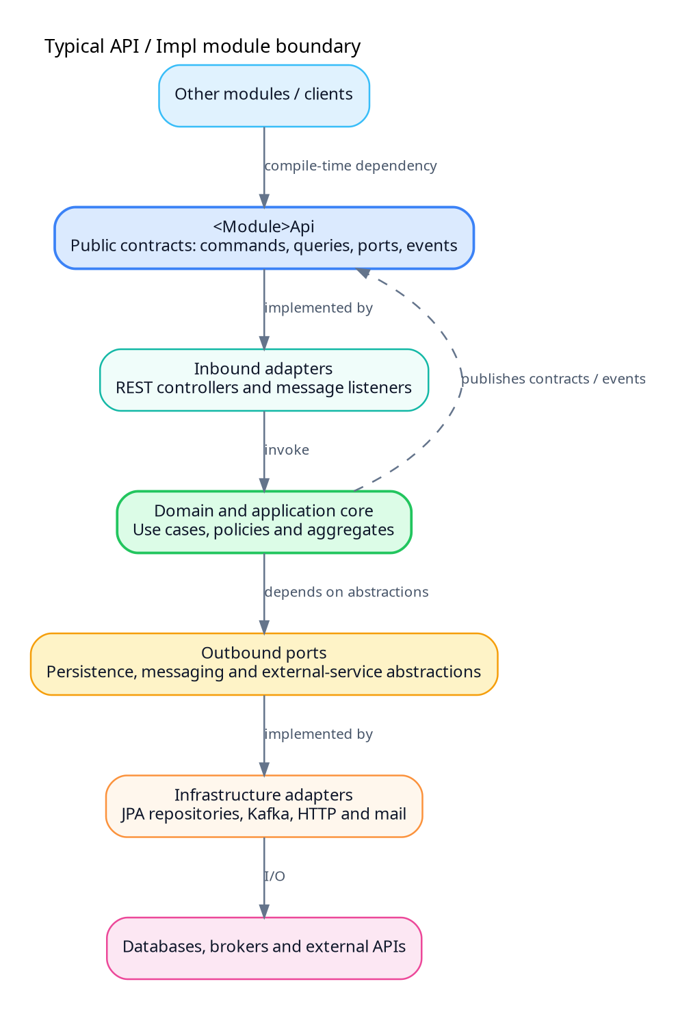
Figure 1. Typical API and implementation boundary
The API artifact acts as the compile-time boundary and contains commands, queries, data-transfer contracts, ports, event contracts, and interfaces. Framework-specific controllers, JPA entities, repository implementations, provider SDKs, and application configuration reside in implementation artifacts.
The implementation artifact owns adapters and framework integration. Inbound adapters translate HTTP or message payloads into application commands. The application core applies business rules. Outbound ports describe required persistence or external behavior. Infrastructure adapters implement those ports.

4.3 Dependency Direction
The intended dependency direction is:
- domain logic depends on language and domain abstractions;
- application services depend on domain objects and ports;
- adapters depend on framework libraries and implement ports;
- feature modules depend on API modules;
- implementation modules are assembled by the top-level application; and
- shared modules contain cross-cutting behavior rather than feature-specific implementation.
A dependency cycle between feature modules usually indicates a missing contract, an incorrectly placed shared concept, or a workflow that belongs in an orchestrator.

4.4 Main Application Assembly
Application depends on implementation modules and enables configuration properties, caching, scheduling, service discovery, OpenFeign, Actuator, Liquibase, database drivers, and Springdoc/OpenAPI. The component scan covers the com.warehouse.* namespace.

4.5 Orchestration Versus Domain Logic
LogisticsOrchestrator, ProcessHub, and CrossLogistics represent explicit coordination layers across bounded contexts. Domain modules retain the business state and invariants associated with shipments, deliveries, devices, and related capabilities.

4.6 Synchronous and Asynchronous Boundaries
In-process calls are appropriate when the caller needs an immediate, strongly consistent result within the same transaction or request. Kafka events are appropriate when propagation can be asynchronous, when multiple consumers require the information, or when the receiving model is a projection. HTTP calls to supporting services introduce network latency and partial failure and therefore require explicit timeout and retry policy.

4.7 Transaction Boundaries
The architecture separates module-owned database transactions from cross-module workflows. Cross-module coordination is represented through orchestrator modules and asynchronous messaging.

5. Runtime Topology and Infrastructure

5.1 Logical Topology
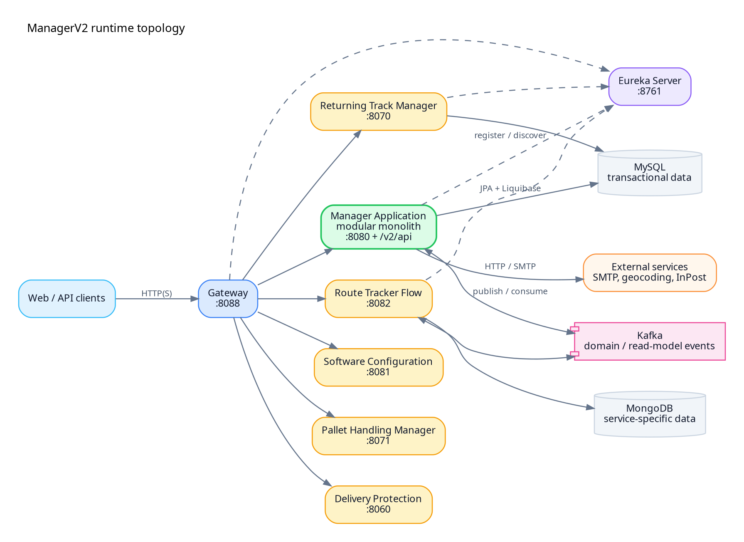
Figure 2. ManagerV2 runtime topology
The topology shown above combines the primary runtime paths found in the repository. It is a logical view rather than a production deployment guarantee. The main application is the central business runtime; the gateway routes selected request paths to it and to supporting services; Eureka provides service registration and discovery; MySQL and MongoDB provide persistence; Kafka propagates events; and external providers supply mail, geocoding, parcel, or related capabilities.

5.2 Main Application
The main service uses port 8080 and the servlet context path /v2/api in the reviewed configuration. A resource mapped as /auth/login at controller level is therefore normally reached as /v2/api/auth/login.
The application enables:
- scheduled jobs;
- caching;
- Feign clients;
- Eureka discovery;
- configuration-property binding;
- Actuator endpoints; and
- OpenAPI/Swagger support.

5.3 Gateway
The custom Gateway defaults to port 8088. Its configuration routes traffic to the main application and to service-specific targets, including software configuration, delivery protection, return tracking, route tracking, and pallet handling.

5.4 Eureka Server
The Eureka server uses port 8761. The reviewed configuration disables self-registration and registry fetching for the server itself, and self-preservation is disabled by default.

5.5 Supporting Services and Default Ports
Runtime | Default port | Typical role
Main application | 8080 | Core modular-monolith API under /v2/api.
Gateway | 8088 | Front-door routing to application and services.
Eureka Server | 8761 | Service registry and discovery.
Software Configuration | 8081 | Software or operator configuration service.
Route Tracker Flow | 8082 | Route tracking, history, and event processing.
Returning Track Manager | 8070 | Return-flow management.
Pallet Handling Manager | 8071 | Pallet-related operations.
Delivery Protection | 8060 | Delivery-protection capability.
Kafka UI | 8090 | Local inspection of Kafka clusters and topics.
MySQL | 3306 | Relational persistence.
MongoDB | 27017 | Service-specific document persistence.
Kafka | 9092 | Event broker.
Port values are defaults from repository configuration and Compose assets.

5.6 Datastores
The primary application uses MySQL in the development profile and manages its schema with Liquibase. H2 and PostgreSQL dependencies support selected test or alternate use cases. Some standalone services use separate relational schemas, while route-tracking components may use MongoDB.

5.7 Kafka and ZooKeeper
The local Compose stack provisions ZooKeeper and Kafka using Confluent images and exposes Kafka on port 9092. The reviewed configuration references topics for shipment returns, shipment events, shipment read-model synchronization, and operator configuration creation.

5.8 External Services
The repository contains integration points for SMTP/mail, geocoding providers, InPost, and internal service endpoints. The current release introduces per-operator encrypted geocoding credentials.

6. Main Application Bootstrap and Configuration

6.1 Bootstrap Class
The application bootstrap enables configuration properties, caching, scheduling, discovery, and Feign clients, and scans the com.warehouse.* namespace.

6.2 Application Identity and Web Context
The application name is manager-application. The reviewed development configuration starts on port 8080 with the /v2/api context path.

6.3 Configuration Profiles
The default application configuration includes a development profile and mail-related configuration.

6.4 Configuration Areas
Area | Representative settings
HTTP | Server port, servlet context, forwarded headers, request limits.
Database | JDBC URL, user, password, pool sizes, transaction timeouts.
Liquibase | Changelog location, contexts, labels, migration enablement.
Security | JWT issuer/audience, signing keys, cookie attributes, CORS origins.
Kafka | Bootstrap servers, topics, consumer groups, serializers, retry policy.
Eureka | Registry URL, service name, instance metadata.
Mail | SMTP host, port, authentication, sender identity.
Internal APIs | Prefixes and paths for device pairing, verification, and read synchronization.
Integrations | Geocoding provider, InPost, route/return service URLs, timeouts.
Operations | Actuator exposure, logging levels, tracing, cache behavior.

6.5 Internal API Prefixes
Configuration defines an internal prefix such as /internal and paths for device pairing, device verification, and shipment read synchronization.

6.6 CORS Configuration
The reviewed configuration permits local user-interface origins and the hosted managerv2gui.onrender.com origin, with credentialed requests.

6.7 Cookie Configuration
Access and refresh tokens are carried in cookies, while the CSRF token is exposed through the XSRF-TOKEN cookie and X-XSRF-TOKEN request header.

6.8 Seed Data
The development profile can seed data during startup.

6.9 Caching and Scheduling
Caching and scheduling are enabled globally by the application bootstrap.

7. Security, Authentication, Authorization, and Multi-Tenancy

7.1 Security Model Overview
The application combines browser-oriented cookie security, stateless Spring Security, method-level permission checks, device credentials, and internal synchronization authentication. Operator context spans the request, identity, authorization, persistence, and SQL-query layers.
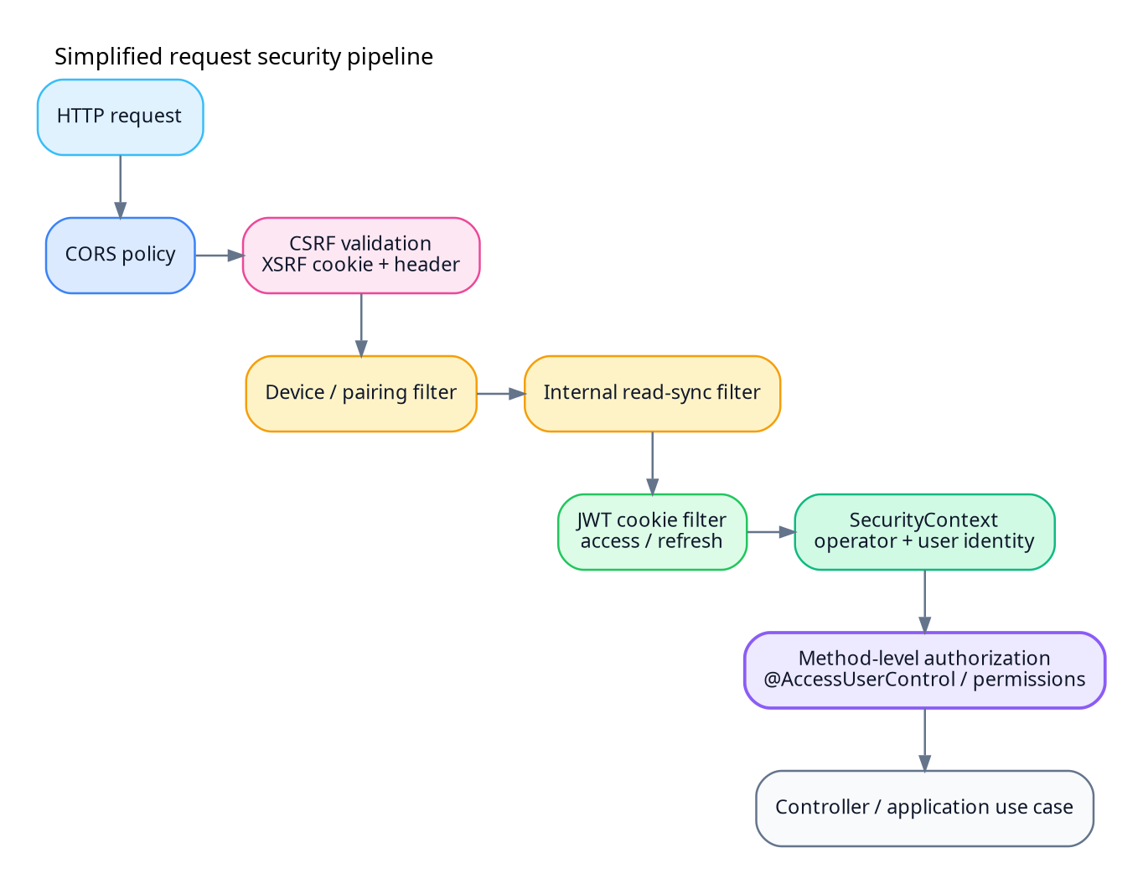
Figure 3. Simplified request security pipeline
The exact filter ordering is implementation-specific, but the conceptual sequence is stable: request-origin policy and CSRF are evaluated, specialized device or internal authentication may run, JWT authentication establishes human identity, and method-level authorization protects the application operation.

7.2 Authentication Endpoints
Representative authorization routes include:
Base path | Method | Operation
/auth | POST /signup | Register a user or initiate a sign-up flow.
/auth | POST /login | Authenticate and issue token cookies.
/auth | POST /refresh | Rotate or refresh authentication tokens.
/auth | POST /logout | Revoke or clear authentication state.
/auth | GET /csrf | Obtain/initialize the CSRF token.
/auth/me | GET | Return the current authenticated user.
/auth/me | PUT /password | Change the current user’s password.
/auth/me | PUT /language | Change language preference.
/operators/{operatorId}/users | POST | Create an operator-scoped user, permission-protected.
/auth/refresh-tokens | GET | Administrative token maintenance/cleanup view.
/users | mixed | User lookup, creation, update, and permission operations.
Controller paths are normally prefixed by the configured /v2/api servlet context. The list above is representative rather than a generated complete OpenAPI inventory.

7.3 JWT Validation
JWT configuration includes signing material, issuer, audience, token type, subject, and operator identity used during authentication.

7.4 Access and Refresh Tokens
The authentication flow uses access and refresh tokens with dedicated login, refresh, and logout endpoints. Both token types are transported through cookies.

7.5 CSRF Protection
The reviewed configuration uses a cookie-based CSRF token named XSRF-TOKEN and expects the X-XSRF-TOKEN request header. Authentication cookies remain HttpOnly.

7.6 HTTP Authorization Rules
Some routes are explicitly public, including preflight requests, login, refresh, logout, CSRF operations, Swagger/OpenAPI resources, selected device-pairing paths, and broad shipment matchers. The security chain uses a permissive final rule and relies on method-level annotations such as @AccessUserControl for protected operations.

7.7 Method-Level Authorization
Method-level permission checks provide the domain-aware authorization layer and are represented by annotations such as @AccessUserControl.

7.8 Operator-Aware Identity
The current release carries operator identity through JWT and current-user abstractions, logging context, repositories, provisioning flows, and integration credentials.

7.9 Data Isolation Patterns
The reviewed codebase uses operator-aware identity and persistence patterns compatible with shared-schema isolation by operator identifier.

7.10 Device Authentication
Device pairing and verification use specialized paths, filters, and device credentials that are separate from human-user JWT authentication.

7.11 Internal Read-Synchronization Authentication
Shipment read-model synchronization paths have dedicated internal security treatment and separate credentials from regular user authentication.

8. Domain and Supporting Modules

8.1 Reading the Module Catalog
This chapter summarizes responsibilities inferred from module names, repository descriptions, dependencies, package structures, release notes, and representative code. It is an architectural catalog rather than generated API documentation.

8.2 Application

8.2.1 Responsibility
Application is the composition root for the modular monolith. It imports implementation modules, starts the web server, enables discovery and Feign, configures persistence and Liquibase, exposes Actuator and OpenAPI, and supplies shared runtime configuration.

8.2.2 Important Boundaries
Application is the composition root and therefore depends on implementation modules. Business feature modules remain separate from the composition root.

8.3 Authorization

8.3.1 Responsibility
The Authorization area owns authentication, user identity, roles, permissions, refresh tokens, current-user access, operator context, and administrative user operations. It provides public contracts used throughout the system for authorization decisions.

8.3.2 Representative Capabilities
- login, logout, sign-up, and token refresh;
- CSRF-token initialization;
- current-user profile, password, and language changes;
- operator-scoped user provisioning;
- role and permission administration;
- refresh-token cleanup and revocation;
- JWT claim construction and validation; and
- propagation of user/operator identity into application context and logs.

8.4 OrganisationStructure

8.4.1 Responsibility
This module represents organizational hierarchy and operator-related structure. It may coordinate the creation of organizations, departments, or related read views used by authorization and logistics modules.

8.5 DepartmentService

8.5.1 Responsibility
DepartmentService manages department data and synchronized department views. The current release refers to department read-model synchronization, indicating that some consumers use local projections rather than direct cross-module queries.

8.6 ShipmentManagement

8.6.1 Responsibility
ShipmentManagement is the central domain for shipment creation, state, returns, events, read synchronization, and integration with delivery and route capabilities. The repository contains both API and implementation structure, and release notes emphasize shipment-event development.

8.6.2 Event Contracts
Representative shipment topics include shipment.events, shipment.return.created, and shipment.read-model.sync.

8.7 DeliveryOperation

8.7.1 Responsibility
DeliveryOperation owns actions performed during delivery execution, potentially including assignment, pickup, handover, completion, exception handling, and status transitions.

8.8 LogisticsOrchestrator

8.8.1 Responsibility
The orchestrator coordinates multi-module logistics workflows. It is the appropriate place for long-running business processes that span shipment, delivery, route, document, notification, supplier, or device capabilities.

8.9 ProcessHub
ProcessHub provides process-level coordination or shared process abstractions across logistics capabilities.

8.10 CrossLogistics
CrossLogistics represents capabilities and contracts shared across logistics contexts.

8.11 Device

8.11.1 Responsibility
The Device module handles device records, pairing, verification, device credentials, and potentially device-specific shipment operations. Public pairing and trusted device calls are separate stages of the lifecycle.

8.12 SupplierServiceManagement
Supplier management owns supplier profiles and supplier-facing logistics information. Supplier codes, contact details, contracts, and operator associations are distinct from shipment snapshots, while a shipment can preserve supplier data effective at creation.

8.13 TransportAssets
TransportAssets manages transport resources such as vehicles, trailers, or related equipment. Its domain concerns include availability, assignment, capacity, maintenance state, operator ownership, and capacity units.

8.14 DriverHub
DriverHub represents driver-related data and workflows. Driver identity is related to, but distinct from, a user account and includes licenses, assignments, availability, external identifiers, and personal data.

8.15 PathFinder
PathFinder provides path-selection logic based on geocoding, destination, route, transport constraints, and operator-specific provider configuration.

8.16 DestinationDetermination
DestinationDetermination resolves the operational destination for a shipment or delivery. It may combine address data, organization structure, department location, geocoding, or business routing rules. Address normalization and geocoding are separate concerns: a normalized address can exist without a successful coordinate lookup.

8.17 GeocodingService

8.17.1 Responsibility
The geocoding service abstracts provider-specific coordinate and address lookups. The current release adds per-operator encrypted credentials, which implies provider selection and secret resolution at request time.

8.18 DocumentManager
DocumentManager handles business-document metadata, binary content, generated templates, and external storage references.

8.19 MessageProvider
MessageProvider centralizes message keys, templates, localization resources, and language fallback behavior used by other modules.

8.20 MailService
MailService sends outbound mail using SMTP configuration and templates from MessageProvider. The surrounding model includes template, locale, business-reference, delivery-attempt, provider-response, and terminal-status data.

8.21 Common
Common contains shared abstractions such as technical value objects, correlation abstractions, and base event metadata used by multiple modules.

8.22 Utility
Utility provides implementation helpers separate from domain concepts and shared business contracts.

8.23 AssetConverter
AssetConverter supports conversion between asset formats or representations and handles source type, target type, size, and encoding boundaries.

8.24 ExceptionHandler
The ExceptionHandler module centralizes mapping from exceptions to HTTP responses and defines the shared error-envelope structure.
The error model distinguishes domain errors from unexpected failures and associates server-side diagnostics with correlation context.

8.25 ManagerTools
ManagerTools contains project-specific operational and development utilities.

8.26 ArchitectureTest
ArchitectureTest is a dedicated module for dependency, package, cycle, and layering constraints.

8.27 E2E
The E2E module validates behavior across module boundaries and infrastructure, including authentication, CSRF, operator isolation, database migration, Kafka propagation, gateway routing, and shipment workflows.

8.28 Gateway and EurekaServer
Gateway and EurekaServer form the service-routing substrate. Gateway failure can make downstream services unavailable, while registry failure can disrupt routing and Feign discovery.

8.29 Standalone Service Directories

8.29.1 SoftwareConfiguration
This service provides configuration capabilities and is routed by the gateway at port 8081 in the default topology. The current release mentions operator configuration creation events, suggesting coordination between configuration provisioning and the main application.

8.29.2 ReturningTrackManager
This service manages return tracking on default port 8070. Compose configuration creates a dedicated relational database, and the reviewed configuration includes a direct JPA schema-update setting.

8.29.3 RouteTrackerFlow
This service manages route events and history at port 8082 and may use MongoDB and Kafka. The current release adds JWT/current-user integration, Kafka processing, and history capabilities.

8.29.4 PalletHandlingManager and DeliveryProtection
These services are represented in gateway routes and repository directories but are not part of the active root reactor.

9. Persistence and Database Evolution

9.1 Main Persistence Stack
The main application uses Spring Data/JPA with a relational database and Liquibase for schema migration. Development defaults target MySQL, while H2 and PostgreSQL dependencies support selected test or alternate use cases.

9.2 Schema Ownership
The main application uses a shared physical database while JPA mappings and migration files are distributed across domain modules.

9.3 Liquibase Changelog Strategy
Liquibase is integrated with the main application and loads relational schema changes from the application resources.

9.4 Operator Scoping in the Database
The current release introduces operator-aware persistence and query patterns for tenant-owned data.

9.5 Read Models
The current release includes synchronized read models for user, role, department, shipment, route, and operator-related data.

10. Messaging and External Integrations

10.1 Messaging Architecture
Kafka supports asynchronous domain events, read-model synchronization, operator configuration, return processing, and route-related workflows. Events decouple producers from consumers, but they also create eventual consistency and operational responsibilities.
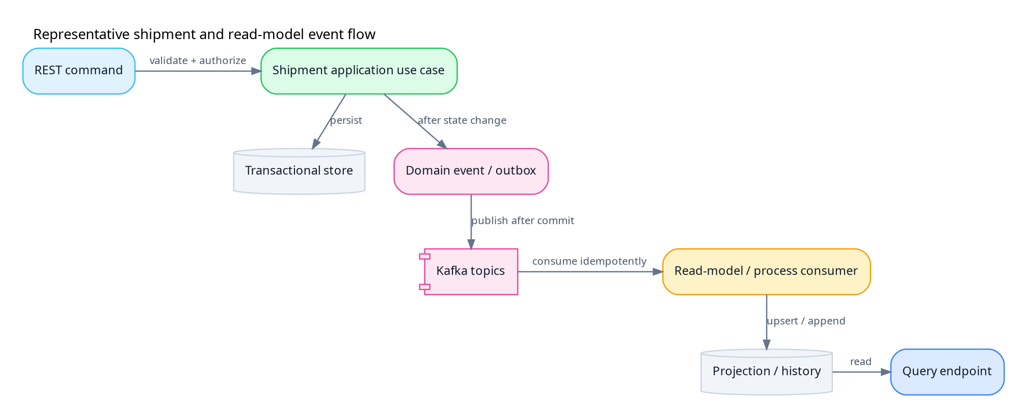
Figure 4. Representative event flow

10.2 Topic Catalog
Topic or logical stream | Purpose
shipment.events | General shipment lifecycle events.
shipment.return.created | Initiate or inform return processing.
shipment.read-model.sync | Synchronize shipment projections.
operator.configuration.create | Provision or synchronize operator configuration.
Route/history events | Feed RouteTracker and history projections.
Topic names are configurable per environment.

10.3 InPost Integration
The reviewed source includes configurable InPost timeout and retry behavior, and the current release includes InPost-related development.

10.4 Geocoding Integration
The geocoding area integrates external providers and includes per-operator encrypted provider credentials in the current release.

10.5 Mail Integration
Mail functionality uses SMTP together with message and template components to deliver notifications.

10.6 Service Discovery and Feign
Eureka-based discovery allows Feign clients to address services by logical service name rather than fixed host.

11. API Surface

11.1 API Base Path
The main application serves APIs under /v2/api in the reviewed configuration. Controller mappings are appended to that context path.

11.2 API Categories
The repository contains several categories of HTTP endpoints:
Category | Authentication expectation | Examples
Public browser endpoints | Anonymous plus rate limiting; CSRF initialization as applicable | Login, refresh, logout, sign-up, CSRF token.
Authenticated user endpoints | JWT cookie, CSRF for mutations, permission checks | Current user, users, shipments, departments, suppliers.
Administrative endpoints | JWT plus privileged permission and operator scope | User creation, role/permission changes, refresh-token maintenance.
Device endpoints | Pairing challenge or device credential | Pairing, verification, device operations.
Internal synchronization | Service credential or signed internal token | Shipment read-model synchronization.
Operational endpoints | Network restriction and operations authorization | Actuator health, metrics, diagnostic endpoints.
Documentation endpoints | Public in local/dev; restricted or disabled in production | OpenAPI and Swagger UI.

11.3 OpenAPI
Springdoc is included in the main application and exposes OpenAPI/Swagger resources.

11.4 Versioning
The configured context path contains v2, representing URI-based major API versioning.

11.5 Language and Localization
The current-user API supports pl, en, and de language choices for user-facing messages and mail templates.

12. Containerization Assets

12.1 Dockerfile
The main Dockerfile is a multi-stage build using Maven 3.9.9 with Eclipse Temurin 21 for compilation and a Temurin 21 JRE for runtime. It builds the Application project and skips tests during image construction, then exposes port 8080.
The multi-stage layout excludes Maven and the compilation toolchain from the final runtime image.

12.2 Docker Compose
The Compose stack is useful for local integration and demonstrates service dependencies. It provisions:
- MySQL 8 with development databases;
- MongoDB using an unpinned latest tag;
- Confluent ZooKeeper and Kafka 7.6.1;
- Kafka UI;
- Eureka and Gateway;
- SoftwareConfiguration;
- ReturningTrackManager; and
- RouteTrackerFlow.
The main Application is not included in the observed Compose service set.

13. CI/CD Definitions

13.1 Jenkins Pipeline
The repository includes a Jenkins pipeline with Windows-oriented commands and build/deploy stages. Its deployment command uses mvn clean deploy -DskipTests, and Sonar-related variables are present without a complete mandatory analysis stage.

13.2 GitLab CI
The GitLab pipeline defines build, test, package, deploy, and SonarCloud-related jobs. The deployment job is currently represented as a placeholder rather than a complete production deployment, and Qodana configuration is commented.

14. Current Release Overview

14.1 Release Position
The current release is planned for September 2026. It is a substantial architectural and domain update rather than a narrow patch.

14.2 Operator-Aware Model
The principal release change is operator-aware identity and data handling across JWT/current-user flows, logging context, repositories, provisioning, configuration, and integration credentials.

14.3 Provisioning and Configuration
The current release adds or extends operator provisioning and operator-configuration creation events.

14.4 User, Role, and Department Read Models
The release develops synchronized read models for user, role, and department information, reducing direct module coupling.

14.5 Shipment and Return Events
Shipment event development includes return events and shipment read-model synchronization.

14.6 Route Tracker Enhancements
RouteTracker gains JWT/current-user integration, Kafka processing, and route-history capabilities.

14.7 Dangerous Goods and InPost
The release adds dangerous-goods functionality and extends the InPost integration.

14.8 Core-to-Impl Renaming
The release renames selected Core modules to Impl, reinforcing the API/implementation naming convention.

14.9 Authentication and Cookie Changes
The release includes refresh-token and cookie changes affecting login, refresh, logout, CSRF, and cross-origin browser behavior.

14.10 Supplier, Geocoding, and Path Finding
The release expands supplier, geocoding, and path-finding capabilities and introduces operator-specific encrypted geocoding keys.

14.11 Legacy RouteLogger Removal
The release removes legacy RouteLogger functionality and consolidates route-history responsibility.

14.12 Infrastructure Updates
The release includes Docker, Eureka, Gateway, and CORS updates associated with the evolving runtime topology.

Appendix A. Repository Map

A.1 Top-Level Areas
Path | Purpose
pom.xml | Root Maven reactor, version, dependency management, profiles, and distribution settings.
README.md | High-level project overview, module descriptions, technology stack, and build notes.
AGENTS.md | Repository engineering and contribution rules.
Application/ | Main Spring Boot runtime and application configuration.
Authorization/ | Identity, authentication, users, roles, permissions, and operator context.
ShipmentManagement/ | Shipment contracts, domain, adapters, and events.
OrganisationStructure/ | Organization/operator structure.
DepartmentService/ | Department capabilities and projections.
DeliveryOperation/ | Delivery execution.
Device/ | Device pairing, verification, and authentication.
Gateway/ | Custom HTTP routing.
EurekaServer/ | Service registry.
ArchitectureTest/ | Architecture fitness tests.
E2E/ | Cross-component end-to-end tests.
docker-compose.yml | Local multi-service infrastructure and selected applications.
Dockerfile | Main application multi-stage image build.
Jenkinsfile | Jenkins pipeline definition.
.gitlab-ci.yml | GitLab CI pipeline definition.
changelog/ or release notes | Current-release feature and migration summary.
LICENSE | Present but not a recognizable license in the reviewed repository.

A.2 Module Classification
Classification | Modules/directories
Composition/runtime | Application.
Identity/organization | Authorization, OrganisationStructure, DepartmentService.
Core logistics | ShipmentManagement, DeliveryOperation, LogisticsOrchestrator, CrossLogistics, ProcessHub.
Routing/location | PathFinder, DestinationDetermination, GeocodingService, RouteTrackerFlow.
Resources | Device, SupplierServiceManagement, TransportAssets, DriverHub, AssetConverter.
Communication/content | DocumentManager, MessageProvider, MailService.
Technical foundations | Common, Utility, ExceptionHandler, ManagerTools.
Platform services | Gateway, EurekaServer, SoftwareConfiguration.
Specialized services | ReturningTrackManager, PalletHandlingManager, DeliveryProtection.
Verification | ArchitectureTest, E2E.

Appendix B. Root Reactor Module Inventory

B.1 Active Modules
The root reactor enumerates these modules in its active project model:
Application
ShipmentManagement
MailService
DepartmentService
OrganisationStructure
DeliveryOperation
PathFinder
Authorization
Utility
DestinationDetermination
DocumentManager
ExceptionHandler
Device
ArchitectureTest
ManagerTools
E2E
Common
AssetConverter
MessageProvider
LogisticsOrchestrator
CrossLogistics
Gateway
EurekaServer
SupplierServiceManagement
TransportAssets
DriverHub
ProcessHub
GeocodingService

B.2 Directories Outside the Active Reactor
DeliveryProtection
PalletHandlingManager
ReturningTrackManager
RouteTrackerFlow
SoftwareConfiguration

Appendix C. Configuration Reference

C.1 Core Runtime Configuration
Property area | Observed value
Application name | manager-application
HTTP port | 8080
Context path | /v2/api
Default profile | Development-oriented
Eureka URL | Localhost registry default
Kafka bootstrap | localhost:9092
Database URL | Local MySQL development database
Liquibase | Enabled for main relational schema
CORS | Local UI plus hosted UI origin
JWT issuer/audience | Explicit configured values
Cookies | Access and refresh cookie settings
Internal prefix | /internal

Appendix D. Port and Endpoint Matrix

D.1 Default Ports
Component | Port
Gateway | 8088
Main application | 8080
Eureka | 8761
Software Configuration | 8081
Route Tracker Flow | 8082
Returning Track Manager | 8070
Pallet Handling Manager | 8071
Delivery Protection | 8060
Kafka UI | 8090
MySQL | 3306
MongoDB | 27017
Kafka | 9092
ZooKeeper | service-specific

D.2 Representative Main-Application Paths
Effective path under /v2/api | Intended audience
/auth/signup | Public or controlled registration flow.
/auth/login | Public authentication endpoint.
/auth/refresh | Refresh-cookie holder.
/auth/logout | Authenticated or refresh-cookie holder; CSRF as designed.
/auth/csrf | Browser client initialization.
/auth/me | Authenticated current user.
/auth/me/password | Authenticated current user; state-changing CSRF.
/auth/me/language | Authenticated current user.
/operators/{operatorId}/users | Privileged operator administration.
/auth/refresh-tokens | Restricted administration.
/users/** | Authenticated and permission-scoped administration.
/internal/** | Trusted service identity only.
/v3/api-docs/** and Swagger paths | Local/development or restricted documentation.
/actuator/** | Restricted operations access.

Appendix E. Glossary
Term | Definition
Access token | Short-lived JWT used to authenticate API calls.
Adapter | Code that connects an application port to HTTP, database, Kafka, mail, or an external provider.
Aggregate | Domain consistency boundary that protects business invariants.
API artifact | Maven module containing public contracts for a feature.
Causation ID | Identifier of the command or event that caused another event.
Correlation ID | Identifier linking work across requests, services, events, and logs.
CSRF | Cross-Site Request Forgery; a browser attack mitigated by anti-CSRF token validation for cookie-authenticated mutations.
Dead-letter topic | Kafka destination for records that cannot be processed after policy-defined handling.
Eureka | Service registry used for discovery.
Feign | Declarative HTTP-client integration used by Spring applications.
Hexagonal architecture | Design in which application/domain logic depends on ports and adapters implement external interactions.
Idempotency | Property that repeating an operation has the same effective result as performing it once.
Impl artifact | Maven module containing feature implementation and infrastructure adapters.
Liquibase | Versioned relational database migration tool.
MDC | Mapped Diagnostic Context used to enrich logs with request/operator metadata.
Modular monolith | One deployable process whose internal modules maintain explicit boundaries.
Operator | Tenant-like organizational scope used for identity, data, configuration, and integrations.
Outbox | Database table that records events atomically with domain state for reliable later publication.
Port | Interface representing an inbound use case or outbound dependency.
Projection | Read-optimized model derived from authoritative events or data.
Refresh token | Longer-lived credential used to obtain a new access token and normally rotated/revoked.
Saga | Long-running distributed workflow using local transactions and compensating actions.
Service discovery | Mechanism for locating running service instances by logical name.
Tenant isolation | Prevention of one operator/tenant reading or changing another’s data.

Appendix F. Source Traceability Index

F.1 Primary Repository Artifacts Consulted
The following artifact categories are the main anchors for this documentation:
Artifact | Information derived
Root pom.xml | Active module list, Java/project versions, profiles, dependency management, distribution settings.
README.md | Product scope, module responsibilities, technology overview, local build information.
AGENTS.md | Architecture, coding, testing, security, event, and migration conventions.
Application/pom.xml | Runtime assembly dependencies and framework capabilities.
Application bootstrap class | Component scanning, caching, scheduling, discovery, Feign, and configuration properties.
application*.yml/properties | Ports, context path, database, Kafka, Eureka, CORS, cookies, internal paths, integrations.
Security configuration and filters | Route policy, JWT, CSRF, CORS, device, internal synchronization, and method authorization.
Authorization controllers | Representative login, refresh, logout, current-user, operator-user, and administration endpoints.
Release changelog | Operator model, read models, events, integrations, module renames, and infrastructure updates.
Gateway configuration/code | Default routing and service targets.
Eureka configuration | Registry port and server behavior.
Dockerfile | Multi-stage Java/Maven image build.
docker-compose.yml | Local infrastructure, service ports, databases, and image versions.
Jenkinsfile | Jenkins build/deploy flow.
.gitlab-ci.yml | GitLab build, test, package, deploy, and analysis jobs.
Release changelog | Operator model, read models, events, integrations, module renames, and infrastructure updates.
LICENSE | Legal-status finding.

F.2 Interpretation Rule
The source hierarchy represented in this document prioritizes executable configuration and source code over descriptive prose, while environment-specific deployment values supersede local defaults. Release notes describe intent and change scope; tests and observed runtime behavior provide implementation evidence.

