Example of E-mail requesting information:

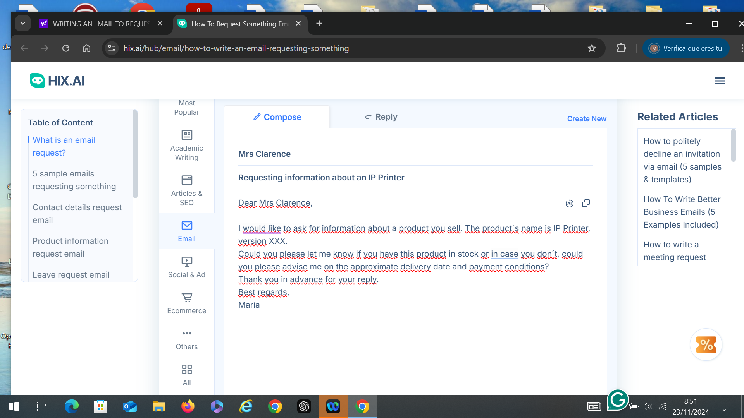

Please use this website, tab named “5 sample E-mails requesting something:

[https://hix.ai/hub/email/how-to-write-an-email-requesting-something#articleTitle2](https://hix.ai/hub/email/how-to-write-an-email-requesting-something" \l "articleTitle2) to créate an E-mail requesting information about a product.

Parts of an E-mail explaining their function: <https://test-english.com/explanation/b2-writing-explanation/formal-email-letter-asking-information/>

BBC Council E-mail requesting info exercises: <https://learnenglish.britishcouncil.org/skills/writing/c1-writing/email-request>

Template o fan E-mail requesting information:

Dear company

I hope this E-mail finds you well. I am writing to request information on a specific product/service that your company offers.

- specifically the IP Printer, version XXX.

- I would like to know about your prices and discounts available for this product, since I am interested.

- When will my request for this product be resolved, I would love to know an approximate date, since I have time that is not that long, I would like to know if they would have it ready in 2 weeks

Thank you for your attention to this matter. I look forward to receiving the requested information at your earliest convenience.

Best regards,  
[JHOSSEF SEBASTIAN MORENO VILLALOBOS]