**Source**

# N1

WACC = 1...10%

Demand = 2...20

Refurbishment investment decision in 2025

**N2**

Demand = 2...20

**Demand**

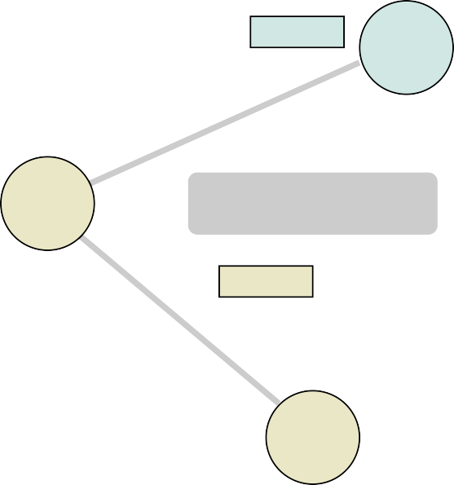

WACC = 1...10%

Demand = 2...20

**N3**