Equitable decarbonization of the heat supply of rented residential buildings: Optimal subsidization strategy under allocating the costs of inaction

Sebastian Zwickl-Bernhard1, Hans Auer[1]*[2]

# Motivation and core objective

The recently published „Fit for 55“ package by the European Commission [1] pledges a clean, sustainable, and just energy future for all European citizens. Thus, achieving the ambitious goal enshrined therein of a 55% reduction in greenhouse gas emissions compared to 1990 in 2030 goes along with tackling the “hot potatoes” of deep decarbonizing the energy system.

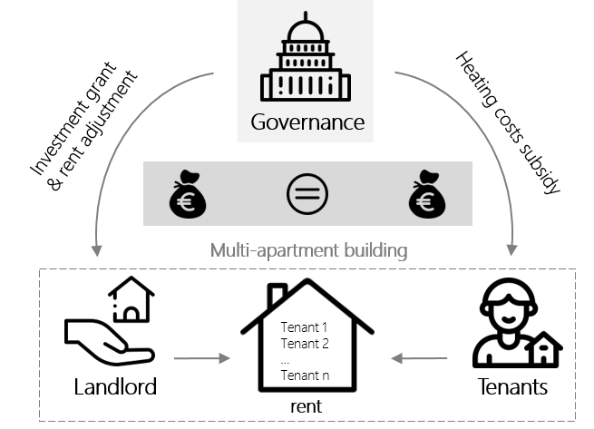Against this background, the core objective of this work is to investigate one of these hot potatoes, namely, the socially balanced decarbonization of the heat supply of rented residential buildings. In particular, we investigate a cost-optimal federal (governance) subsidization strategy to incentivize a sustainable heating system change taking into account a representative ownership structure with a single landlord and multiple tenants within the building. Initially, the multi-apartment building is heated by a gas-based heating system, which is why tenants' energy costs significantly depend on the carbon price. The investment into the heat system alternative can only be made by the landlord. Figure 1 illustrates the basic concept of the approach in this paper. The governance has the option to provide financial subsidy payments for both agents, the landlord and the tenants. The landlord can be incentivized by an investment grant or rent charge adjustment whereas the tenants can be by a heating costs subsidy payment. Nevertheless, the optimal governance’s financial incentives achieve subsidy parity among the landlord and tenants by providing the same net present value of subsidy payments to both. This analysis extends earlier studies and findings in the field of sustainable heat supply alternatives in the residential building sector (i.e., low-temperature heat service needs). In particular, we refer here to a recently published paper investigating the decommissioning of the gas distribution grid in an urban neighborhood [2].

Figure 1 Interrelationships between the governance, landlord, and tenats

# Methodology and case study

To determine the cost-optimal and socially balanced subsidization strategy, we propose a linear optimization model. Thereby, the model’s objective function is to minimizing the governance’s net present value as follows

|  |  |
| --- | --- |
|  | (1) |

where is the landlord’s overnight investment grant and the tenant’s subsidy payment in year and month . An important model constraint considers the landlord’s economic viability of the investment and sets it net present value at the planning horizon end equal to zero. Besides this, the model includes monetary parity (energy and rent-related spending) for each tenant as the net present value of the sustainable heat system alternative is forced to be equal to the initial condition (i.e., gas-based heat supply and initial rent price). Equation (2) shows the net present value of the monetary support between the landlord and all tenants, where is the number of tenants and the additional rent-related revenues of the landlord. Latter result from the provision of a sustainable heating system alternative.

|  |  |
| --- | --- |
|  | (2) |

# The proposed model is applied to a representative multi-apartment building in an urban area in Vienna, Austria. Furthermore, it is assumed that the building has a single owner (landlord) and 30 tenants. We investigate different scenarios with a special focus on the CO2 price and specific emissions of the electricity and district heating energy mix.

# Results and conclusions

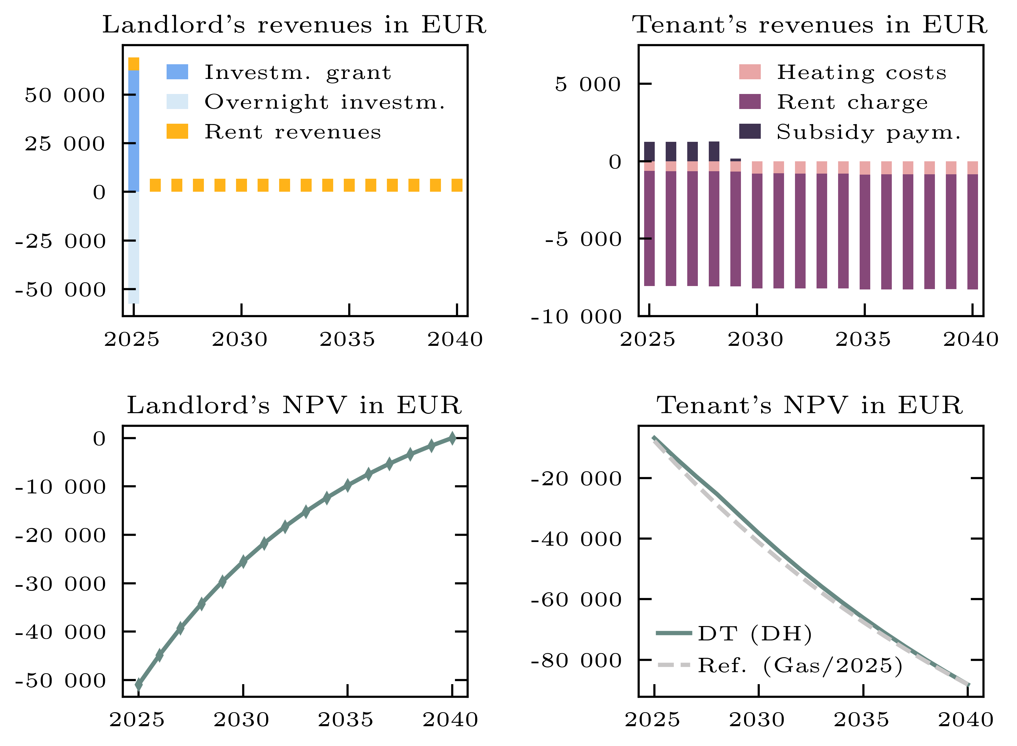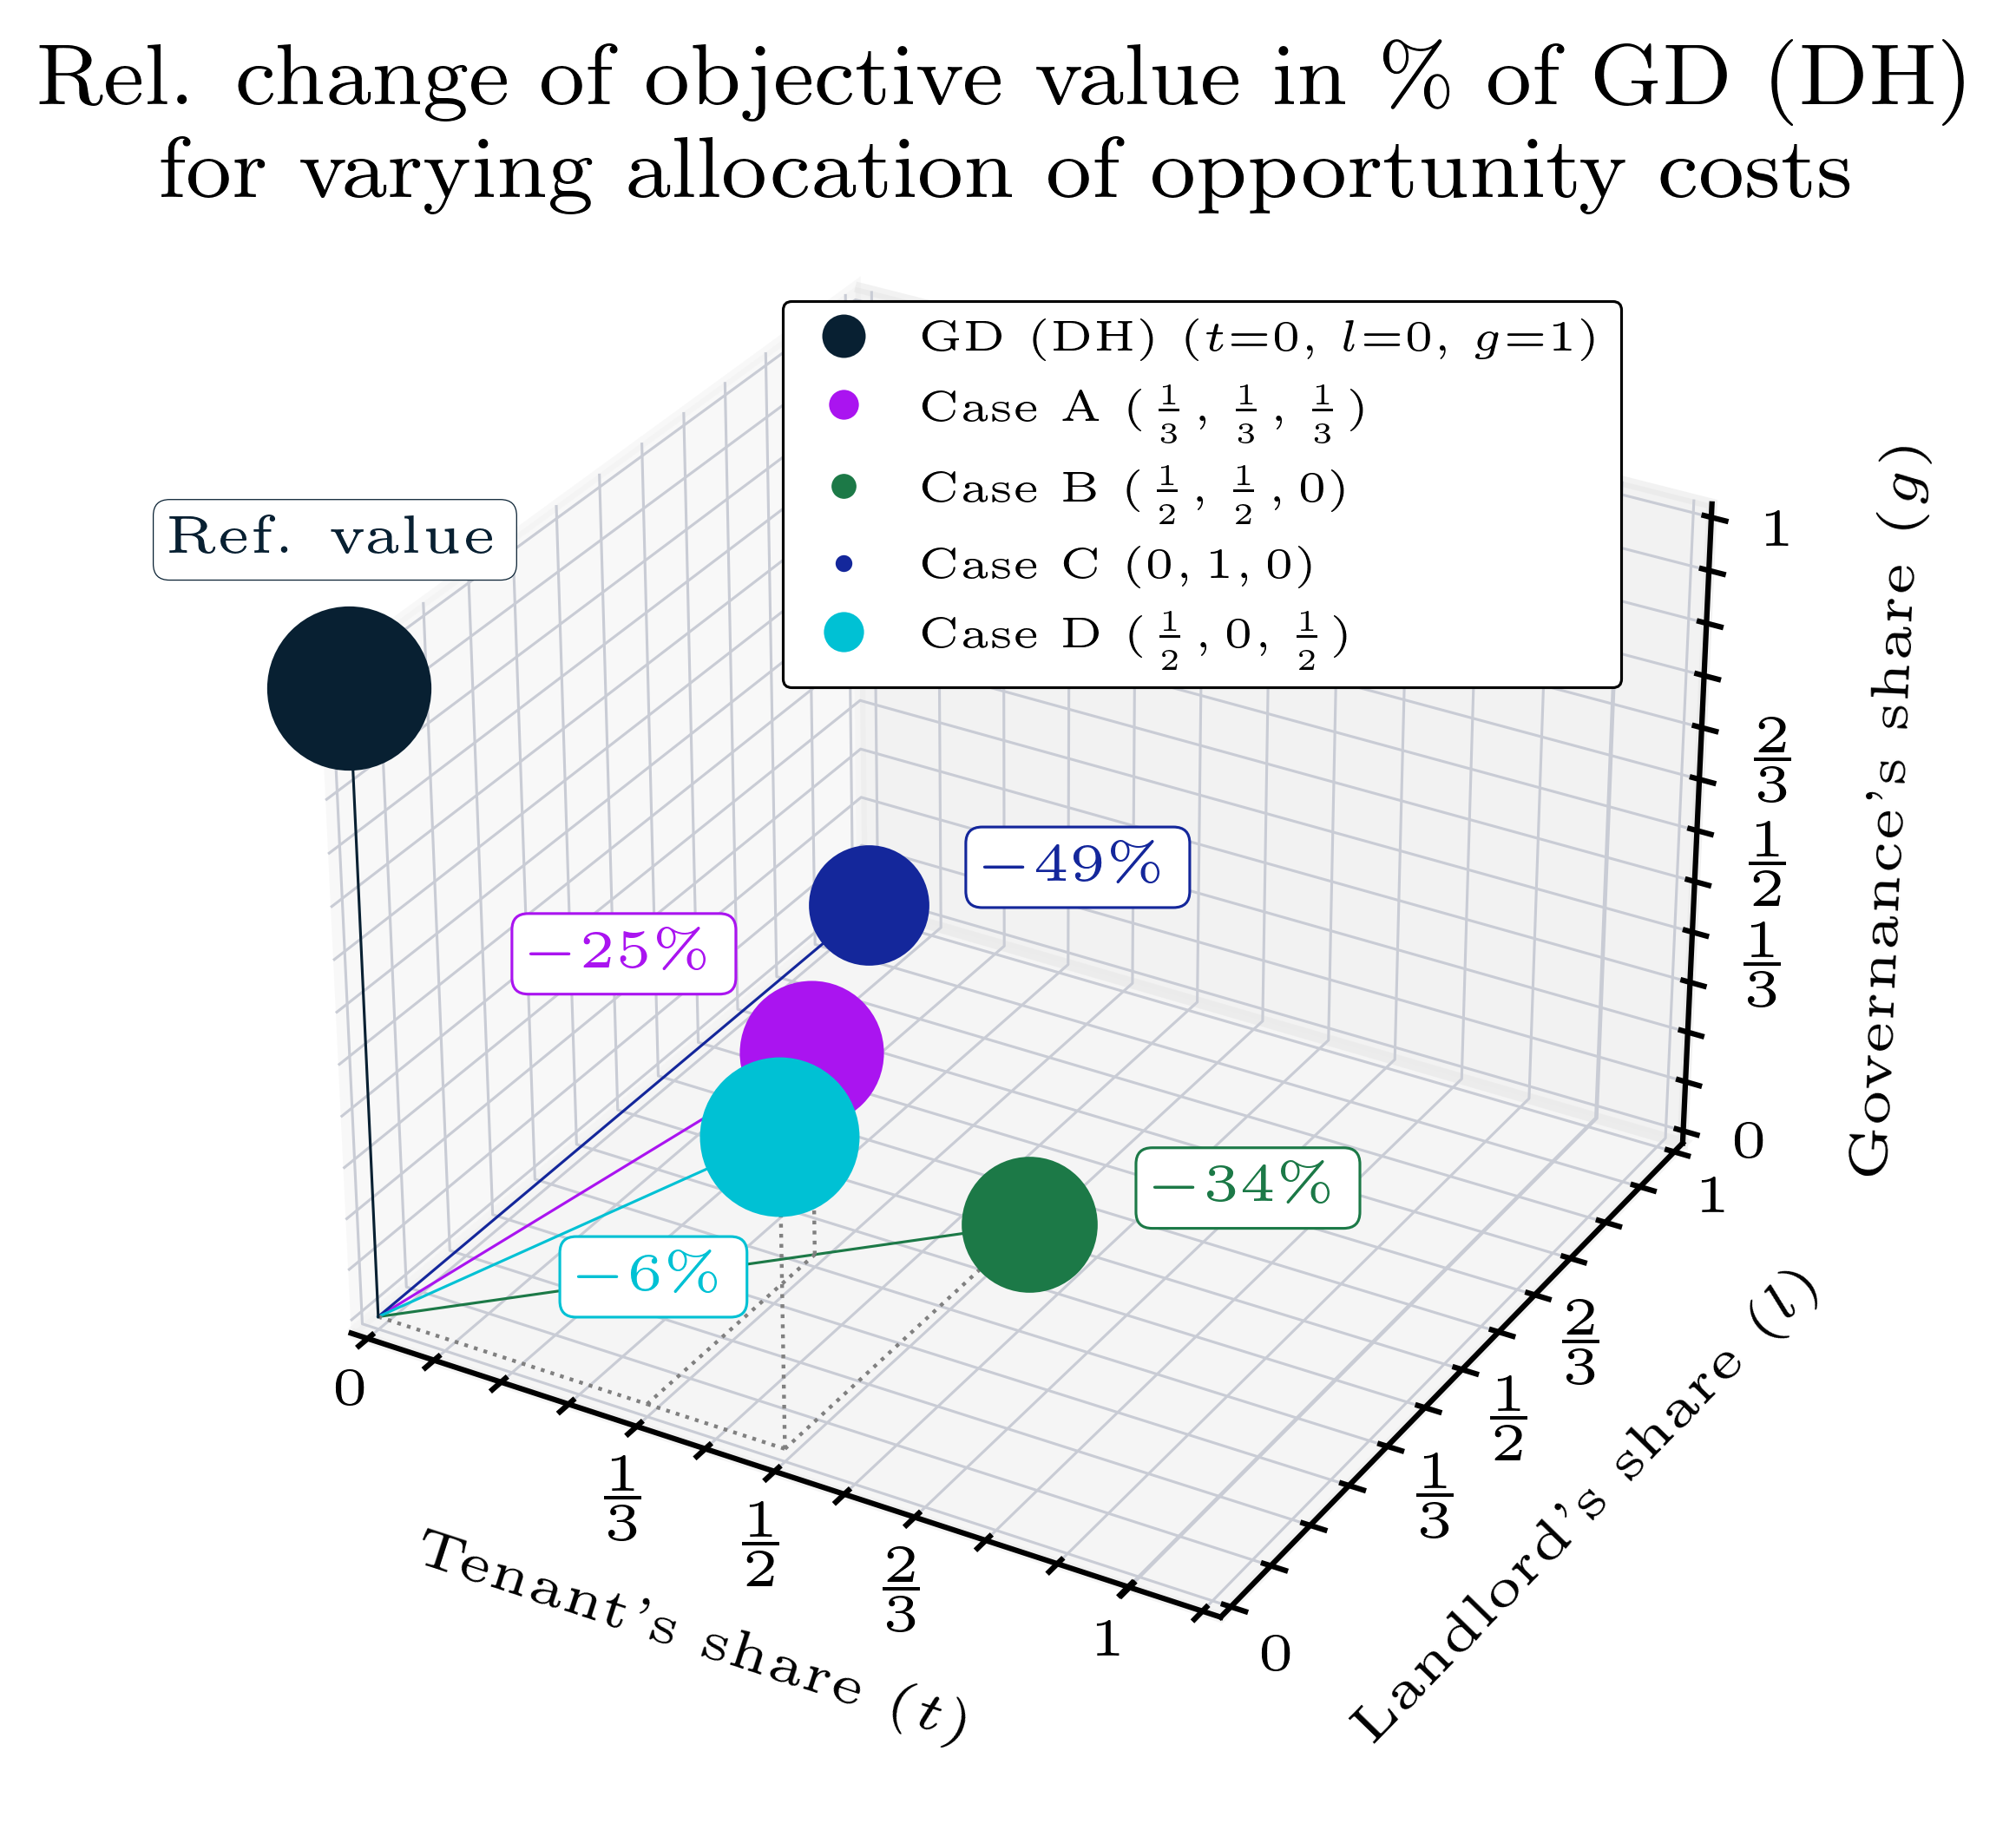Below, preliminary results are presented. Figure 2 shows the landlord’s revenues and net present value (NPV) and a single tenant (right subfigures) connecting to the district heating network in a scenario aligned with limiting the global temperature below 1.5°C. The landlord (i) receives an investment grant and rent-related revenues (top left) and (ii) achieves a net present value equal to zero in 2040 (bottom left). The tenant receives a subsidy payment between 2025 and 2029 (top right) obtaining the same NPV as in the initial condition (bottom right). Figure 3 shows the objective value (i.e., total subsidization) for varying allocation of the opportunity costs (=costs of inaction) among the governance, the landlord, and the tenants. Most importantly, the objective value is significantly reduced in Case C (-49% compared to the reference case where the governance covers the opportunity costs).

Figure 2 Development of the landlord’s and tenant’s economic viability with the district heating option. Top left: landlord’s revenues, bottom left: landlord’s net present value, top right: tenant’s revenues, bottom right: tenant’s net present value.

Figure 3 Comparison of the objective value for varying allocation of opportunity costs among the tenant, landlord, and governance (Case A: governance, landlord, and tenant, Case B: landlord and tenants, Case C: landlord,   
Case D: tenants and governance)

# References

[1] European Commission, „Communication from the Commission to the European Parliament, the Council, the European Economic and Social Committee and the Committee of the Regions 'Fit for 55': delivering the EU's 2030 climate target on the way to climate neutrality, retrieved on 29.09.2021 under https://eur-lex.europa.eu/legal-content/EN/TXT/?uri=CELEX:52021DC0550 (2021).

[2] Zwickl-Bernard, S. & Auer, H. Demystifying natural gas distribution grid decommissioning: An open-source approach to local deep decarbonization of urban neighborhoods. *Energy*, 238, 121805. (2022), doi: https://doi.org/10.1016/j.energy.2021.121805.

1. Institut für Energiesysteme und Elektrische Antriebe / Technische Universität Wien (TU-Wien), Energy Economics Group (EEG), [zwickl@eeg.tuwien.ac.at](mailto:zwickl@eeg.tuwien.ac.at)
2. * This contribution will be presented by Hans Auer ([auer@eeg.tuwien.ac.at](mailto:auer@eeg.tuwien.ac.at))