Cost-optimal and socially balanced subsidization strategy incentivizing a just heating system decarbonization at the building level

Sebastian Zwickl-Bernhard1, Hans Auer[1]*[2]

# Motivation and core objective

The recently published „Fit for 55“ package by the European Commission [1] pledges a clean, sustainable, and just energy future for all European citizens. Thus, achieving the ambitious goal enshrined therein of a 55% reduction in greenhouse gas emissions compared to 1990 in 2030 goes along with tackling the “hot potatoes” of deep decarbonizing the energy system.

Against this background, the core objective of this work is to investigate one of these hot potatoes, namely, socially balanced and fair decarbonization of the heat service supply of a multi-apartment building in an urban area. In particular, we investigate a cost-optimal subsidization strategy from the governance’s perspective to incentivize a sustainable heating system change taking into account a representative ownership structure with a single landlord and multiple tenants within the building. Initially, the multi-apartment building is heated by a gas-based heating system, which is why tenants' energy costs significantly depend on the carbon pricing. Therefore, to decarbonize the heat service supply and make the energy costs more robust against high carbon prices, an investment by the landlord is needed, as the latter is the building’s owner.

Figure 1 illustrates the basic concept of the paper. Governance has the option to provide financial subsidy payments for both agents, the landlord, and the tenants, by an investment grant or rent charge adjustment on the one hand and a heating costs subsidy payment on the other hand. Nevertheless, the optimal governance’s financial incentives achieve subsidy parity among the landlord and tenants by providing the same net present value of subsidy payments to both.

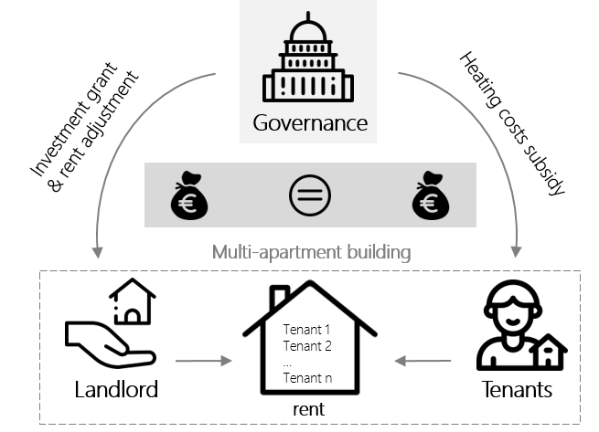

Figure 1 Sketch illustrating the governance’s financial incentives considering social balance

# Methodology and case study

To determine the cost-optimal and socially balanced subsidization strategy, we propose a linear optimization model. Thereby, the model’s objective function is to minimizing the governance’s net present value as follows

|  |  |
| --- | --- |
| $$\min_{x}{\underset{}{\underset{landlords}{\underbrace{Ψ}}+\sum_{y}{\sum_{m}{\frac{n}{{\left(1+i_{g}\right)}^{y}}∙\underset{tenants}{\underbrace{Ω_{heat,y,m}}}}}}}$$ | (1) |

where

The proposed model is applied to a representative multi-apartment building in an urban area. It is assumed that the building has a single landlord (owner) and 30 different tenants.

# Results and conclusions

# References

[1] European Commission, „Communication from the Commission to the European Parliament, the Council, the European Economic and Social Committee and the Committee of the Regions 'Fit for 55': delivering the EU's 2030 climate target on the way to climate neutrality, retrieved on 29.09.2021 under https://eur-lex.europa.eu/legal-content/EN/TXT/?uri=CELEX:52021DC0550 (2021).

1. Institut für Energiesysteme und Elektrische Antriebe / Technische Universität Wien (TU-Wien), Energy Economics Group (EEG), [zwickl@eeg.tuwien.ac.at](mailto:zwickl@eeg.tuwien.ac.at)
2. * This contribution will be presented by Hans Auer ([auer@eeg.tuwien.ac.at](mailto:auer@eeg.tuwien.ac.at))