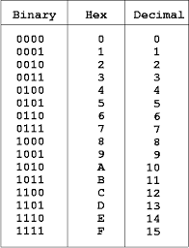
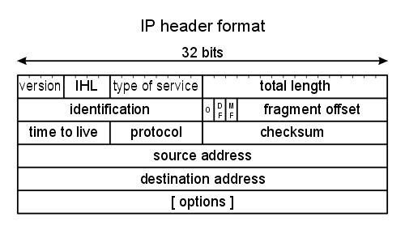

Class | premiers bits | plage d’@ | NET ID
A | 0 | 1.0.0.0  126.0.0.0 | 7
B | 10 | 128.0.0.0  191.255.0.0 | 15
C | 110 | 192.0.0.0  223.255.255.0 | 23

[fragmentation]

