Setup

Start with Step 1: install MySQL
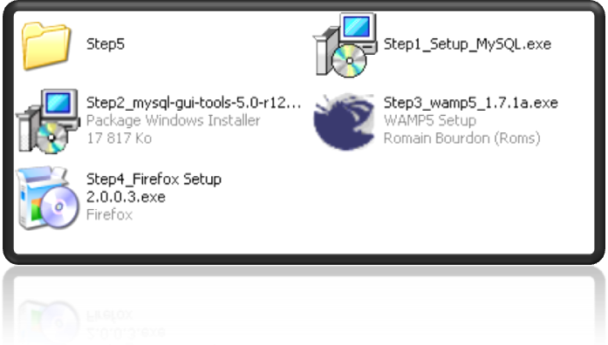
Click on next from the first screen, and then select “Complete”
Click on “next” until the following screenshot :
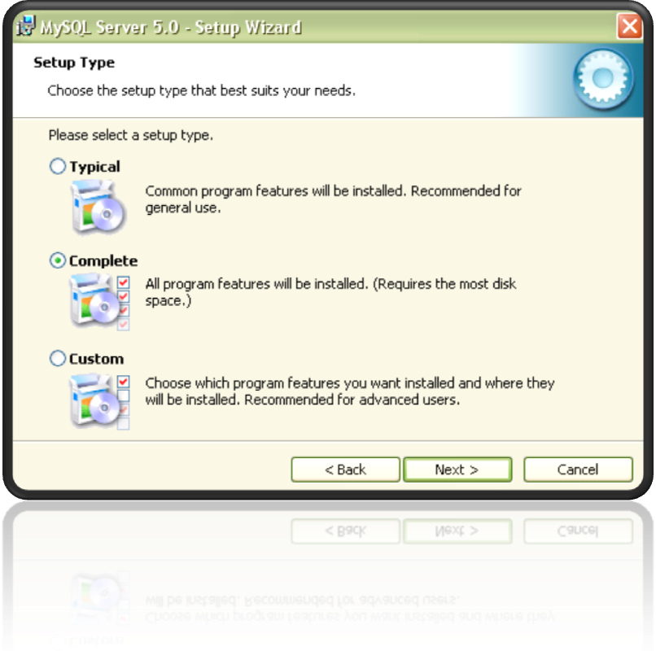
Click on “install” or “next”, until the following screen.
Select Standard Configuration and click next:

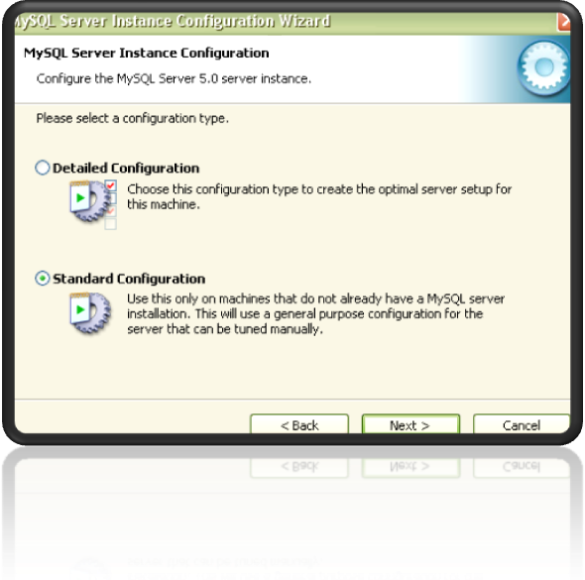

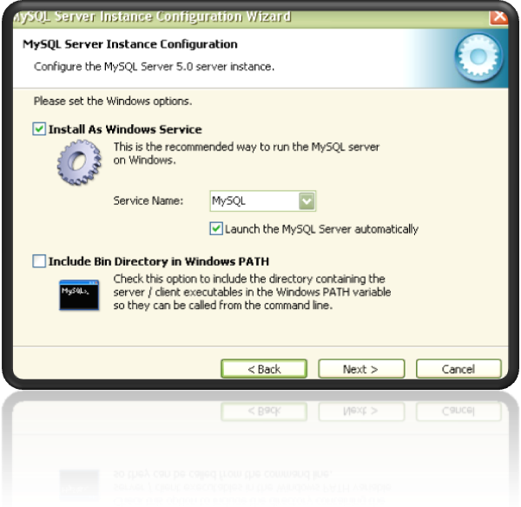
Click next

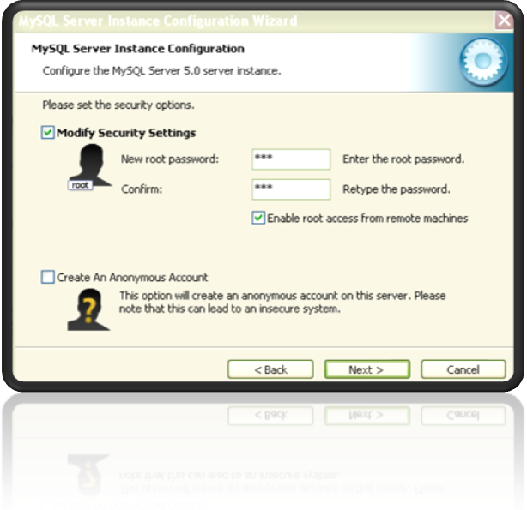
Enter the password “123” the tick the square to “enable root access from remote machines”.
Then press next, then execute and finish the installation

Step 2: install MySQL Tools
Accepts the conditions and always click “next” with the default settings until the end.

Step 3: Start MySQL Tray Monitor

Click on “Start” in Windows
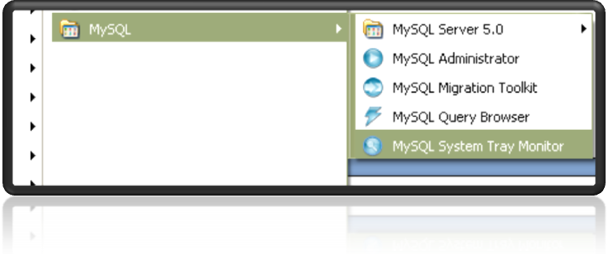

A little icon appears on the bottom of the screen. If the icon is like this, the configuration is ok. If the icon looks like this, right click on it and then select “Start Instance”.

OK, Now the MySQL server is ready. We will install the PHP server (apache).

Step 3: install WAMP

Launch “Step3_wamp5_1.7.1a.exe”
“Accept the agreement”
Select the folder where you want to install the server and then click next:
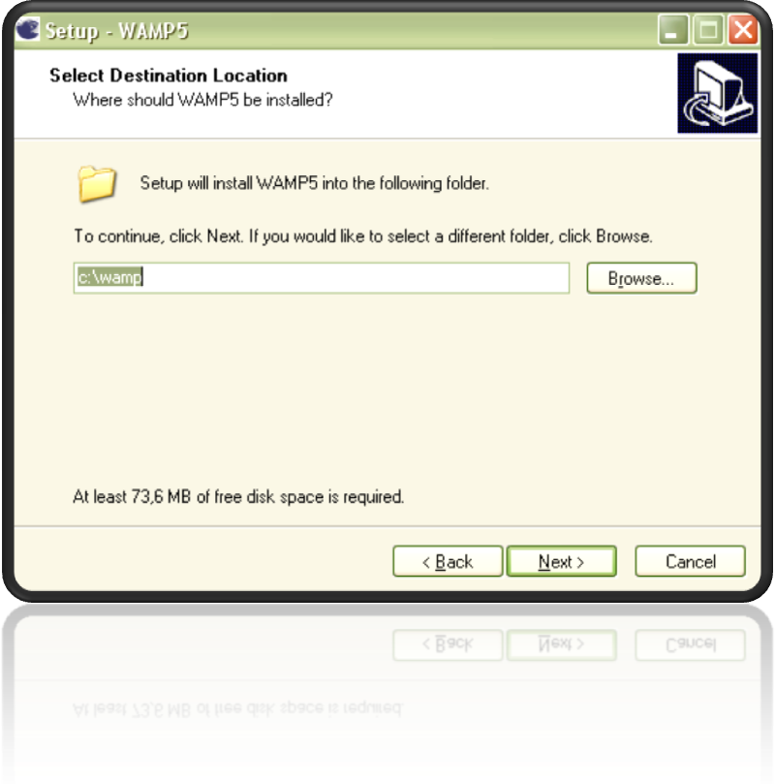

Click next until this screen:
Select Automatically launch WAMP5
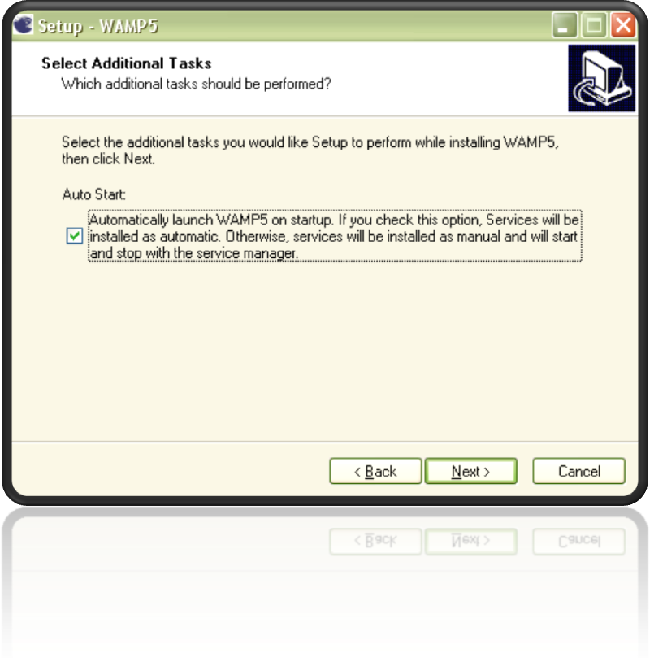
Then click next and “Install”.

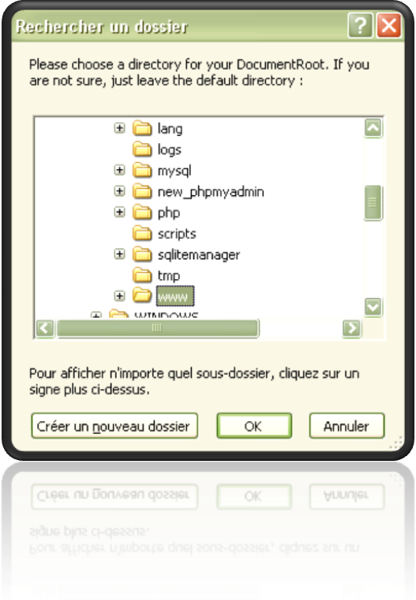
Select a folder where the website will be copied.
(The directory selected is where you have to copy the files in a future step)
Then click next until the end. If a window appears, only click on “OK”
A little icon will appear at the bottom of the screen:
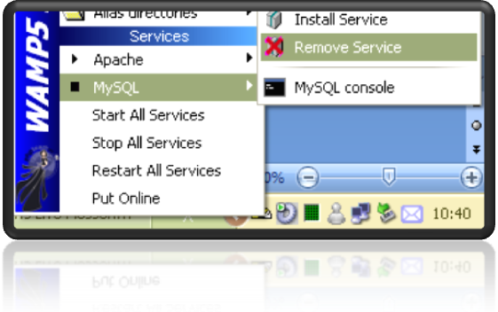
Left click on it (on ), go to MySQL > Remove service

Step 4: Install Firefox
This step is optional. If you have problems to use keys with internet explorer, then install Firefox.

Step 5: Setup the MySQL table
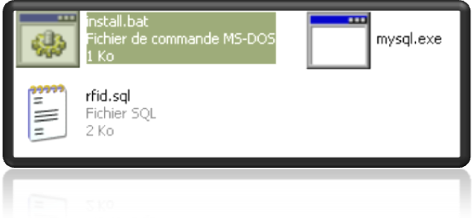
Open the directory “Step 5” and click on “install.bat”

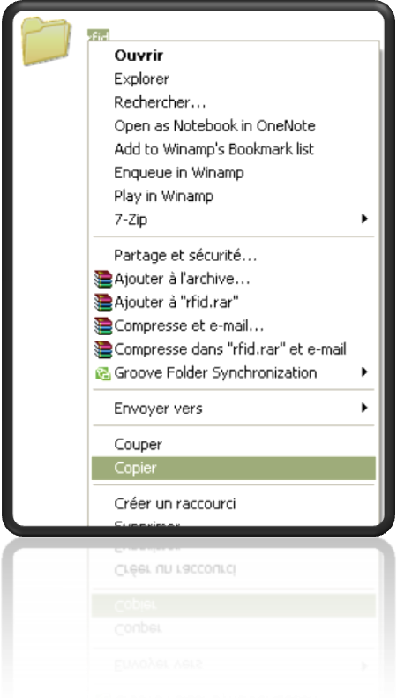
Step 6: Copy the website
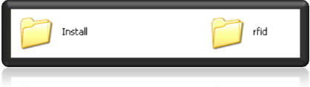
Go to the root of the CD. Right click on the directory “rfid” and copy this directory:
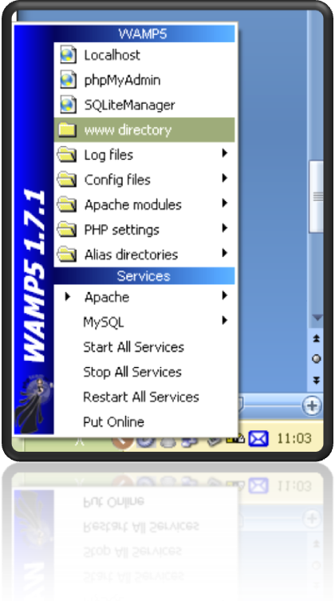
Left click on the yellow icon () and select “www directory”:
Past the directory :
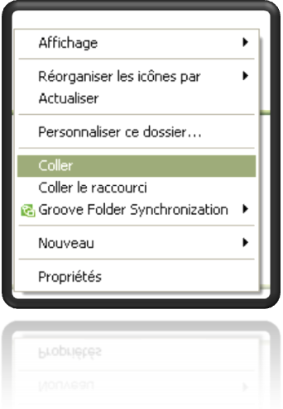
Open Internet Explorer and write: http://localhost/rfid/setup.php

Step 8: install the RFID Reader
Put the CD “Connectland” in the PC.
Plug the USB Device.
Let windows install drivers.

Step 9: configure the device and Fab

Configure device
Open Internet Explorer
Go to http://localhost/rfid/Fab/
Click on Hardware
Click on detect port
Select the port where the device is connected and then click on OK

Configure Fab
Open Internet Explorer
Go to http://localhost/rfid/Fab/
Click on “Configure Fab”
Click on “Create a New Fab”
Fill the form
Then click on Select Fab
Select it and click on “OK”
The system is ready.

Step 10: Use the system
Open Internet Explorer
Go to http://localhost/rfid/Prod/
Then follow the instructions.
The system is blocked if a rfid chip has not the good type.
To unblock the system you have to go to http://localhost/rfid/Prod/

Step 11: Test the system
In order to test the system, you will need to see the table and clean it (because you can register only one time a chip).
So to see the table: in internet explorer write http://localhost/rfid/seetable.php

Note
The RFID reader may not start sometimes when you unplug it and plug again immediately. To resolve this, you need to unplug it and wait (about 20 seconds).
- Device
How to use the reader?
When there is no tag behind the reader, the colors of lights are red.
When there are tags behind the reader, the colors of the lights are green.
When there are more than 1 tag on one reader, the light is blue.
When all lights are green, click on the button and the information will be send to the PC.
Lights are becoming blue after clicking on the button when one tag is read by 2 reader.
- Software
If a tag is already registered, a message is display. If has not a good type, the system is blocked, you have to restart (put http://localhost/rfid/Prod/)

