ALi M5632 Super-Link User Guide

Features
>Conforms to USB 12Mbps & 480Mbps Specification, Version 1.1 and 2.0.
>Patented architecture.
>Single chip solution for host-to-host communication.
>File transfer application software running on Windows 98SE、Win ME、Windows 2000 and Win XP.
>Suitable for mobile and SOHO environment.
>On-chip 3.3V output.
>Internal power-on reset.
>Power management support.
>Smallest completely integrated solution in the market.
>Only requires a single crystal and small serial EEPROM for full implementation.
>High data transfer rate.
>Support TCP/IP, NetBEUI, IPX/SPX protocols.

Overview
M5632 Super-Link overcomes this “peer-to-peer” incompatibility by providing two USB devices, one for each PC.
Two independent Serial-Interface-Engines(SIE) exchange data through a FIFO.
Thus, USB data transmitted by one computer is made available to the other computer through the M5632.
M5632 Super-Link overcomes this “peer-to-peer” incompatibility by providing application program. Two independent host to exchange data through the software. Thus, USB data transmitted by one computer is made available to the other computer through the Super-Link just as below figure：

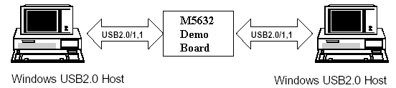

Software Support
>The application/driver runs on Windows 98SE/ME/2000/XP.

Steps By Steps to Install M5632 Super-Link【For Win98SE/ME/2K/XP】
>ALi M5632 Super-Link provides 2 kinds of installation methods for users：
（a）Setup installation.
- From M5632 Super-Link installation package, there is a “setup.exe” for installing. Please click it then into setup procedures.

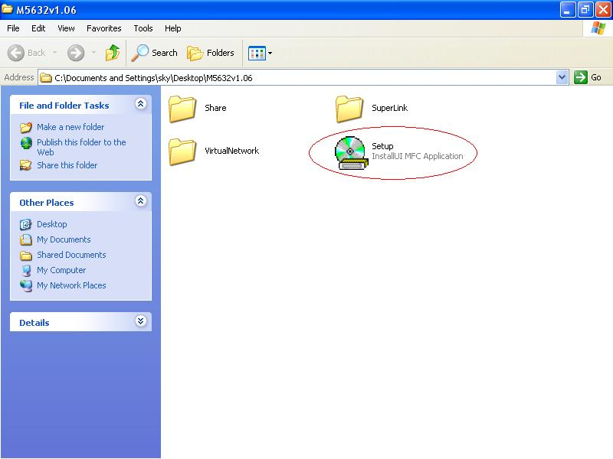

（ii）Click “Setup.exe”, then start to installation steps.
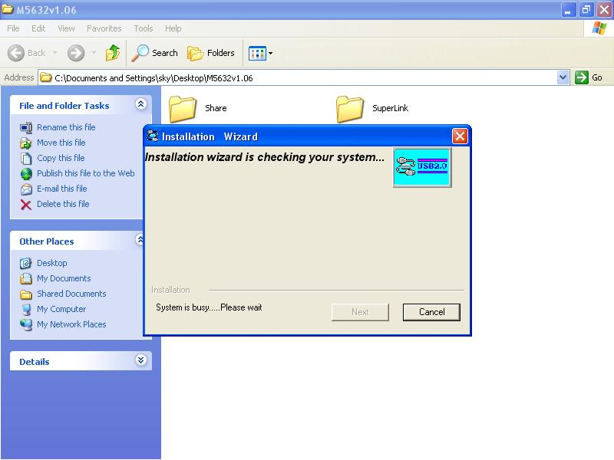

（iii）There are 2 selection for installing，please select “USB Super-Link Adapter”，then click “Next”
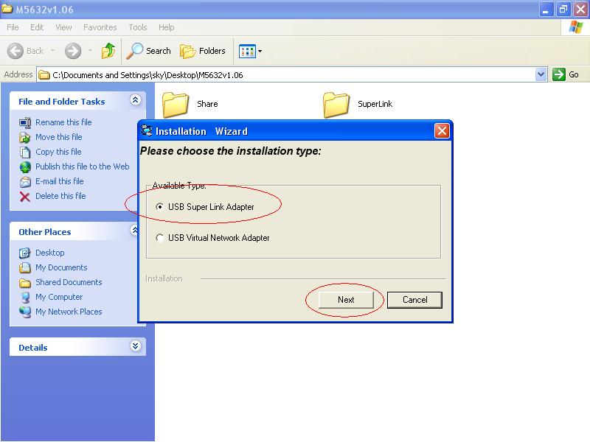

Note：Please unplug your cable first while install driver, or error message would show up.

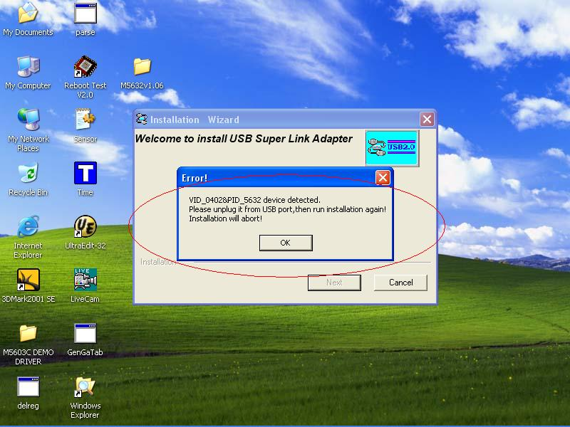

（iv）Please select the target folder you want to install in or follow default setting, then click “Next”
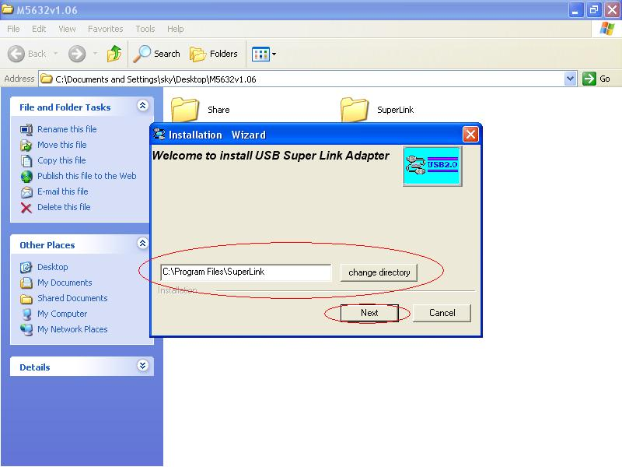

（v）In Windows XP system, there will be a software verification requesting windows pop out, just click
“Continue Anyway”, then continue to install. In Windows 98SE/ME/2K won’t have this requesting
windows.
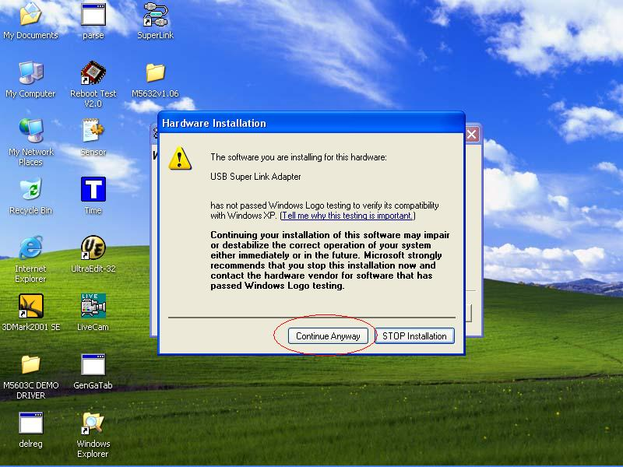

（vi）Just a few seconds, the completed install windows will pop out, just click “Finish” to complete
whole setup procedures.
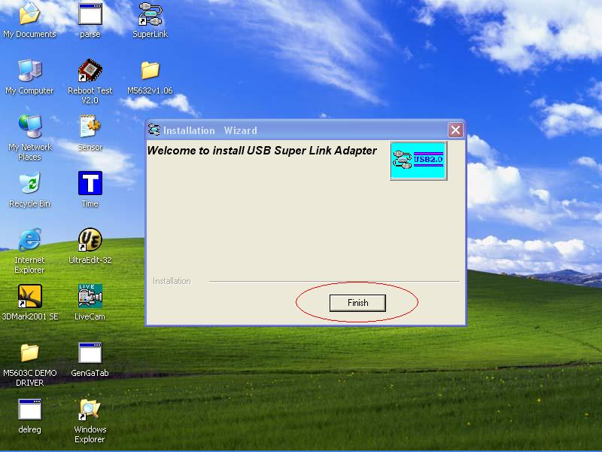

（vii）Users can plug the M5632 Super-Link into Host PC, then following figure is found. Since the necessary components were installed into system, users can just click “Next” to let windows auto search the driver components.
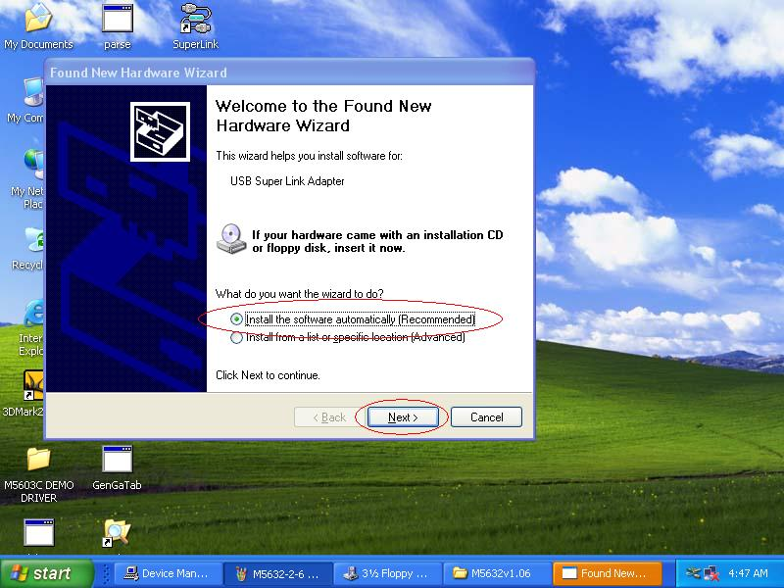

（viii）Also, in Windows XP system, there will be a software verification requesting windows pop out, just click “Continue Anyway”, then continue to install. In Windows 98SE/ME/2K won’t have this requesting windows.
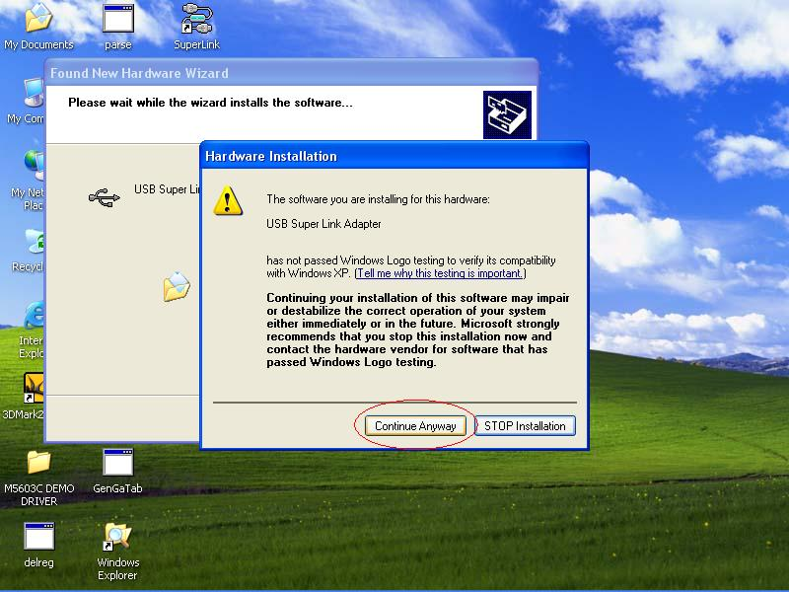

（x）Just a few seconds, the installation is completed, then press “Finish” to completed whole install procedures. Users can find a “Super-Link” shortcut on the desktop.
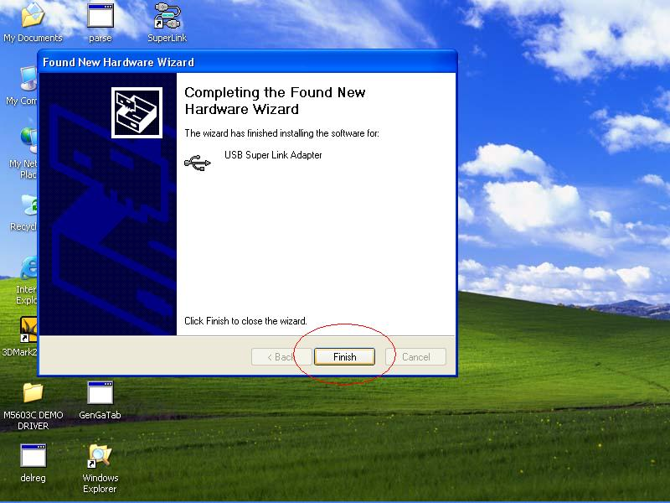

To start to use Super-Link application, just click “Super-Link” ICON then into U/I.
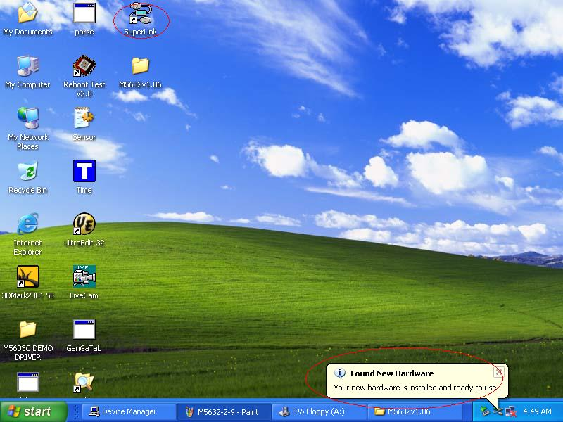

（xi）To check M5632 Super-Link whether install succeed, please go to the device manager to find the “USB Super Link Adapter”，and the installation is successful.
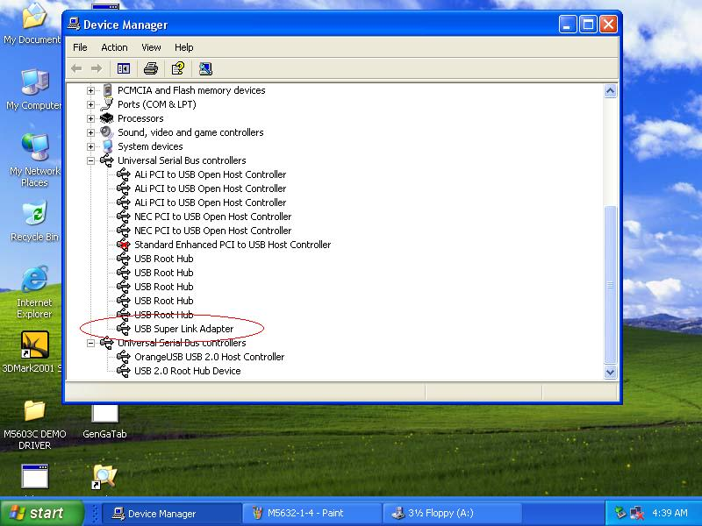

（b）Normal add/remove hardware installation.
- Plug M5632 Super-Link cable into host first. When the “Found New Hardware Wizard” opens, please select the “Install from a list or specific location （Advanced）”,then click
“Next”.
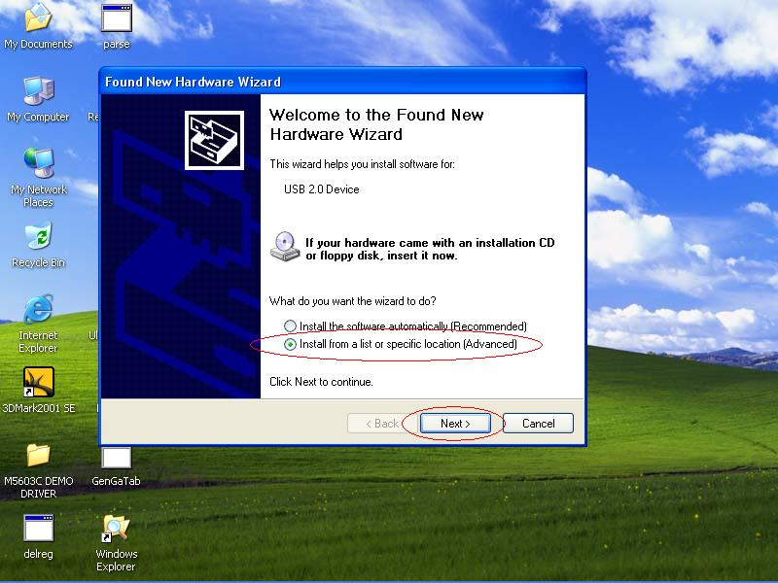

（ii）Select the correct source file location and click “Next”.
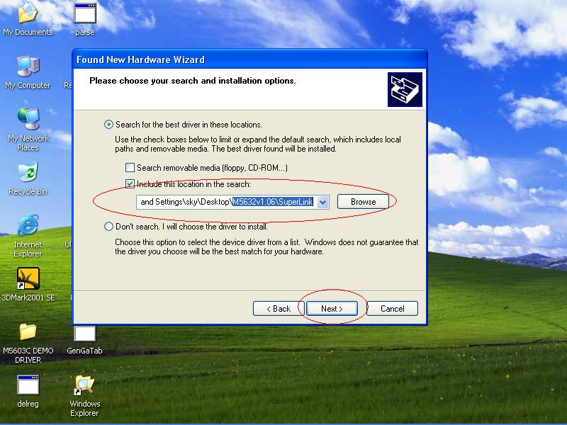

- Also, in Windows XP system, there will be a software verification requesting windows
pop out, just click “Continue Anyway”, then continue to install. In Windows 98SE/ME/2K
won’t have this requesting windows.

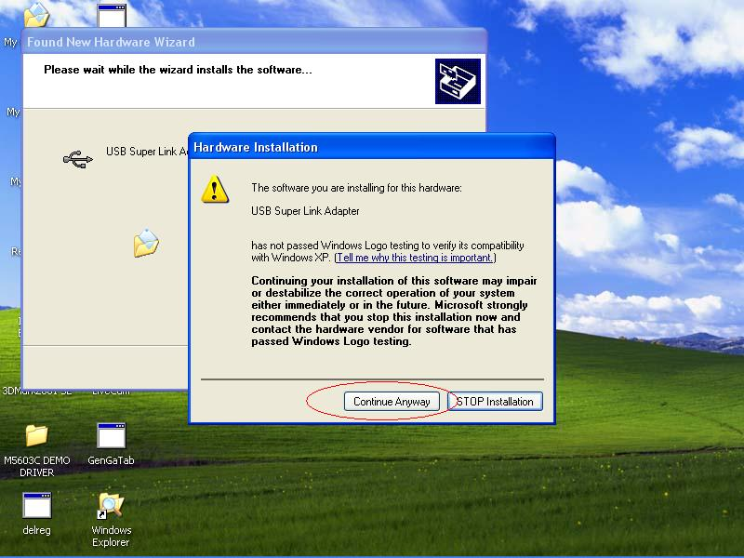

（iv）Just a few seconds, the driver is installed completed, and click “Finish”.
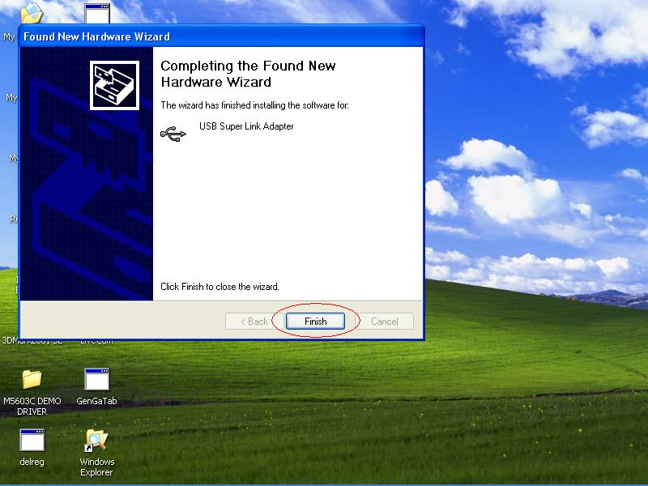

（v）To check M5632 Super-Link whether install succeed, please go to the device
manager to find the “USB Super Link Adapter”.

（vi）To start to use Super-Link application, please go to the install package of M5632, and click
“SuperLink.exe” into the U/I.
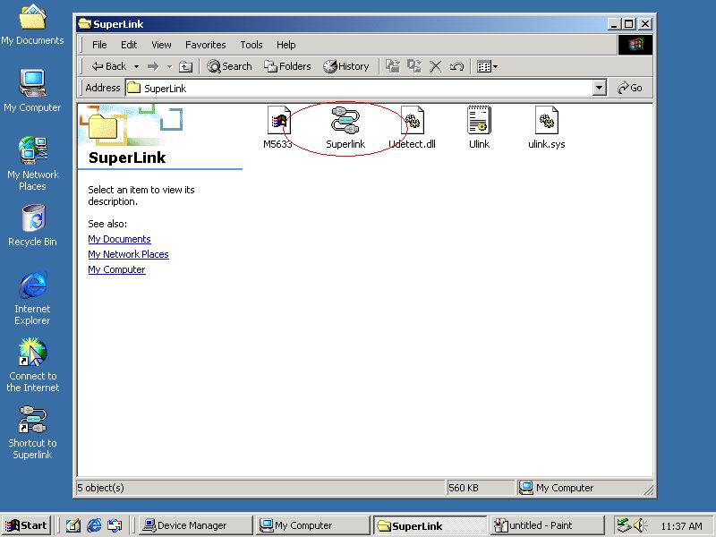

Note：How to switch to M5632 Virtual-Network mode from Super-Link
>Since M5632 support multi-functions by different driver, users can switch Super-Link to Virtual-Network via driver exchanging.
- Click Setup.exe first, and select menu will pop out, select the “USB Virtual-Network” item, and click “Next”.

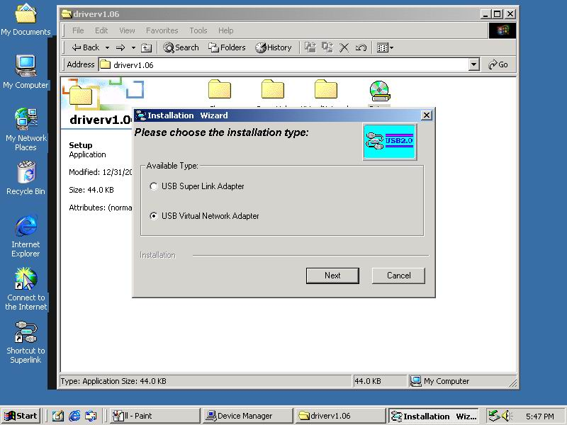
- User can select only remove Super-Link driver or install Virtual-Network driver.
（1）Just remove driver.
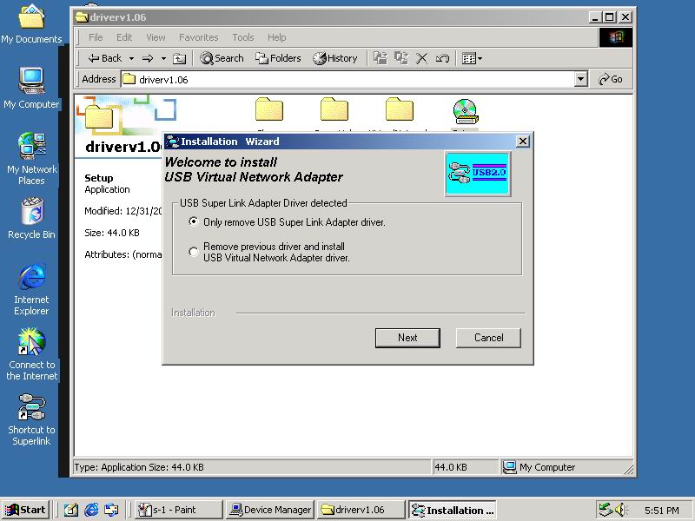

（2）Or install another driver：Virtual-Network driver, and fill in the target folder or follow up default setting. Click “Next”
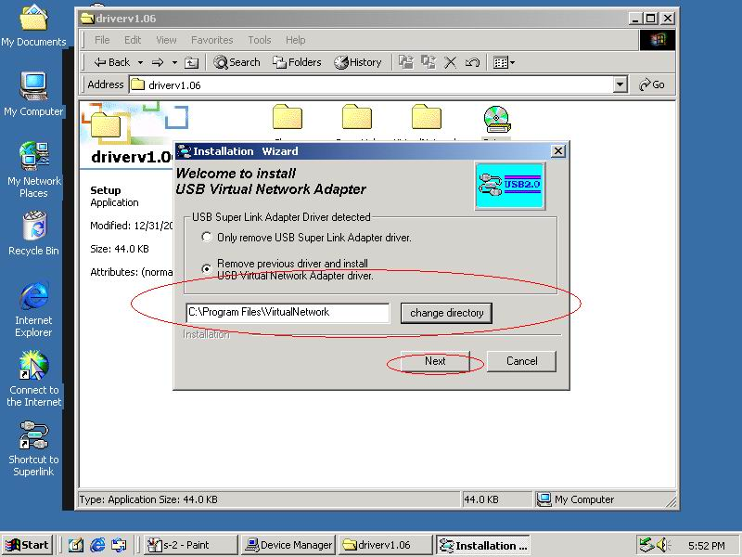
Also just wait a few seconds, and the driver is uninstalled or switched to Virtual-Network.

M5632 Super-Link Software Utilities Manager usage
M5632 Super-Link software application is like windows file manager. Users can use same function key to cut/copy/paste/delete target files and folders just like using windows file manager.

Disk utility edit service
>Cut (Ctrl+X)
>Copy (Ctrl+C)
>Paste (Ctrl+V)
>Delete (Ctrl+D)
>New Folder (Ctrl+N)
>Select All (Ctrl+A)
>Mouse’s drag and drop (To move an item on the screen by selecting the item and then pressing and holding down the mouse button while moving the mouse).

User interface introduction
a. Connect and open remoter.
Only “Local computer” will be shown up if doesn’t connect to remote computer, and application will keep auto-monitor whether the remoter is connected.
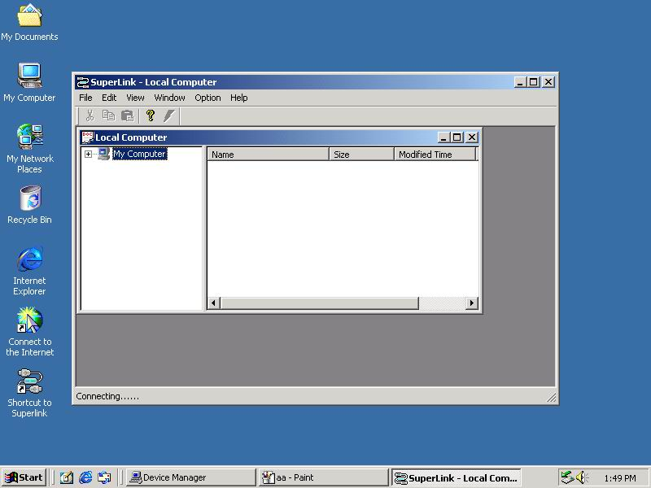

Remote Computer will be show up automatic while both-side computers are connected.

.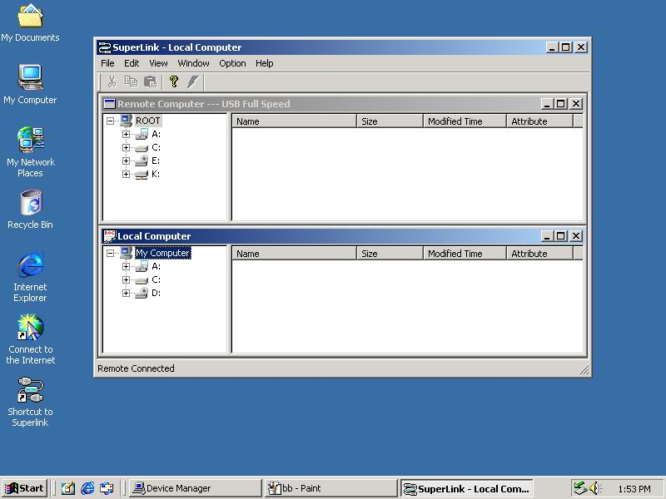

User can also use function selection “Open remoter（F12）”to open the remoter computer.
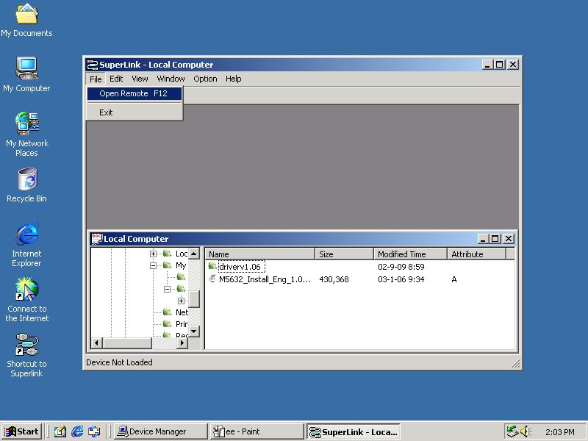

b. Copy/delete/cut/paste function key
User can use function key or mouse’s drag and drop to copy/delete/cut/paste target files or folders, actually, it’s just like windows file manager.

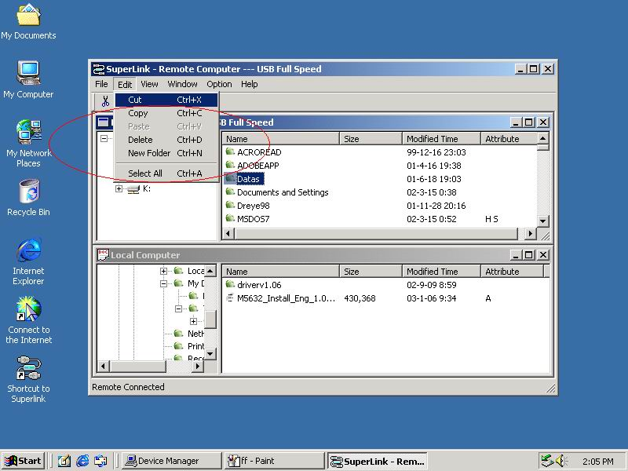

Ex-1：Copy file.
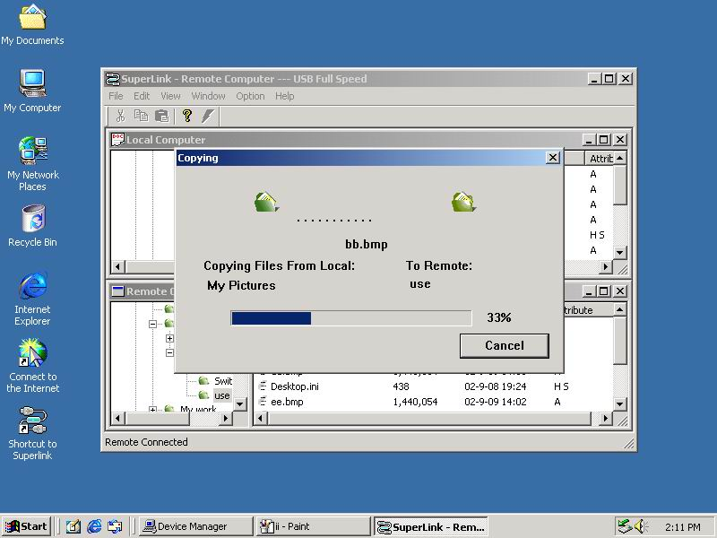

Ex-2：User can also create a target folder both in remoter/local computers. Select “New Folder” item to build up a folder which user want to manage his files.

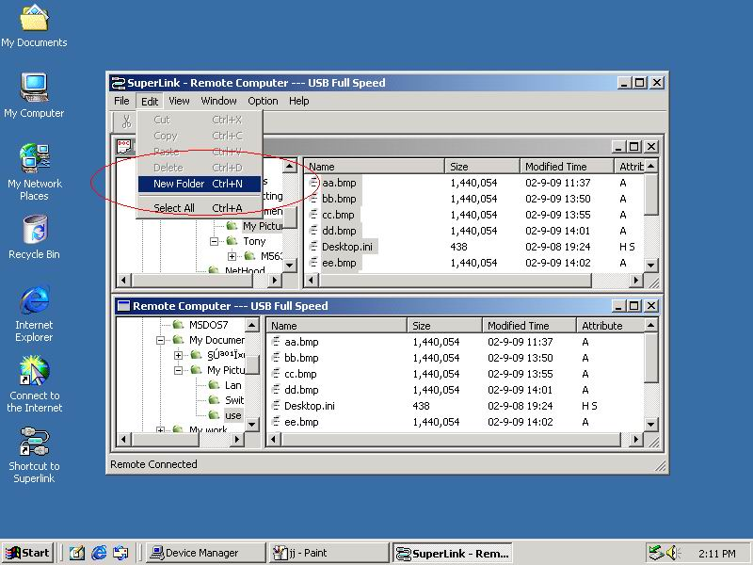

Fill in the target folder’s name, and the target folder is built.
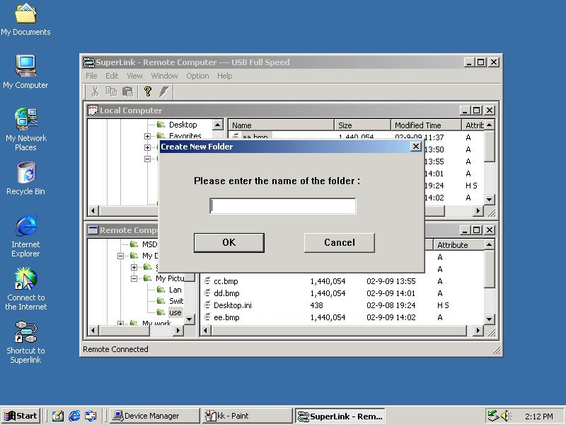

c. Check the interface version of M5632 Super-Link.
Click the “Help” selection or “Question mark” item, and the version information will be shown up.

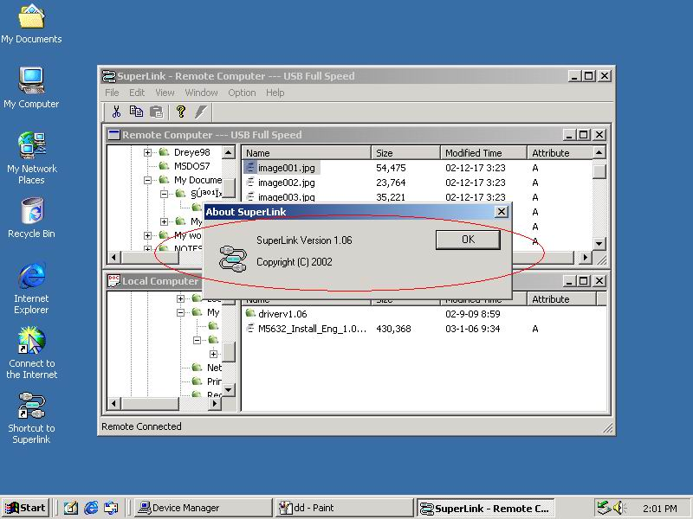

Taipei Office / Main Headquarter:
ALi Corporation
2F, No. 246, Section 1, Nei-Hu Road,
Taipei 114, Taiwan, R.O.C.
Tel: +886 (2) 8752 -2000
Fax: +886 (2) 8751 -1001
Website: www.ali.com.tw

US Office:
ALi Microelectronics Corporation, USA
525 E. Brokaw Road
San Jose, CA 95112
Tel: +1 (408) 452-4900
Fax: +1 (408) 452-4935
Website: www.aliusa.com

China Offices:
ALi (Shanghai) Corporation
6F Building 39, No. 333,
Qin Jiang Road, Shanghai 200233
Tel: +86 (21) 6485-5058
Fax: +86 (21) 6495-1498
ALi (Shanghai) Corporation, Shenzhen Branch
7F, Shenzhen International Trade Commercial Bldg
No. 3005, Nanhu Road, Shenzhen 518014
Tel: +86 (755) 519-5788
Fax: +86 (755) 519-5788 Ext. 6013

