**1.Encuentra en la sopa de letras los tipos de robots**





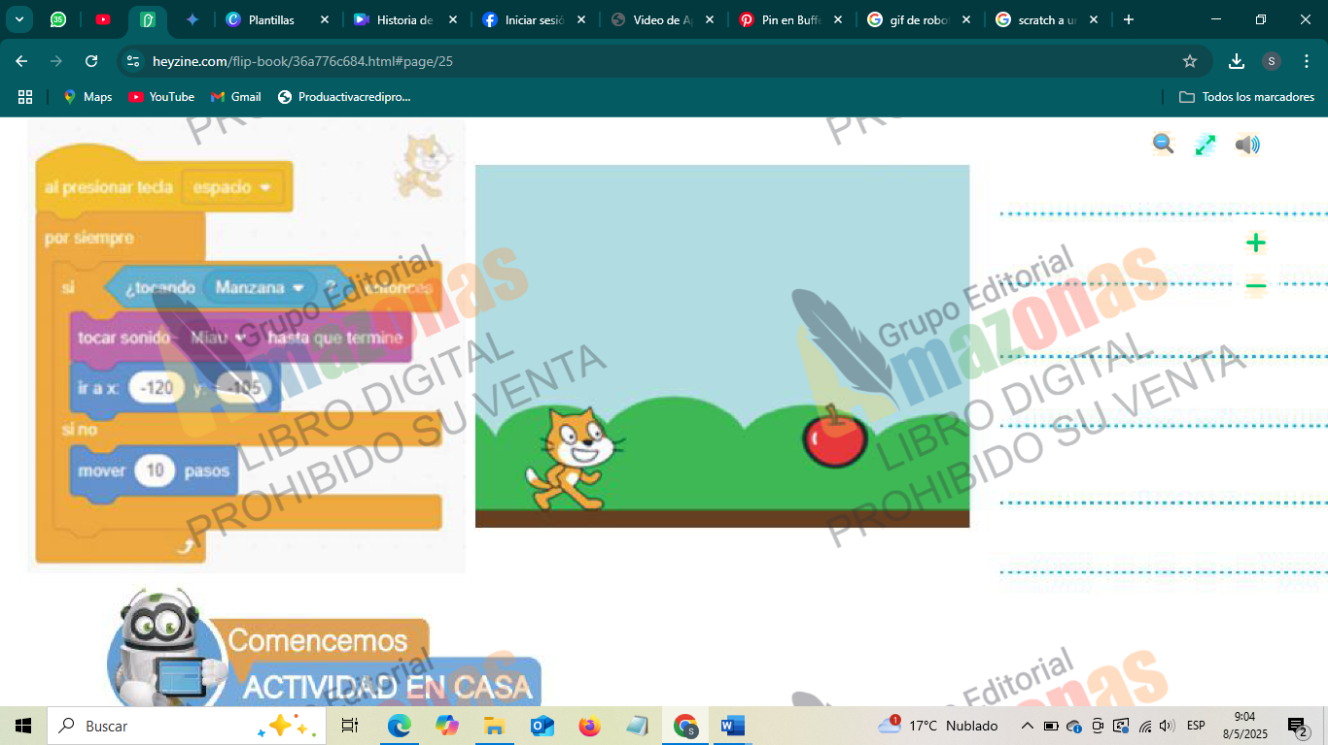



--------------------------------------------------------------------------------------------------------------------------------------------------------------------------------------------------------------------------------------------------------------------------------------------------------------------------------------------------------------------------------------------------------------------------------------------------------------------------------------------------------------------------------------------------------------------------------------------------------------------------------------------------------------------------

**2.Observa los bloques y escribe como es la animación de este programa**

Palabras de búsqueda

* Exploración
* Asistencia
* Entretenimiento
* Limpieza
* Fabricación

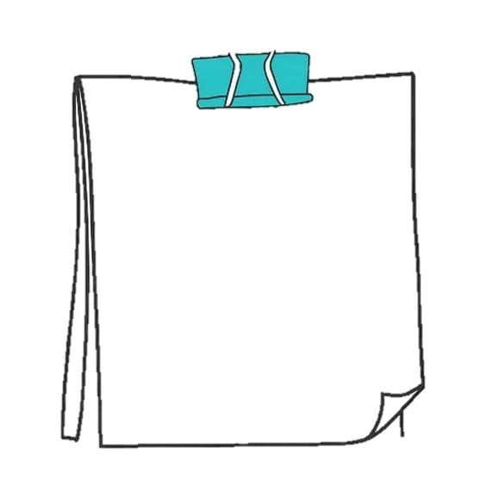

|  |  |  |  |  |  |  |  |  |  |  |  |  |  |  |  |  |  |
| --- | --- | --- | --- | --- | --- | --- | --- | --- | --- | --- | --- | --- | --- | --- | --- | --- | --- |
| S | G | Q | U | F | C | C | G | W | K | H | P | N | U | A | Z | S | Ñ |
| R | Ñ | R | A | J | P | A | H | R | Y | V | J | Y | Z | Ñ | H | L | V |
| O | W | C | L | Z | U | A | B | Ñ | U | W | O | Ñ | V | M | R | C | R |
| H | C | M | Ñ | H | L | S | S | F | U | W | S | U | S | Z | F | I | C |
| D | V | O | T | N | E | I | M | I | N | E | T | E | R | T | N | E | B |
| P | X | E | V | Ñ | U | Y | P | M | S | A | K | N | J | N | Z | L | W |
| Y | V | M | Q | C | Y | V | N | M | U | T | H | T | U | E | M | Z | K |
| F | H | R | G | J | V | L | W | Q | I | R | E | V | P | F | X | K | I |
| F | B | H | Z | I | V | W | P | W | O | L | S | N | Z | E | E | K | F |
| J | J | B | I | I | K | P | N | H | D | U | O | F | C | R | B | D | D |
| N | O | I | C | A | R | O | L | P | X | E | W | J | D | I | Z | J | M |
| G | C | Y | F | A | B | R | I | C | A | C | I | O | N | T | A | F | O |
| X | U | B | Z | U | F | B | J | J | S | W | Y | F | O | Z | L | I | C |
| C | I | O | H | J | C | T | X | I | E | X | S | F | X | C | X | Ñ | X |
| G | S | T | Z | R | T | A | E | L | H | U | J | X | E | E | P | W | P |
| F | K | F | I | D | K | E | E | I | A | O | A | W | V | A | X | J | N |
| Y | J | W | P | V | J | Y | Z | F | J | M | O | S | D | X | N | C | I |
| O | Ñ | P | Ñ | K | B | M | V | S | G | W | A | Ñ | Q | A | A | A | G |



EVALUACIÓN

UNIDAD 1-2