Personalised Endoscopy Report for Evaluation and Continuous Training (PERFECT) for sebastian zeki 15 April, 2020

Please find enclosed a breakdown of results from your endoscopic assessments. The results are organised. At the end of the report there are metrics which you can compare your performance to.

# Table of endoscopy and histology

# Cancer Diagnoses Table

|  |  |  |  |
| --- | --- | --- | --- |
| **Hospital No.** | **Findings** | **Histology** | **Postive Diagnoses only** |

# Dysplasia Table

|  |  |  |  |
| --- | --- | --- | --- |
| **Hospital No.** | **Findings** | **Histology** | **Postive Diagnoses only** |

# All Diagnoses Table

|  |  |  |  |
| --- | --- | --- | --- |
| **Hospital No.** | **Findings** | **Histology** | **Postive Diagnoses only** |

# Barretts metrics- Grade detection and documentation of key elements on reports

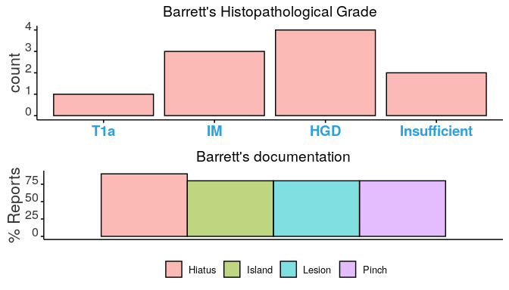

# On average you took 2 biopsies versus the expected number of biopsies you should have taken for your Barrett’s cases.

# 

## [BSG Barrett’s Guidelines here](https://www.bsg.org.uk/wp-content/uploads/2019/12/BSG-guidelines-on-the-diagnosis-and-management-of-Barretts-oesophagus.pdf?x19508),

# Procedures performed

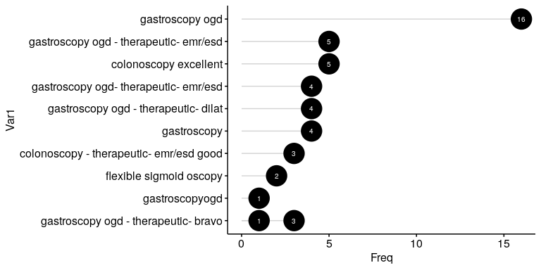

# Biopsies taken per indication- Your biopsies versus the average number of biopsies taken for that indication

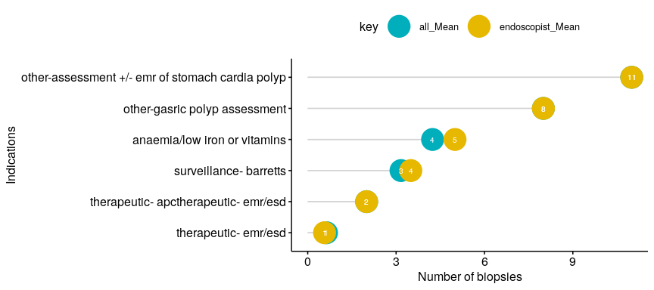

# Adenoma detection and subtypes- Your adenoma detection rate broken down by histopathological subtype



 

