A good workman blames his tools. Understanding the contribution of endoscope model to the adenoma detection rate for experienced endoscopists

Sebastian Zeki PhD

27 June 2017

# R code template Sebastian Zeki 2017

# Date code written

# library(codeDepends)

# sc = readScript(“S:\Gastroenterology\Seb\R\Scripts\Eosinophilics\Eosinophilix.R”)

# g = makeVariableGraph( info =getInputs(sc))

# if(require(Rgraphviz))

# plot(g)

Introduction

The adenoma detection rate (ADR) is a crucial component when assessing the skill of an endoscopist. The rate is attributed to an individual endoscopist and reflects a composite of various techniques that the endoscopist employs such as withdrawl time, use of endocuff etc. However the endoscope used has not been assessed.

Aim

<http://rmarkdown.rstudio.com>.

When you click the **Knit** button a document will be generated that includes both content as well as the output of any embedded R code chunks within the document. You can embed an R code chunk like this:

## Method—Can I extract the comments from an r script to #Data acquisition, cleaning and filtration goes here

Data was acquired from retrospectively from hospital records. 2 (#Filter 1 here) barium swallow reports were analysed. High resolution manometry reports were then acquired and cross referenced with the barium swallow reports. (#Filter 2 here) HRM’s with a barium study within 1 year of the barium were retained. Fundoplication and post therapy patients were excluded from the analysis.

Data acquisiton

Data merging

Data cleaning

# Date cleaning

Data accordionisation

Data forking (filtering and subsetting)

Data analysis

Code overview (with CodeDepends)

## Results  
Table 1: Demographics  
  
  
  
 speed dist   
--- ------------- ---------------  
 Min. : 4.0 Min. : 2.00   
 1st Qu.:12.0 1st Qu.: 26.00   
 Median :15.0 Median : 36.00   
 Mean :15.4 Mean : 42.98   
 3rd Qu.:19.0 3rd Qu.: 56.00   
 Max. :25.0 Max. :120.00   
  
## Including Plots  
  
You can also embed plots, for example:

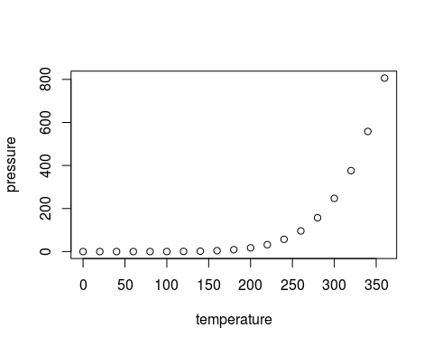

Note that the `echo = FALSE` parameter was added to the code chunk to prevent printing of the R code that generated the plot.  
  
  
  
  
  
####################################### Sandbox ####################################### ####################################### #######################################