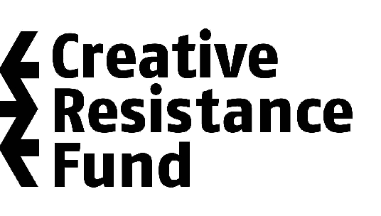



freeDimensional's Distress Services Intake Form
* All information uploaded on our intake form will be see only by freeDimensional staff and Distress Services case consultants and will remain entirely confidential.
* If you have inconsistent internet access or for whatever reason are unable to input to this form directly, a downloadable version is available here:

APPLICANT INFORMATION:

Who is filling out this form? Are you: Artist at Risk ___ Nominator___ Friend/Family___
* If you are Nominator, Friend or Family member filling out this application please indicate your name here:

Name of Applicant:
Date of birth (m/d/year):
Gender:
Address (optional):
Email Address:
Contact phone numbers (at least one):
Country(ies) of citizenship:
Current location:
Languages spoken:

YOU ARE APPLYING FOR WHICH OF THE FOLLOWING:

- Creative Safe Haven (short-term long term residency) ____

- Creative Resistance Fund (small emergency grant) ____

- Services/ Resources Needed:

Psychosocial ____ Legal ____ Medical ____ Employment ____ Education ____

Housing/Food/Clothing ____ Professional Development ____ Community Engagement ____

Other ____

CASE INFORMATION

- Please indicate the level of urgency of your request:

Low ___ On-going ___ Immediate ___

Please state your reason for requesting freeDimensional's assistance and give a detailed account of your current situation.

- What is(are) your area(s) of work? Please describe your latest projects as they relate to your current situation.

- Are you facing persecution as a result of your work? (threats, attacks, harassment, arrests, socially marginalized, blacklisted, etc.) If possible, please give specific examples, with dates, locations, and key individuals involved.

- Is the persecution you are now facing related to aspects of your personal identity? (For example: race, class, ethnicity, gender, or sexual orientation.) If so, please explain.

- Have you been in touch with other organizations about your situation or sought other sources of support? If so, please tell us which ones and who your contact person there is.

- Are you member of any organization, academic institution or professional association? If so, please describe its mission or main focus of work, provide address, phone number, email, and name of the person accountable.

- Are you currently employed? If so, please provide your employer's contact information if relevant to your situation.

- For any additional information you which to provide please use the space below.

Return this form to: distress@freedimensional.org
PLEASE NOTE: All cases all carefully vetted by freeDimensional staff and volunteer Distress Services case consultants. Due to the high volume of requests and varying levels of urgency, the average response time is three days to one week.

